
Marriot international
Ratio Analysis 2020/2021

December 8, 2022
University of Wales Trinity Saint David

By Lee Whillis
2028531
Lecture Christopher Wilkin
Financial Management for the Hotel Industry
BMIH 5007

Executive Summary
The purpose of this report is to analyse the financial ratio of Marriott organisation for 2020 and 2021.
Numbers and ratios are utilized for many purposes (Nobes, 2014). Is important to assess the performance of an organisation that permit managers to look into what improvements can be applied (Penning and Brammer, 2010).
Marriot International Inc, have more than 60 years of experience in the industry of hotels, is registered in the stock market (NASDAQ: MAR), is established in Maryland, United States of America (USA). Marriot is market leader, provides strong portfolio in the hospitality business. Offering more than 8000 proprieties around 139 Countries in the world, presenting 30 different brands.
Ratios can provide useful and quick model of analysing the performance of organisations, but they may present limitations and problems (Atrill, 2020).
Marriott presented a gearing ratio of 27,80% in 2020 and 23.28% in 2021, surprisingly This gearing means a well establish organisation, with low risk.
Ratios are important to analyse profitability, risks, liquidity, and financial position. Helps with strategy, plans for future, is a tool for forecasting, identify trends, helps to make improvements and decision making about investments. without this information, would be difficult to decide what to do.

Table of Contents
Executive Summary 1
Introduction 3
Financial Analysis Trends 4
Profitability 5
Liquidity 7
Gearing 9
Knowledge from Ratio Analysis 11
Benefits and Limitations of Ratio Analysis 12
Conclusion (average of 10% of word count) 13
Bibliography 14

Introduction

This report is being elaborated at the request of the Senior Manager to inform Chief executive, to communicate information about comparison of financial ratios performance from 2020 and 2021.
Trend analyses is an approach to predict the future of sales, stocks, based on recent information(data), assuming will pursue the same direction, as they have in the past (Penning, 2016).
To Critically evaluate and analyse the ratios and their fluctuations.
Identifying the comprehensive understanding of why this ratio are important to decision making, and their limitations.
Managers and owners have the necessity to focus and analyse all business financial numbers before making any decision, the fore some ratios will transmit important details (Sloman and Jones 2017).
Marriot International Inc, have more then 60 years of experience in the industry of hotels, is registered in the stock market (NASDAQ: MAR), is established in Maryland, United States of America (USA). Marriot is market leader, provides strong portfolio in the hospitality business. Offering more than 8000 proprieties around 139 Countries in the world, presenting 30 different brands. Normally operates as ownership resorts, franchises hotels and licenses vacations, and have strong presence on social media such as: Instagram, Facebook, and Twitter (Marriott, 2022).

Financial Analysis Trends
Type of Ratio | Formula | Calculation | Calculation | Percentage
Profitability |  | 2020 | 2021 | 2020 | 2021
Gross Profit Margin | Gross profit  ------------- X 100  Sales Turnover | 1459  -------- X 100  9112 | 2801  -------- X 100  11056 | 13.80% | 20.21%
Net Profit Margin | Net Profit  ------------ X 100  Sales Turnover | 1099  ------- X 100  9112 | -267  ------- X 100  11056 | -2.52% | 7.9%
ROCE (Return on Capital Employed) | Earnings (before interest and tax)  ------------- X 100  Capital Employed (Total assets – Current liabilities) | 84  -------- X 100  24,701 – 5752  18,949 | 1750  --------- X100  25,553 – 6,407 19,146 | 25,55% | 9,14%

Type of Ratio | Formula | Calculation | Calculation | Percentage
Liquidity |  | 2020 | 2021 | 2020 | 2021
Current Ratio | Current assets  -------------- X 100  Current liabilities | 2825  -------- X100  5752 | 3626  ------- X 100  6407 | 0.49% | 0.57%
Acid Test | Current assets (omitted stock)  -------------- X 100  Current liabilities | 6868  -------- X 100  5752 | 5951  -------- X 100  6407 | 119.4% | 92,88%

Type of Ratio | Formula | Calculation | Calculation | Percentage
Gearing |  | 2020 | 2021 | 2020 | 2021
Gearing | Long term (non-current) Liabilities  -------------- X 100  Share capital+ Reserves +Long term (non-current) liabilities | 6868  --------- X 100  24701 | 5951  ---------- X 100  25553 | 27,80% | 23,28%
Interest cover | Operating Profit  --------------- X 100  Interest Payable | 84  ---------- X 100  9203 | 1750  --------- X 100  9333 | 24,13% | 7,16%

Profitability
Profitability ratios represent exactly what is hint in the name the organisations profitability, the capacity of achieving profits and earnings, announcing the success over the years, and helps when contrasting with rivals in business (competitors) (Sloman and Jones, 2017). There are three leading ratios, such as Gross Profit Margin, Net Profit Margin and ROCE (return on capital employed).
Formulas
Gross Profit Margin = Gross Profit
------------------- X 100 = %
Sales Turnover
These ratios estimate the funds spend to obtain profit (By subtracting costs of goods sold from gross profit) and is calculated before overheads (fixed costs) being considered.

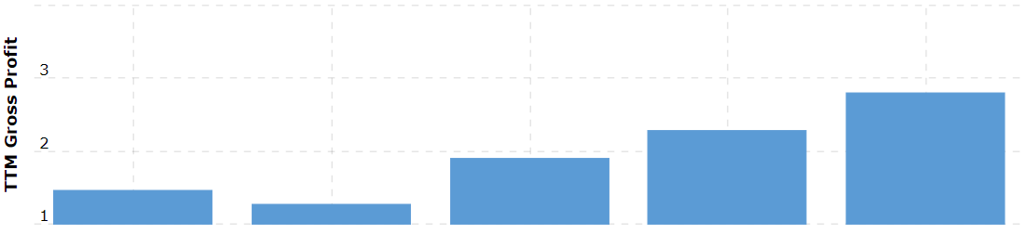
(www.macrotrends.net, n.d.)

Marriot presents a gross profit of 13,80% for 2020($1459B), and 2021% for 2021($2801B), showing an increase in comparison, meaning growth. 2020 the number referred are due to pandemic covid 19, even with this decline Marriot ranked in front of direct competitors like Accor, Hilton, and Hyatt, in 2020 Marriott also suffer from a data breach, that represented a loss as well (Lock, 2022).

Net Profit Margin = Net Profit
---------------- X = %
Sales turnover
The ratio calculates the profit after all costs of the organisation are deduct (such as rent, production, insurance, wages, taxes, etc), giving the exact information how the organisation was effective, and if adds value to the business.
These two ratios should be examined together, to better understand the financial performance of the organisation (Sloman and Jones, 2017).

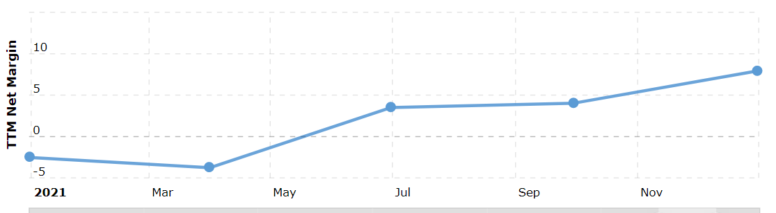
(www.macrotrends.net, n.d.)

The net profit margin ratio in 2020 is represented by -2,52%, a very bad decrease in numbers, while 2021 presented an increase to 7,9%. Due to pandemic in 2020 all most every organisation had really bad ratio numbers, although in general Marriott was better than same competitors, in 2021 Marriott really prove themselves and was able to add value to the organisation. When analysing the ratios seems the performance is not good, but because of pandemic there is much more to analyse.

ROCE = Earnings (Before taxes and interest)
------------------------------------------------- X = %
Capital Employed

The ROCE ratio examines the efficiency of the organisation, and how well they use money to generate profit, and is considered to be the first ratio to calculate profitability (Atrill, 2020).
Higher ratios of gross profit and net profit are index of good effective performance, when analysing the ratios if looked individually, may be deceptive. Also, important to look into trends in profit, is to analyse ROCE over time. organisation can not forget to do a comparison with other organisation in the industry (Sloman and Jones, 2017).

Liquidity
Liquidity ratios refers to capacity of organisation to cover limited financial commitments, there are two ratios normally used, such as acid test ratio and current ratio (Atrill, 2020). Liquidity ratios helps to understand if a business is able to repay the debts they have (Sloman and Jones, 2017).
Current ratios
Current ratios contrast the wealth (funds and assets that will transform is cash very soon, cash flow), with the current liabilities (obligations or payments(debts) for one year).

Formula
Current ratio = Current assets
----------------------- X 100 = %
Current liabilities

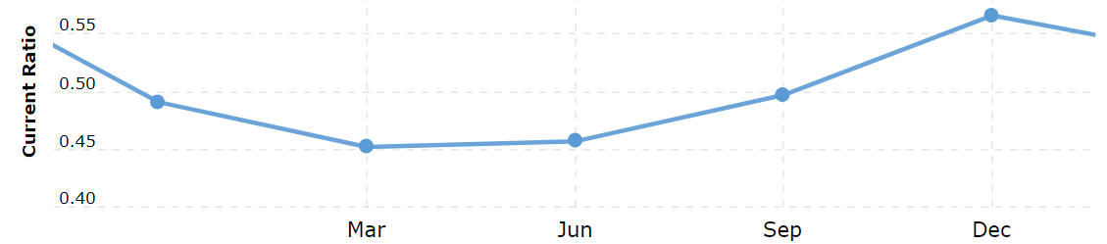
(www.macrotrends.net, n.d.)

This ratio appears to present a classic result, that translate to two times or 2:1, for all organisations.
Atrill, (2020), argue that this may not be exactly true, different organisations may present different ratio results. Bigger the ratio, more fluidness the organisation is, more cash flow the means the business will have more changes to survive.
The current ratio presented by Marriott in 2020 is translated in 0.49% increasing to 0.57% in 2021, notice a slow growth, with indications that Marriott organisation pass to rough waters but will survive this Crisis imposed by covid 19, showing their abilities of great management.

Acid test ratio is alike current ratio, instead give a more rigorous assess of liquidity (Atrill, 2020). For some organisations the stock is not turn in cash as quick, in result the stock may be excluded from liquidity testes (Sloman and Jones, 2017).

Formula
Acid test ratio = Current assets (omitted stock)
------------------------------------------ X 100 = %
Current Liabilities
These ratios normally present a result of 1 or 1:1, nevertheless some fortunate organisations, may present a ratio below 1, but still not having any liquidity worries (Atrill, 2020).

Acid test ratio or quick ratio of Marriott was 0.49 for 2020, and 0.57 for 2021. For two years the organisation presented a ratio bellow 1, showing problems with liquidity, this was provided by covid 19, and all the restrictions imposed by governments around the globe, not generating enough certainties, and not having enough revenue.

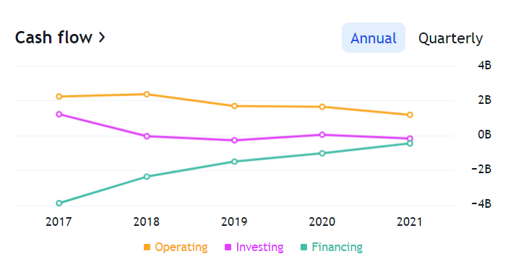
(Trading View, n.d.)

Gearing
Gearing ratios refers to organisations that borrow funds, this can affect the way business will return funds to shareholders, and the risks involved, generally there are two ratios used, such as interest cover ratio and gearing ratio (Atrill, 2020). This will assess benefaction for the considerable length for loaners of the organisation.
Formula
Gearing ratio = Long term (non- current) liabilities
----------------------------------------------- X 100 = %
Share capital+ Reserves + Long term (non-current) liabilities

Gearing ratios are not the same in different industries and organisations.
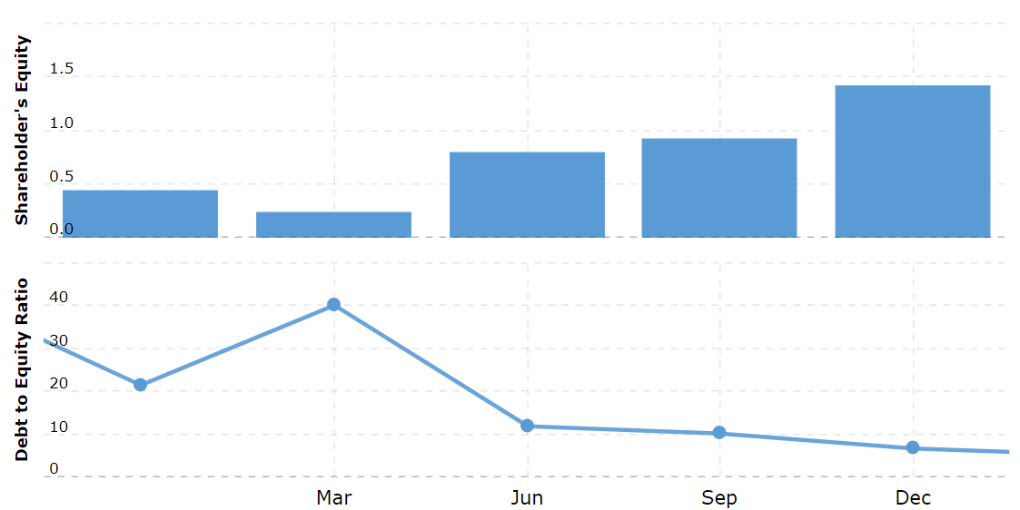
(www.macrotrends.net, n.d.)

Marriott presented a gearing ratio of 27,80% in 2020 and 23.28% in 2021, surprisingly This gearing means a well establish organisation, with low risk. Only higher Gearing above 50% represent financial risks and may take organisation to bankruptcy.

Interest cover ratios refers to the quantity of operating profit obtain to pay interests (Atrill, 2020).

Formula
Interest cover ratio = Operating profit
----------------------- X 100 = %
Interest payable

If the operation profit is higher than the interest payable, the organisation will be in a good position to pay lenders, if the operating profit fall bigger the risk, for lenders get the funds in appropriate time, making shareholders in a bad position and may not attract new funds for the organisation.
Marriott show an interest cover ratio for 2020 of 24.13% and EBIT less than 2, this is considered that Marriott did not meet the minimum acceptable to be considered solid, because did not present consistent revenue. For 2021 of 7.16% and EBIT more then 12, this year Marriott was considered by analysis very solid, with forecast to growth in the future.
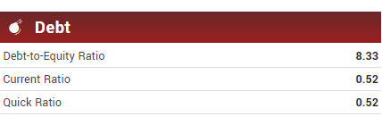
(www.marketbeat.com, n.d.)

Knowledge from Ratio Analysis

Ratios can provide useful and quick model of analysing the performance of organisations, but they may present limitations and problems (Atrill, 2020).
1 – Quality of financial Statements, because they utilize financial statements, they will always deal with limitations.
2- Creative Accounting, despite accounting have rules and regulations, some organisations employ accounting policies or omit particular transactions that may mislead the picture of the financial health, this is creative accounting, and may present problems.
3 – Inflation, in different countries the financial results can be disturbed because of inflation, the same inflation can alter profit.
4 – Over reliance on ratios
5 – Basis for comparison, ratios are great tools, but require data for comparison, there is the necessity for comparison with organisations in the same industry and with the same structure(benchmark).
Also, is noted that because ratios are generated by financial positions (snapshots) at determined times of the organisations, may not represent the whole year, also same organisation utilize the lower seasons to create ratios, these may present to be lower than they really are (Atrill, 2020).
Ratios and their fluctuations are essential for hotel management because they help to make improvements, promote strategy, investments, pricing, etc.
From 2020 to 2021 Marriot adjusted and improvements, and prove to be effective and productive, show the ability to create revenue, and profit, although the numbers are not very representative, covid 19 pandemic and inflation that a great deal to do with these ratios, but is still a great organisation with a forecast of growth for the next years.

Benefits and Limitations of Ratio Analysis
When organisation need to put together decisions, loads of factors they will have to consider.
To reach these considerations managers and owners will look to the health of the organisation, they will use numbers to decide. Same of these numbers are called ratios, providing key figures (Sloman and Jones 2017).
Ratios analyse is normally the calculation in percentage, utilizing data from the financial account of an organization (Penning and Brammer, 2010).
Being one main instrument, when checking performance, normally utilized in two forms, comparison of performance every year, and contrast with other organisations (AAT, 2018).
Single individuals and investors can examine the ratios, to decide to buy shares, or invest in the business, this ratio information will add value for decision (Penning and Brammer 2010).
Ratios are determined from Statement of financial position and income statement (Penning and Brammer, 2010).
In order to utilize the ratio information, the numbers need to be contrasted with other organisation numbers (ratios), that is same industry and similar organisation. The capital resources and scale of operations and maybe brand have to be in the same market and measure, otherwise the number will worth nothing (www.linkedin.com, n.d.).
There are many types of ratios in the financial world, such as Liquidity, Gearing, Profitability, and investment ratios. The ones with more meaning and importance are Liquidity and profitability (AAT,2018).
Ratios are important to analyse profitability, risks, liquidity, and financial position. Helps with strategy, plans for future, is a tool for forecasting, identify trends, helps to make improvements and decision making about investments. without this information, would be difficult to decide what to do.

Conclusion (average of 10% of word count)

In Conclusion Marriott financial ratio for 2020, presents not good numbers, when examine alone, but overall because of covid 19 pandemic, was not so bad, even was able to demonstrate better results than competitors. As for 2021 surprisingly, the numbers where actually quite good, given a forecast of growth for the future. Marriott proved management are in fact doing a good job.
Ratio analyses are a great tool to use, but never alone, due to their limitations and fluctuations, numbers can be manipulated and induce misinterpreted. Ratio helps to improve allocations of funds and resources to be for effective, and helps to add value to organisations. Business and organisations such use this data (ratios) in conjunction with other methods and modules to achieve better results.

Bibliography

Atrill, P. (2020). Financial Management for Decision Makers. 9th ed. Harlow, England; New York: Pearson.
BPP LEARNING MEDIA (2021). AAT Cash and Financial Management.
CFI (2022). Financial Ratios. [online] Corporate Finance Institute. Available at: https://corporatefinanceinstitute.com/resources/accounting/financial-ratios/. [ Accessed 07 Dec. 2022].
Gillespie, A. (2019). Economics for business. Oxford, United Kingdom: Oxford University Press.
Kew, J., Stredwick, J. (2008). Business environment: managing in a strategic context. London: Chartered Institute of Personnel and Development.
Marriott (2022). About Marriott International | Corporate Information. [online] Marriott.com. Available at: https://www.marriott.com/marriott/aboutmarriott.mi. [ Accessed 4 Dec. 2022].
Nobes, C.W. (2014). Accounting: a very short introduction. New York, N.Y.: Oxford University Press.
Penning, A. and Brammer, J. (2012). Financial performance. Worcester: Osborne.
Statista. (n.d.). Marriott revenue worldwide 2021. [online] Available at: https://www.statista.com/statistics/266279/revenue-of-the-marriott-international-inc-hotel-chain/#:~:text=The%20company%27s%20revenue%20dropped%20by%20nearly%20half%20in [Accessed 7 Dec. 2022].
Sloman, J. and Jones, E. (2017). Essential economics for business. Harlow, England; New York: Pearson.
Trading View. (n.d.). Marriott International Financial Statements – NASDAQ: MAR. [online] Available at: https://www.tradingview.com/symbols/NASDAQ-MAR/financials-overview/ [Accessed 8 Dec. 2022].
www.linkedin.com. (n.d.). Use of Ratios in Decision Making. [online] Available at: https://www.linkedin.com/pulse/use-ratios-decision-making-arsim-sadiku [Accessed 5 Dec. 2022].
www.macrotrends.net. (n.d.). Marriott Financial Ratios for Analysis 2005-2020 | MAR. [online] Available at: https://www.macrotrends.net/stocks/charts/MAR/marriott/financial-ratios. [ Accessed 2 Dec.2022].
www.marketbeat.com. (n.d.). MAR Stock Price, Forecast & News (Marriott International). [online] Available at: https://www.marketbeat.com/stocks/NASDAQ/MAR/. [Accessed 4 Dc.2022].

