University of Wales Trinity Saint David

Wales Institute of Science and Art



Re-Sit Report

Group Design Project (ACHA5014)

Oska Robertson
2301207
09/07/26

Table of Contents
1. Introduction 3
2. Project Engineering Management 3
3. Technology and component literature survey 4
3.1. Frame 4
3.2. Suspension 5
4. First-Principles Analytical Engineering 5
4.1 – Introduction 5
4.2 – Powertrain and gearing analysis 6
4.3. – Aerodynamic and Rolling Resistance Analysis 8
4.4. – Kinematic Deceleration analysis 9
4.5. – Section Conclusion 10
5. Modelling and Packaging Studies 10
5.1. – Purpose 10
5.2. Chassis geometry 10
5.3. Component Packaging 10
5.4. Regulation Compliance 11
6. Systems Integration, Sustainability and Conclusion 11
6.1. Overall Design Integration 11
6.2. Sustainability Considerations 11
6.3. Conclusion 11

Introduction
The aim of this project is to research, design and develop a prototype motorcycle for entry into the MotoStudent Petrol Category, which will take place at the MotorLand Aragón circuit in Spain. The prototype motorcycle must comply with all the requirements set out by the regulations to allow it to be eligible to compete.
MotoStudent is a biennial competition for university teams to design and manufacture a racing motorcycle within the specifications, using a standardised KTM 250 SX-F engine⁴ for all teams. This permits a balance between allowing teams to have the freedom to design and develop the bike as they wish, without the expensive research and development costs associated with engine development. Additionally, the standardisation of the engine shifts the focus of the competition towards chassis design, handling, packaging and aerodynamics.

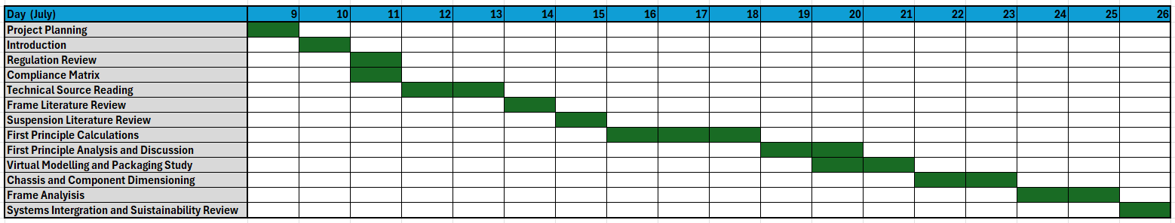
Project Engineering Management
Figure 1-1 - Project Gantt Chart

Regulation | Requirement | Design Choice | Compliance | Justification
B.2.1: Dimensions | 100mm ground clearance with 50° lean angle | Fairing design will be kept narrow to allow greater lean angle | Design checked in CAD to ensure compliance | Large lean angle will allow for improved handling
B.3.1: Frame Design | Self-designed, adequate structural integrity. | 4130 Chromoly Steel frame | FEA performed to ensure structural integrity | 4130 chromoly steel is an ideal balance of strength, weight and cost
B.4: Fairing Design | Edges must be rounded with radius of 1mm minimum | Sharp edges will be avoided while designing | All edges will have a filet applied when designed. | Filet will round off all sharp corners and create a rounded edge
B.7: suspension parameters | Suspension must ensure adequate wheel control and integrity | Upside down front forks and rear monoshock | Suspension will be load tested in CAD to ensure compliance | Upside down shocks allow for lower unsprung mass, rear monoshock improves handling
B.9: Rims and Tires | Rims bust be 17” in diameter, with a width of 2.5” for the front, and 3.5” for the rear | Rims will be designed to meet the fixed requirement | During design, rims will be checked to ensure exact compliance to ruleset | Rims have a set size, so this design must ensure it is exactly to specification

Technology and component literature survey

Frame
The first consideration for this project will be the frame design. These ideas are explored in “The Influence of Frame Structure on the Dynamics of Motorcycle Stability” by G. E. Roe, T. E. Thorpe. This paper examines how frame structure and stiffness affect the stability and handling characteristics², which will be vital for the performance of this motorcycle. This study compares the original production frame of the motorcycle with two experimental duplex tubular frames and aims to reduce flutter (high frequency oscillations at low speed) and weave (low frequency oscillations at high speed).²
The two new frames were a cradle frame (engine supported from the bottom) and an upper support frame with the engine suspended. Both new designs were successful in improving the handling characteristics and stability of the motorcycle. The study suggests that the cradle frame was very effective at reducing flutter at low speeds, whereas the upper supported frame performed well to reduce the weave of the motorcycle.
While this paper is very useful for its research into frame design, it was published in 1989, which means that some of the findings could be outdated when considering advancements in manufacturing and materials science. However, the underlying engineering principles and research into how frame stiffness relates to handling and stability remain relevant.
This line of study was further developed by Sakamoto, K. (2025) for Yamaha in the paper “Estimation of Loads and Frame Deformation on Motorcycle Handling” (SAE Technical Paper 2024-32-0012)³ which focuses on dynamic frame deformation by studying how the frame reacts while under load whilst riding, as opposed to previous research that primarily focused on static loads.
Sakamoto argues that static stiffness measurements require large amounts of trial and error to achieve optimal handling as these calculations do not explain how the motorcycle will react under real riding conditions. Sakamoto found that parts of the frame deform differently than shown by static testing when under combined braking, steering and cornering loads, and local frame flexibility can delay the frames response to applied loads. This can change the motorcycles handling behaviour, leading the rider to perceive a difference in steering response. This suggests that the design of the frame should factor in how quickly the design responds to changing loads, as well as how much the frame flexes.³
Although this paper is very helpful in understanding how the motorcycle reacts under dynamic loads, it does not guide which frame structure would be ideal for this application. However, using these findings in conjunction with the findings of “The Influence of Frame Structure on the Dynamics of Motorcycle Stability” will heavily guide the design of the MotoStudent Motorcycle’s frame structure and stiffness targets. This research suggests that the optimal frame choice for this motorcycle will be an upper supported frame as the bike will be used primarily at high speeds.
These studies also support the use of 4130 chromoly steel for the construction of the frame as it has an excellent strength to weight ratio and fatigue resistance. It is also already commonly used in motorsport applications.⁸

Suspension
Another consideration for this project will be the suspension setup. Key concepts for this section are laid out in “Motorcycle Dynamics” by Vittore Cossalter. In this book he explains that the primary function of motorcycle suspension is to maintain continuous tyre contact with the road, as well as controlling the transfer of forces between thew tyres and chassis.¹
Cossalter discusses the operation of telescopic front forks, and how they provide a mechanically simple, lightweight and compact solution for suspension and steering as a single assembly. A mechanically simple system will allow the part to be easier to manufacture and maintain, as well as providing increased reliability. These forks can also be used in an upside-down configuration, allowing the thicker, heavier end to be placed towards the top of the system at the triple clamp. This increases rigidly of the suspension structure, as well as allowing for more precise steering and decreased unsprung mass, which will allow for greater suspension response and tyre contact.¹

For the rear suspension, Cossalter lays out the advantages of using a monoshock system, as opposed to a twin-shock arrangement. The key advantages to a monoshock system are improved mass centralisation, the ability to use progressive linkage systems and greater adjustability. These features grant the motorcycle improved handling and traction under acceleration. ¹
This book also explains tuning of suspension systems for optimal performance. The spring setup needs to be optimised to find the correct balance of spring stiffness and damping, as excessive stiffness can reduce grip by disallowing the tyre to contact the road adequately, whereas excessive damping can lead to instability for the motorcycle.¹
This book will be instrumental in the understanding of suspension for the MotoStudent motorcycle and clearly lays out the advantages of using upside down forks and a monoshock rear suspension. For a modern racing motorcycle, these will be the primary choices, as other technology will not perform as well for this application.

First-Principles Analytical Engineering

4.1 – Introduction
To begin the engineering for this project, a rough sketch of the motorcycle was created to estimate key parameters, such as the wheelbase, Centre of gravity height and position, as well as rider position. This sketch is only an estimate based on existing Moto3 Motorcycles which use a similar engine and frame set up and could change when it comes to modelling the motorcycle in CAD.
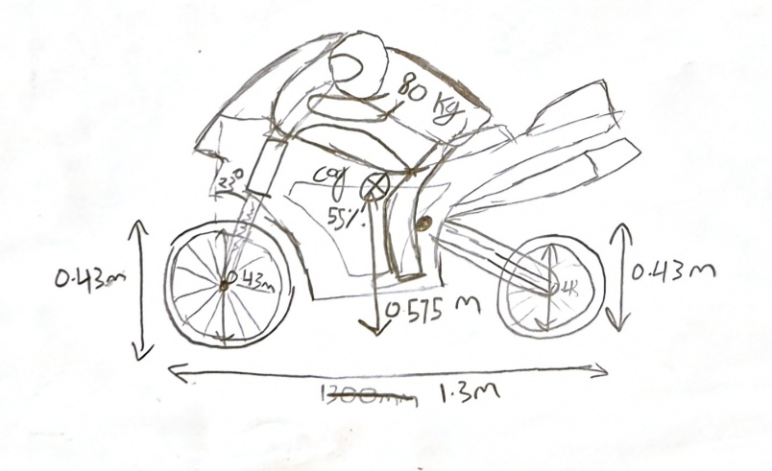
Figure 4-1 - Dimensions Sketch
These measurements were then used to perform first-principles engineering calculations within an excel spreadsheet to analyse the potential performance of the motorcycle before proceeding to detailed CAD and simulation work.

4.2 – Powertrain and gearing analysis
Many of the parameters for these calculations are taken directly from the KTM 250 SX-F, as this engine is required to be used for this project by MotoStudent. This also means that the gear ratios will be fixed, only allowing modification to the front and rear sprockets. To begin the analysis of the powertrain and gearing, all necessary figures were placed into an excel spreadsheet
Table 1 - Parameters
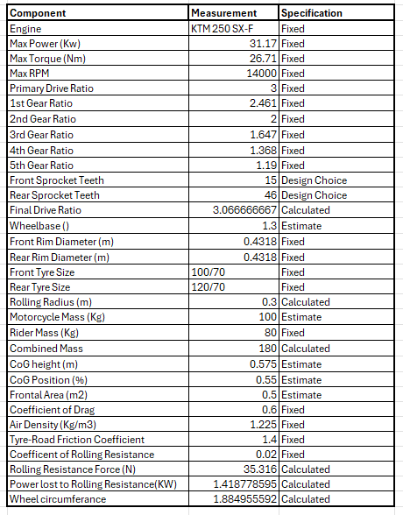⁶
The next step was to calculate the overall gear ratio for each gear. The gear ratios for each gear are provided by KTM, so the overall gear ratio can be calculated as:
iOverall​ = iPrimary​ × iGear​ × iFinal​
This formula can be used in Excel to create a table displaying the overall gear ratios.
Table 2 - Overall Gear Ratio
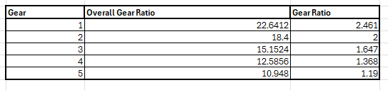
After this, calculations were performed to determine the motorcycles maximum speed in each gear. The engine RPM was converted into wheel RPM using the formula:
Nw​ = Ne/iOverall
This could then be used to calculate the wheel speed alongside the rolling radius of the wheel using:
V = (2 * pi * r * Nw) / 60
These results were then placed into a table.
Table 3 - Wheel Speed and RPM
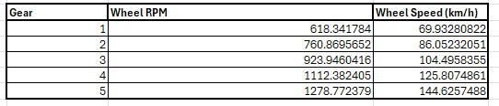
These calculations also show the theoretical top speed of the motorcycle, which will be used later when calculating aerodynamic resistance.

4.3. – Aerodynamic and Rolling Resistance Analysis
Aerodynamic Resistance Analysis is essential for this project as drag force increases with the square of speed, and power requirements will increase with the cube of speed. This means that at high speeds the motorcycle will need to use a lot of power to overcome the aerodynamic resistance. The aerodynamic resistance can be found by:
Fd = 0.5 * Rho * Cd​ * A * V²
This can then be used to find the power required to overcome aerodynamic resistance at any given speed by:
Pd=Fd * V
These calculations were compiled into a table for every gear using the speed calculations from section 4.2
Table 4 - Aerodynamic Resistance and Power Required
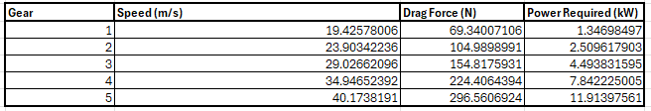
To determine the total resistance faced by the motorcycle, the rolling resistance also had to be determined. This can be calculated by:⁶
Frr = Crr * m * g
This could then be used to determine the power required to overcome rolling resistance:
Prr = Frr * V
The values from these calculations can be added to the aerodynamic resistance calculations to determine the total resistance and power required.
Table 5 - Total Resistance and Power
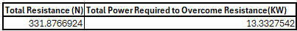
These findings suggest that the motorcycle is non-power limited, as the total power required to overcome drag (13.33 kW) does not exceed the total power of the motorcycle (31.17 kW). This leaves a power margin of 17.84kW for acceleration.

4.4. – Kinematic Deceleration analysis
The braking performance of the motorcycle is just as essential for performance as the power, as braking efficiently for corners will allow for much faster lap times. The dynamic weight transfer is also important, as it determines the stability of the motorcycle under braking, and can be used to determine the rear wheel lift limit.

The first step was to determine the static load for each wheel. An assumed CoG balance of 0.55 was used as this is common for many motorcycles of the same category. First, the horizontal distance from the CoG is established. This can then be used to find the static load of the motorcycle.
Table 6 - Static Load
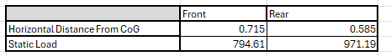
Next, the load transfer can be calculated for any given braking force with the formula:
ΔFz​ = ( m * a * h​) / L
This can then be used with the figures from the static load calculations to find the dynamic load transfer for each wheel with:
Fzf​ = Fzf,static ​+ ΔFz​
Fzr​=Fzr,static ​− ΔFz​
These calculations were placed into a table against a variety of braking forces.
Table 7 - Dynamic Load Transfer
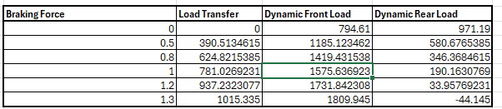
This table shows that at 1.3G, the dynamic load is negative. This indicates that the rear wheel will lift off the ground at this force. To determine the exact braking force required to lift the rear wheel, this formula can be used:
aLift​= g * (x / h)
Using this formula, it was found that the rear wheel will lift at 1.24G. This shows that braking performance is limited by geometry as the tyres limit is 1.4G. This can be accounted for when designing the frame, as a lower CoG will allow the bike to brake more aggressively to fully utilize the tyres limit instead.

4.5. – Section Conclusion
From this analysis it is evident that at the current setup, the motorcycle is limited by its gearing rather than its power, which could be rectified by using a different final drive setup. With some modification, the bike should be able to achieve a higher top speed than it currently performs at.
The braking of the motorcycle is also limited by its geometry, which can be rectified in the CAD design phase with a lower CoG or a longer wheelbase. Modelling and Packaging Studies

– Purpose
The aim of this section is to establish whether the proposed design concepts could be feasible within the regulations. This section also aims to assess the overall motorcycle layout and component packaging, as well as visualising the proposed final design of the motorcycle.
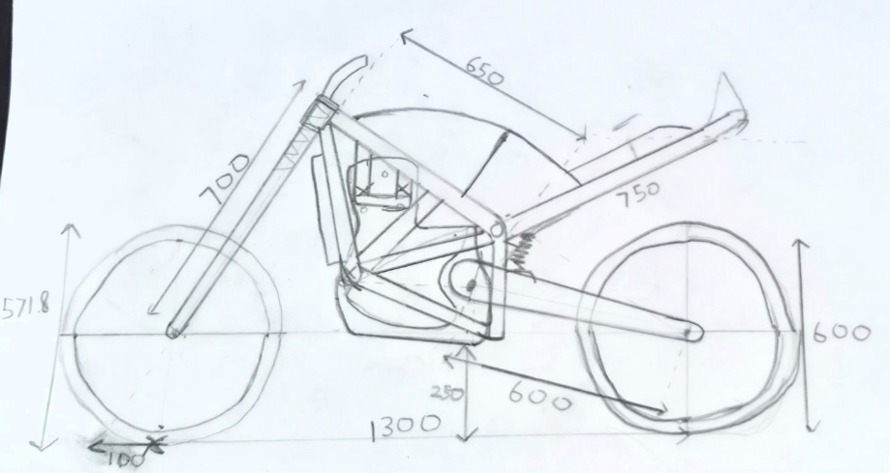
Figure 5-1 - Packaging Study

Chassis geometry
Due to hardware limitations, it was not feasible to create a CAD model to analyse the layout of the frame. Therefore, a hand drawn scale drawing was created to accurately portray the dimensions of the motorcycle. The initial 1300mm wheelbase was kept for this design, as it provides an ideal balance between agility and stability. The rake angle is set at 23 degrees with a trail of 100mm. This allows for the steering response that is necessary for a racing motorcycle.

Component Packaging
Most of the frame design was based around the dimensions of the engine, as this part cannot be changed as it is provided by MotoStudent.⁶ The dimensions for this were sourced from a CAD model⁷ online, which allowed an accurate picture of where the frame should be. Using the mounting points provided, a top mount frame could be designed.
At this stage the fuel tank was also added above the frame, being mindful to leave space for the rider to read the handlebars.
The rear subframe was also added, with consideration to the position of the rider during the race. The seat was set as 230mm long, with 20mm of padding for comfort and support.

Regulation Compliance
Great care was taken with this design to ensure that it meets all the requirements set out by the MotoStudent regulations. This design has approximately 250mm of ground clearance from the engine, which allows plenty of space for a fairing to be added with the necessary spillage prevention requirements. This will also allow for a large lean angle, which is also required.
The frame is designed the accommodate the KTM engine without modifications, which is a requirement for this ruleset. The wheels are also the standard 17” rims as required.

Systems Integration, Sustainability and Conclusion

Overall Design Integration
Overall, this design is a complete package for a racing motorcycle to meet the requirements set out by MotoStudent. The chassis has been designed to integrate the specification engine into the motorcycle in a way that will boost the performance of the motorcycle. The suspension system is set up in a way that will compliment the performance characteristics required for a track racing motorcycle. The packaging is also designed in such a way that all heavy components will be kept close to the centre of gravity. The final design has been informed by analysing calculations performed on the geometry of the motorcycle.

Sustainability Considerations
This design also factors in use of sustainable materials and practices. The lightweight design of the motorcycle reduces material used for construction and improves the efficiency of the motorcycle. The materials chosen are also durable and easy to repair, meaning less material being used on replacement. The aluminium and steel components are also widely recycled so that they can be used after the lifecycle of the motorcycle is complete.⁸ The single cylinder four stroke engine is also relatively fuel efficient when compared to larger displacement racing engines.

Conclusion
Overall, this motorcycle has achieved all the aims of the project set out. This design also takes great care to adhere to all regulations set out by MotoStudent. However, it could be improved by a full CAD model of the frame to perform FEA analysis and reduce weight by removing unnecessary support.

References
- Cossalter, V. (2006) Motorcycle Dynamics. 2nd edn. Raleigh, NC: Lulu Press.
- Roe, G.E. and Thorpe, T.E. (1989) 'The Influence of Frame Structure on the Dynamics of Motorcycle Stability', Proceedings of the Institution of Mechanical Engineers, Part D: Journal of Automobile Engineering, 203(3), pp. 189–198.
- Sakamoto, K. (2025) 'Estimation of Loads and Frame Deformation on Motorcycle Handling', SAE Technical Paper 2024-32-0012.
- MotoStudent (2026) MotoStudent Petrol Category Technical Regulations. Available at: https://www.motostudent.com/regulations.php (Accessed: 26 July 2026).
- KTM (2026) 2027 KTM 250 SX-F Technical Specifications. Available at: https://www.ktm.com/en-gb/models/motocross/4-stroke/2027-ktm-250-sx-f/technical-specifications.html (Accessed: 26 July 2026).
- Engineering Toolbox (2025) Rolling Friction and Resistance. Available at: https://www.engineeringtoolbox.com/rolling-friction-resistance-d_1303.html (Accessed: 26 July 2026).
- GrabCAD (2025) Prototipo Pre Moto 3 CAD Model. Available at: https://grabcad.com/library/prototipo-pre-moto-3-1/details?folder_id=8454751 (Accessed: 26 July 2026).
- MatWeb (2025) AISI 4130 Chromoly Steel Material Properties. Available at: https://www.matweb.com (Accessed: 26 July 2026).

