

University of Wales Trinity Saint David
School of Engineering
ACMA4008
15/05/2021
Daniel Grelak
1901993

Introduction

Drill press is a widely used tool, with application in broad range of industries. Its principle of operation is simple, and everyone can use it after short training. Drill press is a device that produces holes in hard substances (Britannica, 2017). There are many kinds of drill presses, from simple and cheap hobbyist ones to expensive industry grade drills with multiple spindles. This report contains appraisal of concept design of drill press main sliding unit (DPMSU), its design specification, manufacturing method and final design based on all above. Final design of Sliding Unit must fit in existing drill press assembly provided.

Appraisal of concept design

For task of designing suitable DPSMU concept design has been provided (Figure1).

Figure 1 concept design of DPSMU in drill press assembly provided in assignment.
We can identify range of needs and requirements from the concept design:

Customer needs:
- Part must fit in existing drill press design.
- Part must allow user to insert drill and hold it in place.
- Part must be easy to use.
- Drill press is more of a small workshop machine than industrial.
- Drill press must be attractive to potential buyer.

- Functional requirements:
- Part must allow user to drill holes.
- Part must not break while using.
- Part must be safe to use.
- Part must be simple.

- Aesthetic considerations:
- Part must look nice and simply.
- Part must make one with existing assembly.

- Serviceability requirements:
- Part must be easy to service by the user after the training.
- Part must be cheap to service.

3.Design specification

Aspect | DESIGN SPECIFICATION
1.Functional | Drill press will allow user to drill holes in material of choice, end user must be able to easily insert electric drill of choice and change it when needed. Use of press must be easy to learn for everyone and safe to use and drill press must withstand use by hobbyist/small workshops.
2.Aesthetics | Drill must look neatly, width and length of DPSMU should align with rest of assembly. Part will be touched often, and marks should not be visible on it. Potentially part could be in some bright colour to attract buyer.
3.Ergonomics | Part needs to be comfortable to use and should not cause any discomfort for user. Change of drill bit/ drill must be easy and quick.
4.Material | Material for part needs to be light, durable, and resistant to corrosion.
5.Manufacturing | Manufacturing method must allow production of 1000 parts weekly.
6.Safety | Part must not break or crack when using, must withstand force applied by user when drilling a hole.
7.cost | Part should be cheap to manufacture and service.
8.maintenance | Part must be simple to service/ change when necessary.
9.Target market | Hobbyists and small workshops, drill press will not be used in industry as its build is not suitable for heavy use.
10.Price | Product must be in price range for average person. Should be good in value/price ratio.
11.Enviroment | Part should be recyclable and manufacturing method should not have big impact on environment.

4. Material and manufacturing method

As stated in design specification 4. part should be made from material that is lightweight, durable, and resistant to corrosion and other conditions that could possibly appear in workshop/garage. Must also be cheap and easy to use in manufacturing. Material that fulfils all above is aluminium. Aluminium is a material that is widely used in all of industries, is lighter than steel while still strong. It can be used to produce parts of any shape or form and is easy to process and recycle. 6061 aluminium alloy is most common alloy for general-purpose use with good mechanical properties (Materials Management Inc,2015).

Manufacturing method suitable for this application is Aluminium Injection Moulding. That process is economical, cost-effective and allows to produce complex shapes with thin walls. Injection Moulding is suitable for large runs of small parts and end-product possess good mechanical properties (Manufacturing.Net,2018). After injection ’Green’ parts created in mould are put into a furnace for sintering. 2%wt tin powder can be added to increase sintered density and to expand sintering window (PIM-International,2009)

Additional plastic parts like protection pad and bush should be made by Injection Molding from PLA which is biodegradable.

Final part design

Final design of DPMSU does not varies from concept design by far. Concept design has been slightly improved for better performance and customer satisfaction. Weight of the part has been reduced by removing some unnecessary material (Figure 2). Only thin wall is left for strength.

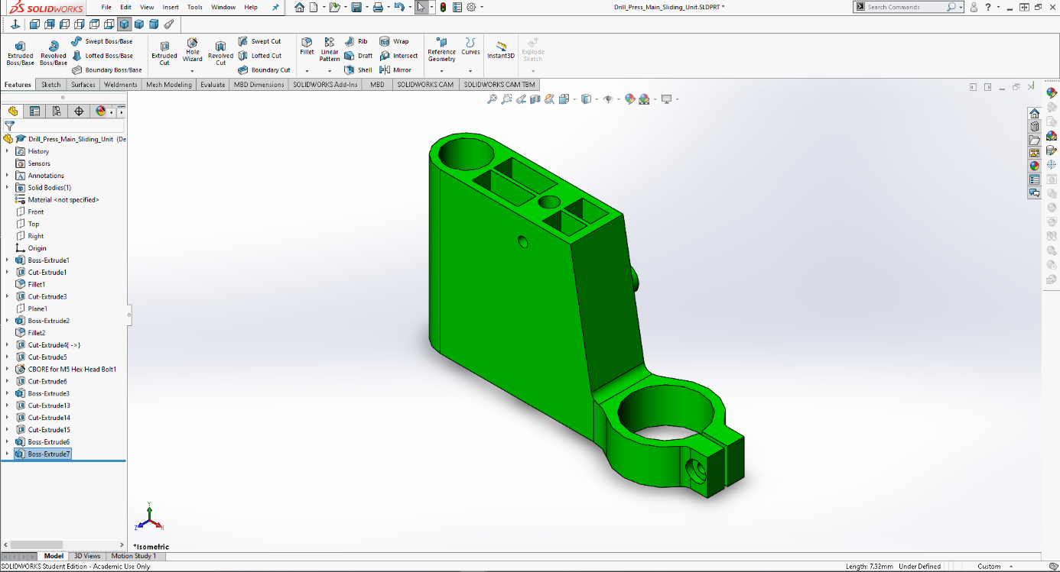

Figure 2 Material removed from part.

Around the part some plastic protection is implemented to prevent from scratching and damaging the surface of DPMSU (Figure 3). It also adds aesthetic value to the part.

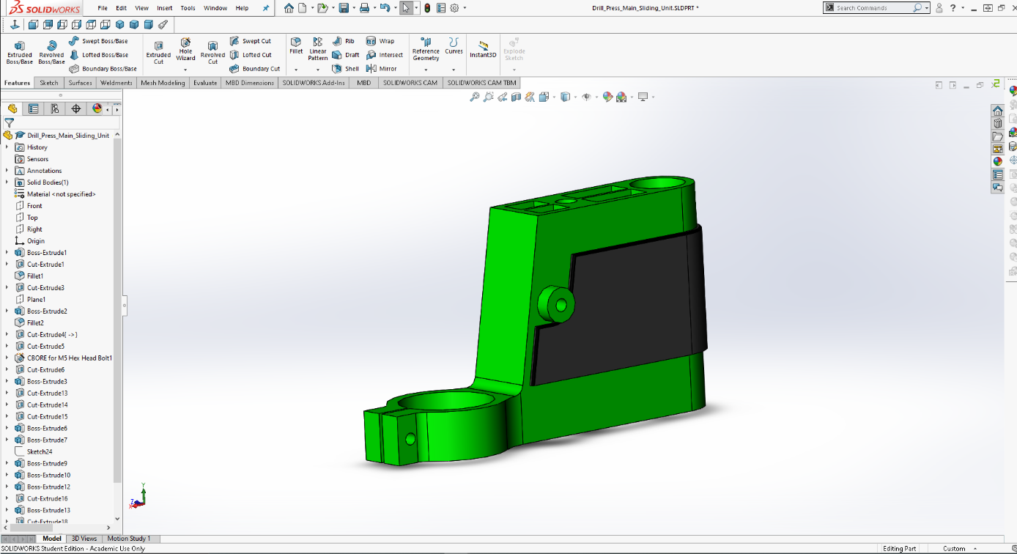

Figure 3 Plastic protection of part.

On one side M5 hex key holder is added to allow user quickly remove drill for change of tool or service (Figure 4). Edges of plastic part were then rounded by fillet.

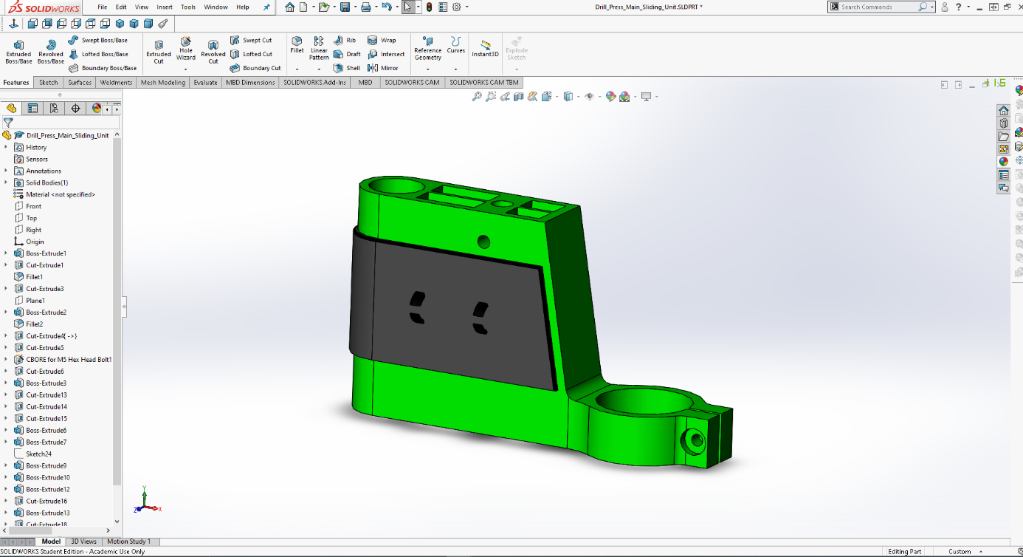

Figure 4 Hex key holder.
For versality additional part were designed (Figure 5). Bush enable user to insert drill with smaller diameter (38mm) making part more useful.

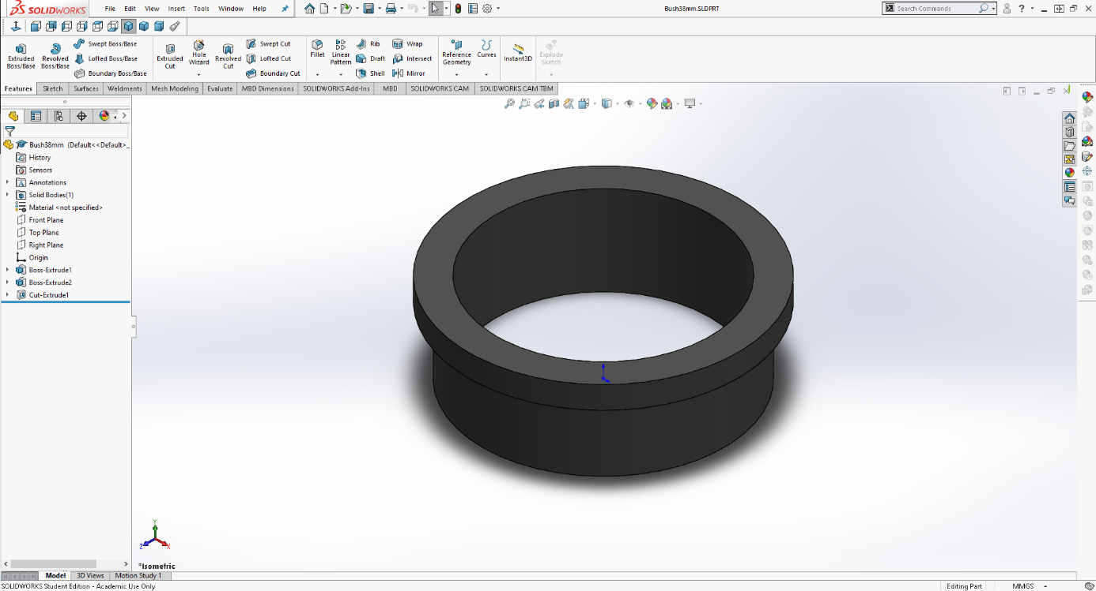

Figure 5 38mm Bush.

After completing Final Design full assembly can be prepared (Figure 6).
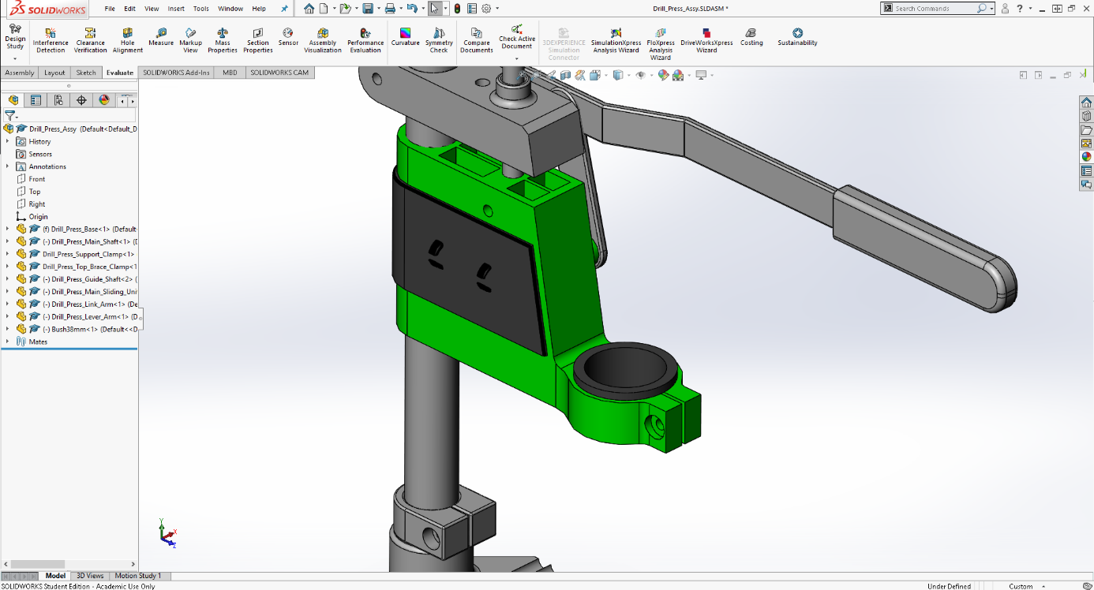

Figure 6 Final design in assembly.
From final design mould for production can be prepared (Figure 7) and full assembly can be rendered before production (Figure 8).

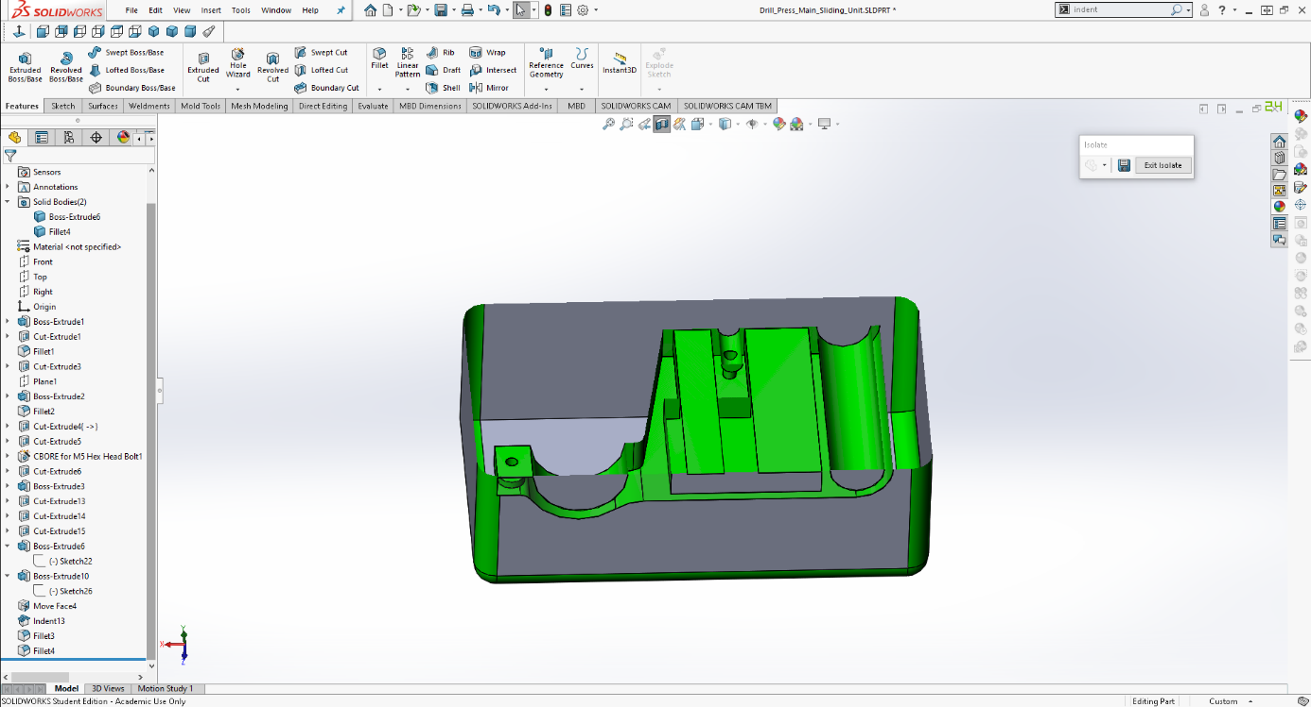

Figure 7 Prototype of mould.
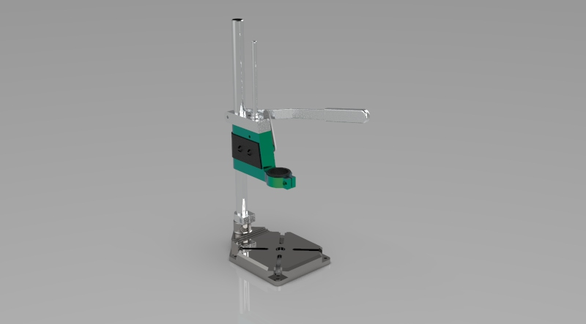

Figure 8 Render of the assembly

Technical drawing

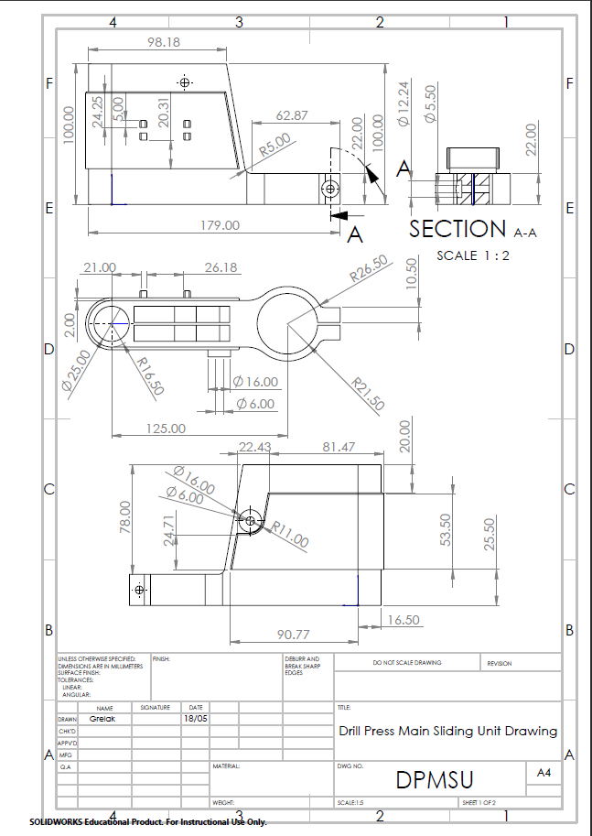

References

Britannica, The Editors of Encyclopaedia. "Drill press". Encyclopedia Britannica, 9 Jun. 2017, https://www.britannica.com/technology/drill-press. Accessed 19 May 2021.
"Aluminum Alloys". Materials Management Inc. 23 December 2015. Archived from the original on 31 July 2016
Manufacturing.net. 2015. Comparing Metal Parts Manufacturing Methods. [online] Available at: <https://www.manufacturing.net/operations/article/13196732/comparing-metal-parts-manufacturing-methods> [Accessed 19 May 2021].
Powder Injection Moulding International. 2009. High strength, lightweight aluminium alloy by MIM. [online] Available at: <https://www.pim-international.com/high-strength-lightweight-aluminium-alloy-by-metal-injection-moulding/> [Accessed 19 May 2021].

