

Project Proposal: ACCA6020

Installation and Use of a Particulate Matter Sensor for Cartridge Rupture Detection and Predictive Maintenance of an Industrial Filter Unit

by

Niall Rees

BEng (Hons) Electrical and Electronics Engineering

October 2023

Contents
1.0 Introduction 3
2.0 Project Background and Literature Review 4
2.1 Sensor Technology 4
2.2 Predictive Maintenance of Filter Systems 4
3.0 Project Design 5
4.0 Resources and Planning 7
Bibliography 10

Introduction

Sandvik Osprey is a world leader in the manufacture of fine gas atomised metal powder, with a vast array of products ranging from stainless steels to super alloys such as cobalt and nickel. The Osprey atomisation process requires product to be pneumatically conveyed through the equipment via use of Camfil Gold series cross flow filtration units, any powder drawn through the system is captured within large cartridge filters, and subsequently discharged via a pulse jet of air, into a collection drum below the unit. Figure 1 displays one of the filter stacks in question on the site.
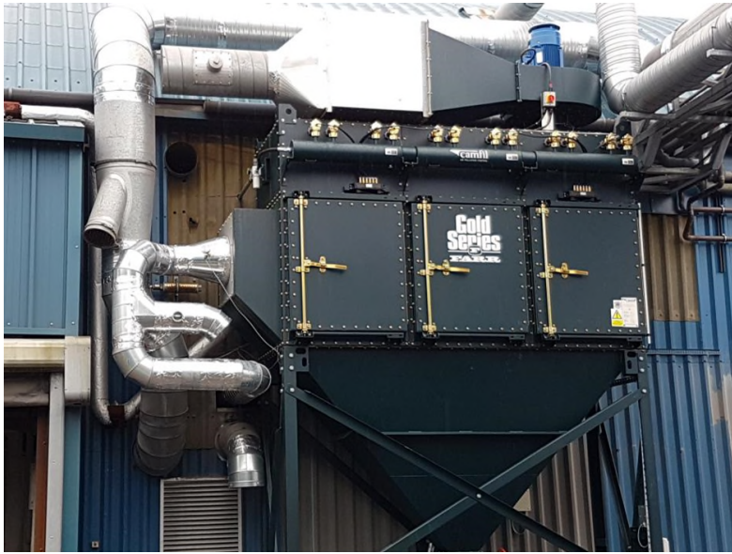
Figure 1 - Atomising Plant Dust Collector

Currently, to comply with Natural Resources Wales Environmental permits [1], and UK government Industrial Emissions directives, controlling air pollution [2], annual stack emissions testing is carried out by a third party body to report on the discharge levels of metals such as cobalt, nickel, chromium, copper and lead. These are compared to a set threshold limit. Therefore, if excess particulate is passed through to the exhaust side of a filter unit, it can indicate wear or rupture of one or more cartridges creating a risk of fines and compliance breaches for the company.

Rupture or wear of cartridge filters incite unplanned plant down time and costly filter replacement maintenance. Each filter contains a total of 12, 21m2 cartridge units, costing £707, coupled with potential emissions fines and manufacturing delays, the breakdown of these units become a large expenditure for the company.

The reports generated annually are the only quantitative data available to the company as to the health of the filter. Inspection routines are carried out every 6 months by the maintenance department, however, these can only reveal obvious faults, and can contain subjective opinions of what a healthy filter looks like depending on who is carrying out the inspection, so issues may go un-noticed. A maintenance regime that replaces filters after a set period can prove costly, as components changed may have plenty of remaining useful life.

The project proposed is for the addition of a particulate sensor, mounted in the exhaust air stream of the filter unit to monitor the change in particulate levels emitted. From this data, and other filter parameters such as inlet temperature and differential pressure drop, an accurate determination of filter degradation or failure can be predicted so that maintenance can be planned. This removes inspection ambiguity, and unnecessary filter replacement.

The main outcomes from the project will be:

- Installation of an appropriate sensor technology.
- PLC interfacing along with appropriate logic to process sensor output data.
- HMI development for operator/maintenance personnel to view data in real time.
- Integration of sensor data to site SCADA system for data logging and trend analysis.
- PLC, control panel wiring, instrumentation, and cable schedule design drawings.
- Integration of existing temperature and differential pressure sensors.
- Development of alarm levels and threshold limits for determining filter rupture.
- Development of predictive maintenance techniques to estimate remaining useful life of filter cartridges.

2.0 Project Background and Literature Review

2.1 Sensor Technology

Initial background research has been conducted to establish sensor technology appropriate for monitoring particulate in a duct or stack. Some of the established techniques to measure particulate concentration include the principle of scattering of light. These sensors are based on the Mie theory of scattered light. As a beam of light hits suspended particles, it is scattered. The amount of light scattered can be related proportionally to the size and concentration of particles [3]. The principle is utilised in technology such as in a laser back scattering, laser forward scattering and laser side scattering techniques [4].

Another common type of sensor for particulate monitoring in stacks and ducts is the electrostatic sensor. As pneumatically conveyed particles move through a duct, they gather charge due to the triboelectric effect. Electrostatic sensors have an electrode inserted into the flow of particulate. Electrostatic induction and charge transfer is seen as particles come into contact with the electrode. This small charge transfer can be amplified using signal conditioning circuits within the instrument to give a measurable output based on the number of particles passing over the electrode [5]. Electrostatic sensors have limited use for precise measurement of mass concentration as they output a fairly erratic signal due to the varying physical properties such as particle size, velocities, charge variations, environmental conditions, and locations. Their use is mainly to translate relative mass concentrations, making them ideal for trending and bag rupture detection applications [6]. Due to the lack of sensitive optics, these sensors are extremely rugged and suited for harsh process environments. From this information, the use of an electrostatic dust measurement probe will be used for this project.

2.2 Predictive Maintenance of Filter Systems

An excellent study into the predictive maintenance of a cyclone filter within a grain milling operation using digital twin technology has been published in [7]. A model of a cyclone filtration system has been developed and a digital twin created. Using historical data and real time sensor data, anomalies and abnormal operating conditions can be identified and calculate remaining useful life. This study utilised differential pressure drop across the filter, as well as flow velocity through the unit to identify filter failure. This study contains useful insight into the use of trend data and modelling to build predictive maintenance models of a filter system.

Correlation based anomaly detection for predictive maintenance has been presented in [8] using the example of electric generators. This study used anomalous sensor data as a sign of potential failure of equipment. This is one of the methods that may be employed in this project to determine degradation of the filter units. Setting normal operating thresholds for the filter units allows for efficient recognition of anomalies, down to specific faults.

3.0 Project Design

The project will involve the installation of a sensor in an established industrial environment, and mature control system. The sensor will have a standard 4-20mA current output for ease of scaling and connection to an industrial PLC system. The dust filter is processing fine combustible dusts, and the sensor location is deemed a hazardous area according to ATEX regulations, BS EN IEC60079 – 10 – 2 Classification of areas: Explosive dusts. Therefore, the sensor must be rated for use in the hazardous area. It must be installed according to IEC60079-14: Electrical installations design, selection, and erection for hazardous areas.

The sensor output will be interfaced to a GE Rx3i industrial PLC via an analogue input card. Connection and wiring schematics will be created using Autodesk Electrical CAD software packages. Control panel wiring schematics will be created in the same manner. Schematics and cabling diagrams for a process control and instrumentation document will be created. The schematics will make up a data sheet to allow inspections of the hazardous area circuit in accordance with BS EN IEC 60079 - 17: Electrical Inspections and Maintenance.

The PLC program for reading and scaling the sensor output will be carried out using GE Machine edition programming environment. HMI programming for the operator/maintenance personnel will be developed in this software package. HMI design will include real time data display, trend chart for particulate levels over time, alarm configuration and notifications.

The PLC is connected to an industrial network, the scaled analogue variable from the sensor will be added to an industrial Supervisory Control and Data Acquisition Software (SCADA), GE Historian. This will allow data recording and storage of sensor trends to be displayed and downloaded for post processing and analysis in Excel or MATLAB. From this SCADA system, maintenance personnel can access and display sensor trend data from local PCs for diagnostics and fault identification.

Sensor data from the particulate measurement will be downloaded, along with the filter differential pressure and inlet temperature for post processing and development of the predictive maintenance algorithm. Historical trend data captured during a filter operating at optimal conditions will allow normal working threshold parameters to be determined. From this, anomalies can be recognised for alarm notifications of cartridge rupture and filter degradation. MATLAB software predictive maintenance toolboxes will be used to train a model to recognise anomalies outside of working thresholds. This process is documented in [9].

Figure 2 displays a simple block diagram for data flow and connection.
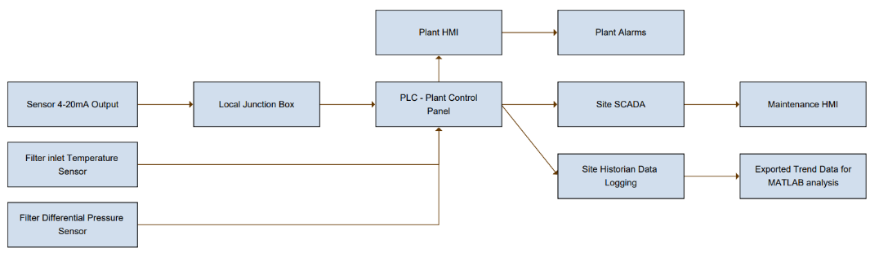
Figure 2 - Sensor Data Flow

Figure 3 sensor data flow from connected sensors to develop the predictive maintenance algorithm for anomaly detection. This includes common fault conditions to be monitored.

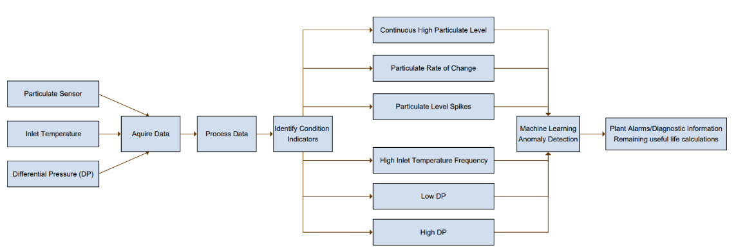
Figure 3 - Anomaly Detection Sensor Data Flow

4.0 Resources and Planning

For the project specialist engineering software will be required. These are to include:

- GE Machine edition: PLC Programming software for HMI and controller logic.
- GE Historian SCADA to record sensor data and allow data export for post processing.
- MATLAB Machine Learning toolbox (Licenses granted).
- Microsoft Office suite for data analysis and report generation.
- Electrical CAD drawing software – Autodesk Electrical/SEE Electrical CAD

The resources required to install the sensor to BS EN IEC 60079 ATEX standards include:

- Comp EX Electrician qualified to EX05 and EX06, competency for installations for dusts in hazardous environments.
- 4-20mA Loop calibration instrument to verify sensor output and PLC input scaling.
- Electrical schematic diagrams for control panel and junction box wiring.

Initial bench testing of the instrument will be carried out to establish a baseline particulate reading. Manufactures datasheets will be used to set the measurement range appropriate for metallic particles.

Figures 4 and 5 show an indicative project plan to complete the sensor installation by 21/11/2023. Data acquisition timescales may vary to establish the quality of the data. This will be ongoing throughout the project cycle.

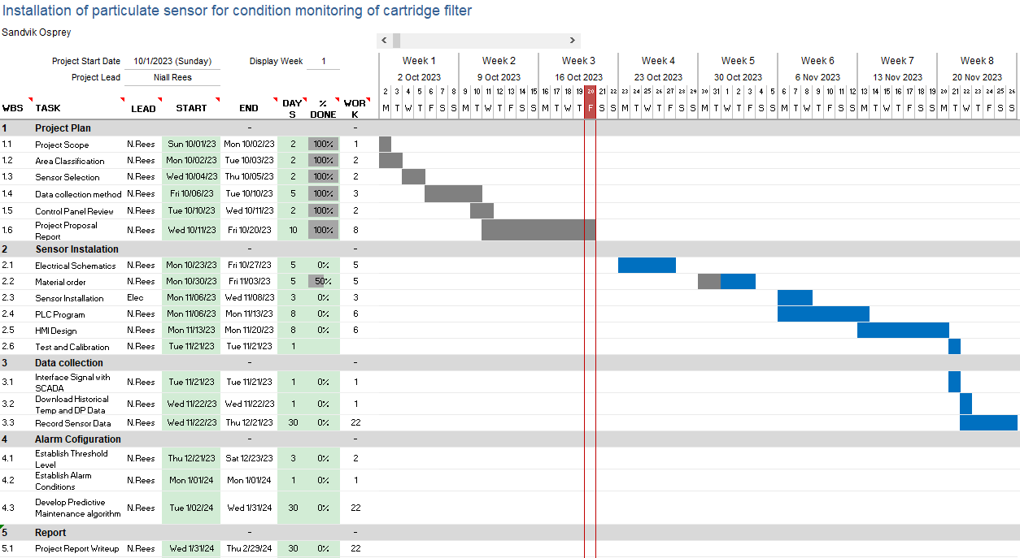
Figure 4 - Project Plan

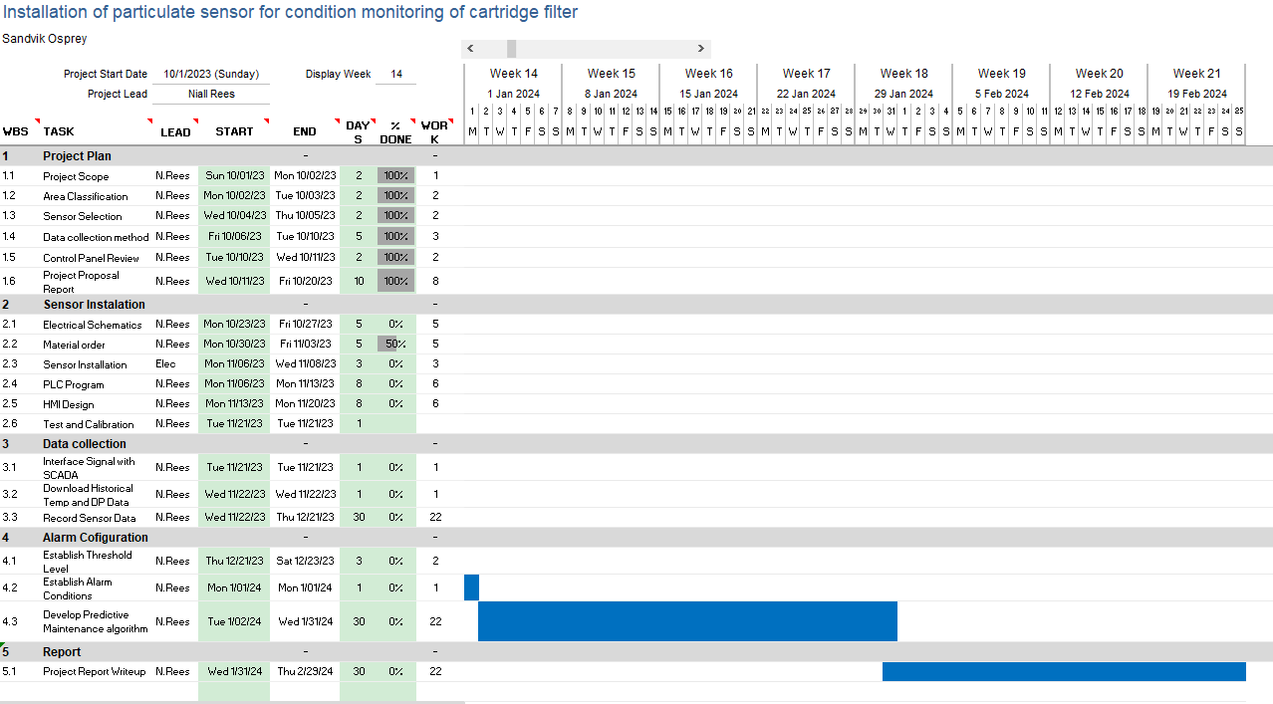
Figure 5 - Project Plan

Bibliography

[1] | Natural Resources Wales, “Natural Resources Wales,” 10 2023. [Online]. Available: https://naturalresources.wales/permits-and-permissions/environmental-permits/?lang=en.
[2] | UK Government, “Industrial emissions standards and best available techniques,” 2023. [Online]. Available: https://www.gov.uk/guidance/industrial-emissions-standards-and-best-available-techniques#industrial-emissions-directive-ied. [Accessed 15 10 2023].
[3] | Y. S. T. W. X. S. Xiaoyu Yu, “Dust-concentration measurement based on Mie Scattering of a Laser Beam,” PloS one, vol. 12, no. 8, p. https://doi.org/10.1371/journal.pone.0181575, 2017.
[4] | Land Ametek, “Opacity and PM Monitoring in Emission Stacks: Application Note,” 2009. [Online]. Available: https://www.ametek-land.com/-/media/ameteklandinstruments/documentation/industries/coalpower/ametek_land_opacity_vs_pm_application_note_rev_1_en.pdf. [Accessed 15 10 2023].
[5] | Y. H. L. W. X. Q. W. Z. K. R. J. W. G. Z. Yong Yan, “Electrostatic sensors – Their principles and applications,” Measurement, vol. 169, 2021.
[6] | Y. Yan, “Continuous measurement of particulate emissions,” IEEE instrumentation & measurement magazine, vol. 8, no. 4, pp. 35-39, 2005.
[7] | N. L. R. M. Federico Solari, “Digital Twin Based on Historical Data and Simulation Results: Fault Detection and Estimation of the Remaining Useful Life of a Cyclone Bag Filter,” Applied Sciences, vol. 13, no. 14, p. 8297, 2023.
[8] | M. K. J. T. T. N. S. C. T. S. Pushe Zhao, “Advanced Correlation-Based Anomaly Detection Method for Predictive Maintenance,” in 2017 IEEE International Conference on Prognostics and Health Management (ICPHM), Dallas, 2017.
[9] | Mathworks, “Predictive Maintenance with MATLAB,” Mathworks, 2020.
[10] | D. S. S. S. O. N. Bjorn Kroll, “System modeling based on machine learning for anomaly detection and predictive maintenance in industrial plants,” in IEEE Emerging Technology and Factory Automation (ETFA), 2014.

