

MARKETING MANAGEMENT
AMAZON INC.

NAME: SUHAIB VELLIYATH
STUDIENT ID: 2215786
NAME OF LECTURER: TUSHARA BALENDRAN
MODULE NAME: MARKETING MANAGEMENT
MODULE CODE: LCM7001
ASSIGNMENT TITLE: ASSIGNMENT- 1
WORD COUNT: 3498

TABLE OF CONTENTS

- INTRODUCTION 3
- DEFINITION OF COMMUNICATION 3
- COMMUNICATION MODEL 4
- INTEGRATED MARKETING COMMUNICATIONS 5
- NEW PROMOTIONAL ACTIVITIES 6
- BRANDING AND BRAND EQUITY 7
- CUSTOMER JOURNEY OF AMAZON 9
- TOUCHPOINTS DURING THE CUSTOMER JOURNEY 12
- CONCLUSION 14
- REFERENCES 15

INTRODUCTION
Amazon Inc. is a leading e-commerce company that has transformed the way people shop online throughout the world. Jeff Bezos launched Amazon Inc. in 1994, and it has since grown enormously to become one of the world's largest online retailers(Berryman, 2014). Amazon Inc. provides excellent customer service and has consistently prioritised client happiness in its operations. The organization has always sought new ways to promote its brand and manage the customer journey across several communication channels(Finne and Grönroos, 2017). This research evaluates Amazon Inc.'s unique marketing methods for increasing brand awareness as well as managing and accessing the customer journey across many communication channels to guarantee current and future stakeholders' expectations are met. The paper will give an overview of Amazon Inc. as well as the significance of the customer journey and how it can be handled to ensure customer happiness. It will then go into Amazon Inc.'s unique marketing tactics for increasing brand awareness and managing the customer journey. Following that, there will be a discussion of the importance of touchpoints in the customer experience and how Amazon Inc. has used them to assure customer satisfaction.

DEFINITION OF COMMUNICATION
Customer involvement is the foundation of Amazon's definition of communication. According to Amazon, customers should receive an experience that is customized to meet their unique requirements and expectations(Vollero, Sardanelli, and Siano, 2021). To ensure that customers are informed and engaged throughout the customer journey, Amazon has created an integrated communication strategy. Amazon uses direct mailers, print, radio, and television advertisements, as well as other traditional media. Email, social media, and website content are all examples of digital media. Amazon makes sure that customers are informed about the business, its goods and services, and any modifications to the customer journey through these channels(De Brito et al., 2016).
Amazon uses surveys, interviews, and market research to gauge customer engagement. This aids Amazon in identifying areas where customers might require extra assistance or direction to complete the customer journey. Amazon employs analytics to monitor consumer behavior across all channels of communication, which enables the corporation to spot problem areas and modify its communication plans as necessary(Baleviciene, 2020). The unique marketing strategy used by Amazon is similarly founded on the concept of customer experience marketing. This idea places a strong emphasis on the value of comprehending consumer demands and tailoring an experience to them(Quyyam and Ghous, 2021).

COMMUNICATION MODEL
The Shannon and Weaver communication model is often used to explain communication efficacy. According to this model, the effectiveness of communication is governed by transmission efficiency, noise level, and message clarity(Al-Fedaghi, 2012). The speed at which the message is carried, the precision of the transmission, and the dependability of the transmission medium all contribute to transmission efficiency. The amount of interference present in the message transmission determines the noise level. The message's clarity is determined by the message's encoding and decoding accuracy(Mishra, 2016). The Shannon and Weaver communication model serves as the foundation for the Amazon communication model.
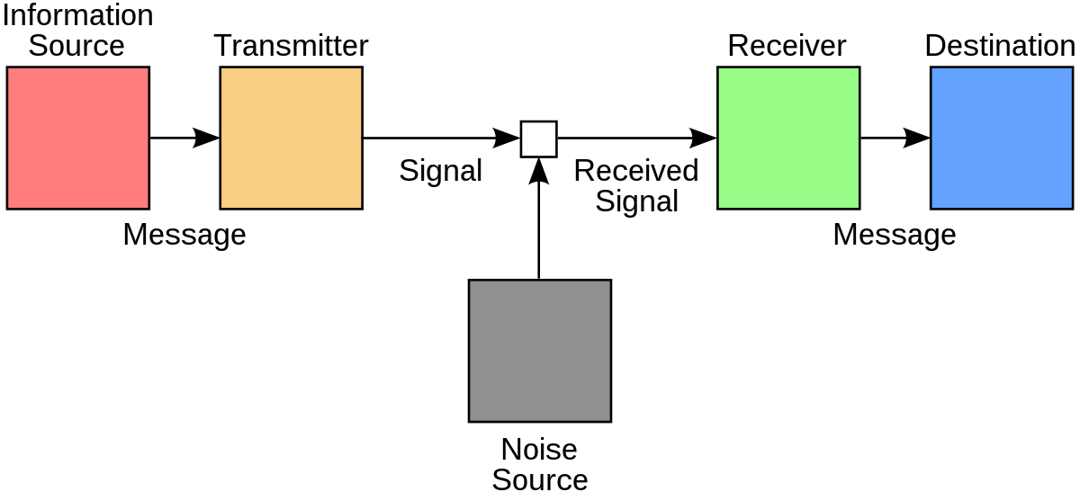
Figure 1.1 Marketing Communication model Source: (Al-Fedaghi, 2012)
Amazon's communication method, according to this model, begins with the sender, who encodes the message and sends it to the receiver. The medium over which the communication is conveyed, such as Amazon's online services, email, and so on, is referred to as the transmitter(D’Arbelles, Berry and Theyyil, 2020). The device that receives the message, such as a computer or mobile device, is referred to as the receiver. The amount of interference present in the message transmission determines the noise level. The Amazon communication model takes transmission efficiency into account as well. Amazon employs several technologies to ensure that communications are delivered swiftly and securely. To ensure that communications are sent promptly and properly (Agnihotri, 2022). Amazon's web services, for example, require high-speed and dependable networks. Amazon also employs encryption technology to protect message security. The clarity of the message is taken into account by the Amazon communication model. Amazon's messaging service allows customers to customize their messages so that they are clear and easy to read. Amazon also employs several technologies to check that messages are properly structured and contain the required information(Duralia, 2018).
Amazon employs the Johari Window model of communication in addition to the Shannon and Weaver models. This paradigm is made up of four parts: self, others, blind spot, and unknown. In this paradigm, the sender communicates with the receiver by giving information about themselves that the receiver is both aware of and unaware of. The sender then listens to the receiver's response to see how much information has been shared and how much has been understood. This technique helps to ensure that both parties grasp the message and that their communication is effective. The Amazon communication model recognizes the significance of feedback. This feedback is used to improve the customer experience and ensure that Amazon offers the best service possible. Amazon also uses feedback to improve its communication model, ensuring that communications are clear(De Brito et al., 2016).

INTEGRATED MARKETING COMMUNICATIONS
Amazon uses Integrated Marketing Communications (IMC) to develop a single message that is consistent across all channels and suited to the demands of its customers. IMC is a strategy that combines all of a company's promotional assets to provide a coherent message to a specific audience(Finne and Grönroos, 2017). Advertising, public relations, sales promotion, direct marketing, web marketing, and social media are all part of Amazon's IMC strategy. Amazon uses advertising to raise awareness and interest in its products and services. Public relations is concerned with developing relationships with consumers and the general public. Creating promotional events and incentives to entice people to acquire Amazon items or services is what sales promotion entails.
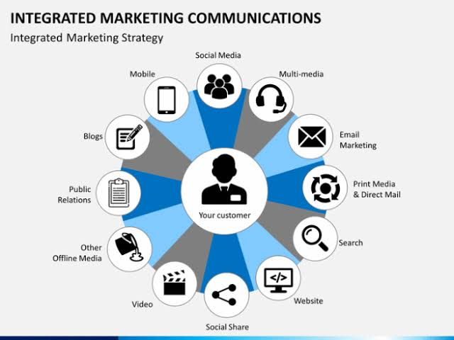
Figure 1.2 Integrated Marketing Communication model Source: (Finne and Grönroos, 2017)
Direct marketing is concerned with making direct touch with customers and prospects by mail, email, and other means of communication. Websites, search engine optimization, and other online activities are used in online marketing to create leads and sales(Piller, Lindgens, and Steiner, 2012). Amazon communicates with its customers through a variety of methods, including email, websites, and social media(Stephansen, 2013). This enables Amazon to build a uniform message that is delivered consistently and effectively.

NEW PROMOTIONAL ACTIVITIES
Amazon is an e-commerce behemoth that has transformed the way people shop and conduct business. The corporation is the world's largest online retailer, selling everything from books to gadgets, and the Amazon marketplace is believed to account for roughly 50% of all e-commerce sales in the United States. Amazon's success can be attributed to its customer-centric model, breakthrough technologies, and smart alliances. A range of promotional methods can be used by Amazon to build brand awareness and grow its client base(Şerban, 2018). Here are a few possible tactics for Amazon to boost brand recognition:
1. Social Media Marketing: In today's digital environment, social media is one of the most effective tools available to businesses. Amazon may use social media to market its products, share stories, and interact with customers. The company's social media networks can be used to run promotional campaigns, promote new products and services, and connect with customers.
2. Content Marketing: Another successful technique for Amazon to promote its brand and build its consumer base is content marketing. Amazon can use content marketing to tell fascinating stories and develop interesting material that educates and informs people about its products and services. Amazon uses content marketing to interact with customers and earn their confidence.
3. Influencer Marketing: Influencer marketing allows Amazon to reach a larger audience while also building relationships with key industry influencers. Amazon can harness influencers' reach and influence to reach a broader audience and enhance brand awareness by working with them.
4. Online Advertising: Amazon can also reach its target demographic through online advertising. Amazon may target certain audiences with its ads and promote its products and services through Internet advertising(Permana and Nugraha, 2020).
5. Offline Promotion: Amazon may also improve brand recognition through traditional offline advertising techniques. Amazon can reach its target audience through print and television advertising, direct mail, and public relations. These are just a handful of the promotional methods that Amazon might employ to increase brand awareness.

BRANDING AND BRAND EQUITY
Amazon is well-known for its dedication to customer pleasure, its forward-thinking approach to technology, and its diverse selection of products and services. Amazon's strong brand has been a major component of its success. Amazon has built a strong and recognizable brand that resonates with its target markets(Hoang Tien and Nguyen Hoang Tien, 2022). Amazon has built a strong image and an emotional connection with its customers through effective branding.
Brand equity, according to Keller's Customer-Based Brand Equity (CBBE) model, is the additional value that a brand contributes to a product or service. It is the total of all good and negative associations with a brand(Sinčić Ćorić and Jelić, 2015). Strong brand equity can assist a company in differentiating itself from competitors, increasing consumer loyalty, and commanding greater prices for its goods and services(Yoo and Donthu, 2001). Identity is at the bottom of the Brand Equity pyramid.
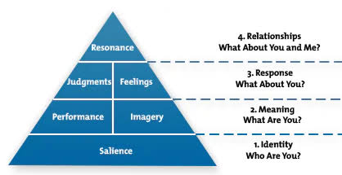
Figure 1.3 Keller’s model Source: Keller, Kevin, Strategic Brand Management
This is the model's most fundamental level, and it pertains to the brand's visual features, such as its logo, colors, and tagline. Amazon's striking logo and bright blue color scheme have become synonymous with the corporation, making it easy for customers to recognize the brand(Yadav and Sagar, 2018). Furthermore, Amazon's motto "Earth's Most Customer-Centric Company" emphasizes the company's dedication to client pleasure(do Carmo, Sacomano Neto, and Donadone, 2023). Meaning is the second level of the Brand Equity pyramid. This level is concerned with the brand's principles and ideals. By continually upholding its key values of customer-centricity, innovation, and convenience, Amazon has established a strong brand meaning(Chekalina, Fuchs, and Lexhagen, 2018). Customers have developed an emotional attachment to the firm because they trust and admire its commitment to providing the finest possible experience. The response is the third level of the Brand Equity pyramid. This level focuses on how customers react to the brand. Amazon's customer-centric approach has led to high levels of consumer happiness and loyalty, as evidenced by good customer reviews and repeat purchases. Amazon's emphasis on innovation has also resulted in a slew of new products and services, such as Amazon Prime and Alexa, that have raised customer involvement even more(Akhmaeva, 2020).
Relationships are at the summit of the Brand Equity pyramid. This level refers to the brand's contacts and interactions with its customers. Amazon has developed close ties with its customers by giving personalized suggestions, unique bargains, and exceptional customer service. These ties have contributed to increased client loyalty and a deep emotional connection to the brand. In conclusion, Amazon has successfully used Keller's Customer-Based Brand Equity methodology to build a powerful and recognizable brand(Kuhn, Alpert, and Pope, 2008). Amazon has built a strong reputation and an emotional connection with its customers by focusing on identity, meaning, responsiveness, and connections. This has enabled Amazon to distinguish itself from competitors, increase consumer loyalty, and command a higher price(Kumari, 2020).

CUSTOMER JOURNEY OF AMAZON
The stages of the Customer Journey of Amazon Customers are;
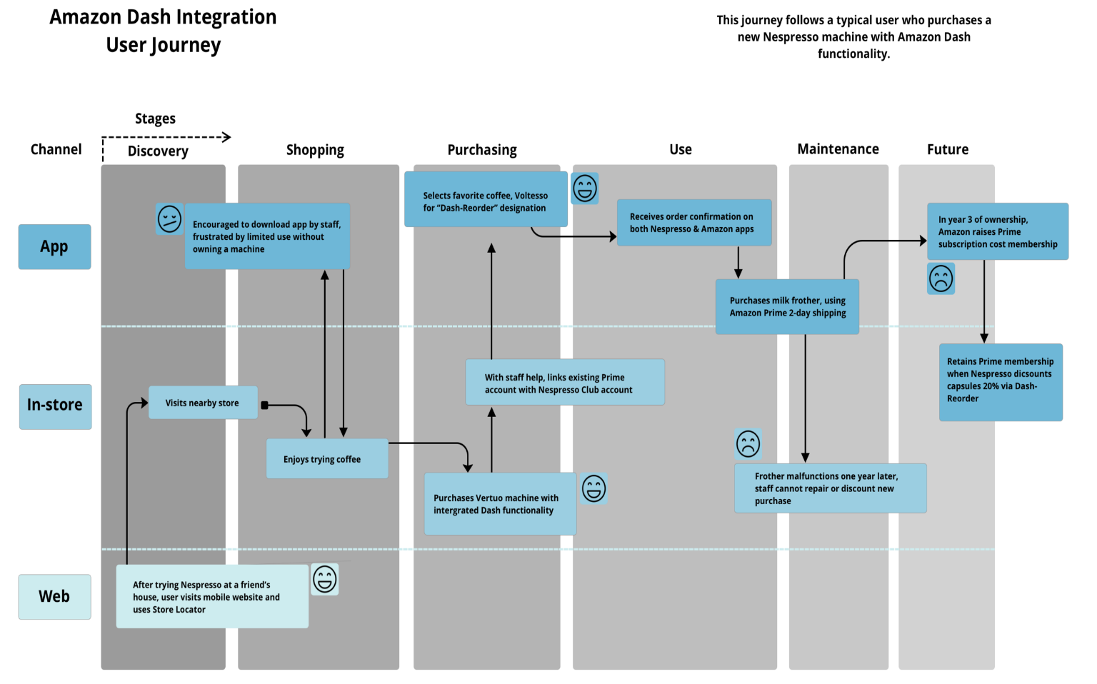
Figure 1.4 Customer Journey of Amazon
- Passive: Potential customers learn about Amazon's products and services through a variety of channels, including advertising, word of mouth, and web searches. Customers can learn about Amazon and the items and services it provides through advertising.
- Need: They identify a need for a specific product or service and begin researching the available possibilities. When potential customers become aware of Amazon and the products and services it provides, they may begin to investigate the various possibilities available to them.
- Want: They decide to buy the product or service that Amazon has to offer. Potential clients may determine that the product or service offered by Amazon is the greatest fit for them after examining their options.
- Find: They search for goods or services on Amazon's website or app. Once a potential consumer has opted to buy from Amazon, they must locate the product or service they require. This is accomplished by browsing the Amazon website or app for the desired goods or services.
- Buy: They make the buy. Customers purchase locating the goods or services they want by adding them to their shopping cart and going to the checkout page.
- Get: They obtain the product or service. After making a purchase, a consumer will receive the good or service they bought promptly. This can range from a few days to a few weeks, depending on the product or service.
- Retain: They keep using the goods or services and are happy with their purchase. After receiving the goods or service, the customer will continue to utilize it. If consumers are pleased with the goods or services, they may become repeat customers and return to Amazon to purchase further items.
- Re-engage: They return to Amazon to make further purchases & become repeat consumers. Customers may return to Amazon to make more purchases as they become happier with the goods and services that they receive.
Strength and Weakness of Customer Journey Map
The customer journey map is an effective tool for gaining a knowledge of consumer behavior and motives. It enables organizations to obtain insight into how their customers interact with their products and services, allowing them to make more informed decisions about how to improve the customer experience. This customer journey map's power rests in its capacity to assist organizations in understanding the customer journey from initial awareness to purchase and beyond. This assists firms in identifying possible areas for improvement and developing plans for better serving their clients. This customer journey map's comprehensiveness is one of its key strengths. It addresses the entire consumer journey, from early awareness to purchase and retention. This implies that companies can obtain a comprehensive insight of how their customers interact with their products and services, as well as what inspires them to purchase. The map can also be used to discover possible areas for improvement and establish plans to better serve clients. Some companies may need more specific information about each stage of the customer journey, such as customer demographics, purchase history, or customer feedback.
The customer journey map can also be used to discover prospective customer acquisition or retention possibilities. Businesses may discover areas for development and establish plans to better engage and keep customers by understanding the customer journey. This can include advertising to customers, offering discounts or promotions, or providing incentives for customers to purchase from the firm. The customer journey map's shortcoming is that it may not be thorough enough for some firms. Some companies may need more specific information about each stage of the customer journey, such as customer demographics, purchase history, or customer feedback.
Recommendations
The customer journey map is a useful tool for businesses to better understand the experiences and demands of their consumers. It assists businesses in identifying potential issues and challenges that customers may have, allowing them to address them and improve the customer experience. Several recommendations should be addressed in order to maximize the usefulness of this customer journey map.
Foremost, organizations should ensure that their client journey map is up to date. Businesses must update their maps to reflect changes in client demands and expectations. Furthermore, organisations should ensure that their customer journey map is as complete as possible, covering all potential client touchpoints. Second, companies should create customer journey maps to identify possible areas for development. Businesses may improve the customer experience by studying how customers engage with their brand.
Third, organisations should establish customer personas to better understand the demands and preferences of their customers. Personas give businesses a more thorough image of their consumers, allowing them to adjust their customer journey map to their target audience's demands. Fourth, companies should think about how their customer journey map might be tailored to different client categories. Because different customer segments may have varied wants and preferences, firms should personalise their customer journey maps to their specific client segments. Firms should examine how to incorporate their customer journey map into their overall customer experience plan.

TOUCHPOINTS DURING THE CUSTOMER JOURNEY
Pre-Purchase Stage
The pre-purchase stage of the customer journey for Amazon involves potential customers learning about Amazon’s products and services through a variety of channels, such as social media, online advertising, digital marketing content, company events, and peer referral. People become aware of Amazon’s offerings and begin researching the available possibilities. This allows them to compare prices, read reviews, and gain an understanding of customer feedback. Consumers can find out more information about Amazon’s products and services by visiting the company’s website or mobile app. Here, they can learn more about the features and benefits of Amazon’s products and services, as well as any promotions or discounts offered(Xu, 2019).
Amazon also has a range of online communities, such as discussion forums and social media accounts, that customers can use to ask questions, interact with other customers, and learn more about the company’s products and services. Once potential customers have identified a need and begun their research, they may decide that Amazon’s products and services are the best fit for them. This is the point at which they enter the purchase stage of the customer journey. At this stage, Amazon offers customers a range of payment options, including credit and debit cards, digital wallets, and PayPal(Rashaduzzaman, 2020). Customers can also take advantage of Amazon’s one-click checkout feature, which allows them to quickly and easily purchase without having to fill out any forms.
Purchase Stage
The purchase stage of the customer journey for Amazon is the final step in the customer experience. It is the point where customers decide to buy the product or service they need. Customers begin the purchasing process by searching for the product or service they need on Amazon’s website or app. Amazon has an extensive selection of products and services, so customers can easily find what they need. Once they have located what they need, they can add it to their shopping cart and proceed to the checkout page. At this point, customers can select the payment method they prefer, such as credit card, PayPal, Apple Pay, Google Pay, or Amazon Pay. Customers can also choose to add a gift card or promotional code to their order(Lu et al., 2019).
After making their purchase, customers will receive their product or service promptly. Depending on the product or service, this could take anywhere from a few days to a few weeks. When customers receive their product or service, they can start using it immediately. If they are not satisfied with the product or service, they can take advantage of Amazon’s return policy. This allows them to return the product or cancel the service for a full refund. The return policy also applies to items that are defective or not as described. The purchase stage of the customer journey for Amazon is relatively straightforward and streamlined.
Post-Purchase Stage
The post-purchase stage of the customer journey for Amazon is essential in ensuring customer satisfaction and loyalty. After they have made a purchase, Amazon can take steps to ensure that the customer is happy with their purchase. This can be done by providing customers with excellent customer service and delivery speed. By offering customers fast and reliable delivery, Amazon can ensure that customers are consistently satisfied with the service they are provided. Additionally, Amazon can send customers a thank you letter after they have purchased to show appreciation. In addition to providing excellent customer service, Amazon can also utilize post-purchase marketing strategies to further engage customers(Bhasin, 2018). Amazon can use email marketing, targeted offers, and other marketing strategies to encourage customers to return to the site and make further purchases.
Amazon may send subscription renewal emails to customers to encourage them to renew their subscriptions(Donici et al., 2012). They may also send follow-up emails to customers after they have made a purchase to thank them and encourage them to return to the site. Overall, the post-purchase stage of the customer journey is essential for Amazon to ensure customer satisfaction and loyalty. By taking steps to provide excellent customer service, engaging in post-purchase marketing strategies, and utilizing loyalty programs, Amazon can ensure that customers are consistently satisfied with their purchases(Baboolal Frank, 2021).

CONCLUSION
Amazon Inc. has the potential to develop novel marketing methods for increasing brand awareness and managing and accessing the customer experience across a range of communication channels. Amazon can ensure that current and future stakeholders' expectations are met by harnessing the assets of its existing customer relationship management solutions. To accomplish this, Amazon must first understand the customer's entire journey and then adjust its marketing strategy to each stage. Amazon can enhance brand exposure while simultaneously increasing customer engagement by using customer segmentation, personalization, and interactive marketing. Amazon must guarantee that they are tracking metrics and analyzing their strategy to ensure that they are reaching the expectations of their customers. Amazon can ensure that they are developing and implementing successful marketing tactics that will lead to greater consumer happiness, loyalty, and sales by doing so. To ensure the effectiveness of its marketing initiatives, Amazon must focus on knowing the customer's end-to-end journey, using its current customer relationship management systems, and adopting the right technologies.

REFERENCES
Agnihotri, Dr. A. (2022) ‘CONSUMER BEHAVIOR TOWARDS DIGITAL MARKETING IN AMAZON’, INTERANTIONAL JOURNAL OF SCIENTIFIC RESEARCH IN ENGINEERING AND MANAGEMENT, 06(05). doi: 10.55041/ijsrem13082.
Akhmaeva, L. G. (2020) ‘USER EXPERIENCE AND OPPORTUNITIES IN THE USE OF VOICE ASSISTANTS IN INTERACTIVE MARKETING COMMUNICATIONS: AMAZON ALEXA, GOOGLE HOME, APPLE SIRI, YANDEX ALICE’, Vestnik Universiteta, (5). doi: 10.26425/1816-4277-2020-5-49-57.
Al-Fedaghi, S. (2012) ‘A conceptual foundation for the Shannon-Weaver Model of communication’, International Journal of Soft Computing, 7(1). doi: 10.3923/ijscomp.2012.12.19.
Baboolal Frank, R. (2021) ‘Analysis Of Amazon: Customer Centric Approach’, Academy of Strategic Management Journal, 20(SpecialIssue2).
Baleviciene, D. (2020) ‘INTEGRATED MARKETING COMMUNICATIONS’, in Art Marketing. doi: 10.4337/9781800883284.integrated.marketing.communication.
Berryman, R. M. (2014) ‘Amazon. com, Inc.: a case study analysis’, academia.edu.
Bhasin, H. (2018) Marketing strategy of Amazon – Amazon marketing strategy, Marketing91.
De Brito, S. R. et al. (2016) ‘Concentration of access to information and communication technologies in the municipalities of the brazilian legal amazon’, PLoS ONE, 11(4). doi: 10.1371/journal.pone.0152655.
do Carmo, M. J., Sacomano Neto, M. and Donadone, J. C. (2023) ‘Amazon.com Inc.’, in Corporate Financialization. doi: 10.4324/97810033095361-5.
Chekalina, T., Fuchs, M. and Lexhagen, M. (2018) ‘Customer-Based Destination Brand Equity Modeling: The Role of Destination Resources, Value for Money, and Value in Use’, Journal of Travel Research, 57(1). doi: 10.1177/0047287516680774.
D’Arbelles, K., Berry, P. and Theyyil, A. (2020) ‘Electronic word-of-mouth marketing on Amazon: Exploring how and to what extent Amazon reviews affect sales’, The McMaster Journal of Communication, 12(1). doi: 10.15173/mjc.v12i1.2384.
Donici, A. N. et al. (2012) ‘E-Commerce across United States of America: Amazon.com.’, Economy Transdisciplinarity Cognition, 15(1).
Duralia, O. (2018) ‘Integrated marketing communication and its impact on consumer behavior’, Studies in Business and Economics, 13(2). doi: 10.2478/sbe-2018-0022.
Finne, Å. and Grönroos, C. (2017) ‘Communication-in-use: customer-integrated marketing communication’, European Journal of Marketing, 51(3). doi: 10.1108/EJM-08-2015-0553.
Hoang Tien, N. and Nguyen Hoang Tien, C. (2022) ‘Employer branding strategy of Amazon and experiences for Vietnam high tech corporations’, International Journal of All Multidisciplinary Research Studies, 1(2).
How to Create a Customer Journey Map? – Plerdy (no date). Available at: https://www.plerdy.com/blog/customer-journey-map/ (Accessed: 20 April 2023).
Kuhn, K. A. L., Alpert, F. and Pope, N. K. L. (2008) ‘An application of Keller’s brand equity model in a B2B context’, Qualitative Market Research, 11(1). doi: 10.1108/13522750810845540.
Kumari, P. (2020) ‘Comparing Customer Attitude towards Amazon and Flipkart in Patna’, International Research Journal on Advanced Science Hub, 2(Special Issue ICSTM 12S). doi: 10.47392/irjash.2020.252.
Lu, W. et al. (2019) ‘Crowdsourcing for food purchase receipt annotation via amazon mechanical turk: A feasibility study’, Journal of Medical Internet Research, 21(4). doi: 10.2196/12047.
Mishra, S. (2016) ‘Shannon and Weaver Model Of Communication | Businesstopia’, Businesstopia.
Permana, I. and Nugraha, S. (2020) ‘E-Commerce: The Booster for Brand Advocacy Ratio in Asia’, in. doi: 10.2991/aebmr.k.200915.086.
Piller, F. T., Lindgens, E. and Steiner, F. (2012) ‘Mass Customization at Adidas: Three Strategic Capabilities to Implement Mass Customization’, SSRN Electronic Journal. doi: 10.2139/ssrn.1994981.
Quyyam, T. and Ghous, H. (2021) ‘Sentiment Analysis of Amazon Customer Product Reviews: A Review’, International Journal of Scientific Research and Engineering Development, 4(11).
Rashaduzzaman, M. (2020) ‘Influence of Convenience, Time-Savings, Price, and Product Variety on Amazon Prime Members and Non-Prime Shoppers’ Online Apparel Purchase Intention’, Textiles, Merchandising, and Fashion Design: Dissertations, Theses, & Student Research, 16.
Şerban, R. A. (2018) ‘Measuring Brand Value: The Case of Romanian Public Traded Companies’, Studies in Business and Economics, 13(3). doi: 10.2478/sbe-2018-0043.
Sinčić Ćorić, D. and Jelić, D. (2015) ‘Applicability of keller’s brand equity model in the B2B chemical market’, Economic Research-Ekonomska Istrazivanja , 28(1). doi: 10.1080/1331677X.2015.1100841.
Stephansen, H. (2013) ‘Starting from the Amazon: communication, knowledge and politics of place in the World Social Forum’, Interface, 5(May).
Vollero, A., Sardanelli, D. and Siano, A. (2021) ‘Exploring the role of the Amazon effect on customer expectations: An analysis of user-generated content in consumer electronics retailing’, Journal of Consumer Behaviour. doi: 10.1002/cb.1969.
Xu, L. (2019) ‘The Prevalence and Effectiveness of Price Promotion on Amazon’, International Journal of Business and Administrative Studies, 5(4). doi: 10.20469/ijbas.5.10001-4.
Yadav, N. and Sagar, M. (2018) ‘Amazon India’s “Apni Dukaan”: branding strategy’, Emerald Emerging Markets Case Studies, 8(3). doi: 10.1108/EEMCS-09-2017-0230.
Yoo, B. and Donthu, N. (2001) ‘Developing and validating a multidimensional consumer-based brand equity scale’, Journal of Business Research, 52(1). doi: 10.1016/S0148-2963(99)00098-3.

