Rhys Davies (1708879)

Reasearch and development methods
Project Proposal


Title: pH and Conductivity Control System

Author: Rhys Davies

Course: BEng Electrical Engineering

Faculty: Gareth Jones

Submission Date: 14th April 2018

Declaration:

The work of this report completed under the supervision of Gareth Jones. I declare that this report is the product of my own work and is not being submitted for any other degree etc.

Sign the declaration – R.Davies

Abstract
This paper reports on the proposed project I am thinking of creating which is a fully automated pH and conductivity control system. Conductivity and pH control is widely needed and used across industry ranging from food industries, cosmetics and cooling water systems. Due to place of work having limited knowledge on the wholes system this is what gave me the idea to construct this project.
Contents
Title: pH and Conductivity Control System 1
Author: Rhys Davies 1
Course: BEng Electrical Engineering 1
Faculty: Gareth Jones 1
Submission Date: 14th April 2018 1
Declaration: 1
Abstract 2
Introduction 3
My Project 3
What is pH? 4
Why measure pH? 4
What is Conductivity? 5
Why measure Conductivity? 5
Areas for research 6
pH Sensor 6
Conductivity Sensor 6
Conductivity and pH Solutions 7
Solution Pumps 7
Chemical Storage 8
S7 Siemens PLC 9
Control and Solenoid Valves 9
Emergency Shutdown Logic 10
Gant Chart 11
Bibliography 12
Table of Figures 13
Conclusion 13

Introduction
Working in BOC Margam as an instrument technician I am involved in the maintenance of water treatment plants and quite often I perform calibrations on both the pH and conductivity probes. Within the company water treatment is usually an area which has very limited knowledge due to the bulk of installations of new equipment is completed by an external company. With that in mind I thought it would be a sufficient project to possibly create a fully automated system that can control the pH and conductivity of a vessel which if successful could possibly eliminate the need to have a contract with the external company. Saving BOC thousands of pounds each year.

My Project
For my major project I have decided to design and construct an automated pH and conductivity dosing system. I will build a small simulation model which involves 3 small chemical storage containers for raw water, mixing vessel, acid solution and alkaline solution. Using a 3 term controller the pH and conductivity will be controlled to the required value using a Siemens S7 PLC program. The way it should work is that a tank full of water will keep getting pumped out and the returned back into the tank. As I manually cause the water to increase/decrease in pH and conductivity I’ll expect the PLC program to open and shut the corresponding valves on the acid/alkaline and a conductivity blow off valve to help correct the pH and conductivity value. If the pH/conductivity value were to get out of control, a line of ladder within the PLC program will shut down every valve and will stop every pump and the system will go into a tripped condition (ESD) until reset.
The pH/conductivity probe will be placed inline of the discharge pipework from the water tank therefore it will always have a good flow of water going past the probes to get an accurate reading.
Polyethylene plastic storage tanks will be used because the material won’t react with the acid/alkaline solution.
A possibility that may or may not happen could be that a level measuring device could be used to determine an accurate reading of the vessel. Advantages of this would be you could see if the vessel is close to overfilling, a trip condition could then be put in place to prevent the vessel from over filling.

What is pH?
pH stands for the potential of hydrogen and is a number scale that can be used to measure the acidity and alkalinity of any flowing liquid solution. Every solution will have its own pH value ranging from 1 to 14. If the pH value indicates between 1 and 6 the solution is considered acidic and if the value is measured between 8 and 14 it is considered to be an alkaline. As the pH value increases or decreases further away from 7, the severity if the solutions increases. Number 7 on the pH scale is known as the neutral value meaning that it is not acidic or neither an alkaline. There is only one solution which has the pH of 7.0 which is pure water. Even the pH of natural drinking water is ranged between 6.5 and 8.5. Shown below is a pH scale showing the severity of different solutions. [1]
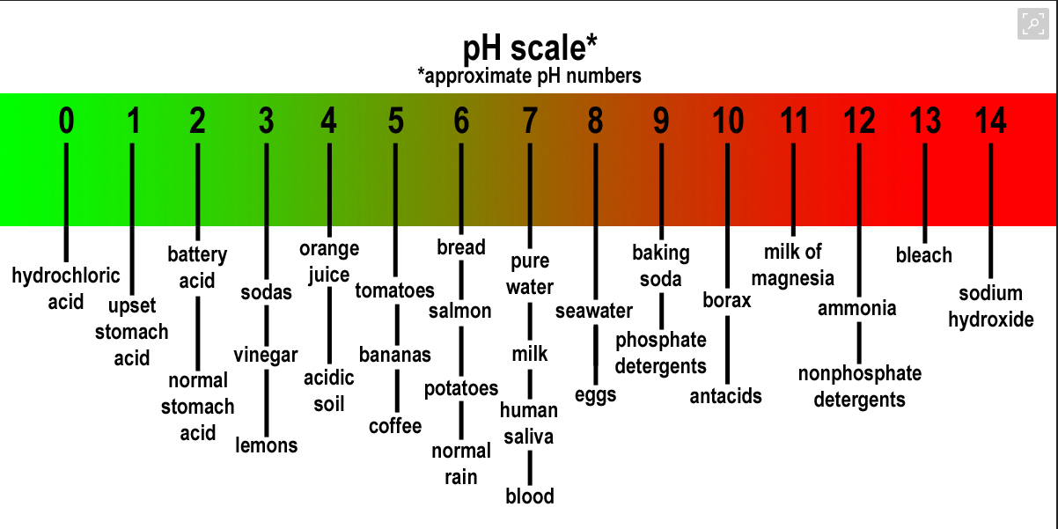
Figure 1 - pH severity scale

Why measure pH?
For fruit and vegetables to grow it is important to maintain the correct pH level where the elements in the nutrient solution are always available for the plant. If the solution is considered too acidic or too alkaline it can cause a lock up situation which is where the plant restricts the certain elements essential to grow via its roots. Without the right nutrients the plant growth would be limited, resulting in crop failure. [2]
The pH of drinking water is critical to human health along with the pH of swimming pools is very important because the human eyes and skin cant withstand high acidity or alkalinity eventually causing permeant damage but to eliminate bacteria and viruses the swimming pools need to be at a slightly higher pH. The pH of the river water fish live and breed in needs to be controlled due to the pollution entering rivers resulting in fish numbers dramatically decreasing and possibly extinction. [2]

What is Conductivity?
Conductivity is the measurement of the ability of a liquid solution to conduct an electric current. Conductivity measurements are used in routinely in many industrial and environmental applications as a fast, inexpensive and reliable way of measuring the ionic content in a solution. Conductivity is measured mainly in ppm and µS and is the total soluble salts contained within a liquid solution.
Pure water does not contain salts, so it has a conductivity measurement of zero. By adding soluble elements to the water, electricity is able to move through the solution giving it a conductivity rating [2]. The greater the concentration of ions in the solution the higher the conductivity. Conductivity is also temperature dependent so increased temperatures cause the solution to become less viscous resulting in the difference in charge and size of the ions.
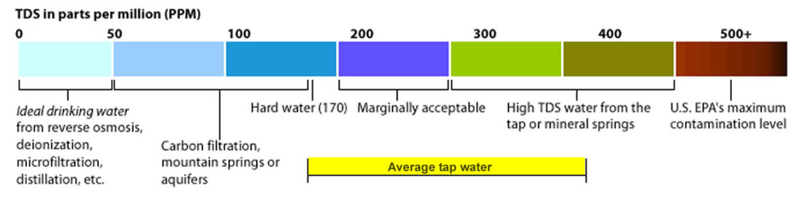
Figure 2- Conductivity severity scale

Why measure Conductivity?
Conductivity of water is important because it reveals water's salinity and the concentration of other minerals and contaminants. Environmentalists can use conductivity to track the movement of water systems in order to predict and solve problems with marine life. Conductivity tests demonstrate the connection between soil conditions and drought, heavy rain, and other environmental conditions that could affect farming and crop yield. [3]

Areas for research
This project requires a lot information to be researched to get a good understanding of all the details needed to be completed. Below are some bullet points of the areas that need to be covered.
- pH sensor
- Conductivity sensor
- pH solution
- Conductivity solution
- Solution pumps
- Chemical Storage
- Siemens S7 PLC
- Control and Solenoid valves
- Emergency shut down logic

pH Sensor
Before using pH meters they should be calibrated to be accurate. A pH sensor should be calibrated before every time it’s used if used not often or once every 3 months if it’s used in a continuous monitoring system. To calibrate a pH meter you test the sensor against a known pH value from a buffer solution and then manually adjust the pH sensor accordingly. Temperature is another factor that would cause an incorrect reading luckily most pH meters have built in thermometers and automatically correct the pH measurement as the temperature changes. [4] [5]
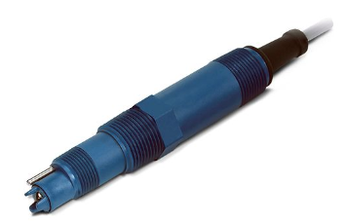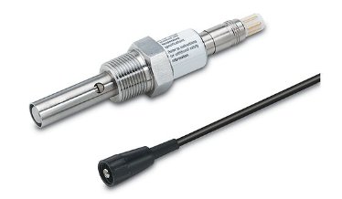
Figure 3- Rosemount pH Sensor Figure 4- Rosemount Conductivity Sensor

Conductivity Sensor
Before using a conductivity sensor they should be calibrated to get most accurate reading possible. A conductivity sensor should be calibrated before every time it’s used if not used often or every 3 months identical to the pH sensor if used in a condition based monitoring system. To calibrate a conductivity meter you test the sensor against a known conductivity value from a buffer solution and then manually adjust the sensor accordingly. [6] [7]

Conductivity and pH Solutions
Both pH and conductivity have are effected by temperature, all the latest calibration equipment has temperature compensation built into them but solutions are designed to be give out readings of under a temperature of 25ᵒC. 25ᵒC is perfect temperature condition to measure pH and conductivity. [4]
“A pH of 6.86 is ideal for people who need to get an accurate neutral reading, particularly those working in water purification plants, the food industry, aquatics, and Hydroponics, and wherever the pH is expected to be neutral.” [8]
When calibrating the conductivity/pH probe, it can either be calibrated from a 1 point cal or a 2 point calibration. A 2 point calibration is a much more accurate reading because it is placed into solutions at either end of its scale where as a 1 point cal just calibrates at a neutral solution.
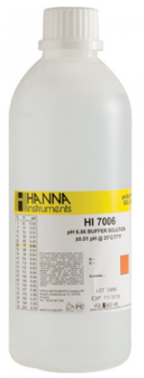
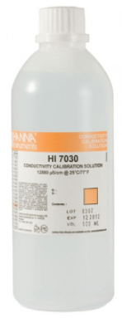

Figure 5- Hanna pH Calibration Solution Figure 6- Hanna Conductivity Calibration Solution

Solution Pumps
For this project to work I’ll be needing 4 chemical dosing pumps. Each pump needs the following credentials.
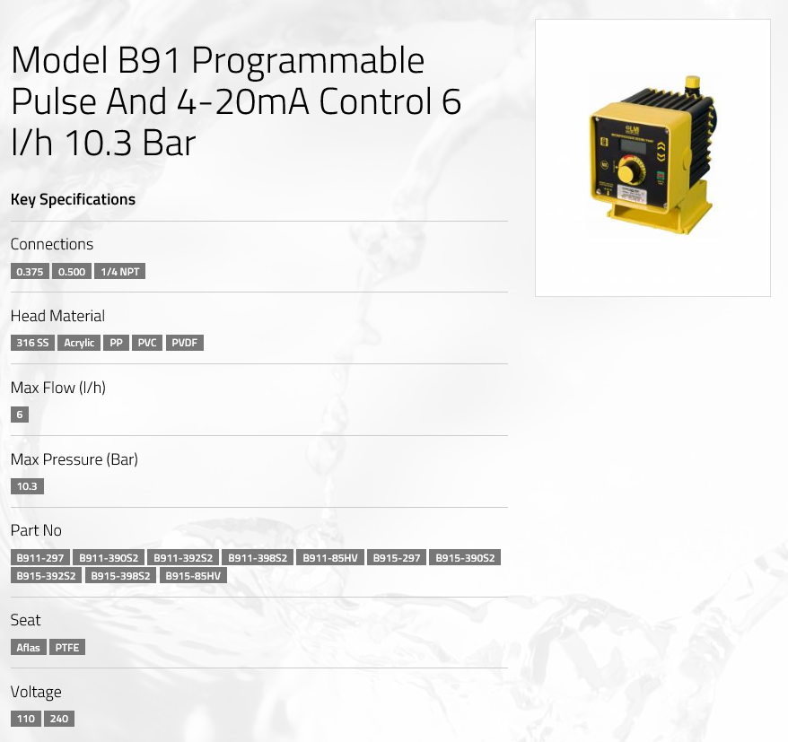
- To be able to operate under a 4-20mA signal.
- A supply voltage 110V or lower.
- Be able to produce a reasonable pressure.
- Inlet and Outlet connections must ideally ¼ NPT.
- To have a PTFE seat which is cable to handle highly corrosive acid.

After doing some research I came across a company called LMI (Liquid Metering Instruments) and after looking through their website I discovered the model ‘B91 4-20mA Control dosing pump’ and reading through is specifications it seemed to be the ideal pump for my project.
Figure 7- LMI Dosing Pump Model B91

Chemical Storage
The probability of a major leak from a specific and maintained storage tank is low. But the consequences of an acid spill have the potential to be very serious and measures to contain spillages and leaks of acid have to be in place. Bunding is a method to help contain any acid leaks from vessels. By placing a bund around the vessel it completely eliminates the chance of any solution such as acid to enter drainage or water systems. It also stops the liquid from contaminating the land it is placed on which could be farmland. The bund walls and floor should be constructed of materials resistant to the acid being stored. Acid resistant tiles are available and bricks and cement can be faced with acid resistant coatings. Coatings will require maintenance and regular renewal. The choice of materials will depend on the acid itself, its concentration and temperature. [9]

When storing a large volume of any corrosive substance such as hydrochloric acid, it can’t be placed into any large vessel. Due to hydrochloric acid being very corrosive is attacks nearly all metals including stainless steel. If HCI (hydrochloric acid) was to be left in steel vessel, it will start to corrode straight away and within a short period of time the vessel will collapse and empty its contents across the land it is sitting on. This is why it is extremely important to follow the COSHH regulations regarding acid storage. Therefore all corrosive substance vessels are constructed from plastics and ceramic materials.

“The following materials are commonly used in the construction of hydrochloric acid storage tanks.
- UPVC reinforced with resin impregnated fibreglass;
- High density polyethylene;
- Polypropylene reinforced externally with resin impregnated fibre glass;
- Carbon steel lined with suitable grade rubber.” [9]

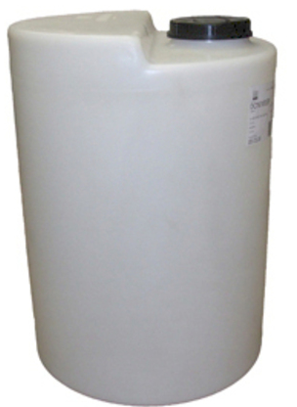

Figure 8 - High Density Polyethylene Storage Tank

S7 Siemens PLC
To make the system fully automated a PLC program needs to be written, I plan to do this using the universities software. To find a suitable PLC ill need up to 12 inputs and outputs. Searching through the internet I’ve decided to use the Siemens S7-1200 PLC CPU. It has 24 I/O which is plenty for my project, it is also small and lightweight therefore I won’t have anything bulky looking out of place. Even though there area cheaper options available I feel that this is the correct PLC to use because it has plenty of I/O available and due to it being able to handle S7 programmes it is something that I am familiar to.
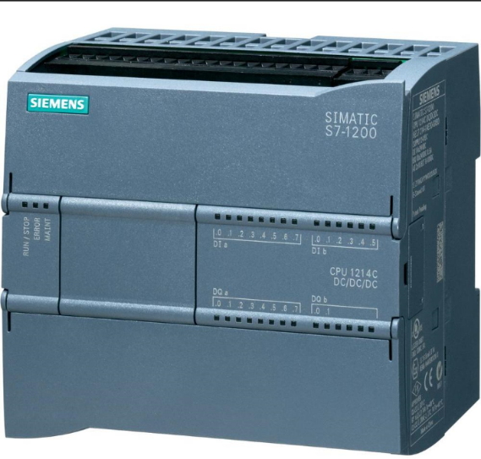

Figure 9 - Siemens S7 1200 PLC

Control and Solenoid Valves
As well as the storage vessels and pipework needing to be acid resistant the solenoid and control valves need to be also. Trying to find a 4-20mA controlled, plastic modulated valve proved to be difficult but after doing a lot of research I eventually found one. I’m going to need 2 of these control valves on both acid and alkaline discharge pipework. These will be used to control the pH of the vessel using a PID controller within the Siemens S7 PLC. The valve can be bought either to be powered by 110V or 240V, it is 2 way which is what I need because once the solenoid valves shuts I want to keep the solution within the tank. [10]
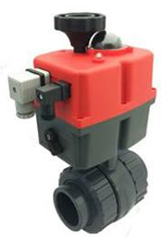

Figure 10 - 4-20mA Plastic Actuated Ball Valve

Solenoid valves are electromechanically operated valve. The valve is controlled by an electric current through a solenoid, I would be using a two port valve so that the flow can be switched on or off. Solenoids operate using an electromagnetic coil to change the state of a valve from open to closed or the opposite way. The main seat seal is a stable, long-lasting flat diaphragm that provides a tight shut-off at the valve seat. I’ve decided to use the Omega SV-10 Series solenoid valves are ideally suited for my project to control such as pure water, seawater, acids of medium concentration, salt solutions, as well as alkaline washing and bleaching. [11]
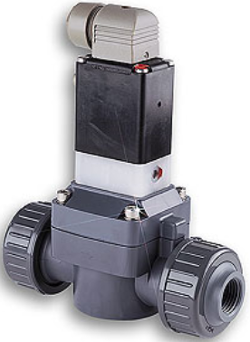

Figure 11 - PVC Solenoid Valve

Emergency Shutdown Logic
With every PLC program there will be an emergency shutdown procedure so that either a software or hardware issue were to arise the project operations would shutdown safely and then could only be restarted if it was manually reset once the failed issue had been resolved. For example, with this project if the hydrochloric acid discharge valve was to fail open this would then cause a constant flow of acid entering the water tank. Eventually the pH of the water vessel will slowly start to increase and eventually it will be full of hydrochloric acid. Inside the PLC program there will be lines of ladder to eliminate that from happening. If the PLC input from the pH probe exceeds a certain setpoint it will start an internal timer for which if the pH hasn’t fallen beneath the setpoint within the certain time the pump will stop, the water inlet valve will shut and the outlet valve will shut to contain the liquid in the vessel. Even though I haven’t talked about measuring the level of the water vessel but another example could be that if the level was to decrease below a unsafe value the risk of running the circulation pump dry could be a certain failure, so again within the PLC if the level reached an extremely low value it would stop the pump and shut the discharge valve, but by keeping the inlet valve open water could still enter the tank therefore increasing the level. In the event of a low level there could be a few issues ranging from a possible leak, a burst pipe or a manual sample drain could have been left open therefore draining the level.

Gant Chart
Figure 12 - Project Gant Chart
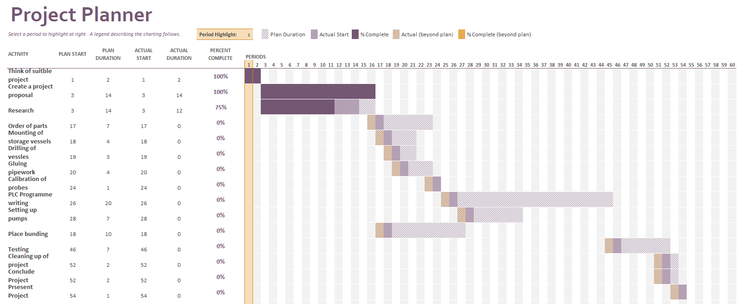

Bibliography

[1] | E. P. Richard Lawn, Measurement of pH, Royal Society of Chemistry, 2003.
[2] | bluelab, “pH,” 2014. [Online]. Available: https://www.getbluelab.com/Resource+Library/pH.html.
[3] | J. Whetzel, “Why Is Conductivity Important?,” 25 April 2017. [Online]. Available: https://sciencing.com/conductivity-important-6524603.html.
[4] | M. Cable, Calibraion: A Technicians's Guide, ISA Technician Series, 2005.
[5] | J. L. C. E. R. a. R. H. F. Thoms W. Shields, General Thoragic Surgery, Lippincott Willias & Wilkins , 2009.
[6] | K. V. Bela G. Liptak, Analysis and Analyzers, ISA - Internaltional Society of Automation, 2016.
[7] | Emerosn, “Rosemount™ 400 and 400VP,” May 2017. [Online]. Available: http://www.emerson.com/documents/automation/manual-400-400vp-contacting-conductivity-sensors-en-70708.pdf. [Accessed 19th March 2018].
[8] | Hanna Insruments, “HI-7006L pH 6.86 Buffer Solution, 500 mL bottle,” Hanna Instruments , [Online]. Available: http://www.hannainstruments.co.uk/ph-6-86-buffer-solution.html?utm_source=google_shopping&gclid=EAIaIQobChMIk-PO4af52QIVhbftCh0OsQyuEAQYAiABEgIqjfD_BwE.
[9] | Health and Safety Excutive , “Bulk storage of acids,” 2003. [Online]. Available: http://www.hse.gov.uk/pUbns/priced/hsg235.pdf.
[10] | All Valves Online, “Series 942E - Modulating Plastic Actuated Ball Valve,” [Online]. Available: https://www.allvalves.co.uk/actuated-valves/110-240v-2way-pvc-modulating-4-20ma-control.
[11] | Omega, “OMEGA-FLO® PVC Solenoid Valves for Corrosive Applications, 1/ 2 " to 2" NPT,” [Online]. Available: https://www.omega.co.uk/pptst/SV10.html.

Table of Figures
Figure 1 - pH severity scale 4
Figure 2- Conductivity severity scale 5
Figure 3- Rosemount pH Sensor Figure 4- Rosemount Conductivity Sensor 6
Figure 5- Hanna pH Calibration Solution Figure 6- Hanna Conductivity Calibration Solution 7
Figure 7- LMI Dosing Pump Model B91 7
Figure 8 - High Density Polyethylene Storage Tank 8
Figure 9 - Siemens S7 1200 PLC 9
Figure 10 - 4-20mA Plastic Actuated Ball Valve 9
Figure 11 - PVC Solenoid Valve 10
Figure 12 - Project Gant Chart 11

Conclusion
Due to this report being a project proposal the project hasn’t been built yet so there are no faults or results to report however when the building of the project begins I will be making notes of ways improvement can be carried out and if I was to build the same project again what will I do next.

