

PROBLEM SOLVING AND DECISION MAKING
MODULE CODE: BMSW4004_LON
NAME: BILKIS HUSNEARA RASHID
STUDENT ID: 1817627
LECTURER’S NAME: MR KUMAR
DATE: 28/04/2020

Chosen Problem: Communications problem in North London Cares
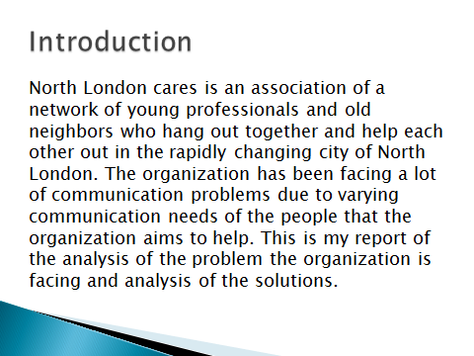
Speaker note: Communication is a complex problem especially when many people are involved in. communicating to a variety of people in provision of care can be challenging due to difference in people’s characters which call for application of varying communication means. The North London cares in the aim of reducing the disconnection which exists among people living in the town through bringing the little connections that exists on social media and some which have no connections with the communities at all has been facing a lot of communications problems for a long time arising from many forces.

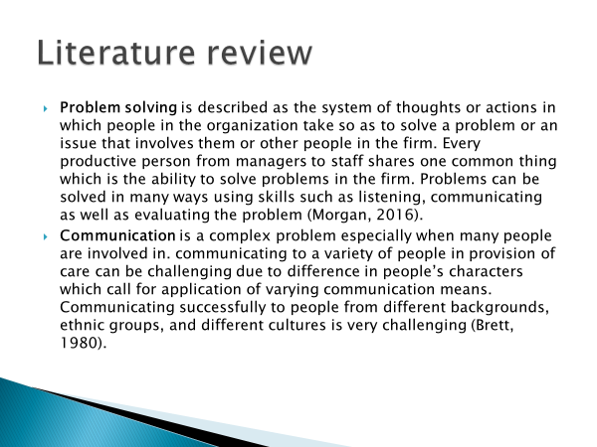
Speaker Note:
- Problem solving is described as the system of thoughts or actions in which people in the organization take so as to solve a problem or an issue that involves them or other people in the firm. Every productive person from managers to staff shares one common thing which is the ability to solve problems in the firm. Problems can be solved in many ways using skills such as listening, communicating as well as evaluating the problem (Morgan, 2016).
- Communication is a complex problem especially when many people are involved in. communicating to a variety of people in provision of care can be challenging due to difference in people’s characters which call for application of varying communication means. Communicating successfully to people from different backgrounds, ethnic groups, and different cultures is very challenging (Brett, 1980).

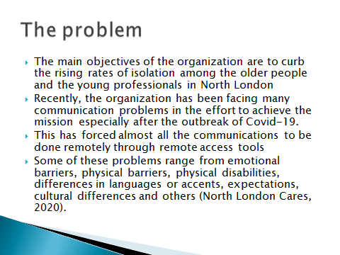
Speaker note: The main objectives of the organization are to curb the rising rates of isolation among the older people and the young professionals in North London as well as bring a connection among people to improve their confidence, resilience and other skills so that they can also feel as part of the community. Recently, the organization has been facing many communication problems in the effort to achieve the mission especially after the outbreak of Covid-19. This has forced almost all the communications to be done online through the website and social media pages such as twitter, Facebook, Linked In, Instagram and others since the objective involve dealing with a variety of people with varying communication needs. Some of these problems range from emotional barriers, physical barriers, physical disabilities, differences in languages or accents, expectations, cultural differences and others (North London Cares, 2020).
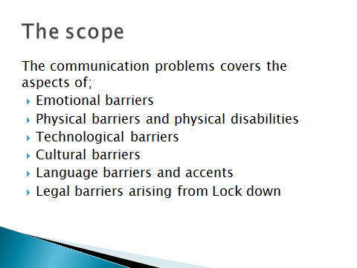
Speaker note: Emotional barrier is one of the biggest issues in the communication system (Straus, 2002). Some people living in the city find it difficult to accept to associate with other people due to their natural emotions as well as taboos being cited by some other people. Some of the sensitive topics such as sex education forms of greetings and others are the most affected by this barrier. Moreover, since the country went under lock down, communication is mostly online. People with physical disabilities who have difficulty in accessing the online platforms and using the online media of communication have been majorly been closed out by the service of the organisation especially when there is no one to help them around. Phone calls, social media, text messages and other virtual communication media have been rendered less effective since the people with hearing defects, visual problems and others have less or access to these communication media which are on use right now. To add on that, Some people have no access or little access to the technologies being applied due to the outbreak of the disease and some which were being applied before the outbreak for networking. People also have different cultures; some doesn’t believe in the importance of networking with other neighbours and tends to stick to being alone by all means. Some people also believe that they only have to network with some specific people such as people of the same gender or a particular group.
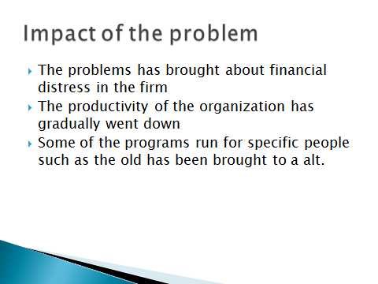
Speaker note: The migration has brought about a lot of financial constraints, the organization has been forced to add up more funds to cater for the purchase of equipment needed for the remote social assistance for helping people remain connected during the disconnection brought about by Covid-19 outbreak. Besides that, many problems arising from communication problems have greatly barred the organization from reaching put many people who are lonely and in isolation right now. The remote access to socialising has been less effective as compared to the face to face assistance which was previously being offered. Many people (but not all) in their homes have varying reasons which makes it difficult to access the online help tools to remain connected ranging from lack of knowledge to use such tools especially the old persons, not all places in town have good network coverage, the rates of internet access is not afforded by all, some people with physical disabilities are unable to use these tools. Many clients who were previously in contact with the firm have gone missing citing the many reasons increasing the risk of stress arising from disconnection by the people who were continuing to receive help from the firm. Many programs especially designed for the old persons and the disabled have also been closed down due to inability to continue since face to face communication which is effective for such people was cut off as a result of Covid-19 outbreak. Consequently, the overall productivity of the firm has tremendously dropped since clients have become fewer reaching out to many people in the city has become difficult since communication is only done remotely.
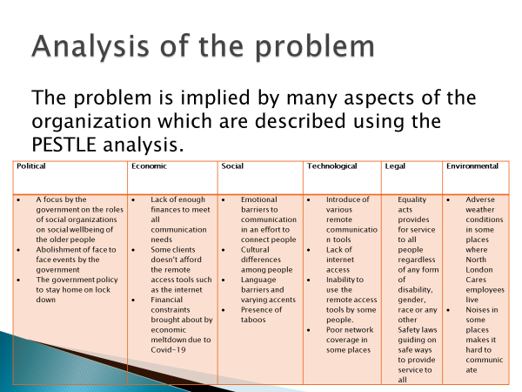
Speaker note: The PESTLE analysis is a very great tool to analyze a problem in an organization so as to provide an effective solution to it. It analyses the political, economic, social, technological, legal and environmental aspects of a problem (Cottrell, 2011).
Political:
- A focus by the government on the roles of social organizations on social wellbeing of the older people
- Abolishment of face to face events by the government
- The government policy to stay home on lock down
Economic:
- Lack of enough finances to meet all communication needs
- Some clients cannot afford the remote access tools such as the internet
- Financial constraints brought about by economic meltdown due to Covid-19
Social:
- Emotional barriers to communication in an effort to connect people
- Cultural differences among people
- Language barriers and varying accents
- Presence of taboos
Technological:
- Introduce of various remote communication tools
- Lack of internet access
- Inability to use the remote access tools by some people.
- Poor network coverage in some places
Legal:
Equality acts provides for service to all people regardless of any form of disability, gender, race or any other Safety laws guiding on safe ways to provide service to all
Environmental:
- Adverse weather conditions in some places where North London Cares employees live
- Noises in some places makes it hard to communicate

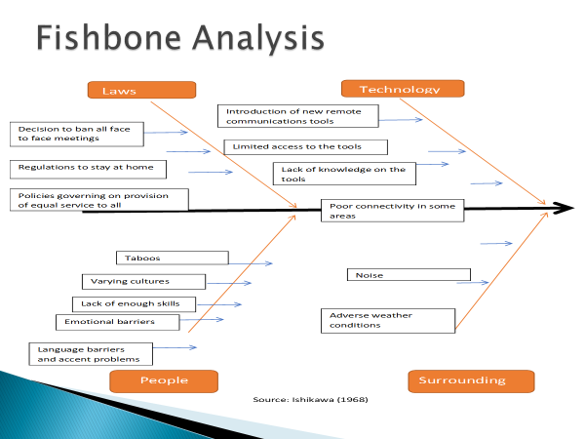
Source: Ishikawa (1968).
Speaker Note: According to Ishikawa (1968). The fishbone diagram on the other hand is a very important tool which provides a well-defined structure for identifying the root cause of a problem and the effect that the problem brings about. It is a very important tool which allows you to analyse the problem very well so as to avoid jumping into conclusions. It enhances knowledge through a well-structured analysis of a problem. This analysis will help us to find alternative solution.
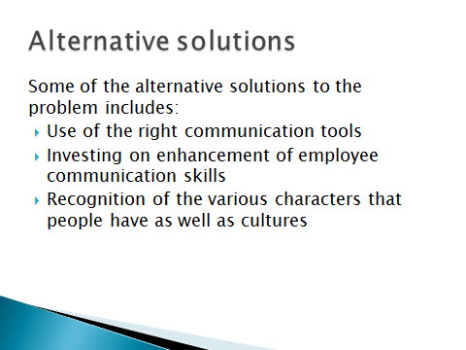
Speaker note: The use of the right communication tool covers the staff and the clients using the services of North London Cares. Incomplete communications arises due to passing of important information using ineffective communication tool. When communicating to the members using the service of the firm or the employees, the right tools which are effective to all should be used. Emails should be used to pass information which are not urgent and when all the personnel have an access to it. At this situation, the use of YouTube and videos to promote connection will be most appropriate. Besides that, many problems on communication arise from poor communication skills among the employees. The employees should be equipped with the needed communication skills to handle this problem; especially on the use of the remote communication tools. Recognition of the difference in cultures, emotions and behaviors among people which makes them adapt differently to the different forms of communication tools present so as to apply the right means of communication (Mayer, 1992).
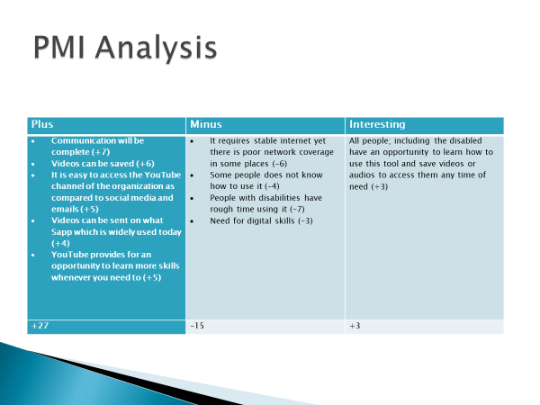

Speaker note: PMI analysis (plus, minus, interesting) is a concept which is used to discuss an idea or a decision in all the aspects. Plus, stands for the positive ones, minus, stands for the negative side and interesting represent neutral points which can be further discussed. It is a great way to look at an idea or a decision from numerous perspectives (John, 2017).
Plus | Minus | Interesting
- Communication will be complete (+7)  - Videos can be saved (+6)  - It is easy to access the YouTube channel of the organization as compared to social media and emails (+5)  - Videos can be sent on what Sapp which is widely used today (+4)  - YouTube provides for an opportunity to learn more skills whenever you need to (+5) | - It requires stable internet yet there is poor network coverage in some places (-6)  - Some people does not know how to use it (-4)  - People with disabilities have rough time using it (-7)  - Need for digital skills (-3) | All people; including the disabled have an opportunity to learn how to use this tool and save videos or audios to access them any time of need (+3)
+27 | -15 | +3

This is the analysis is based on the use of YouTube and sending videos to network the members of the community due to the current situation. From the analysis, the plus outweighs the negatives thus the North London cares should make use of YouTube and the use of videos to establish connection among members. More communication skills should be enhanced among the employees and the various cultures and emotions recognised for effective communication.

Speaker note: The implementation plan provides a layout of how the planned change shall be put into action. The implementation shall start from development of the YouTube and WhatsApp channels for sharing videos and audios, then the channels shall be marketed for all service users to know, contents shall then be uploaded and made available for the service users.
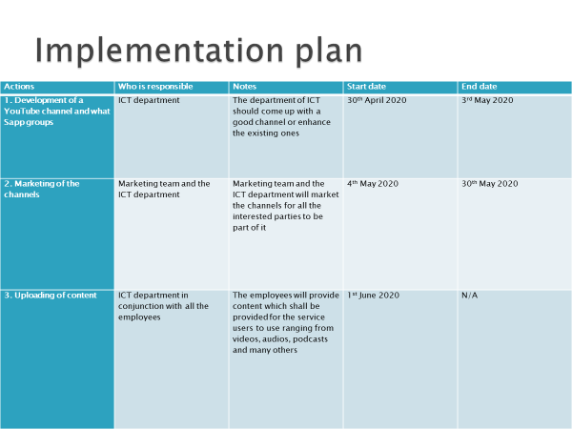
Speaker note: Stakeholders are the people directly affected by any action taken by the firm such as employees, the service users, suppliers, the shareholders, the community and many others. It is very vital to communicate every action that the organization takes to stakeholders through dialogues and feedback from them (James, 2020). Above is my communication strategy for all the stakeholders of North London Cares.
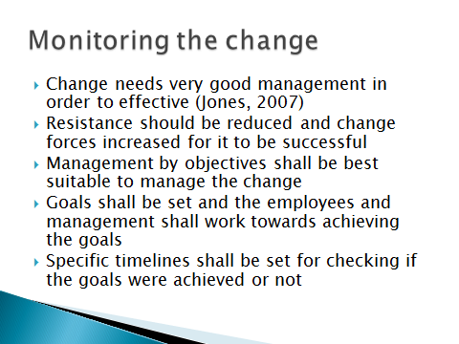
Speaker note: Change in the organization is a complex process which should be managed very well if success needs to be achieved. Lewin’s theory on change management suggests that for change to be successful, forces of change must be increased, resistance should be reduced and both should be carried out simultaneously (Jones, 2007). To manage this change successfully, management by objectives will be most suitable since less finance are on the flow; objectives shall be set, such as the target number of clients per month set and the employees shall work towards it. The managers shall be tasked with reviewing how the goals shall be met and ensure that they meet these goals.
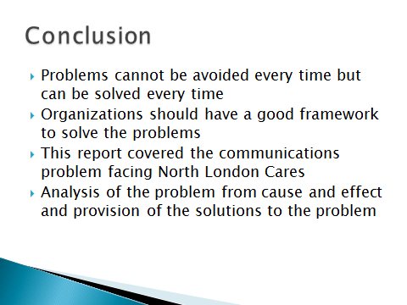
Speaker note: Finally I can say, Problems exist in every organisation and every organisation should have a well-defined framework to handle these problems. Problem solving describes how organisations or even individuals can solve problems that exist between the current state of affairs and future desired state. This is my report on the analysis of the communication problem the organization is facing brought about by many forces that I outlined and analysis of the possible solutions to the problem. It provided a well-structured of how the communication problem can be solved and the progress monitored for successful change.
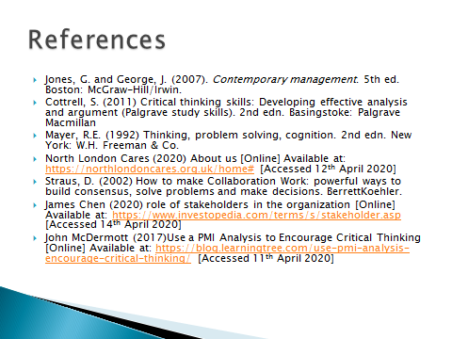

References
- Jones, G. and George, J. (2007). Contemporary management. 5th ed. Boston: McGraw-Hill/Irwin.
- Cottrell, S. (2011) Critical thinking skills: Developing effective analysis and argument (Palgrave study skills). 2nd ed. Basingstoke: Palgrave Macmillan
- Ishikawa, K. (1968) Guide to Quality Control. Tokyo: JUSE
- Mayer, R.E. (1992) Thinking, problem solving, cognition. 2nd ed. New York: W.H. Freeman & Co.
- North London Cares (2020) About us [Online] Available at: https://northlondoncares.org.uk/home# [Accessed 12th April 2020]
- Straus, D. (2002) How to make Collaboration Work: powerful ways to build consensus, solve problems and make decisions. Berette Koehler.
- James Chen (2020) role of stakeholders in the organization [Online] Available at: https://www.investopedia.com/terms/s/stakeholder.asp [Accessed 14th April 2020]
- John McDermott (2017)Use a PMI Analysis to Encourage Critical Thinking [Online] Available at: https://blog.learningtree.com/use-pmi-analysis-encourage-critical-thinking/ [Accessed 11th April 2020]

