‘What helps me learn language and mathematics? : An analysis of a child’s learning in mathematics and language with recommendations for ensuring progress.’
This assignment will highlight the techniques and strategies in order to benefit a learner’s understanding across mathematics and literacy that have been observed through Professional Teaching Practice. The pupil chosen to be observed is a 10 year old girl in a class of mixed year four and five pupils and is currently working within a middle ability group. According to Clark and Moss (2011), observing a learner through a ‘mosaic approach’ has the capability to demonstrate effective communication skills and knowledge of their learning. Therefore, within this assignment, analysing the process in which a child understands mathematics and language will also include photos drawn by the pupil, interviews and the pupil’s work. Macblain (2014) supports the use of a ‘mosaic approach’ as although practitioners need to be able to monitor a child’s learning, it is essential that the learner can self-reflect on their own progress. However, during teaching practice, it was highlighted that there are factors to a child’s learning which will be discussed through each technique of learning with regards to the ‘ASK Model’. Nottingham (2013) connotes that using the ‘ASK’ model through teaching is beneficial as understanding the learning of both areas will be influenced through the behaviour, skills and current understanding of the topic in all areas of learning. Synthesising with this, Macblain (2014) recognises Montessori’s theory such that learners need environments which stimulate their learning and thereby, acknowledging each individual’s needs. Currently, according to Corbett and Strong (2011), individual’s needs are not achieved with regards to practitioners having a lack of confidence in delivering the learning. Additionally, Donaldson (2015) adheres with this such that in order to provide meaningful learning, practitioners must adapt their teaching and assessment in order to complement the learning. Therefore, recommendations on how the pupil could improve her understanding will be discussed within this assignment.
According to Askew (2012), learners extend their mathematical knowledge through a range of methods which do not rely on an individual learning objective alone. Donaldson (2015) supports this such that learners should be able to develop their mathematical skills through communicating with peers and practitioners, individually and through a cross-curricular approach in order to become “ambitious, capable learners” (Donaldson, 2015:33). In accordance to the Welsh Government’s (2016) mathematical programme of study, there are six strands of mathematical development. However, the strand studied and discussed with the pupil, was the development of number and reasoning.
Within teaching practice, the focus pupil encountered a range of topics within number, however, her overall attitude towards maths was that it was challenging in comparison to English. The Welsh Government (2008) emphasises that the learner’s attitude towards a subject is dependent on their feelings and behaviour on that current day. This was shown through placement as mostly, the learner was happy to participate in lessons, however, there were occasions where she lacked the diligence and would often converse with those on her table which affect the quantity of workload. Additionally, Donaldson (2015) and the Welsh Government (2008) connote that the environment in which learning takes place can be a factor of performance, hence, the need for engaging environments. This was a limitation within the placement school as the learner’s group would alternate classrooms, therefore, creating confusion on the tools available.
During her interview (see appendix one), the pupil noted that maths created a confusion with regards to problem solving. According to Anghileri (2007) and Dolati and Tahriri(2017) , understanding problem solving is a vital necessity as it engages the learner to understand methods of teaching through terminology in which they are familiar with . An element of numerical reasoning development which included problem solving was the teaching of ratio (see appendix five) which Pound and Lee (2011) emphasise that problems such as these may apply to their lives, but many individuals find it difficult to connect the two. However, there are factors to consider when giving word problems such that the performance of these problems relies on a learner’s ability to understand what they have read and transforming their knowledge to the appropriate skills needed to complete the task (Hansen, 2005). According to Nottingham (2013), enhancing learning and growth mindset through modelling work to learners is beneficial as it encourages the skill of decision making. Angherili (2007) synthesises with this when acknowledging Vygotsky’s ‘Zone of Proximal Developmenr’ such that practitioners need to be equipped to provide guidance on a mathematical concept, however, it is essential that the thought process of a calculation is fostered. Suggate et al (2001) emphasises that scaffolding the learners’ thinking skills with questions to prompt what they already know and need to find out is beneficial to develop their mathematical enquiry. Furthermore, Bruner (1996, cited in Hansen, 2005, p. 6) highlights the significance of modelling various mathematical strategies to represent the particular topic such that it provides understanding in all contexts ( see appendix four ).
Additionally, Tandi (2005) and Askew (2012) emphasise that understanding ratio may be considered quite difficult for learners who learn visually in terms of number relationships. This was highlighted throughout the teaching practice as the pupil preferred to use elements of the classroom to help aid her understanding and methods. For instance, as discussed in the interview, the pupil claimed that the multiplication grids (see appendices three and four ) on the walls supported her learning within ratio with regards to the problem solving as she was able to visually identify which multiplication was required. However, this may be argued that visualising the multiplication grids limits the thinking skills of the learner (Anghileri, 2007) as it doesn’t allow the learner to mentally solve the problem. Despite this, the learner already had some knowledge of her timetables as she understood the concept of doubling and was thereby able to apply this to other multiplications mentally, increasing the multiplicative thinking (Anghileri.,2007). Supporting this, Askew (2012) and Gardner (2008) synthesises that in order to remember multiplication, it is dependent on the memory of the child as an individual who has a memory that is linguistical, can remember meanings and methods. According to Estyn (2013), this is an essential attribute to learning as if there is a strain in remembering number facts, this limits the ability to answer basic mathematics. For example, when evaluating the pupil’s work within the start of ratio (see appendix five), the learner was able to recognise the scaling of numbers, however, the confusion was highlighted in the basics of counting tallies.
Similarly, in order to increase her knowledge in number and multiplication, the pupil used her knowledge of one hundred squares and number lines to model her learning for multiplying and dividing numbers as Tandi (2005) states that any mathematical visualisation should be able to develop understanding the characteristics between numbers. Additionally, Haylock and Manning (2014) recognise that number lines highlight an image to support their connection between numbers. However, Suggate et al (2001) and Donaldson (2015) connote that the knowledge and skills towards an area of learning is complemented by their attitude such that if a child is confident with the current learning, it will empower the learner to interact with her wok and with her peers. For instance, the focus pupil demonstrated a lack of interest in an area of mathematics as a result of not feeling confident. However, when given the opportunity to work within pairs, the learner was able to collaborate with her peers to consolidate understanding as Askew (2012) synthesises with this such that paired work allows the learners’ attainment to improve.
In addition to this, Askew (2012) states that a learner can use their knowledge of number to apply this to another concept of mathematics; division. This was highlighted in placement where the learner, kinaesthetically, applied their knowledge of multiples to be able to use the bus method when dividing. Anghileri (2007) and Macblain (2014) emphasise that in order for understanding to be consolidated, learners should be enabled to reverse their calculation which demonstrates the learning between multiplication and division. The Welsh Government (2016) synthesises with this such that it is a current requirement for learners to be able to verify their workings through an inverse method. Furthermore, this enhances the learners’ skills and knowledge to explain the mathematical process they have done in order to complement the characteristics promoted in the new curriculum (Donaldson, 2015). From a teacher’s perspective, it is essential that learners are aware of the use of apparatus to verify and support their workings as well as the communicative feedback between the practitioner and the learner (Askew, 2012; Davis et al, 2017). As a result of the interview (see appendix one, question 6) and appendix Two, the learner was confident with the resources within the classroom to support her learning, hence, the whiteboards and calculator which was observed daily during placement.
With regards to recommendations within mathematics, Hansen and Vaukins (2012) connote that written communication should be improved to consolidate understanding. Therefore, enabling feedback that is meaningful and encourages the learner to fulfil any divisions in their learning is crucial as feedback should allow positive attitudes towards mistakes which is an essential attribute to encouraging learning (Hansen and Vaukins, 2012; Barnes, 2015). Additionally, Nottingham (2013) clarifies that a learner’s willingness to learn may be dependent on the views of the teacher, therefore, in the future, opportunities for learners to identify the mistakes through the teaching delivered may influence their positive attitude to work ethic within maths. In accordance to Estyn (2017), allowing the learners the opportunity to self and peer assess their work is of tremendous benefit for their future learning as it enhances their knowledge on the subject through the learners’ verbal communication and as a result, encourages learners to be involved in their own work and the work of others’ (Grigg, 2015; Dunn, 2017). This would thereby increase the confidence of the learner and their work ethic whilst the learning is taking place which is a powerful tool in visualising the next steps for themselves (Hattie, 2012).
Furthermore, enhancing the willingness to learn mathematics in the future, may consider how a lesson is portrayed such that Haylock and Cockburn (2017) emphasise that children learn best in practical experiences, therefore, lessons should provide opportunities for learners to visualise and physically interact with concrete materials to consolidate their understanding. This technique would benefit the focus pupil as independent learning experiences, where she can visualise the learning and make her own decisions, would enhance her application of numerical skills both independently and socially (Estyn, 2017). In addition to consolidating understanding, Hansen (2005) suggests that knowledge on the mathematical terminology is needed, particularly within placement, the confusion lay within understanding the language in ratio such that learners must understand the symbols and definitions for the terms; ratio and proportion. Supporting this, the Welsh Government (2016 a ) states that in order to achieve an outcome two, all learners must recognise and demonstrating their understanding on the mathematical concepts and terminology in which they are able to apply these to their learning. For example, perhaps identical resources for each classroom and the modelling of how these terminologies are used will support learners in making the connection between the two (Haylock and Cockburn, 2017). However, as a result of constantly alternating classrooms, Cremin and Burnett (2018) indicate that the teacher’s role in how an environment is portrayed, is essential as practitioners should create environments dependent on the learners’ prior experiences in order to be inclusive to learners of all levels within Maths. Moreover, inclusive environments include positive behaviour to the area of learning, therefore, Bruner (1996, cited in Cremin and Burnett, 2018, p. 189) insinuates that it is the partial responsibility of the practitioners to form an individual’s attitude to learning.
In accordance to Brien (2012) and Barnes (2015), learners learn elements of Literacy through a cross-curricular approach such that the four aspects of communication should be embedded in all areas to provide a meaningful education. Hence, the requirement for practitioners to plan for the cross-curricular skills in order to create individuals who are competent within Literacy (Donalsdson, 2015). The Welsh Assembly Government (2008) emphasises that how a child learns is dependent on the complementation of their emotions and the type of activity provided as well as the encouragement from the practitioner. Furthermore, the Welsh Government (2016b)’s current programme of study for English states that schools should provide “a language-rich environment across the key stage where oracy, reading and writing experiences are connected” (Welsh Government, 2016 b , p 2 ).
Cox (2011) connotes that learners visualising the element of writing as communication is significant emphasising that practitioners are required to engage learners through meaningful activities and through their own perspective to writing. In similarity with this, Fisher et al (2017) synthesises that writing should be promoted across the curriculum as it develops a learner’s cognitive thinking skills which allows insight on a learner’s knowledge with regards to the purpose of writing. In regards to the focus pupil, her thinking skills were developed through writing a newspaper report (see appendix six) heuristically in which Cox (2011) and Donaldson (2015) connote that learners must be able to analyse and discuss their thoughts and skills. For instance, discussing the purpose of writing in groups benefits the learning as Graham and Kelly (2010) emphasise that learners feel most confident to share knowledge which will thereby enhance their compositional and transcriptional skills. However, Smith (1982, cited in Cox, 2011) states that even though learners benefit through discussion, learners learn best through teaching the two skills separately which was highlighted during placement, using mind maps to plan writing. Additionally, using mind maps to allow learners to plan, benefits their learning as they must understand the purpose of writing and the audience in order to be able to write in a formal context such as within a newspaper (Graham and Kelly, 2010; Cox, 2011). During the interview, the focus pupil connoted that noting information on to mind maps and planning work supported her writing as she was aware of what to write and was able to identify the features that needed to be included. This refers to the work of Vygotsky (1986, cited in Cremin and Burnett, 2018, p55) such that learners requiring the support off an individual who may be more skilled, may be of more benefit to that individual’s learning. Despite this, it is essential that the learner can transfer the skills to independently produce a form of writing and thereby able to obtain the responsibility for their own learning (Cremin and Burnett, 2018). This was illustrated when producing a newspaper report as the learner was able to identify the skills and tools needed that aided her learning such as the use of digital competence in order to discover the information required dependent on the language needed (Learning Wales, 2016). Additionally, it is essential that the focus pupil is aware of ways to aid her learning, particularly the regular use of a dictionary to discover relevant texts required (Welsh Government, 2016b) which was highlighted through observations (see appendix three and four).
Additionally, Horner and Ryf (2007) and Donaldson (2015) insinuate supporting a child’s learning, particularly in groups, requires the opportunity to assess their work as it enhances the listening and discussion skills whilst demonstrating examples of effective praise and criticism which progresses the learning. Hence, Corbett and Strong (2011) highlights that the ability to develop listening skills consolidates learning, especially for the focus pupil, to which she claimed that listening to how something is taught is the best method of practice. For instance, when writing about an ideal world (see appendix seven), she was able to listen and contribute to discussions within the classroom in order to then transfer that knowledge to create her own visualisation. Hence, Brien (2012) states that is useful to assess the learning through contribution and sufficient time given to do so thereby emphasising that assessing a child’s understanding of the task is quite difficult if no verbal oracy is used. Alternatively, an element of listening that was developed was the identification of sentence types ( see appendix six) such that it was highlighted that the learner used their intellect and communication skills to recognise the tone of the words spoken in order to categorise them (Nottingham, 2013). Even though the learner had not yet completed the task, her motivation was shown through the enthusiasm in her tone of voice as a competent learner is able to listen effectively in order progress their abilities to challenge their thinking enhancing their understanding (Donaldson, 2015).
In relation to the learner’s attitude to elements of Literacy, it was acknowledged that there was a lack of confidence when writing with regards to spelling (see appendices six and eight). However, Corbett and Strong (2011) indicate that the practitioners should enable their pupils to concentrate on their compositional skills than on their transcriptional as this allows time to redraft. Although the focus pupil’s attitude to English was positive, the behaviour in the planning lesson compared to producing the newspaper report (see appendix five ) differed such that she was distracted by conversing with peers. However, O’Grady (2005) conveys that a learner may be diverted as a result of thinking of the process of written work. Therefore, Fisher et al (2017) emphasises the way in which the teaching and outcomes are delivered, influences the learners’ engagement in their own learning.
To develop spelling in the future, the learner should have the opportunity to be tested on words with the familiar phonetic structure as Cremin and Burnett (2018) state that children need to be comfortable with the activities in order to embed influential learning that is monitoring their targets. Within placement, the learner undertook several spelling tests in which many she did not achieve her potential (see appendix eight) due to not recognising the appropriate phonetic structures to spell the words as most learners will spell words how they sound and thereby need to be taught the rules (Waugh et al, 2019). Once patterns and rules are understood, Robinson (2016) emphasises that learners may begin to spell independently, reflecting on the accuracy of the word spelt. Therefore, resources to support the learning should be provided, particularly a spelling book, as spelling is an essential attribute to understanding a piece of work (Cremin and Burnett, 2018). Waugh et al (2019) synthesises with this such that the use of a spelling book allows practitioners to monitor the knowledge of spelling skills and offers opportunities for further support.. However, Hattie (2012) insinuates the effective strategy to widen understanding would be to demonstrate spelling whilst explaining how it will affect their writing. For instance, creating mnemonics may be a prudent tool for pupils to learn spellings and increase their thinking skills, which could benefit the focus pupil who had trouble recognising patterns (Robinson, 2016; Waugh et al, 2019). Supporting this, the Welsh Government (2016b) highlights the importance of allowing learners to experience a range of techniques with regards to spelling to enhance the quality of written work which will allow her to achieve her outcome of level four.
According to Medwell et al (2017) and Waugh et al (2019), there is a connection between a learner’s spelling and handwriting such that producing good handwriting complements a learner’s compositional skills within language. Therefore, weekly activities to engage learners to focus on their formation of letters is beneficial (Robinson, 2016). However, Cox (2011) states that if there is a concern on a child’s handwriting, this limits their learning such that their written work should signify future improvements over time. Within placement, it was highlighted that even though the learner connoted that her preferred element of literacy was handwriting, there was a lack of motivation to finish the task thereby stating that learners need creative approaches and games to enhance their deposition and engagement (Robinson, 2016).
Although, another recommendation would be to deepen the learner’s knowledge on content through increasing reading skills. In order to achieve a level four and five in English, learners are required to demonstrate perception on a variety of different texts to convey meaning in their writing and speech (Welsh Government, 2016b ). Graham and Kelly (2008) and Hansen and Vaukins (2012) state that developing reading skills allows learners to recognise words and comprehend the language through both Literacy and Mathematics. Additionally, effective practice of reading allows questioning to commence where this will challenge the learner to fully understood what has been read (Graham and Kelly, 2008). In accordance to Radmehr and Drake (2017), who refers to Bloom’s Taxonomy, questioning the individuals allows progression of their cognitive development and activates their prior knowledge in order to apply the knowledge gained in to their own learning. Therefore, prompting questions based on elements or vocabulary of ta text that a learner has read deepens the understanding which can thereby broaden their experiences within Literacy ( Cox, 2011). This will then encourage the focus learner to continuously increase her reading skills independently which Cox (2011) emphasises that schools need to consider the interests and language a learner equips to develop their reading experiences.
Word count= 3,503

Reference List
- Anghileri, J. (2007) Developing Number. London: Continuum 2007.
- Askew, M. (2012) Transforming Primary Mathematics. London: Routledge.
- Barnes, J. (2015) Cross-Curricular Learning 3-14. 3rd edn. Los Angeles: SAGE.
- Brien, J. (2012) Teaching Primary English. London: SAGE.
- Clark, A. and Moss, P. (2011) Listening to Young Children: The Mosaic Approach. 2nd edn. London: NBC National Children’s Bureau.
- Cox, R. (2011) Primary English Teaching: An introduction to Language, Literacy and Learning. London: SAGE.
- Corbett, P. and Strong, J. (2011) Talk for Writing Across the Curriculum. Maidenhead: Opem University Press 2011.
- Cremin, T. and Burnett, C. (2018) Learning to Teach in the Primary School. 4th edn. Abingdon: Routledge.
- Dolati, Z. and Tahriri, A. (2017). ‘EFL Teachers’ Multiple Intelligences and Their Classroom Practice.’ SAGE. Vol.7(3). DOI: 10.1177/2158244017722582.
- Davis, A et al. (2017) Mathematical Knowledge for Primary Teachers. 5th edn. Oxon: Routledge.
- Donaldson, G. (2015). Successful Futures. Cardiff: Crown. Available at: https://gweddill.gov.wales/docs/dcells/publications/150225-successful-futures-en.pdf
[ Accessed: 30th March 2019]
- Dunn, D. (2017) How to be an Outstanding Primary School Teacher. 2nd edn. London: Bloomsbury 2017.
- Estyn. (2013) Numeracy in Key Stages 2 and 3 : a baseline study. Cardiff: Crown. Available at: https://www.estyn.gov.wales/sites/default/files/documents/Numeracy%20in%20key%20stages%202%20and%203%3A%20a%20baseline%20study%20-%20June%202013.pdf [Accessed: 30th March 2019]
- Estyn (2017). Supplementary guidance : the inspection of numeracy in schools. Cardiff: Crown. Available at:
https://www.estyn.gov.wales/sites/default/files/documents/NIA%20Supplementary%20guidance%20-%20numeracy_0.pdf [Accessed: 3rd April 2019].
- Fisher, D. et al (2017) Teaching Literacy in the Visible Learning Classroom. Cslifornia: Corwin.
- Gardner, H. (2008) Multiple Intelligences: New Horizons in Theory and Practice. New York: BasicBooks.
- Graham, J. and Kelly, A (2008) Reading Under Control. 3rd edn. London. Routledge.
- Graham, J. and Kelly, A. (2010) Writing Under Control. 3rd edn. London: Routledge.
- Grigg, R. (2015) Becoming An Outstanding Primary School Teacher. 2nd edn. Oxon: Routledge.
- Hattie, J. (2012) Visible Learning for Teachers: Maximising Impact on Learning. Oxon: Routledge.
- Hansen, A. (2005) Children’s Errors in Mathematic: Understanding Common Misconceptions in Primary Schools. Exeter: Learning Matters Ltd.
- Hansen, A. and Vaukins, D. (2012) Primary Mathematics across the Curriculum. 2nd edn. London: SAGE Learning Matters Ltd.
- Haylock, D. and Cockburn, A.D. (2017) Understanding Mathematics for Young Children: A Guide for Teachers of Children 3-7. London: SAGE.
- Haylock, D. and Manning, R. (2014) Mathematics explained for Primary Teachers.5th edn. London: SAGE.
- Horner, C. and Ryf, V. (2007) Creative Teaching: English in the Early Years and Primary Classroom. Oxon: Routledge.
- Learning Wales (2016) Digital Competence Framework. Available at:
https://learning.gov.wales/resources/browse-all/digital-competence-framework/framework?lang=en&year=year_4&selectedYear=col_10&lang=en [Accessed: 1st April 2019]
- Macblain, S. (2014). How Children Learn. London: SAGE.
- Medwell, J. et al (2017) Primary English: Knowledge and Understanding. 8th edn. London: SAGE.
- Nottingham, J (2013). Encouraging Learning. Oxon: Routledge.
- O’Grady, W. (2005) How Children Learn Language. Cambridge: Cambridge University Press.
- Pound, L. and Lee, T. (2011) Teaching Mathematics Creatively. London: Routledge.
- Radmehr, Z. and Drake, M. (2017) ‘Revised Bloom’s Taxonomy and integral Calculus: unpacking the knowledge dimension’ International Journal of Mathematical Education in Science and Technology. Vol.48(8). pp1206-1224. DOI: 10.1080/0020739X.2017.1321796
- Robinson, K. (2016). A Creative Approach to Teaching Spelling: The What, Why and How of Teaching Spelling, Starting with Phonics. London: Bloomsbury.
- Suggate,J. et al (2001) Mathematical Knowledge for Primary Teachers. 2nd edn. London: David Fulton Publishers Ltd.
- Tandi, C-M. (2005) Teaching Maths to Pupils with Different Learning Styles. London: PCP.
- Waugh, D. et al (2019) Teaching Grammar, Punctuation and Spelling in Primary Schools. 3rd edn. London: SAGE Learning Matters.
- Welsh Assembly Government (2008) Learning and Teaching Pedagogy. Cardiff: Crown. Available at: https://learning.gov.wales/docs/learningwales/publications/130212ltpedagogyen.pdf [Accessed: 30th March 2019].
- Welsh Government (2016 a) Curriculum for Wales: Programme of Study for Mathematics Key Stages 2-4. Cardiff: Crown. Available at:
https://learning.gov.wales/docs/learningwales/publications/150717-nc-maths-en-v2.pdf [Accessed: 30th March 2019].
- Welsh Government (2016 b ) Curriuclum for Wales: Programme of Study for English Key Stages 2- 4. Cardiff: Crown. Available at:
https://learning.gov.wales/docs/learningwales/publications/150717-nc-english-en-v3.pdf [Accessed: 1st April 2019]

Appendix One – Interview

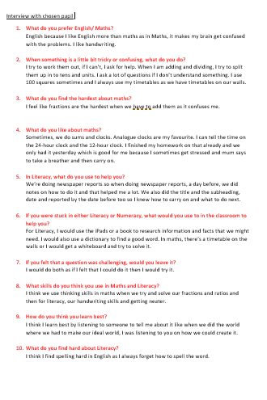

Appendix Two- observation from a literacy and maths lesson.

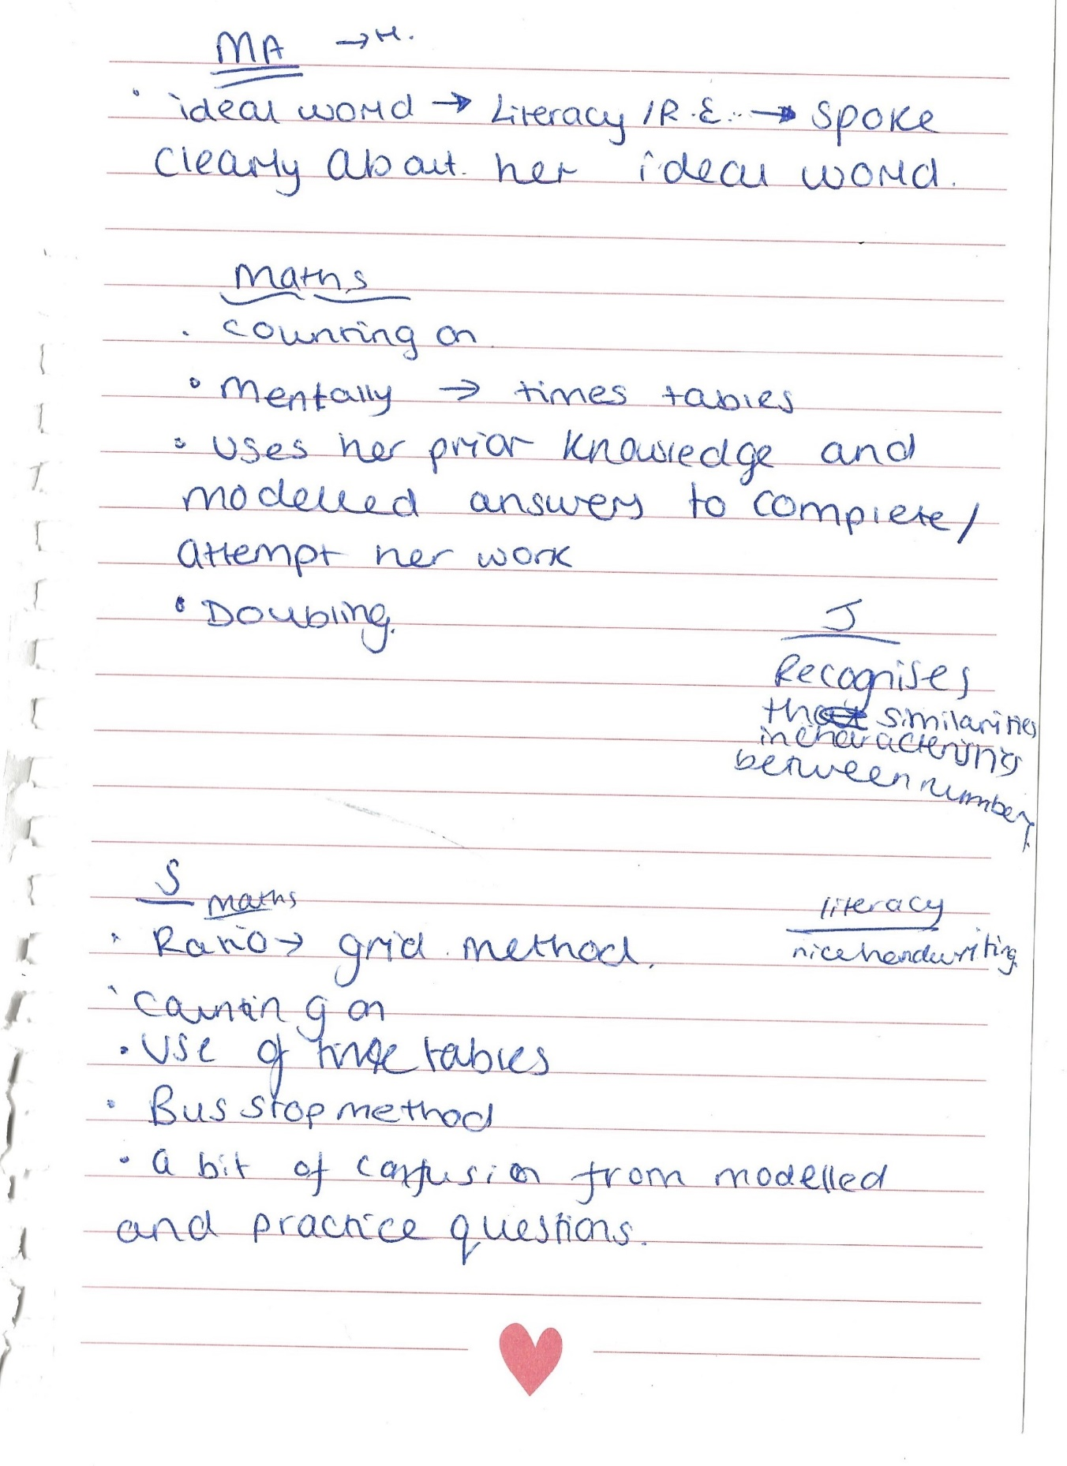
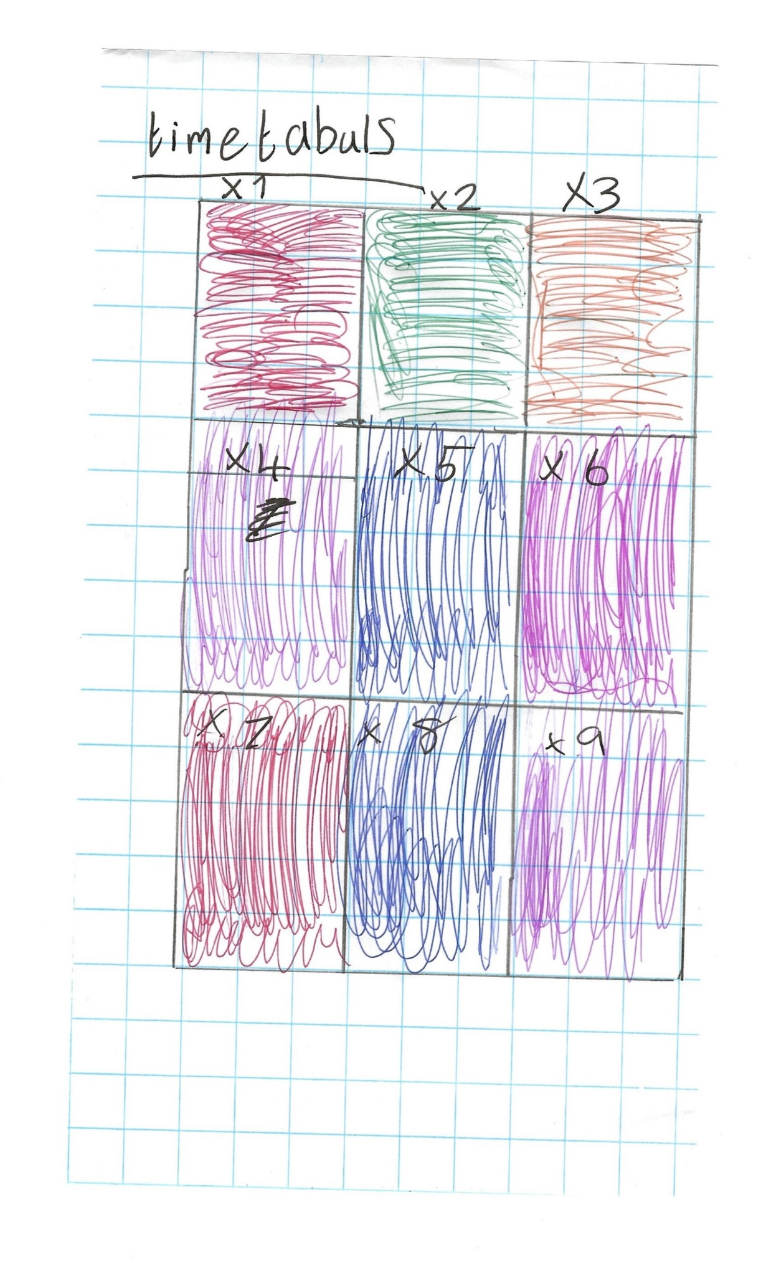
Appendix Three – resources, drawn by the pupil.

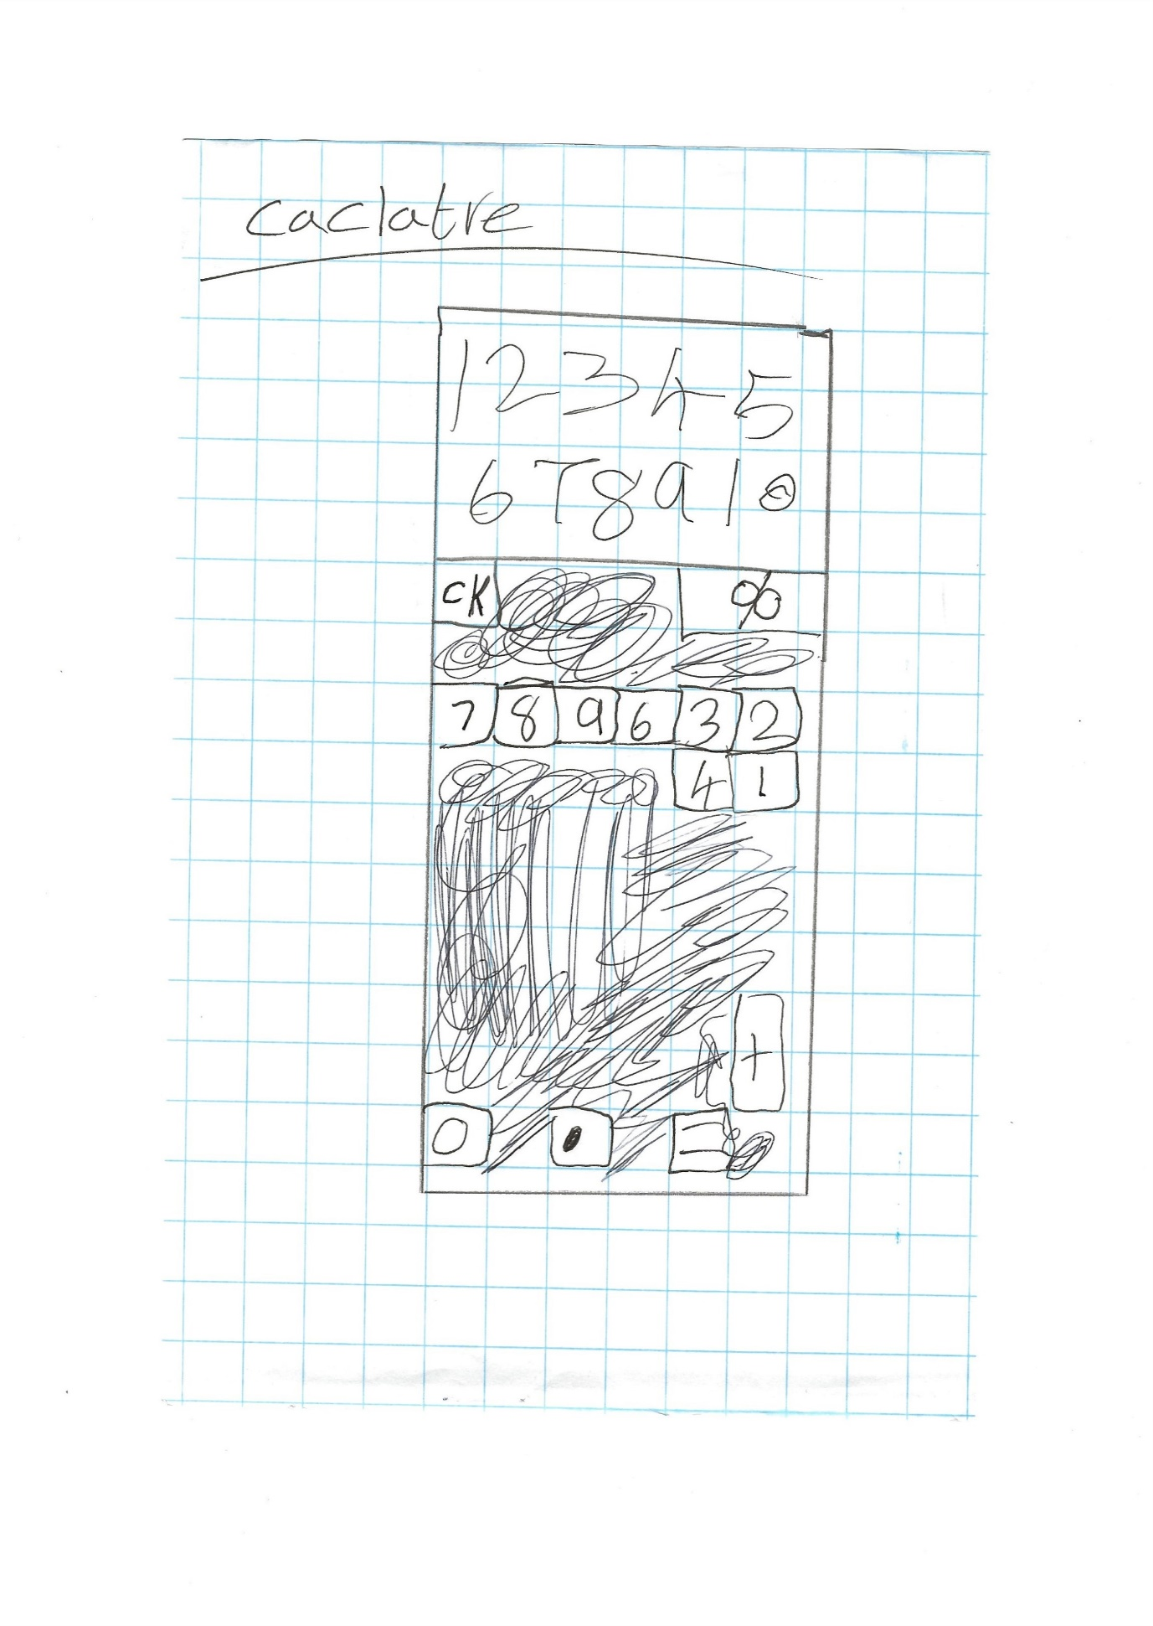

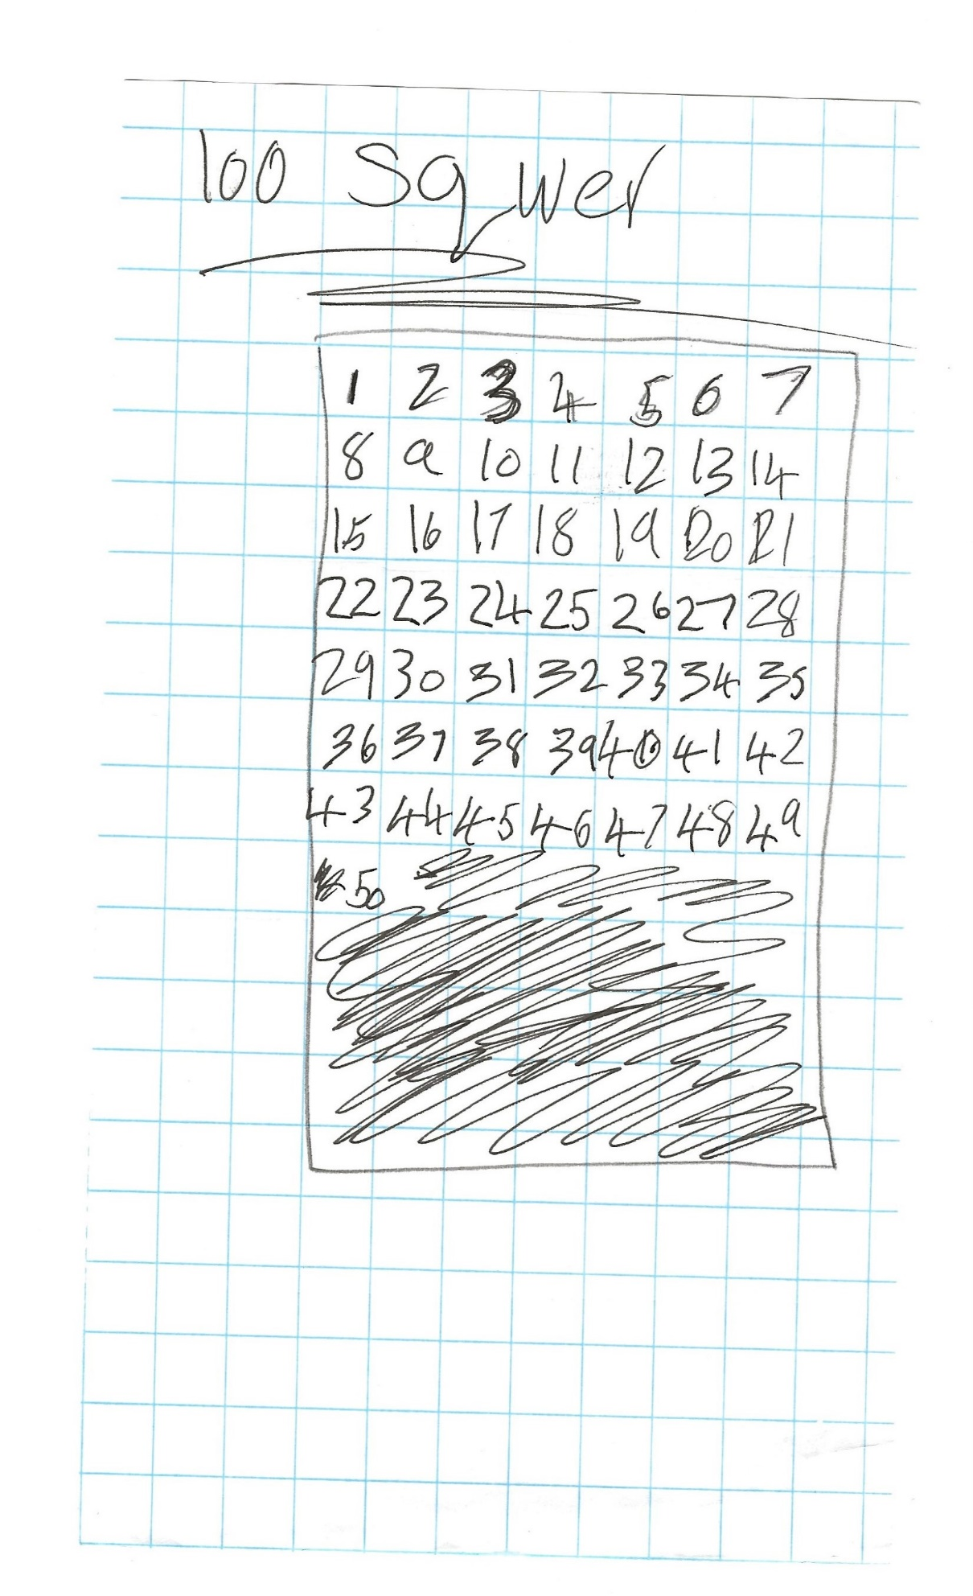

Appendix Four- Photographs taken by the pupil.
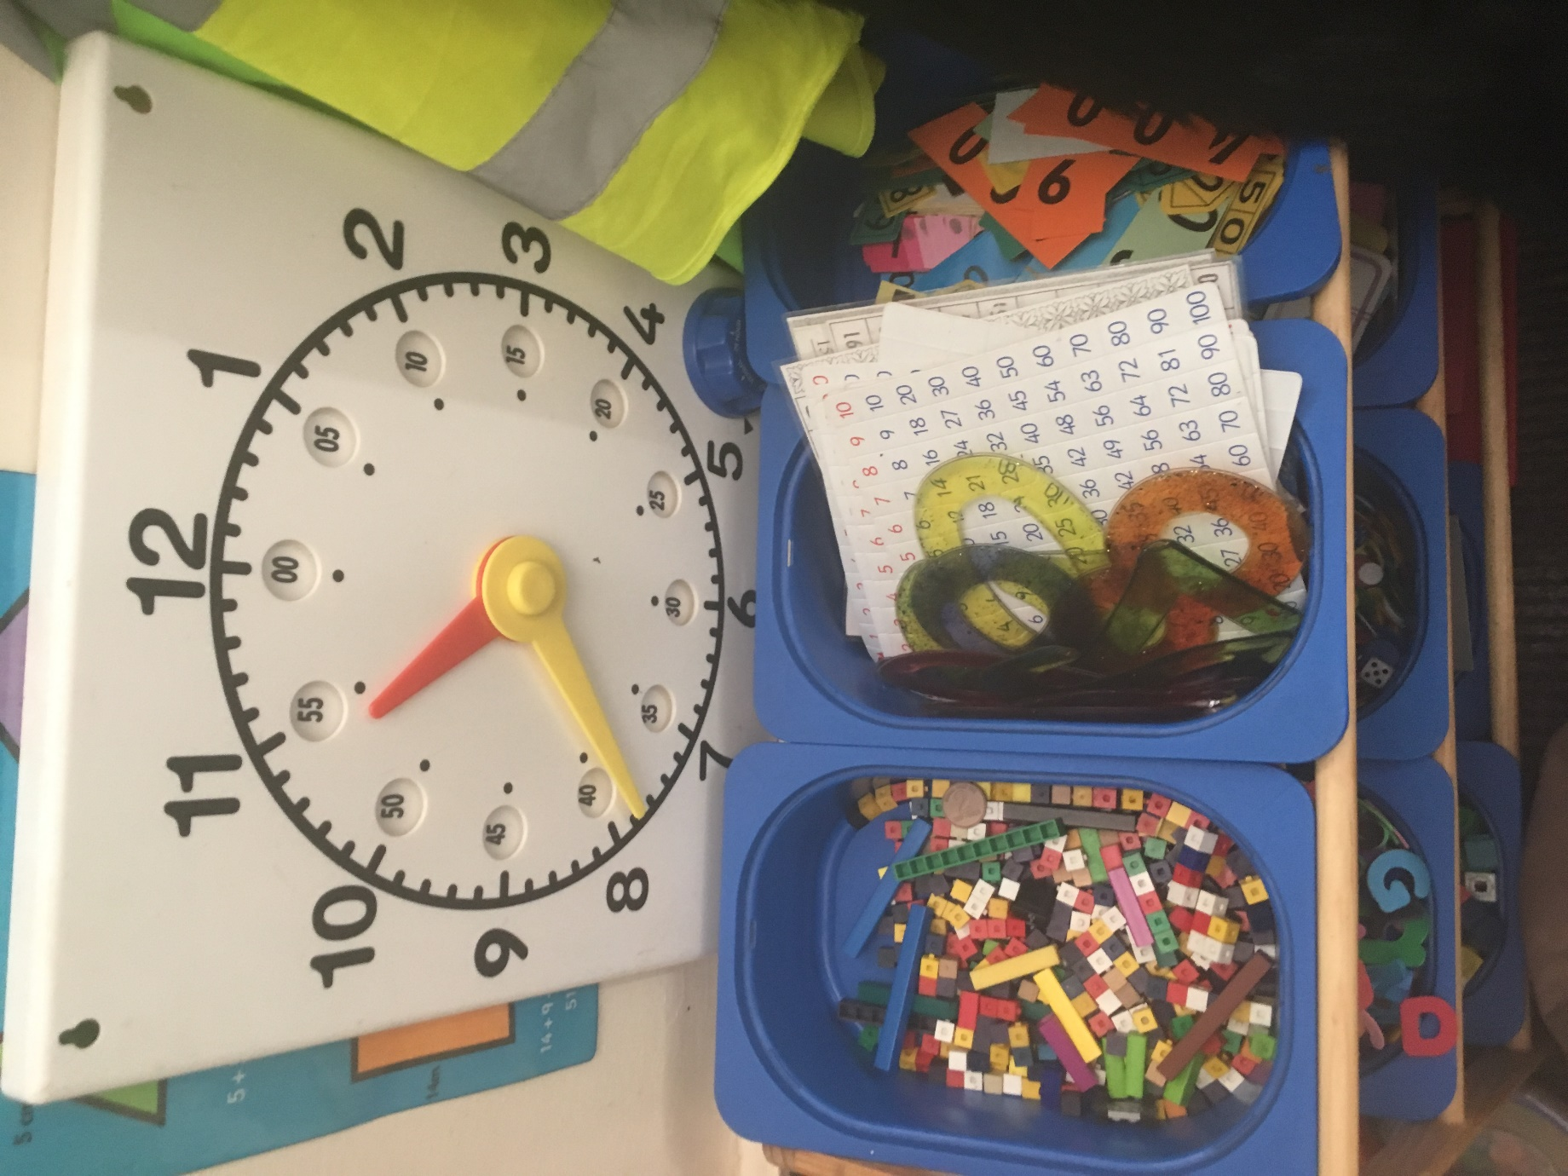

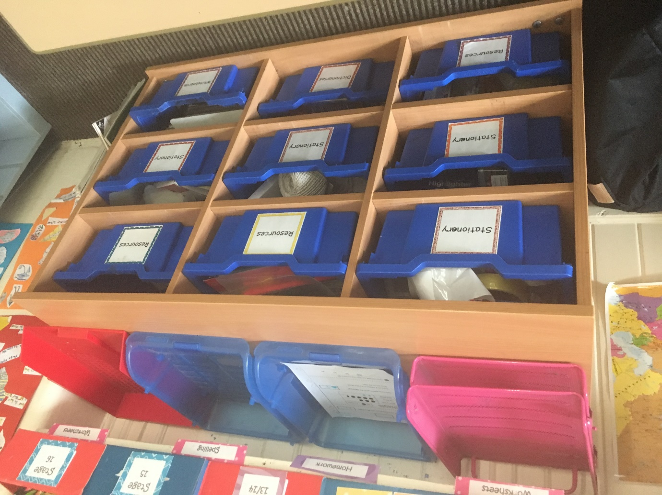

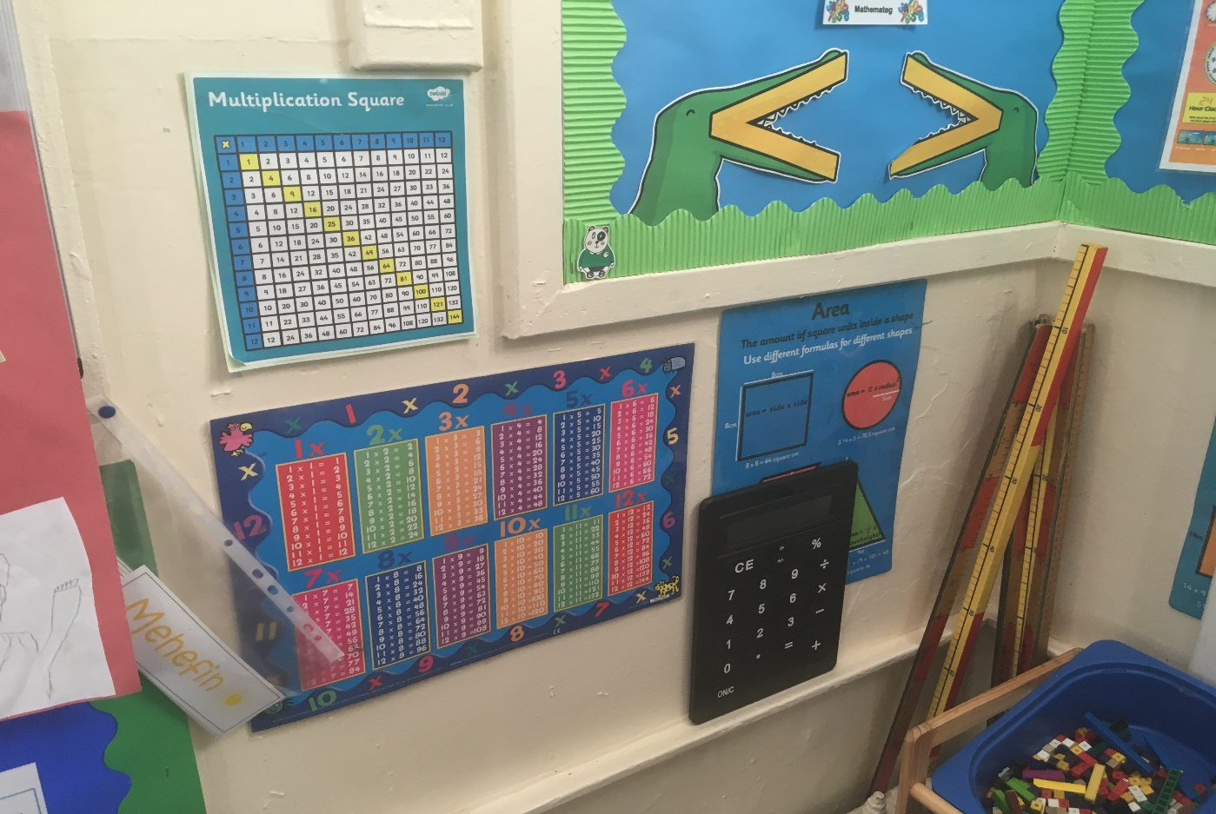
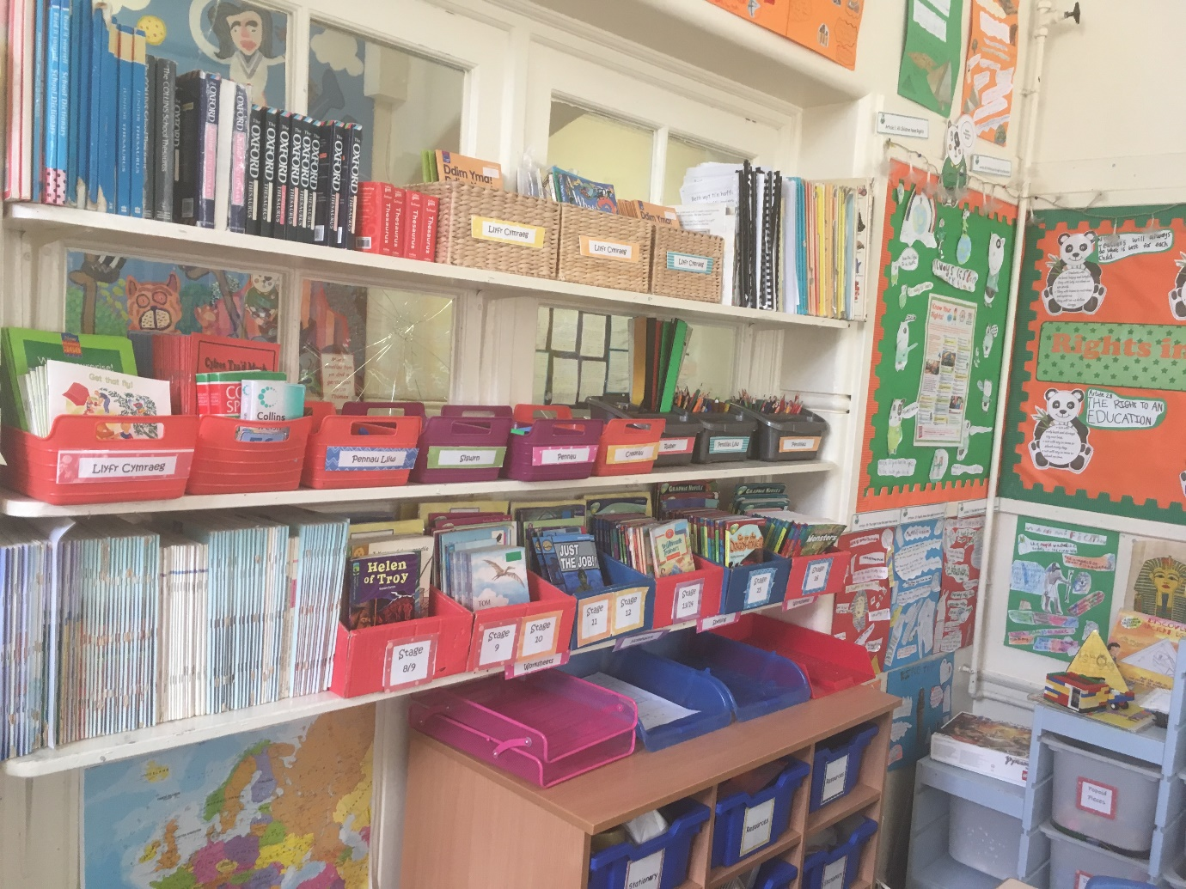

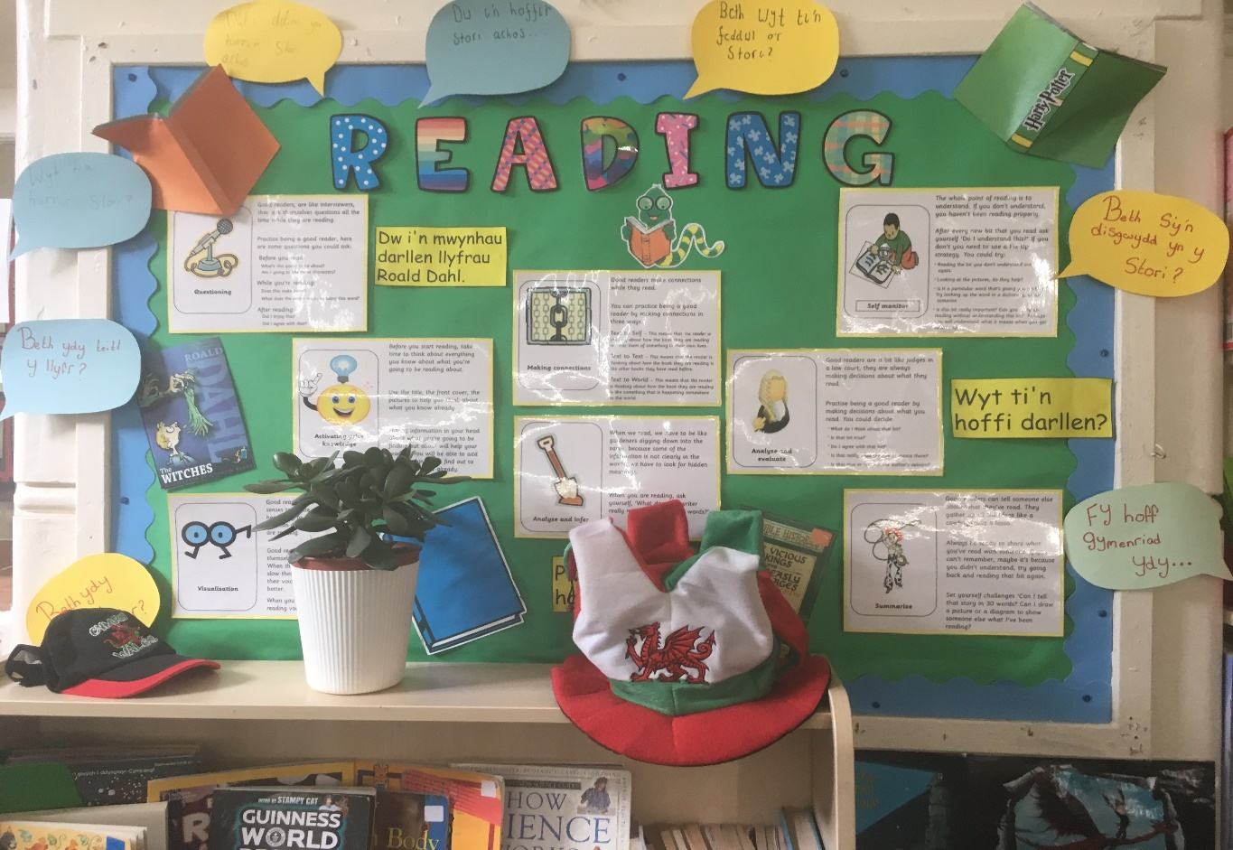
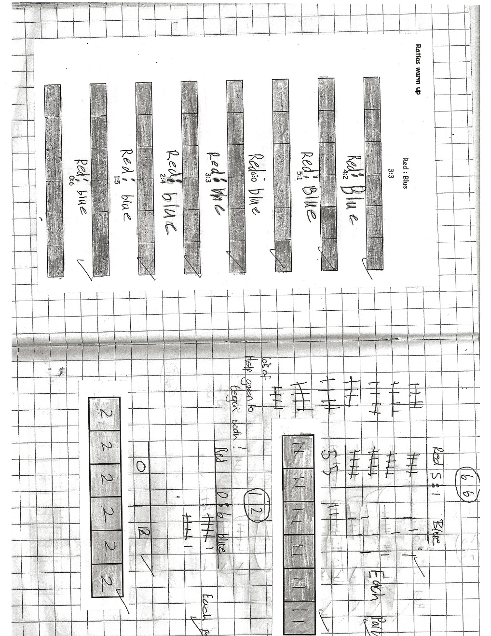
Appendix Five- Maths

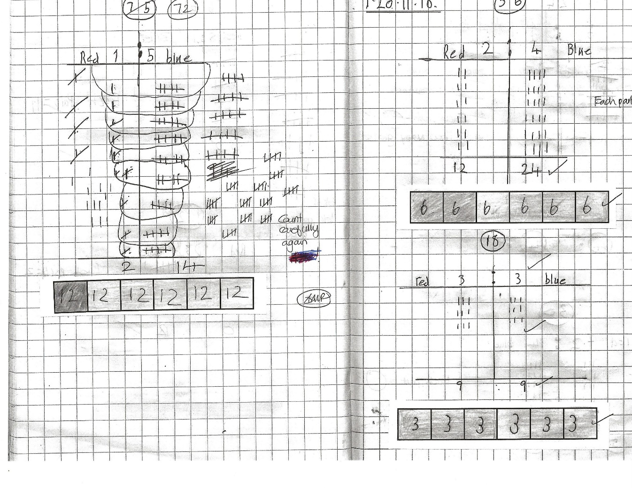

During this observed lesson, the pupil was able use her knowledge of counting on and patterns to show her workings for the ratio scales. However, a little difficulty arose from counting on.

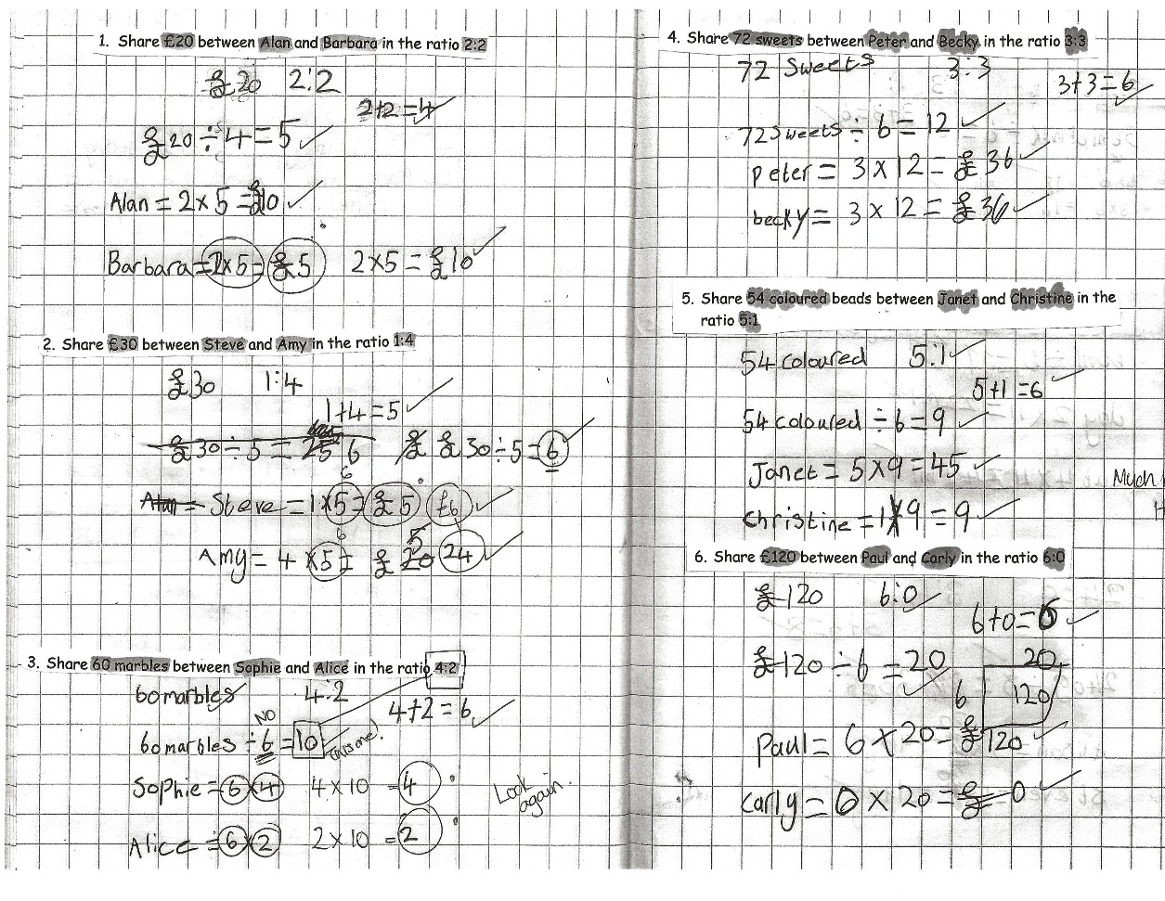

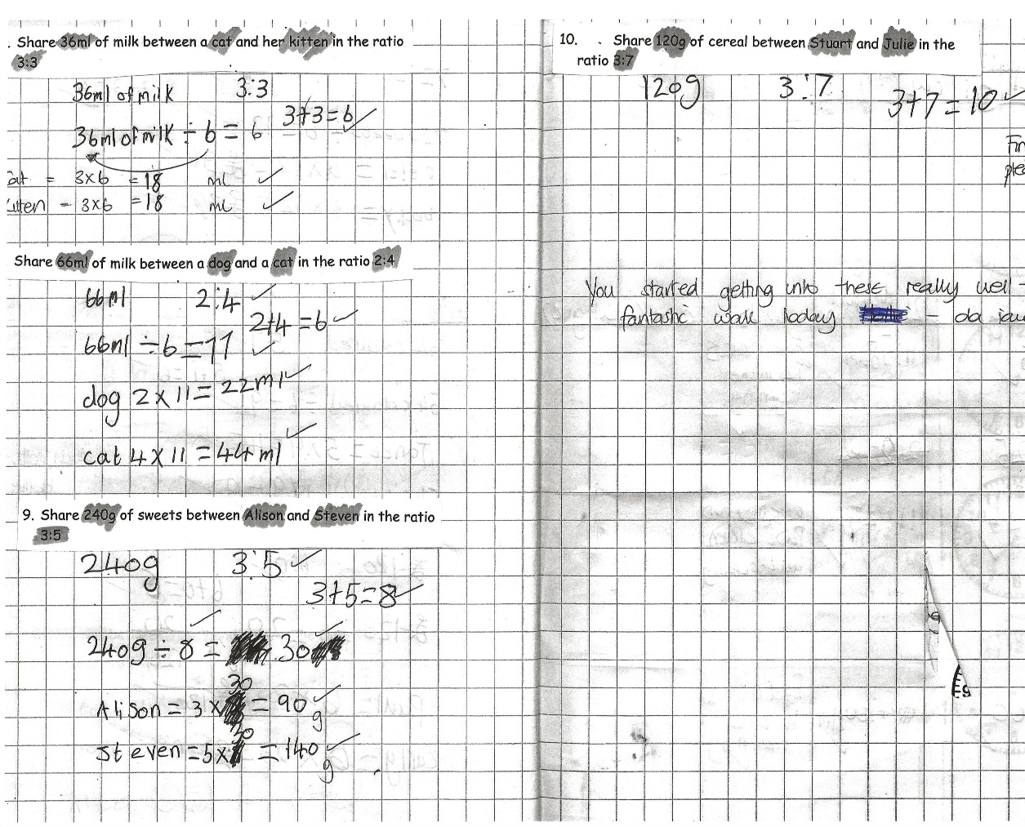

The pupil was able to activate her prior knowledge on the previous lesson and was able to apply it to word problems. The use of multiplication and division was used with times tables.
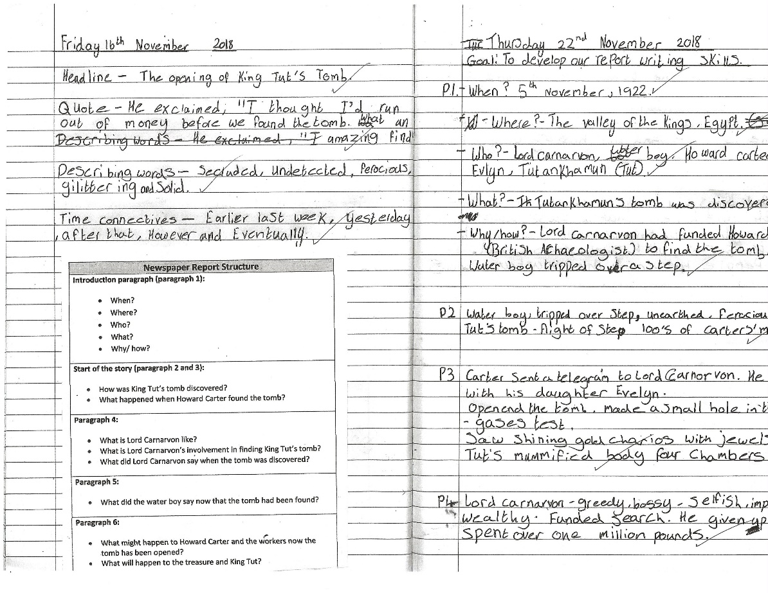
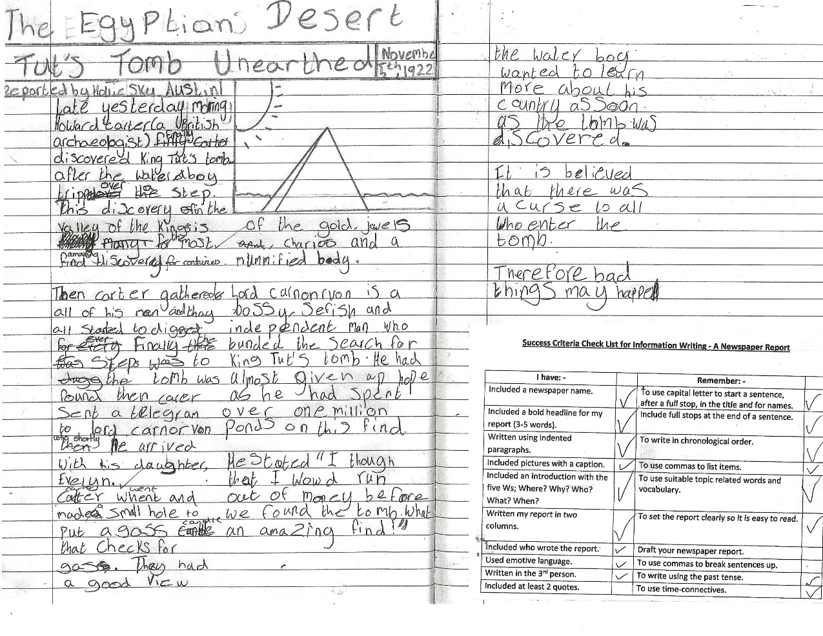
Appendix Six – English
The pupil was able to use a given template to plan independently using the 5 W questions. She was able to work collaboratively to share information.
The pupil was able to use her planning and her success criteria to create her newspaper report. She was able to identify the features needed and ensured she was able to check them as she went along. She achieved the goal but may need a redraft.
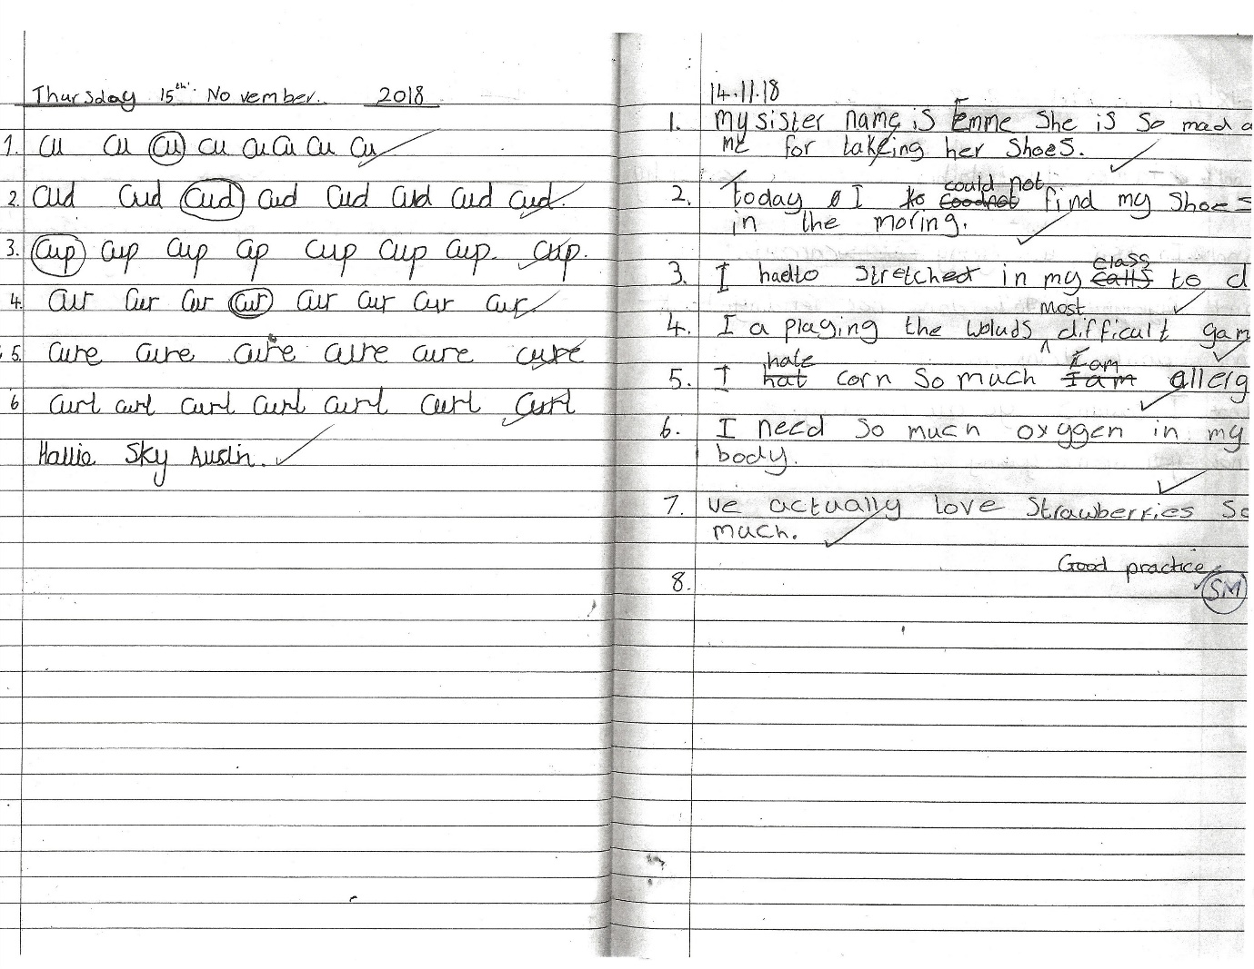
The pupil was able to recognise formation of letters in order to produce joint handwriting. She showed willingness to complete this activity.
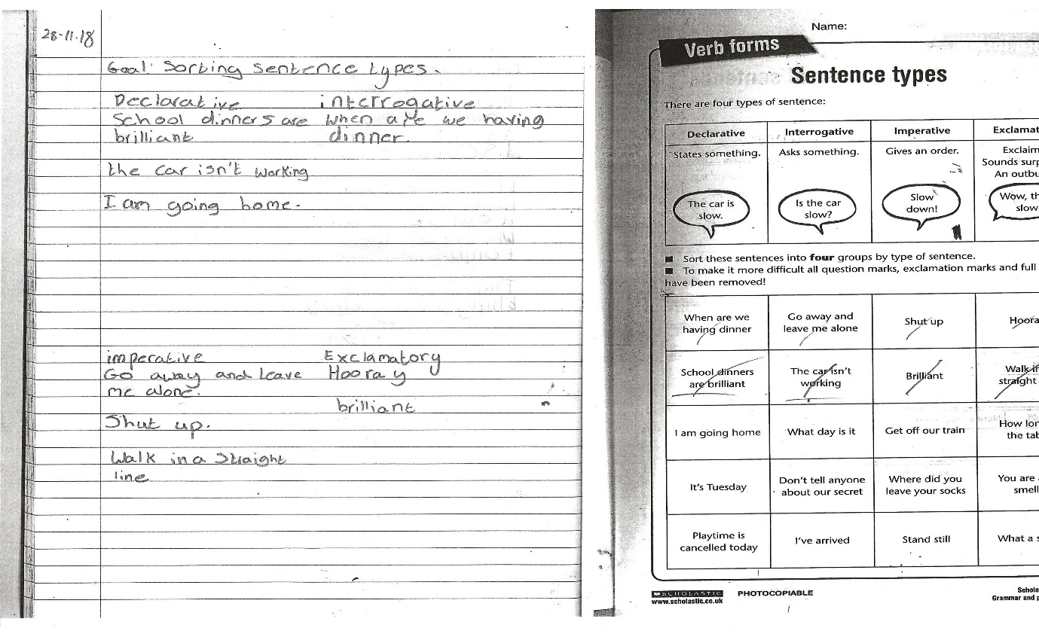
The pupil used her listening skills to listen to the words and the tones that follow in order to categorise them. She had good knowledge of the sentence types but didn’t finish due to talking to peers.
Appendix Seven

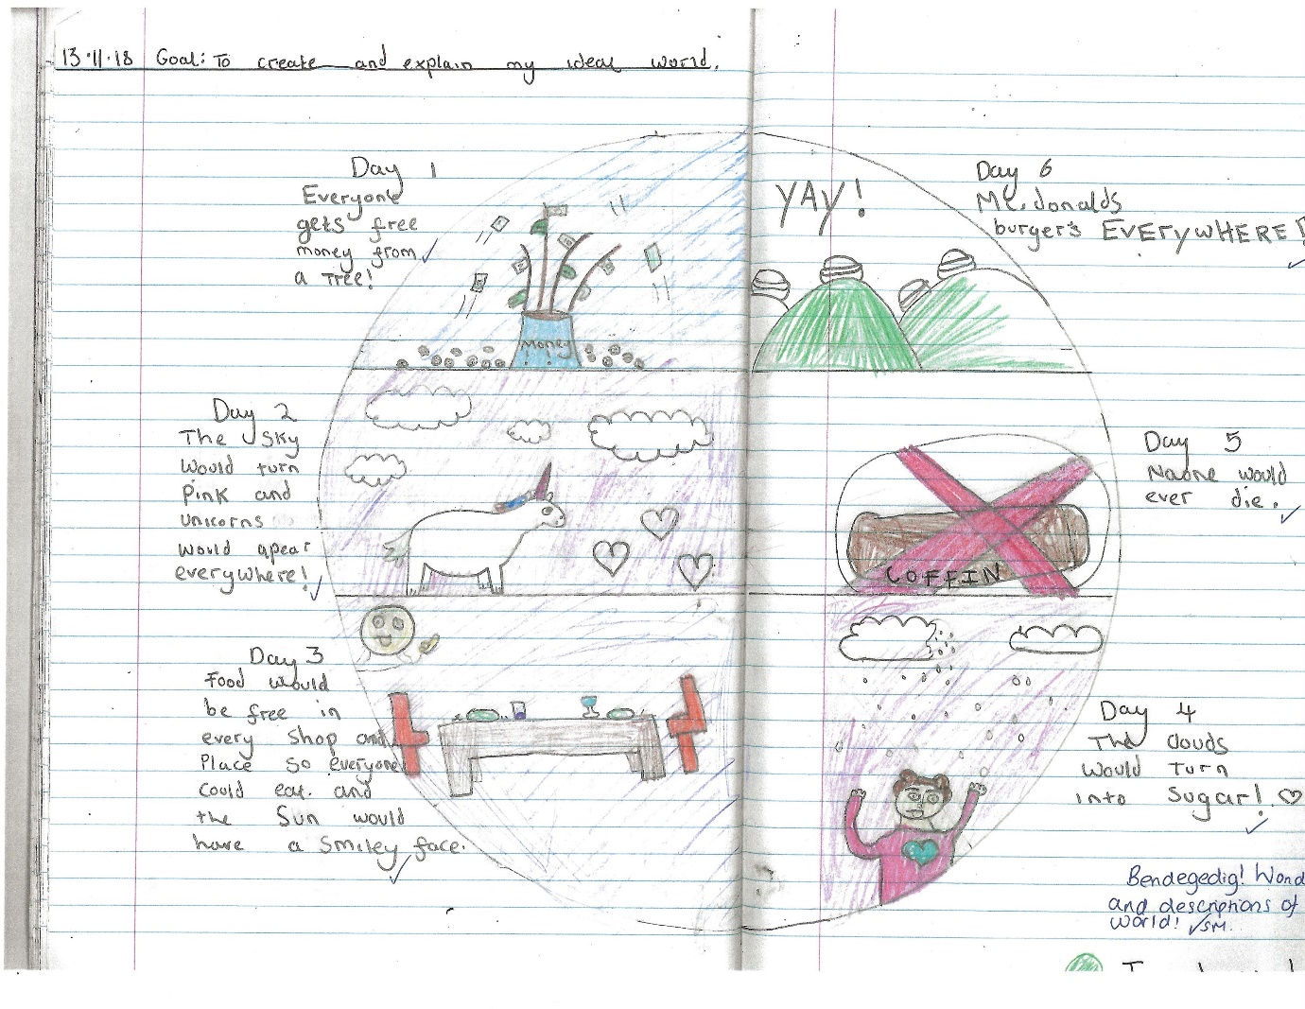
This pupil was able to collaborate in group discussions to discuss an ideal world. She was then able to use her thinking skills to create her own perception of an ideal world to which she described each day.

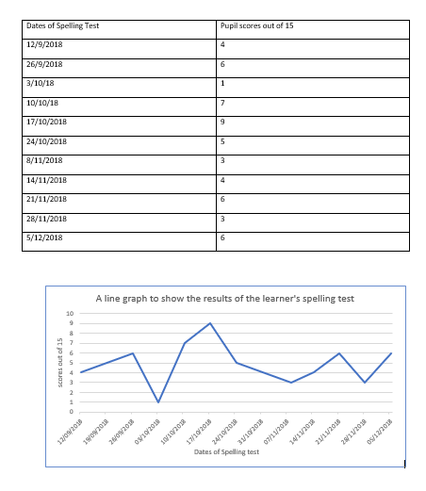
Appendix Eight – Spelling Test results

