DANIEL OPREA ( 2118369 )
DIGITAL SKILLS AND RESEARCH METHODS
( BMSW4003_BIRM)
ABDI RAHMAN

Digital Skills
RESEARCH REPORT



Digital Skills involve the potential and experience of a person to determine the information requirements of digital technology sources.
It is a person's ability to find, use, evaluate, make and share content by applying information technology.
In addition , primary and secondary are considered the main type of research method.
Primary data are entered as information collected through first-hand research. For example: opinion polls, questionnaires or focus group discussions.
Secondary data refers to information that was previously collected by someone else. For example: company reports, newspaper articles and news as well as internet analysis. The main objective of this report is to improve a person's digital skills in the workplace.
This report is based on how to write a professional CV, its advantages , impression, examination and analysis.

Digital skills can be divided into five categories:
1. Information and data management: which consists of an efficient process of searching for information and collecting data. Furthermore, the verification of the veracity of the data, their organization and processing are included.

2. Communication: This is the knowledge needed to communicate properly with other people through digital devices. They can be used on social networks, by email or through a website or many other options.

3. Creating digital content: These are the qualities that allow you to create and publish content that we can find on any digital platform. It can be in the form of text, graphics and even programming itself.

4.Safety: This allows users to use digital devices safely, thus avoiding risks and difficulties.

5. Problem solving: these range from the ability to solve technical problems of digital devices to making a web portal more available to users.
Digital skills can be divided into five categories: 1. Information and data management: which consists of an efficient process of searching for information and collecting data. Furthermore, the verification of the veracity of the data, their organization and processing are included. 2. Communication: This is the knowledge needed to communicate properly with other people through digital devices. They can be used on social networks, by email or through a website or many other options. 3. Creating digital content: These are the qualities that allow you to create and publish content that we can find on any digital platform. It can be in the form of text, graphics and even programming itself. 4.Safety: This allows users to use digital devices safely, thus avoiding risks and difficulties. 5. Problem solving: these range from the ability to solve technical problems of digital devices to making a web portal more available to users.

Every element of life has been transformed by technology, including interpersonal interactions, business, the entertainment industry, and even education. Today, more than ever, students appear to be confronted with developments that not only drastically impact the way they learn, but also their daily lives. It's impossible to dispute that current technologies have had a significant impact on the education of new generations of students. Children have grown up with computers, tablets, other gadgets, and complex digital systems, so they are well prepared for the modernisation of education. In light of this, the importance of technology in education becomes especially clearer. Learning methods have changed over time, as a new technology with the potential to improve education have been steadily introduced.

Educational technology is the application of advanced technologies, such as software and hardware, to aid modern teaching methods. Pupils and teachers will have access to a variety of digital and instructional materials, facilitating reciprocal cooperation and making it easier for students to grasp the issue. As a result of this new strategy, changes have happened at all levels of education, from elementary school to college.
The improvement of the learning experience is intimately linked to student needs and life habits. Because they utilise social media, the Internet, and video games on a regular basis, children want the information to be given in a similar manner at school. The lesson's material should be visual and engaging, grabbing the students' attention and containing information.
It goes without saying that teachers must be aware of their students' needs, how they communicate with one another, and what may be done to stimulate their interest in the educational issue. Young people will want to use their knowledge for educational purposes rather than foster intergenerational strife. Surprisingly, contemporary technologies and educational approaches also benefit instructors, as many areas of their duties have been simplified.
It will include a hypothesis (a presumption that must be present in order for it to be tested as true or incorrect), as well as an argument.

Technology's main purpose is to make jobs easier and to address many of humanity's problems by bringing together tools to stimulate the creation, use, and information sharing. As technology evolves and makes our lives easier, we must emphasise how helpful it is to our lives.
People's communication, learning, and thinking are all influenced by technology. It makes a contribution to society and has an impact on how people interact on a daily basis. Technology is extremely important in today's world. It has both positive and negative effects on the environment, as well as an immediate impact on people's lives.

Thanks to technology, students have access to a wealth of internet resources, which motivates them to conduct research and therefore become more self-sufficient. It also facilitates learning by making concepts more palatable, such as by using an instructional film.

While I believe that technology is largely accepted, I believe that there are still some misunderstandings and concerns; yet, students and instructors are comfortable using it in the classroom. Phones may be extremely distracting in the classroom, and teachers may struggle to get their students to put them down. Teachers, on the other hand, can use their phones to check on their pupils' work, providing rapid comments or simply checking in. Because technology is no longer new and can be found everywhere, the notion was that it would be widely accepted, despite its misconceptions and concerns. The idea is that because technology has become such a vital part of everyone's day-to-day lives and people rely on it substantially, students and professors in the educational sphere (university, college, or school) are confident in using technology to cooperate.

The question's hypothesis was that, despite its misconceptions and concerns, technology is widely accepted since it is no longer new and can be found everywhere. The idea is that because technology has become such a vital part of everyone's day-to-day lives and people rely on it substantially, students and professors in the educational sphere (university, college, or school) are confident in using technology to cooperate.

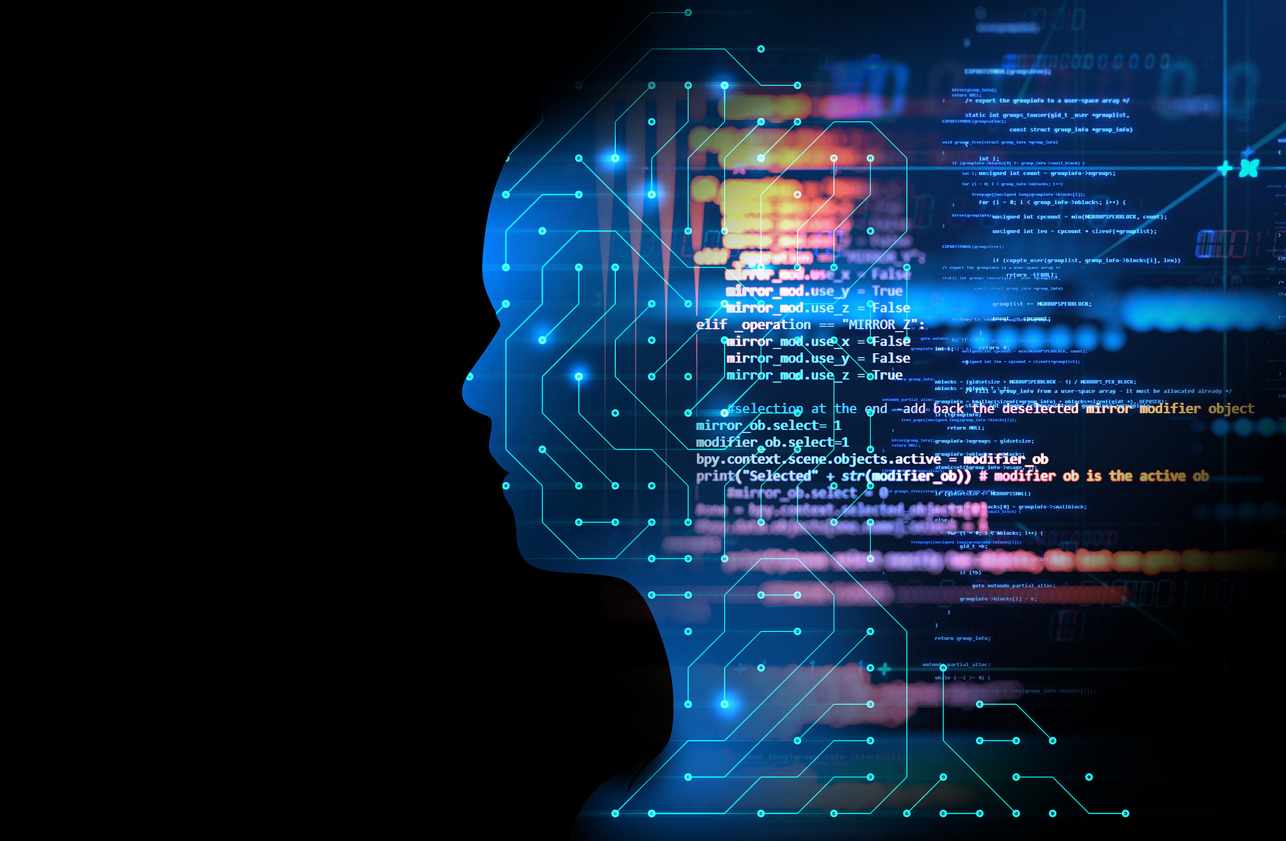

To support or refute the question, secondary and primary research were chosen. Secondary research, often known as desk research, is a type of research that relies on data that has already been collected. Existing data is gathered and summarised to improve the research's overall effectiveness. Find out much you can about Secondary research is research that has been published in research reports and other comparable papers. These materials can be obtained, among other places, in public libraries, on websites, and in data from previously completed surveys. Some government and non-government organisations can also retrieve data and use it for research. On the other hand, primary research is defined as a process in which researchers collect data directly rather than relying on data from previous studies. In a technical sense, they "own" the data. Primary research is conducted with the goal of solving a specific problem that necessitates in-depth inquiry.
We used primary research, and because there are many different types of primary research methods to choose from, I chose questionnaires with closed questions that are multiple-choice because they are quick and easy, and because I realised that people aren't going to stand there and complete a 20-minute write-up on anything, so quick and easy, so basically five minutes would get me the answers I want, and comparison with secondary research.

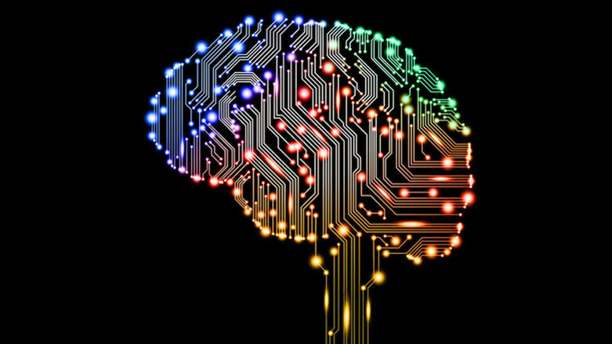

Students and staff are comfortable utilising technology to interact because it was created to communicate in order for relationships to survive and thrive. As a result, regardless of whether it was used for good or bad, everyone acquired confidence in using it. Teachers, in their role as educators, offer encouragement, criticism, thought, and opportunities. They employ technology to assist their students with chores or assistance outside of college, university, or school hours, and they instil confidence in their pupils, as I previously indicated. People have grown accustomed to having technology because it is now so widely available and freely distributed.

