

LOCATION: Swansea | LLEOLIAD: abertawe
LEVEL 7 | LEFEL 7
EXAMINATION PERIOD | CYFNOD ARHOLIADAU
JANUARY 2022 | IONAWR 2022

MODULE CODE: ACCA7029
COD Y MODWL: ACCA7029
ENTERPRISE CORE NETWORKING
TIME
3 HOURS (including uploading all the work on Moodle)

answer ALL quESTIONs

Equipment or materials required – None
Adnoddau neu ddefnyddiau sydd eu hangen - Dim

ANSWER ALL QUESTIONS

- With a use of a topology
  - Explain the importance of STP protection mechanisms. (12 marks)
STP: Spanning Tree Protocol
The function of STP is to prevent redundant links in the bridge network from forming loops.

STP can be applied to the establishment of tree topology in computer networks. Its main function is to prevent redundant links in the bridge network from forming loops.

However, certain factors can cause STP to fail, and troubleshooting may be very difficult, depending on the network design. The spanning tree protocol is suitable for the network equipment of all manufacturers. There are differences in configuration and functional strength, but the principles and application effects are the same.

  - Design a best suiting network topology to accommodate static route, floating static route and static null routes. Justify your design with appropriate network details. (13 marks)

Static routing is a way of routing in which routing entries are manually configured rather than dynamically determined. Unlike dynamic routing, static routing is fixed and will not change, even if the network status has changed or is reconfigured. Generally speaking, static routing is added to the routing table item by item by the network administrator.

Static routing:
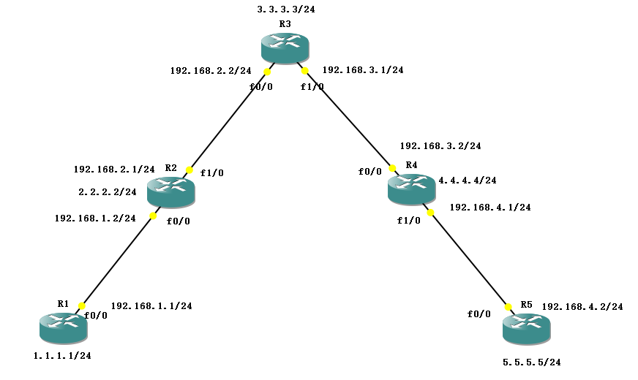

Static floating route:

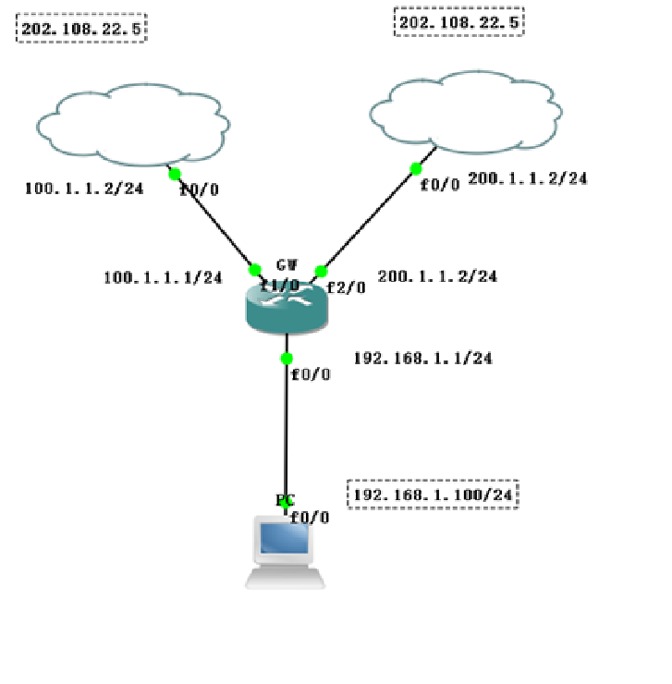

PC(config)#int f0/0
PC(config-if)#ip add 192.168.1.100 255.255.255.0
PC(config-if)#no sh
PC(config-if)#ex
PC(config)#no ip routing
PC(config)#ip default-gateway 192.168.1.1
//Specify the default gateway of the device host as 192.168.1.1

172.16.1.0/24
172.16.2.0/24
172.16.3.0/24 172.16.0.0/22
But at this time, it will be summarized into one more 172.16.0.0/24
As a result, if there are data packets to be sent to this network segment, routing black holes will result.

Ip route 172.16.0.0 255.255.252.0 192.168.1.2
Ip route 172.16.0.0 255.255.255.0 null 0 (lead to an empty interface, no longer issued)

ip route 0.0.0.0 0.0.0.0 192.168.1.2 [*default route/default route]
The final strategy of the router.

Ip route 0.0.0.0 0.0.0.0 A.B.C.D ip routing
Ip default-gateway A.B.C.D no ip routing
Ip default-network A.B.C.D ip routing

- Briefly explain
  - Route Summarization in EIGRP. (5 marks)
EIGRP route summary
EIGRP supports automatic summarization and manual summarization at any point
1. Automatic summary
It is turned off by default in some IOS

Suppress detailed routing (component routing components)
A black hole route with an outgoing interface of null 0 is formed locally, and the management distance is 5
Only valid for its own direct route
Summarize to the main class boundary
When summarizing, try to specify the metric value of the summary route to minimize the impact of component routing changes and convergence

  - Discuss common OSPF Optimization techniques. (7 marks)
Ways to speed up the rapid convergence of OSPF
1. Neighbor's hello and dead interval time, the command is ospf timer hello interval by default 10s 40s
2. Set the SPF calculation interval, spf-schedule-interval {interval1 | millisecond interval2 }, (default 5 seconds), shorten the interval between two SPF algorithm runs to speed up convergence.
3. Configure the update interval of LSA. The command is lsa-originate-interval 0. Specify the update interval of LSA to 0 to cancel the update interval of LSA, so that topology or routing changes can be immediately announced to the network through LSA.
4. Configure the time interval at which LSA is received, the command is lsa-arrival-interval 0, and the time interval at which LSA is received is specified as 0, so that topology or routing changes can be immediately perceived.
5. To reduce the delay time of LSA transmission on the interface, the command is ospf trans-delay interval.

The OSPF router sends out an LSA, with the topology change, and the SPF algorithm processes all routers in the area.

  - Explain the LSA types in OSPF (8marks)
There are 11 types of OSPF LSAs, but there are 6 types of LSAs commonly used, namely 1, 2, 3, 4, 5, and 7. Therefore, the following mainly describes the commonly used 6 types of LSA.

The 11 types of LSA types are:

- Router LSA (RouterLSA): Every router in the area will be advertised. Describe the direct link status information of the router. Only pass in this area and will not exceed the ABR.

- Network LSA (NetworkLSA): A network LSA notification is generated by a DR in a multi-access network. Describe the router connected to it including the DR router itself

- Network summary LSA (Networksummary LSA): originated by ABR routers, describing inter-area routes, and used to advertise destination addresses outside the area.

- ASBR summary LSA (ASBRsummary LSA): It is initiated by the ABR router. The content of the advertisement is an ASBR router. For LSA5

- Autonomous system external LSA (Autonomous system external LSA): also called external LSA (ExternalLSA), originating from ASBR routers, used to advertise LSAs to destinations outside the OSPF autonomous system or default routes outside the OSPF autonomous system. Flooding in the entire autonomous system.

- Group membership LSA (Groupmembership LSA): used in multicast OSPF protocol (MOSPF).

- NSSA External LSA (NSSAExternal LSA): Refers to the LSA advertisements originating from ASBR routers (inside the non-pure stub area) in the non-pure stub area, and it is flooded only in the non-pure stub area where the LSA originated. The ABR in the non-pure peripheral area can convert this type of LSA to LSA5, and then flood the backbone area.

- BGP external attributes LSA (External attributes LSA for BGP): is proposed as another option for running the internal BGP protocol (iBGP protocol), once used to transmit BGP protocol information through an OSPF domain.

9．Opaque LSA (local link range) (opaqueLSA): is a proposed type of LSA, consisting of a standard LSA header followed by information about special applications.

- Opaque LSA (local area range) (opaque LSA)

- Opaque LSA (AS range) (opaque LSA)

  - Authentication, Authorization and Accounting Framework and its use cases. (5 marks)

Authentication - Enables a user to be identified and verified prior to being granted access to a network device and/or network services.

Authorization - Defines the access privileges and restrictions to be enforced for an authenticated user.

Accounting - Provides the ability to track and log user access, including user identities, start and stop times, executed commands (that is, CLI commands), and so on. In other words, it maintains a security log of events.

- ABC Multinational company is planning on setup its branches in Wales. Initially, they propose to set up two branches (one at Swansea and another at Cardiff). You have been hired as a Network Infrastructure Associate. You are asked to lead and successfully complete this new setup. The key objectives of your design must provide

    - Secure scalable network
    - Efficient network manageability
    - High Availability
    - Secured Remote Access

Your answer must address (not limited to) the technical aspects (LAN/WAN design, topology, architecture, choice of devices, redundancy, technologies, implementation, etc) addressing the key objectives including planning, designing, project management, risk assessments, etc (50 marks)

Switched LAN architecture
1. Hierarchical network model
Hierarchical network design needs to divide the network into separate layers. Each layer provides specific functions, which define the role of the layer in the entire network.

(1) The main purpose of the access layer is to provide a method for connecting devices to the network and controlling which devices on the network are allowed to communicate.

(2) The distribution layer first aggregates the data sent by the access layer switch, then transmits it to the core layer, and finally sends it to the final destination.

(3) The core layer is the high-speed backbone of the Internet. The core layer can also connect to Internet resources.

Redundancy: Load Balance
Secured Remote Access: use SSH

Realize internal network VLAN division, three-layer routing function, and enable OSPF routing protocol; virus VPN protection, export realization NAT address translation, the entire network uses starview for network management.

1 R2624 router; core equipment: 1 S68 series (or S65/S35 series equipment), equipped with 2 Gigabit fiber interfaces; aggregation equipment: 2 S3550-24, each equipped with 1 Gigabit fiber interface; access Equipment: 4 sets of S2126G Layer 2 switches: Experimental PC: 8 sets; the default gateway of the end user points to the ip address of their corresponding vlan interface.

The configuration is divided into:
The first step: the basic configuration of network equipment;
The second step: ospf configuration and testing;
The third step: network connectivity test;
The fourth step: Four parts of NAT function test

Diwedd/End

