
Applied Leadership and Management in the Workplace
Module Assignment Submission
Student Name: | Winta Omer
Student Number: | 2238482
Module No: | BMSK4011
Module Title: | Continuous Professional Development

Statement of Confirmation of Authenticity
By the act of making this submission, the student declares that this is the work of the student named above. The work has not, in whole or in part, been knowingly presented elsewhere for assessment, or where assessment has been built on a previous assessment, this has been identified. Where materials have been used from other sources it has been properly acknowledged. If this statement is untrue, the student acknowledges that an assessment offence has been committed.
Attention is drawn to the plagiarism and unfair practice policies of both the University and of ILM.

Table of Contents
Section 1: Know how to identify development needs 3
1.1 Identify learning styles for self and another 3
1.2 Use a simple technique for identifying development needs for self & another 4
1.3 Identify potential barriers to learning for self and another. 5
1.4 Explain how these barriers to learning can be overcome. 5
Section 2: Know how to develop self & others to achieve organisational objectives 6
2.1 Analyse learning/development options to meet needs of self & another. 6
2.2 Identify support mechanisms for the development of self & another 6
2.4 Method used to monitor the development of self & another. 8
References 10
Appendix A Curriculum Vitae 11
Appendix B Continuous Professional Development Record 12

Section 1: Know how to identify development needs

Understanding and identifying development needs is essential for growth in any professional field. It starts with self-reflection, assessing areas for improvement personally and within one’s job role. Feedback from peers and evaluations from management also highlight developmental opportunities (Smithers & Robinson, 2003). Moreover, staying informed of industry changes ensures that skill sets remain relevant. Actively engaging in this multifaceted approach of development need identification is crucial for career advancement and achieving professional goals.

Identify learning styles for self and another

Learning styles refer to the different ways in which individuals prefer to learn and process information. Understanding one's learning style can significantly enhance the effectiveness of studying and acquiring knowledge. According to Honey and Mumford's learning styles model, there are four main types: activists, reflectors, theorists, and pragmatists.
As I have identified myself as a theorist, I enjoy analysing information and understanding the underlying principles. Theorists prefer logical reasoning and systematic approaches when it comes to learning. They thrive on conceptualising ideas and theories before applying them in practice.
On the other hand, my friend Sara is a reflector. Reflectors prefer observing situations from various perspectives before making any judgments or decisions. They enjoy taking their time to think through ideas thoroughly and often seek feedback from others.
Understanding our respective learning styles has allowed us to adapt our study techniques accordingly. As a theorist, I find it helpful to engage in critical thinking exercises such as analysing case studies or participating in group discussions that encourage theoretical debates. As a reflector, Sara benefits from activities that allow her to observe others' perspectives, such as attending workshops or reading reflective journals.

Use a simple technique for identifying development needs for self & another

SWOT Analysis
S W O T My self
STRENGTHS  - Strong analytical and conceptual skills.  - Quick at understanding and applying complex theories.  - Systematic and structured approach. | WEAKNESSES  - Tendency to overthink or focus too much on theory.  - I struggle with practical application at times.  - Sometimes less adaptive to unstructured situations.
OPPORTUNITIES  - Roles requiring strategic planning and theory-based problem-solving.  - Opportunities to engage in research and development.  - Collaborative projects with individuals of complementary styles. | THREATS  - Rapidly changing environments need quick, practical responses.  - Situations where emotional intelligence is as crucial as logical reasoning.

S W O T Person 2 (Sara)
STRENGTHS  - Excellent at thorough analysis and reflection.  - Careful consideration of multiple perspectives.  - Strong in observing and listening. | WEAKNESSES  - Hesitancy in making quick decisions.  - Over-cautiousness leads to delayed actions.  - Less effective in high-pressure situations.
OPPORTUNITIES  - Roles benefiting from risk assessment and detailed analysis.  - Environments valuing thoughtful planning and decision-making.  - Collaborations that allow time for reflection and observation. | THREATS  - Fast-paced scenarios requiring immediate action.  - Environments where her reflective approach may be undervalued.  - Risk of missing opportunities due to slower decision-making.

Gap Analysis
I use a technique called gap analysis to assess my areas for growth, and based on the results, I have been categorised as a theorist. My friend Sara is classified as a reflector. This classification reflects our learning styles and preferences.
As a theorist, my inclination lies in comprehending concepts and theories. I find pleasure in analysing information and uncovering explanations for various phenomena. My drive stems from the desire to explore ideas and concepts, enabling me to develop a profound understanding of subjects. This approach suits me well in settings prioritising critical thinking and problem-solving, aligning with the theories presented by Smith (2021).
On the other hand, Sara's categorisation as a reflector indicates her preference for observation and contemplation before taking action. She enjoys gathering information through observation and reflection before making decisions or forming opinions. Reflectors often take their time to examine situations from different perspectives before reaching conclusions, as Smith (2021) notes in his research.
Understanding our learning styles has allowed us to tailor our development plans accordingly. For instance, as a theorist, I focus on expanding my knowledge base by reading works by theorists within my field of interest. Additionally, attending workshops or seminars that emphasise discussions helps me refine my analytical skills.
As an individual, Sara finds value in engaging in activities promoting self-reflection. For instance, she may keep a journal or participate in group discussions to actively listen to others' viewpoints before articulating her thoughts.

Identify potential barriers to learning for self and another.

Myself
As I pursue my studies in Applied Leadership and Management in the Workplace, I face several unique challenges:
- Language Proficiency: English is my second language, sometimes making understanding complex management theories and concepts more difficult.
- Time Management: Juggling my responsibilities as a parent and working part-time means I have limited time to dedicate to my studies.
- Cultural Differences: Coming from a different cultural background, I find it challenging to relate to specific management practices or case studies based on unfamiliar contexts.
Despite these barriers, I am committed to enhancing my skills and knowledge in Applied Leadership and Management in the Workplace, which is crucial for my career progression.

Sara
For Sara, who is studying nursing, the challenges are slightly different:
- Balancing Work and Studies: As a working mother, Sara has to manage her time meticulously to balance her job, family, and nursing studies.
- Practical Application: Nursing requires a significant amount of practical skills. Finding time for clinical practice sessions alongside theoretical studies is a significant challenge for her.
- Emotional and Physical Exhaustion: The demanding nature of her work and studies in nursing, coupled with family responsibilities, can lead to emotional and physical burnout.
Sara is determined to overcome these obstacles to achieve her dream of becoming a nurse, understanding the importance of this role in healthcare.

Explain how these barriers to learning can be overcome.
To improve language proficiency, engaging in English language courses and practical exercises such as conversing with speakers, reading English literature and participating in English-speaking forums or groups can be helpful. Using language learning apps and watching media can also enhance language skills.
Creating a schedule that sets aside specific times for studying, work and family responsibilities can be beneficial when it comes to time management. Time management tools or apps can assist in keeping track of tasks and deadlines. Additionally, it is essential to communicate with family members and work colleagues about my study needs to create an environment.
To adapt culturally, seek resources that explain management theories in a manner that can provide valuable insights. Engaging in study groups and attending workshops or seminars focusing on cultural management can broaden perspectives and promote better understanding.
For Sara, finding a balance between work, studies, and family is crucial. Setting a flexible study schedule that considers her commitments can be beneficial. Prioritising tasks wisely and potentially reducing work hours may provide time for her studies. It could also involve family members in household responsibilities to lighten the load.
In terms of managing both sessions and theoretical learning, allocating specific times for each aspect of her education will assist Sara in staying organised with her workload. Using simulations or virtual learning tools can be an addition to Sara's nursing education, especially when she cannot attend classes physically.
To manage physical stress effectively, Sara should prioritise taking breaks to prevent burnout. Engaging in mindfulness practices, incorporating exercise into her routine, and ensuring she gets rest are all essential. Seeking support from peers, family members, or counselling services can also greatly assist in managing stress and avoiding exhaustion.

Section 2: Know how to develop self & others to achieve organisational objectives
When they are developing themselves, others play a role in achieving the goals of an organisation. To do it successfully, leaders must possess the skills and knowledge to guide their team members towards success.
Self-development is a process that involves acquiring skills, knowledge, and behaviours to enhance performance. It allows individuals to gain self-awareness, recognise their strengths and weaknesses, and take steps towards growth. When leaders focus on developing themselves, they become role models for their team members, inspiring them to improve.
Moreover, self-development empowers leaders to develop others by providing guidance, support, and growth opportunities. Leaders who invest in the development of their team members create a work environment where individuals feel valued and motivated. They offer feedback on performance, provide tailored training programs or workshops based on needs, and encourage employees to set goals for themselves.
It is crucial to align team goals with objectives. According to Gold et al. (2010), setting SMART goals (Specific, Measurable, Achievable, Relevant Time-bound) ensures effectiveness while aligning with strategies.
Also, as per Gold et al.'s research (2010), effective leadership development requires a combination of training programs and learning experiences gained through practical work situations.
This method enables people to put their gained knowledge into practice in real-world scenarios while receiving feedback from their supervisors or mentors.

Analyse learning/development options to meet needs of self & another.
As a student studying Leadership Management Level 4 and ESOL Level 1 and engaging in self-directed learning, I constantly strive to analyse various learning and development options to meet my needs.
Leadership Management Level 4:
  - I am enrolled in a leadership management course. This helps me understand critical concepts and apply them in real situations.
  - I also use online platforms like Coursera to learn more about specific topics in leadership.
ESOL Level 1:
  - I attend English classes to improve my language skills. These classes focus on basic English, which is what I need.
  - I participate in language exchange groups. This helps me practice speaking English with others.
Self-Directed Learning:
  - I read Books and articles about leadership, and English help me learn at my own pace.
  - I regularly think about what I have learned and how I can use it in my work and daily life.

On the other hand, Sara, who is studying nursing, IT, and self-care, has different learning needs.
Nursing:
  - Sara does hands-on training in hospitals. This experience is essential for her nursing skills.
  - She attends workshops to learn about new nursing methods and tools.
  - She studies with other nursing students. They help each other understand complex topics.
IT Skills:
  - Sara takes online IT courses. These teach her the computer skills needed in nursing.
  - Sometimes, her workplace offers IT training. She always joins these sessions.
Self-Care:
  - Sara practices meditation to stay calm and focused.
  - She exercises regularly. This keeps her healthy and reduces stress.
For both of us, the key is to balance these activities with our other responsibilities. We choose options that fit into our lives and help us grow in our careers and personal development.

Identify support mechanisms for the development of self & another
I understand the importance of support mechanisms in personal and professional development. These mechanisms shape our skills, knowledge, and overall growth.

Myself
Teachers and Study Groups: My teachers give me great advice, and I learn a lot from study groups. We share ideas and help each other understand tough topics.
Language Exchange Partners: I practice speaking English with a language exchange partner. It's a fun and effective way to improve my language skills.
Online Resources: I use online forums and educational websites. They offer lots of information and tips for both leadership management and learning English.

Sara
Nursing Mentors and Teachers: Sara gets a lot of help from her nursing teachers and mentors. They know a lot and always give her helpful advice.
Workplace Support: Her workplace is supportive. They offer training and understand when she needs time for her studies.
Time Management Tools: Sara uses planners and apps to organise her schedule. It helps her balance her work, studies, and family time.

Prepare development plans for yourself and another person
Myself
What do I want to learn? | What do I have to do? | What support and resources will I need? | How will I measure success? | Target Date for Review
Complete all levels of Leadership Management (Level 4 to Level 6). | - Attend all classes and actively participate.  - Complete all assignments and projects.  - Apply theories in practical work situations. | - Course materials and access to learning platforms.  - Feedback from instructors and mentors.  - Study groups for collaborative learning. | Passing each level of the course. | End of each academic term or level.
English Language Proficiency (ESOL Level 1 & 2) | - Enrol in ESOL classes and maintain regular attendance.  - Engage in daily language practice.  - Utilize language learning resources. | - ESOL course materials and instruction.  - Language practice partners or groups.  - Online resources and language apps. | Passing ESOL Level 1 and then Level 2 exams.  Improved communication skills in English. | ESOL Level 1: End of the course or exam date.  ESOL Level 2: Every three months and the end of the course.

Personal Objectives

Short Term Goals (next 12 months)
- Complete Leadership Management Level 4:
  - Successfully finish all coursework and assessments for Level 4.
  - Apply key learnings from the course to real-life scenarios in the workplace.
- Achieve ESOL Level 1 Proficiency:
  - Pass the ESOL Level 1 examination.
  - Engage in regular language practice, including speaking, reading, and writing.
- Begin ESOL Level 2 Preparation:
  - Enrol in ESOL Level 2 upon successful completion of Level 1.
  - Start familiarising myself with Level 2 material and requirements.

Medium Term Goals (2-3 years)
- Progress through Leadership Management Levels 5 and 6:
  - Complete Level 5 in the second year and begin Level 6 in the third year.
  - Continuously apply and refine leadership skills in my professional environment.
- Complete ESOL Level 2:
  - Achieve a passing grade in ESOL Level 2 by the end of the second year.
  - Practice advanced English skills in professional and personal settings.
- Personal and Professional Growth:
  - Develop a network of professional contacts and mentors in my field.
  - Enhance my public speaking and presentation skills.

Long Term Goals (3-5 years)
- Complete Leadership Management Level 6 and Consider Further Education:
  - Successfully finish Level 6 and explore opportunities for higher education or specialised training related to my career.
  - Aim for a leadership or management position that utilises my acquired skills.
- Full Proficiency in English:
  - Achieve English proficiency that allows for seamless communication in professional contexts.
  - Possibly teach or mentor others in English, sharing my learning experience.
- Establish a Strong Professional Identity:
  - Gain recognition in my field through contributions such as projects, leadership roles, or community involvement.
  - Continuously update and refine my skills to stay relevant in my industry.

Person 2
What do I want to learn? | What do I have to do? | What support and resources will I need? | How will I measure success? | Target Date for Review
Basic IT Skills Relevant to Healthcare | Attend all nursing classes and participate actively.  Complete all assignments and practical training. | Access to nursing textbooks and resources.  Guidance from nursing instructors. | Passing grades in all nursing courses.  Demonstrated skills in practical sessions. | End of each semester/academic term.
Basic IT Skills Relevant to Healthcare | Enrol in basic IT courses specifically designed for healthcare professionals.  Practice using healthcare IT systems. | IT course materials.  Access to healthcare IT software for practice. | Successful completion of IT courses.  Ability to efficiently use healthcare IT systems. | End of IT course duration.
Advanced IT Skills for Nursing | After basic IT skills, enrol in advanced courses or workshops.  Apply these skills in practical nursing scenarios. | Advanced IT training programs.  Support from IT professionals in healthcare. | Proficiency in advanced healthcare IT applications.  Positive feedback on IT usage in nursing settings. | Every six months, for a progress check.

Personal Objectives

Short Term Goals (next 12 months)
Do well in her first year of nursing school.
Learn basic computer skills needed for nursing.

Medium Term Goals (2-3 years)
Graduate from her nursing program.
Improve her IT skills for things like patient records.

Long Term Goals (3-5 years)
Pass her registered nurse test and start working.

2.4 Method used to monitor the development of self & another.
I have embraced techniques recommended by Cottrell (2015) to keep track of my growth. One practical approach that I will employ is self-reflection. Cottrell (2015) highlights the significance of reflecting on our actions and behaviours to identify improvement areas. By evaluating my leadership management skills and ESOL learning, I can recognise any weaknesses or areas that require development.
Additionally, seeking feedback from others plays a role in monitoring development. Actively seeking input from mentors, peers, or supervisors provides insights into areas where improvement is necessary. This feedback enables me to make adjustments and continue progressing.
Another technique I plan to utilise is setting SMART goals, as proposed by Doran (1981). SMART stands for Specific, Measurable, Achievable, Relevant and Time-bound. By establishing measurable and attainable goals within a defined timeframe, I can monitor my progress effectively and ensure that I am moving in the right direction towards personal growth. This approach keeps me motivated while providing a sense of direction on my path of self-improvement.
Lastly, maintaining a journal has proven invaluable in monitoring my development. Regularly documenting my thoughts, experiences, and accomplishments allows me to track my progress effectively. This brings back memories of my progress and inspires me to continue striving.
In conclusion, keeping track of our development and that of others for growth and success is crucial. By engaging in practices like introspection, setting goals, seeking feedback from others, and maintaining a journal, we can effectively monitor our progress towards achieving our objectives.

References

Honey P., & Mumford A., (1992). The Manual of Learning Styles (3rd ed.). Maidenhead: Peter Honey Publications Ltd.

Smith, J.D. (2021). The Importance of Understanding Learning Styles in Personal Development. Journal of Personal Growth 45(2), 78–92.

Gold, J., Thorpe, R., & Mumford, A. (2010). Leadership and Management Development. CIPD Publishing.

Cottrell S. (2015). Skills for Success: Personal Development and Employability. Palgrave Macmillan.

Doran G.T. (1981). "There is a S.M.A.R.T. way to write management's goals and objectives." Management Review, 70(11), 35–36.

Megginson, D., & Whitaker, V. (2007). Continuing Professional Development. Chartered Institute of Personnel and Development.

Smithers, P., & Robinson, S. L. (2003). Identifying Development Needs: The Importance of Employee Involvement at All Levels. Journal of European Industrial Training, 27(9), 422-431. doi.org/10.1108/03090590310499298

Appendix A: Curriculum Vitae
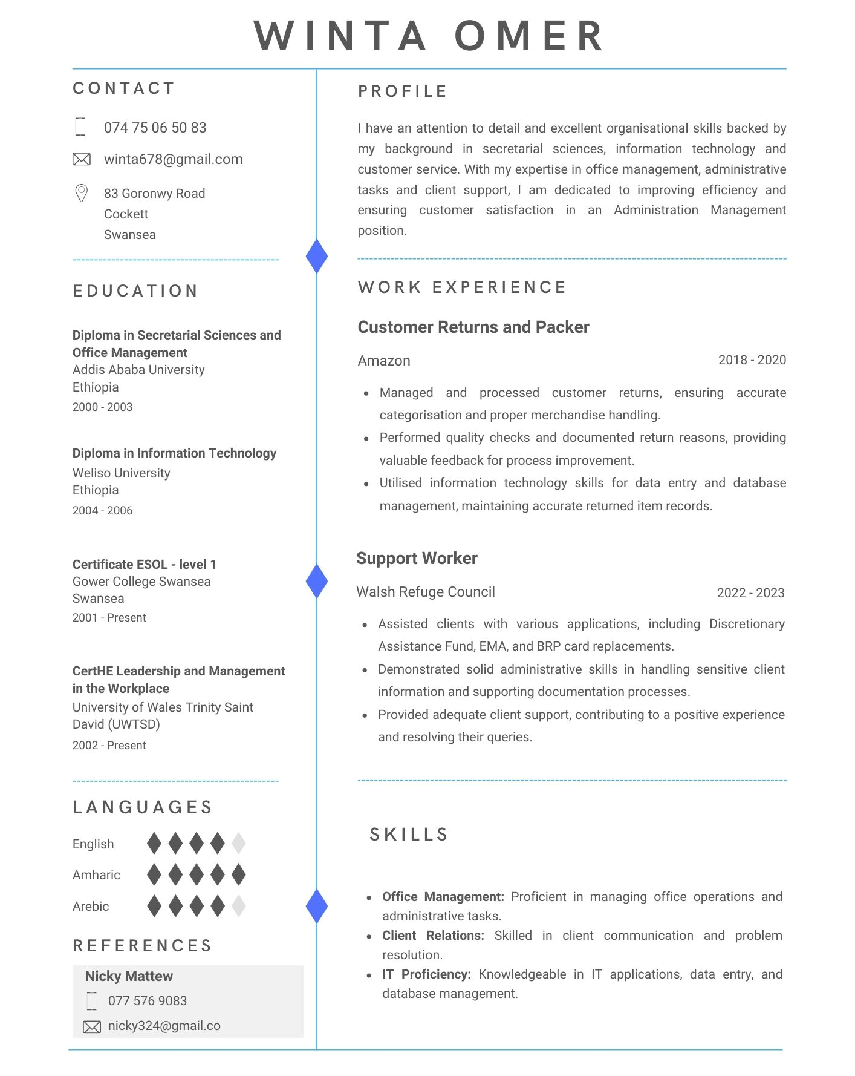

Appendix B Continuous Professional Development Record

Appendix B: Continuous Professional development plan (Megginson & Whitaker, 2007)
Continuous Professional development plan - Winta Omer
Formal learning and development | Informal learning and development | Start date | End date | Duration | Status | Details
CertHE Leadership and Management in the Workplace |  | Jan-2023 | Present | One year | In Progress | Studying Leadership and Management theories and their practical applications at UWTSD.
ESOL Level 1 |  | Sep-2001 | Present | Four years | In Progress | English language studies aimed at enhancing proficiency for professional and personal communication.
Psychologically Informed Environments Training |  | 12/07/2023 | 18/07/2023 | Two days | Scheduled | Training is designed to understand and create environments considering psychological principles in practice.
Healthy relationships |  | 25/10/2023 | 25/10/2023 | Two hours | Scheduled | Short training on building effective health relationships at Gower College Swansea.

