Data Management (Design)
Contents
Normalisation 2
UNF 2
1NF 3
2NF 4
3NF 5
Determinacy Diagram 6
Construct Tables 6
Report 8
Introduction 8
Entity Relationship Diagram 8
Invoice Table 8
Customer Admission Table 9
Student Admission Table 9
Tournament Admission Table 9
Customer Table, Customer Age Table, Customer Parent table 10
Tournament and Tournament Level Tables 10
Appendix 11

Report

Introduction
This report will be based on the various tables and diagrams that have been completed. The various diagrams and tables are as followed; Normalisation tables, from UNF to 3NF, there is a determinacy diagram with construct tables and finally there is an ERD (Entity Relationship Diagram). Each of these diagrams and tables will show something different but are all based on the same premise and have all been built and designed for the same reason, this is to help a swimming club called Shark Attack. Each diagram and table will be explained and will be dissected so the reader can understand what is happening and why everything is the way it is in the table.

Normalisation
Normalisation has been used for making all the information more readable with as little redundancy as possible. With UNF there is no normalisation happening jus the barebones idea for what information might go into what tables. As you can see the information is all scattered with no real pattern emerging. The normalisation will help with this and will make sense of the mess.
With the 1NF all the tables have been vastly shortened so that all the information is only entered once, this will stop redundancy. Also with 1NF the primary keys for each table have also been highlighted. With NF2 each table has got their own primary key set up, this is evident by the “_ID”.
Finally, with 3NF all the tables have been completed with primary keys, secondary keys and fields. These tables have been designed so that they will all communicate with one another, this is done by the primary and secondary keys relating to and from each table. The primary keys are in bold, while the foreign keys for each table are in italics.

Determinacy Diagram
Appendix 1 shows the determinacy diagram. This diagram was made from the use of normalisation and the use of the construct tables. As you can see from the construct tables, each table has been implemented into the determinacy diagram and also shows what information each table outputs.
As you can see all the tables have been linked together as well, for example with the customer table, customerage table and customerparents table all of them are all connected in the same box as they all share the same information. This is a theme among the determinacy diagram and works in the same way the Pool table and the PoolBooking table as well. If each table shares the same information then they will be linked together in the same box.
The determinacy diagram also shows what information the user can input into each table. This is done by the use of arrows pointing out of each table. An example of this would be from the customer table; the customer table shows the information “Customer Name” and “Customer Email Address”. These items will be turned into various fields within the database and will allow the user to enter any information that is needed into the diagram. All the information is also linked together on the diagram by the use of arrows. It shows what fields will link to other fields and other tables, an example of this would be from the Tournament table to the TournamentAdmission table.

Entity Relationship Diagram
On the ERD there are fifteen different tables all holding different information. These tables all link together to create an information system that will have information to be entered in correctly and with little, to no, redundancy.

Appendix 1 shows the entire ERD, this is mainly just to show that all the tables have fields, primary keys, foreign keys, relationships with labels and how the information will flow from one table to the next.

Invoice Table
Appendix 2 shows the table called Invoice. This table has the primary key called Invoice_ID this is because if there is a need to call an Invoice then that particular invoice will need to have a unique ID to distinguish it from any other ID there might be.

This particular invoice has three foreign keys and they are the CustomerAdmission_ID, StudentAdmission_ID and TournamentAdmission_ID. These are all needed in the invoice table as the company needs to know how much money it will be gaining from anyone gaining admission either as a student/customer or to/from a tournament.

This table also shows that there are three different tables connecting to it. These tables are the CustomerAdmission table, StudentAdmission table and the TournamentAdmission Table, respectively. From the relationships on the table all the connectors are “One and only one” and the reasoning behind this is that there only one result from the connecting tables are going into the Invoice Table. This is also to show that there will be one invoice for a customer gaining admission, a tournament admission and a student admission.

Customer Admission Table
Appendix 3 shows the table called CustomerAdmission. This table will hold all the information relating to a customer gaining admission to the swimming club. The primary key for this table is called CustomerAdmission_ID because when someone gains admission into the swimming club then that person needs to be recorded and have a unique ID in case any queries are going to be made.

This table has two foreign keys and one unique field. The reasoning behind this table having the two foreign fields is because this table needs information from the two other tables, these are the Customer table and the Pool table, and as the information going into this table is needed in most of the table it also stops any redundancy issues that might happen. The unique field for this table is called CustomerAdmission_Fee and will be used to record the amount of money the customer used to gain entry into the pool. This information will also be used in the Invoice table, as explained above.

Student Admission Table
Appendix 4 shows the table called Student Admission. This table, acts a lot like the CustomerAdmission Table and the TournamentAdmission table. This is because they all serve the same purpose just with a slight tweak. In this case the table holds the information for a Student gaining admission into the swimming club.
This table holds one primary key, one foreign key and one regular field. The primary key is called StudentAdmission_ID, this is the same reason as the CustomerAdmission_ID in the CustomerAdmission table. The foreign key is called Student_ID and holds any information related to the student, i.e. the name, the class etc and will therefore bring any student information into this table. The unique field name is called StudentAdmission_Fee and works in the same way as the CustomerAdmission_Fee in the CustomerAdmission table – it will record any money being used for the student gaining access to the swimming club.

Tournament Admission Table
Appendix 5 shows the table called Tournament Admission. This table, is also like the other two admission tables and will serve the same purpose but for Tournament admission information. This table has one primary key, one foreign key and two unique fields.

The primary key is being used for any querying, much like every other table in this ERD. The foreign key is from the Tournament table and will carry over information from that table into this one. Finally, the two unique fields are called TournamentAdmission_Travel and TournamentAdmission_Fee, respectively. These fields will be used to track any money being used for travel to a tournament and any money being used to enter a specific tournament.

Customer Table, Customer Age Table, Customer Parent table
Appendix 6 shows the tables called Customer, CustomerAge and CustomerParent. The reason that these are all in one screenshot is because they all complement each other and are needed to complete each other.

The Customer table hold information from the CustomerAge table and, by default, the CustomerParent table as well. This is because they are all sharing the information relating to a customer and the age of the customer. The age is important as it is specifically specified in the brief that there needs to be a way for customers who are under eighteen to get into the swimming club and this is where the table CustomerAge and CustomerParent work.

The Customer table has a primary key called Custoemr_ID and will be used to track a customer. The foreign key is called CustomerAge_ID and links to the CustomerAge table. The unique field is called CustomerName and will be used to track the name of a customer.

The CustomerAge table carries over the information from the Customer table and adds the customers age to the information. This table has a primay key called CustomerAge_ID and two foreign keys called Customer_ID and CustomerParent_ID.

The CustomerParent table holds the information from the customer’s parent, if under eighteen. This table has the primary key called CustomerParent_ID and a field called CustomerParent_Name, this is used to track the customer’s parent’s name.

Tournament and Tournament Level Tables
Appendix 7 shows the tables Tournament and Tournament Level. The reason that these tables are together are because the Tournament Level table takes information from the Tournament table and vice versa.

The tournament table takes information relating to the student and the pool tables, this is because there are foreign keys called Student_ID and Pool_ID. These are needed in this table as the tournament will need information relating to the students and the pools. The tournament table has two fields called Tournament_Name and Tournament_Location, these hold the tournament name and the tournament location information, respectively.

The tournament Level table will give the tournament table the information relating to the tournament level which is only the ID of the tournament, this is shown by the TournamentLevel_ID primary key and with the Tournament_ID foreign key.

Pool Table and Pool Booking Table
These tables are also together in the same way that the Tournament and Tournament Level tables are grouped together.
The Pool table will allow the customer to input and store any information relating to the pool. This will include, as can be seen in appendix 9, that this infomraiton will be the location of the pool, the name of the pool and the pool booking ID. This is shown through the use of the field names. This table will be linked with the PoolBooking table and this is done by the use of the secondary key being used that will link these tables together to stop any redundancy.
The PoolBooking table will take information from the Pool table; this is done by the use of the foreign key. The PoolBooking table will also allow the user to input the date of the pool being booked, any time the pool has not been booked and the date that the pool has been booked. All of these have been implemented by the use of the fields.

Tournament Table and TournamentLevel Tables
Appendix 10 shows the tables Tournament and TournamentLevel. These tables are all relating to the tournament information.
The tournament table shows the information that the user will enter relating to the tournament. This information is going to be the name and the locations of the tournament. There are going to be fields named these respectively. This table also takes information from the student tables and pool tables. This is done by the use of the foreign keys.
The tournament level table only has foreign keys. This is because the information coming into this table will be from other tables. The information will be coming from the tables called “Tournament” and “Class”. These tables will make all the information that this table needs.

Coach Salary Table
Appendix 11 shows the coach salary table. The coach salary table will allow the user to insert any information relating to paying the coaches. This will include the information such as the information of the amount of days the coach has been working and the last time the coach got paid.This information will be entered into the following fields; CoachSalary_workingDays and CoachSalary_PayDate.
There is one foreign key and that is CoachID. This is done because it relates all the information relating to the coach. This information will include the coaches name etc, see the Coach table for more information.

Student Table, Coach Table and Class Table
Appendix 12 shows the tables Student, Coach and Class. These tables are all relating to the a student and that is why they are all grouped together here.
The student table has the information relating the student, this will include the information from other tables e.g. the Customer table which is done through the use of the primary key and the relationship from that table. There will also be the class foreign key which is used to show what class the student will be and/or is in at the current time. The student table also allows the user to input the student’s current level of swimming. This is done by the use of the field name called StudentLevel.
The class table will borrow information from the coach table and the student table. This is done through the use of foreign keys, e.g. CoachID and StudentID respectively. This is done so the information will be easily found on the table and because then there will be no to minimal data redundancy. There are also two fields on this table. These fields are called ClassLevel and ClassName. This information will be passed onto the Student and Coach tables as these are needed to show what level and what class the student is in currently.
The Coach table has information from the class table and the pool table. The reason that there is no foreign key for the student table is because the information is already being sent to the Class table. This means that there is no need for the data to be sent to the table twice. There is also a field called CoachName and this is just for the entry of the coaches name and to track who the coach is, this will also be done with the primary key as well.

Normalisation

UNF
Customer Name, Customer Age, Parent Name, Customer Name, Customer Email Address, Parent Email Address, Customer Name, Pool Name, Pool Location, Pool Name, Pool booking date, Pool Booking time booked, Pool booking time free, coach name, coach, class level, class name, customer Name, Customer Email Address, Customer Name, Pool Name, Pool Location, Customer Admission Fee, Customer Name, Customer Email Address, Student Level, Class level, class name, coach name, class level, class name, coach name, class level, class name, Customer Name, Pool Name, Pool Location, Customer Name, Customer Email Address, Student Level, Class Level, Class Name, coach name, class level, class name, Pool Name, Pool Location, Customer Name, Customer Email Address, Student Level, Customer Name, Customer Email Address, Student Level, Class level, class name, coach name, class level, class name, Coach Name, Class Level, Class Name, coach name, class level, class name, Customer Name, Pool Name, Pool Location, Coach Name, Class Level, Class Name, coach name, class level, class name, Customer Name, Pool Name, Pool Location, Coach Salary working days, coach salary pay date, Tournament Name, Tournament Locations, Customer Name, Customer Age, Parent Name, Customer Name, Customer Email Address, Parent Email Address, Customer Name, Pool Name, Pool Location, Tournament Name, Tournament Locations, Customer Name, Customer Age, Parent Name, Customer Name, Customer Email Address, Parent Email Address, Customer Name, Pool Name, Pool Location, Class Level, Class Name, coach name, class level, class name, Pool Name, Pool Location, Customer Name, Customer Email Address, Student Level, Customer Name, Customer Email Address, Student Level, Class level, class name, coach name, class level, class name, Tournament Name, Tournament Locations, Customer Name, Customer Age, Parent Name, Customer Name, Customer Email Address, Parent Email Address, Customer Name, Pool Name, Pool Location, Tournament Admission travel, tournament admission fee, Customer Name, Customer Email Address, Student Level, Class level, class name, coach name, class level, class name, coach name, class level, class name, Customer Name, Pool Name, Pool Location, Customer Name, Customer Email Address, Student Level, Student Admission Fee, Customer Name, Customer Email Address, Customer Name, Pool Name, Pool Location, Customer Admission Fee, Tournament Name, Tournament Locations, Customer Name, Customer Age, Parent Name, Customer Name, Customer Email Address, Parent Email Address, Customer Name, Pool Name, Pool Location, Tournament Admission travel, tournament admission fee, Customer Name, Customer Email Address, Student Level, Class level, class name, coach name, class level, class name, coach name, class level, class name, Customer Name, Pool Name, Pool Location, Customer Name, Customer Email Address, Student Level, Student Admission Fee

1NF
Customer Name, Customer Email Address, Customer Age, Parent Name, Parent Email Address.
Customer Name, Pool Name, Pool Location, Pool Booking date, Pool Booking time booked, Pool booking time free, coach name, coach class level, class name.
Customer Name, Customer Email Address, Pool Name, Pool Location, Customer Admission Fee.
Customer Name, Customer Email Address, Student Level, Class level, class name, coach name, Pool Name, Pool Location
Class Level, Class Name, coach name, class level, class name, Pool Name, Pool Location, Customer Name, Customer Email Address, Student Level
Coach Name, Class Level, Class Name, Customer Name, Pool Name, Pool Location
Coach Name, Class Level, Class Name, Customer Name, Pool Name, Pool Location, Coach Salary working days, coach salary pay date
Tournament Name, Tournament Locations, Customer Name, Customer Age, Parent Name, Parent Email Address, Pool Name, Pool Location
Tournament Level, Tournament Name, Tournament Locations, Customer Name, Customer Age, Parent Name, Customer Email Address, Parent Email Address, Pool Name, Pool Location, Class Level, Class Name, coach name, class level, class name
Tournament Name, Tournament Locations, Customer Name, Customer Age, Parent Name, Customer Email Address, Parent Email Address, Pool Name, Pool Location, Tournament Admission travel, tournament admission fee.
Customer Name, Customer Email Address, Student Level, Class level, class name, coach name, Pool Name, Pool Location, Student Admission Fee
Customer Name, Customer Email Address, Pool Name, Pool Location, Customer Admission Fee, Tournament Name, Tournament Locations, Parent Name, Parent Email Address, Tournament Admission travel, tournament admission fee, Student Level, Class level, class name, coach name, Student Admission Fee

2NF
Customer_ID, Customer Name, Customer Email Address, Customer Age, Parent, Name, Parent Email Address.
Pool_ID, Pool Location, Pool Name, Pool Booking, Pool Booking date, Pool booking time booked, Pool booking time free.
CustomerAdmission_ID, Customer Name, Customer Email Address, Pool Name, Pool Location
Student_ID, Student Level, Customer Name, Customer Email Address, Class level, class name, coach name, Pool Name, Pool Location
Class_ID, Class Level, Class Name, coach name, class level, class name, Pool Name, Pool Location, Customer Name, Customer Email Address, Student Level
Coach_ID, Coach Name, Class Level, Class Name, Customer Name, Pool Name, Pool Location
CoachSalary_ID, Coach Name, Class Level, Class Name, Customer Name, Pool Name, Pool Location, Coach Salary working days, coach salary pay date
Tournament_ID, Tournament Name, Tournament Locations, Customer Name, Customer Age, Parent Name, Parent Email Address, Pool Name, Pool Location
TournamentLevel_ID, Tournament Level, Tournament Name, Tournament Locations, Customer Name, Customer Age, Parent Name, Customer Email Address, Parent Email Address, Pool Name, Pool Location, Class Level, Class Name, coach name, class level, class name
TournamentAdmission_ID, Tournament Name, Tournament Locations, Customer Name, Customer Age, Parent Name, Customer Email Address, Parent Email Address, Pool Name, Pool Location, Tournament Admission travel, tournament admission fee.
StudentAdmission_ID, Customer Name, Customer Email Address, Student Level, Class level, class name, coach name, Pool Name, Pool Location, Student Admission Fee
Invoice_ID, Customer Name, Customer Email Address,Pool Name, Pool Location, Customer Admission Fee, Tournament Name, Tournament Locations, Parent Name, Parent Email Address, Tournament Admission travel, tournament admission fee, Student Level, Class level, class name, coach name, Student Admission Fee

3NF
Customer_ID, CustomerName, Customer_EmailAddress
CustomerAge_ID, Customer_ID, CustomerParent_ID
CustomerParent_ID, CustomerParent_Name, CustomerParent_EmailAddress
Pool_ID, PoolLocation, PoolName
PoolBooking_ID, Pool_ID, Coach_ID, PoolBooking_Date, PoolBooking_TimeBooked, PoolBooking_TimeFree,
CustomerAdmission_ID, Pool_ID, Customer_ID.
Student_ID, Customer_ID, Class_ID, StudentLevel
Class_ID, Coach_ID, Student_ID, Class_Level, Class_Name
Coach_ID, Class_ID, Pool_ID, CoachName
CoachSalary_ID, Coach_ID, CoachSalary_workingDays, CoachSalary_PayDate
Tournament_ID, Student_ID, Pool_ID, Tournament Name, Tournament Locations
TournamentLevel_ID, Tournament_ID, Class_ID
TournamentAdmission_ID, Tournament_ID, TournamentAdmission_Travel, TournamentAdmission_fee.
StudentAdmission_ID, Student_ID, StudentAdmission_Fee
Invoice_ID, CustomerAdmission_ID, StudentAdmission_ID, TournamentAdmission_ID

Determinacy Diagram

Construct Tables
Table: Customer
Customer(Customer#, Customer Name, Customer Email Address)

Table: CustomerAge
CustomerAge(CustomerAge#, Customer#, CustomerParent#)

Table: CustomerParent
CustomerParent(CustomerParent#, CustomerParent Name, CustomerParent Email Address)

Table: Pool
Pool(Pool#, Pool Location, Pool Name)

Table: PoolBooking
PoolBooking(PoolBooking#, Pool#, Coach#, PoolBooking_Date, PoolBooking_TimeBooked, PoolBooking_TimeFree)

Table: CustomerAdmission
CustomerAdmission(CustomerAdmission#, Pool#, Customer#)

Table: Student
Student(Student#, Customer#, Class#, Student Level)

Table: Class
Class(Class#, Coach#, Student#, Class Level, Class Name)

Table: Coach
Coach(Coach#, Class#, Pool#, Coach Name)

Table: CoachSalary
CoachSalary(CoachSalary#, Coach#, CoachSalary working days, CoachSalary Pay date)

Table: Tournament
Tournament(Tournament#, Student#, Pool#, Tournament Name, Tournament Locations)

Table: TournamentLevel
TournamentLevbel(TournamentLevel#, Tournament#, Class#)

Table: TournamentAdmission
TournamentAdmission(TournamentAdmission# Tournament#, TournamentAdmission Travel, TournamentAdmission Fee)

Table: StudentAdmission
StudentAdmission (StudentAdmission#, Student#, StudentAdmission Fee)

Table: Invoice
Invoice(Invoice#, CustomerAdmission#, StudentAdmission#, TournamentAdmission#)

Appendix
Appendix Number | Image
1 | 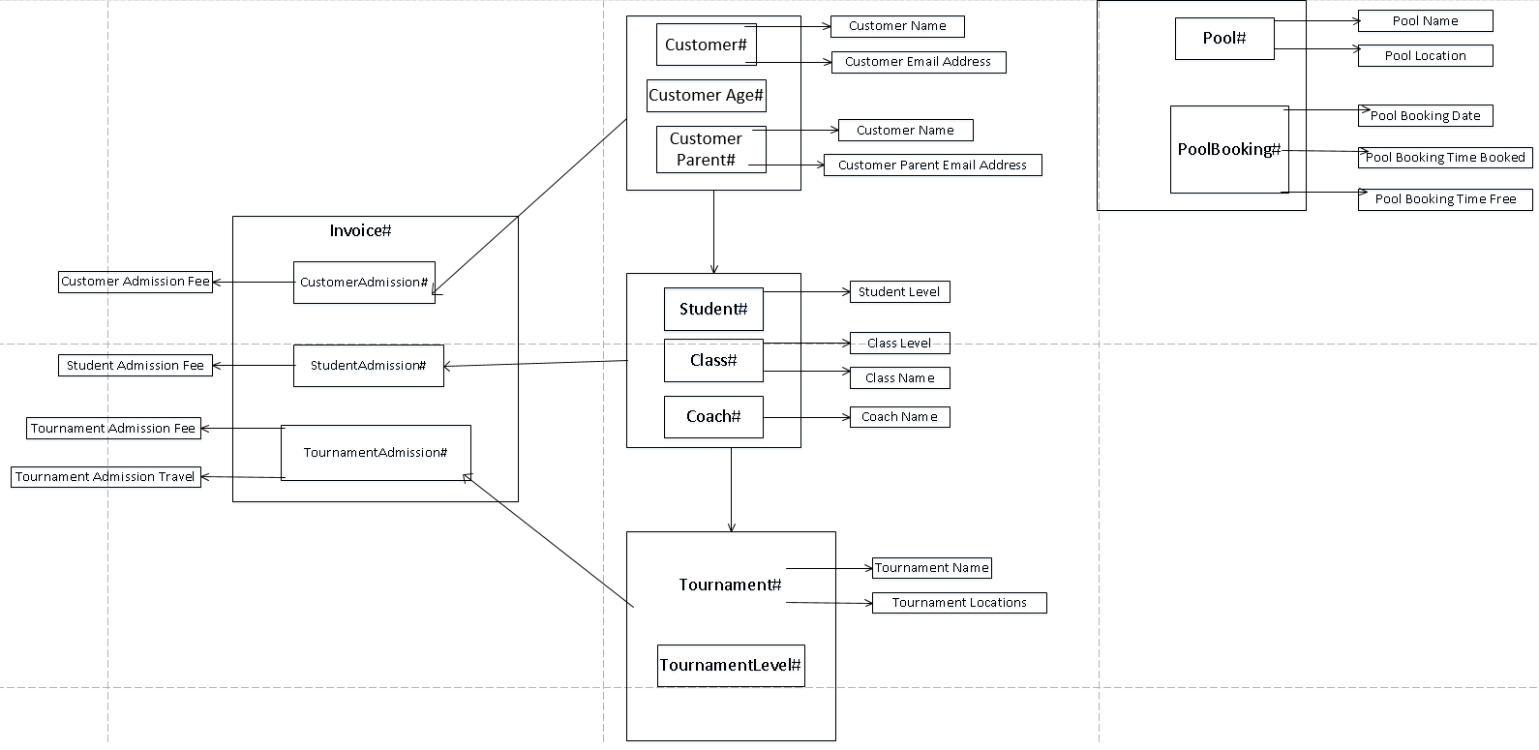
2 | 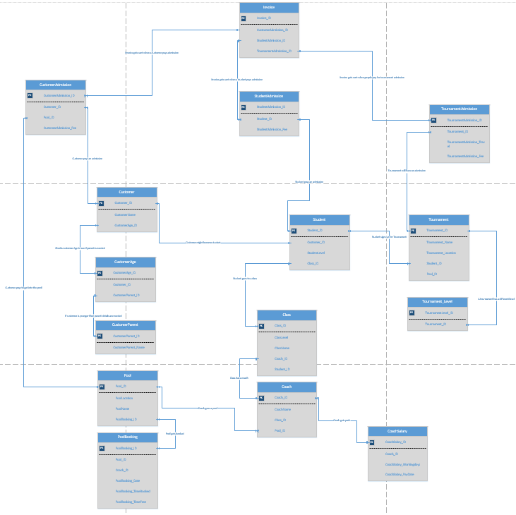
3 | 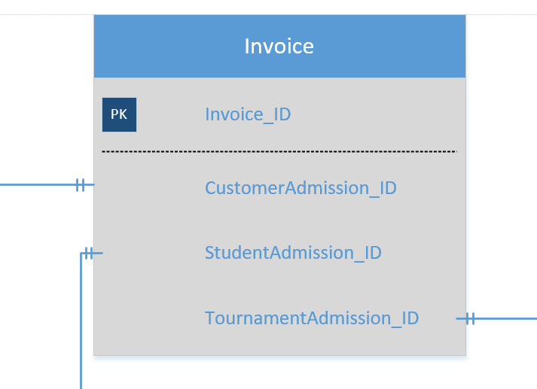
4 | 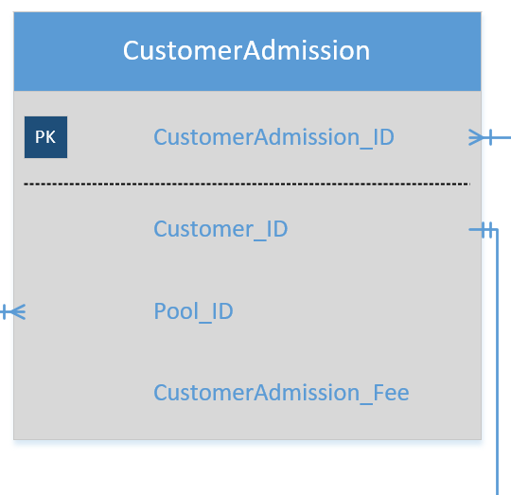
5 | 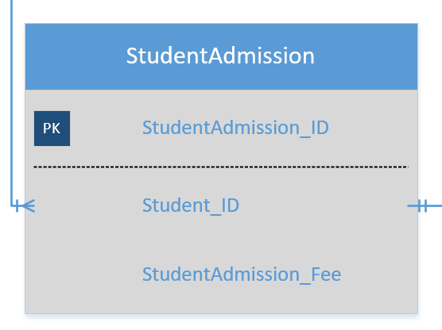
6 | 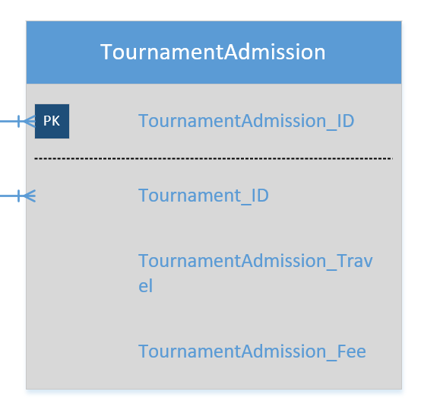
7 | 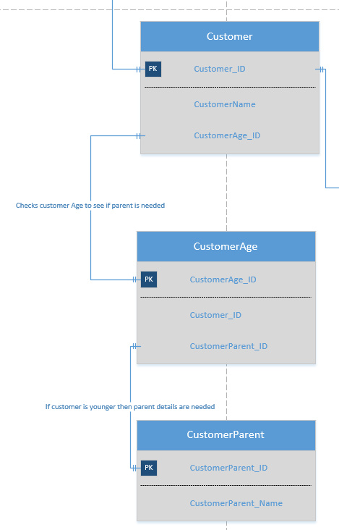
8 | 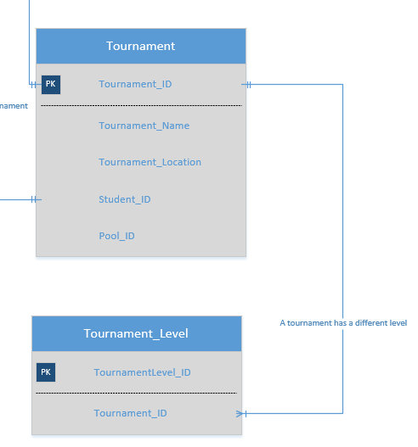
9 | 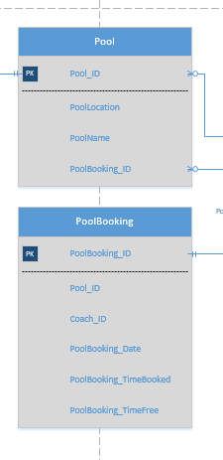
10 | 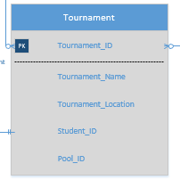  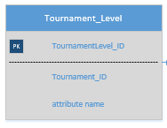
11 | 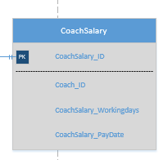
12 | 

