Slide 1

_

Slide 2

Slide 3

Slide 4

Slide 5

Slide 6

Slide 7

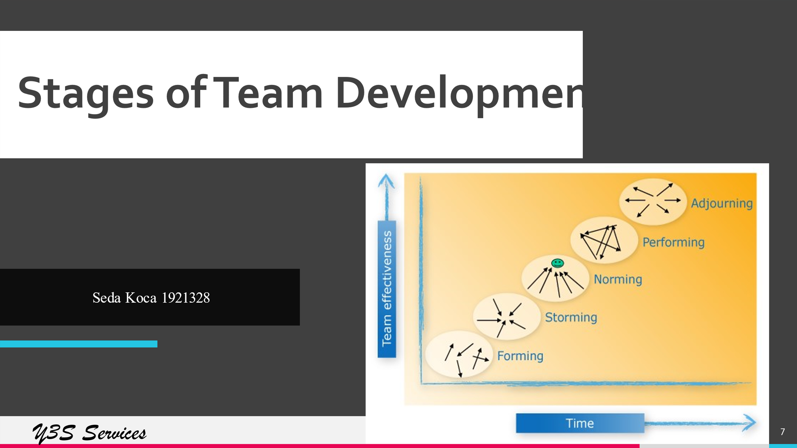

Slide 8

Slide 9

Slide 10

Slide 11

Slide 12

Slide 13

Slide 14

Slide 15

Slide 16

Slide 17

Slide 18

Slide 19

Slide 20

Slide 21

Slide 22

Slide 23

Slide 24

Slide 25

Slide 26

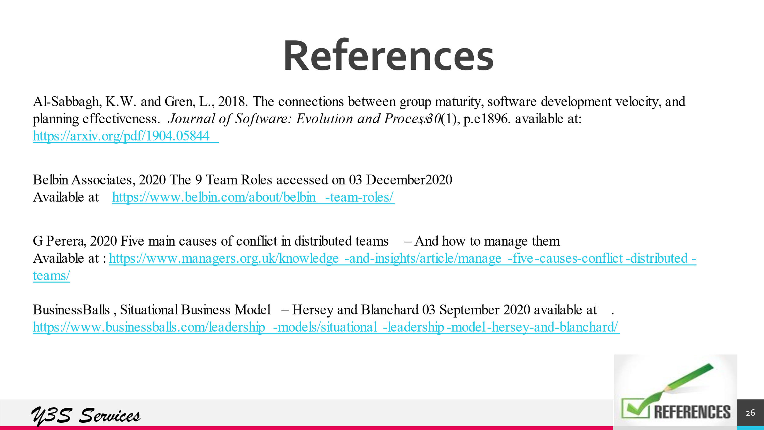

Slide 27



