

Programme :- Master of Business Administration
Module :- Marketing Management
Module Code :- LCMB7024
Assignment Title :- Assessment component 1:
Marketing Environment Analysis
Assessment Component :- 1- individual Report
Case Organisation :- TATA Steel
Lectures Name :- TaongaKaonga Sobere-Snithers
Student Name :-Keyurbhai Kanubhai Patel
Student ID :- 2509905
Word Count :- 2735

Table of contents

Task 1: Marketing Environment Analysis 2
1.1 Environmental Actor: Climate Change and Ecological Pressures 2
1.2 Political and Legal Actor 4
1.3 Socio-economic Actor 5
1.4 Integrated Critical Analysis 6
Task 2: Strategic Growth and Competitive Positioning 7
2.1 Strategic Growth Approach Using the Ansoff Matrix 7
2.2 Market Penetration: Strengthening Existing Markets 7
2.3 Product Development: Creating Low-Carbon Differentiation 7
2.4 Market Development: Expanding Carbon-Sensitive Markets 8
2.5 Selective Diversification and Sustainable Competitive Advantage 9
Task 3: Managerial and Professional Reflection 11
3.1 Rationale for Key Decisions 11
3.2 Professional Reflection on the Analysis 11
3.3 Information Required Before Finalising Recommendations. 12
References 13
Appendix 16
Appendix 1 16
Appendix 2 18

Task 1: Marketing Environment Analysis
Tata Steel is one of India's and the world's leading steel companies. It shows significant performance for FY2025-26 with consolidated revenue of ₹232,140 crore, crude-steel production of 23.4 million tonnes and deliveries of 22.5 million tonnes in India (Tata Steel, 2026). At the same time, steel is still a carbon-intensive sector, which leads to growing environmental, regulatory and market pressures for steel producers to shift towards less carbon-intensive products. The marketing environment is hence significant as, in today's times, customer needs and regulatory aspects, with product differentiation, are being increasingly linked with environmental performance. This analysis has critically examined three external factors that impact

1.1 Environmental Actor: Climate Change and Ecological Pressures
The environmental factor is the most basic of the pressures that are driving Tata Steel's lower-carbon transition since traditional steel manufacturing is crucially reliant on carbon-intensive processes. Direct emissions intensity has been rising since 2021, and the share of blast furnace-basic oxygen furnace (BF-BOF) production remains around 70% of total steel production around the world (IEA, 2025). Thus, decarbonisation is not a matter of a bit of marketing communication here and there, but a large-scale technological shift. The World Steel Association (2025) also classifies steel as a carbon- and energy-intensive sector, and mentions efficiency, increased scrap recycling and low-carbon technologies as key transition options.

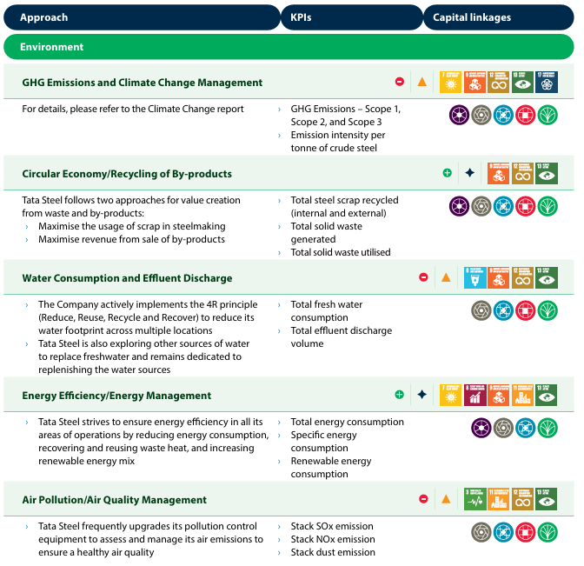

Figure 1: Tata Steel environmental approach
(Source: Tata Steel, 2026)
This green force is already affecting the production capacity of Tata Steel. The company started an Electric Arc Furnace (EAF) in March 2026 with a capacity of 0.75 MTPA that uses scrap to reduce its emissions to less than 0.3 tCO₂e per tonne of crude steel (Tata Steel, 2026). It is also noteworthy that its transition in Europe is taking place: The Port Talbot operation is transitioning towards a 3.2 MTPA EAF-based steelmaking route (Tata Steel, 2026). These investments can be regarded as evidence that environmental pressure is driving the product and the production proposition to change, not just corporate sustainability reporting.
However, there are commercial drawbacks to the environmental opportunity. The IEA (2025) estimates that the costs of early commercial hydrogen-DRI-EAF plants are 50-140% higher than those of BF-BOF plants, depending on the site. Likewise, the studies show that electrification, recycling, and hydrogen are potential means of decarbonisation, but are limited by technology availability, infrastructure, and energy conditions (Keramidaset al., 2024). The problem with electricity prices and cross subsidies for India is that it can be a barrier for deep decarbonisation (Åhman and Arens, 2024). So being environmentally responsible does not in itself bring competitive advantage; Tata Steel must transform improved environmental performance into added value for customers and take care of the possible increase in production costs.
This is a huge marketing implication. Lower-carbon steel can be a differentiated industrial product in which customers are looking to lower their Scope 3 emissions. However, there is a need for trustworthy measurement and certification of “green” steel. Muslemaniet al. (2021) suggest that green-steel markets are susceptible to the uncertainty of definitions, carbon accounting and assurance, which can be a source of risk of greenwashing. Thus, Tata Steel's approach to the environment should be expressed in emissions intensity and in certified standards and not in vague 'sustainability' statements.
Environmental factors: Academic studies also indicate that the automotive industry can be a significant early adopter of green steel; however, the market needs the right policies to stimulate demand and reliable carbon accounting to make this happen (Muslemaniet al., 2021).

1.2 Political and Legal Actor
Government and regulatory institutions are a second important external actor as environmental expectations are increasingly translated into formal market requirements. In December 2024, the Government of India (GoI) released its Green Steel Taxonomy, which introduces emission-intensity thresholds and a star rating system for green steel. Steel with emissions below 1.6 tCO₂e per tonne of finished steel can be classified as five-star, and steel with emissions greater than 2.2 tCO₂e cannot be classified as green (Ministry of Steel, 2024). By FY2025-26, 12.4 million tonnes of steel were being produced certified under the framework, with 90 steel units certified. (Ministry of Steel, 2024).
This policy context thus poses pressures and opportunities. Energy efficiency, renewable energy, green hydrogen, material efficiency, process transition and carbon capture are important decarbonisation pathways in India's steel-sector roadmap (Ministry of Steel, 2024). This can provide an incentive for Tata Steel to create and sell products with environmental attributes which can be verified independently. But the government is also aware that the technology of making steel with hydrogen is not yet commercially viable at scale in India, and regulation alone cannot solve technological and economic barriers (Ministry of Steel, 2024).
The EU's Carbon Border Adjustment Mechanism (CBAM) has officially transitioned to its definitive phase on 1 January 2026 and is also applied to imports of iron and steel. CBAM certificates will be a commercial issue as EU importers will have to factor in embedded emissions (European Commission, 2026). Regulation can therefore be increasingly linked with environmental performance and market access and cost exposure.
Legal factors: However, there is the assumption that demand equals willingness to pay following legal factors as per PESTLE analysis (Refer to appendix 1). According to EY (2025), the current green-steel premium is around US$210 per tonne, but this is projected to drop as technology advances and carbon prices go up according to environmental factors of PESTLE analysis (Refer to appendix 1). Environmental performance becomes more and more linked to access to markets by legal requirements.

1.3 Socio-economic Actor
Socio-economic factors:Customers are the third external actor since reduced carbon production can only be a marketable environmental attribute if the customers recognize and appreciate it. According to EY (2025), the demand for green steel in India is expected to reach 4.49 million tonnes by FY2030, with construction, infrastructure and automotive industries contributing 2.52 million tonnes, 1.5 million tonnes and 0.48 million tonnes, respectively according to the economy factors of PESTLE analysis (Refer to appendix 1). This means that there is potential demand from decarbonisation that is greater than regulation.

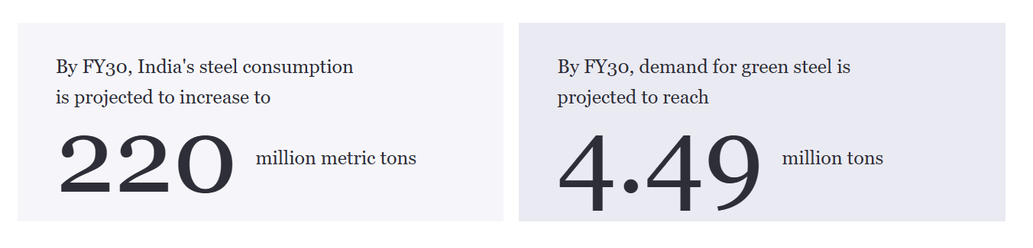
Figure 2: Green Steel in India
(Source: EY, 2025)

1.4 Integrated Critical Analysis
The three actors are not independent of each other. The need for decarbonisation is driven by the pressure of the environment, the drive by the government to define and enforce standards, market rules, and customer demands for lower-carbon steel to provide commercially viable demand. For instance, there could be a green-steel taxonomy in India along with CBAM, which can lead to increased value of low-carbon production and customer demand can enable investment. The transition should therefore be understood as a market transformation, including the aspects of environmental value, regulatory legitimacy and the willingness to pay customers, and not as an operational sustainability programme.
Tata Steel is in a market where environmental demands and requirements are becoming a part of regulation and customer requirements. It has possibilities for green-steel positioning through its investments in EAF and its low-carbon transition, which are limited by technological costs and uncertain willingness to pay. Therefore, successful environmental marketing needs to be backed up by regulatory alignment and depend on credible carbon performance and certification and the creation of value for the customer.

Task 2: Strategic Growth and Competitive Positioning

2.1 Strategic Growth Approach Using the Ansoff Matrix
Tata Steel should implement a phased growth strategy, focussing mainly on Product Development and Market Development. The Ansoff Matrix is suitable for Tata Steel growth strategyin its commercial setting and also for lower carbon intensity of steel production. This is crucial as India's Green Steel Taxonomy defines steel as any requirement under 1.6 tonnes of CO₂ per tonne of finished steel as 5-star green steel and steel over 2.2 tonnes of CO₂/tfs as non-green steel (Impriindia, 2026). Environmental performance can therefore increasingly become a means to differentiate the market, and not just a regulatory requirement (Refer to appendix 2)

2.2 Market Penetration: Strengthening Existing Markets
Market penetration should be the bedrock of Tata Steel's move over, since it carries a lesser level of strategic risk as compared to entering into new markets. Tata Steel should promote the use of lower CO2 intensity steels within the current automotive, construction and infrastructure customer base through the effective and transparent communication of verified CO2 intensity reductions with known product quality (Tata Steel, 2026).
Enhanced demand for green-steel in India is expected to grow by 4.49 million tonnes by FY2030, with a contribution from the construction and infrastructure industry of 2.52 million tonnes and 0.48 million tonnes from the automotive industry. Tata Steel has an existing customer base and distribution network, which can be leveraged to meet this new demand in terms of sales (Prabhaker and Kumar, 2024). But a green premium is not the only way to achieve market penetration. Task 1 detected a current green-steel premium of around US$210 per tonne, i.e. the affordability to adopt might limit the use of green steel. These should then be integrated with lower-carbon products along with technical performance, lifecycle-carbon information and customer-specific sustainability documentation, therefore, Tata Steel should consider these.

2.3 Product Development: Creating Low-Carbon Differentiation
Product Development must, indeed, be Tata Steel's core strength. The company can distinguish itself from the competition not only by cost, but by tangible carbon performance, recycled content and independently verified environmental attributes for steel.
This approach is already being followed by Tata Steel's investment in a 0.75 MTPA Electric Arc Furnace (EAF) in Ludhiana that started operation in March 2026 and will be used to produce crude steel with emissions of less than 0.3 tCO₂e per tonne (Tata Steel UK, 2026). The company should leverage this capability to create certified low-carbon steel grades for automotive and construction and renewable energy applications.
This strategy critically captures the synergy between the Environmental and Technological factors that emerge from the PESTLE analysis (Refer to Appendix 1). There is pressure from the environment as the production of steel continues to emit carbon and stakeholders including customers, governments and investors are demanding emission cuts (Tata Steel, 2026). The environmental targets must however be supplemented with technological abilities to give sustainable competitive advantage. Investment by Tata Steel in Electric Arc Furnace technology and low carbon production processes is an example of the use of technology to overcome environmental challenges. The problem of high investment costs, risks associated with new technology and doubt about customer's willingness to pay green premium is likely to affect the profitability of this strategy.
So the steel quality + reduction in embodied carbon + credible certification would be the competitive advantage. This is important for strategic reasons since green-steel claims might have potential greenwashing concerns if the carbon measurement is inconsistent (Tata Steel, 2026). Tata Steel should, therefore, implement clear emissions measurement and validated certification to substantiate environmental performance as a defendable product characteristic.

2.4 Market Development: Expanding Carbon-Sensitive Markets
Market Development shall be extended to market segments where carbon performance is a greater influence on purchasing and market access for Tata Steel. Embedded emissions are becoming more relevant to imported iron and steel, due to the launch of the EU's Carbon Border Adjustment Mechanism (CBAM) as of 1 January 2026 (Horst and de Andrade Júnior, 2022).
Tata Steel can, therefore, focus on European customers who look for lower carbon inputs particularly in automotive, construction and engineering industries. This is an important opportunity to implement the strategy through its continued move towards a 3.2 MTPA EAF-based steel route in Port Talbot (Tata Steel UK, 2026). The difficult issue is that while market development is desirable, it should be done in stages as the cost and return calculations, as well as the customer's acceptance of the product and the certification process, might have variations. Long-term supply contracts with the customers who care about carbon emissions can help to lower uncertainty in demand and offer more visibility in investment.

2.5 Selective Diversification and Sustainable Competitive Advantage
Diversification should be done judiciously as it is the highest risk level according to Ansoff matrix. In addition to steel production, Tata Steel can grow into related activities in the circular economy such as scrap collection, recycling, low carbon material solutions, and so on, which support its core business of steel (Dutta, 2025).
Overall, Tata Steel should become competitive by adopting a low carbon production process, optimising the use of materials in a circular way, based on verified environmental performance, technological abilities and the strength of their customer relationship.
Accordingly, the suggested order of the strategies is Market Penetration, Product Development, Market Development and Selective Diversification. It is a "growth/transition risk balance approach" because it takes advantage of existing markets to create demand, introduces differentiated low carbon products, enters carbon sensitive markets, and then gradually moves into adjacent activities. This sequencing helps Tata Steel transform the environmental and regulatory challenges highlighted in Task 1 into a differentiation, better market access and longer-term competitive entry.

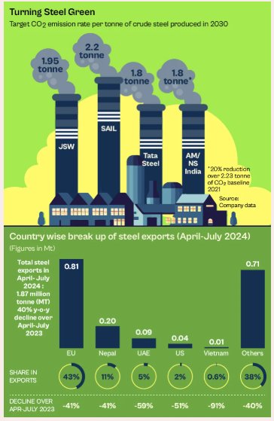

Figure 3: Green Steel - a sustainable method
(Source: Mazumdar, 2024)

Task 3: Managerial and Professional Reflection

3.1 Rationale for Key Decisions
Tata Steel was chosen for this essay since it is a pertinent case of how the company as a steel producer operates today under various pressures from the environment, regulation, and customers while trying to grow commercially. This company is believed to be the best one for the task because of its shift towards low carbon steel production, which is linked both to sustainability and marketing strategy of the company. In Task 1, I chose three actors– climate change and ecology pressure, government/regulation, and Socio-economic. These actors were chosen because there is a link between the environmental pressure, regulation and actors demands (Tatasteel, 2026).
In Task 2, I chose the Ansoff Matrix since I felt that it could provide a strategic method to link the environmental transformation of Tata Steel to various opportunities for growth. I gave preference to Market Penetration aligning with Product Development due to the significance that I attached to Tata Steel’s customer relationships and its capability to produce low carbon products as key bases for growth. I incorporated Market Development by tapping into carbon sensitive international markets and Diversification into circular economy operations. I deliberately suggested a step-by-step strategy due to cost considerations.

3.2 Professional Reflection on the Analysis
I think the biggest strength in my strategy has been to combine environmental and commercial factors instead of addressing sustainability separately as an issue of corporate social responsibility. In addition, I linked environmental performance to differentiation and value creation for the customer as well as market entry. At the same time, I understood that lower-carbon steel is not always a source of competitive advantage as customers may refuse to pay for it. It motivated me to highlight the importance of emissions measurements and certification (Tata Steel, 2026).
Reflecting further, I recognise that the recommendations presented in Task 2 were strongly influenced by the Environmental and Technological dimensions of the PESTLE analysis. From the environmental perspective, it has become clear that climate change, decarbonisation needs and increasing demand for green steel influence the competitive situation in the steel industry. Simultaneously, from the technological perspective, it has been revealed that possession of advanced technologies, such as Electric Arc Furnaces and recycling systems, has become an essential element of success. Nevertheless, it should be noted that investments in technology do not guarantee a competitive advantage since high costs and possible lack of customer interest can neutralize its advantages.
However, I see a number of limitations in my analysis. First, I used mostly secondary sources and had no access to customer data and information about costs and profit from production of low-carbon steel produced by Tata Steel. In addition, I did not conduct any primary research among automotive, construction and infrastructure clients and could not verify willingness to pay. Finally, the analysis did not offer detailed competitor benchmarking for the portfolio of low-carbon products produced by other major steel producers.

3.3 Information Required Before Finalising Recommendations.
As a consultant, there is a need for me to gather further information before arriving at final recommendations. I will look into Tata Steel carbon cost per product level, its margins, the willingness of customers to pay and the competitors’ prices and demand forecasts. Further, I will look into the business implications of CBAM and other regulations that may be introduced in future. Finally, I will attempt to get further customer information and internal stakeholder information to find out if the recommended growth pathway is practically viable.

References
Åhman, M. and Arens, M. (2024) ‘Are electricity prices and cross-subsidies a barrier to decarbonising India's steel industry?’, Utilities Policy, 91, 101853. https://doi.org/10.1016/j.jup.2024.101853.
Dutta, S.K., (2025). Towards an outcome-based approach in ESG reporting: sustainability drive of Tata steel. IIM Ranchi Journal of Management Studies, 4(2), pp.107-126. https://www.emerald.com/irjms/article-pdf/4/2/107/10075058/irjms-08-2024-0080en.pdf
European Commission (2026) CBAM definitive regime. Available at:https://taxation-customs.ec.europa.eu/carbon-border-adjustment-mechanism/cbam-definitive-regime_en (Accessed on 29th September)
EY (2025) How the demand for green steel in India is shaping future trends. Available at:https://www.ey.com/en_in/insights/mining-metals/the-future-of-green-steel-demand-in-india-trends-and-projections(Accessed on 29th September)
Horst, D.J. and de Andrade Júnior, P.P., (2022). Sustainability of the steel industry: a systematic review. Proc. Paper, 6, pp.2-73. https://biointerfaceresearch.com/wp-content/uploads/2023/02/BRIAC136.525.pdf
IEA (2025) Breakthrough Agenda Report 2025: Steel. Paris: International Energy Agency. Available at:https://www.iea.org/reports/breakthrough-agenda-report-2025/steel (Accessed on 29th September)
Impriindia, (2026).Green Steel Taxonomy, 2025: Building India’s Low-Carbon Industrial Economy. Available at: https://www.impriindia.com/insights/policy-update/green-steel-low-carbon-industrial/ [Accessed on 29.9.26]
Keramidas, K., Mima, S. and Bidaud, A. (2024) ‘Opportunities and roadblocks in the decarbonisation of the global steel sector: A demand and production modelling approach’, Energy and Climate Change, 5, 100121. https://doi.org/10.1016/j.egycc.2023.100121.
Kotler, P., Armstrong, G., Harris, L.C. and He, H. (2024) Principles of marketing. 19th edn. Harlow: Pearson.https://middleeast.pearson.com/content/dam/region-core/middle-east/pearson-middle-east/catalog-files-2025/discipline-based/MARKETING2025.pdf
Mazumdar, R. (2024). Green Steel: Can India’s Steel Industry Reduce Carbon Emission Without Cutting Corners? Available at: https://thesecretariat.in/article/green-steel-can-india-s-steel-industry-reduce-carbon-emission-without-cutting-corners [Accessed on 29.9.26]
Ministry of Steel (2024) Green Steel Initiative: Greening the Steel Sector in India – Roadmap and Action Plan. Government of India. Available at:https://www.steel.gov.in/green-steel-initiative(Accessed on 29th September)
Ministry of Steel (2024) Green Steel Taxonomy for India. Government of India. Available at:https://www.steel.gov.in/green-steel-taxonomy-india(Accessed on 29th September)
Muslemani, H., Liang, X., Kaesehage, K., Ascui, F. and Wilson, J. (2021) ‘Opportunities and challenges for decarbonizing steel production by creating markets for “green steel” products’, Journal of Cleaner Production, 315, 128127. https://doi.org/10.1016/j.jclepro.2021.128127 .
Prabhaker, S.P. and Kumar, S., (2024). 4. Development Of Framework For Optimised Value Delivery In Construction Projects With Reference To Tata Steel Limited. The Researchers' International Research Journal, 10(1), pp.23-43. https://theresearchers.asia/old_website_2014-23/Papers/Vol-X,%20Issue-1/Development%20Of%20Framework%20For%20Optimised%20Value%20Delivery%20In%20Construction%20Projects%20With%20Reference%20To%20Tata%20Steel%20Limited.pdf
Tata Steel (2026) Integrated Report & Annual Accounts 2025–26. Available at:https://www.tatasteel.com/investors/integrated-reportannual-report/integrated-report-annual-accounts-2025-26-119th-year-and-related-documents/(Accessed on 29th September)
Tata Steel (2026) Integrated Report/Annual Report 2025–26. Available at:https://www.tatasteel.com/investors/integrated-reportannual-report/ (Accessed on 29th September)
Tata Steel (2026) Manufactured Capital – Integrated Report 2025–26. Available at:https://www.tatasteel.com/investors/integrated-report-2025-26/manufactured-capital.html (Accessed on 29th September)
Tata Steel (2026) Tata Steel reports Consolidated EBITDA of ₹34,848 crores and Profit after Tax of ₹10,886 crores for FY2026. Available at:https://www.tatasteel.com/newsroom/press-releases/india/2026/tata-steel-reports-consolidated-ebitda-of-rs-34-848-crores-and-profit-after-tax-of-rs-10-886-crores-for-the-twelve-months-ended-march-31-2026(Accessed on 29th September)
Tata Steel UK. (2026). Inside the Transformation of Port Talbot’s Steelplant. Available at:https://www.tatasteeluk.com/corporate/news/inside-the-transformation-of-port-talbot-steelplant [Accessed on 29.9.26]
Tata Steel. (2026). Zeremis® Carbon Lite - low carbon emission steel. [online] Available at: https://products.tatasteelnederland.com/about-us/sites-and-facilities/service-centres/finland-naantali/zeremis-carbon-lite [Accessed on 29.9.26]
Tatasteel, (2026). Integrated Report and Annual Accounts 2024-25 .Available at: https://www.tatasteel.com/investors/integrated-report-2024-25/pdf/fy25-integratedreport.pdf [Accessed on 29.9.26]
Tatasteel, (2026). Tata Steel Inaugurates its first Scrap-based Electric Arc Furnace in India. Available at: https://www.tatasteel.com/newsroom/press-releases/india/2026/tata-steel-inaugurates-its-first-scrap-based-electric-arc-furnace-in-india/ [Accessed on 29.9.26]
World Steel Association (2025) Climate change and the production of iron and steel. Available at:https://worldsteel.org/climate-action/climate-change-and-the-production-of-iron-and-steel(Accessed on 29th September)

Appendix

Appendix 1
PESTLE analysis
Political Factors | Government policy is one of the key factors impacting Tata Steel as India is increasingly encouraging the shift to low-carbon steelmaking. The Green Steel Taxonomy sets emission-intensity limit thresholds and a star rating system, and the steel with the lowest emission intensity (below 1.6t CO₂e per tonne of finished steel) will be awarded the highest rating (Ministry of Steel, 2024).
Economy Factors | The economical contribution of Tata Steel is very high so that it has a higher value in Indian economy.
Social Factors | Tata Steel therefore has a two-part customer problem; not only must they be able to show performance in the environment that meets the requirements of still more demanding customers, but the prices and technical attributes must also be commercially acceptable. This makes certification and transparent carbon measurement and sector-specific value propositions important marketing mechanisms.
Technological factors | This is a chance for Tata Steel to add to its green-steel credentials and puts pressure on the company to invest in cleaner technologies. International policy is also relevant since the EU's Carbon Border Adjustment Mechanism (CBAM) came into existence in January 2026 (European Commission, 2026), making embedded carbon more important for exports of steel to Europe.
Legal Factors | Green-steel classification will impose specific emission limits for Tata Steel, and CBAM will also result in extra carbon cost burdens for Tata Steel's exports to the EU (Ministry of Steel, 2024; European Commission, 2026). Therefore, it is crucial to correctly measure, certify and make environmental claims transparent to eliminate compliance risks and greenwashing issues (Muslemaniet al., 2021).
Environmental Factors | Of particular importance are environmental pressures since the conventional steelmaking process is carbon- and energy-intensive. Hence, Tata Steel is under growing pressure to adopt electric arc furnaces, reuse scrap and use renewable energy sources and other low-carbon technologies (IEA, 2025). It has also made strides towards decarbonising its steel production with its 0.75 MTPA scrap-based EAF in India, which it aims to bring emissions below 0.3 tCO₂e/ tonne of crude steel by 2026 (Tata Steel, 2026). But, with higher investment involved in emerging technologies, environmental performance needs to have a tangible impact on customer value.

Table 1: PESTLE analysis
(Self created)

Appendix 2
Ansoff strategy | Application to Tata Steel | Strategic purpose
Market Penetration | Sell lower carbon steel products to existing customers in India. | Boost market share and customer retention.
Product Development | Launch certified low carbon and recycled content steel products. | Differentiate Tata Steel with Different Environmental Value.
Market Development | Seek new lower carbon product markets in carbon sensitive international markets. | Capture new demand and maintain market access.
Diversification | Establish related activities of circular economy and recycling. | Develop other income-generating opportunities.

Table 2 : Ansoff Matrix strategy of Tata Steel
(Self created)

