What does it mean to commemorate? How do memorials create personal meaning in a public place?
Emily Jenkins
1702370
Photojournalism and Documentary Photography
Word count: 1910
Paul Duerinckx

According to the Cambridge English dictionary, commemoration is to reflect or to remember; to give respect to a person, object or event and is usually carried out by hosting a ceremony, celebration or by building a memorial to physically mark that remembrance.
The most widely known practises of commemoration are annual events such as the celebration of the birth of a person. Birthdays are celebrated by most cultures around the world, although others tend to celebrate ‘coming of age’ birthdays as a key milestone in a person’s life; for example a 21st birthday marks the official day that a person becomes an adult. Wedding anniversaries are another example. Convention has it that because each wedding anniversary signifies a milestone, a specific gift should be exchanged by the couple or gifted to them by their family and friends.
However, the tradition most commonly recognised is the commemoration of a loved one that has recently passed away. Funerals are conducted in various different ways throughout hundreds of cultures around the world. Whether it is burial or cremation, funerals are made to reflect on the deceased person’s life, the positive impact that they had on others and to officially say goodbye, as most find it difficult to succumb to the fact that their loved one’s physical presence has diminished to just a memory.
The atmosphere at a birthday party would be somewhat different to one at a funeral. Commemoration at a funeral service would have a mixture of emotions such as joy, sadness and anger because different people will remember a past loved one in different ways. So it could be argued that funerals are the most nostalgic of all commemorative events. Professional caregivers such as hospice, grief counsellors, clergy and medical practitioners have long understood the importance of remembrance. It is an established principle that helps us to heal, so we can go on living our lives in meaningful ways. Somewhere in our subconscious, we are always aware that our time on this earth will eventually run out; we want to make our mark, to be remembered. And funerals or memorials allow us to do that. “The awareness of death,” writes Robert Pogue Harrison in his Dominion of the Dead, “that defines human nature is inseparable from – indeed it arises from – our awareness that we are not self-authored, that we follow in the footsteps of the dead.”
We have learnt to value memory; someone who has passed away still exists when we decide to remember them, and therefore, we cannot ignore or forget what or who we have experienced in the past. Memories get passed down from generation to generation and gradually become lessons. These lessons are what affect our decision making in everyday life. “We are products of our past, but we don't have to be prisoners of it,” writes Rick Warren in his The Purpose Driven Life: What on Earth Am I Here for? Commemoration is just a small way of how we remind ourselves of what we have learnt.
Furthermore, as technology has rapidly developed for the better, we now have multiple methods of preserving memories into physical objects such as memorial statues, texts and scripts, books, gravestones, paintings, illustration and photography. The reason behind this is because a book or a photograph outlives a human and therefore will guarantee that others have access to these memories and new information in the future.
As stated in Geoffrey Batchen’s book Forget Me Not – Photography and Remembrance, the English photographer Julia Margaret Cameron made an albumen print of a young woman and titled it Mnemosyne or Memory in September 1868. Gazing down and away from the camera, the young woman gently strokes her long, flowing dark hair, as if lost in thought. Flowers and leaves circle her head and hang freely from her waist. But the woman also carries an artefact, looped over one arm - a string of beads. Cameron named this print for the Greek goddess of memory and mother of the Muses. “It would seem to be suggesting that photography itself is an art of memory,” Batchen writes, “this is an idea that has long been popular, so much so that we usually construe photographs and memories as synonymous.” He also writes that as early as 1859, the American writer Oliver Wendell Holmes called photography, “the mirror with a memory,” and the Eastman Kodak Company has extensively promoted this notion as well: “[Kodak] enables the fortunate possessor to go back by the light of his own fireside to scenes which would otherwise fade from memory and be lost.”
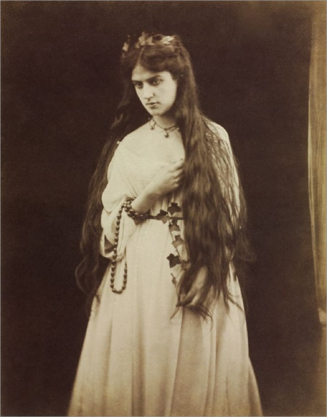

‘Memory’ taken by Julia Margaret Cameron in 1868.

Batchen finishes the paragraph with, “And so we have taken our photographs, voraciously and anxiously…” In this day and age, the number of people owning a camera is rapidly increasing. Whether they’ve bought the newest Canon or just have a small standard smartphone, taking a photo is so much easier due to improved technology; it is the easiest, quickest and most efficient way to save a memory or a moment. This allows us to preserve memories such as holidays, birthdays or important events like prom and graduation. Social media sites are centred around photography so much that a picture can now be shared and seen by hundreds of people around the world within seconds. Whether they have been printed, framed, stuck in a photo album or stored on a hard drive, these are the memories that are personal and sentimental to us; it gives us a strange warmth of satisfaction and nostalgia that we have captured a moment that would have otherwise been forgotten if we solely relied on our memory.
On the other hand, many could argue that the majority of photographs taken over recent years have no meaning or purpose other than to show off over social media. In 2011 alone, there were more than 400 billion photographs taken and shared over Instagram - that is approximately 137 million pictures taken every hour - and with the ‘Selfie’ culture continuously growing, it could be argued that narcissism is playing an underlying role within today’s society. The technology and accessibility allows us to take multiple photographs of the same subject matter, allows us to select our favourite and then delete the rest. Photographs are now being taken to prove self-worth to others; selfies are always posed and fake. We are always striving to achieve perfection, for a pretty photograph, which could also be the reason why we only tend to photograph happy events, usually posed and smiling towards the camera. The time and care it took for a photographer to take just one picture in an old film camera has been severely overlooked since digital technology grew popular. Many may argue that we simply do not appreciate the importance of preserving memories in a photograph anymore.
However, the need to photograph only positive moments in our lives does not originate from narcissism. We preserve the important events and people in our lives - birthdays, marriages, anniversaries, holidays and new houses - are all recorded because they matter. Photographs are our personal story, and can become a timeline of our lives filled with faces, places and experiences that we love. Our lives are not always easy; people have problems. But photographs are a visual tool that we use to reflect on a memory and the emotions that came with it. And positive emotions – such as enjoyment and hope – help us to connect with others and build our capacity to cope when things go wrong.
In simple terms, photography is used to document events, but the subject matter can be captured in hundreds of different ways. For example, family photos are usually pleasantly nostalgic to look back on, while a photographer documenting war would capture an entirely different emotion. It is that emotion that we respond to when we look at a photograph, and it is with that emotion that we will remember it.
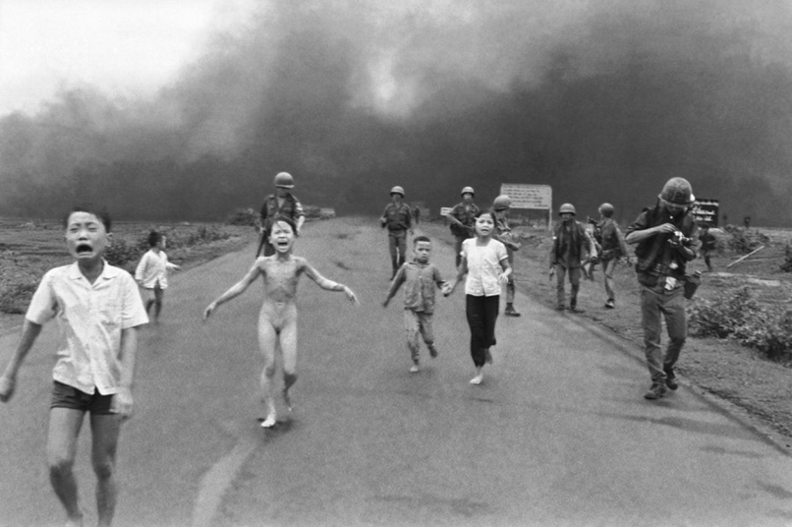

‘Napalm Girl’ taken by Nick Ut in 1972

Photojournalist Nick Ut became widely known for his photographs of the Vietnam War, especially Napalm Girl which was taken in 1972. A young girl, naked, runs screaming toward the camera in agony after a napalm attack incinerated her village. Her name is Kim Phuc and she was 9 years old when she was photographed. Some napalm did make contact with her back and left arm; it set her clothes on fire, and she stripped them off as she ran. According to an account that Kim later gave in an interview, Phan Thi Kim Phuc ran naked down the road screaming: “Nóng quá, nóng quá” meaning, “too hot, too hot!”
Photojournalism’s purpose is to document the reality and raw emotion of unpleasant events, to shock and even upset the viewer. The majority of world-wide problems such as war ultimately result in death – something that we all subconsciously fear. As much as we would like to ignore it, we force ourselves to reflect on dark times such as these in hope that we will remember the sacrifice others had to make so we can live the way we do today.
We make decisions that affect us individually and as a community. As we look back through history, we can succumb to the fact that some of those decisions were in fact mistakes. Reflecting on those mistakes ensures that we do not repeat them, and thus they become lessons to the future generation. For example, Armistice Day is on 11 November and is also known as Remembrance Day. It marks the day World War One ended, at 11am on the 11th day of the 11th month, in 1918. A two-minute silence is held at 11am to remember the people who have died in all wars. This includes World War Two, the Falklands War, the Gulf War, and conflicts in Afghanistan and Iraq. We commemorate this as a community because it continues to bring people together in an atmosphere of love and support. The first two-minute silence in Britain was held on 11th November 1919, when King George V asked the public to observe a silence at 11am. He made the request so, "the thoughts of everyone may be concentrated on reverent remembrance of the glorious dead".
In conclusion we have recognised that the commemoration of the dead is very important. To remember a person who has passed away, we remember the positive impact that they had on our lives and the lessons that they taught us, so we can live on and pass that knowledge on to someone else. We use the medium of photography, art, sculpture, architecture and text to preserve these memories and information into a more permanent, physical space so there will be less chance of it being forgotten. Commemoration is to reflect on what we have learnt from past experiences so that we can develop and evolve to tackle similar problems that may emerge in the near future, with the goal that it will be dealt with quicker, easier and more efficiently. Self-development means that we all learn from the same experience in different ways. We have funerals because it helps us to acknowledge changes in personal self-identity so we can search for new meaning in life. We have learnt to respect and commemorate the dead because we’re not self-authored. Our relationship with the dead reflects the relationships we have between the current living: the way we order and govern our society - and that, at least, we can change.

References:
bmcr.brynmawr.edu/2004/2004-03-48.html
Forget Me Not Photography & Remembrance by Geoffrey Batchen, Published by Princeton Architectural Press, 37 East Seventh Street, New York, New York in 2004
http://bmcr.brynmawr.edu/2004/2004-03-48.html
https://dictionary.cambridge.org/dictionary/english/commemorate
https://digital-photography-school.com/6-reasons-why-photography-matters/
https://en.wikipedia.org/wiki/Commemoration_Day
https://jpgenrgb.files.wordpress.com/2018/07/batchen-forget-me-not.pdf
https://www.batesville.com/helping-families/funeral-purpose/
https://www.bbc.co.uk/newsround/15492752
https://www.goodreads.com/book/show/692892.The_Dominion_of_the_Dead
https://www.photographytalk.com/beginner-photography-tips/7889-is-social-media-destroying-photography
https://www.remembranceprocess.com/why-remembrance/
https://www.theguardian.com/artanddesign/interactive/2013/may/19/power-photography-time-mortality-memory
https://www.theguardian.com/commentisfree/2017/may/29/how-do-we-celebrate-the-virtues-of-dead-loved-ones-in-a-secular-age
https://www.timeanddate.com/fun/anniversary-gift-traditions.html https://www.quora.com/Human-Behavior-Why-do-people-take-photos
The Dominion of the Dead – 15 Nov 2003 by Robert Pogue Harrison

