Sabrina Malek

BIS Assignment 2 part 2

Contents
1.0 Major Data Governance Elements 2
2.0 Problems Identified 3
References 5

Table of Figures
Figure 1: Data source 2
Figure 2 3
Figure 3 4

Major Data Governance Elements
Based on the data extracted from UKAEA, there are a few major elements of data governance that are relevant to the dataset. One of the biggest challenges in Data Governance that related to this dataset is dealing with redundant data. It is important for UKAEA to have a policy about dealing with data redundancy as storing redundant data will make data management more challenging [1]. Dealing with data redundancy is a hassle, as there are several steps during the process.
When initiating a data governance function, UKAEA needs to emphasis on data policies, standards and strategies as the first step. Data policies are “a collection of statements that describes the rules controlling the integrity, security, quality, and use of data during its lifecycle and state change” [2]. These guidelines ensure organizational data to be accurate and protected. It specifies what procedures should be used to manage the data warehouse. In order for a data governance data to effective, it needs to have a cross-discipline approach to information management and it needs input from different departments within UKAEA, such as finance, information technology and data stewards. UKAEA needs to “identify stakeholders, establish decision rights, and clarify accountabilities” [3]. It is important to establish policies and standards for data management.
In order to improve data quality, the data from UKAEA needs to be cleansed. Removal of incorrect, incomplete and duplicated data is one of the ways to achieve high-quality data.
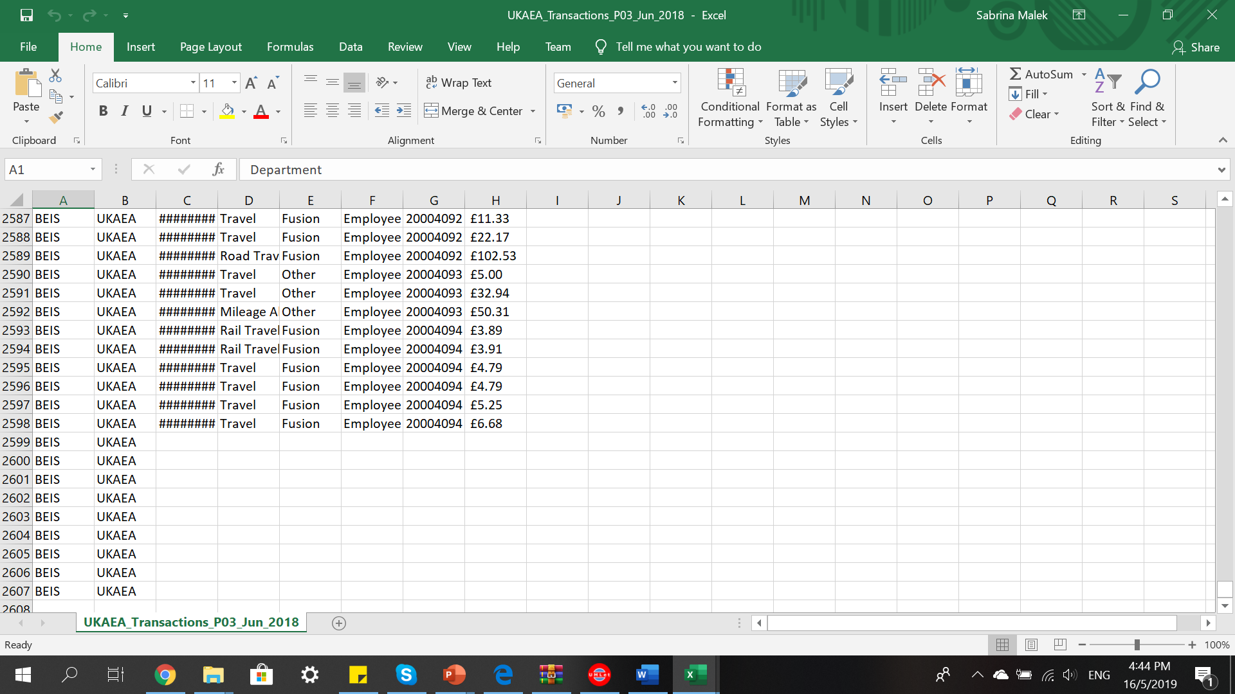
Figure 1: Data source
Figure 1 shows example of incomplete data within the data source. These data were removed to ensure data quality. Apart from completeness of data, uniqueness, timeliness, validity, accuracy, consistency, and reliability are also important in establishing high level data quality. Data cleansing, data scrubbing, and data profiling are some of the elements of governing the data. Figure 2 shows the process of removing redundant data for data source.
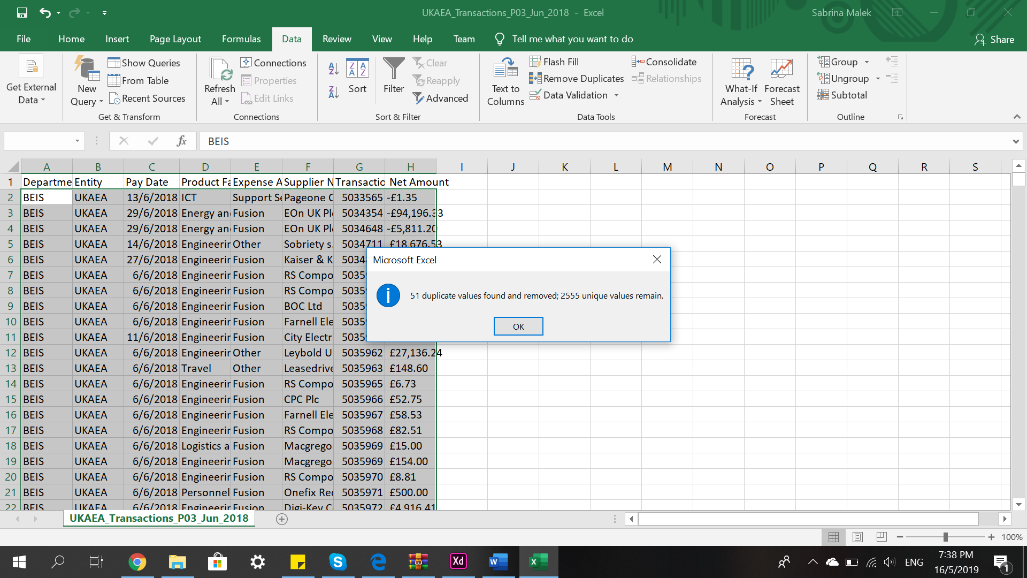
Figure 2
In terms of security, privacy and compliance, it is important to appoint a Data Protection Officer. Apart from making sure that the data handling is secure, UKAEA also need to “comply with privacy laws governing the collection and use personal data “[4]. This leads to General Data Protection Regulation (GDPR).
GDPR is a regulation on data protection and privacy. It reports the export of personal data outside EU. The use of personal data in databases will relate to GDPR compliance. As a result, these personal data are pseudonymised.
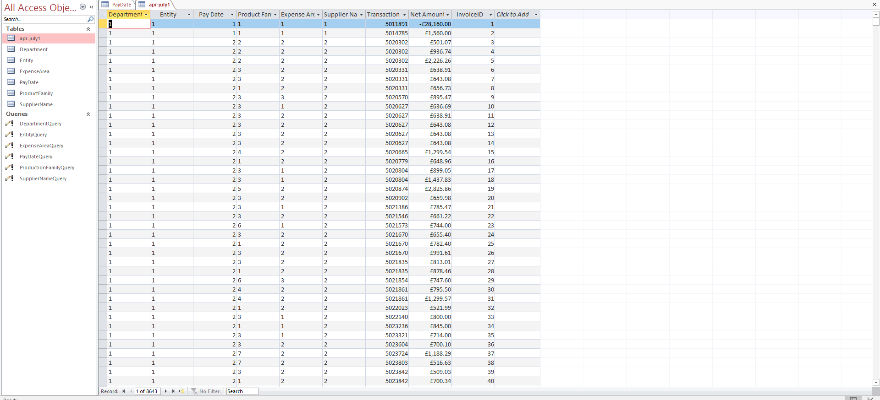
Figure 3

Data Architecture describes the process of data, storage of data and utilization of data in a system [5]. Standards for data processing operations are provided in Data Architecture. Defining target state and alignment of data during development are usually done by a data architect. Data Integration is used to “combine data from disparate sources into meaningful and valuable information” [6]. It integrates data into useful information emphasizing on data profiling and standardization.

Problems Identified
One of the problems identified in UKAEA database is data redundancy and incomplete data. UKAEA can create a data team and a data map to overcome this problem [7]. This team will specialize in building a good data governance framework. Apart from that, UKAEA can improve its data collection. They can implement the right data entry. Different groups are needed in making sure the correct way of data collection is being implemented. UKAEA can implement hybrid data governance framework for its database. Maintaining financial records within a financial data warehouse would be difficult without accountability. In order to comply with privacy laws governing personal data, UKAEA may implement appropriate measures. Internal data protection policies are needed in terms of accountability. This includes staff training, appointing a Data Protection Officer, and reviews of internal policies.

References
- “The Biggest Challenges in Data Governance 2018,” EOL IT Services. [Online]. Available: https://www.eolitservices.co.uk/2018/02/05/biggest-challenges-data-governance/. [Accessed: 16-May-2019].
- “What is data governance policy ? - Definition from WhatIs.com,” SearchCompliance. [Online]. Available: https://searchcompliance.techtarget.com/definition/Data-governance-policy. [Accessed: 16-May-2019].
- “Enterprise Information Management: Best Practices in Data Governance,” An Oracle White Paper on Enterprise Architecture, May 2011.
- “5 essential elements of Data Governance,” NodeGraph, 23-Jan-2019. [Online]. Available: https://www.nodegraph.se/5-essential-elements-of-data-governance/. [Accessed: 16-May-2019].
- “Six Reasons Why Enterprises Need a Modern Data Integration Architecture,” Datanami, 04-May-2018. [Online]. Available: https://www.datanami.com/2018/05/04/six-reasons-why-enterprises-need-a-modern-data-integration-architecture/. [Accessed: 17-May-2019].
- A. Reeve, “What Is Data Integration?,” Managing Data in Motion, pp. 7–13, 2013.
- “Data governance framework: issues and solutions,” ComputerWeekly.com. [Online]. Available: https://www.computerweekly.com/tip/Data-governance-framework-issues-and-solutions. [Accessed: 17-May-2019].

