

Business Planning (ACMA4015)
Darrell Byrne
2420160
Degree Apprenticeship in Logistics and Supply Chain Management
22nd October 2024
Table of Contents
Mission Statement
Executive Summary
Industry At A Glance
Key External Drivers
SWOT Analysis
Marketing
Operations
Management Forecast
Financial Highlights

Mission Statement
Nexstock mission is to provide fast, reliable and seamless ‘just in time’ delivery that exceed customer expectations. We are dedicated to ensuring timely and efficient order fulfilment by leveraging our years of logistical knowledge and focussing on low cost high service.

Executive Summary
Nexstock is an offshoot from Tata Steel Distribution UK&I based in the West Midlands. Nexstock aims to offer a route to market for smaller retail customers who require ‘just in time’ material, as these sizes are normally from the standard portfolio the plan would be to keep an agreed stock level that can be pulled from with a 24 hour delivery turnaround and delivered by Tata’s own fleet and drivers within a set radius.
This proposal outlines the implementation and benefits of offering a 24 hour turnaround alongside the standard day 1 for day 2 / 3 offering for larger orders. With growing demand for faster fulfilment and customers looking to manage their inventory due to tighter margins this service aims to deliver products to customer by the next business day following order placement.
Key highlights of this service include:
- Enhanced customer experience: by offering quick, reliable delivery customers will receive their orders the next day which in turn improves satisfaction and loyalty
- Improved operational efficiency: streamlined logistics led by better inventory management, as stock will be ‘picked’ from the floor operations can ensure no gaps to loading schedules
- Increased competitive advantage: The ability to offer faster delivery positions the company as a leader in customer service within the industry, creating a unique selling position
- Cost optimization: with a combination of an online ordering tool, own fleet and drivers and smart warehouse management costs can be kept manageable whilst still offering a premium service
In summary Nextstock will set Tata steel ahead of its competitors and will not only lead to customer loyalty but also support sustainable growth in a previous untapped market, which in turn will strengthen our marketing position.

Industry at a glance
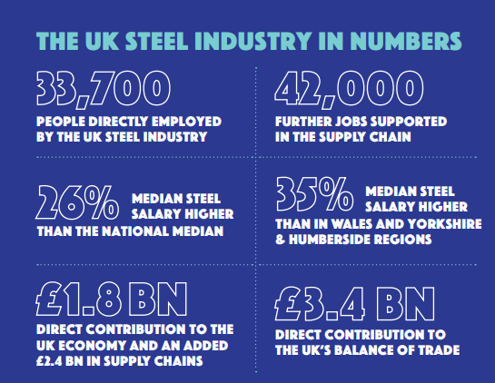

The steel industry is a critical sector in the global economy, playing a pivotal role in manufacturing, construction, transportation, and infrastructure development. As one of the most essential materials used across various industries, steel production involves transforming iron ore into steel through processes like blast furnaces or electric arc furnaces. Here's an overview of the steel industry:

Key Facts:
- Global Market Size: The steel industry is worth trillions of dollars globally, with annual production exceeding 1.8 billion metric tons.
- Major Producers: The top steel-producing countries are China, India, Japan, the United States, and Russia. China alone accounts for more than 50% of global steel production.
- Primary Products: Steel products include flat products (plates, coils), long products (bars, rods, wire), and specialty products (stainless steel, alloys), which are used in construction, automotive, machinery, and other sectors.

Trends and Challenges:
- Sustainability: With growing environmental concerns, the steel industry is moving towards greener practices, such as using hydrogen in production and recycling more scrap steel.
- Technological Innovations: Automation, AI, and Industry 4.0 technologies are improving efficiency, reducing costs, and enhancing production processes.
- Supply Chain Disruptions: The steel industry faces challenges like fluctuating raw material prices, supply chain bottlenecks, and trade restrictions.

Economic Impact:
- Employment: The industry provides millions of jobs worldwide, ranging from production and manufacturing to research and development.
- Infrastructure Growth: Steel is the backbone of the construction and automotive industries, driving the development of buildings, roads, bridges, and vehicles.

Outlook:

Despite challenges such as fluctuating raw material costs and environmental regulations, the global steel market is poised for steady growth, particularly driven by emerging economies and infrastructure projects. The adoption of sustainable practices and digital transformation will continue to shape the future of the steel industry

Key External Drivers
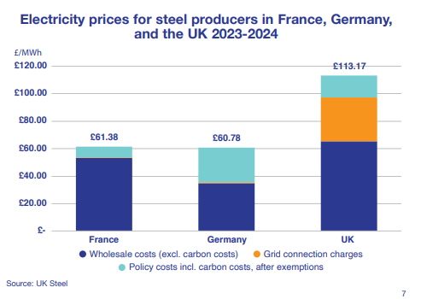
Electricity prices are a critical component of the steel industry's cost structure, particularly for electric arc furnace-based producers. Variations in energy costs across regions can influence global competitiveness, and the shift towards renewable energy sources is expected to play a key role in shaping future electricity price trends. Steelmakers will continue to monitor and adapt to these price fluctuations, adopting energy-efficient practices and investing in sustainable energy sources to mitigate the impact on their bottom lines

SWOT Analysis
Strengths
- Location: The location is one of the primary strengths of Nexstock, being based in the midlands means there is great motorway links and the radius set covers a large proportion of industry.
- Servicing of needs: The services that will be brought to steel manufacturers in the midlands is one that is truly needed and will see consistent growth.
Weaknesses
- Supply is currently a concern in the UK with import tariffs, managing the orderbook will be key
Opportunities
- Limited competition: Competition in this area is very limited it will give Nexstock the opportunity to build a loyal customer base.
Threats
- Competitor challenges: Competitors could possibly realise the potential and look to set up something similar and undercut the market to gain an edge.
Marketing
Marketing for Nexstock will be done through the main Tata Steel outlets which includes internet, print and tv Ads. As the product is already established the sales teams will be tasked with selling through cold calling

Operations
- Forecasting: Will be based on current projected sales, any volume not sold via Nexstock will be sold via the main platform
- Procurement: Will be through the main parent in terms of purchasing coil etc
- Production: Maintained through the parent with a stock allocation given to Nexstock
- Distribution: This will be carried out through own fleet and managed day to day to review performance
- Facility: The parents facility will be used and is fully costed via this
Management forecast
As the product will be sold via the parent no additional staff will be required.
Financial Highlights
As the model is set to fit into the parent break even is based on covering the cost of transport hire only
Financial Highlights | Y1 | Y2 | Y3 | Y4 | Y5
Revenue | £31,200,000 | £33,742,800 | £36,492,838 | £39,467,005 | £42,683,565
Direct Costs | £26,000,000 | £28,119,000 | £30,410,699 | £32,889,170 | £35,569,638
Operating Expenses | £1,200,000 | £1,236,000 | £1,273,080 | £1,311,272 | £1,350,611
Net profit | £3,840,000 | £4,212,288 | £4,616,697 | £5,055,899 | £5,532,784

Break-Even Analysis
Monthly Revenue to Break-even : | £0.23
Assumptions:
Average Monthly Revenue | £2,600,000
Average Monthly Variable Cost | £2,166,667
Estimated Monthly Cost | £100,000
Revenue Forecast | Y1 | Y2 | Y3 | Y4 | Y5
Units / Tonnes | 52,000 | 53,560 | 55,167 | 56,822 | 58,526
Selling Price | £600 | £630 | £662 | £695 | £729
Revenue | £31,200,000 | £33,742,800 | £36,492,838 | £39,467,005 | £42,683,565
Material Unit Cost | £500 | £525 | £551 | £579 | £608
Direct Cost of Revenue | £26,000,000 | £28,119,000 | £30,410,699 | £32,889,170 | £35,569,638
Forecast Profit & Loss | Y1 | Y2 | Y3 | Y4 | Y5
Revenue | £31,200,000 | £33,742,800 | £36,492,838 | £39,467,005 | £42,683,565
Gross Margin | £5,200,000 | £5,623,800 | £6,082,140 | £6,577,834 | £7,113,928
Transport / Fleet | £1,200,000 | £1,236,000 | £1,273,080 | £1,311,272 | £1,350,611
Employment | £0 | £0 | £0 | £0 | £0
Depreciation | £0 | £0 | £0 | £0 | £0
Marketing Costs
Miscellaneous Costs
Total Operating Expenses | £1,200,000 | £1,236,000 | £1,273,080 | £1,311,272 | £1,350,611
Profit Before Interest & Taxes | £4,000,000 | £4,387,800 | £4,809,060 | £5,266,562 | £5,763,317
EBITDA | £4,000,000 | £4,387,800 | £4,809,060 | £5,266,562 | £5,763,317
Interest Expense | £40,000 | £43,878 | £48,091 | £52,666 | £57,633
Taxes Incurred | £120,000 | £131,634 | £144,272 | £157,997 | £172,900
Net Profit | £3,840,000 | £4,212,288 | £4,616,697 | £5,055,899 | £5,532,784
Net Profit / Revenue | 12% | 12% | 13% | 13% | 13%
Forecast Cash Flow | Y1 | Y2 | Y3 | Y4 | Y5
Revenue | £31,200,000 | £33,742,800 | £36,492,838 | £39,467,005 | £42,683,565
New Current Borrowing | £0 | £0 | £0 | £0 | £0
New Long Term Liabilities | £0 | £0 | £0 | £0 | £0
Sales of Assets | £0 | £0 | £0 | £0 | £0
New Investment | £0 | £0 | £0 | £0 | £0
Total Cash Received | £31,200,000 | £33,742,800 | £36,492,838 | £39,467,005 | £42,683,565
Operating Expenses & Costs | £27,360,000 | £29,530,512 | £31,876,141 | £34,411,105 | £37,150,781
Current Borrowing Repayments | £0 | £0 | £0 | £0 | £0
Dividends | £0 | £0 | £0 | £0 | £0
Total Expenditures | £27,360,000 | £29,530,512 | £31,876,141 | £34,411,105 | £37,150,781
Net Cash Flow | £3,840,000 | £4,212,288 | £4,616,697 | £5,055,899 | £5,532,784
Cash Balance | £750,000 | £4,962,288 | £9,578,985 | £14,634,885 | £20,167,669
Financial Indicators | Y1 | Y2 | Y3 | Y4 | Y5
Profitability %'s :
Gross Margin | 16.7% | 16.7% | 16.7% | 16.7% | 16.7%
Net Profit Margin | 12.3% | 12.5% | 12.7% | 12.8% | 13.0%
EBITDA to Revenue | 12.8% | 13.0% | 13.2% | 13.3% | 13.5%
Leverage Ratios :
Debt to Equity
Debt to Assets Ratio
Interest Coverage Ratio
Liquidity Ratios :
Current Ratio
Current Debt to Total Assets Ratio
Additional Indicators :
Revenue to Equity Ratio | 0 | 0 | 0 | 0 | 0
Forecast Balance Sheet | Y1 | Y2 | Y3 | Y4 | Y5
ASSETS
Current Assets
Cash | £750,000 | £4,962,288 | £9,578,985 | £14,634,885 | £20,167,669
Other | £0 | £0 | £0 | £0 | £0
Total | £750,000 | £4,962,288 | £9,578,985 | £14,634,885 | £20,167,669
Long Term Assets
Long Term Assets | £0 | £0 | £0 | £0 | £0
Acc. Depreciation | £0 | £0 | £0 | £0 | £0
Total | £0 | £0 | £0 | £0 | £0
Total Assets | £750,000 | £4,962,288 | £9,578,985 | £14,634,885 | £20,167,669
Liabilities & Capital
Current Liabilities | £0 | £0 | £0 | £0 | £0
Current Borrowing | £0 | £0 | £0 | £0 | £0
Other Current Liabilities | £0 | £0 | £0 | £0 | £0
Total | £0 | £0 | £0 | £0 | £0
Long-Term Liabilities | £0 | £0 | £0 | £0 | £0
Total Liabilities | £0 | £0 | £0 | £0 | £0
Paid In Capital | £0 | £0 | £0 | £0 | £0
Retained Earnings | £0 | £0 | £0 | £0 | £0
Earnings | £0 | £0 | £0 | £0 | £0
Total Capital | £0 | £0 | £0 | £0 | £0
Total Liabilities & Capital | £0 | £0 | £0 | £0 | £0
NET | £750,000 | £4,962,288 | £9,578,985 | £14,634,885 | £20,167,669

