Assignment 1 Report
Data Security and Compliance (ACCA5034)
SamUEL MIFSUD
2024
Table of Contents
Task 1 - Research in Data Security and Compliance 2
I. ABSTRACT 2
II. INTRODUCTION 2
III. SECURITY TECHNOLOGIES 2
A. Firewalls 2
B. Intrusion Detection Systems 2
C. Encryption 1
IV. PHYSICAL SECURITY 1
A. Protection Measures 1
B. Detection Measures 1
C. Reaction Measures 2
V. SECURITY AND PERSONNEL 2
A. Social Engineering 2
B. Access Control 2
VI. EVALUATION AND DISCUSSION 2
VII. REFERENCES 3
Task 2 – Case Scenario 0
Organisation Structure 0
Policies and Procedures 0
Compliance 0
Governance 0
References 1

Task 1 - Research in Data Security and Compliance

I. ABSTRACT

II. INTRODUCTION
Computers are an increasingly important part of the modern world, not only in businesses and personal computing, but in critical infrastructure too.
As the prevalence of computer systems increases, though, so do the threats against them. Bad actors with malicious intentions towards a business, person or nation can use various methods to exploit weaknesses in computer systems to cause damage and harm. Whether it is a personal machine or a system running critical services such as healthcare or power for a nation, cybersecurity is an exceptionally important thing today.
Many of the principles remain the same regardless of the location, and aspects of security are applicable regardless of the situation. In this report, I will examine three major aspects of security that apply to various areas: Security Technologies, the digital tools and resources used to protect systems; Physical Security, external measures used to keep the physical hardware of the systems secure and out of reach of bad actors; and Security and Personnel, which focuses on the role of system users in maintaining security and the strategies they can use to help protect them.
I will also review how these aspects should be used by an organization to secure their IT infrastructure through Protection, Detection, Reaction and Safeguarding.

III. SECURITY TECHNOLOGIES
For any computer system, especially one connected to the internet, there are multitudes of digital threats to protect against. Bad actors can target specific systems with attacks or distribute malicious software that infects any unprotected computers it can. But there are tools available to protect against both kinds of attacks.

A. Firewalls
One such tool is a firewall. Firewalls are a barrier between two parts of a network. They restrict what communication can be sent through them based on a set of rules, only allowing communication, for example, through certain ports, or to and from certain IP addresses [1].
Firewalls can be placed in various places in the networks. Individual computer systems can utilise firewalls to restrict communication between themselves and the local network, as well as wider networks, such as the Internet, or the firewall can be placed further out, between the local network and wider networks.
Firewalls operate at the Protection stage, pre-emptively blocking unnecessary network traffic from entering the protected part of the network, the local network or the system itself, in the hopes of catching and preventing any malicious traffic.
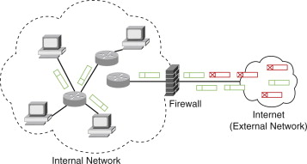
Fig. 1 Diagram demonstrating a firewall protecting a local network from external threats [2]

B. Intrusion Detection Systems
Intrusion Detection Systems operate at the Detect stage, as the name would imply. They are automated tools that can detect cyberattacks and respond, or prompt a response, to them [3] [4].
They can use algorithms, such as machine learning [3], to detect potentially malicious activity within the local network in real time [4], and allow them to be stopped before damage is done.
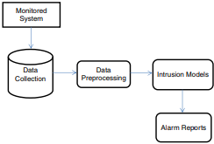
Fig. 2 Diagram of a typical Intrusion Detection System [4]

C. Encryption
Encryption is a Protection stage security measure that makes data unreadable without first decrypting it. Encrypted data is changed in a way that ideally cannot be reversed without the decryption key, making it impossible for bad actors who do manage to get access to the data to use it for any malicious purposes [5].
Encryption is an important tool that should be used anywhere sensitive data could be accessed by unauthorised users. Any sensitive data sent through the Internet should be encrypted so that it cannot be read if intercepted. Companies can encrypt data in their databases so that, in the event of a data breach of that database, it is useless to bad actors. Storage devices can be encrypted to make them useless to bad actors if stolen.
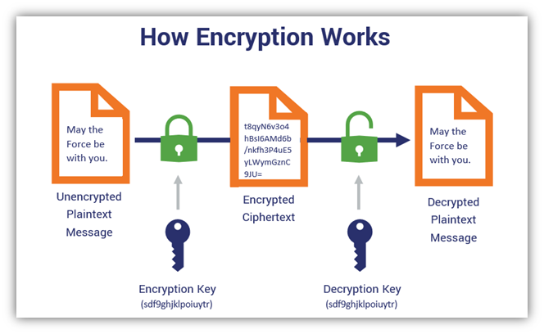
Fig. 2 A diagram showing the process of encryption and decryption [6]

IV. PHYSICAL SECURITY
Physical Security encompasses a variety of external measures to protect important and valuable hardware from a variety of attacks.
While digital security is an important first step, it is ultimately useless if a bad actor can simply walk into the location of the hardware and steal a device containing sensitive data, or damage critical hardware. As such, Physical Security is equally important.
Physical threats to computer systems and networks can come in many forms. From physical breaches by bad actors, whether by force or through social engineering, to environmental threats such as natural disasters, there are many things to consider when designing physical security measures.

A. Protection Measures
Ideally physical threats would be prevented at the Protection stage before they can cause any damage. There are a variety of physical security measures that can be put in place to do this.
To protect against intentional physical attacks such as theft or vandalism physical access control measures can be put in place. These measures can be as simple as placing a lock on doors to rooms or buildings with sensitive devices in, however this can be inconvenient for users if they need to access these rooms regularly. Organisations can implement keycard readers to allow for more convenient access to secure areas, and restrict individuals’ keycards to only allow them access to areas they need access to for their role [7] [8] [9].
Protection against environmental threats is more difficult, but there are certain measures that should be put in place. Fire suppression systems are not only vital for protecting personnel, but also can prevent damage to computer systems

B. Detection Measures
If the measures taken at the Protection stage are ineffective against a problem, detection measures can enable the company to more quickly move to the Reaction stage, potentially mitigate the damage that can be done.
Security cameras can act as a deterrence and help prevent attacks, but primarily they are used to detect an attack in progress. If a bad actor manages to breach physical security measures and gain access to secure areas the cameras allow security personnel to see them and respond accordingly. They can also record footage that can aid in reacting to threats by helping to identify any damage done and potentially identifying the bad actor, allowing for legal action to be taken against them and potentially assets to be recovered [7] [8].

C. Reaction Measures
Backups are an important reactive measure to allow recovery in case devices containing important data are stolen or destroyed. Backups are a separate copy of the data which can be used instead if the original copy is lost [10].
Backups should be made regularly to ensure that the data in them is up to date and accurate. Multiple backups should be made, if possible, in different physical locations so that an event such as a natural disaster cannot destroy the original copy and all backups, though in some cases all backups may need to remain on site if no suitable alternatives are available. For organisations, a procedure should be defined to allow for quick and efficient recovery from data loss and reduce downtime [10].

V. SECURITY AND PERSONNEL
Regardless of the quality of digital and physical security measures put in place, whether the target is an organisation or an individual authorised users still need to be able to access the protected systems.
This presents a weakness, as bad actors can utilise these weaknesses by targeting users and using their access to bypass security measures entirely [11]. Alternatively, in the case of an organisation the authorised users themselves may also be the bad actors, attempting to sabotage the company from the inside.

A. Social Engineering
The main way a bad actor can exploit authorised users for malicious purposes is through social engineering. Social engineering involves manipulating users, which can be used to get information that would allow bad actors to gain access to secure systems or could be used to make users perform damaging actions themselves [11].
The best way to protect against social engineering is education. Companies should implement training to help users recognise social engineering attempts, avoid giving away sensitive information, and not perform actions on behalf of bad actors [11]. Individuals can also take measures to educate themselves and improve their personal security.

B. Access Control
Access Control is an important tool for businesses as it protects against both social engineering and malicious actions by employees by limiting what any individual user can do [12].
Most users in an organisation will have specialised roles that only require access to specific resources relevant to their job [12]. Restricting administrative rights and access to data to only user accounts that need them, and restricting access to certain physical resources, such as server rooms, should limit the damage a bad actor can do if they gained the rights of that employee.

VI. EVALUATION AND DISCUSSION
Digital, Physical and Personnel security are all exceptionally important for an organization or individual.
If systems are digitally and physically secured but employees are susceptible to social engineering then bad actors can bypass the security methods in place entirely. Without physical security, a bad actor could potentially enter property unauthorized and remove systems containing sensitive data, or cause damage. Without digital security, systems could be vulnerable to malware or other cyberattacks.
As such, all of these aspects of security should be employed to ensure complete security. For the Safeguard stage of security, policies, procedures and systems should be regularly audited and evaluated to ensure that they still meet the security needs of the organisation and are up to date.

VII. REFERENCES
[1] A. Voronkov, L. H. Iwaya, L. A. Martucci and S. Lindskog, “Systematic Literature Review on Usability of Firewall Configuration,” ACM computing surveys, vol. 50, no. 6, pp. 1-35, 2018.
[2] “Network Firewall,” ScienceDirect, [Online]. Available: https://www.sciencedirect.com/topics/computer-science/network-firewall. [Accessed 12 12 2024].
[3] Z. A. E. Houda, B. Brik and L. Khoukhi, “Why Should I Trust Your IDS?": An Explainable Deep Learning Framework for Intrusion Detection Systems in Internet of Things Networks,” IEEE open journal of the Communications Society, vol. 3, no. 11, pp. 1164-1176, 2022.
[4] R. Singh, H. Kumar, R. K. Singla and R. R. Ketti, “Internet attacks and intrusion detection system: A review of the literature,” Online information review, vol. 41, no. 2, pp. 171-184, 2017.
[5] “What is encryption?,” IBM, [Online]. Available: https://www.ibm.com/topics/encryption. [Accessed 12 12 2024].
[6] C. Crane, “Symmetric Encryption 101: Definition, How It Works & When It’s Used,” The SSL Store, 4 11 2024. [Online]. Available: https://www.thesslstore.com/blog/symmetric-encryption-101-definition-how-it-works-when-its-used/. [Accessed 12 12 2024].
[7] “Cybersecurity | The importance of Physical Security,” Devoteam, [Online]. Available: https://www.devoteam.com/expert-view/cybersecurity-the-importance-of-physical-security/. [Accessed 12 12 2024].
[8] “Physical Security and Cybersecurity: How They Work Together,” Lenel S2, [Online]. Available: https://www.lenels2.com/en/news/insights/Physical_and_Cybersecurity.html. [Accessed 12 12 2024].
[9] “Why Your Business Needs Both Cyber & Physical Security,” Redpalm, 02 07 2024. [Online]. Available: https://redpalm.co.uk/physical-security-and-cybersecurity/. [Accessed 12 12 2024].
[10] M. T. Alrashdan, M. A. Wahed, E. Aljarrah, M. Tubishat, M. Alzaqebah and N. Aljawarneh, “The impact of data recovery criteria, data backup schedule and data backup prosses on the efficiency of data recovery management in data centers,” nternational journal of data and network science, vol. 8, no. 4, pp. 2539-2546, 2024.
[11] K. F. Steinmetz and T. J. Holt, “Falling for Social Engineering: A Qualitative Analysis of Social Engineering Policy Recommendations,” Social science computer review, vol. 41, no. 2, pp. 592-607, 2023.
[12] “What is access control in cybersecurity: understanding the basics,” NordLayer, [Online]. Available: https://nordlayer.com/learn/access-control/what-is-access-control/. [Accessed 12 12 2024].

Task 2 – Case Scenario

Organisation Structure
An organisation structure diagram can be created to show the hierarchy of employees in the unit and the company. Below is an example I created for an information security unit
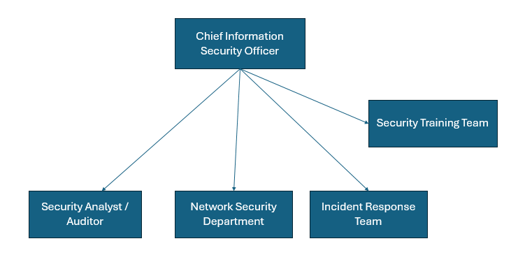

Policies and Procedures
Policies should be outlined to ensure good security practices are carried out. Access control measures should be implemented to ensure that employees do not have access to information they don’t need for their role. Sensitive data should be encrypted in transit.

Compliance
The unit should ensure that the company abides by relevant laws that protect handling of customer and employee data, such as the UK’s Data Protection Act 2018 [13]. Data should only be used for the purposes specified when collected, accurate and up to date, deleted when no longer required and kept secure. It should only be accessed by employees who need access to it and, following company policies, reasonable access control measures should be put into place.

Governance

References

[1] | A. Voronkov, L. H. Iwaya, L. A. Martucci and S. Lindskog, “Systematic Literature Review on Usability of Firewall Configuration,” ACM computing surveys, vol. 50, no. 6, pp. 1-35, 2018.
[2] | “Network Firewall,” ScienceDirect, [Online]. Available: https://www.sciencedirect.com/topics/computer-science/network-firewall. [Accessed 12 12 2024].
[3] | Z. A. E. Houda, B. Brik and L. Khoukhi, “Why Should I Trust Your IDS?": An Explainable Deep Learning Framework for Intrusion Detection Systems in Internet of Things Networks,” IEEE open journal of the Communications Society, vol. 3, no. 11, pp. 1164-1176, 2022.
[4] | R. Singh, H. Kumar, R. K. Singla and R. R. Ketti, “Internet attacks and intrusion detection system: A review of the literature,” Online information review, vol. 41, no. 2, pp. 171-184, 2017.
[5] | “What is encryption?,” IBM, [Online]. Available: https://www.ibm.com/topics/encryption. [Accessed 12 12 2024].
[6] | C. Crane, “Symmetric Encryption 101: Definition, How It Works & When It’s Used,” The SSL Store, 4 11 2024. [Online]. Available: https://www.thesslstore.com/blog/symmetric-encryption-101-definition-how-it-works-when-its-used/. [Accessed 12 12 2024].
[7] | “Cybersecurity | The importance of Physical Security,” Devoteam, [Online]. Available: https://www.devoteam.com/expert-view/cybersecurity-the-importance-of-physical-security/. [Accessed 12 12 2024].
[8] | “Physical Security and Cybersecurity: How They Work Together,” Lenel S2, [Online]. Available: https://www.lenels2.com/en/news/insights/Physical_and_Cybersecurity.html. [Accessed 12 12 2024].
[9] | “Why Your Business Needs Both Cyber & Physical Security,” Redpalm, 02 07 2024. [Online]. Available: https://redpalm.co.uk/physical-security-and-cybersecurity/. [Accessed 12 12 2024].
[10] | M. T. Alrashdan, M. A. Wahed, E. Aljarrah, M. Tubishat, M. Alzaqebah and N. Aljawarneh, “The impact of data recovery criteria, data backup schedule and data backup prosses on the efficiency of data recovery management in data centers,” nternational journal of data and network science, vol. 8, no. 4, pp. 2539-2546, 2024.
[11] | K. F. Steinmetz and T. J. Holt, “Falling for Social Engineering: A Qualitative Analysis of Social Engineering Policy Recommendations,” Social science computer review, vol. 41, no. 2, pp. 592-607, 2023.
[12] | “What is access control in cybersecurity: understanding the basics,” NordLayer, [Online]. Available: https://nordlayer.com/learn/access-control/what-is-access-control/. [Accessed 12 12 2024].
[13] | “Data Protection Act 2018,” United Kingdom Government, [Online]. Available: https://www.legislation.gov.uk/ukpga/2018/12/contents. [Accessed 12 12 2024].

