
Luke Akerman (2404201)
UWTSD | Lecturer: Dr. Nitheesh Kaliyamurthy
Network Operating Systems and Services (NOSS)
Email: 2404201@student.uwtsd.ac.uk

Coursework 1: RESEARCH, BUILD and deploy a virtualised enterprise network
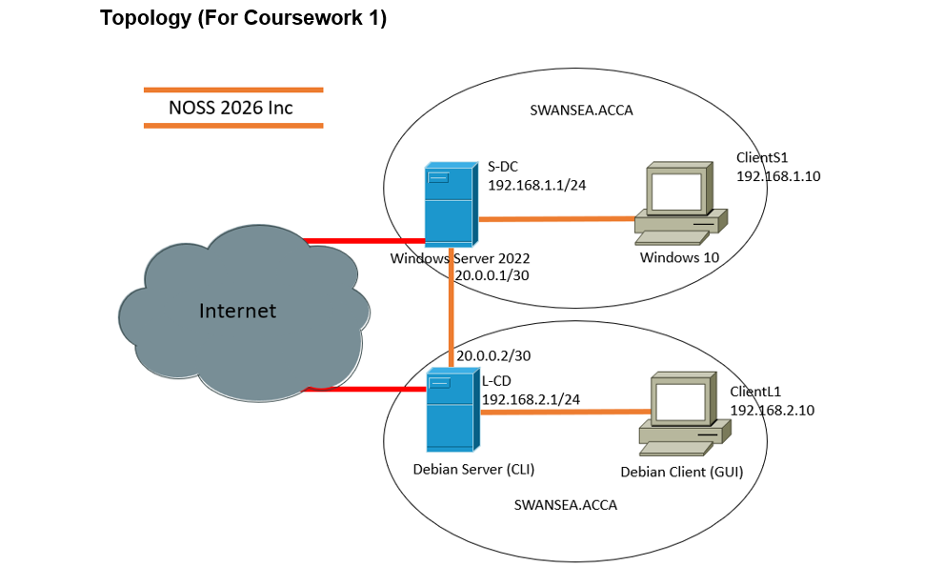

Task 1
Hypervisor research and justification:
Type 1 hypervisors or “bare metal hypervisors" is a form of virtualisation that runs on the physical hardware of the computer. It is installed on top of the physical hardware [1], similar to how an operating system is installed. This allows it to communicate and use the machines hardware (CPU, GPU, RAM etc) directly as opposed to communicating through the operating system.
Type 2 hypervisors is a form of virtualisation where the virtual machine is installed on top of the operating system and runs like an application. Unlike a type 1 hypervisor, type 2 does not communicate with the machine hardware directly instead having to go through the operating system. [1] This means you must allocate how much memory and CPUs you need for the VM to run efficiently.
For the given topology I chose to use a type 2 hypervisor as it allows me to install and run multiple OS easier and with limited hardware availability. Type 2 offers more compatibility as the topology requires both windows and Linux servers. Later on in development I will be required to have the Linux and windows servers to communicate to each other which can be fulfilled better on a type 2 as type 2 has better scalability. While type 1 offers better security type 2 offers better resource allocation allowing me to fulfil the topology using less resources

Research on IP addressing
Data is transmitted on a network by getting broken into small packets which is then sent across the network and reconstructed by the receiver. Each packet has a source and destination IP address to I identify the sender and receiver devices. [2] Each computer on a network is given a unique decimal number label (e.g. 192.168.0.1) so each device can identify each other on the network and locate each other to allow for the packets to be directed appropriately by the routers. [3] There are 2 main types of IP addressing. IPV4 is the most common IP addressing and works by using numerical decimal numbers to for an IP address and uses 32 bits. [3] IPV6 uses 128 Bits and offers a much bigger combination of possible addresses and uses hexadecimal as opposed to decimal (e.g. 2001:0DC8:E004:0001:000:0000:0000:F00A) .
Routers and switches are both important in a network. A switch is used in LANs to help the data travel efficiently. A switch is needed in networks where there are multiple end devices to ensure the data is directed to the correct machine efficiently. [4] A router is used at the third layer of the ISO-OSI model to create a connection between networks. It transports Packets in a LAN and stores IP addresses in an IP address table for more efficient transport and has its own IP address for communication with other routers and devices. [4]
Research on routing
Routers use routing protocols to maintain a standard on how they communicate with each other on a network allowing them to find a path to each end point. [5] Routers creates a routing table using the routing protocols allowing them to communicate and decide the best path for the data to go [5]
Static routing is a protocol that involves the user configuring the IP addresses and routes manually. This routing is commonly used in smaller networks and offers better security as the administrator controls the path that data follows. Static is also predictable as the path is already made by the user and is more reliable that dynamic routing. [6]
Dynamic routing creates routes automatically using algorithms based on real time information. Dynamic is better for larger networks where static would take to long to set up and require too much maintenance. Using dynamic routing offers more flexibility as it automatically adapts to new devices being added. However, it is more complex to set up but requires less maintenance.
For the topology I am using, I believe that static routing would be the most suitable as the network is small with only 2 servers and 2 hosts. The windows server needs a more stable and reliable routing protocol as the Debian (Linux) server acts as a DHCP relay.

Research on network services
VPNs (Virtual private networks) are used to better encrypt data by masking the users IP address preventing trackers from monitoring network usage. A VPN is very important for businesses that have remote workers as they can access company networks and access the resources anywhere securely. The best practice for a company VPN is to use strong VPNs such as OpenVpn and use MFA (Multi Factor Authentication) to increase security even more. [7] [8]
A Dynamic Host Configuration protocol (DHCP) server is used to automate the management and assignment of IP addresses in a network which reduces how much manual configuration an administrator needs to do and reduces errors making it better for larger enterprise networks. It uses DORA (Discover, Offer, Request, Acknowledge) to distribute IP addresses. [9] Networks using DHCP should not use it on a domain controller to reduce the chances of an attack [10]
AD DS (active directory Domain services) is used to store information about objects within a network to allow administrators to use and create a structure within a network. This allows them to decide which users can access certain information on a network for better security. [11] Users should follow the PoLP (Principle of Least Privilege) which means users should have as little privileges as they need for best security
AD CS (Active Directory Certificate services is used to distribute and manage PKIs (public key infrastructure) on a windows server. These are used to encrypt electronic documents and data as well as digitally sign them for validity. [12]

Task 2
Chosen Hypervisor:
I chose to use a type 2 hypervisor as I was most comfortable using it. I have extensive experience in using type 2 hypervisors in the past having to create similar topologies using windows server 2022 and a windows 10 machine using VMWare. Type 2 hypervisors also offer better protection for virtualisation as VMWare and Virtual Box both allow me to create snapshots that I can refer to if anything was to go wrong with the tasks. Type 2 will benefit me when I am pinging both servers to each other as Virtual box allows me to virtually connect the servers together and configure them to connect. This will allow me to deliver course work 2 much easier with the same output as a type 1 hypervisor.

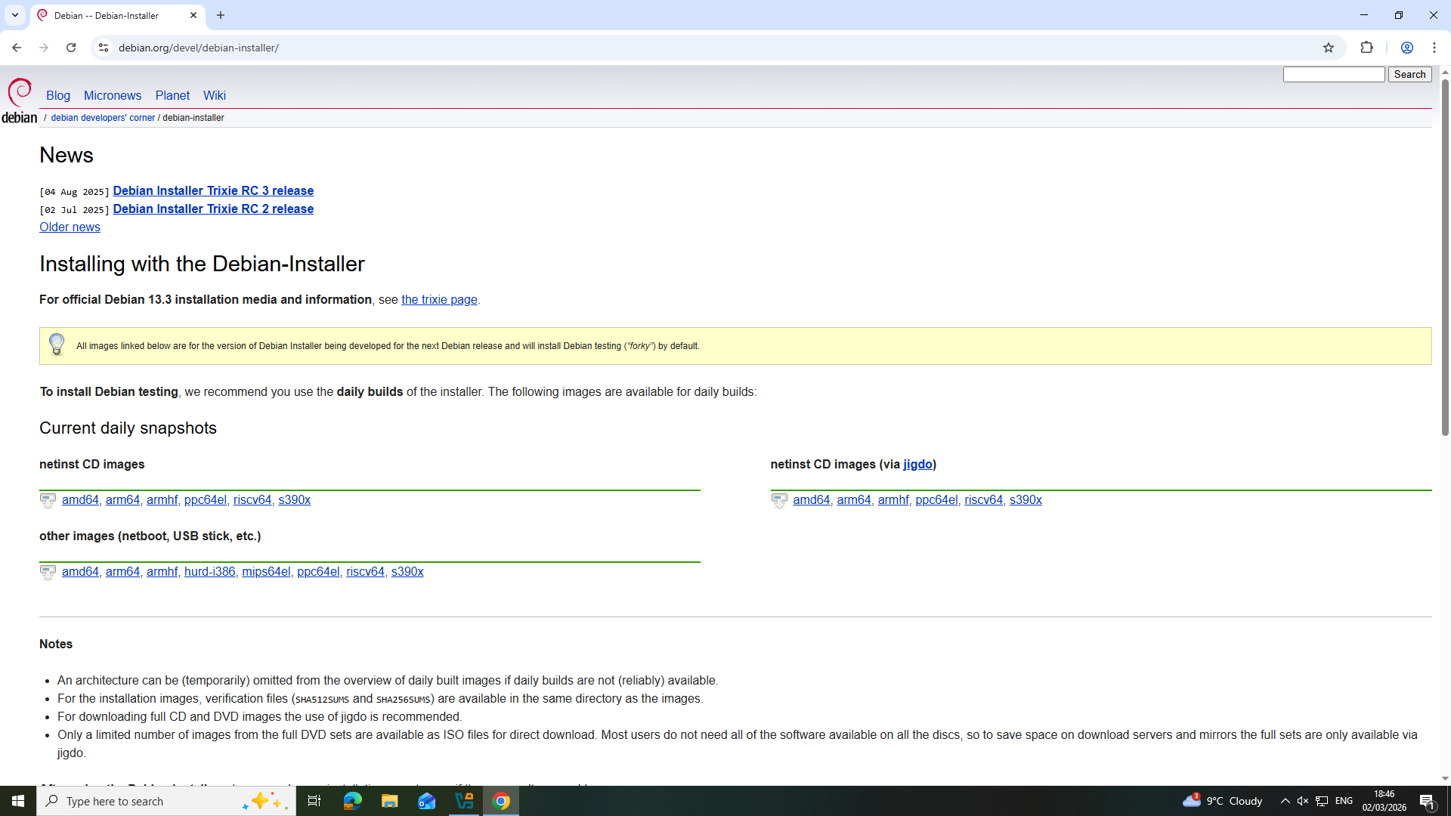
Downloading the Debian Linux Server
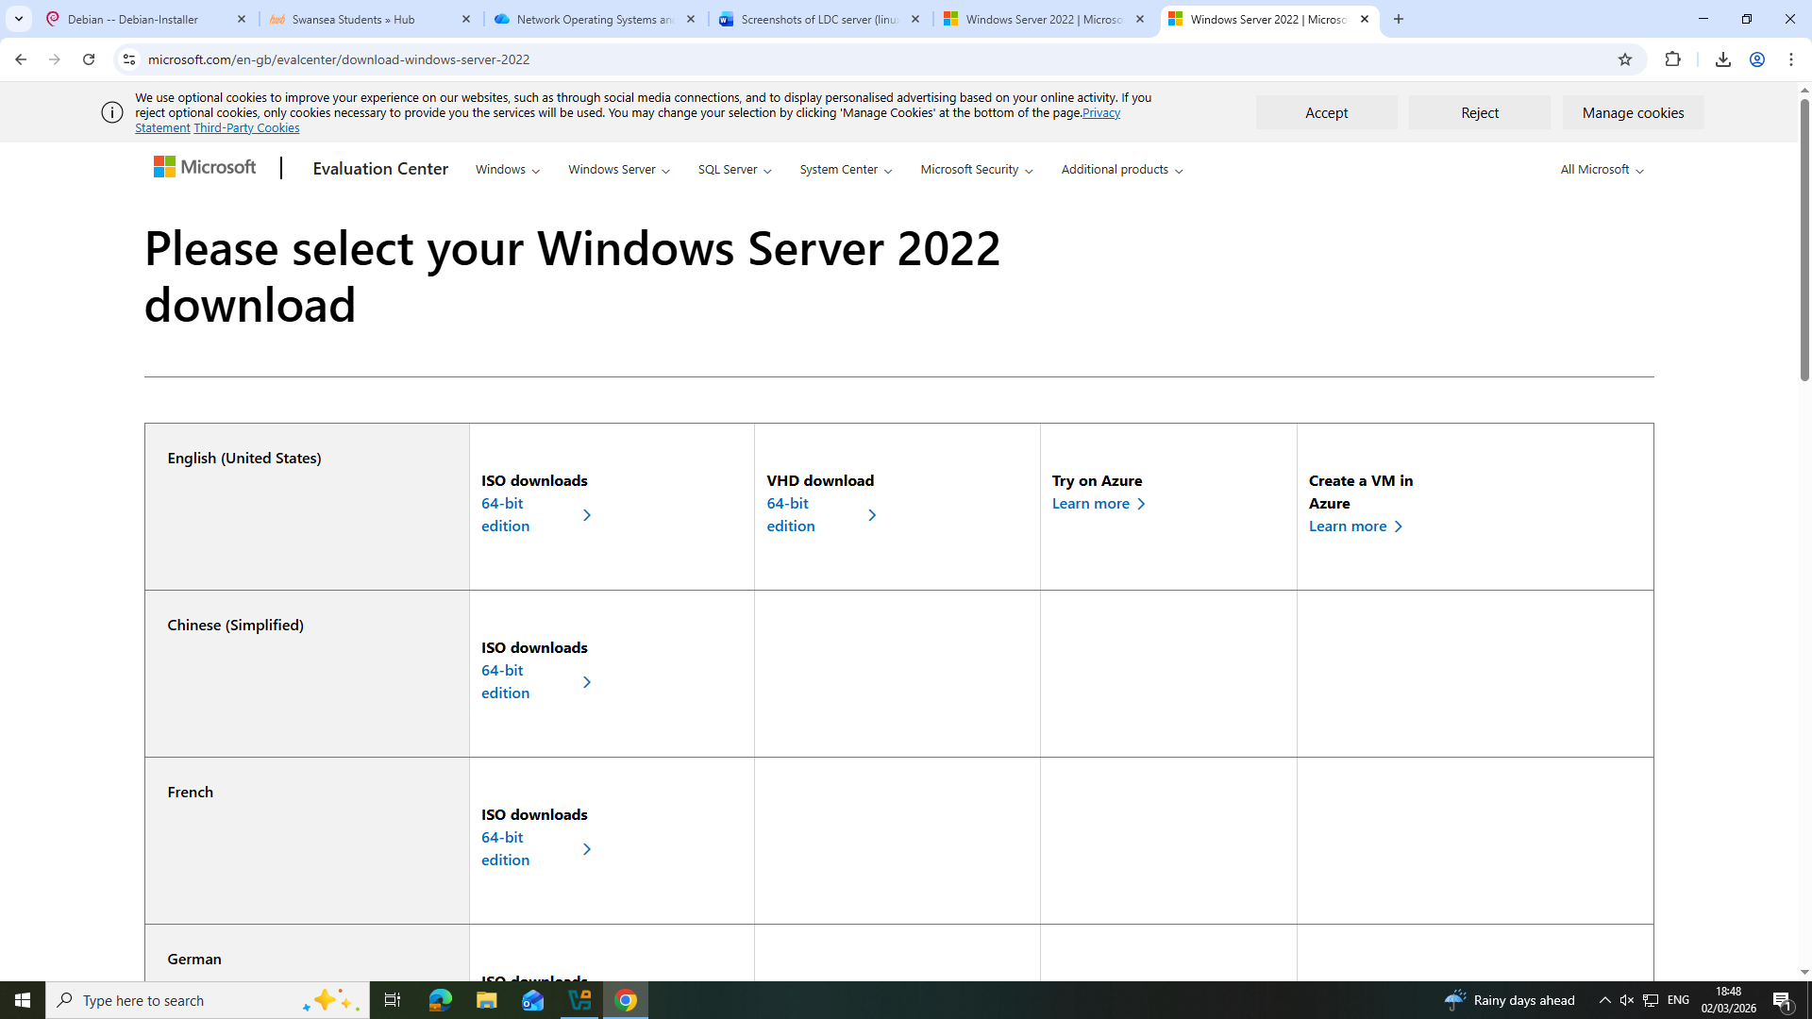

Downloading the Windows Server 2022

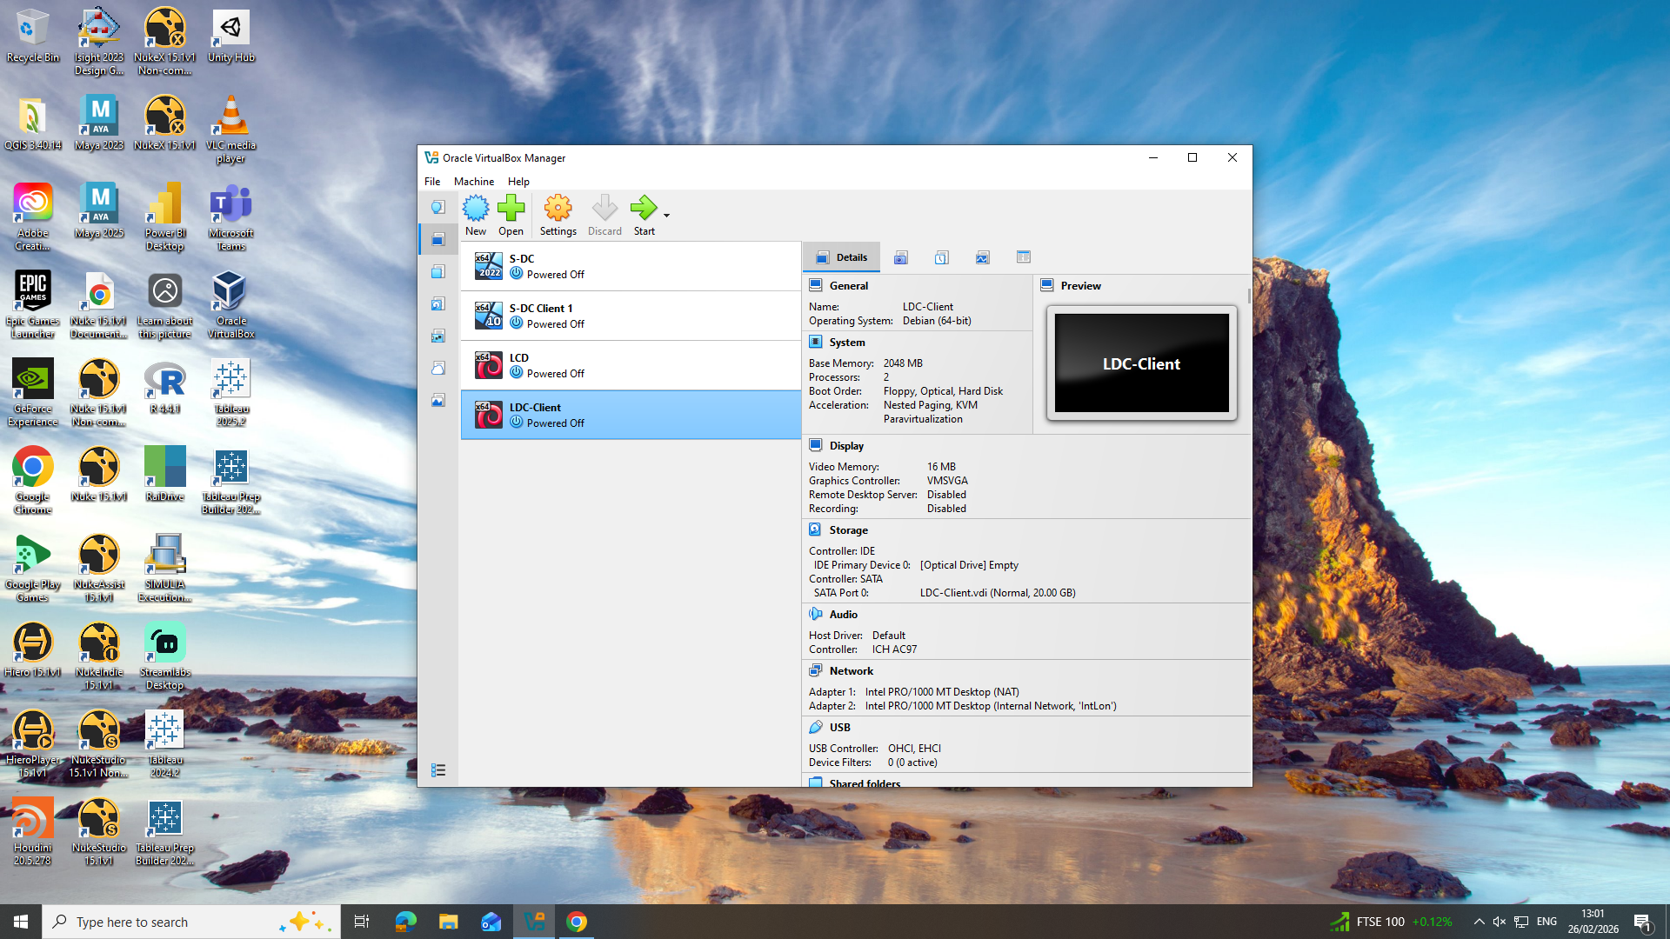
Virtual box setup showing all the machines created to match the topology

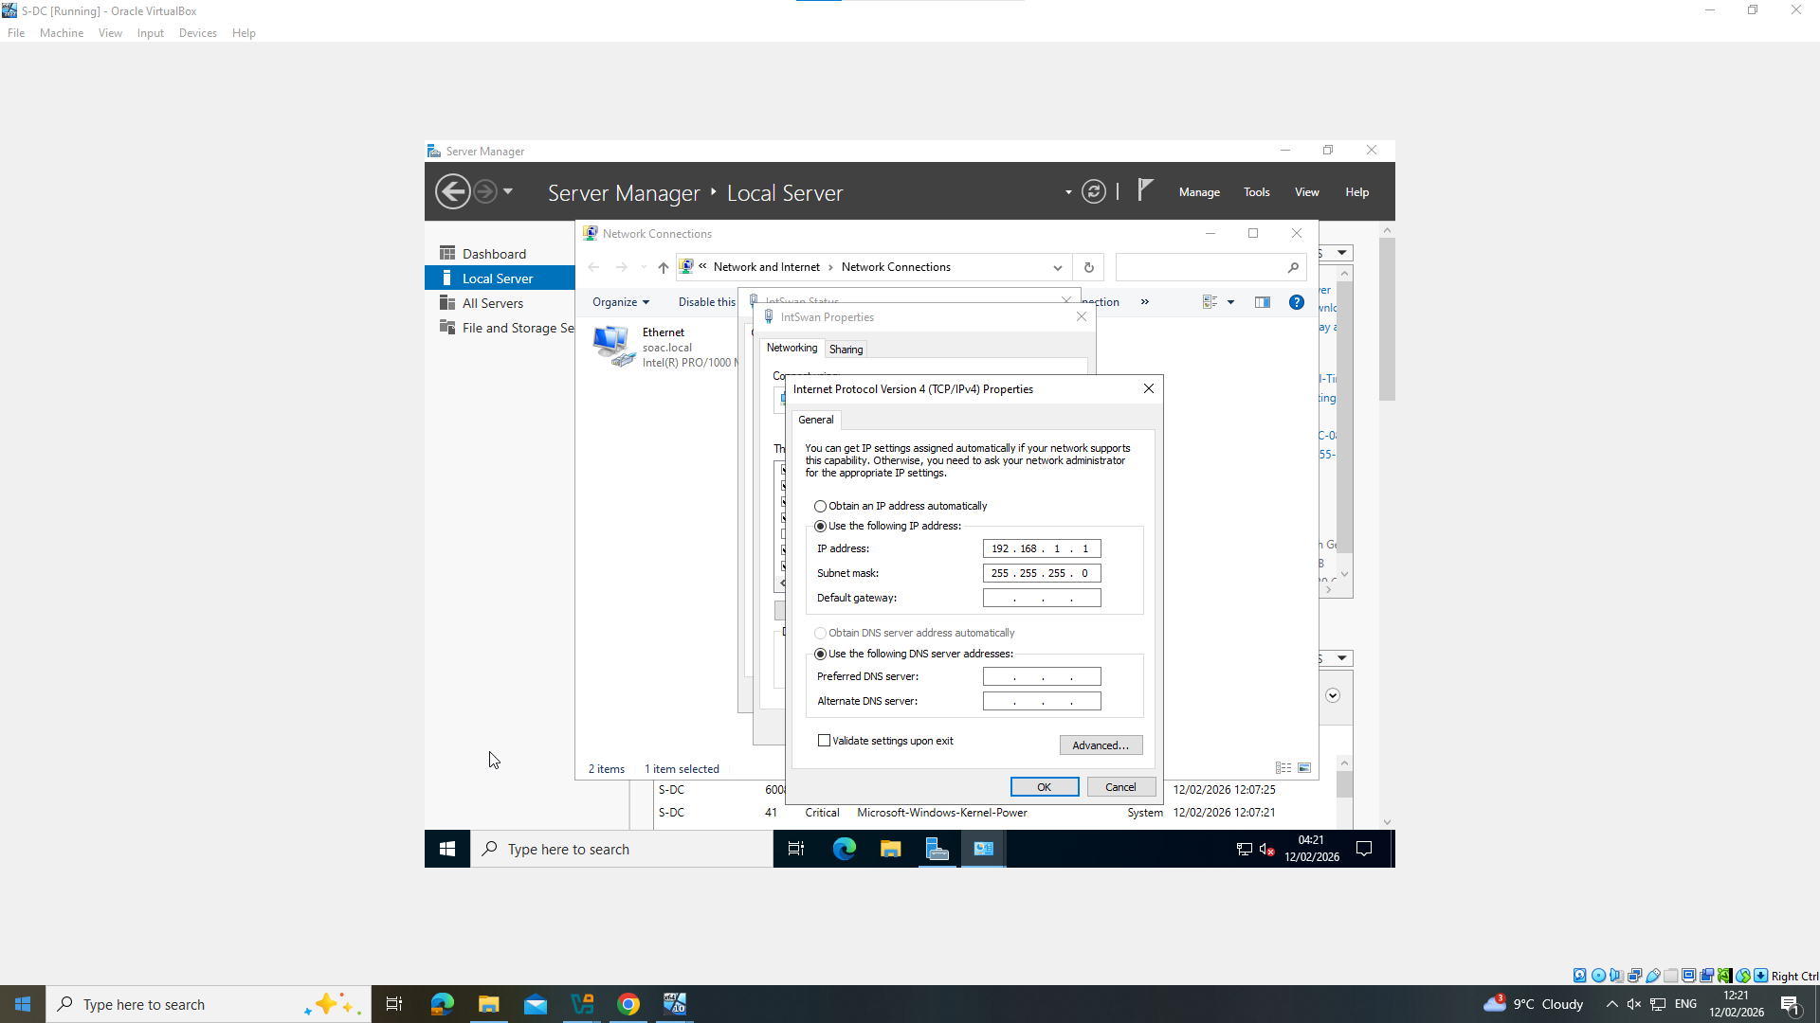

2 screenshots showing the ip addressing for the S-DC Windows server

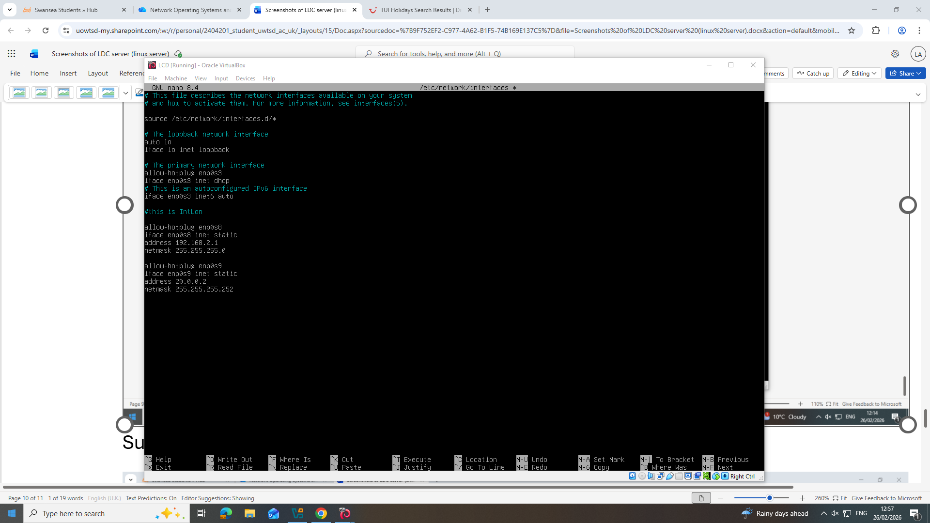

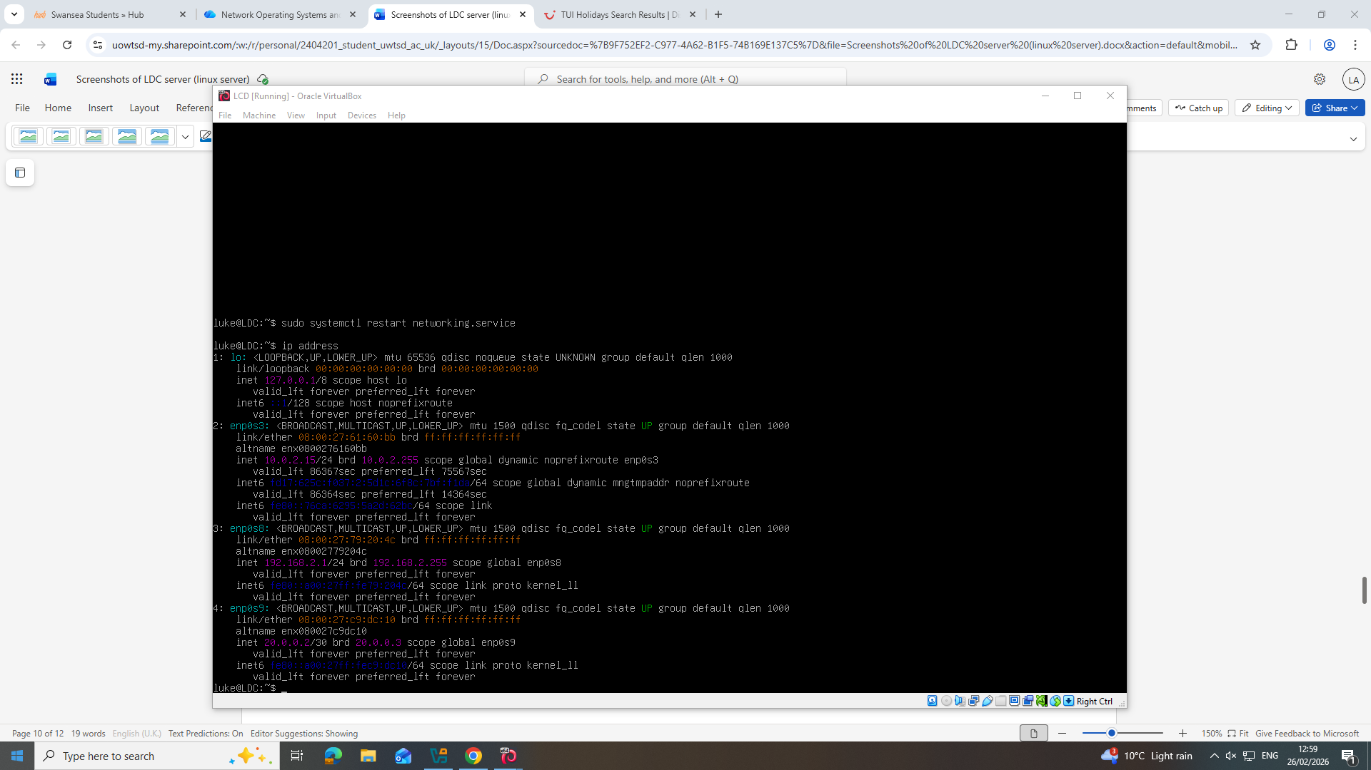

2 screenshots showing the IP addressing for the L-DC Linux server

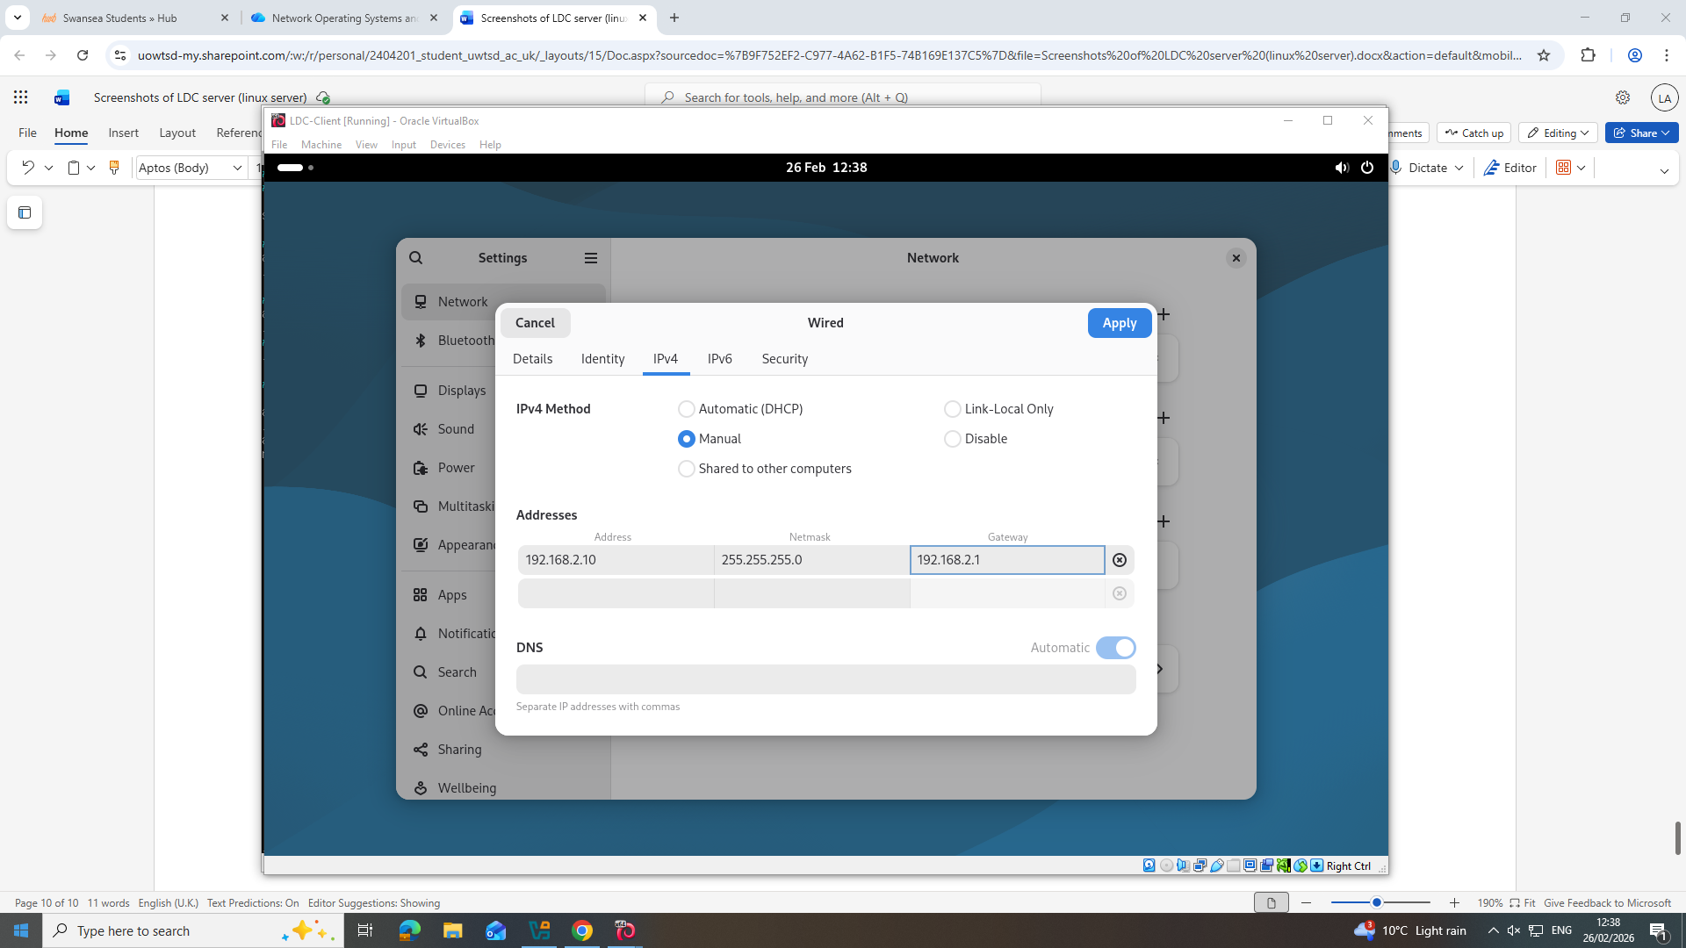
Screenshot showing the IP addressing for the L-DC Linux Client

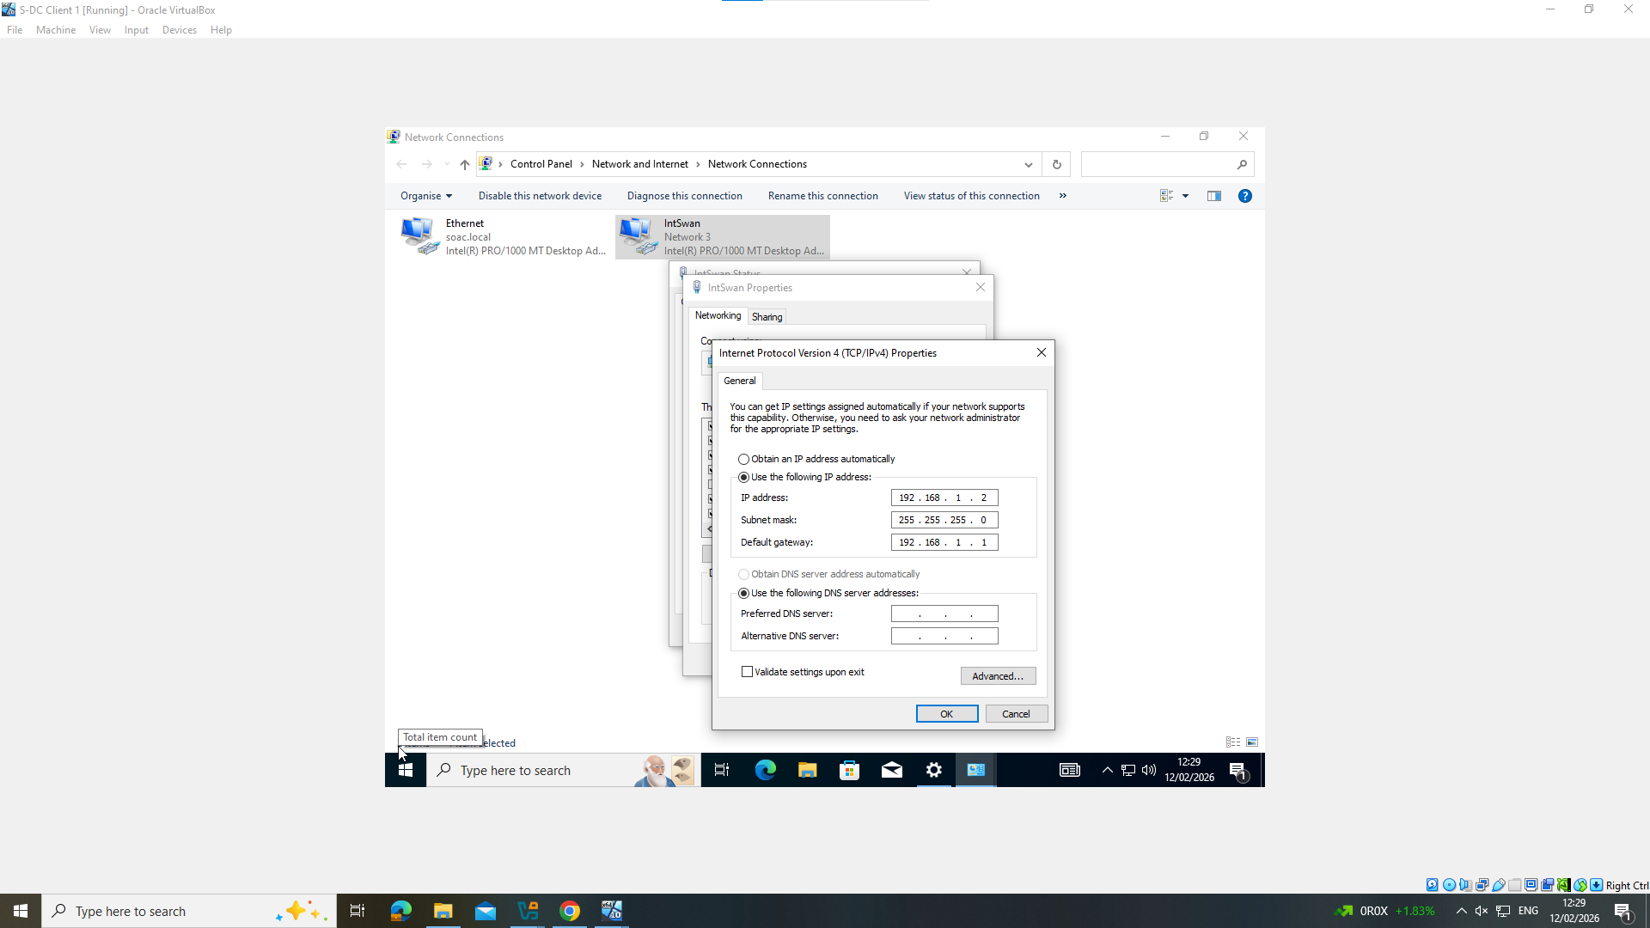
Screenshot showing the IP addressing for the S-DC Windows Client

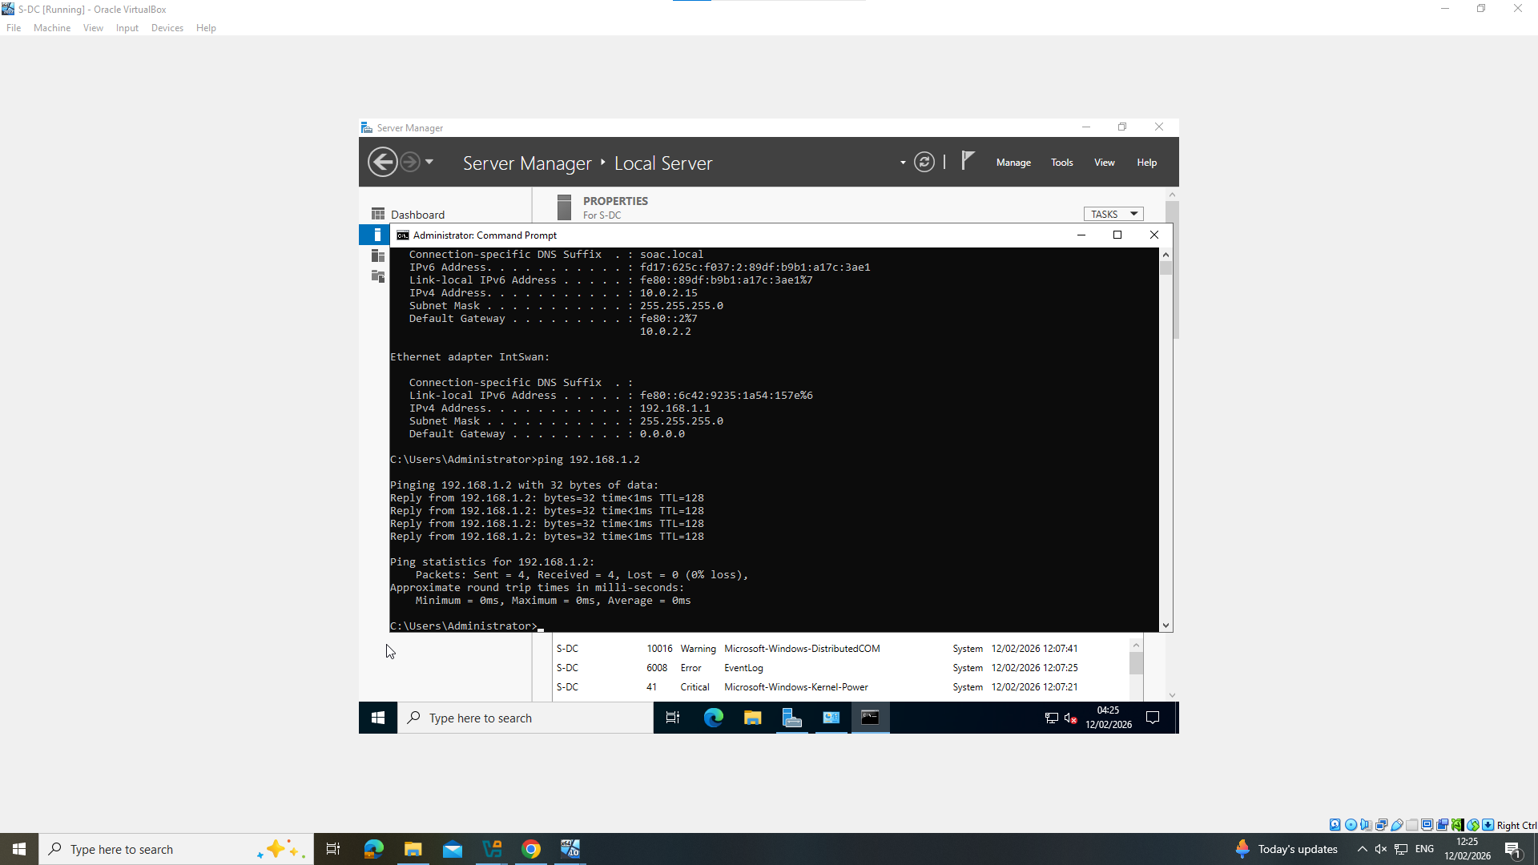
Screenshot showing the S-DC windows server pinging the S-DC Windows Client

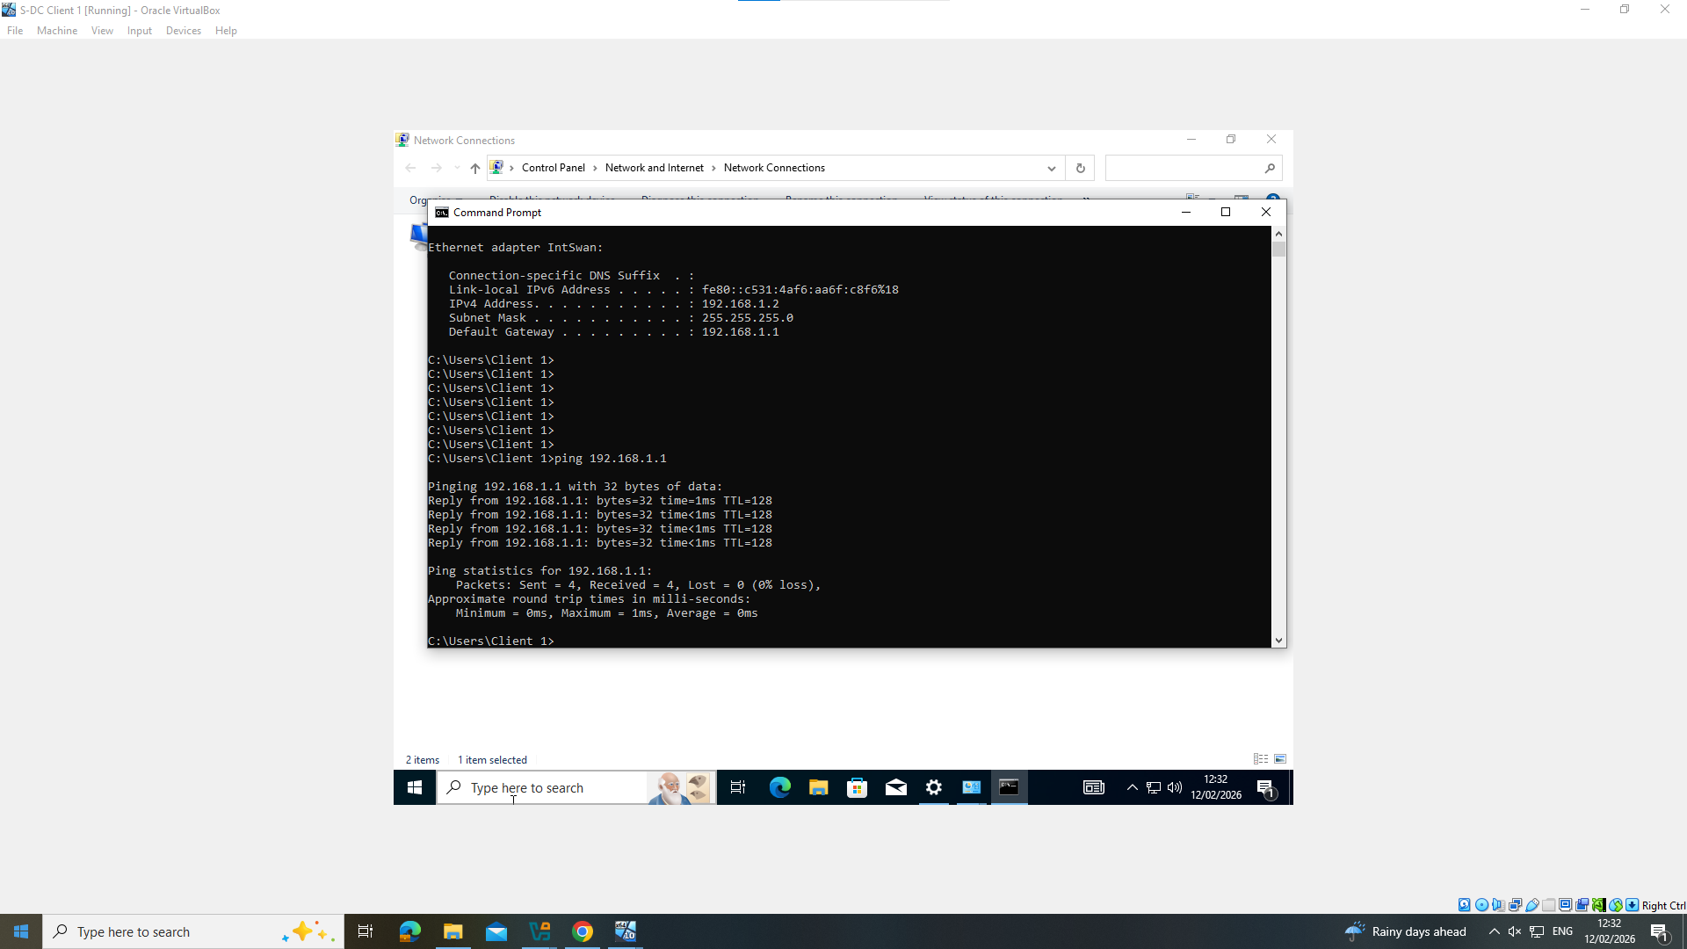
Screenshot showing the Windows Client pinging the S-DC windows Server.
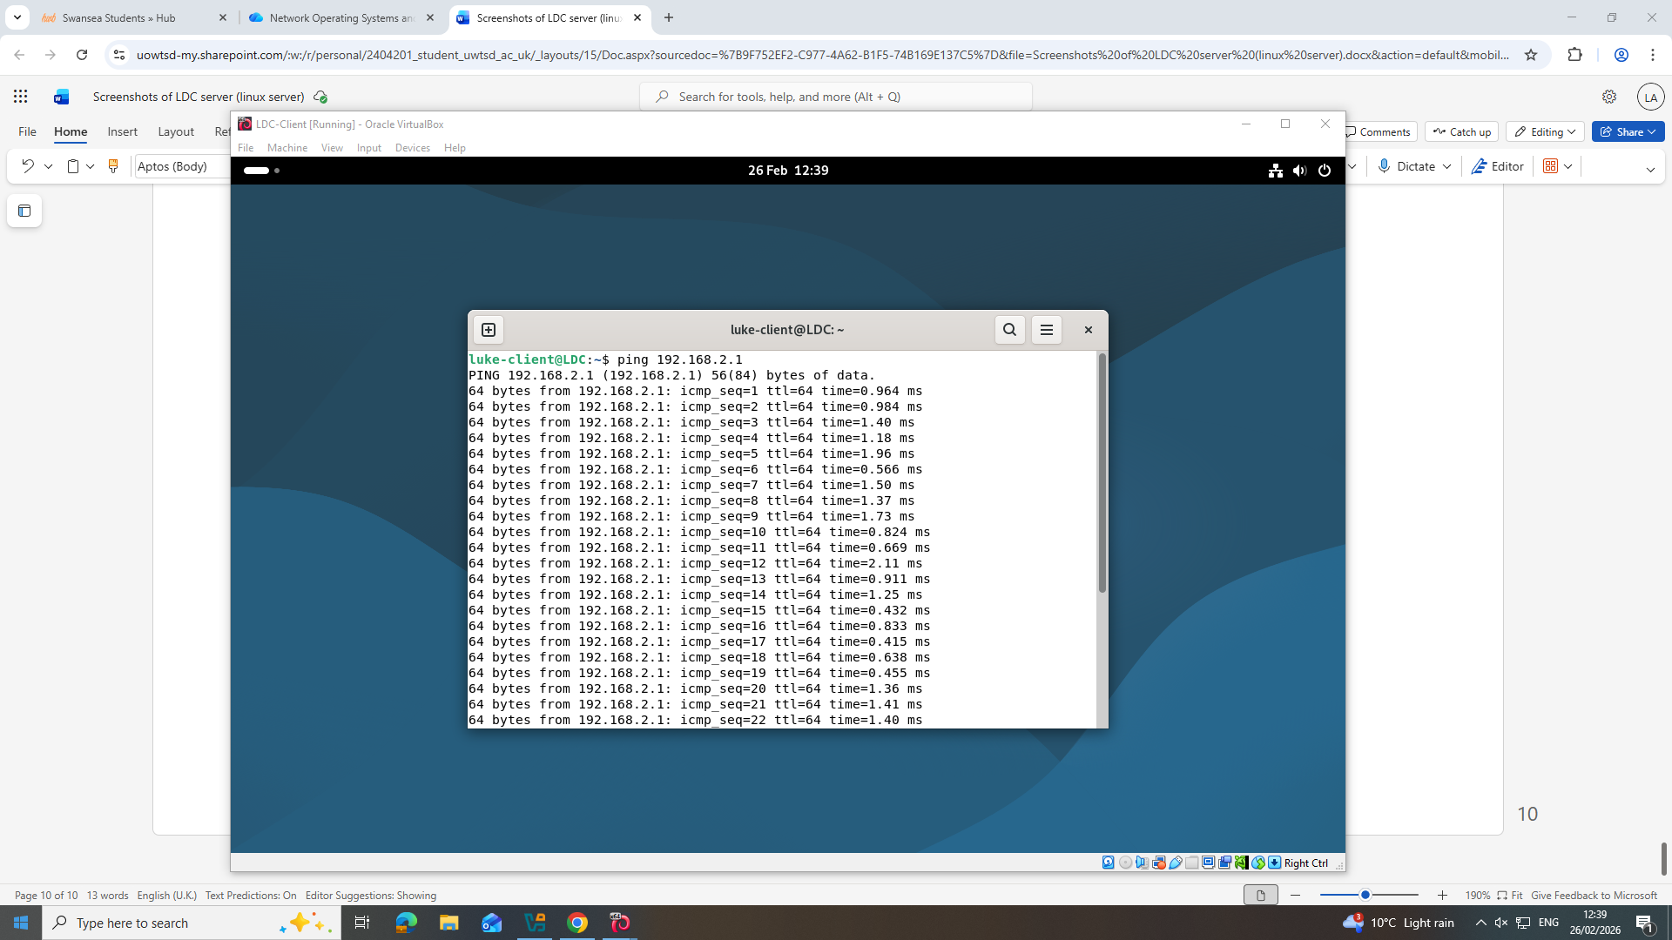
Screenshot showing the L-DC Client pinging the L-DC server.

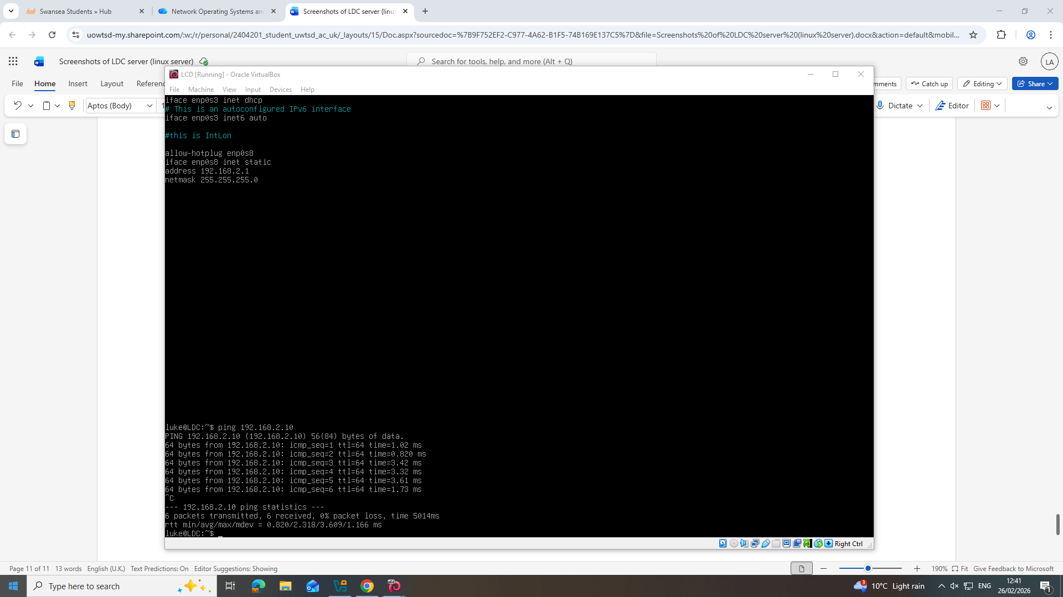
Screenshot showing the L-DC Linux server pinging the L-DC Client

Task 3
Technical reflection
In the development the virtualised network in task 2, I believe I was able to meet the requirements of the task well ensuring that I followed the topology given by implementing a windows 2022 server and a windows client along with a Linux server and client ensuring I met the criteria. I configured all the required clients and servers using a type 2 hypervisor on Oracle Virtual Box allowing me to work on all the machines simultaneously. However, I encountered some minimal setbacks while using Linux server with IP addressing. I configured the wrong IP address initially which was quickly and easily fixed with the help of my peers.
Personal reflection
I have previous experience working with Windows servers and type 2 hypervisors having previously using them in my level 3 course so configuring them wasn’t a new concept for me. However, configuring a CLI Linux server was something I have never done previously and as a result I had some drawbacks initially getting used to it but with the help of my lecture, peers and online videos was able to learn and meet the requirements set. While struggling initially I found learning to use a CLI Linux server to be an extremely important skill for me to learn allowing me to understand where I was struggling and how I can overcome the challenges.

References

[1] | AWS, “AWS.Amazon.com,” Amazon, [Online]. Available: https://aws.amazon.com/what-is/hypervisor/.
[2] | Cloudflare , “Cloudflare.com,” Cloudflare, inc, [Online]. Available: https://www.cloudflare.com/en-gb/learning/network-layer/internet-protocol/.
[3] | GeekForGeeks, “geekforgeeks.org,” 7/ 10/ 2025. [Online]. Available: https://www.geeksforgeeks.org/computer-science-fundamentals/what-is-an-ip-address/.
[4] | GeeksForGeeks (Switch and routers) , “Geeksforgeeks,” [Online]. Available: https://www.geeksforgeeks.org/computer-networks/difference-between-router-and-switch/.
[5] | Wikipeadia , “Wikipeadia.org,” Wikipeadia, [Online]. Available: https://en.wikipedia.org/wiki/Routing_protocol.
[6] | (. S. Classroom, Static vs dynamic routing & routing metrics, Sunny Classroom, 2023.
[7] | Microsoft, “azure.microsoft.com,” Microsoft, [Online]. Available: https://azure.microsoft.com/en-us/resources/cloud-computing-dictionary/what-is-vpn.
[8] | NCSC, “NCSC.gov.uk,” NCSC, [Online]. Available: https://www.ncsc.gov.uk/collection/device-security-guidance/infrastructure/virtual-private-networks.
[9] | Microsoft Learn, “learn.microsoft,” Microsoft, [Online]. Available: https://www.ncsc.gov.uk/collection/device-security-guidance/infrastructure/virtual-private-networks.
[10] | R. Allen, “ActiveDirectorypro.com,” Active Directory pro, [Online]. Available: https://activedirectorypro.com/dhcp-best-practices/.
[11] | Microsoft Learn , “learn.microsoft.com (active directory),” Microsoft, [Online]. Available: https://learn.microsoft.com/en-us/windows-server/identity/ad-ds/get-started/virtual-dc/active-directory-domain-services-overview.
[12] | Microsoft learn, “learn.microsoft.com (AD certificate authoritise),” Microsoft, [Online]. Available: https://learn.microsoft.com/en-us/windows-server/identity/ad-cs/active-directory-certificate-services-overview.

