BMSW5106
Module Title: Knowledge & information management skills for the workplace
Student Name: Tracy Asantewaa
Student ID:1713700
Lecturer’s Name: Mohammed Kalam
Date of Submission: 11th may 2020

Word Count: 4298

Contents
Introduction 3
Company overview: 3
Task 1 – Evaluate the concept and importance of knowledge management 3
Data 3
Information 3
Knowledge 4
Explain the relationship between data, information and knowledge 4
Knowledge management 6
Explain the relationship between individual knowledge and organizational knowledge 6
Organizational knowledge 6
Individual knowledge 7
Apply analysis and modelling techniques to identify knowledge assets 7
Knowledge assets 7
Evaluate actual and potential knowledge assets 9
Actual knowledge assets 9
Potential knowledge assets 9
Task 2 – Understand the key knowledge management processes in the context of organizational development 9
Explain what is required to create, store, apply and integrate knowledge 9
Consider the importance of Intellectual Property rights 11
Task 3 – Develop a framework for establishing a knowledge management culture 12
Explain the contribution knowledge assets have on an organization 12
Evaluate the organization’s framework for enabling knowledge sharing 12
Recommend improvements to the current framework 14
Conclusion: 15
References 16

Introduction
Knowledge & information management skills are capabilities which enables an individual to manage others effectively within an organizational context (Baren, 2011). However, knowledge management skills differ according to the position, for example, leadership position requires managing, influencing, organizing skills but technical positions prefer IT skills. On the other hand, the capability of collecting and managing information from various sources as well as distributing them to various recipients fall under organisational responsibilities of employees and top managers simultaneously. As such, information can be of both technical and physical type and the information manager should be capable of managing this information throughout the whole lifecycle of the information’s relevance to the context regardless of its format (Callahan, 2018). So, this report is going to evaluate the concept and importance of knowledge management in terms of an organization’s knowledge assets and their management at first step. Then, I will focus on the key knowledge management processes required for organizational development. After this I will develop a framework for establishing a knowledge management culture. Indeed, I can say that this assignment is a brief discussion of knowledge and information management skills as well as the practical application of the strategies and technologies as well.

Company overview:
In this report, I have taken the British multinational grocery & general merchandise retailer “TESCO Corporation” as an example. It is a UK based company which has 3,400 stores all over the country, but it’s headquarter is situated at Welwyn Garden City, Hertfordshire, England in United Kingdom. Tesco being the 3rd largest company of the country has diversified its operations into almost all areas of retailing, such as retailing of books, clothing, furniture, toys, petrol, telecoms and internet services.

Task 1 – Evaluate the concept and importance of knowledge management

Data
Data is the raw form of observations which may not be considered as a valuable source until it is transformed into information (Milovanović, 2011). For example, a series of non-random facts or a collection of observations through research can be considered as data. Such as a NID number or a date is a source of data.

Information
When data is processed and transformed into a valuable form useful for certain purpose accomplishment, then it is known as Information (Liebowitz, 2011). So, basically a meaningful data is considered as information. For example, a collection of data after being processed for a reason into a meaningful source and received as well as accepted by the information taker is information. As such, bank statements, or bus time schedule can be considered as information.
However, information is the meaningful transformed form of data through defined process. Sometimes when data is processed as information with the intention to serve the people, then it can play the role in reducing uncertainty or changing behaviour.

Knowledge
Knowledge is such kind of capability of deliberating well with regards in order to deal with life (Garfield, 2018). Also, knowledge means enlightenment which indicates an individual to lead his life in the right way. So, we need knowledge and judgmental mind in order to live a better life as well to build better social relations.
However, knowledge is something which is an essential, but less-sufficient; since to be wise, one person needs to be knowledgeable. But, any person who is knowledgeable cannot be called wise at all time. Basically, knowledge guides an individual to judge things in the right way at the same time in a changing observation perspective.

Explain the relationship between data, information and knowledge
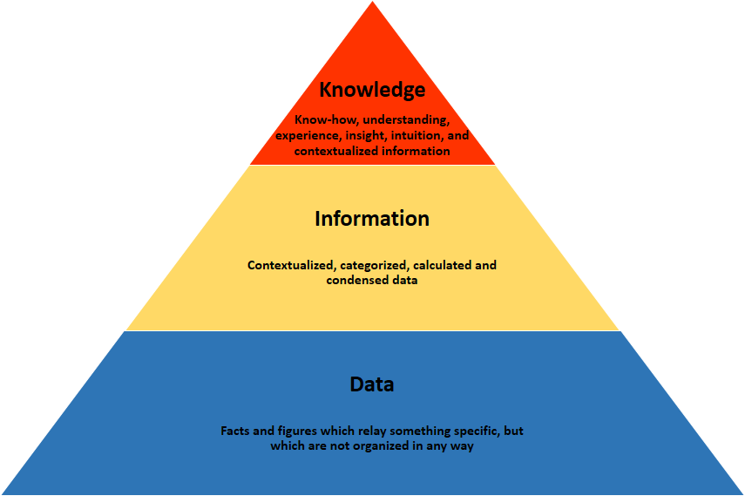
Fig: Data, information & knowledge relationship pyramid, (Mohanta, 2010)
Data, information and knowledge those are the terms which can be used interchangeably at times (Mohanta, 2010). For instance, data is a raw fact which have no value in real until it is transformed to information. So, basically information is the contextual form of non-organized data. However, when data is processed with the aim to be accepted into a meaningful and organized form, then it is known as data.
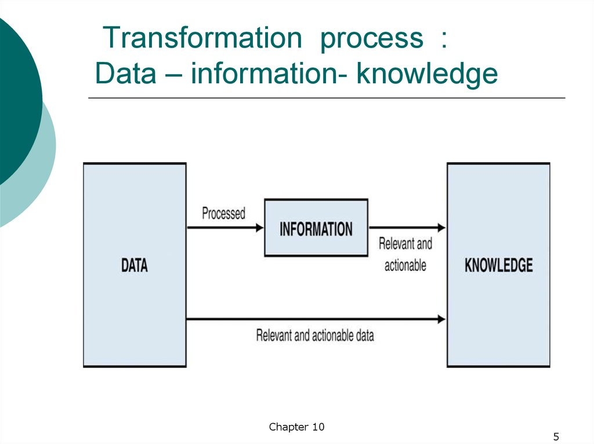
Fig: Data- information- knowledge transformation (Lips,2014).

Again, evidenced and experience-based information is actually known as knowledge. So, when information is processed into a relevant and understanding fact it will be considered as knowledge (Lips, 2014).

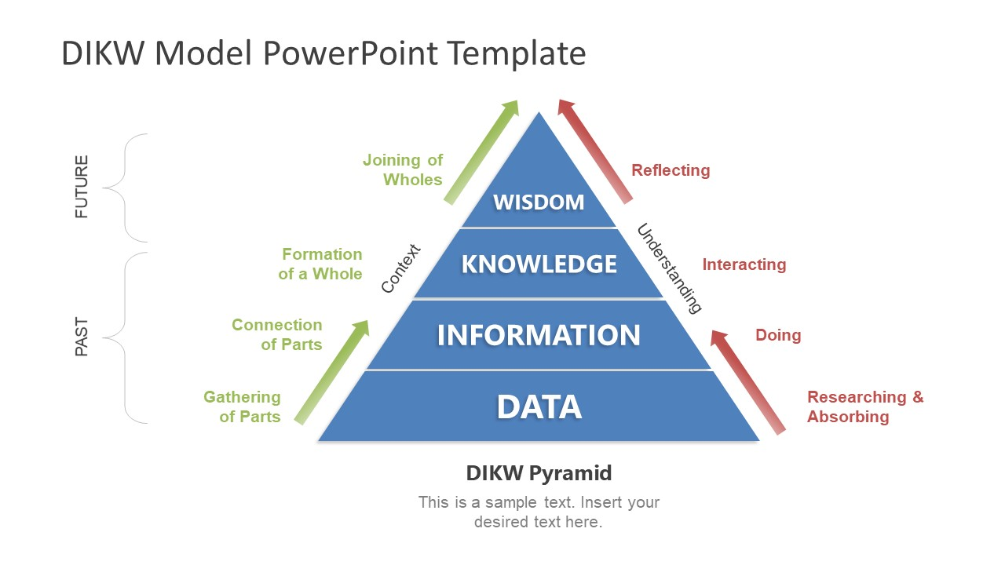
Fig: DIKW model of pyramid (Kenneth Boulding, 1955)

DIKW model is a pyramid where relation between data, knowledge and wisdom is shown clearly. It says, when a part of a fact is collected or gathered it is considered as data. When it is connected accurately after research and processing it is information, then when it is interacted and formatted in a contextual form it is knowledge. For example, in TESCO, customer information such as purchase history with different data are collected in a store for several customers in a day. When the data is treated for overseeing the customer reference trend by accumulating all the data in a format, those are called information. But, when management of TESCO plans long term organisational goals based on their own experience with the previous plans and based on the collected information, this can be termed as knowledge.

Knowledge management
Knowledge management is such kind of capability which is used by the community in an organization in order to gather, utilise and improve as well as use knowledge most frequently in a proper way whenever it is needed so that they can accomplish it with an added value in their professional life. This term was introduced by Kelleher and Levene in 2001 in British standard institute.
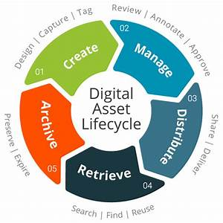
Fig: Knowledge management cycle (Kelleher and Levene, 2001)
In any organisation, considering all available knowledge leads to effective planning, working and outcomes. As such, knowledge management of both knowledge in individual level and organisational level should be a priority. For example, knowledge management is done through annual organisational report and financial reports by TESCO as they cumulatively discuss the trends and effectiveness of applied organisational strategies in detail to improve knowledge in the certain area of concern.

Explain the relationship between individual knowledge and organizational knowledge

Organizational knowledge
Organizational knowledge means the collective form of knowledge which possessed by a group of people who belongs to a specific organization (Hatch, 2010). So, organizational knowledge is a collective series of information which is easily shared by people of an organization for communication but difficult to transfer.

Individual knowledge
Individual knowledge means the contextual information that is used and believed by an individual in order to justify the truth as well to differ the right or wrong. So, when an individual store the cognitive structure through learning process in his memory, it is called individual knowledge.
The relationship between individual knowledge and organizational knowledge is an argued issues now-a-days. However, individual knowledge can be transformed into organizational knowledge. When an individual share his or her knowledge with a group of people in an organization then it turns into organizational knowledge (O’Dell, 2011). But organizational knowledge cannot be transformed or retain.
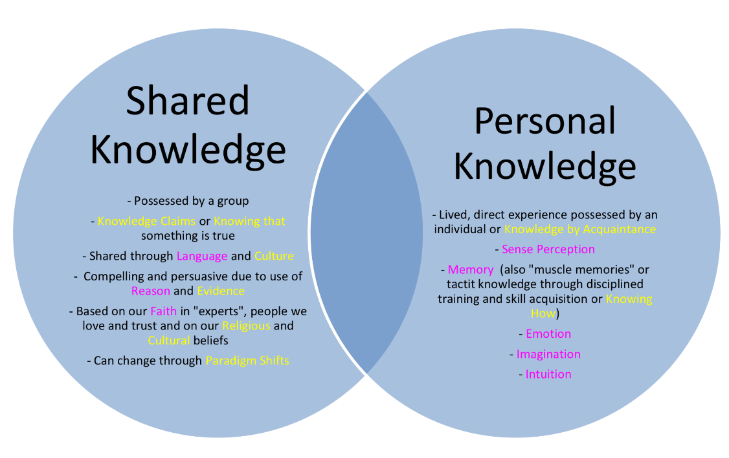
Fig: Individual knowledge- organizational knowledge relationship (Hatch, 2010).

But, the differences between organizational knowledge and individual knowledge can set up different management strategies for knowledge management (Ebel, 2013). For example, organisational knowledge such as the financial resource and asset calculations provided in the annual report of TESCO can lead to the management and business strategies for the next fiscal year. But, individual knowledge of employees by the HR is just as much important to increase employee engagement by planning and organising different interventions programme.

Apply analysis and modelling techniques to identify knowledge assets

Knowledge assets
A knowledge asset is such kind of asset which is actually generated from experience or creation from an organization but can be transformed into physical asset in the future (Corney, 2018). As, how to identify and how to turn knowledge assets into profitable capital. Since knowledge asset add value to the development of an organization therefore it is considered as resource. Knowledge asset generate new knowledge. It is Knowledge management who accomplishes knowledge asset within an organization to achieve the desired goal of that organization including structural knowledge (data, policy) and market knowledge (relation with the clients and competitors).
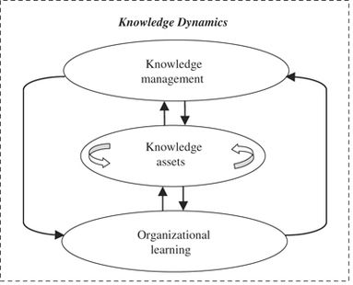
Fig: Knowledge assets, (Bebensee, 2010).

There are four types of knowledge asset, Core knowledge asset (reputation or corporation culture), Dynamic knowledge asset (profitable but not durable), Supportive knowledge asset (durable), Low budget knowledge asset (less profitable & durable).
In order to determine the areas where knowledge asset lies in an organization, is known as mapping. Mapping also identifies Concepts, ideas, skills, problems, solutions for identifying knowledge asset (Bebensee, 2010). Mapping is a technical process that includes-
Inventing a knowledge asset: Including owners, the organization in the process, maintaining the guidelines, giving reviews.
Appreciating the role of knowledge: Appreciating the functions of knowledge in the organizational context.
Mapping knowledge flows: Collecting organizational and departmental developmental chart of the organization.
Identifying knowledge gap: Through training program or client reviews identifying the knowledge gaps of the organization.
Identifying the risks: Through the register or lesson learned exercise have to point out the risks and issues.
Integrating the range of information: This organization integrates a range of information including customers’ information such as customer data collection, analysis as well as using the data in the process etc.
When the techniques of identifying knowledge assets in an organization like TESCO is applied, we came to learn the knowledge asset areas of this multinational company. However, they focused on the information’s about the customers, so they collected, integrated and finally used that data which includes each customer individual profiles. From this data they made a report pointing where the purchase is made most, which products are purchased more and when. Depending on this information’s they made advertisements and campaigns. Finally, the started their promotions as well as thus got the popularity as a multinational company.

Evaluate actual and potential knowledge assets

Actual knowledge assets
Actual knowledge asset is such kind of knowledge asset which is real physical asset of an organization. For instance, the business relationship with clients or competitor (Gurteen, 2012).

Potential knowledge assets
Potential knowledge assets are such kind of knowledge asset which may be owned by an organization in the future. For example, future business profit of an organization (Goodluck, 2011).
If I evaluate the actual and potential knowledge asset of the TESCO multinational organization, I can say that the popularity they got worldwide, or the customer satisfaction level of the organization, or the widespread service standard, or their top class management facilities, or their skilful employees, or their business concept everything can be considered as the actual knowledge asset of the organization.
Again, if we analysis on the potential knowledge asset of the organization we can include the top position in the country as a multinational company which they can own in the future.
SO, from the above discussion, we can now understand how the knowledge management plays an important role in an organization by accomplishing knowledge assets.

Task 2 – Understand the key knowledge management processes in the context of organizational development

Explain what is required to create, store, apply and integrate knowledge
In order to create, store, apply and integrate knowledge as well as experience of an organization, a collective organization of employees, procedures, software, data collection as well as latest technological devices are required (Altaher,2010). This organized collection of employees, data and device, technologies are known as the knowledge management system (Heaidari, 2011). For instance, if we consider a work in an international company which delivers around 2,500 projects each year, it is almost nearly impossible for one person to keep a close observation on the projects individually which is the responsibility of top managers in TESCO. Consequently, I have a lot of senior managers who handles all those big budget projects, but they are retiring soon. So, in this critical situation, if I want to capture the project management experiences or knowledge of handling those big projects from the respective seniors for the future development of the organization, therefor I would definitely need a knowledge management system.
However, knowledge management includes various types of knowledge. For example, explicit knowledge which is objective type and can be measured. Such as, analysing the total budget of a specific project. On the contrary, tacit knowledge is something that cannot be measured. For example, an international project which has a relative amount of budget as the similar national projects without using international components. It is considered as quite a tough job for the managers to transform tacit knowledge into explicit knowledge (Hecht, 2011).
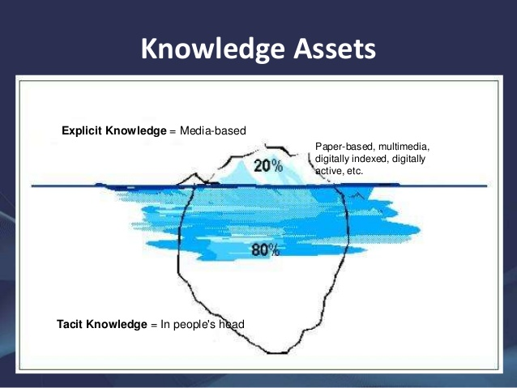
Fig: Explicit KA & Implicit KA (Hecht, 2011).
For instance, for a chosen the multinational company where I work, an example of tacit knowledge in an organization can be the communication challenges or the language barriers that can be extremely difficult to transform into explicit knowledge. On the other hand, explicit knowledge such as annual store plan of certain TESCO store can be transferred to the then store managers at any point of time in a year for successful understanding of his on the stores business policy and planning.
Again, if I want to create, store, apply and integrate knowledge at first step I need to identify the knowledge asset of my organization through the knowledge mapping process. Then, through this process I have to make a document on the basis of the workflows as well as the decision-making process which involves all workers of the organizations who create, store, apply knowledge including the engineers, designers, scientist or professionals. Although, all of them are part of an organization, there may also have assets like the senior managers in an organization. For instance, managers and store clerks are not the only type of employee in TESCO stores throughout UK, they include management specialists, marketing managers, engineers looking after electric supply system, devices and equipment, IT specialists helping collection, storing and integration of data by managing database and so on.
As described before, the process of identifying the assets of the organization is one step in the creation, storing, application and integration of knowledge in an organisation. So, now after identifying those assets I have capture those tacit and explicit knowledge in group or individual. Basically, capturing knowledge means collecting all the relevant and necessary documents in order to organize them meaningfully. So, after this step, I can now store all those knowledge in a respiratory form including database, reports, documents etc. And, finally using specialized technological tools I can integrate this knowledge in a meaningful and useful way.

Consider the importance of Intellectual Property rights
Intellectual property refers to the intangible asset of an individuals which are mostly originated by their own intellect. So, when considering intellectual property rights, it means to consider the original creator of that intellectual information’s ownership of that through which is in turn utilised to create better systems, applied for creation of further intellectual properties serving human life one way or another. Different intellectual properties of this age include patents, ownership of digital information spread, trade secrets, etc. Intellectual property rights are considered to play a vital role in our national economy. Today, hundreds of companies are buying original and safe products using their own trademarks, copyrights, IP numbers, etc. So, in this situation only intellectual property rights can save them domestically and can protect their rights as well. There are several important factors relevant to applying intellectual property rights. These include-
In creating high-paying jobs: From the American industries we can see the example of IP extensive industries. They employ more than 55 million peoples nationally as well as over 100 of people internationally. The jobs in those companies are seem to grow faster than the average jobs as well as the workers earns about almost $50,576 which is 30 percent more from the non-IP intensive company workers.
In driving economic growth: As we can see that, Americas IP growth is $5.8 trillion since the IP intensive companies are over 38 percent of the total. This overwhelming economic impacts on the national economy growth of America which is about 40 percent.
In protecting consumers & families: In America, IP rights not only make people to be wise in the selection of their safety, reliability and effectiveness while purchasing products, but also ensures high-quality and original products for the consumers. So, overall IP rights gives the consumers’ confidence so that they can rely on the market.
In generating breakthrough solutions: According to WHO, they served nearly 300 drug products which is insufficient so the local pharmaceutical industries have to co-operate. Again, innovative agricultural companies are playing an important role to fulfill the food demand as well. Besides, IP driven discoveries contributes in green technologies which indirectly attributes in the global climatic change.
In encouraging innovations: IP rights encourages the innovative economy to be adventurous as well facilitates information and knowledge technologies as well. This is American founding fathers made IP rights mandatory for the authors and inventors.
In TESCO’s context, intellectual property rights are applied for business strategies, brand names, brand contents and designs, etc. So, considering their intellectual property rights, other companies are required to ask for their approval before applying the same in own business. It is also considerable that, taking trade data not available to public for academic paper writing can be also deemed as the violation of their intellectual property rights.

Task 3 – Develop a framework for establishing a knowledge management culture

Explain the contribution knowledge assets have on an organization
Knowledge asset can contribute in achieving competitive advantage which means creating value better than the present potential competitors in the long term of an organization (Doan, 2011). As a result, this competitive advantage contributes in developing the knowledge skill of an employee. The contribution of knowledge assets can be the following and much more:
To enhance managers’ capability: Knowledge asset can contribute in enhancing manager abilities as well as skills in such activities which add value to the organizational development. For instance, when manager takes decision to use competencies in order to achieve competitive advantage as well as outperform the potential competitors (Al-Hakim, 2011).
To capture, keep, increase, and derive human resources: Human potentials such as the skills, knowledge, experience, and intelligence, training and bonding those are considered as the knowledge asset of an organization. A successful organization possible only if those resources are captured, kept, increased and derived into benefits of the organization.
To bring a change: In order to bring a positive change in the organizational performance the core values should be developed as such the employees should empowered, so we can say by developing knowledge asset an organization can bring success.
To prevent waste of knowledge: In order to prevent waste of knowledge an organization needs a fruitful knowledge management system which can ensure to reshape the knowledge by creating, identifying, collecting as well as integrating knowledge assets (Mosconi, 2013).
So, from the above discussion, I can relate the contribution of knowledge asset with my organization context. For example, TESCO top managers have been able to sustain the business sand progress it throughout its lifespan by engaging with the knowledge assets. Throughout the long run of the business, there had been multiple changing scenarios in the retail business sector. But, the knowledge assets contributed to the important of different business functions to be successful in delivering positive outcome regardless of this changes. Indeed, I can say that, knowledge asset should be emphasized for the future betterment of any organization.

Evaluate the organization’s framework for enabling knowledge sharing
In an organizational context, there are a lot of knowledge assets which can be captured or not, but understanding the way of committing resources in the best possible way is knowledge sharing which is kind of a decision-making frame-work and easily understandable to everyone (Allameh, 2011). Knowledge sharing enables these knowledge assets to be effective for utilisation on required points of operations. Industrial memories are such knowledge assets that can enable capturing of data which can then be shared through the framework.
However, Brain Gongol categorized “Industrial memory” in three interesting parts-
Event Memories: It’s like the arrival of new employees.
Process Memories: It notes the duration time of a project which can be repeated in future days.
Decision-making Memories: it explains how the company selects a path over another.
These three categories of memories can be expanded according to Ewen La Borgnes’s observation on the left work projects. Although expertise is mostly implicit, the output and the network were explicit.
When, Information and output produced, Expertise, A network of connection, all of these are put difficultly in capturing memories, the following graphic are the interpretation. However, this graphic explains that the implicit knowledge is easy to capture and best suitable to enterprise-wide initiatives. On the contrary, explicit knowledge needs manual interpretation to make it sensible.

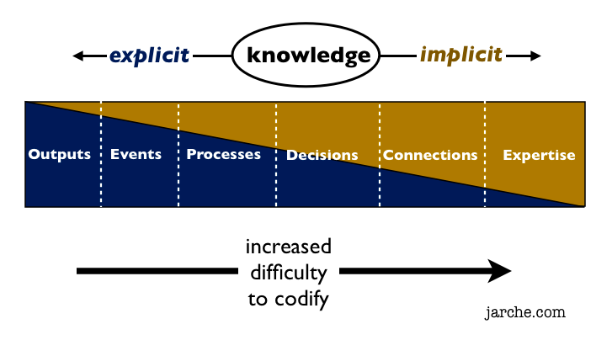
Fig: Knowledge sharing framework (Newell, 2009)
None of the above categories pose a complete spectrum. This is why we have to find-out the most accurate knowledge management framework in order to codify the knowledge artifacts. So, when we look back to the Patti anklam perspective we can see the differences between big knowledge management, little knowledge management and personal knowledge management. However, this distinction is effective because big KM is easily captured and good for knowledge, little KM provides new structure for group whereas PKM puts individual control for making sense. Therefor this knowledge sharing framework can be considered as an effective framework for the employees to share knowledge.
So, this framework is probably the best platform for sharing knowledge in an organizational context among the employees (Newell, 2009). This figure gives an idea of a structure which possess a full spectrum of knowledge sharing to support intuitional memory. In my experience, of organisational knowledge sharing in TESCO, this frame work is utilised for effective knowledge management in the organisation for achieving effective outcomes.
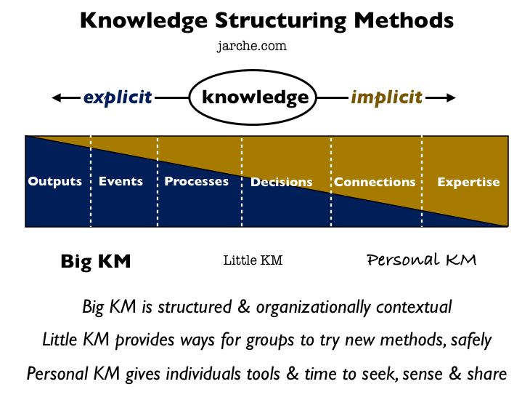
Fig: Knowledge sharing framework (Newell, 2009)

For instance, on the basis of the above discussion I can say that, if I choose a knowledge management for my organizational context where I work, I can choose the following one framework. Since, here big KM is much sufficient but complex in characteristics, the little KM and PKM need to co-operate the big KM. Indeed, these three have to function co-operatively in order to provide the best.

Recommend improvements to the current framework
The current knowledge-sharing framework in my workplace is not an appropriate to share knowledge among the employees. Also, TESCO can and need to continually improve its current frame work for knowledge sharing for effectiveness over time in the organisational operations. So, I can take the following improvement initiatives to develop the knowledge sharing platform in my organization:
By developing a conversation friendly environment: Building a collaborative space encourages open and sharing conversations among the employees within an organizational context (Hester, 2011). So, the impact of friendly environment cannot be overlooked.
By encouraging to share knowledge: Since, each of the employees cannot be extrovert or confident enough to share their skills and thoughts with another, so the opportunity should be created from the management to speak comfortably. For instance, the proper context can be built up by setting time for face to face conversation, by seating beside to share content, schedule site visit and meetings once in a week.
By incentivize knowledge sharing: Making new ways to reward the employees when someone shares a content or knowledge that came to the organizational benefit. If an employee contributes in a huge way to profit of the company then offering him a bonus may be a way of rewarding. Again, if someone inputs a little amount but that inspirable then he could be rewarded with little gifts. As a result, these rewards will encourage not him but also the other employees to share knowledge.
By arranging training process: If an employee feels uncomfortable in sharing his thoughts in a group meeting or if he feels insecure to share his content, then a coach can be applied to train his speaking skill as well as sharing skills (Jackson, 2011).
By finding a knowledge sharing software: The right knowledge sharing software enables an employee to find new contents, to take expert advices, to take the advantage of training process encourages the employees to share knowledge. So, thus an organization can be transformed into an organizational culture of knowledge sharing (Andreeva, 2011).
From the above broad discussion on knowledge sharing benefits in an organization also indicates the other aspect of knowledge sharing culture, such as increasing social interaction, raising a problem-solving team etc. If a apply those initiatives in my organizational context such as in case of TESCO’s organisational functions like marketing research analysis, customer service, etc., I believe that knowledge sharing culture would be developed as well as the organization will get the most effective result in the near future.

Conclusion:
Knowledge and information management skills are the potential capability which every employee should poses to attain the highest effective goal in personal as well as professional carrier. These knowledge management skills, knowledge asset all are part of a knowledge management. The system which runs knowledge management is known as knowledge management system. Again, knowledge management identifies the knowledge assets and transforms them into real potential resources. However, knowledge sharing framework is build up by the knowledge management system. So, this assignment describes all the aspects of knowledge management cycle. Beside this, I described the importance of intellectual property rights. At the end, I show a framework of knowledge sharing which indicates the proper environmental platform in organization for sharing each other’s knowledge. I have also many examples for clear conceptions of each theories and applied them in practical context of my experience with TESCO. Indeed, I can say that, if knowledge and information management skills of employees work in a team to create, store, as well as share knowledge effectively within a knowledge sharing framework the organization will be successful in achieving their highest performance goal.

References
- Allameh, S.M., Zare, S.M., and Davoodi, S.M.R. (2011) 'Examining the Impact of KM Enablers on Knowledge Management Processes', Procedia Computer Science, vol 3, pp. 1211-1223.
- Al-Hakim, L.A.Y. and Hassan, S. (2011), 'The role of middle managers in knowledge management implementation for innovation enhancement', International Journal of Innovation, Management and Technology, vol. 2, no. 1, pp.86-94.
- Altaher, A.M. (2010) 'Knowledge Management Process Implementation 2011', International Journal of Digital Society (IJDS), Vol. 1, Issue 4, December, pp. 265-27
- Andreeva T. & Ikhilchik I. (2011) Applicability of the SECI Model of knowledge creation in Russian cultural context: Theoretical analysis, Knowledge and Process Management,
- Baren A. (2011). Skills for Knowledge Management Leaders.
- Bebensee, T., Helms, R., and Spruit, M. (2010), "Exploring Web 2.0 Applications as a means of Bolstering up Knowledge Management", in David Gurteen (ed. 2012), Leading Issues in Social Knowledge Management (pp. 22 – 41). Academic Publishing International Limited.
- Doan Q.M., Rosenthal-Sabroux C., Grundstein M. (2011), A Reference Model for Knowledge Retention within Small and Medium-sized Enterprises. KMIS, 2011: 306-311
- Goodluck, I. (2011), 'Budgeting for knowledge management in organizations', Chinese Librarianship: an International Electronic Journal, [electronic], no. 32
- Gurteen, D. (2012), "Introduction to Leading Issues in Social Knowledge Management – A brief and personal history of Knowledge Management!", in David Gurteen (ed. 2012), Leading Issues in Social Knowledge Management (pp. iii – viii). Academic Publishing International Limited.
- Callahan, S. (2018). Putting stories to work: Discover. In J.P. Girard & J.L. Girard (eds.), Knowledge management matters: Words of wisdom from leading practitioners (49-71). Macon, GA: Sagology.
- Corney, P.J. (2018). When they leave their knowledge (and networks) leave with them. In J.P. Girard & J.L. Girard (eds.), Knowledge management matters: Words of wisdom from leading practitioners (91-111). Macon, GA: Sagology.
- Garfield, S. (2018). Communities manifesto. In J.P. Girard & J.L. Girard (eds.), Knowledge management matters: Words of wisdom from leading practitioners (113-127). Macon, GA: Sagology.
- Hatch, J., (2010). Defining Organizational Knowledge: Turning individual knowledge into organizational intellectual capital,
- Heaidari, M., Moghimi, M.S., and Khanifar, H. (2011) 'The critical success factors in implementing knowledge management: agricultural organization in Islamic Republic of Iran', British Journal of Science 54, vol. 1, no.2, September, pp. 54-75
- Hecht, M., Maier, R., Seeber, I., and Waldhart, G. (2011), "Fostering adoption, acceptance, and assimilation in knowledge management system design", in: Lindstaedt, S., Granitzer, M.: i-KNOW '11
- Hester, J. (2011). Successful KM Storytelling.
- Jackson, M.H. and Williamson, J. (2011), 'Challenges of implementing systems for knowledge management: Static systems and dynamic practices', in McPhee, R. and Canary H. (Eds.)
- Liebowitz, J. (2011) Knowledge retention: What practitioners need to know.
- Milovanović, S. (2011) 'Aims and Critical Success Factors of Knowledge Management System Projects', Economics and Organization Vol. 8, No 1, pp. 31 – 40
- Mohanta (2010). Knowledge worker productivity improvement processes, technologies and techniques in defence R&D laboratories: an evaluative study , Bharath University, School of Management Studies
- Ebel, A., Marchiori, Lucarelli, Lonzi, Fidalgo, Pellicer, & Iglesias. (2013). Knowledge management and decision support with special focus to process and quality optimisation at flat steel production
- Lips, M. (2014). Transforming Government—by Default? In Society and the Internet
- O’Dell, C and Hubert, C (2011) The New Edge in Knowledge: How Knowledge Management Is Changing the Way We Do Business, John Wiley, New Jersey
- Newell, S. et al. (2009). Managing Knowledge Work and Innovation. 2nd ed. Basingstoke: Palgrave Macmillan
- Mosconi, E. Roy, Marie-Christine. (2013). Linking Management and Organizational Performance (Online) International Business Research. Sep2013, Vol. 6 Issue 9, p68-76. 9.

