Week Four – Tutorial Sheet

1. Create the following classes (in red) and add the associated attributes to the class (in green).

User
user’s name
user’s password

Customer
customer’s name
customer’s age
first line of customer’s address

Player
Player’s score
Number of player’s remaining lives

Each of the classes you create should have a suitable name along with an equally suitable name for the attributes. We prefix the attribute names with an underscore to make it clear that these are attributes.

EX:
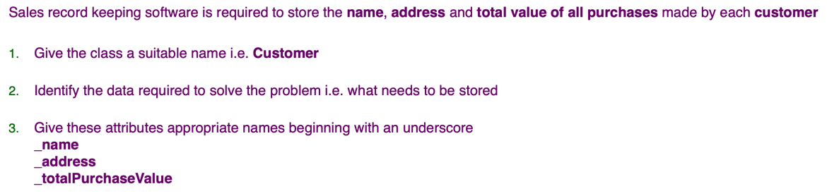

2. In the same manner as the previous task, create classes necessary for the following scenarios:

A shop requires an application that store details for a number of products including the name and the price of each product which is individually entered.

A library is looking to replace their current paper based loan system.

A bottle manufacturer needs to track the serial number (e.g. B8839S) for each bottle, the contents in millilitres (e.g. 330.2ml) and the status of bottle top i.e. whether top is open or closed.

NB: It is beneficial to identify plurality here as this would show the need for collections of items
3. Create the classes necessary for a document filing system. Consider what information may be necessary in storing documents. This could include a variety of pieces of data such as document name and document size in addition to many others. Identify these attributes and include them within the class. Within the filing system there can be many documents and a document can have many pages.

4. Remember the creation of objects is termed instantiation. This is the process of declaring an object in our program for later use. Select one of the classes you have created from which to instantiate an object. Demonstrate instantiation in C#, to support your own notes it would be beneficial to represent the use of this object following instantiation.

5. Outline the benefits of object orientation

6. What is an access modifier in the context of object orientation ?

7. A biscuit manufacturer want to record information on the biscuits being produced by the biscuit baking machine. Specifically, the number of biscuits baked during that day and the number of broken biscuits caused by over baking.

Create an appropriate class and attributes
Create an object representing the baking machine

