University of Wales Trinity Saint David
Wales Institute of Science & Art


Kinetic Energy Recovery
Alternative Propulsion Systems / ACHA5010

Dylan Joseph Arthur
2004556
Date (01/2023)
Contents
1 Introduction 2
2 WLTP cycle 3
3 Selected vehicle 3
3.1 Specifications 3
3.2 Vehicle in WLTP Cycle 4
4 Forces acting upon the vehicle 5
4.1 Rolling Resistance 5
4.2 Aerodynamic resistance 5
4.3 Acceleration Force 6
4.4 Total drag forces 6
4.5 Tractive Forces 6
5 Tractive Power 8
6 Energy 9
6.1 Traction and Braking Energy 9
6.2 Kinetic Energy 10
7 KERS Implementation 12
7.1 Flywheel KERS 12
7.2 Electric KERS 13
7.3 Chosen KERS 13
7.4 KERS Specification 14
8 Conclusion 16
References 17

Introduction
With an increasing focus placed on emissions and efficiency of road vehicles many methods of attempting to improve the Internal combustion engines characteristics have been utilised, such as the addition of a turbocharger, or the use of an Atkinson cycle. However even with intensive measures to improve them the maximum thermal efficiency is expected to be 45% using established techniques (Dahham.R, Wei.H, Pan.J, 2022). This results in 55% of energy still being wasted, and the implementation of a kinetic energy recovery system (KERS) would allow for higher efficiencies due to the kinetic energy of the vehicle being converted into electrical energy under braking to then be employed for tractive effort or other energy requirements (Pipitone.E, Vitale.G, Lanzafame.R, Brusca.S, 2019). This report will detail an investigation made looking at how a KERS could be implemented into an existing vehicle, analysing the WLTP drive cycle to quantify the amount of recoverable energy and how it would affect the drivability and efficiency of the vehicle. Different recovery systems will also be analysed, as any chosen system must be realistic and functional for a road car, not taking up too much space or being overly heavy that would reduce effectiveness.

WLTP cycle
The WLTP (Worldwide Harmonised Light Vehicle Test Procedure) is a modern way of testing the fuel consumption as well as CO2 and other pollutants, having been introduced in 2017 based on real driving data collected from around the world (WLTPfacts.eu n.d.). The cycle takes a total of 1800 seconds over a distance of 23.26km, reaching a top speed of 131.3km/h in the Class 3 test, which Is relevant for most modern higher-powered vehicles, and is split into 4 speed sections of low, middle, high and extra high to cover a wide range of driving conditions. Figure 1 shows the average speeds of the four phases used in the WLTP cycle.
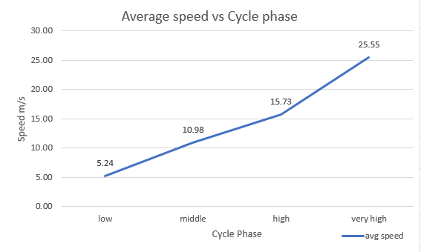
Figure 1: WLTP average speeds

Selected vehicle

Specifications
The vehicle chosen for this investigation is a Honda Civic Type R EP3 (2001-2006), it is a front wheel drive 3 door hatchback that utilises a 2.0L naturally aspirated 4-cylinder petrol engine. To begin any calculations some specifications of the vehicle need to be collected, these are shown below.
Power: 197bhp (147kW) at 7400 rpm (max 8100 rpm)
Torque: 196Nm (145 lb-ft) at 5900 rpm
Weight: Kerb - 1204kg, Test - 1321kg (90% fuel load +75kg (driver & luggage))
Power to Weight: 122.09 W/kg
Aerodynamic Coefficient of drag: 0.33
Rolling Resistance Coefficient: 0.11 (smooth road surface)
Frontal Area: 1.988m²
Claimed Top Speed: 147mph (237km/h)
(Ze Perfs 2022, Racing Cars Technology n.d., x-engineer n.d.)

Vehicle in WLTP Cycle
The collected specifications place the vehicle into class 3 of the WLTP cycle due to its ratio of rated power in W/kg being larger than 34 W/kg at 122.09 W/kg. The max speed of 237km/h also surpasses the class 3 cycle max speed of 131.3km/h therefore it is capable of completing the ‘extra high’ phase, to add to this the max acceleration and deceleration forces were calculated using the test mass of 1321kg and the class 3 cycle max acceleration of 1.58m/s² and deceleration of -1.49m/s². This results in maximum acceleration force of 2087.18 N and maximum deceleration force of 1968.29 N. With this data collected and correct WLTP procedure selected the required tractive effort and forces acting on the vehicle can be calculated.

Forces acting upon the vehicle
In order to calculate the Power required, and energy usage from the vehicle throughout the cycle the various resistive forces acting upon it must be calculated, these include the rolling resistance, aerodynamic resistance, and an acceleration force.

Rolling Resistance
Looking first at the rolling resistance a baseline rolling resistance value of 0.011 was found for a smooth road, this includes the friction between the road and tyres as well as bearings and seals and was kept as constant throughout the cycle, only having an effect on the vehicle while it is in motion.

Aerodynamic resistance
This is the aerodynamic drag force acting on the vehicle throughout the cycle, calculated using the below equation, and increases exponentially as can be seen in figure 2 below showing how the aerodynamic resistive force changes throughout the speed range experienced in the WLTP test procedure.
$$Force=A×ρ×cd×v^{2}$$
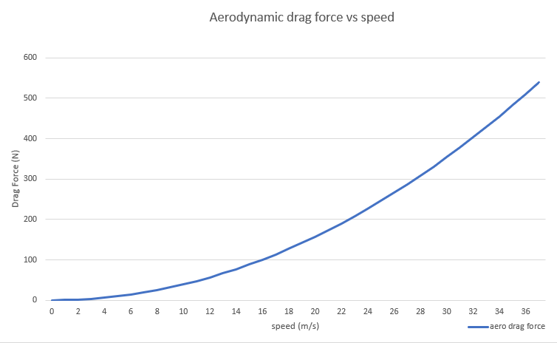
Figure 2: Aerodynamic drag force

Acceleration Force
As during the test procedure the vehicles speed is increasing and decreasing very frequently there is also a resistive force that must be overcome in order for the vehicle to accelerate, this is a product of the vehicles mass and the acceleration in m/s/s. This force also only acts as a resistive force when the vehicle is accelerating.

Total drag forces
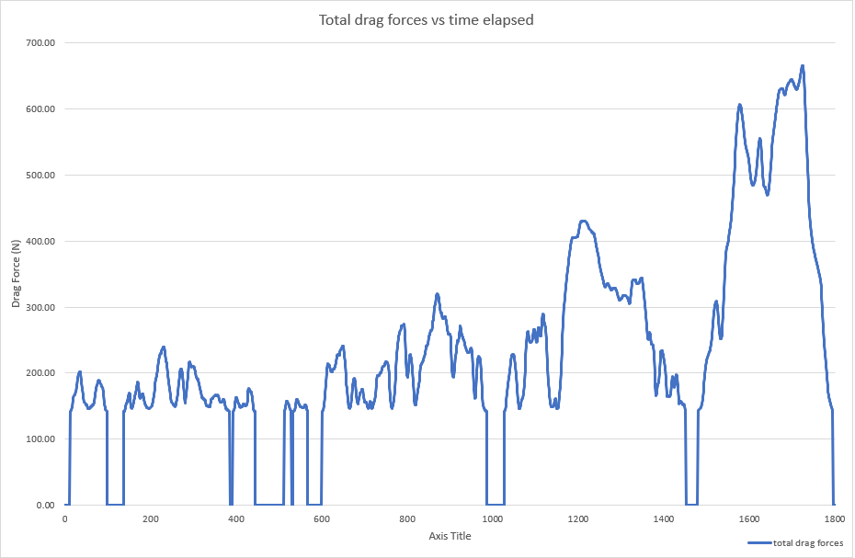
Figure 3 below shows the magnitude of the drag forces acting on the vehicle throughout the test, not including the acceleration force which is only relevant in acceleration scenarios. The four phases are clearly visible with the areas of zero drag force being where the vehicle is stationary between phases, and the ‘very high’ phase includes by far the largest drag forces, peaking at 666N and the same exponential shape is shown.
Figure 3: Total drag force

Tractive Forces
The tractive force represents the force the vehicle is required to output in order to complete the WLTP cycle, this is equal to the total restrictive forces that it must overcome to accelerate and maintain the required speeds during the cycle. The total tractive forces can be seen in figure 4.

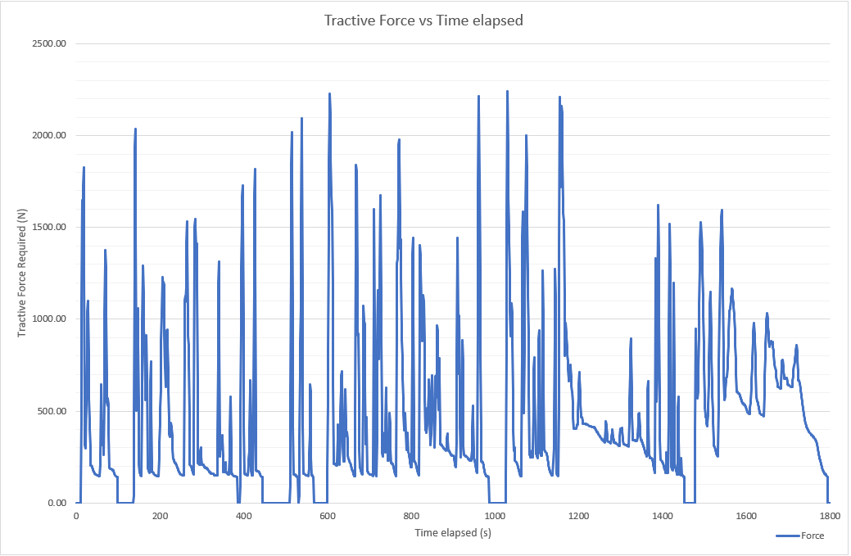
Figure 4: Required Tractive Force

Looking at figure 4 the points of largest required tractive force are the points where the vehicle is accelerating most rapidly, this is because increasing speed has the largest force requirement when compared to aerodynamic drag or rolling resistance. The largest force requirement is 2240N of tractive effort where the vehicle is accelerating at the beginning of the ‘high’ phase just after 1000 seconds into the test, this is where the maximum acceleration of the test occurs at 1.58m/s².

Tractive Power
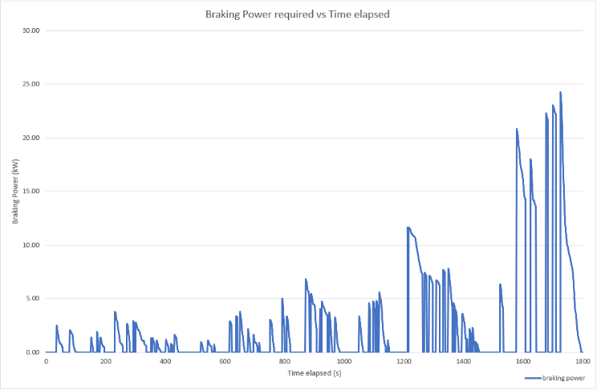
To calculate the required power for all points of the test the tractive force is multiplied by the speed in m/s for each second of the test, the plotted results of tractive power can be seen in figure 5.
Figure 6: Required Braking Power
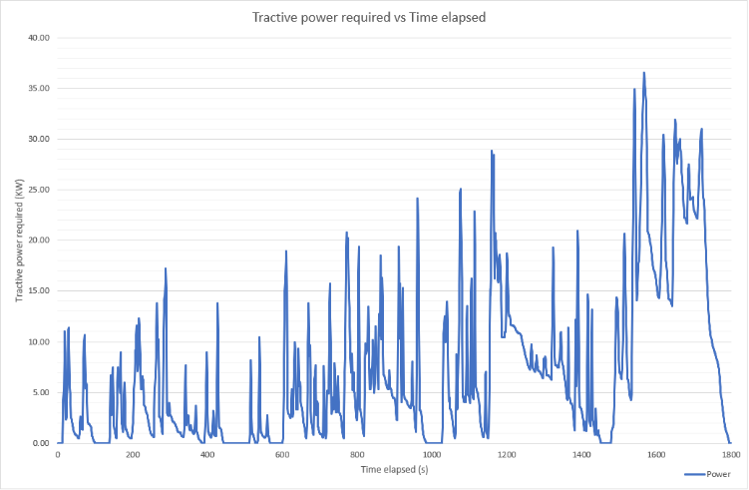
As can be seen in figure 5 the tractive power peaks at 36.6kW at 1572s into the test, this is when the vehicle is travelling at 31.6m/s and acceleration at 0.47m/s² which is the highest acceleration at high speed for the test, which results in the largest resistive acceleration force. Alternatively figure 6 shows the braking power which peaks at 24.25kW where the vehicle begins braking from the maximum speed, the peaks in figure 6 represent where the largest amount of energy could be recovered using a regenerative braking system, as the kinetic energy could be converted into electrical energy using a regen system as opposed to heat using friction brakes. Figure 7 shows the average power which further displays the rapidly increases losses with the increase in speed and power demand.
Figure 5: Required Tractive Power
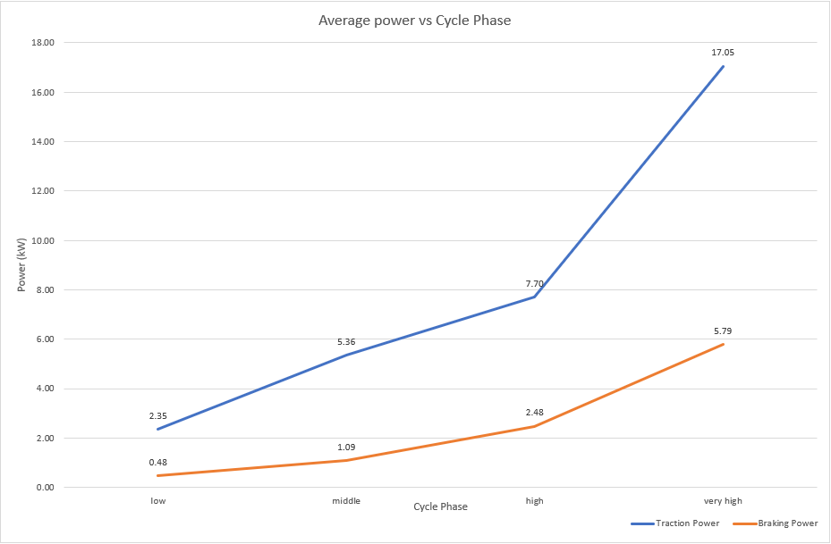
Figure 7: Average traction and braking power per phase

Energy

Traction and Braking Energy
To visualise the energy losses incurred throughout the cycle the cumulative Traction and braking energies have to be calculated, found by finding the sum of the power for the whole cycle and dividing it by 3600 to get the energy usage in kWh. Both the traction and braking energy can be seen in figure 8 below.
Figure 8: Cumulative Traction and Braking energy
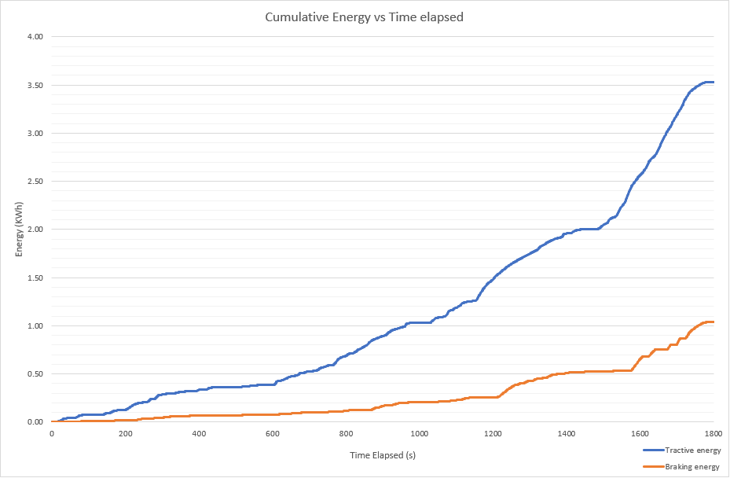

Looking first at the Traction energy it increases exponentially with speed, reaching 3.53 kWh by the completion of the test. By far the largest gradient and fastest energy usage being after 1500 seconds where the vehicle is in the ‘extra high’ phase, this is due to the aerodynamic drag being a square of velocity, therefore doubling the speed will increase the aerodynamic drag by a factor of 4 making it much more power demanding at higher speeds. The difference between the traction and braking energy represents the losses incurred within the system, this can be plotted seperately shown in figure 9.
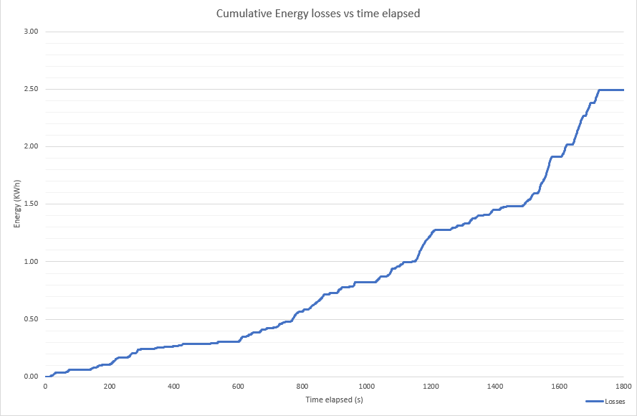
Figure 9 shows the cumulative energy losses throughout the cycle duration with the gradient of the line representing the rate of energy loss. The total energy loss came to be 2.49 kWh, which is 70% of the total tractive energy making the vehicle only 30% efficient. The implementation of a KERS system would greatly improve this as otherwise wasted energy could be collected to be utilised for tractive effort reducing the load on the internal combustion engine.
Figure 9: Cumulative energy losses

Kinetic Energy
The stored kinetic energy of the vehicle as it is moving can be calculated and is needed in order to find how much energy can be recovered through the braking phases. The kinetic energy fluctuation throughout the WLTP cycle can be seen in figure 10.
Figure 10: Kinetic Energy
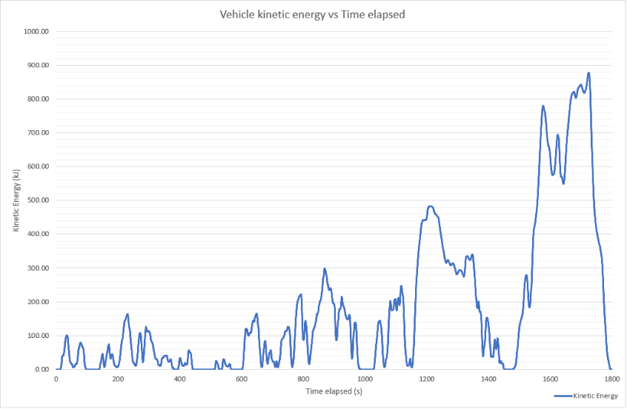

As expected, increasing the velocity of the vehicle exponentially increases the kinetic energy, this is due to the equation of kinetic energy (KE = ½ m v²) including a square of velocity. This gives an idea of how much kinetic energy the vehicle possesses at any given time however to find the energy that is recoverable during the braking phases, only these values can be plotted shown in figure 11.
Figure 11: Recoverable kinetic energy
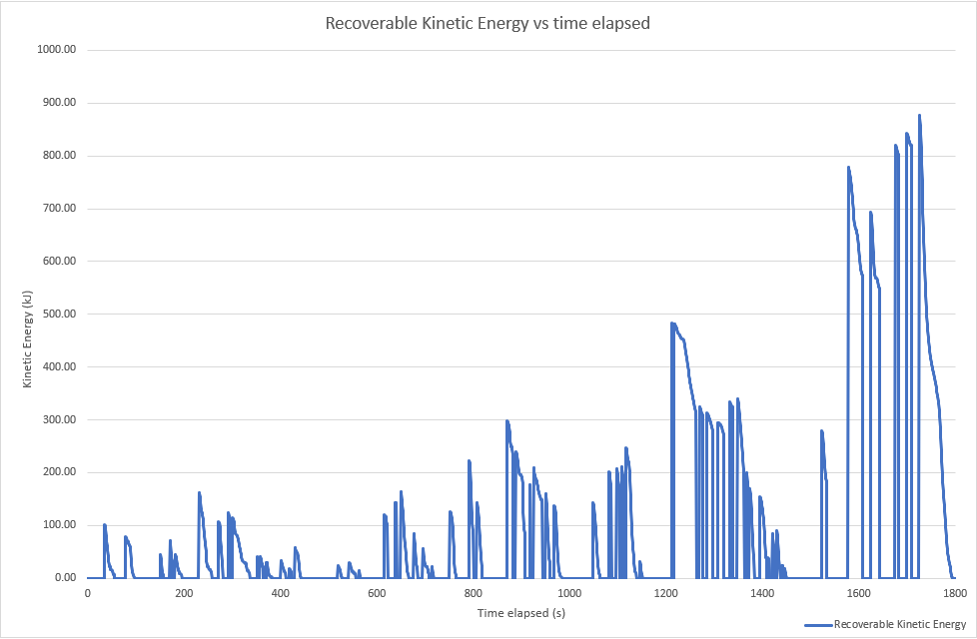

Figure 11 shows the magnitude of the kinetic energy that is recoverable during the braking phases, with the largest peaks in the 1500-1800 second range being the areas where the largest amount of wasted energy can be recovered during heavy braking from high speeds. Looking back at figure 6 this also matches the points where the higher braking power is required, therefore indicating that a KERS would recover most energy when braking hard, however as indicated by figure 11 the points of hard braking are of short duration therefore having a recovery system that is capable of harvesting and storing energy rapidly is very important.

KERS Implementation

Flywheel KERS
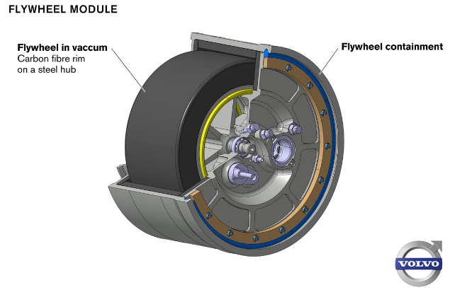
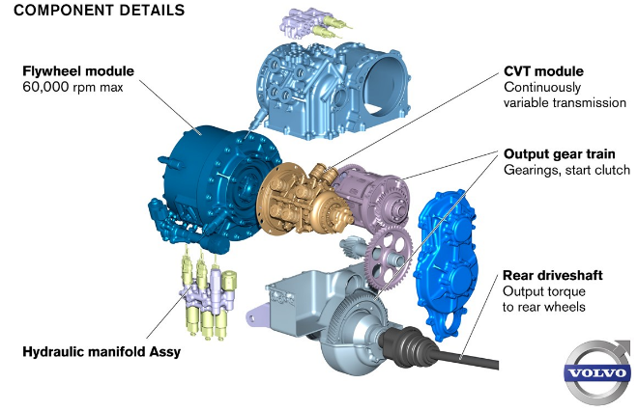
A flywheel KERS uses motors attached to the axles of the vehicle to harvest kinetic energy under braking and convert it to electrical energy to power a motor that spins a flywheel, storing the otherwise wasted energy mechanically as rotational kinetic energy. Although most popular in motorsport applications flywheel KERS have been tested on road cars, such as in 2013 Volvo completed tests using a rear axle mounted flywheel spinning at a maximum of 60,000 rpm and sending up to 59.7 Kw to the rear wheels (Volvo 2013). During tests this system reduced fuel consumption by 25% and due to the nature of a flywheel system is most effective for stop and start urban traffic (Ingram. A 2013), with the energy being used when the vehicle is moving off and accelerating up to speed. The weight of this system is 60kg total, including 6kg for the flywheel itself which measures 200mm in diameter and 120mm deep manufactured from carbon fibre and steel (greencarguide n.d.) making it much lighter and more compact than other battery storage-based recovery systems, the system itself can be seen in figures 12 and 13.
Figure 12: Axle mounted Flywheel KERS Assembly (Volvo, 2011)
Figure 13: Flywheel KERS module (Volvo, 2011)

Electric KERS
This energy recovery system involves electric motors attached to the drive shaft of the vehicle which acts as a generator when the vehicle is decelerating, converting the kinetic energy to electrical energy similarly to the flywheel system however it is then stored in a chemical battery. Due to the speeds required for charge and discharge capacitors are often fundamental elements in these systems (Kapoor. K, Parveen. C.M, 2013). One negative with a battery or capacitor storage system is the very high weight when compared to a mechanical flywheel system for given rated power, with the benefit being its ability to store energy for a much longer duration with Volvo stating their flywheel system being in a partial vacuum being able to spin for up to 30 minutes (greencarguide n.d.), this is still far below a conventional lithium ion or capacitor setup. A battery setup also will be the cheapest option to implement, however the use of supercapacitors will greatly increase the cost while also decreasing the voltage stability of the system due to supercapacitors having self-discharge properties (Kapoor. R, Parveen. C.M, 2013).

Chosen KERS
The chosen system for the use on the Honda civic Type R EP3 is a flywheel system, this has been chosen as due to the nature of the car being a sporty vehicle that is geared short and most commonly used in urban and extra urban driving which suits the stop and go requirements for a flywheel. Another reason for selection is that the 2.0 litre 4 cylinder naturally aspirated petrol engine is lower in torque, therefore the addition of a boost during lower speeds will remove load from the internal combustion engine. Figure 14 shows a dynamometer graph, with run 2 (dotted line) being the chosen vehicle, and the VTEC system can be seen engaging at 6000 rpm with both torque and power being modest before this point. The benefit of KERS would be to smooth out this transition and allow for a more consistent curve, boosting performance and economy at lower rpms.
Figure 14: Honda Civic EP3 Type R dyno graph (CivInfo, 2007)
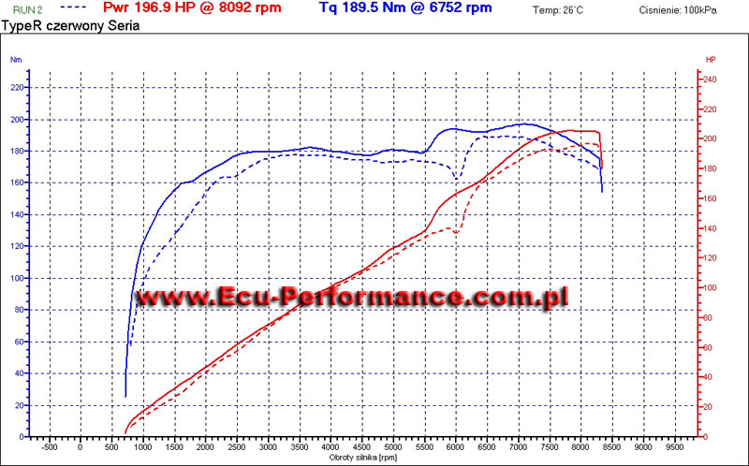

Due to the chosen vehicles weight being low at only 1204kg kerb weight, adding a large battery system weighing hundreds of kilograms would negatively affect performance and fuel economy when a flywheel can output the same energy for a fraction of the weight, and would be well suited to the type of driving the vehicle will be used for the majority of the time. To add to this a flywheel being a mechanical storage system has no issue with multiple full charge and drain cycles in quick succession which battery systems would struggle with, therefore for these reasons the flywheel KERS has been selected.

KERS Specification
Looking back at figure 11 the maximum recoverable kinetic energy in one braking event peaks at 870 kJ, assuming that the efficiency of the motor that is acting as a generator to recover the energy has an efficiency of 70% (greencarguide n.d.) this gives a peak of 609 kJ energy meaning that the flywheel must have a capacity higher than this in order to capture all of the kinetic energy available in hard braking from high speed scenarios, also assuming that all energy is used by the next recovery period there isn’t need for the flywheel to be able to store more than this which would increase weight and cost. Flywheel KERS requires the use of a CVT (continuously variable transmission) to maximise the efficiency of the system, which due to the complexity and advanced nature of these components will greatly increase the cost of the system which must be factored into account to ensure the vehicle does not become too expensive.
The 600 Series Flywheel manufactured by PUNCH Flybrid fits the requirements perfectly, featuring an absolute energy storage of 600kJ, operating temperature range of -40°C-110°C and a design life of 80,000 hours or 10 million cycles with no degradation in performance (PUNCH Flybrid n.d.). To add to this it has an environmental protection rating of IP69 meaning it is protected from ingress of dust and against high temperature high-pressure water and steam making it suitable for use in automotive applications (Jolles. P, 2018). Another system made by PUNCH Flybrid is their F Boost system, which is a more modular electromechanical flywheel energy storage with its highest power variant able to reach 200kW and 1000kJ with a total mass of only 50kg giving it a ratio of 4kW/kg (Deakin, A 2021). When tested on a Ford Transit completing an urban door to door delivery cycle, which would be similar to urban traffic driving, a maximum of 34% decrease in fuel consumption was seen over the 2000 second test shown in figure 15 (Deakin, A 2021). For these reasons and the modular nature, allowing power and energy to be varied independently, the F Boost system would be an excellent choice to add to the vehicle being investigated.
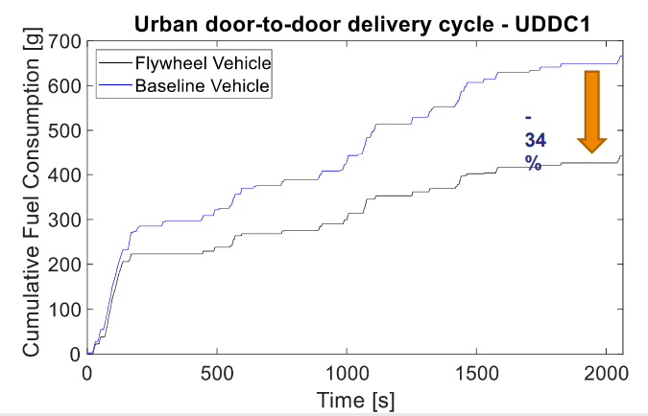
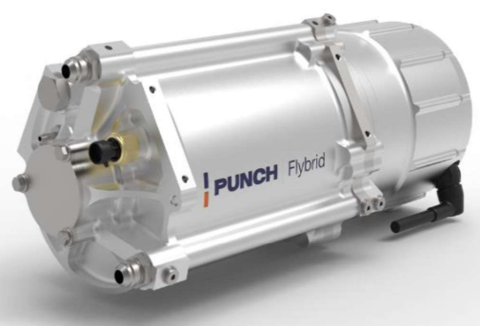
Figure 15: Fuel consumption with F Boost on Ford Transit
Figure 14: PUNCH Flybrid F Boost module

Conclusion
To conclude this investigation, a flywheel kinetic energy recovery system was chosen to be added to the Honda Civic Type R as it added lower weight to the vehicle for the same power output and lower cost than an advanced electrical storage system. In particular the F Boost system manufactured by PUNCH Flybrid allows for a wide range of power and energy values making it suitable to modify and adjust to best suit the chosen application. Also when investigating the WLTP cycle the highest speed sections were found to produce the highest losses and given that the flywheel excels in stop start driving the vehicle with the integrated flywheel KERS would be best suited to urban and extra urban driving, boosting performance, reducing engine load, and increasing fuel economy of the vehicle.

References
- Dahham, R.Y.; Wei, H.; Pan, J. Improving Thermal Efficiency of Internal Combustion Engines: Recent Progress and Remaining Challenges. Energies 2022
- Pipitone, E., Vitale, G., Lanzafame, R., Brusca, S. et al., "A Feasibility Analysis of an Electric KERS for Internal Combustion Engine Vehicles," SAE Technical Paper 2019-24-0241, 2019
- WLTP Facts.eu “what is WLTP and how does it work?” n.d.
- Ze Perfs., “Honda Civic Type R (EP3) 200 PS (2001-›2006) technical specifications and performance figures” 2022
- Racing Cars Technology., “Aerodynamics – Table for drag coefficient and drag area for various models” n.d.
- X-Engineer., “How to calculate rolling resistance” n.d.
- Volvo cars., “The Flywheel KERS (Kinetic Energy Recovery System)” 2013
- Ingram. A, Green car reports – “Volvo Flywheel Hybrid System (aka KERS) Tests Completed Successfully” 2013
- GreenCarGuide., “Volvo’s Flywheel KERS Puts a new spin on hybrid cars” n.d.
- Volvo cars., Flywheel KERS press release images 2013
- Kapoor, R., Parveen, C.M., “Comparative Study on Various KERS. Proceedings of the World Congress on Engineering 2013
- CivInfo. Power curve - Mw1978 2007
- PUNCH Flybrid “600 Series” specifications n.d.
- Jolles, P., F2 labs “ IP69 vs. IP69K” 2018
- Dr Deakin, A., PUNCH Flybrid. “F-Boost - An Integrated High Performance Flywheel Energy Storage System” 2021

