ECIE5004

Celebrating Language and Culture Belonging to Wales

Portfolio
Carla Thompson

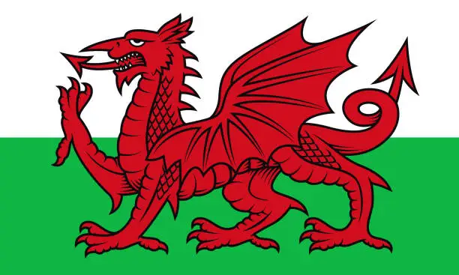

(Vexels,2019)

Contents
Pages
Rational 3
Curriculum and Polices

Activity overview 5-6
Activity one
Activity Two
Activity Three

Evaluation 7

Appendices 8-9

References 10-11

Rational
The Welsh Language and culture is of a strong importance to those in Wales and one in which that has been fought for over many years. ‘It is said that the Welsh Language is the oldest language in Britain dating back to 4000 years ago’ ((BBCCymruWales,2014) and during these times periods, the Welsh language has been found, lost and found again, causing there to have been many adaptations to have been made throughout these times and many cases in which the language had to be fought for. When living in Wales, there are different areas in which the Language may be used more fluently whereas there are other areas in which the language isn’t often used and this is due to the changes over time. With the Welsh language being such an importance, it is important that we implement as much as possible throughout the country and carry the language with us and use it so that it can be made stronger and not lost.
On the other side of the Language and culture in Wales, the roles of educators have changed. It has gone from being not allowed to speak Welsh due to historical reasons (this gets spoken about later on) and that the Welsh Language was not a priority to now in modern days, that it has become a popular and important language that the curriculum is wanting children to learn and develop on. The future generation can bring the language back to life and carry it around with them to share with the world.
Moving on from this, the Welsh Government has now developed a strategy called “Cymraeg 2050: A million Welsh Speakers” and they have said that their “ambition as Welsh Government is to see the number of people able to enjoy speaking and using Welsh reach a million by 2050” (Welsh Government,2017). Further into this portfolio the writer will go onto discuss the history of the Welsh language and the challenges it has faced in order to be where it is today, the importance of how the Welsh Language can be built up upon and what it is can be done in order to support it. Not only this, but the writer will also talk about what it is we do now in order to support the Welsh Language.
History
The 1535 Act of Union was a crucial time for the Welsh, as it was the decade in which speaking Welsh was made illegal in courts. This was so that King Henry the Eighth could show his power across realm. However, it was still allowed in church.
In 1563, Queen Elizabeth had then gone onto Authorising the first translation of the bible to Welsh. The churches then went onto establishing schools in Wales (BBC News,2013).
1760- The Industrial Revolution. The industries materials were found in smaller populated parts of Wales. This then brought Welsh speakers from those areas to the industry spreading their language with others who had moved from external areas encouraging them to speak Welsh also (See appendix A).
Nineteenth century- Welsh Not- the Welsh Not was used as a disciplinary method in order to prevent children and young people from using their native language, Welsh. It was a wooden plaque with the words Welsh Not written on it, that would get worn around the child neck on a string if the child had been caught speaking Welsh, bringing humiliation and shame upon them. If another child were to then be heard speaking Welsh, it would then get past on them and so forth. The last child to be wearing the Not at the end of the day would then get further punishments, whether that be physical or detention. In doing this it showed children the power that the English language had over Welsh, giving the English a sense of superiority (Welsh Past,2024).
All the way up until now where the role of educators has played a big part in building upon the promotion of the Welsh Language and how we can make it a priority moving forward. Cymraeg 2050: A million Welsh speakers, is one of the curriculums that is being worked on by the Welsh Government where they have looked at the percentage of people who speak Welsh in Wales daily and would like it to go from ‘10% of people in 2013-2015 up to 20% by 2050’. Not only that, but the government has also based the Cymraeg 2050, upon three strategic themes that they will focus as they work across other areas of policies. The three strategic themes include:
- “Increasing the number of Welsh speakers
- Increasing the use of Welsh
- Creating favourable conditions, infrastructure and context” (Welsh Governement,2024).
(See Appendix C the amount of Welsh speakers in Wales overtime)
Curriculum and policies
Donaldsons successful future
In 2014 the Government had asked Donaldson to review the Curriculum and Assessment Arrangements in Wales. In doing so, his findings lead him to believe that the children and young people deserve the most relevant and high-quality education. In order to achieve this, he came up with four common purposes for children and young people in order for them to be determined, thrive and develop in their education and changing world (See Appendix B) (Donaldson,2015).
National Curriculum 2022
The National Curriculum 2022 looks at the four purposes and wants to implement ways in which learning can provide the best possible outcomes for all learners. They are supporting schools to develop “opportunities for effective immersion to support learners to speak Welsh in formal and informal situations, in Welsh-medium, bilingual and English-medium schools” (Welsh Government,2022). This meaning to use the Welsh language in other areas of learning in order to expand their knowledge and understanding.
Curriculum Cymreig
This curriculum is currently used in Wales and was originally the outcome of the Education Reform Act in 1988. In the beginning the curriculum was built to establish common curriculums for both Wales and England, however after further developments it was campaigned that Wales wanted their own curriculum. This curriculum would “reflect the culture, environment, economy and history of Wales, and the influences which have shaped the country of today” (Jones et al Roderick,2013).
Bilingualism
Barker 2014 talks about bilingualism being all about language, communication and interaction. These factors are important to children and young people because they need to be able to communicate and interact with adults and in their lives in general. Children are born ready to absorb languages and communication styles, its how they form their identity. In doing this they also need the support and encouragement that allows them to feel confident and happy.

Welsh Activities (Overview)
Activity One- Welsh Assembly (Criw Cymraeg)
In the writers personal setting the school holds a Welsh Assembly every week. It is part of the Siarter Iaith Cymraeg Campus journey. The Siater Iaith Cymraeg Campus’ aim is to “promote a strong Welsh ethos in schools and to provide a range of enriching activities that propel the children to enjoy learning Welsh” (Siater Ieith, 2025).
In the writers’ school, the assembly involves the children joining in with Welsh games on the board. This is to engage the learners in new words and phrases that are beneficial to their learning. Within this assembly the children also take part in singing Welsh songs, learning new Welsh phrases and recapping upon others they have previously done. Engaging the children in these activities allows them the excitement of games but also opens their pathways to learning through play. At the end of the assembly, one of their favourite parts is finding out what class has won the dragon for the week and who the Criw Cymreag winners are. In order to win the dragon for the week, it has to go to the class who has worked together and spoke and used the most Welsh throughout their learning and classroom. It’s recorded by pressing a counter clicker each time someone gets spotted using their Welsh. On the other hand, to win the crew cymreag certificate, it goes to the individual in each class who has been spotted trying their best to use their Welsh and learn the new phrases. Doing these rewards encourages children to use their Welsh and expand their knowledge and understanding of Welsh, it gives them the excitement and builds their identity. Giving the children a reward to try and work for, gives them the motivation to keep trying and aim high, it shows them all of the possibilities that learning a language can do for them.

Activity Two- Shwmae Day
The writers setting is also a school in which encourages Welsh speaking and as a part of this, the school celebrates Shwmae Day. This is a day that is all about being Welsh and living in Wales.
The first ever Shwmae Day was on the 15th of October 2013 in order to promote every conversation to begin with Shwmae. “The event aims to show that the Welsh language belongs to us all – fluent speakers, learners or those shy about their Welsh” (Welsh Government,2024).
As a school the children and staff wear the colours of the Welsh flag, learn new phrases in Welsh and use the Welsh we know to carry out activities or when asking questions. To add to this, they children then go onto learning about the Welsh culture, take part in art and craft, which involves making something like a sculpture, model or picture that is related to Wales and important to Wales.

Activity Three- Eisteddfod
The Eisteddfod is not only got a big importance in schools but also in Wales as a whole. Every year on the 1st of March we celebrate St. Davids Day to show our honour to the Patron Saint of Wales, Saint David. The Eisteddfod is a National Tradition, it’s a “celebration of language, music, and art, the Eisteddfod is more than just an event; it’s a cornerstone of national identity” (Welsh Past,2024). The Eisteddfod plays a big role in promoting the Welsh language and involving people in Wales in the culture and background of Wales. The word Eisteddfod “itself stems from the Welsh terms « eistedd » (to sit) and « fod » (be), translating roughly to « a gathering » or « to be seated” (Welsh Past, 2024).
In order to celebrate St. Davids in the writers setting is by holding an Eisteddfod in the hall where the whole school comes together. In the week building up to the day of the Eisteddfod, part of the crew cymreag team come together and plan art and craft competitions for the different year groups to take part in. This involves drawing daffodils, leaks, building castles and dragons and so forth. On the day of the Eisteddfod then is when the entries are looked at and there is a first, second and third place chosen from each year group. We also learn about St David and about Wales. This is important for the children as it gives them a sense of belonging and understanding where they belong and how it has become what it is now. In doing all of this it promotes the language to schools and influences them to get involved.

Evaluation
In conclusion, the Welsh Government are doing all they can in order to provide the best education and support they can for the future generation to learn and expand upon their Welsh. They are also wanting children to learn and understand the Language and Culture behind it as well. As educators, there is now a heavy reliance on helping the children and the Government to achieve this goal and they need to ensure that the best practices are in place in order to do so. The writer will now go onto evaluating their setting and look into what it is they could improve on in order to support the learners.
Welsh Assembly- Criw Cymraeg
By having the weekly assemblies and allowing the children to learn their Welsh in different ways is a really key part to the new Curriculum for Wales 2022 as kits allowing the children to learn and experience Welsh in a different way, that isn’t in their classrooms like the other lessons. The assembly is also beneficial as it gets the children excited and allows them to have that friendly competition with the other classes. It’s a space where they are comfortable in making mistakes and know that they can keep trying. However, if there were to be improvements made to this activity, having some of their learning from this assembly brought back and used in some form of Welsh lesson as well may benefit them in the sense that they are revisiting the assembly and building upon the assembly sessions learning. This doesn’t have to be an at the desk lesson, just another form of learning as they only have the assembly sessions once a week. If there are cancellations it means that they then have to wait until the next week for a Welsh session, whereas if you also include a session from the assembly in the classroom they are not missing out.
Shwmae Day
Shwmae Day is beneficial in schools as it’s a day where children can use their Welsh throughout all of their activities in the day, it a day where they get to celebrate the Welsh culture and language. It is also beneficial as they get to look into the history of Wales and carry out fun Welsh related colouring, games and singing which is also another importance to the curriculum for Wales 2022. There are so many different opportunities in which the children can explore and use their Welsh.
Eisteddfod
“The first Eisteddfod was held in 1176, under the patronage of Lord Rhys, in his castle in Cardigan. He invited poets and musicians from all over the country and awarded a chair to the best poet and musician, a tradition that has carried on to the present day” (BBC,2014). So, as you can see the importance of the Eisteddfod is more than it just being celebrated in schools. It is one that is celebrated all over Wales and is of a high value and important part of being Welsh. Taking part in the Eisteddfodd in schools is beneficial because it builds upon the importance of the Welsh language and culture as it is of such a great importance to know and understand the roots of Wales. It is enjoyable for the children and adults, allowing them the opportunity to see what it is like to take part in something so special.

In conclusion to this portfolio, the importance of having these activities in place, supports the governments guidelines for children and young people to be learning more Welsh and understanding the Welsh culture. They support the curiculums of ensuring children are learning through different methods and incorporating the language through different subjects.
Appendices
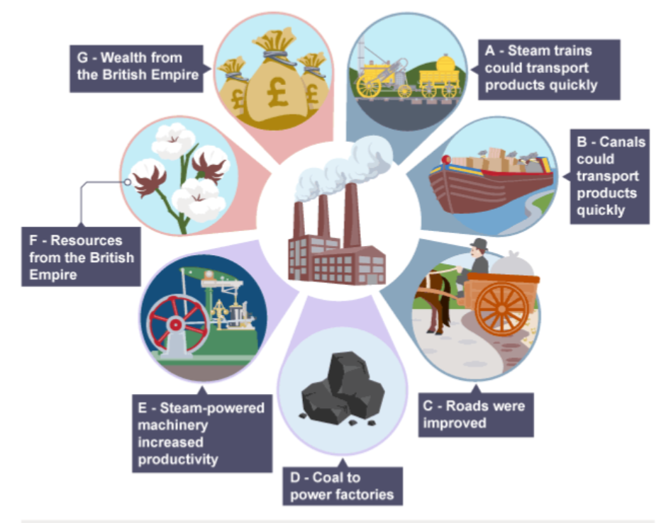

A

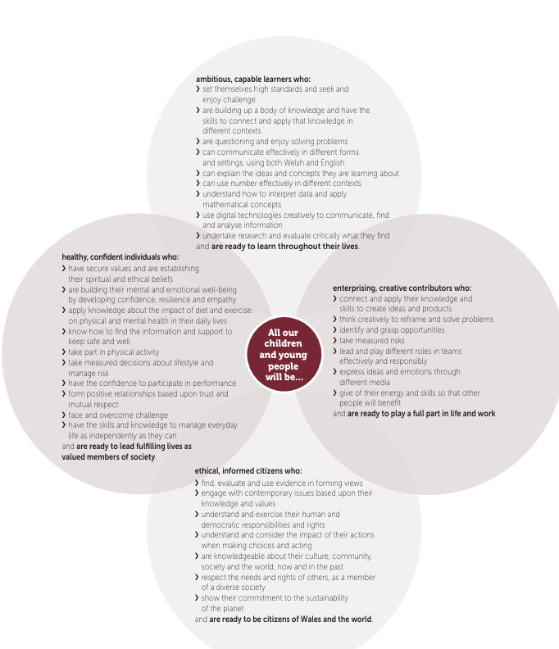

(Donaldson,2015)
(BBC Bitesize,2025)

B

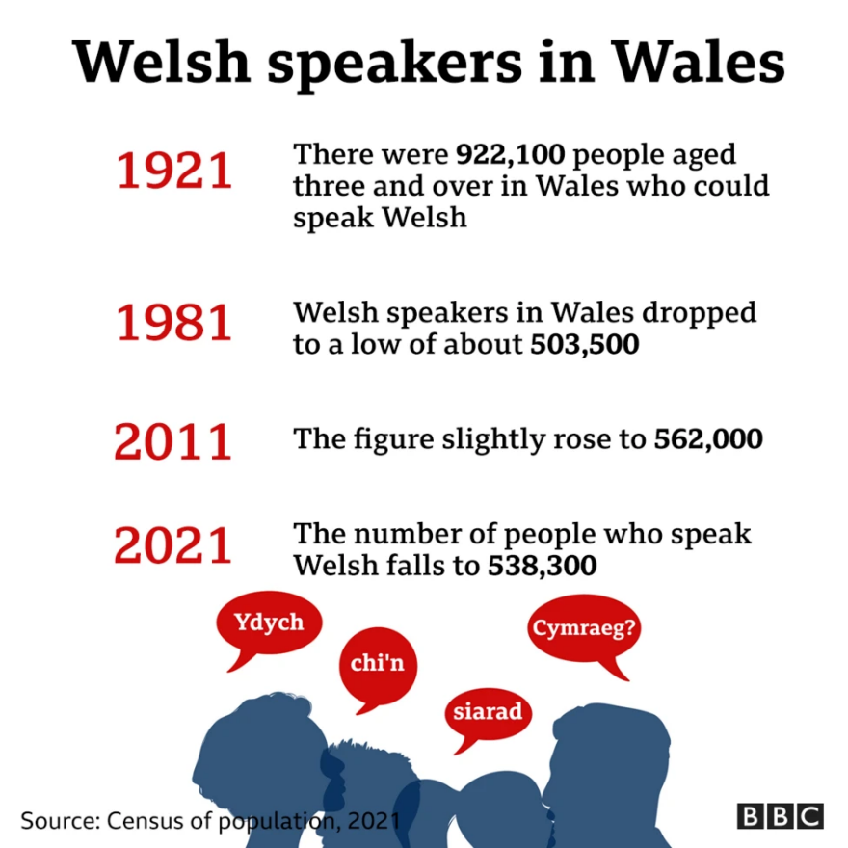
C

(BBC News,2022)

Reference
Baker, C. ( 2014) A Parents’ and Teachers’ Guide to Bilingualism. Bristol: Multilingual Matters (Accessed 31/01/26).
BBC Bitesize, The Origins of the Industrial Revolution, (2025), www.bbc.co.uk/bitesize/articles/z6kg3j6#z4s6m39. (Accessed 28/12/25).
BBC Cymru Wales, (2014), The History of the Welsh Language. Available at www.bbc.co.uk/cymru/cymraeg/yriaith/tudalen/welsh.shtml (Accessed 02/12/25).
BBC News, (17 July 2013), Historic Welsh Language Law Document Found in Parliament, www.bbc.co.uk/news/uk-wales-north-east-wales-23343832. (Accessed 11/12/25).
BBC, BBC Wales Eisteddfod Guide- a Brief History of the Eisteddfod, (2014), www.bbc.co.uk/wales/eisteddfod2008/sites/guide/history/pages/history_eisteddfod.shtml, (Accessed 03/01/2026).
BBC News, Welsh Language: Fewer Speakers in Wales in Past Decade, (6 December 2022), www.bbc.co.uk/news/uk-wales-63860772 (Accessed 03/01/26).
Donaldson Graham, (2015), Successful Futures Independent Review of Curriculum and Assessment Arrangements in Wales, https://www.gov.wales/sites/default/files/publications/2018-03/successful-futures.pdf. (Accessed 28/12/25).
Jones Gareth et al Roderick Gordon, The Cwricwlwm Cymreig, History and the Story of Wales, (2013), https://www.gov.wales/sites/default/files/publications/2018-11/the-cwricwlwm-cymreig-history-and-the-story-of-wales-final-report.pdf (Accessed 31/12/25)
Siarter Ieith, Siarter Iaith Cymraeg Campus, (2025), https://hwb.gov.wales/api/storage/2888456e-0694-4990-b770-7e3351c525e4/siarter-iaith-cymraeg-campus-eng.pdf (Accessed 31/12/25).
Welsh Government, (2017), Cymraeg 2050: a Million Welsh Speakers. Available at https://www.gov.wales/sites/default/files/publications/2018-12/cymraeg-2050-welsh-language-strategy.pdf (Accessed 03/12/25).
Welsh Government, Curriculum for Wales: Annual Report, 2022, www.gov.wales/curriculum-wales-annual-report-2022-html. (Accessed 29/12/25).
Welsh Government, Diwrnod Shwmae Su’mae Day 2024, Business Wales, (2024), businesswales.gov.wales/news-and-blog/diwrnod-shwmae-sumae-day-2024. (Accessed 01/01/2026).
Wales Past, The significance of the Eisteddfod in preserving Welsh traditions, (14 December 2024), https://www.walespast.com/the-significance-of-the-eisteddfod-in-preserving-welsh-traditions/ (Accessed 01/01/26).
Welsh Government, Cymraeg 2050: Welsh Language Strategy Action Plan 2024 to 2025, (13 March 2024), www.gov.wales/cymraeg-2050-welsh-language-strategy-action-plan-2024-2025-html (Accessed 02/01/26).
Welsh Past, The history and cultural impact of the Welsh Not, (5 December 2024), https://www.walespast.com/the-history-and-cultural-impact-of-the-welsh-not/ (Accessed 02/01/26).
Welsh Government, Introduction to Curriculum for Wales Guidance – Hwb, (28 January 2020), hwb.gov.wales/curriculum-for-wales/introduction-to-curriculum-for-wales-guidance/ (Accessed 03/01/25).
Vexels, Global Flags Graphic Design, (2019), www.freeimages.com/illustrations/vector/welsh-flag. (Accessed 3 Jan, 2026).

