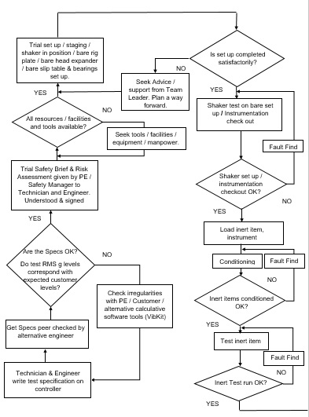
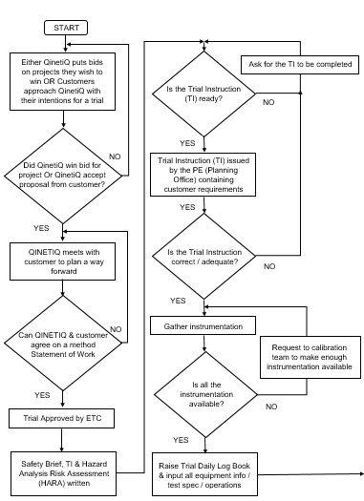
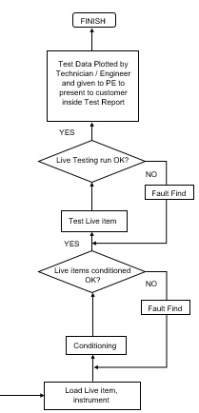
A CPA Flowchart to show the critical path of the Trial Delivery Process
Pre-delivery
Delivery
Post Delivery *Customer Value*

