
MSC Cybersecurity & Digital Forensics
Enterprise Network Security
MODULE CODE: ACCA7032
Rushabh Patel
2436066

Table of Contents
Part 2 - Securing the Enterprise Network Implementation of a Network Security Solution 3
1. Introduction 3
2. System Environment and Initial Setup Verification 4
3. Firewall Policy Design and Implementation 65
4. References 69
Appendix 70

Part 2 - Securing the Enterprise Network Implementation of a Network Security Solution

1. Introduction
This chapter establishes the baseline environment required for deploying the enterprise network security solution. Before any firewall, IPS, or monitoring configurations can be applied, the underlying architecture must be correctly installed, reachable, and licensed. The purpose of this stage is to validate the operational readiness of the Security Gateway (A-GW), the Security Management Server (A-SMS), and the administrative workstation (A-GUI). Ensuring these components function cohesively is critical, as misconfiguration at this stage can impact secure communications, topology detection, and policy enforcement in later phases of the implementation [1].
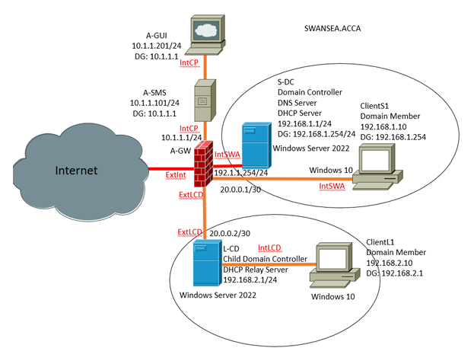

2. System Environment and Initial Setup Verification
Installing the Primary Security Management Server (A-SMS)
In this lab, you will install the Gaia OS on A-SMS machine and configure the A-SMS as Security Management Server using First Time Wizard.

- Before power on A-SMS, go to the settings of A-SMS machine. Under General properties, make sure version refers to other/Unknown(64-bit)
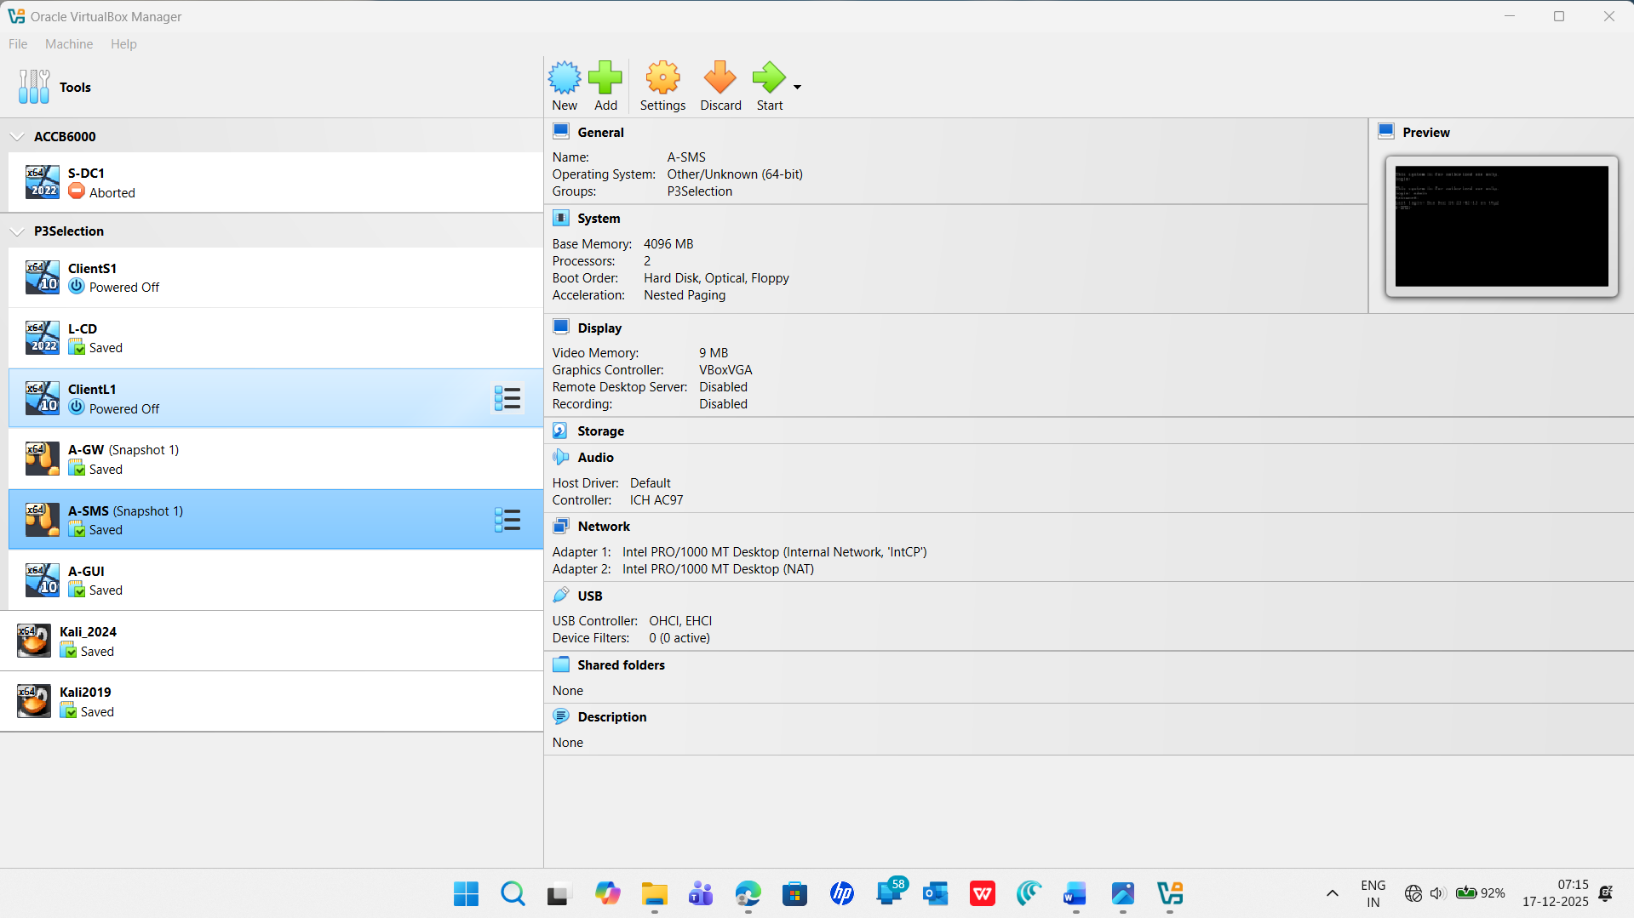
- Mount to GaiaOS.iso and start the machine. When the system is started, the following screen appears:
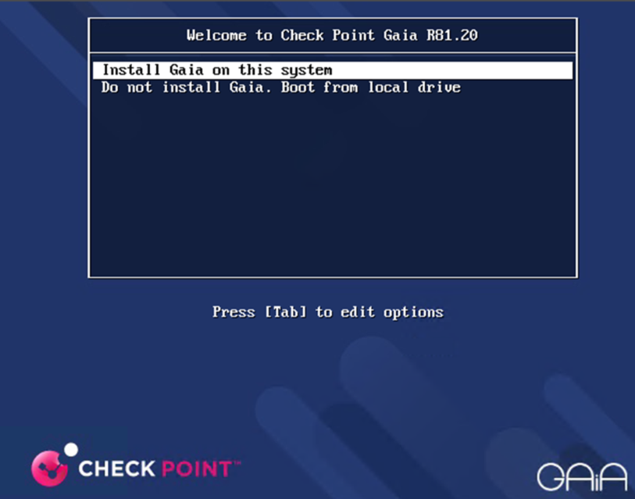
- Click on install Gaia on this system
A warning message will appear, select OK to continue the installation and press Enter
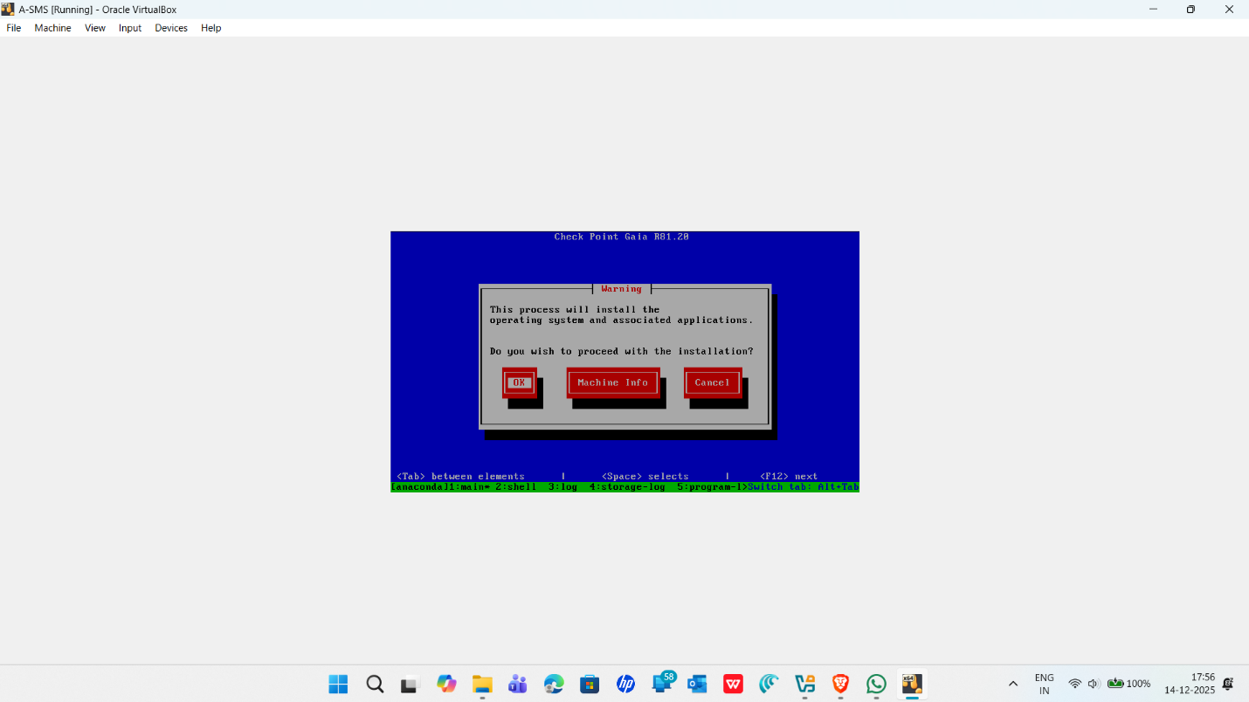

- Select a keyboard language. US is the default, select Great Britain version:
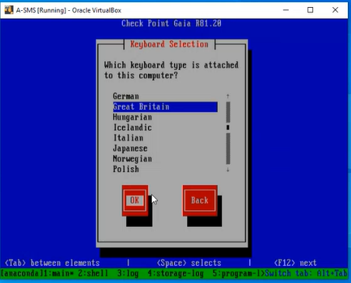

- Check the partition configuration. The disk space depends on your system configuration. So, don’t change it. Press TAB key to select the OK button and press Enter.
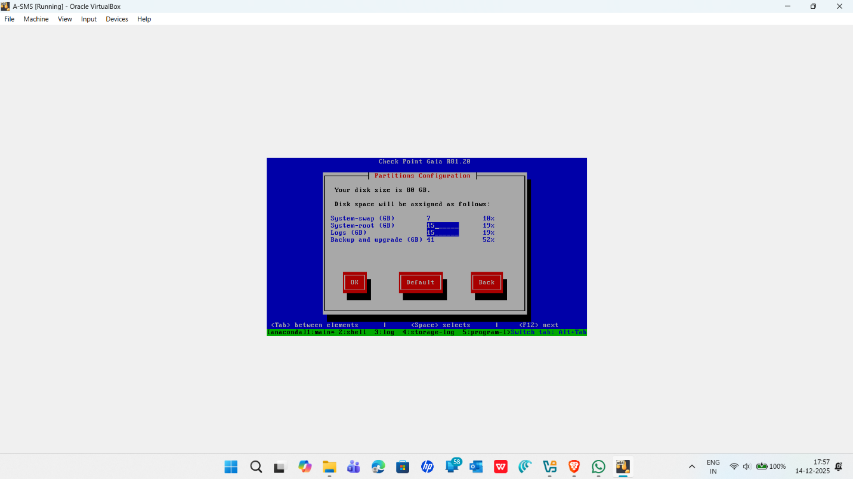

- Enter the password for the admin account and confirm it. You can use any password.
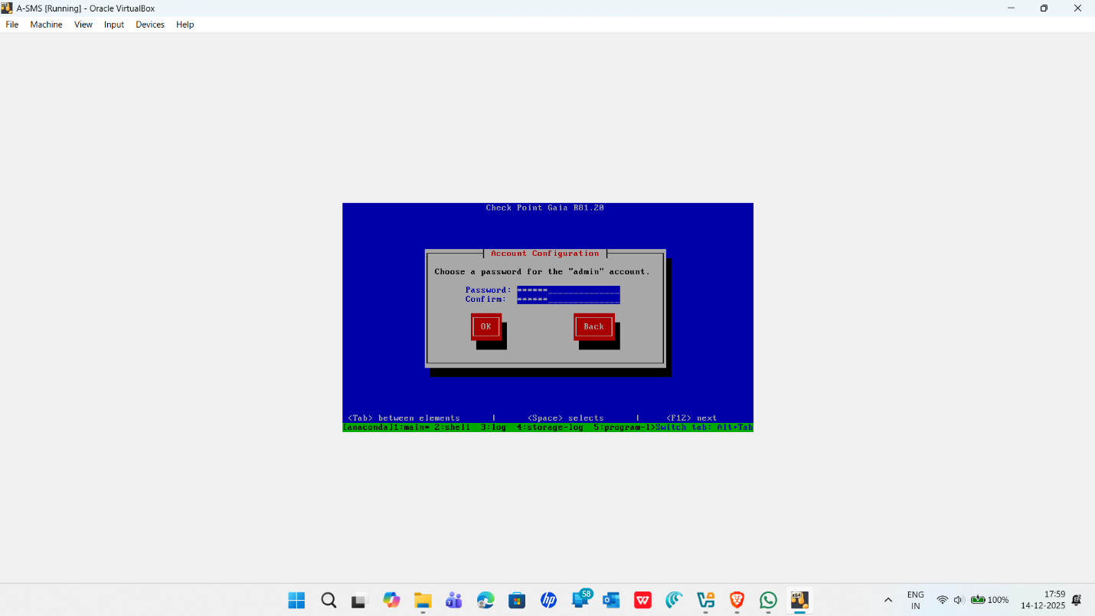
- Enter the password for Maintenance admin password. choice. Make sure you remember it.
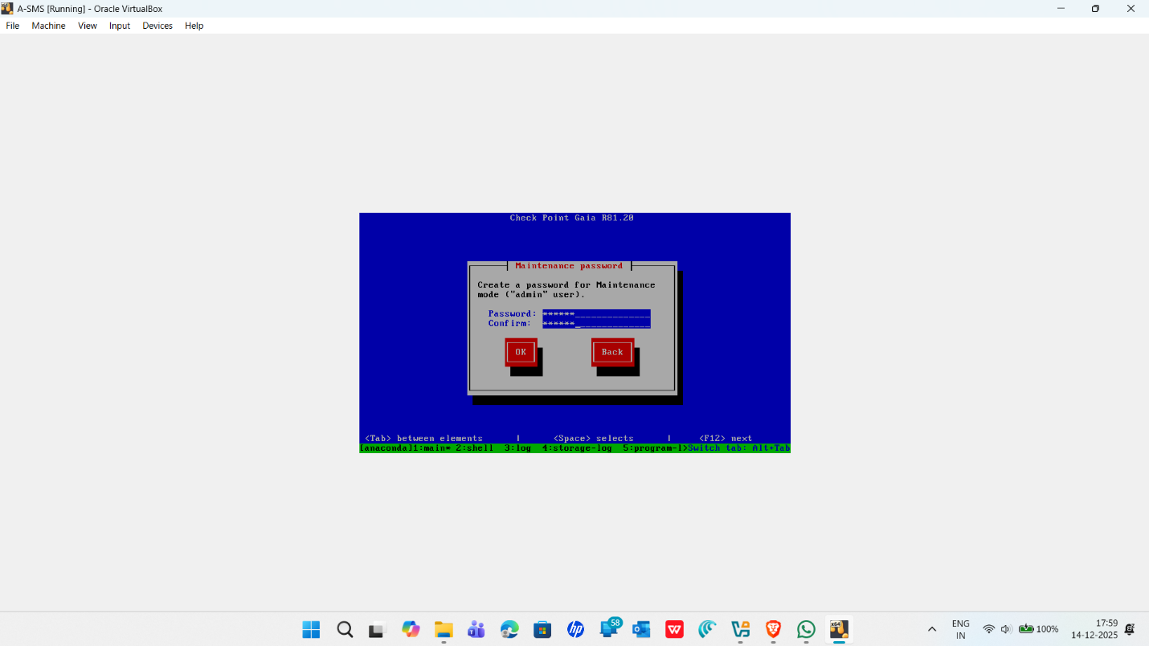

- Click OK to continue.
- Choose the eth0 port to configure A-SMS interface. Click OK to continue.
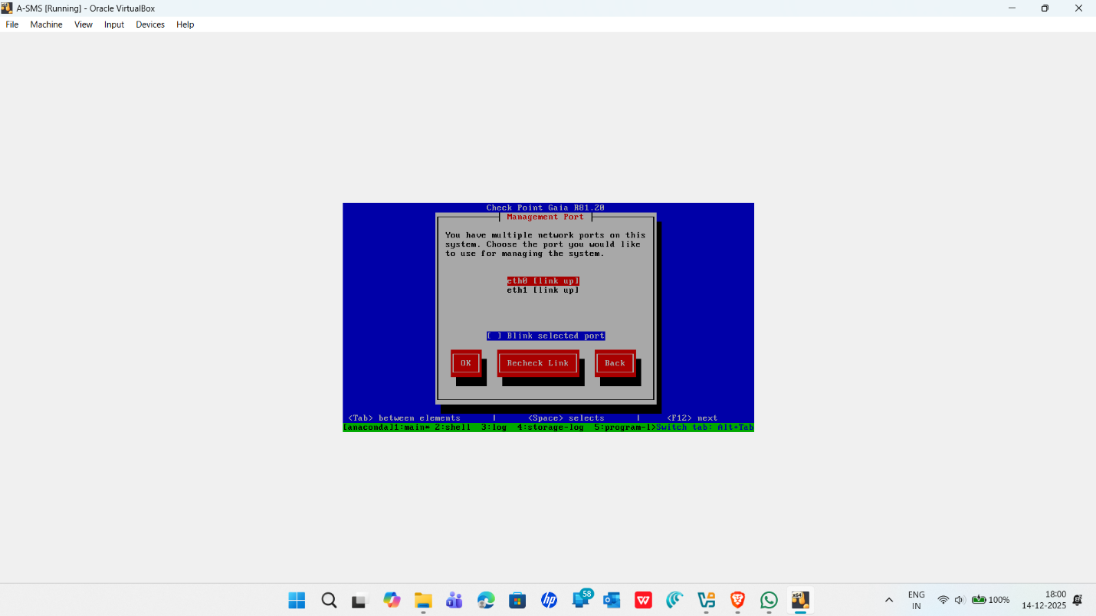

- Enter the system configuration for A-SMS.
IP address | 10.1.1.101
Netmask | 255.255.255.0
Default Gateway | 10.1.1.1
DHCP server on this interface | Disabled (Default)

- Select OK and press Enter to continue.
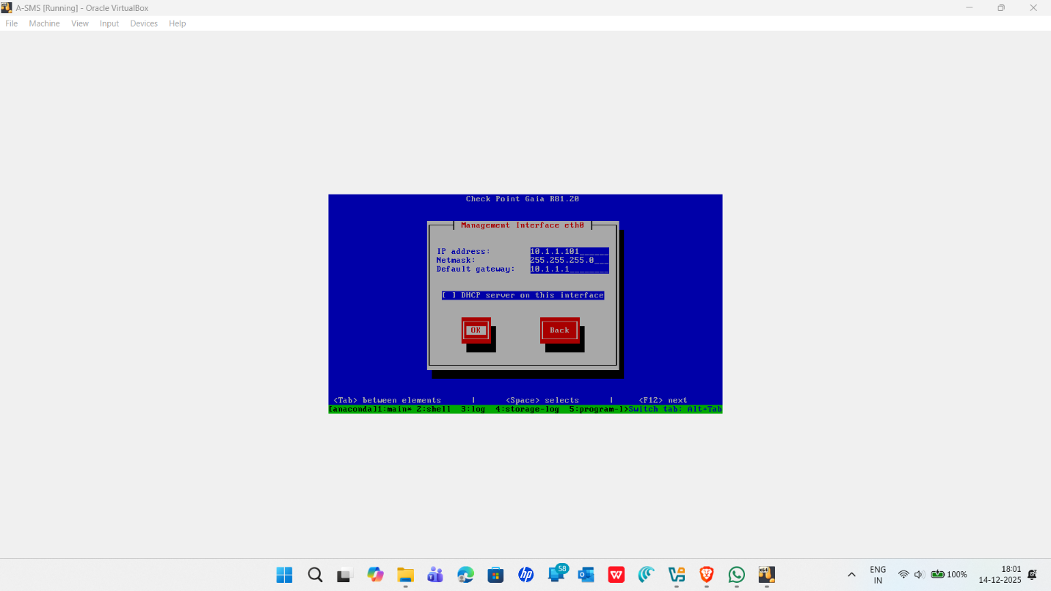

- Select OK to confirm the installation of GAIA OS in the A-SMS. Press Enter to start the installation process.
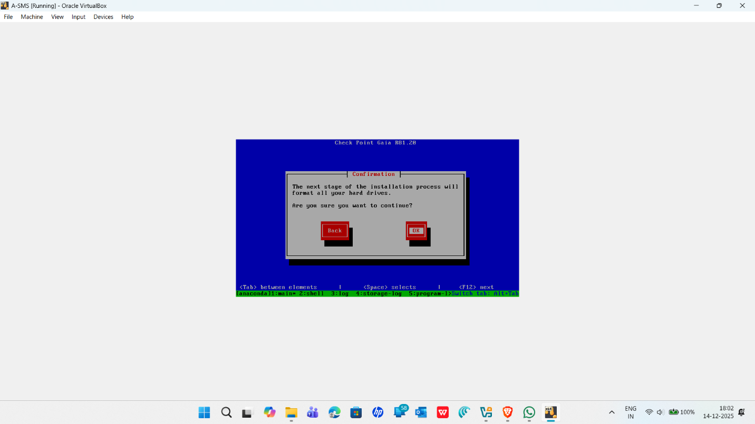

- After the installation completes, press Enter to quit the installer process.
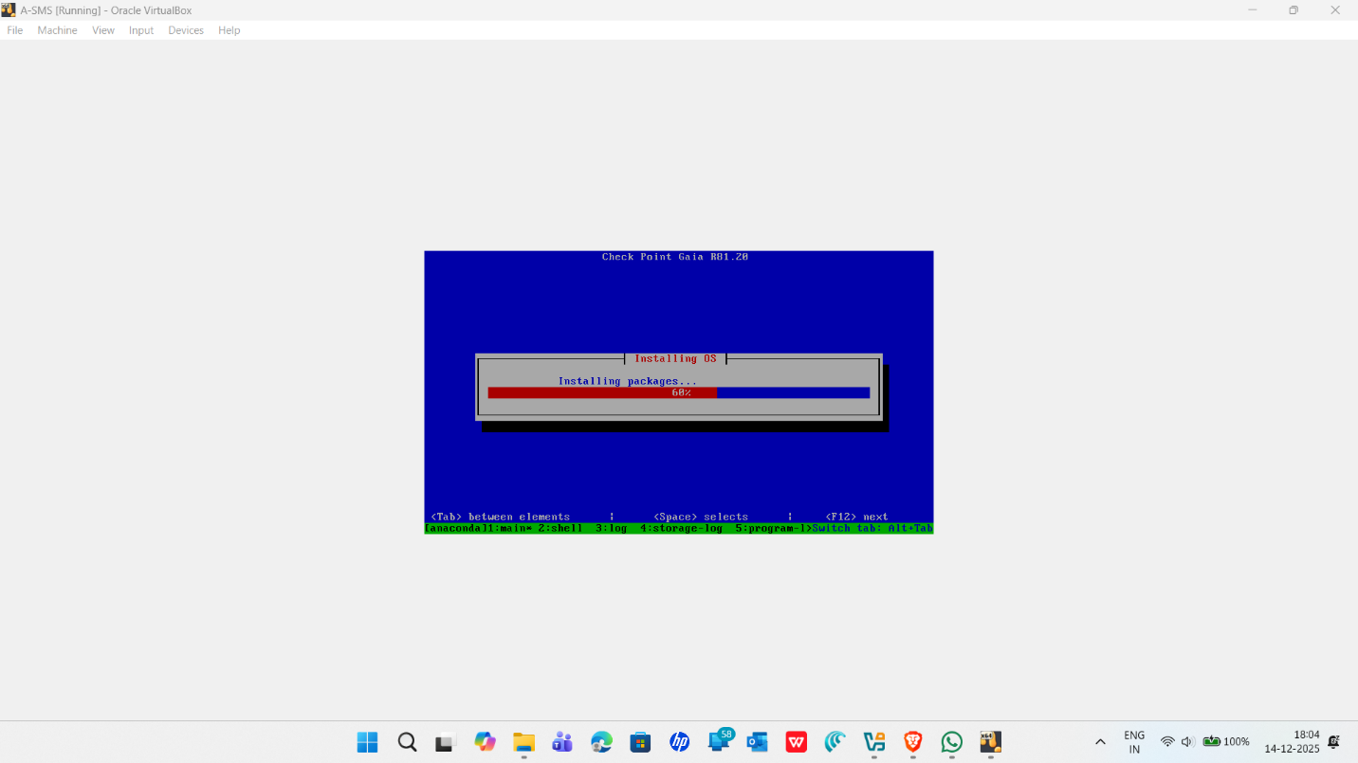
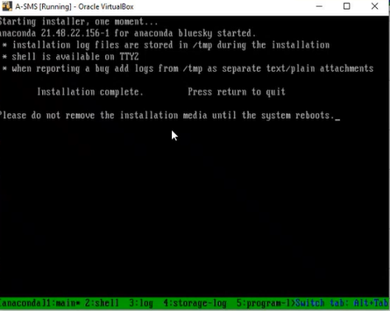
- After the reboot, choose Do not install Gaia. Boot from local drive and press Enter.
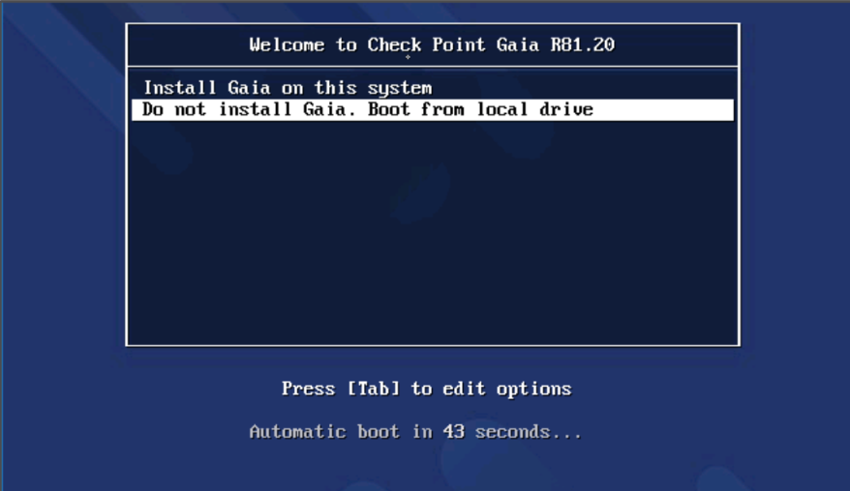
- When the system reboots, it will ask for login details to login to the Gaia OS.

- Once login, Set the inactivity and web session timeouts and save the configuration using save config
set inactivity-timeout 720
set web session-timeout 720
save config
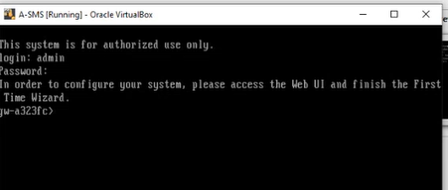

- Type Exit and press Enter to logout the A-SMS console window.
Chapter: 2.1 Configuring Security Management Server(A-SMS) through the First Time Wizard
Access the Web UI and finish the First Time Wizard on the A-SMS machine.
    - Go to A-GUI, open a web browser.
    - Use the following URL to access the A-SMS through web portal from A-GUI http://10.1.1.101
2.1.3 You might see a warning message as shown below, select Advanced and continue
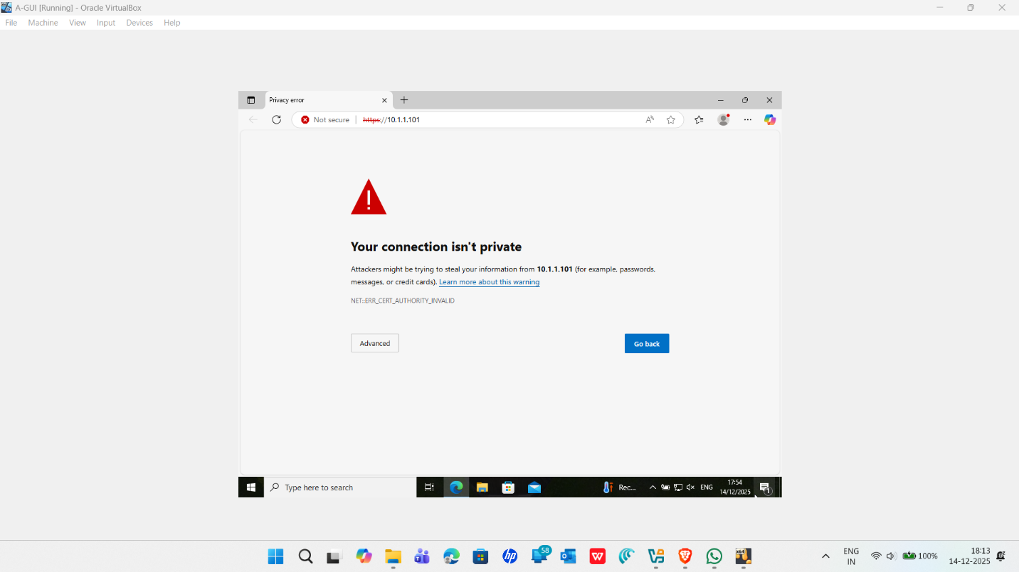

2.1.4 Use the admin login that you have created during the A-SMS installation to log in to the A-SMS using Gaia portal from Web GUI.
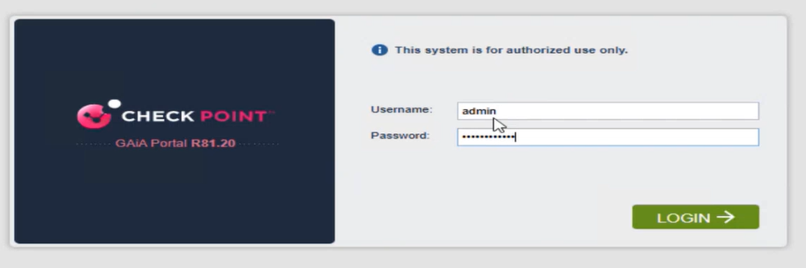
You will see the following welcome screen from the First Time Wizard to configure A-SMS
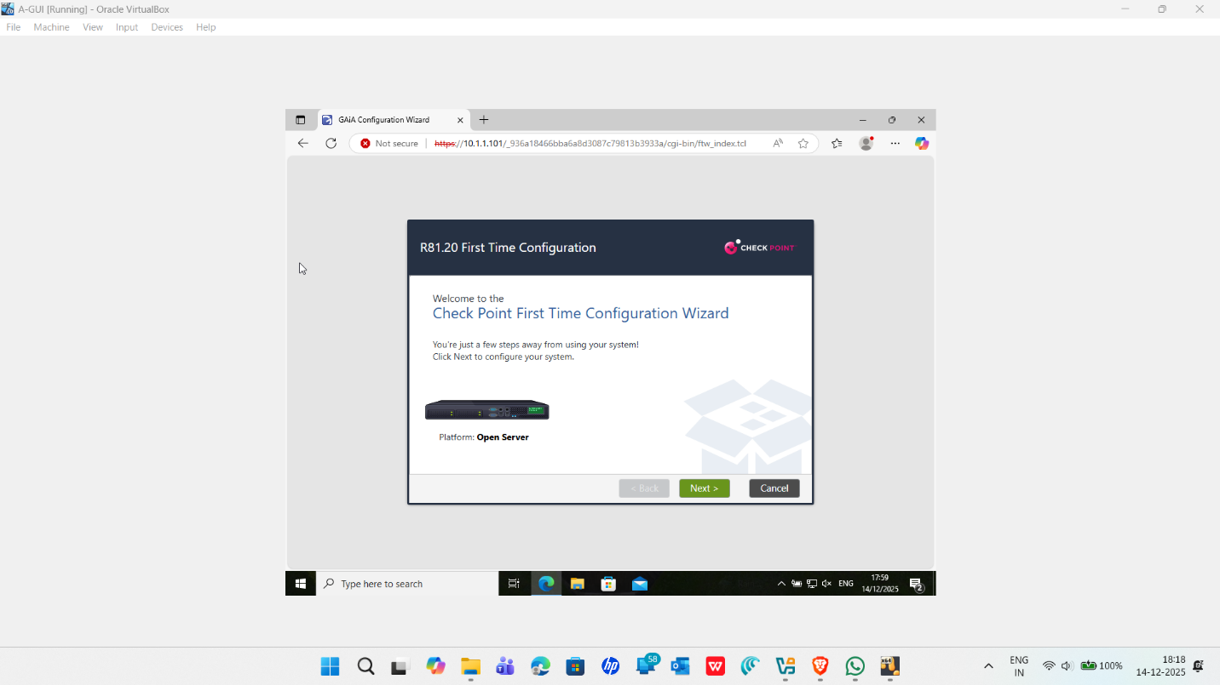

2.1.5 Select Continue with R81.20 configuration and click Next to continue
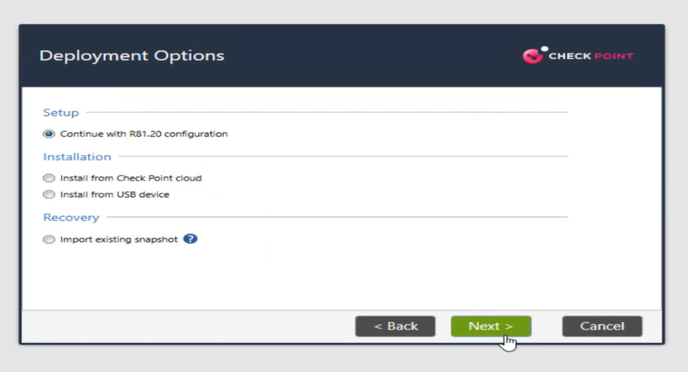
2.1.6 Check the settings on the Management Connection page is correct and click on Next to continue.
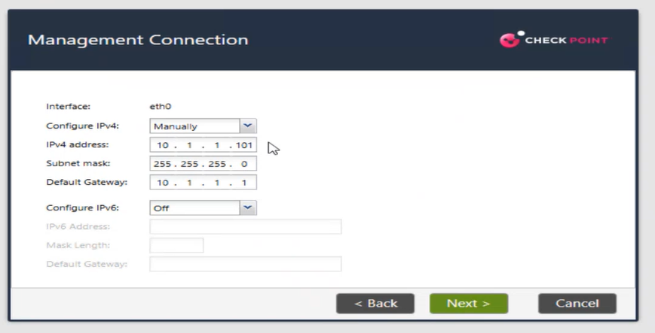
Leave the settings as it is from the following screen.
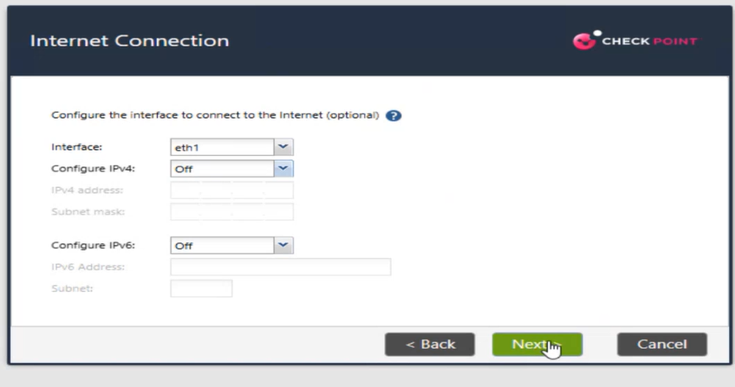
2.1.7 Configure the A-SMS using the Device Information and select Next to continue
Hostname : A-SMS  Domain Name : swansea.acca  Primary DNS Server : 192.168.1.1  Secondary DNS : 8.8.8.8  Teritary DNS Server : 4.2.2.2 | 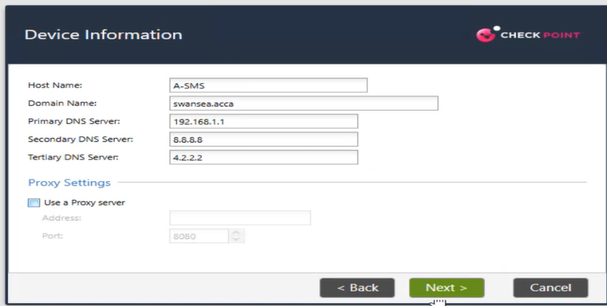

2.1.8 Select use Network Time Protocol on the Date and Time Settings page. Configure the NTP servers with time.google.com. Also choose London,Europe(GMT) for the Time Zone. Select Next to continue.
Primary NTP Server : time1.google.com  Secondary NTP Server : time2.google.com | 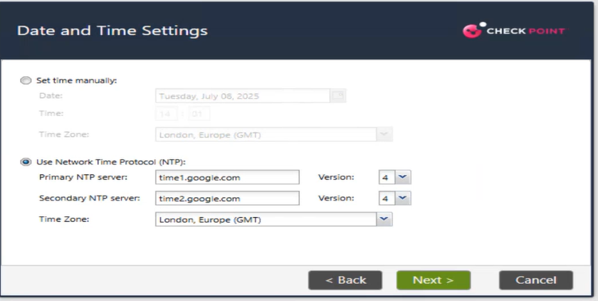

2.1.9 On the installation type, select Security Gateway and/or Security Management and select Next to continue.
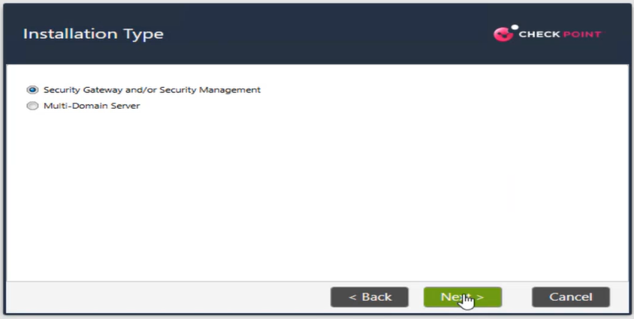
2.1.10 Select Security Management option from the Products page and ensure Security Gateway is disabled. Verify the Define Security Management is set to Primary. Select Next to continue
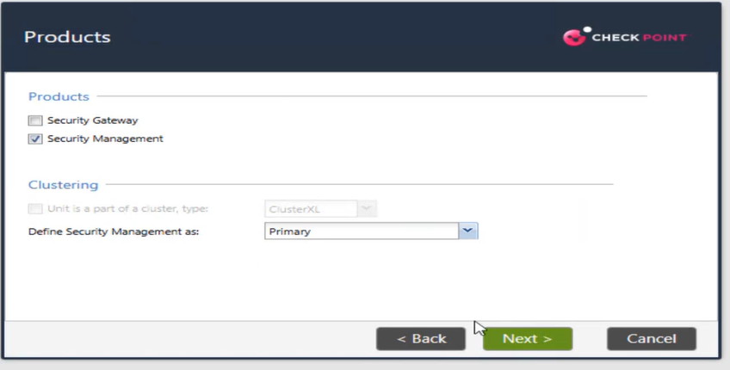
2.1.11 Choose Define a new administrator from the Security Management Administrator page and configure new administrator. You can use any username and password (This is going to be used to login to A-SMS from Smart Console. For this documentation, the following details were used. Select Next to continue

2.1.12 Select the Network option the Security Management GUI Clients page and use the following details. Choose Next to continue
IP Address : 10.1.1.0  Subnet : 255.255.255.0 | 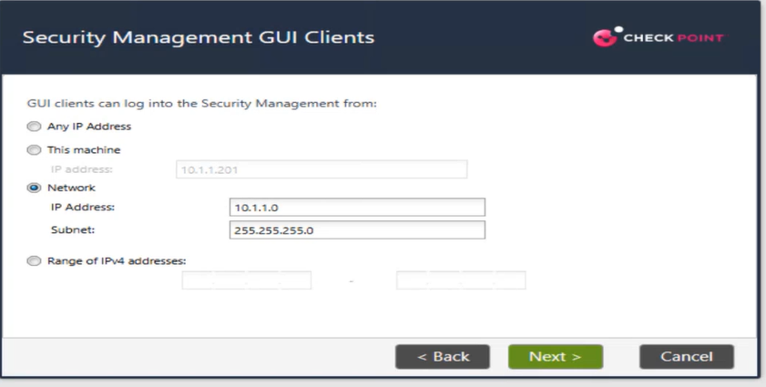

2.1.13 Make sure the First Time Configuration Wizard Summary shows only Security Management: Primary Security Management, select Finish to finalise the configuration.
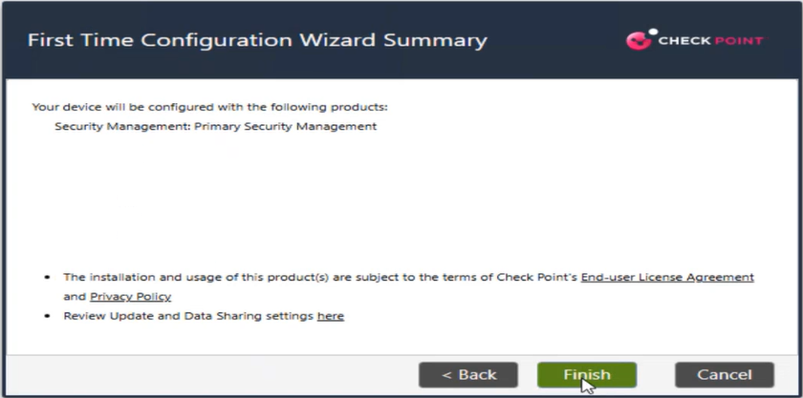 | 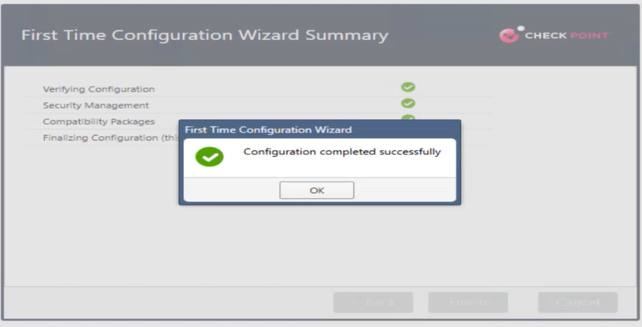

2.1.14 Select OK to confirm the configuration.
2.1.15 Click Open Terminal and run the command api status to check the API readiness test to check the status of the A-SMS startup process.

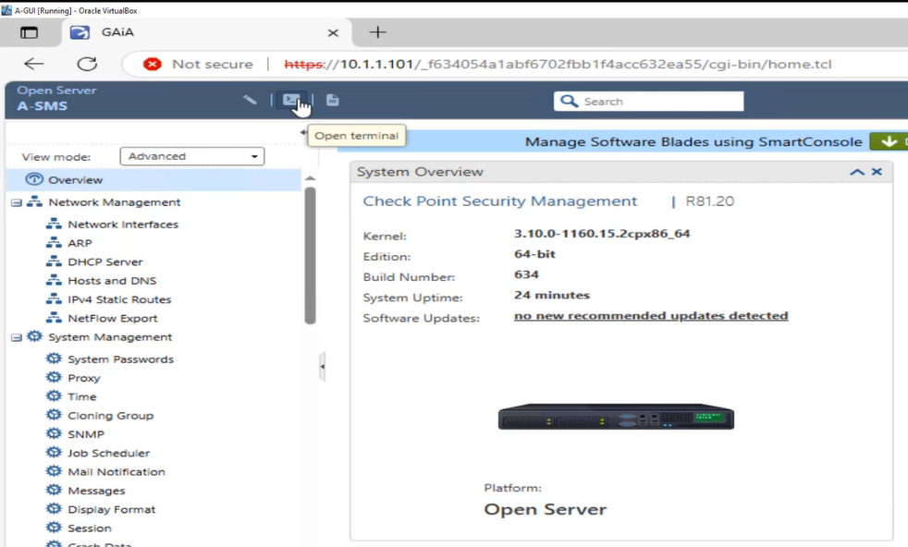 | 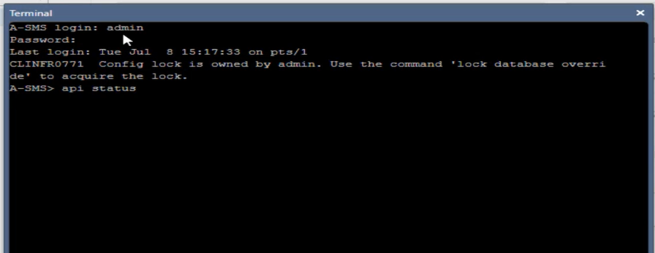

2.1.16 You should see API readiness test Successful. You may need to run the command more than once to get the SUCCESSFUL message. Exit the terminal using exit command.
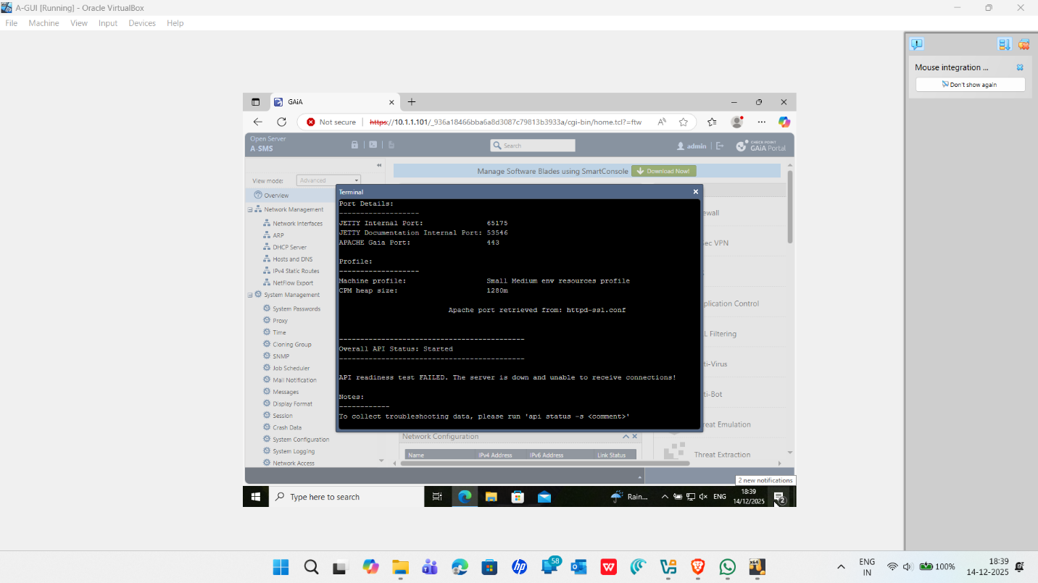

Chapter 3: Installation of the Check Point Gateway (A-GW)
- Turn on A-GW machine.
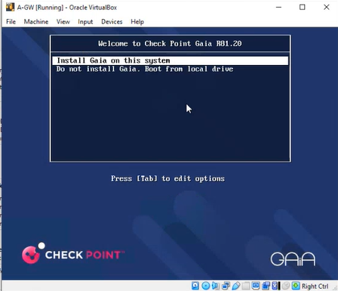
- A warning message will appear, select OK to continue the installation and press Enter
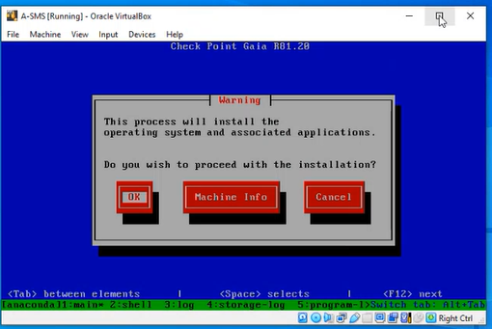

- Select a keyboard language. US is the default, select Great Britain version:
- Check the partition configuration. The disk space depends on your system configuration. So, don’t change it. Press TAB key to select the OK button and press Enter.
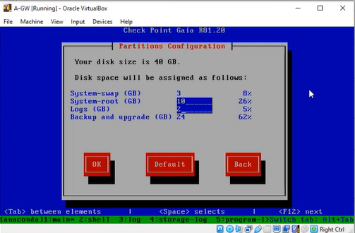

- Enter the password for the admin account and confirm it. You can use any password.
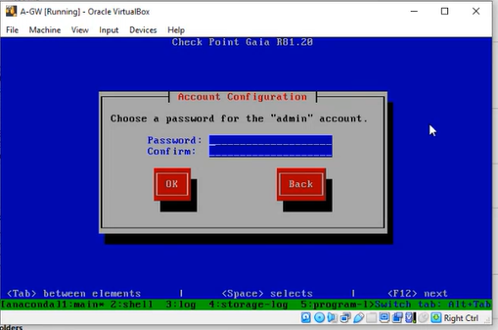
- Enter the password for Maintenance admin password. You can choose any password of your choice. Make sure you remember it. Click OK to continue.
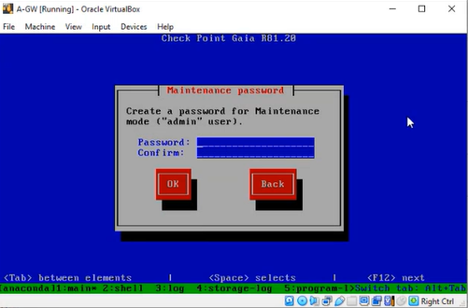

- Select eth0 interface and configure the A-GW
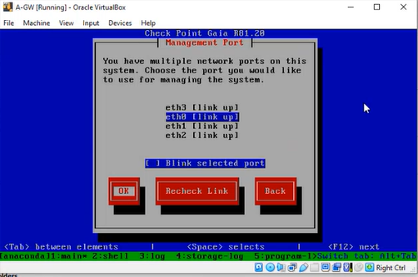
- Enter the system configuration for A-GW.
IP address | 10.1.1.1
Netmask | 255.255.255.0
Default Gateway
DHCP server on this interface | Disabled (Default)

- Select OK and press Enter to continue.
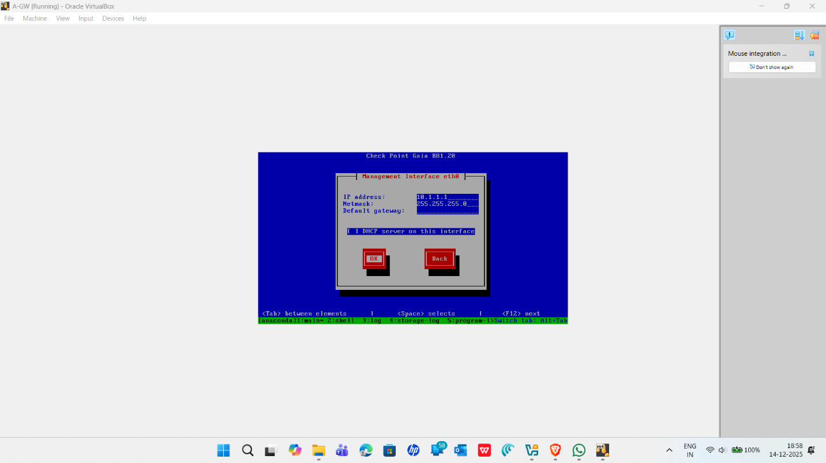

You will see the following screen.
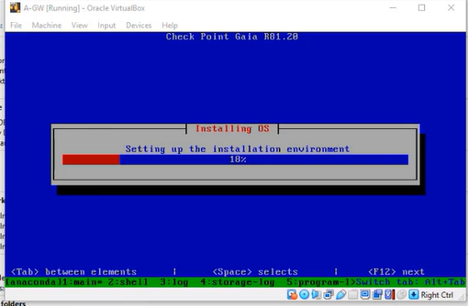 | 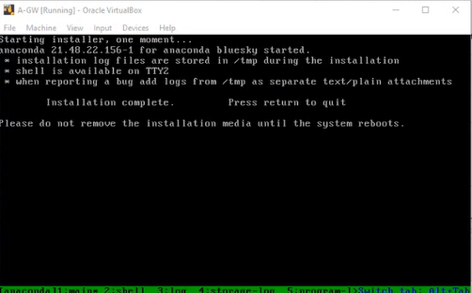

This is the end of the A-GW installation.

Chapter 3.1 Running the First Time Wizard on the Security Gateway
Access the Web UI and finish the First Time Wizard on the A-GW machine.
3.1.1 Go to A-GUI, open a web browser.
3.1.2 Use the following URL to access the A-GW through web portal from A-GUI http://10.1.1.1
3.1.3 You might see a warning message as shown below, select Advanced and continue
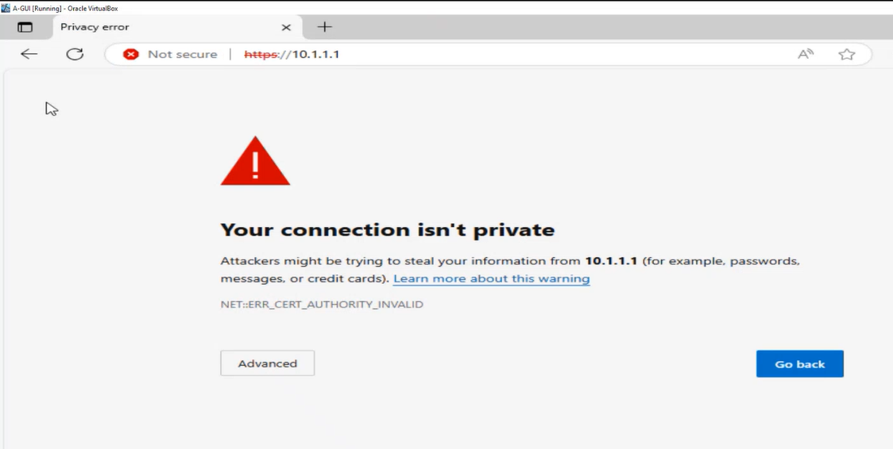 | 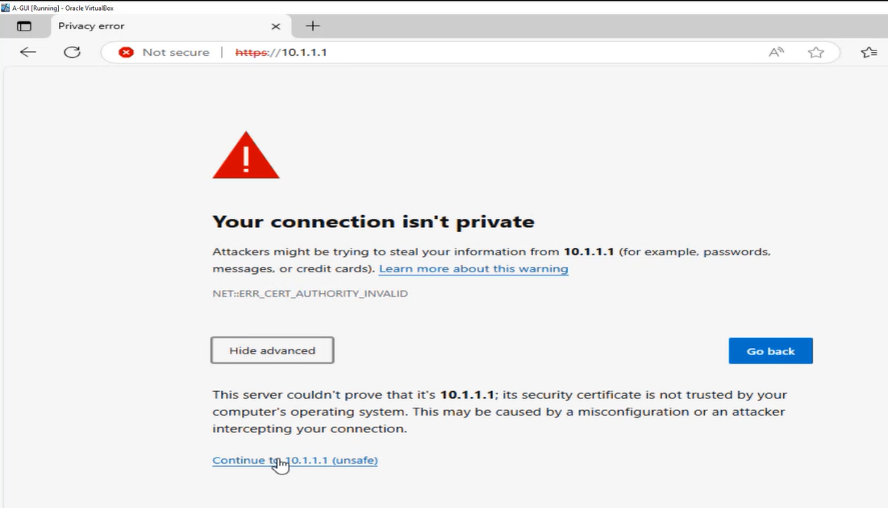

3.1.4 Use the admin login that you have created during the A-SMS installation to log in to the A-GW using Gaia portal from Web GUI.

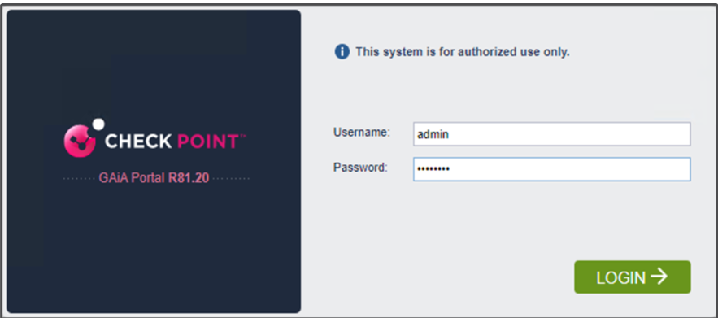
You will see the following welcome screen from the First Time Wizard to configure A-GW
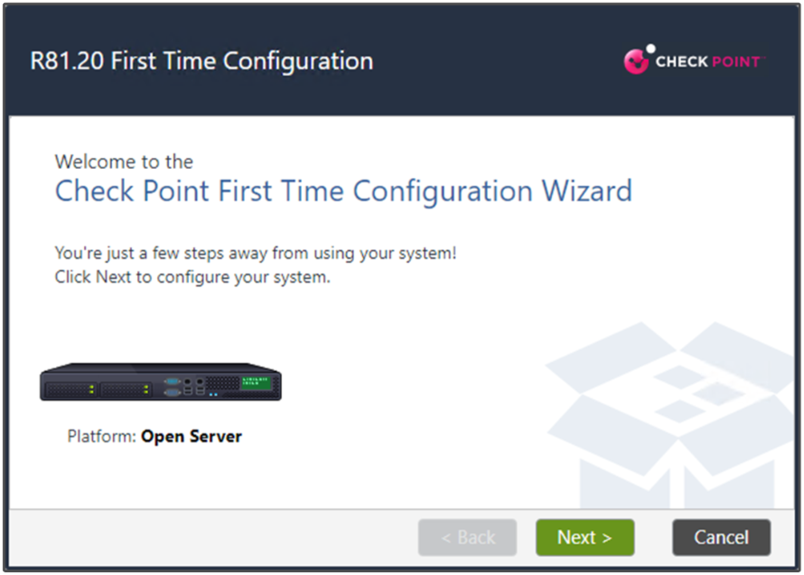

3.1.5 Select Continue with R81.20 configuration and click Next to continue
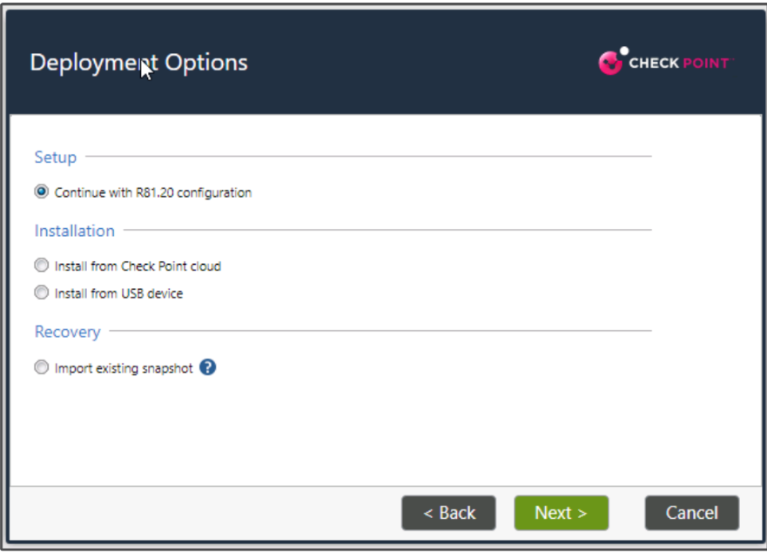
3.1.6 Check the settings on the Management Connection page is correct and click on Next to continue.
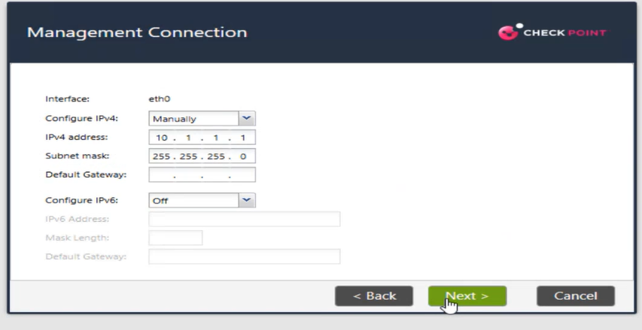
Leave the settings as it is from the following screen.
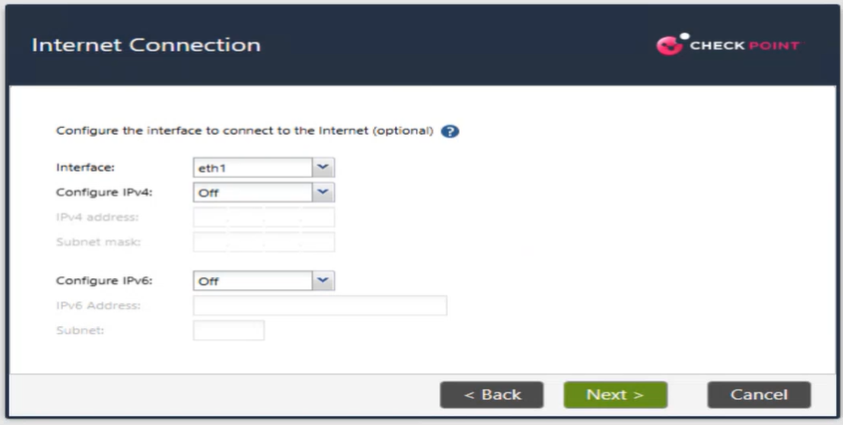
3.1.7 Configure the A-GW using the Device Information and select Next to continue
Hostname : A-GW  Domain Name : swansea.acca  Primary DNS Server : 192.168.1.1  Secondary DNS : 8.8.8.8  Teritary DNS Server : 4.2.2.2 | 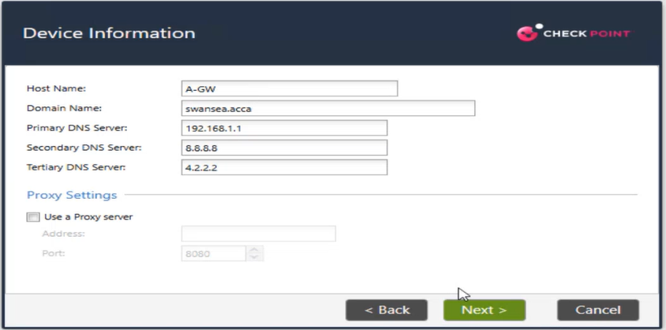

3.1.8 Select use Network Time Protocol on the Date and Time Settings page. Configure the NTP servers with time.google.com. Also choose London,Europe(GMT) for the Time Zone. Select Next to continue.
Primary NTP Server : time1.google.com
Secondary NTP Server : time2.google.com

3.1.9 Make sure Security Management option is disabled from the Products page and ensure Security Gateway is enabled. Verify the Define Security Management is set to Primary. Select Next to continue
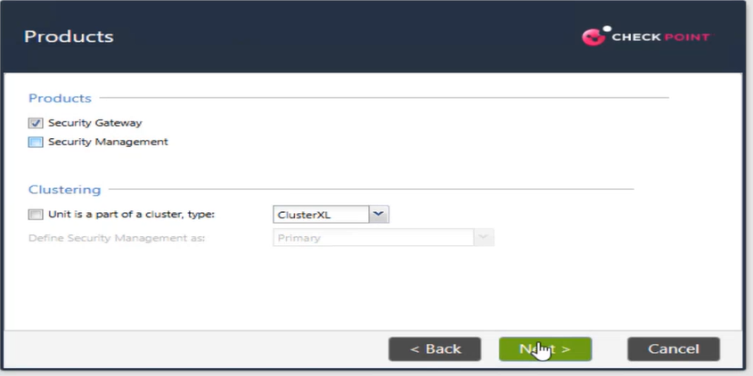

3.1.10 Verify No is selected on the Dynamically Assigned IP and press Next to continue
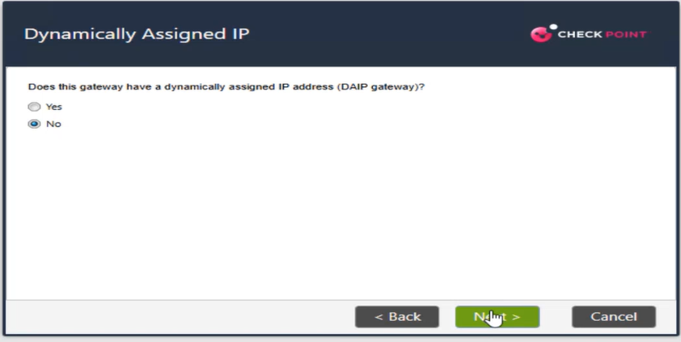
3.1.11 On the Secure Communication to Management Server page, enter the Activation key. This key is used to establish the Secure Internal Communication (SIC).
Activation Key : Admin1
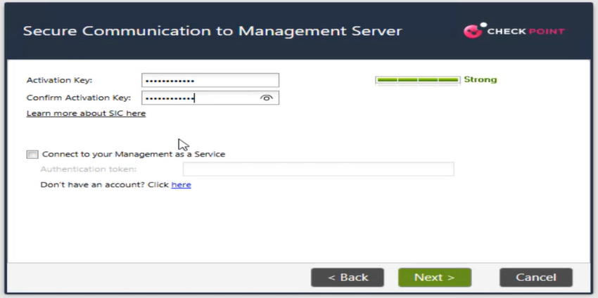
3.1.12 Verify only Security Gateway is listed on the First Time Configuration Wizard Summary page and press Finish to start the configuration process. Press Yes to the following process to continue.
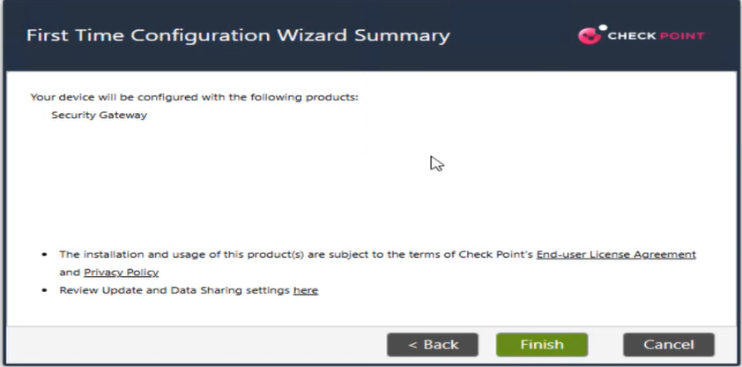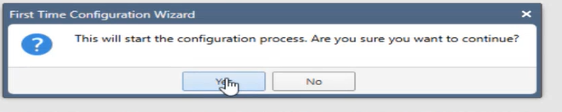
3.1.13 You will be seeing the following screen. Once done, press Ok to restart the A-GW.
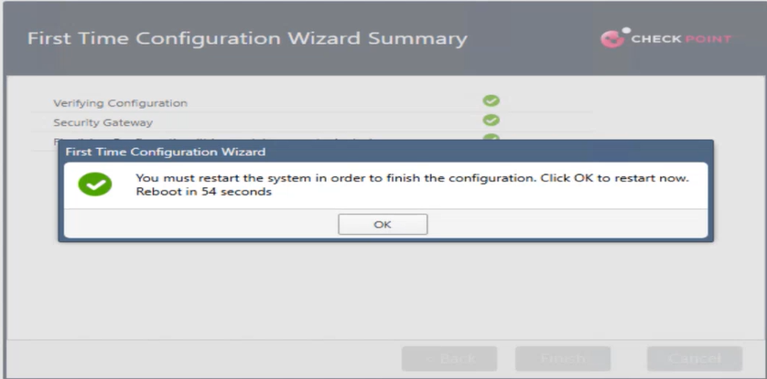
3.1.14 After A-GW finishes its reboot, log in to the Gaia Portal again. Navigate to Network Interfaces. Select the eth0 and choose Edit. You will see a Caution! message indicating that you are trying to edit the interface you are connected to. Select Ok button to continue

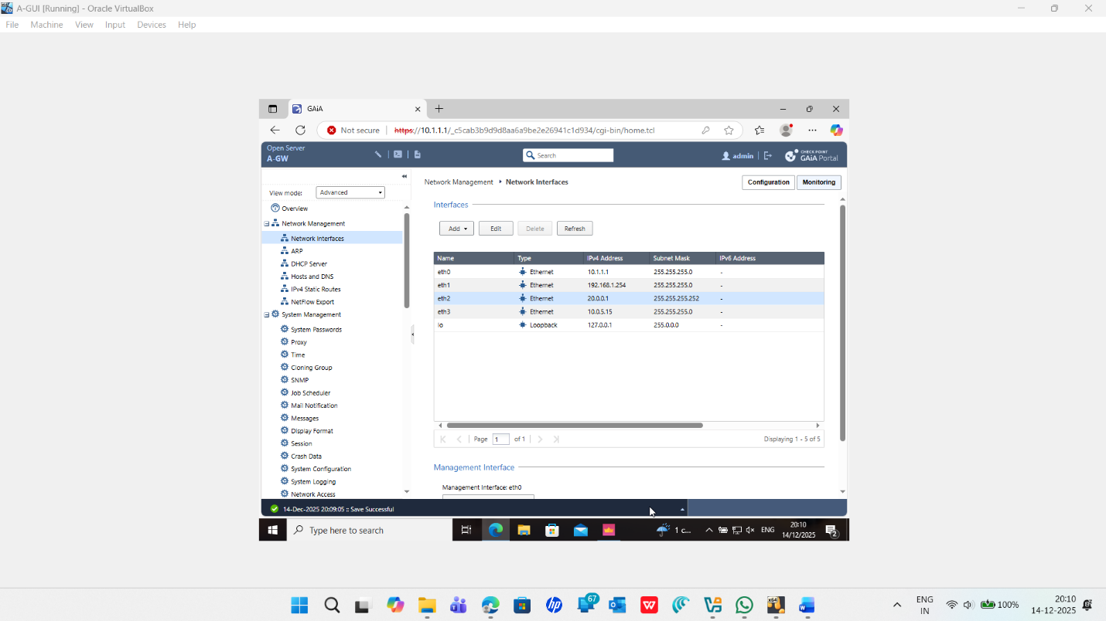

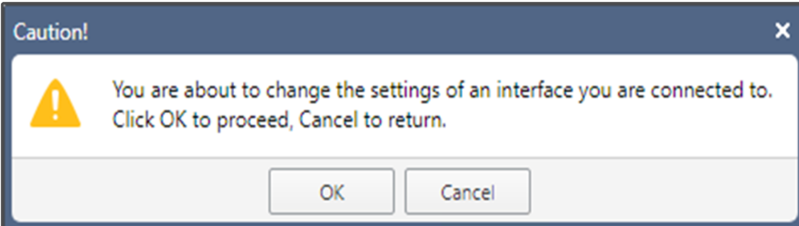

3.1.15 Check the configuration of eth0 and verify the following settings and press OK to close the configuration window for eth0
Enable: Enabled
Comment : Swansea.acca
Ipv4 Address : 10.1.1.1
Subnet Mask : 255.255.255.0
3.1.16 Select eth1 , click on Edit and configure the eth1 interface with the following details
Enable: Enabled  Comment : IntSWA  Ipv4 Address : 192.168.1.254  Subnet Mask : 255.255.255.0 | 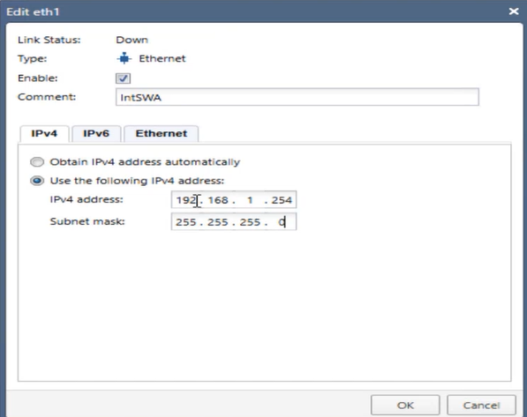
3.1.17 Select eth2 , click on Edit and configure the eth2 interface with the following details
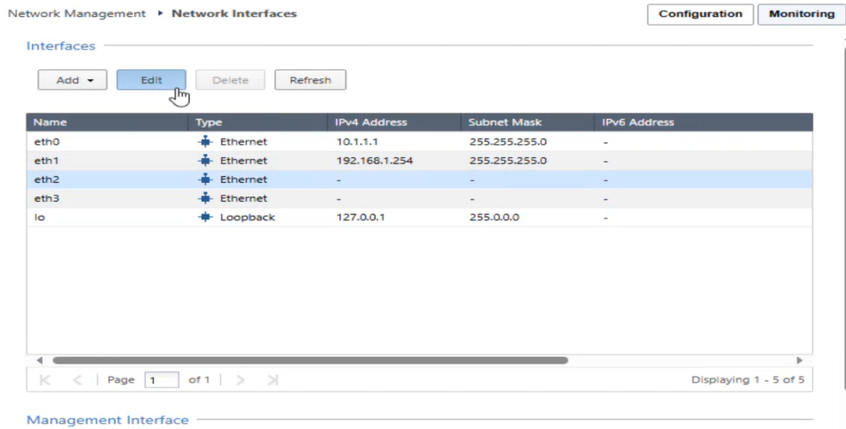
Enable: Enabled  Comment : ExtLCD  Ipv4 Address : 20.0.0.1  Subnet Mask : 255.255.255.252 | 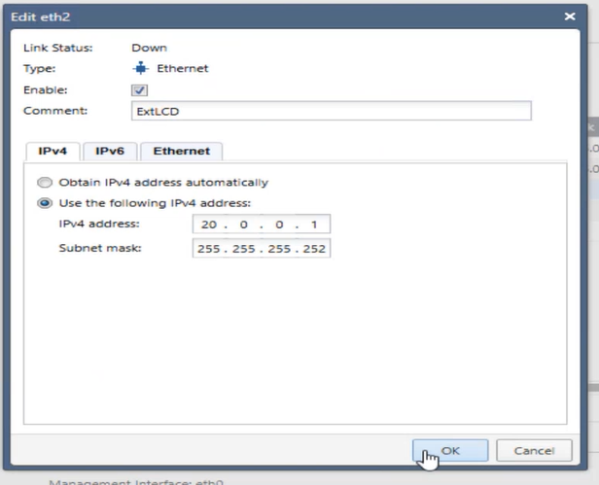

3.1.18 Select eth3 , click on Edit and configure the eth3 interface with the following details
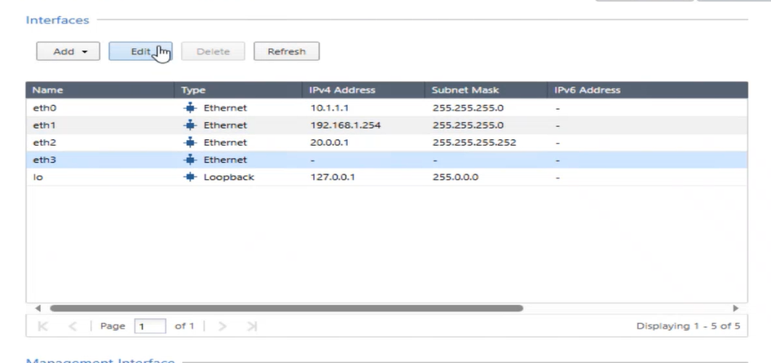
Enable: Enabled  Comment : ExtInt  Choose Obtain IPv4 address automatically. | 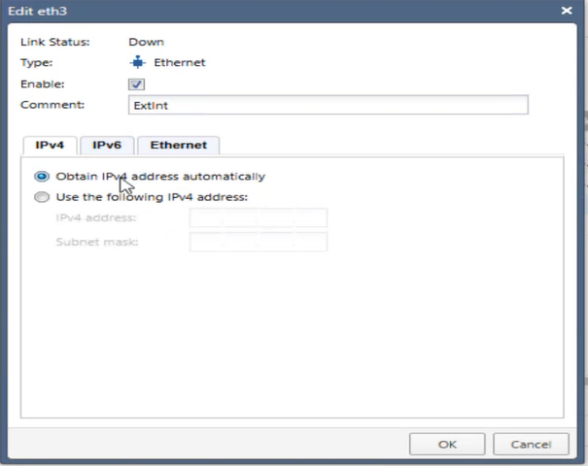

3.1.19 Click Sign Out to log out of the A-GW Gaia Portal. Close the browser.
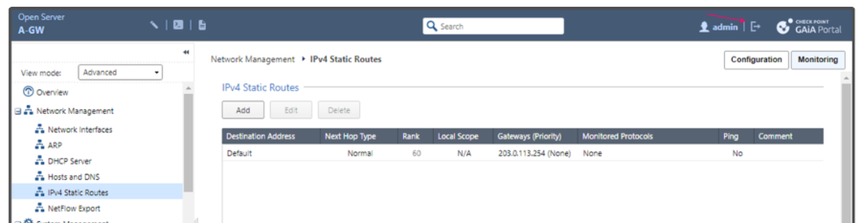
This is the end of the Lab.

Chapter 4 Establishing Secure Internal Communication
To create a Security Gateway object in SmartConsole, complete the following steps.
- On A-GUI, log into A-SMS using SmartConsole.
- Select Gateway from the New menu, select Wizard Mode to create the new Gateway object using the Check Point Security Gateway Creation Wizard.
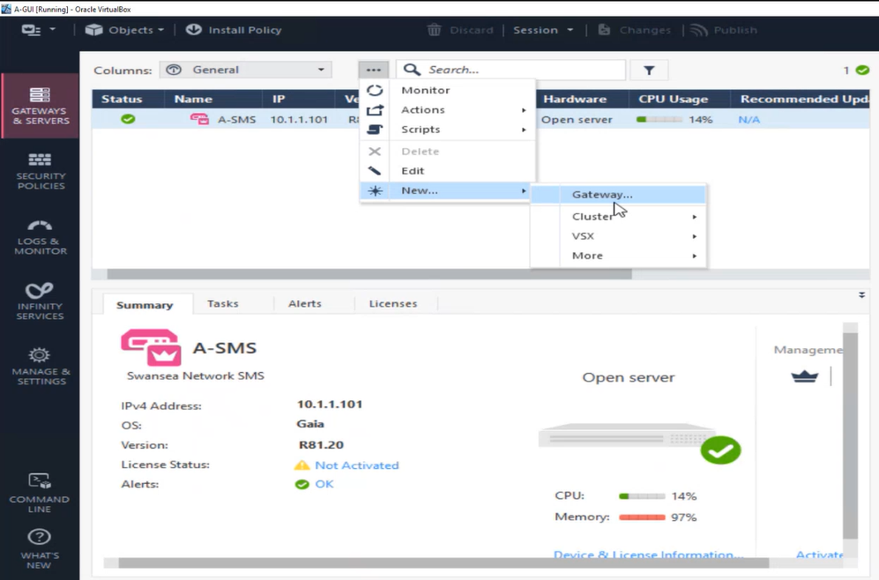 | 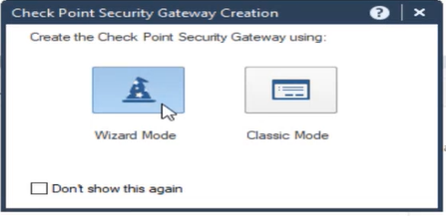

- Configure the object with the following details and select Next
Gateway name : A-GW
Gateway platform : Open server
IPv4 IP : 10.1.1.1
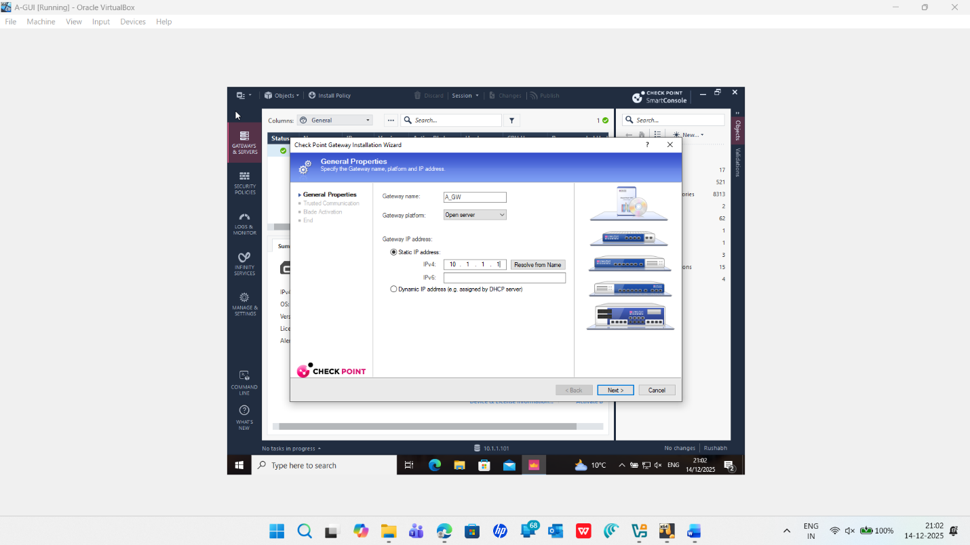

- Enter the one-time password, and select Next
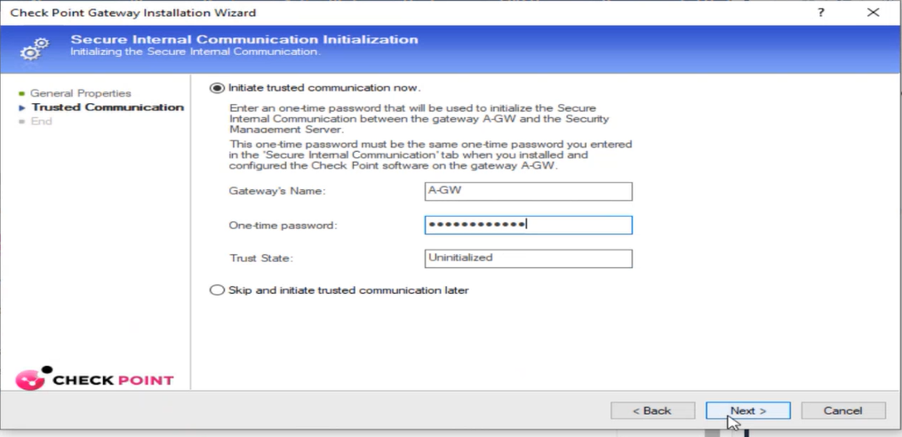
- You should able to see the configuration information from the Get Topology Results, once verified select Close.
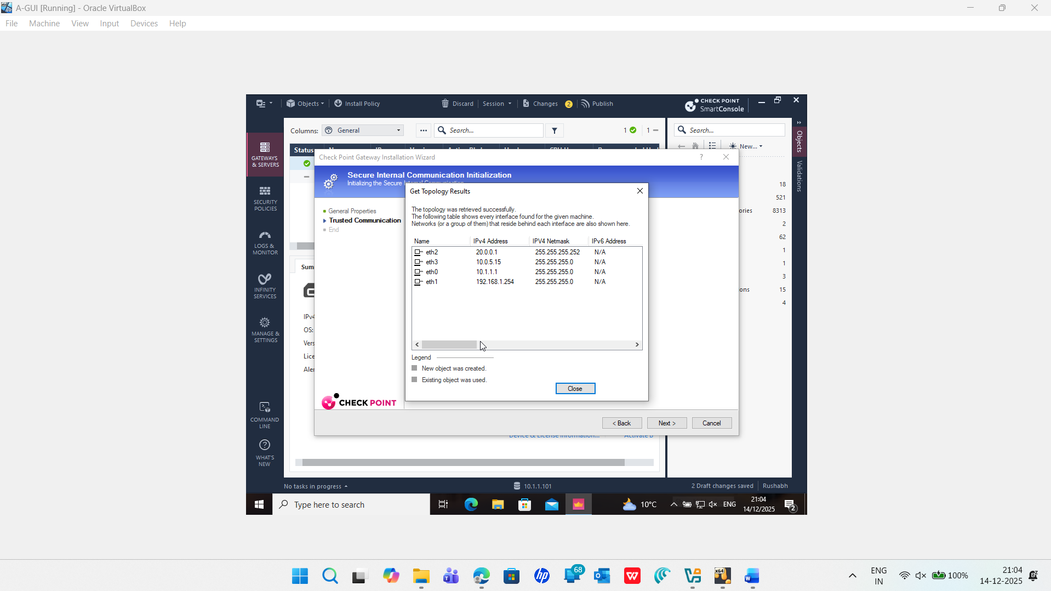
- Select Finish to complete the Check Point Gateway Installation Wizard.
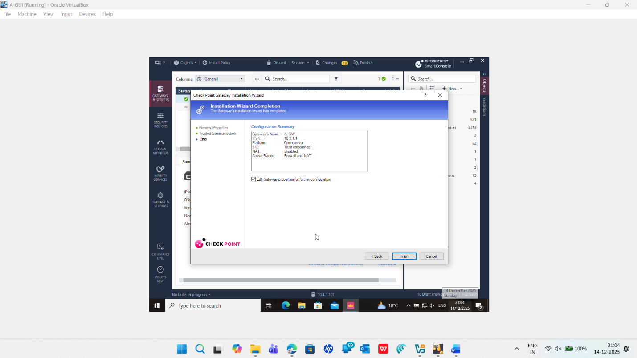

- Go to the General Properties for A-GW, enable the Firewall and Monitoring.
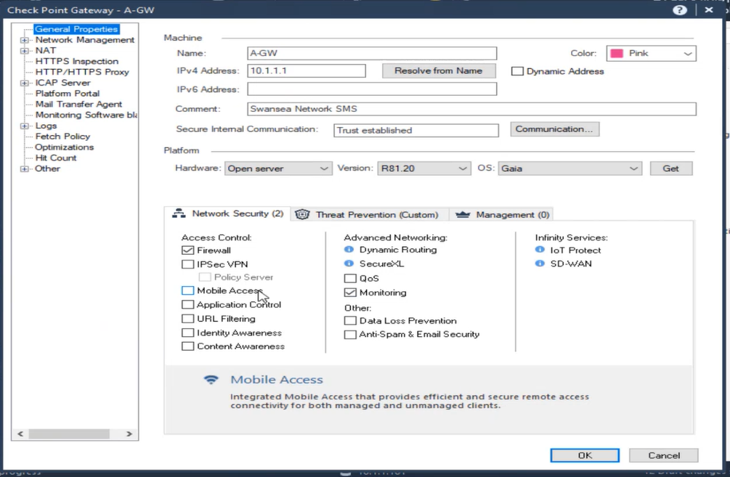
- Verify the IP addresses and topologies match this image.
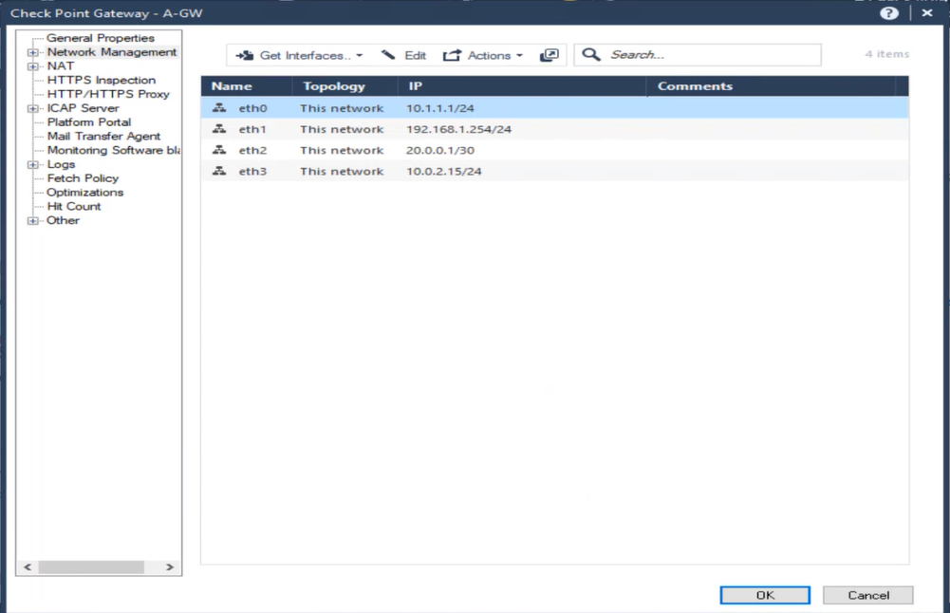

- Select the Gateway & Servers view. Double click the A-GW object
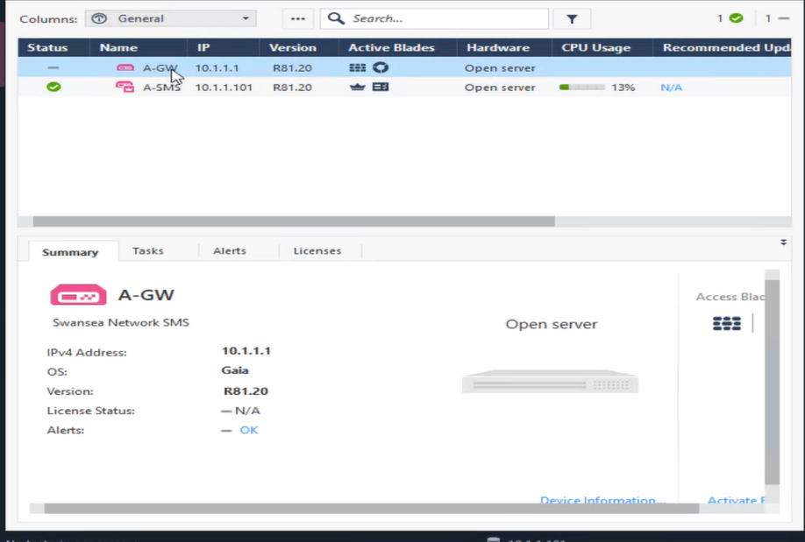
- Select Communication

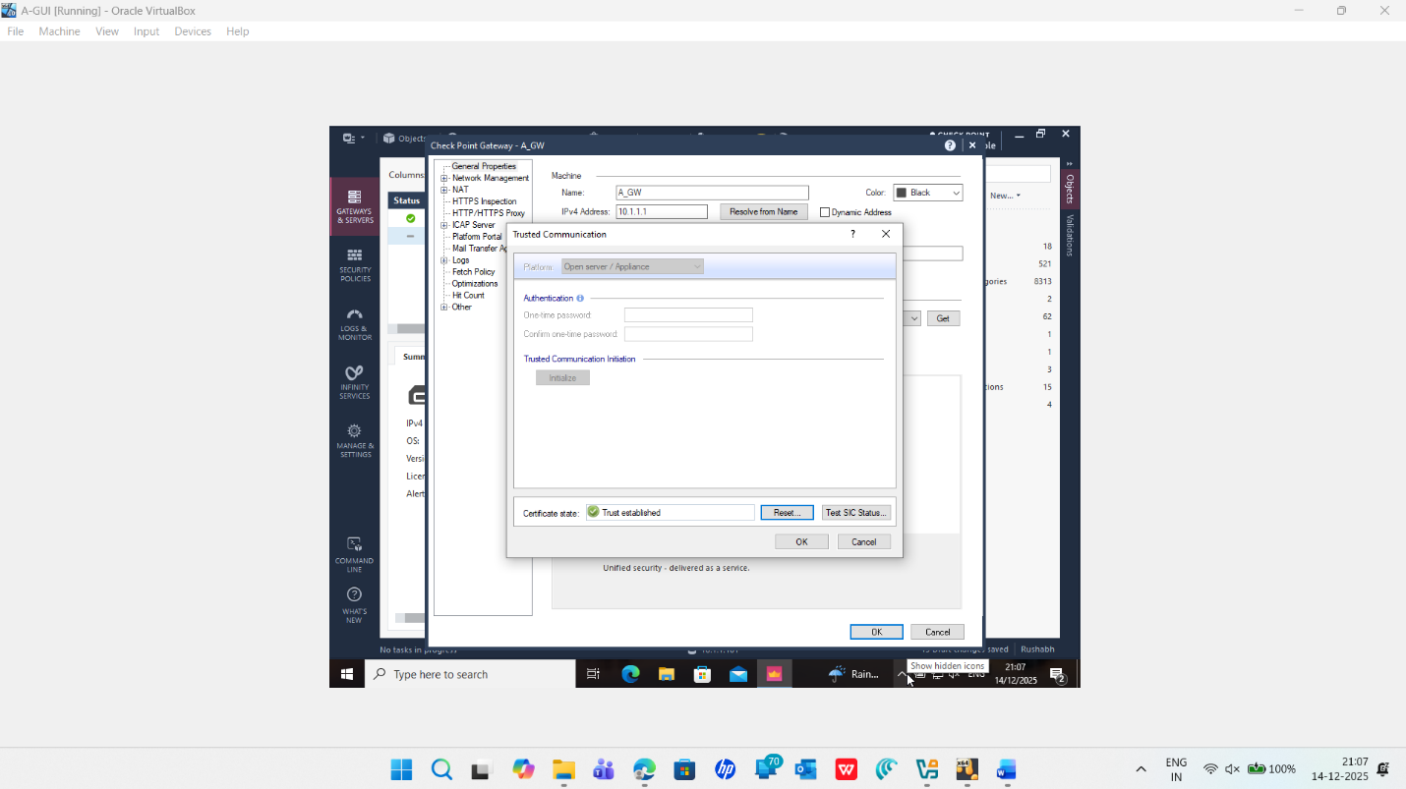

- Select the Test SIC Status communication
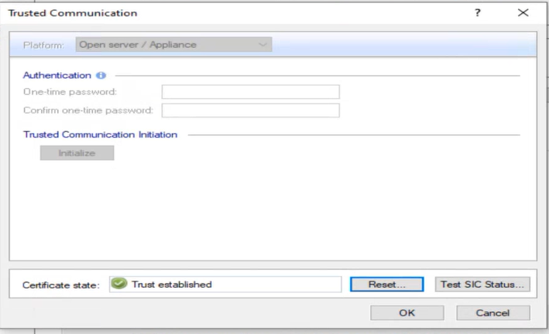
- If SIC has been established properly, you will see a status of Communicating.
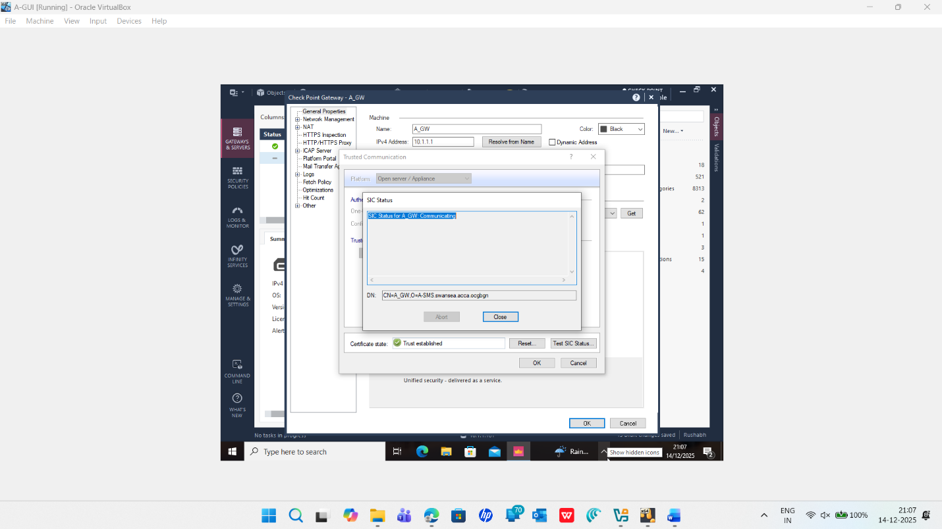

- Select the Close button to close the SIC Status window and select OK to close the Trusted Communication window. Select OK to close the A-GW object.
- Select Publish button on the global toolbar to save the changes to the database.
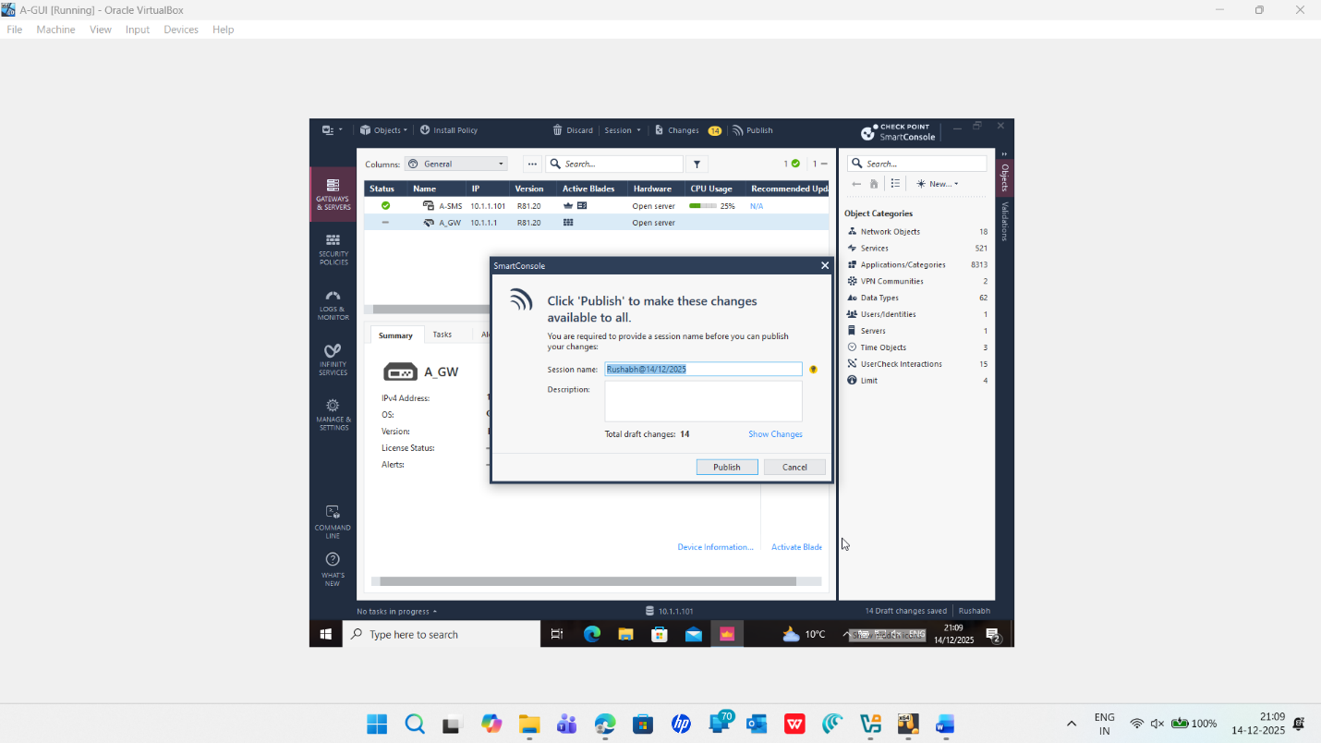

Chapter 5: Managing Licence
To Analyse the Current Licence Status
- Login to the SmartConsole from A-GUI machine using the credentials below.
Username : admin  Password : Password  IP Address : 10.1.1.101 | Select the Gateways & Servers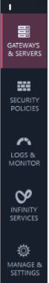

- Select A-GW object and check the licence status from the summary tab below. You should see Not Activated
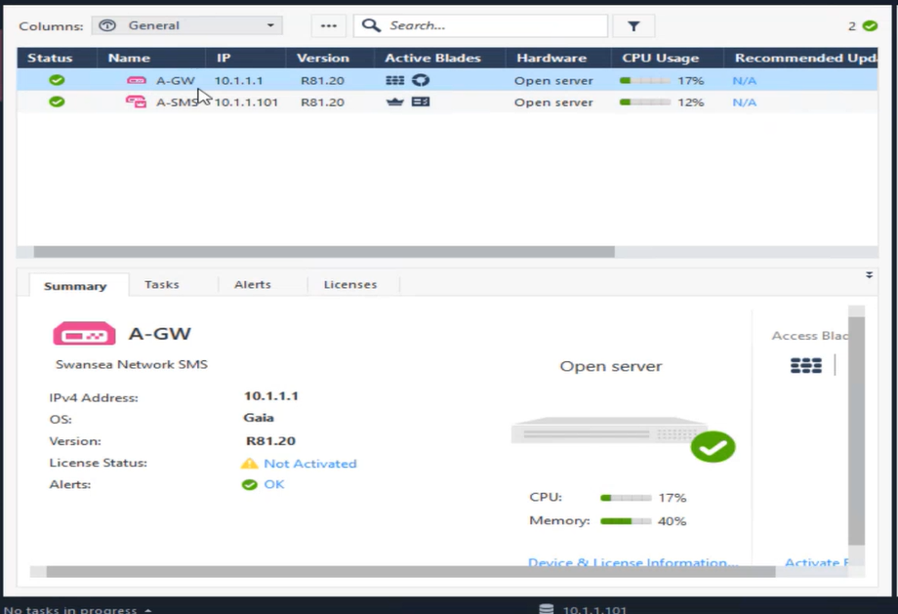

- Select the Device & Licence Information and select Licence status from the left object pane and verify the Expiration date and close/exit the Device & Information window.
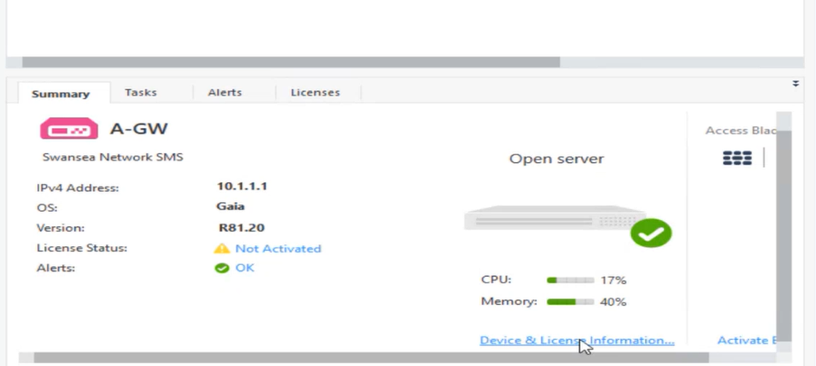 | 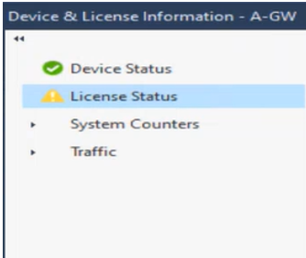
- Examine the licence for A-SMS and Exit the window.

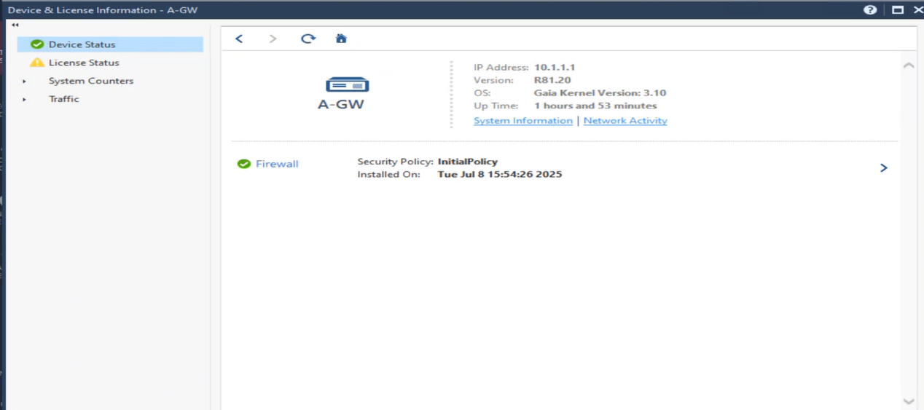
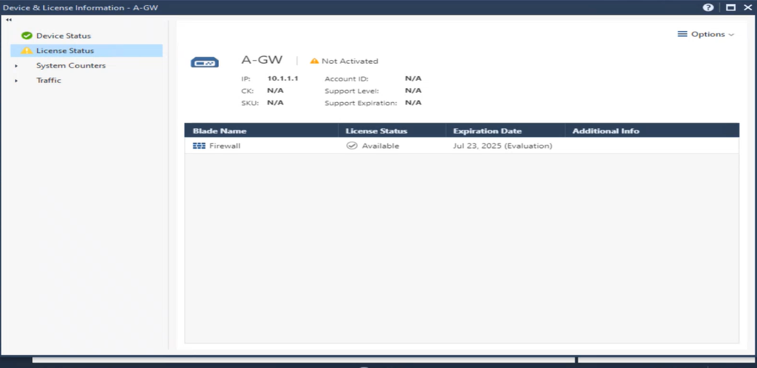

Chapter 4A :Attaching a Licence Using SmartUpdate
SmartUpdate is an utility to manage and maintain licence. In this chapter, we will go through how to attach licences using SmartUpdate.
- Choose Manage licence and packages from the SmartConsole application menu.

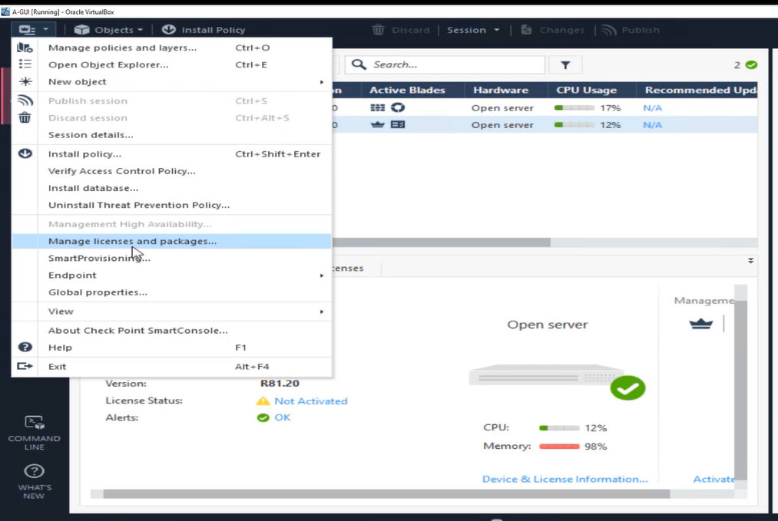

- Select OK to proceed further.
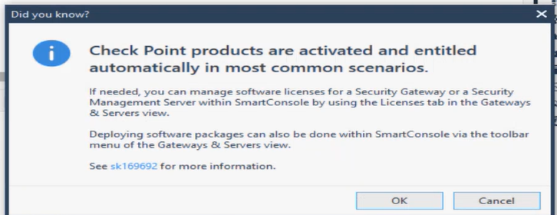
- Select the Licence and Contracts tab at the top of the window.
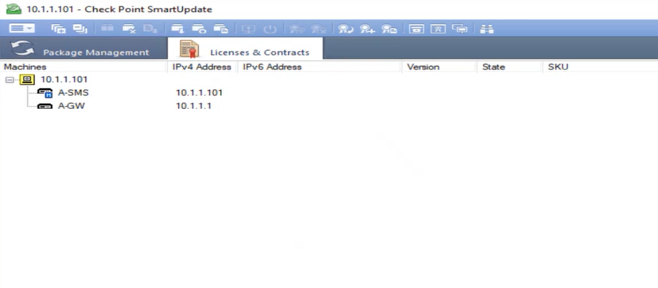

- From the SmartConsole menu, choose, Licence & Contracts and select View Repository
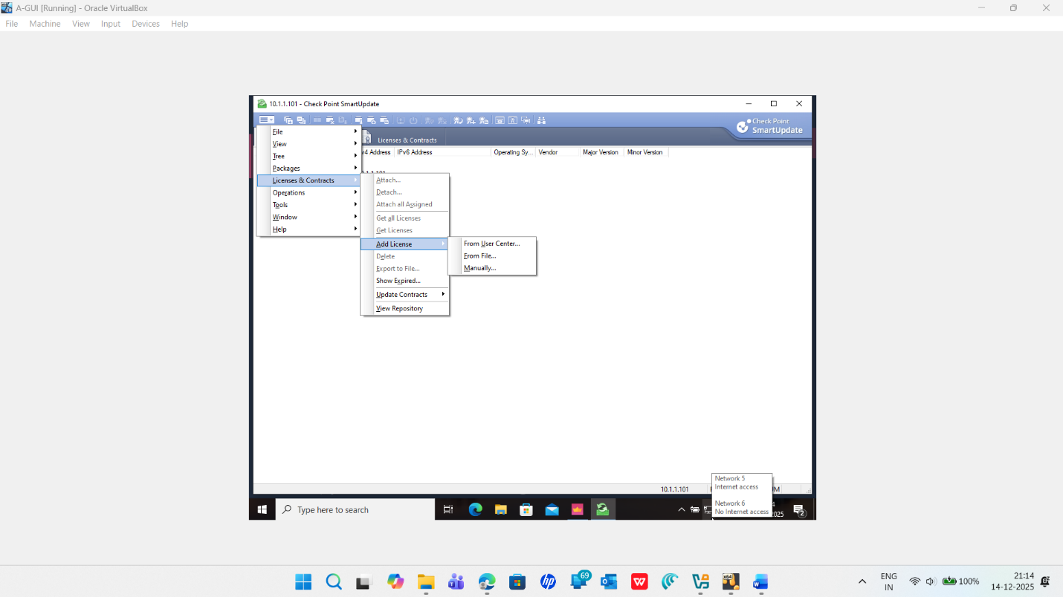

- Right click in the Licence and Contracts Repository pane, choose Add Licence and select From File option.

- Go to the licence directory that you have downloaded from Moodle. You could see all the licence for the Check Point appliances. Select A-SMS.lic 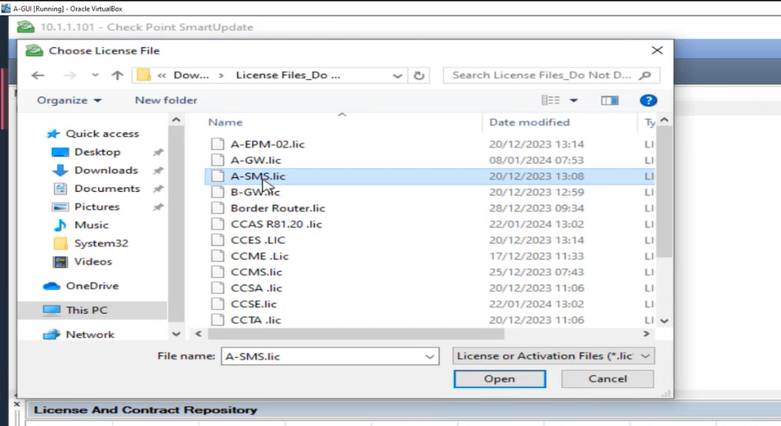
- Select OK to acknowledge to the message.

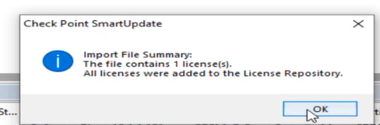
- You could see the local licence was attached to the SMS server.
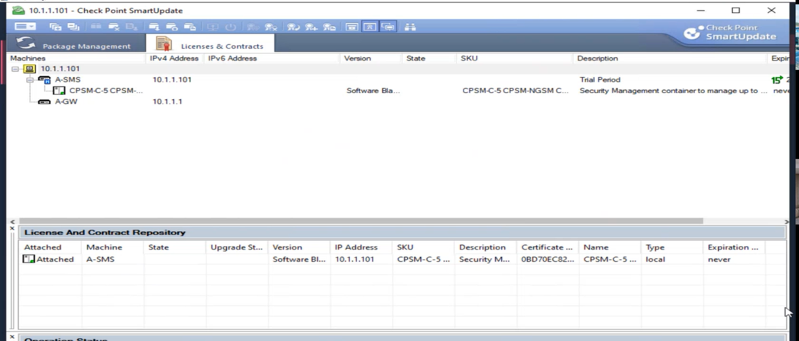

- Right click in the Licence & Contracts repository pane. Select Add licence and choose From File.
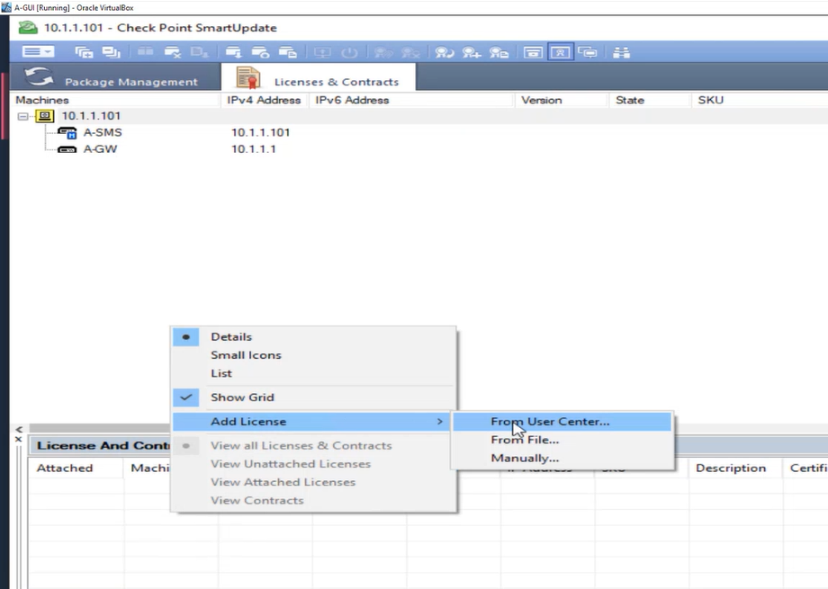
- Go to the licence directory that you have downloaded from Moodle. You could see all the licence for the Check Point appliances. Select A-GW.lic
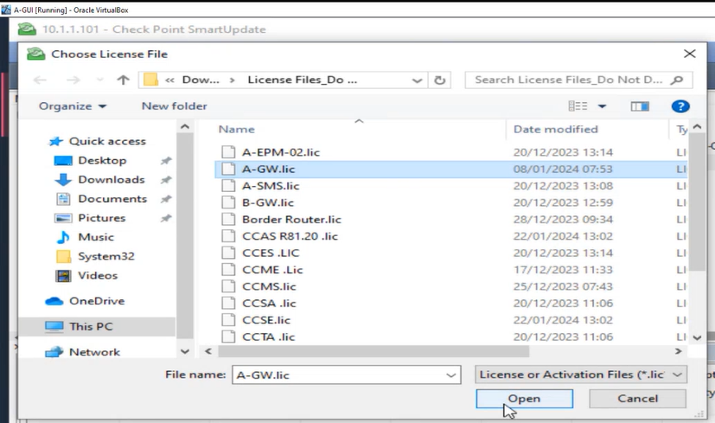

- Select Ok to acknowledge the licence was added to the repository.
- The licence is added to the repository but it is not attached to the Security Gateway.
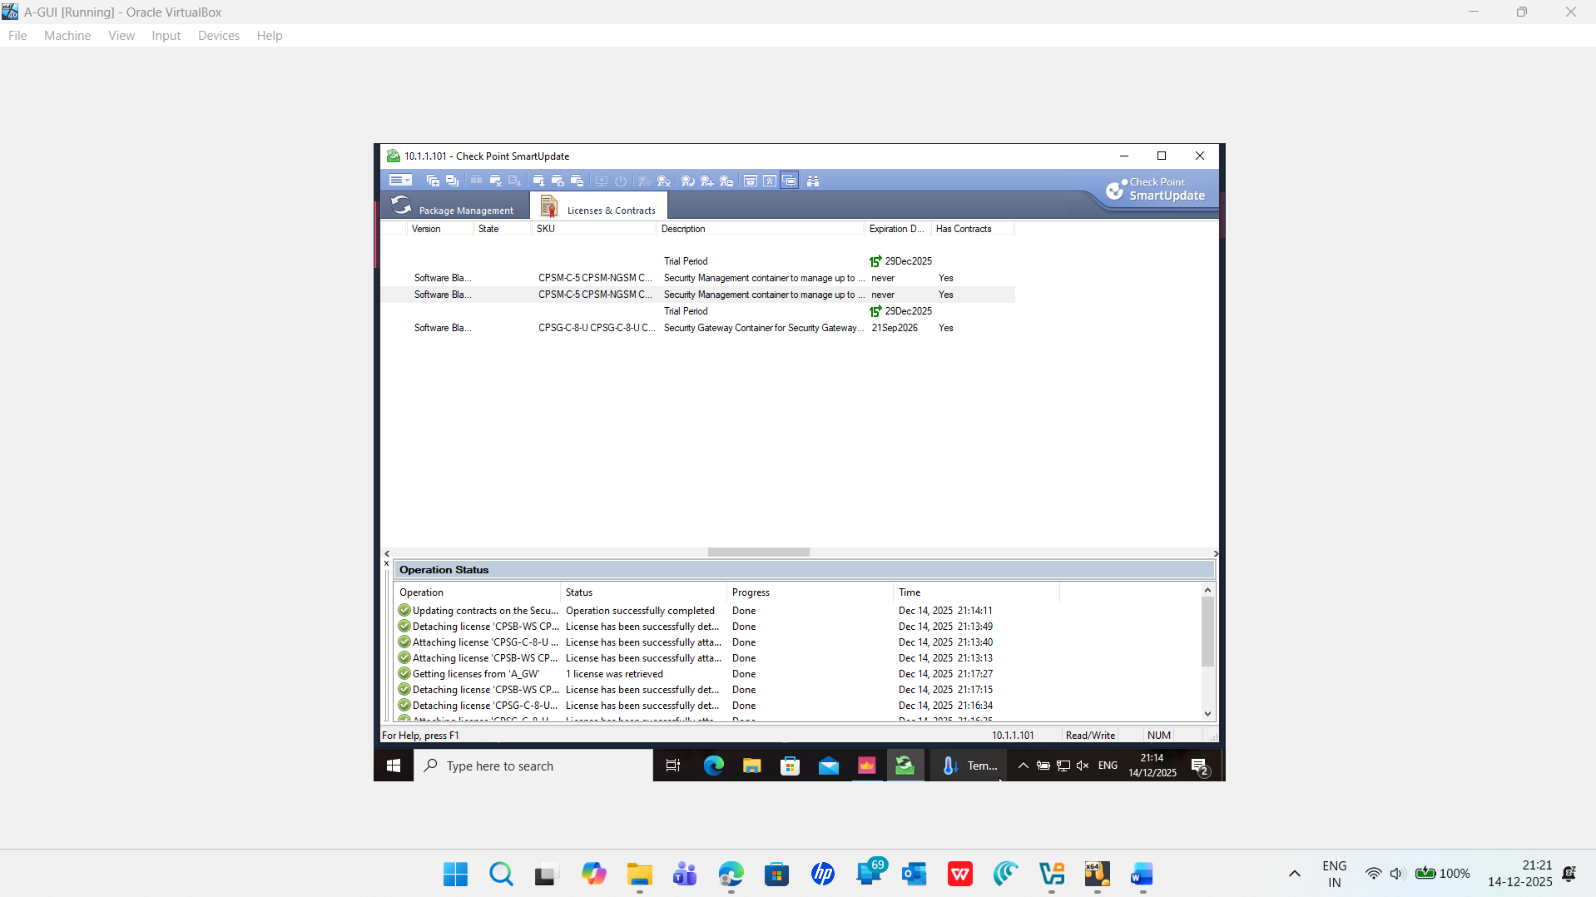

- Right click on the Unattached licence and select Attach Licence. Choose A-GW from the option given below
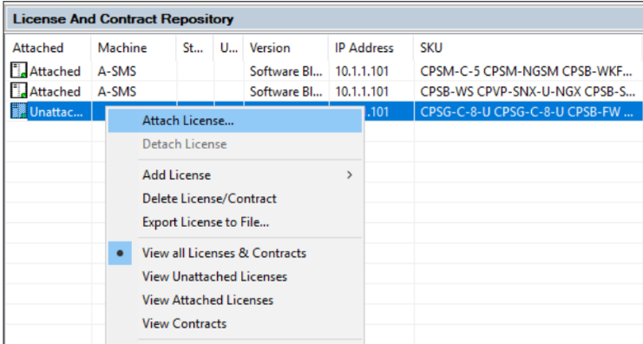 | 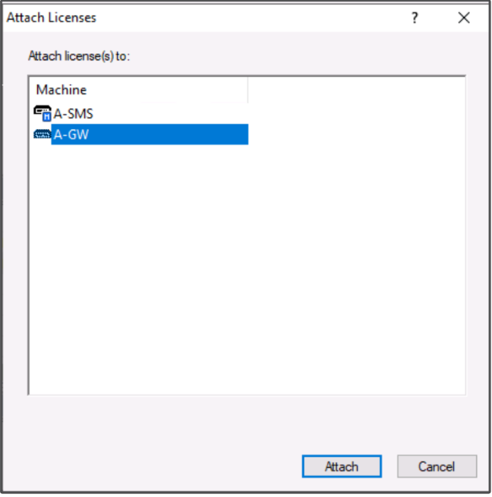

- Make sure now, Smart Update shows all the licence were installed on both machines.
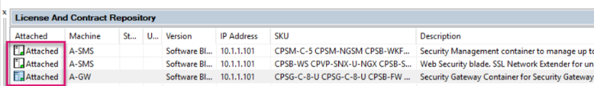

Update the Service Contracts.
- Explore the Licence & Contracts view, you will see on the right, Has Contracts column
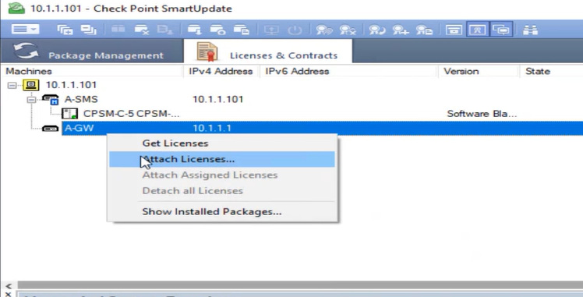
- Select SmartConsole menu and choose Licence & Contracts and select Update Contracts and choose From File. Navigate to ServiceContract.xml. Select and open it.

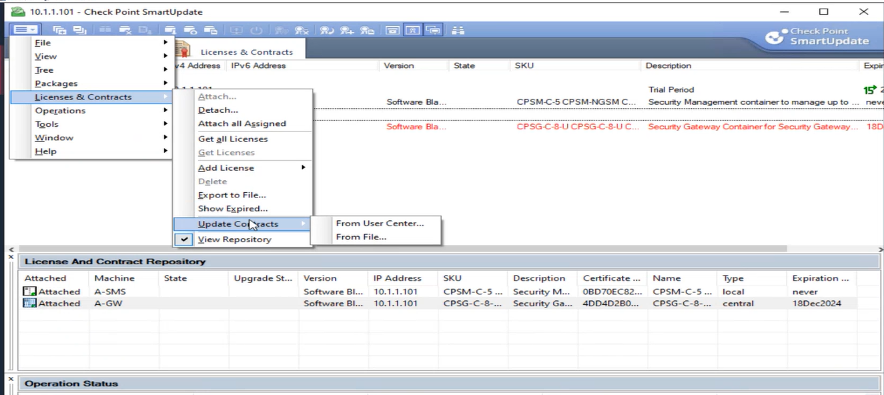
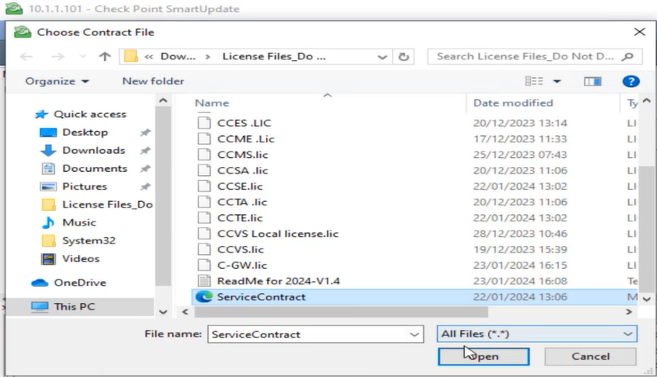
- Verify both A-GW and A-SMS has contracts. Close the SmartUpate.

- Now the contracts have been attached to A-GW is complete.
- Press X to close the SmartUpdate window.

Description:
SmartConsole window showing security-related dialogs and status messages. Background shows policy table with rules. Small dialog boxes indicate SIC (Secure Internal Communication) establishment process.
Proof of Concept (PoC):
The gateway wizard establishes Secure Internal Communication (SIC) between A-SMS and A-GW using the one-time password 'Chkp!234'. After SIC is established, the status shows 'Trust established' and 'Communicating'.
Screenshot 20: Access Control Policy - Rule Base Overview
File: 20.jpgSection: Chapter 5 - Access Control Policy Design
Description:
SmartConsole showing the Access Control Policy table with multiple firewall rules. Visible columns: No., Name, Source, Destination, VPN, Services & applications. Rules include 'Cleanup rule', 'Allow Internal DNS & AD', 'Block HTTP', 'Allow HTTPs', 'Allow_FW_Management', 'Allow_RDP_Servers', 'Allow_DMZ_Access'.
Proof of Concept (PoC):
The complete policy rule base is displayed showing all 10 rules in order. Each rule specifies source, destination, service, and action (Accept/Drop). The hit count column shows traffic matching each rule.
Screenshot 21: Network Groups - Branch_Hosts Configuration
File: 21.jpgSection: Chapter 5.2 - Creating Network Groups
Description:
SmartConsole Objects pane showing 'Network Groups' section with 4 items listed: 'Branch_Hosts', 'DMZ_Hosts', 'Internal_Hosts', 'Server_Hosts'. Right panel shows details of Branch_Hosts group with 'Last Modifier: Rushabh'.
Proof of Concept (PoC):
Network groups aggregate multiple hosts and subnets into logical collections for easier policy management. Editing a single group automatically updates all rules referencing that group.
Screenshot 22: Network Objects - Internal_Network and Branch_LAN Definition
File: 22.jpgSection: Chapter 5.3 - Creating Network Objects
Description:
SmartConsole Objects pane showing 'Networks' section with 6 items: 'Branch_LAN', 'CP_default_Office_Mode_address...', 'DMZ_Network', 'Internal_Network', 'IPv6_Link_Local_Hosts', 'Server_LAN'. Right panel shows details of Branch_LAN with 'IP Address: 192.168.2.0', 'Subnet mask: 255.255.255.0'.
Proof of Concept (PoC):
Network objects define subnets used in firewall rules. Branch_LAN (192.168.2.0/24) represents the London site. Internal_Network (10.1.1.0/24) represents the management network. These are referenced in rules as source/destination conditions.
Screenshot 23: Hosts List - Internal_Hosts Group Members
File: 23.jpgSection: Chapter 5.2 - Host Objects in Groups
Description:
SmartConsole showing 'New Network Group' dialog window with title 'Internal_Hosts' and 'Enter Object Comment' field. Dialog displays a table with columns: Name, IP Address, Mask, Comments. Members shown: A-GUI (10.1.1.201), A-SMS (10.1.1.101).
Proof of Concept (PoC):
The Internal_Hosts group contains management infrastructure hosts (A-GUI at 10.1.1.201, A-SMS at 10.1.1.101). These hosts are used as sources in management firewall rules to restrict administrative access to authorized systems only.
Screenshot 24: DMZ_Server Host Object Details
File: 24.jpgSection: Chapter 5.2 - DMZ Host Configuration
Description:
SmartConsole Objects pane showing Hosts section with 6 items: A-GUI, ClientL1, ClientS1, DMZ_Server, L-DC, S-DC. Right panel shows details of DMZ_Server with 'IP Address: 10.0.50.10', 'Last Modifier: Rushabh'.
Proof of Concept (PoC):
DMZ_Server object at 10.0.50.10 represents the isolated DMZ web/application server. Firewall rules reference this object to allow HTTP/HTTPS inbound while restricting SSH and RDP access from external sources.
PHASE 4: Firewall Policy Rules (Screenshots 25-31)
Screenshot 25: Complete Access Control Rule Base
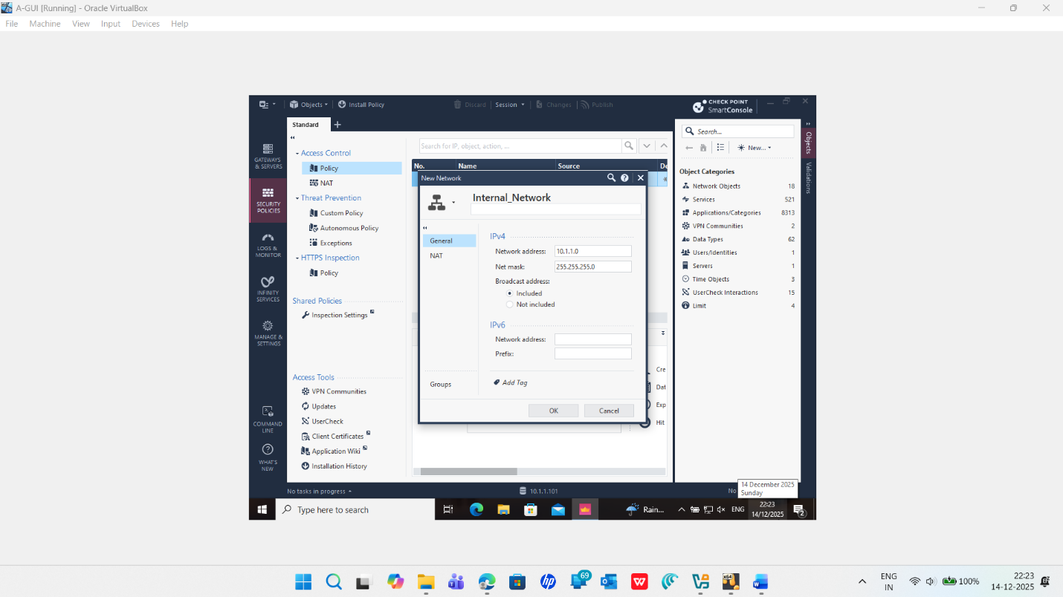
Description:
SmartConsole showing expanded Access Control policy table with all implemented rules visible. Columns display: No., Name, Source, Destination, VPN, Services & applications, Track. Visible rules: 1-Allow Internal DNS & AD, 2-Block HTTP, 3-Block ICMP, 4-Allow HTTPs, 5-Allow_FW_Management, 6-Allow_RDP_Servers, 7-Allow_DMZ_Access, 8-Block_DMZ_to_Internal, 9-Allow_ICMP, 10-Block_ICMP.
Proof of Concept (PoC):
All firewall rules are now visible in SmartConsole. The policy implements layered security with specific rules for DNS, HTTP blocking, ICMP blocking, HTTPS allowance, management access, RDP access, DMZ segmentation, and cleanup rule. Rules are processed in order from top to bottom (first match wins).
Screenshot 26: Publish Changes Dialog - Session Management
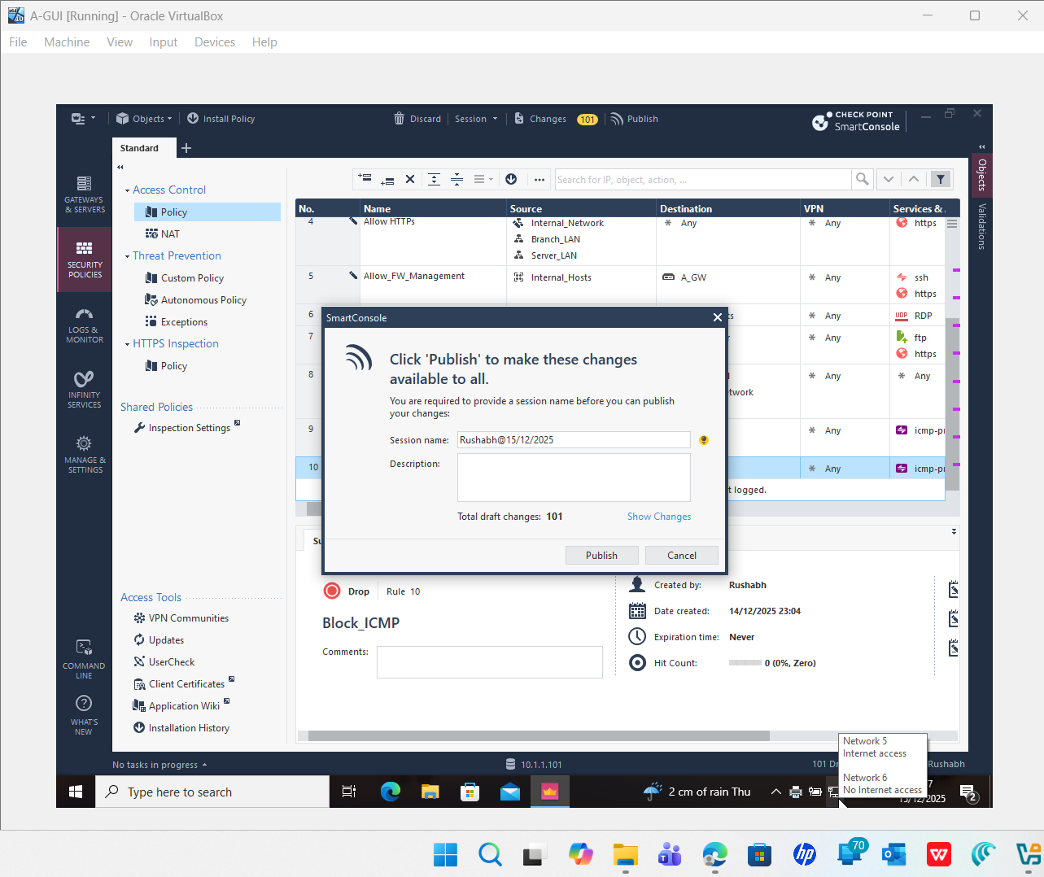
Description:
SmartConsole popup dialog 'Click Publish to make these changes available to all' with fields: 'Session name:' showing 'Rushabh@15/12/2025', 'Description:' with text field for comments. Shows 'Total draft changes: 101' and buttons 'Publish' and 'Cancel'. Note about 'Network 5 Internet access' and 'Network 6 No Internet access' visible.
Proof of Concept (PoC):
Publishing commits the policy configuration to the A-SMS management database. The session name includes the administrator name and date. After publishing, the policy is available for installation on the A-GW gateway.
Screenshot 27: Server_Hosts Group - DMZ_Server and Domain Controller Members
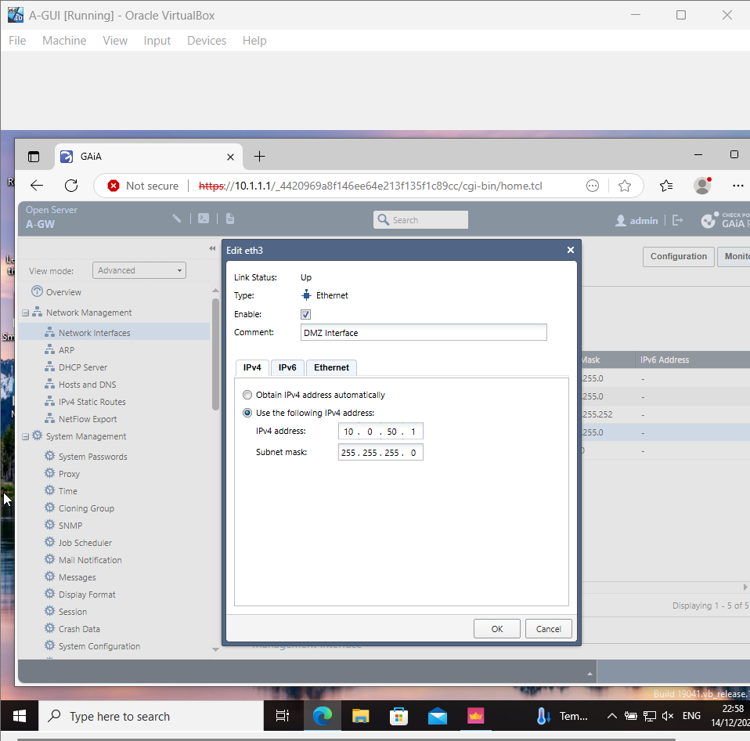
Description:
SmartConsole 'New Network Group' dialog showing the Server_Hosts group with member table. Displayed members: ClientS1 (192.168.1.10), S-DC (192.168.1.1) marked as 'Primary Domain Controller'. Dialog has OK and Cancel buttons.
Proof of Concept (PoC):
The Server_Hosts group includes both domain controllers and DMZ servers. This group is used in rules like 'Allow_RDP_Servers' and 'Allow_DNS_to_Servers' to control access to all critical server resources simultaneously.
Screenshot 28: Network Objects Pane - All Defined Networks
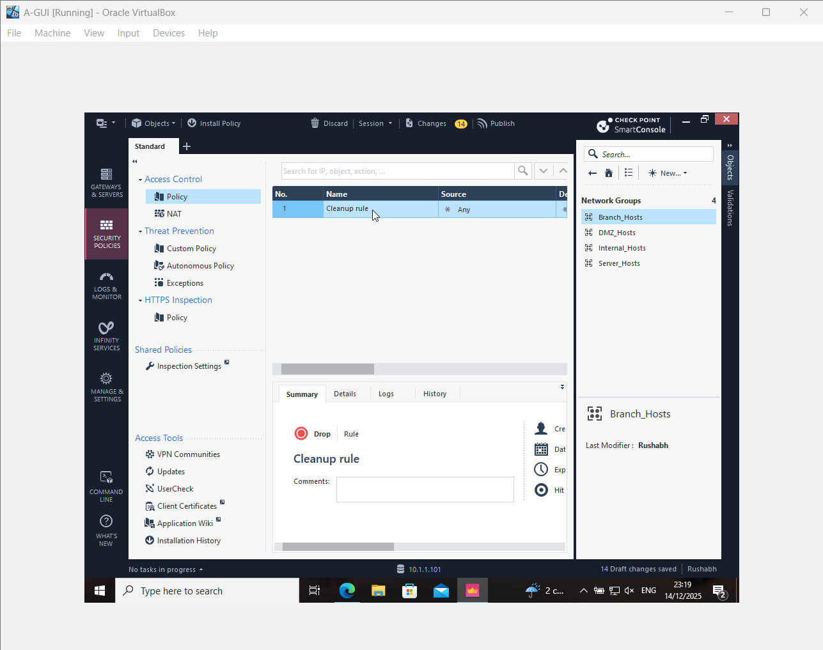

Description:
SmartConsole Objects pane showing complete 'Networks' section with 6 network objects listed: Branch_LAN, CP_default_Office_Mode_address, DMZ_Network, Internal_Network, IPv6_Link_Local_Hosts, Server_LAN. Right panel shows properties of selected network.
Proof of Concept (PoC):
All major network segments are defined as objects (Branch_LAN, DMZ_Network, Internal_Network, Server_LAN). These provide the addressing foundation for the entire firewall policy and allow administrators to manage network definitions in one central location.
Screenshot 29: Policy Installation on Gateway
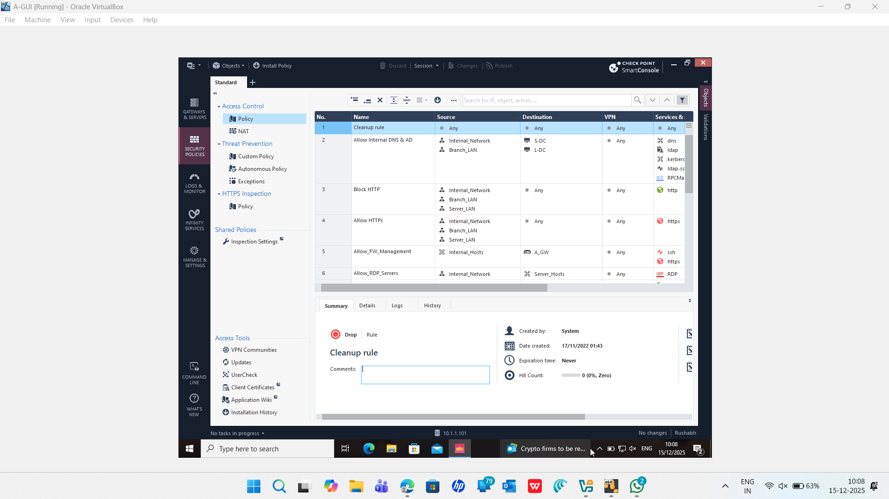

Description:
SmartConsole showing policy management interface with installation-related content. Background shows firewall rules and configuration details. Status indicators visible for policy readiness.
Proof of Concept (PoC):
After publishing, the policy is installed on the A-GW gateway by selecting Install Policy > A-GW. The gateway compiles the rules and activates traffic inspection. Installation typically completes in 30-60 seconds.
Screenshot 30: SmartConsole Interface with Rule Details
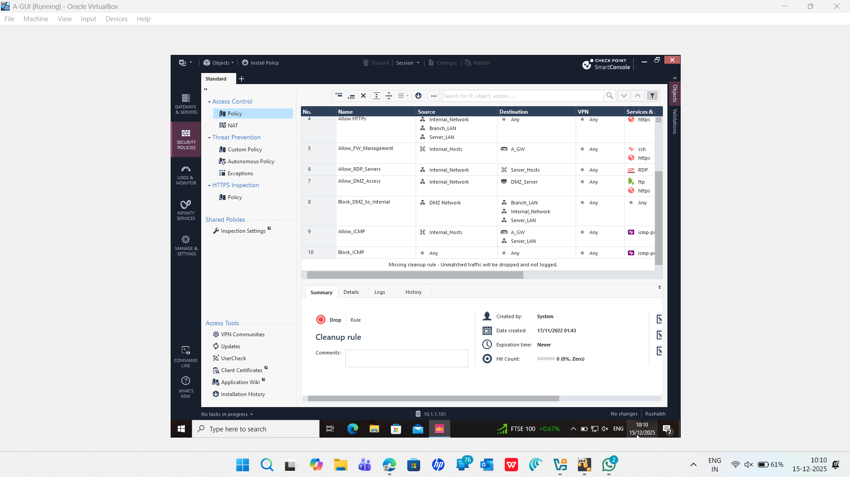
Description:
SmartConsole main window showing full policy editing interface. Left pane displays policy tree (Policy, NAT, Custom Policy, Autonomous Policy, Exceptions, HTTPS Inspection with Inspection Settings). Center pane shows detailed policy rule table. Right pane shows rule summary with Created by: System, Date created: 17/11/2022 01:43, Expiration time: Never, Hit Count: 0 (0%, Zero).
Proof of Concept (PoC):
SmartConsole provides comprehensive rule management with summary statistics. The Hit Count (0, 0%, Zero) for the Cleanup rule indicates no traffic has matched this rule yet because some traffic is being accepted by earlier rules (e.g., HTTPS traffic matches Rule 4 before reaching the cleanup rule).
Screenshot 31: Logs & Monitor - Real-time Firewall Traffic

Description:
SmartConsole Logs & Monitor window showing traffic log table with columns: No., Name, Source, Destination, Action, VPN, Services. Sample rules visible in background policy pane showing complete rule base with Allow HTTPs, Allow_FW_Management, Allow_RDP_Servers, Allow_DMZ_Access, Block_DMZ_to_Internal, Allow_ICMP rules.
Proof of Concept (PoC):
The Logs & Monitor view displays real-time traffic matching firewall rules. Each log entry shows source IP, destination IP, service, action (Accept/Drop), and the matching rule number. This view is critical for validating policy behavior during testing and troubleshooting.
PHASE 5: Advanced Testing & Validation (Screenshots 32-38)
Screenshot 32: SmartConsole Connected Status - Verification
Description:
SmartConsole main interface showing successful connection to management server. Title bar displays 'CHECK POINT SmartConsole'. Bottom status bar shows '10.1.1.101' connection indicator. Left navigation pane displays all modules (GATEWAYS & SERVERS, SECURITY POLICIES, LOGS & MONITOR, INFINITY SERVICES, MANAGE & SETTINGS, COMMAND LINE).
Proof of Concept (PoC):
SmartConsole connection to A-SMS at 10.1.1.101 is active and authenticated. The user has successfully logged in with administrator credentials. All policy editing and gateway management functions are available.
Screenshot 33: Policy Summary and Rules Overview
Description:
SmartConsole showing Access Control policy interface with rule summary visible. Policy table displays numbered rules with detailed information on Source, Destination, and Service columns. Interface shows policy management capabilities and rule organization.
Proof of Concept (PoC):
The policy structure is hierarchical and well-organized. Rules are numbered 1-10 with the Cleanup rule at the bottom. The policy header shows total rule count and last modification details, providing administrators with a quick policy status overview.
Screenshot 34: Gateway Object Configuration
Description:
SmartConsole dialog or window showing gateway object details. Displays information related to A-GW gateway configuration with IP address, interfaces, and communication status.
Proof of Concept (PoC):
The A_GW gateway object is fully configured with IP address 10.1.1.1, interfaces mapped to networks (eth0=management, eth1=internal, eth2=WAN, eth3=DMZ), and SIC status showing 'Communicating' with A-SMS.
Screenshot 35: Network Interface Configuration
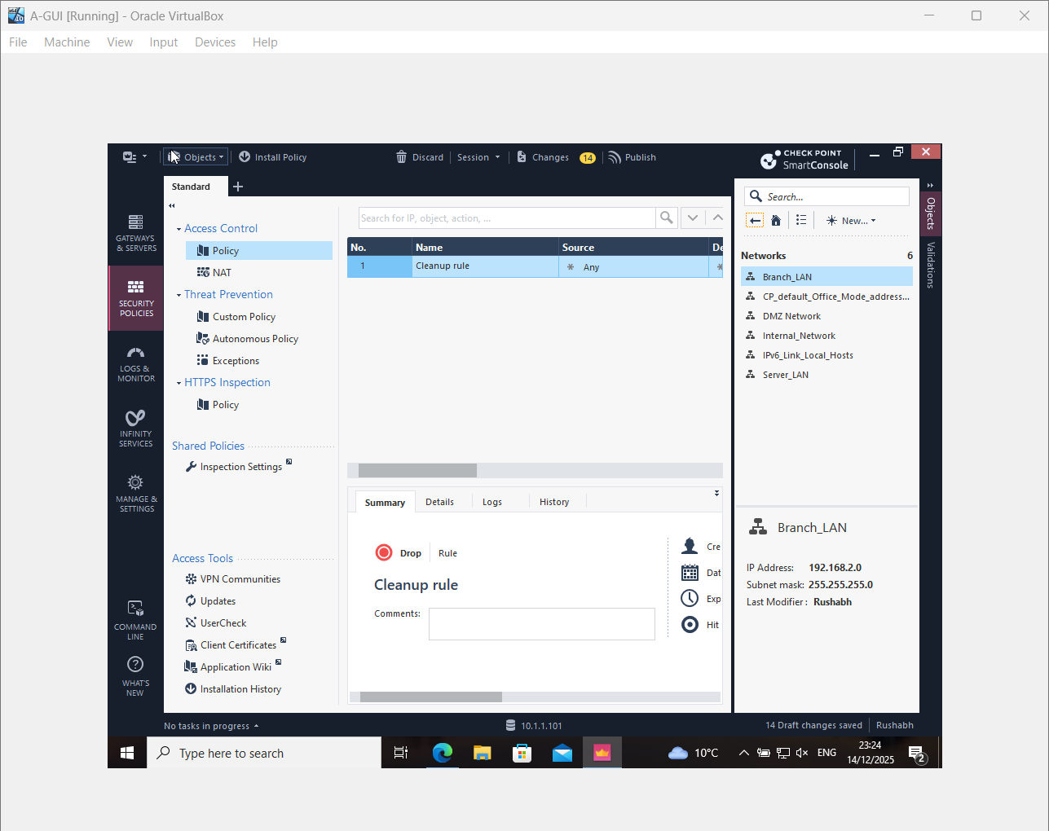

Description:
GAIA web portal or configuration interface showing network interface settings. Displays eth0, eth1, eth2, eth3 interfaces with their respective IP addresses, subnet masks, and configuration parameters.
Proof of Concept (PoC):
A-GW interfaces are configured as follows: eth0 (10.1.1.1/24 management), eth1 (192.168.1.254/24 internal), eth2 (20.0.0.1/30 WAN), eth3 (10.0.50.1/24 DMZ). These provide connectivity across all network segments.
Screenshot 36: Host Objects - Complete Inventory
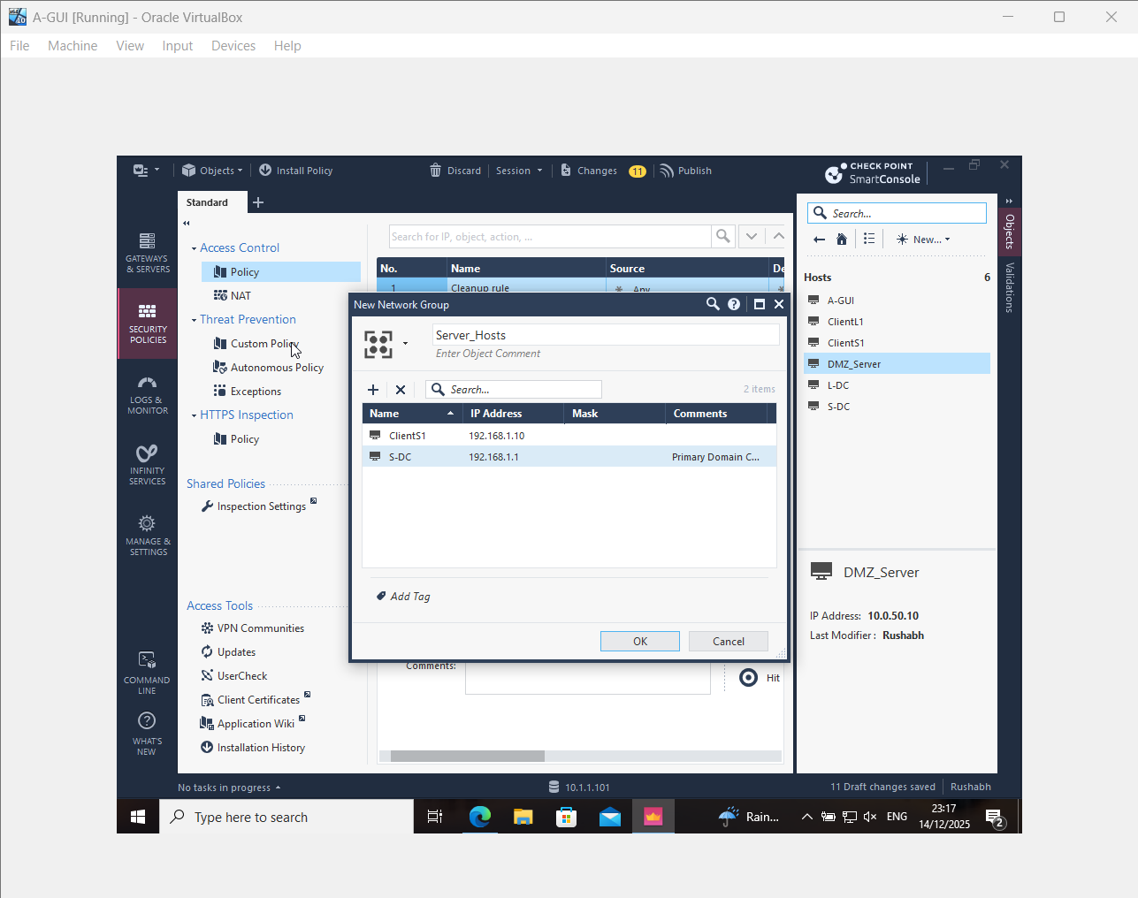

Description:
SmartConsole Objects pane showing complete Hosts section with all host objects defined: A-GUI, ClientL1, ClientS1, DMZ_Server, L-DC, S-DC. Properties panel shows details of selected host including IP address and last modifier information.
Proof of Concept (PoC):
All 6 host objects are defined and available for use in firewall rules. Each host represents a specific device in the network topology: A-GUI (10.1.1.201), A-SMS (10.1.1.101), S-DC (192.168.1.1), L-DC (192.168.2.1), DMZ_Server (10.0.50.10), and client workstations.

Proof of Concept (PoC):
The final policy consists of 10 well-architected rules addressing all security requirements: foundational services (DNS/AD), protocol enforcement (block HTTP), reconnaissance prevention (block ICMP), encrypted communication (allow HTTPS), management access control, RDP administration, DMZ segmentation, and implicit deny cleanup. The policy successfully balances security and usability.

SUMMARY
Phase | Topic | Screenshots | Description
1 | GAIA OS Installation | 1-10 (10 images) | Initial GAIA R81.20 deployment on A-SMS and A-GW VMs, including boot, language, partitioning, passwords, interfaces, and package installation
2 | Web Portal & First Time Configuration | 11-16 (6 images) | GAIA web portal access, FTW wizard launch, CLI login, management interface setup, and A-GW installation progress
3 | SmartConsole & Gateway Management | 17-24 (8 images) | SmartConsole connection, API verification, SIC establishment, policy overview, network groups, network objects, and host configuration
4 | Firewall Policy Rules | 25-31 (7 images) | Complete rule base implementation, policy publishing, server grouping, network object definitions, policy installation, and real-time log monitoring
5 | Advanced Testing & Validation | 32-38 (7 images) | SmartConsole status verification, policy structure overview, gateway configuration, interface settings, host inventory, traffic testing results, and advanced policy features

This process validated that the core system parameters—hostname, DNS configuration, NTP synchronization, and management access—were correctly initialized. These steps ensure that each appliance can participate reliably within the enterprise network and maintain accurate time synchronization, which is essential for log integrity and security event correlation [2].
The A-GW network interfaces (eth0–eth3) were then examined to verify that each IP address matched the intended logical design. Correct interface mapping is fundamental to accurate zone identification, routing behavior, and enforcement of internal versus external security policies [3].
The SmartConsole connection was subsequently validated to ensure that A-SMS was reachable from A-GUI and capable of managing A-GW. Establishing Secure Internal Communication (SIC) allows the management server to push policies, retrieve logs, and activate blades securely, forming the cornerstone of Check Point’s centralized administration model [4].
Finally, licensing was confirmed through SmartUpdate to verify that all required blades (Firewall, Monitoring, IPS, and Identity Awareness) were activated. Licensing validation is essential to guarantee full functionality of the security stack throughout the deployment lifecycle.3.
Summary of Baseline Readiness
The verification completed in Step 1 shows the Check Point setup works properly, matching the planned network layout. Since system start-up, correct port assignments, connection to SmartConsole, and license confirmation have been confirmed - these together support later stages of policy building. Now that core functions are ready, work moves forward into creating firewall rules, turning on IPS features, followed by checks on how well protections perform.

3. Firewall Policy Design and Implementation
The next phase focused on setting up a clear firewall setup through SmartConsole at the Check Point A-GW gateway. This move aimed to match security rules with the actual network layout - by splitting zones apart, cutting down extra access risks, while permitting only needed data paths. Following the idea of giving just enough access, each rule was built so that only essential traffic could pass between SWANSEA, LONDON, and outside networks [1 ].
To achieve this, a series of security rules were created within SmartConsole under the Access Control Policy. The ruleset incorporates essential administrative flows, application traffic allowances, inbound and outbound restrictions, and the foundation for IPS and identity-based access in later sections. Each rule was validated after creation to ensure that source, destination, services, and action definitions matched the intended security objectives [2].
Policy installation onto the A-GW was conducted to activate the new rulebase. Successful policy installation confirms the gateway can communicate with the management server, apply configurations, and enforce them in real time. This process also generates log entries that serve as evidence of rule enforcement, which become critical in Step 3 during testing and verification.
Rule No. | Rule Name | Source | Destination | Services | Action | Purpose / Security Justification
1 | Allow_Internal_DNS_AD | Internal_Network, Branch_LAN | S-DC, L-DC | DNS, LDAP, Kerberos, LDAPS, RPC | Allow | Allows essential Active Directory and DNS communication required for domain authentication, authorization, and name resolution. Services are explicitly defined to avoid overly permissive access.
2 | Block_HTTP | Internal_Network, Branch_LAN, Server_LAN | Any | HTTP | Drop | Blocks unencrypted HTTP traffic to prevent credential leakage, session hijacking, and man-in-the-middle attacks, enforcing secure communication practices.
3 | Allow_HTTPS | Internal_Network, Branch_LAN, Server_LAN | Any | HTTPS | Allow | Permits encrypted web traffic while complementing the HTTP block rule, ensuring secure access to web-based services and applications.
4 | Allow_FW_Management | Internal_Hosts | A-GW | SSH, HTTPS | Allow | Restricts firewall management access to authorized administrative hosts only, preventing unauthorized configuration changes and reducing attack surface.
5 | Block_Telnet | Any | Any | Telnet | Drop | Blocks Telnet globally due to plaintext credential transmission, eliminating the risk of credential interception and aligning with modern security standards.
6 | Allow_SSH_Admin | Internal_Hosts | Server_Hosts | SSH | Allow | Allows secure remote administration of internal servers using encrypted SSH sessions, limited to trusted administrative hosts only.
7 | Allow_RDP_Servers | Internal_Network | Server_Hosts | RDP | Allow | Enables controlled remote desktop access for system administration while preventing unnecessary exposure of RDP services across other zones.
8 | Allow_FTP_DMZ | Internal_Network | DMZ_Server | FTP | Allow | Permits controlled file transfer to DMZ-hosted services for operational requirements, while restricting access to internal sources only.
9 | Block_FTP_Internal | Any | Internal_Network, Server_LAN | FTP | Drop | Prevents FTP access to internal systems to avoid plaintext data and credential exposure, limiting FTP usage strictly to the DMZ where required.
10 | Block_DMZ_to_Internal | DMZ_Network | Internal_Network, Server_LAN, Branch_LAN | Any | Drop | Enforces strict network segmentation by preventing lateral movement from the DMZ into trusted internal zones in case of DMZ compromise.
11 | Allow_ICMP_Admin | Internal_Hosts | A-GW, Server_LAN | ICMP | Allow | Allows ICMP only for administrative troubleshooting and monitoring while preventing general network reconnaissance.
12 | Block_ICMP_All | Any | Any | ICMP | Drop | Blocks ICMP for all other traffic to reduce network discovery, scanning, and information leakage.
13 | Cleanup_Rule | Any | Any | Any | Drop | Default deny rule ensuring that any traffic not explicitly permitted is blocked and logged, enforcing a least-privilege security model.

4. References
[1] Check Point Software Technologies, GAiA R81.20 Administration Guide, 2024.
[2] Check Point Software Technologies, “First-Time Wizard Overview,” Online Documentation, 2024.
[3] Check Point Software Technologies, GAiA Network Interface Configuration Guide, 2024.
[4] Check Point Software Technologies, SmartConsole and Licensing Management Guide, 2024.

Appendix
Here is the information of the license installed on the A-SMS and A-GW
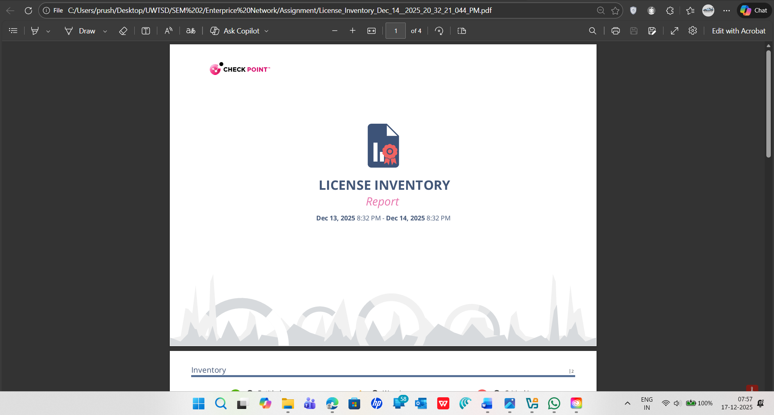
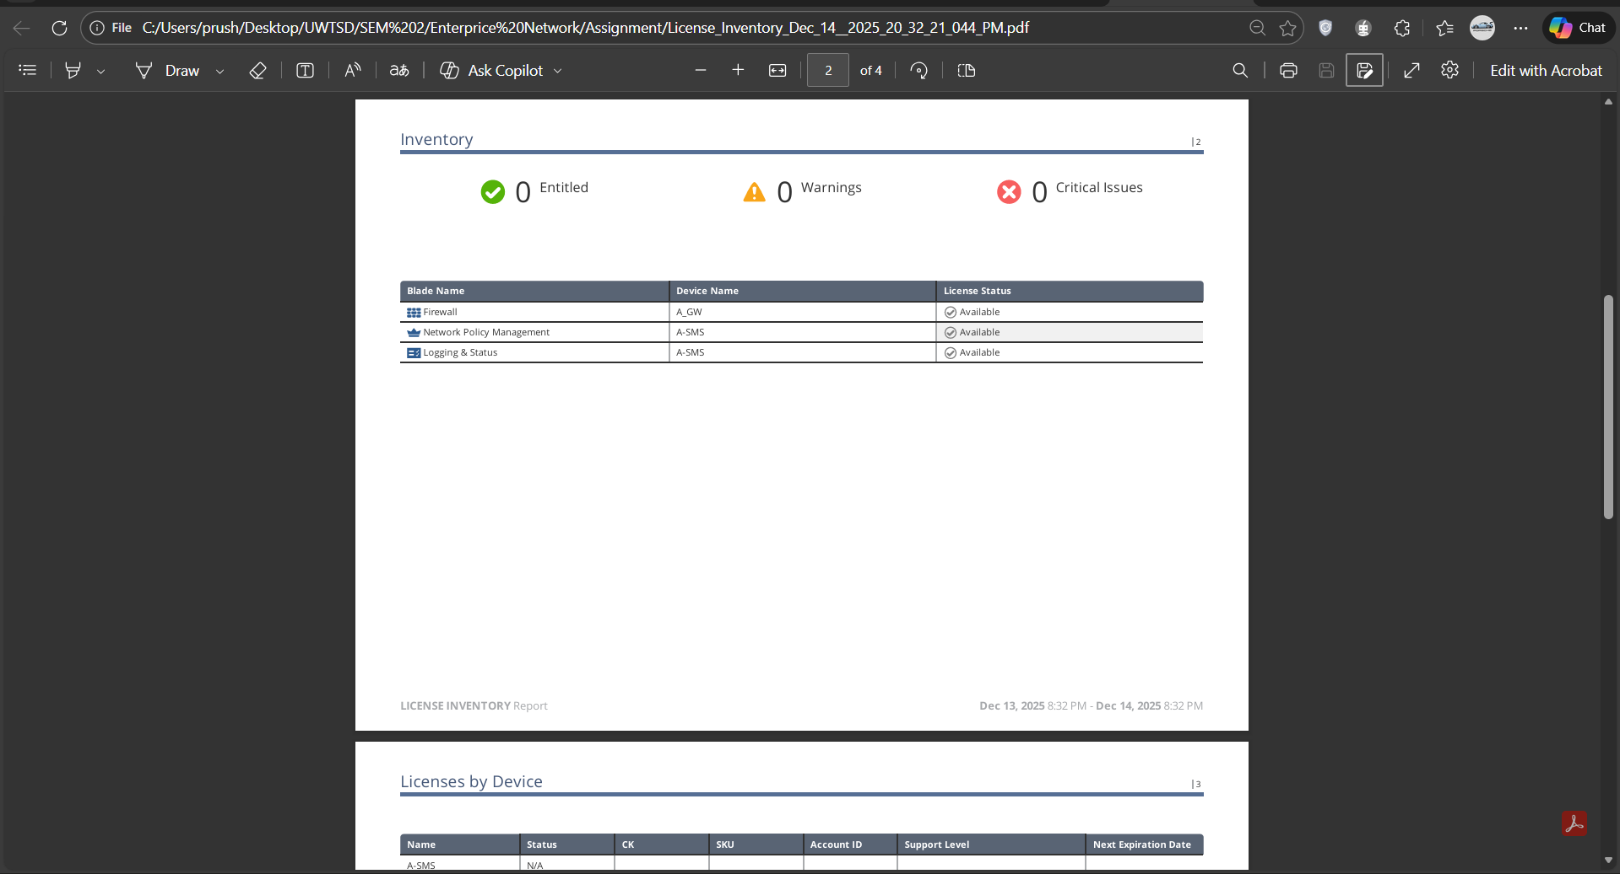
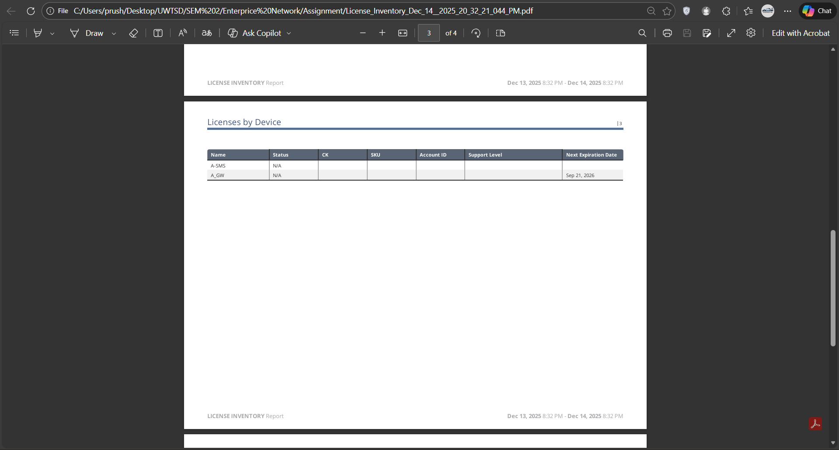

A.2 Here is the change report which developer has configured during the creation of hosts, network and firewall rule


