UNIVERSITY OF WALES TRINITY SAINT DAVID

STUDENT NAME: SABINA-ANDREEA SABAU

STUDENT NUMBER: 1917334

MODULE CODE: LCBB4002
MODULE NAME: COMMUNITY ENGAGEMENT

ASSIGNMENT 1
ASSIGNMENT TITLE: VODAFONE UK

LEVEL 4/ TERM 1/ GROUP 3

LECTURER NAME: MOLLY JACK

Table of content
Introduction 2
Discussion 2
Size of the Sector, Mission, Values and Goals 2
Customers 3
SWOT Analysis 4
PESTEL Analysis 5
Role of the Employees 6
Training and Developments 7
The Selected Role and Its Importance 7
Skills and Knowledge required to Perform the Role 7
Training and Development sessions Required 7
Conclusion 8
References 9

Introduction
Vodafone Group is one of the leading mobile phone companies throughout the world. However, in the United Kingdom, Vodafone is considered as one of the prime telecommunication service providers and the most vital part of the Vodafone Group which is based on the aspects of innovation, investments as well as customer-oriented services. The group is successfully operating their businesses across 26 countries approximately with the cooperation of more than 55 networks. Headquarter of this company is situated in Newbury where the phone call was made from London on 1st January in the year of 1985 and consequently the company was formed in the UK. In recent dates, the company has more than 13,000 employees across the UK. With the advancements of technology, besides being the provider of network and connectivity, Vodafone is engaged in initiating several new programs for the future betterment of the people. One of these initiatives can be measured by the new infrastructure plan to be constructed in the UK for the digital future as the company believes in a digitally connected society with a steady flow of information (Vodafone Limited, 2020). Hence, the paper aims to evaluate the current approaches of Vodafone to comply with its operations with the current digital era. Additionally, the size of the company considering the industry where it operates, vision, goal, employee engagement, SWOT, and PESTEL analysis, along with training and development procedure will be examined in this paper by closely analysing the roles of the organizational position of Vodafone in the UK market.

Discussion

Size of the Sector, Mission, Values and Goals
The Telecommunication Industry of the UK holds a considerable position within the entire telecommunication markets worldwide. As mentioned by the House of Commons Committee on Exiting the European Union in the UK parliament report, a considerable presence of the telecom industry can be observed in the entire social and economic activities of the UK. In 2015 the UK telecom industry has earned approximately £30.2 billion, which was an increment of over 22.3% from the calculated revenue of 2010. At the same time, this growth aided the entire economic growth of the UK by 17.4% where telecom industry accounted for 1.7% of the economy, which was found to be increased by 1.8% after 2010 (Parliament UK, 2017). However, concerning the revenue incurred in 2007 (i.e. approximately 42.1 billion British pounds) the telecom industry’s revenue has dropped down at a consistent rate over the years, which amounted to only 33.8 billion British pounds in 2018 from 42.1 billion pounds in the year 2007. This could be better understood from the following bar diagram (Statista, 2020).
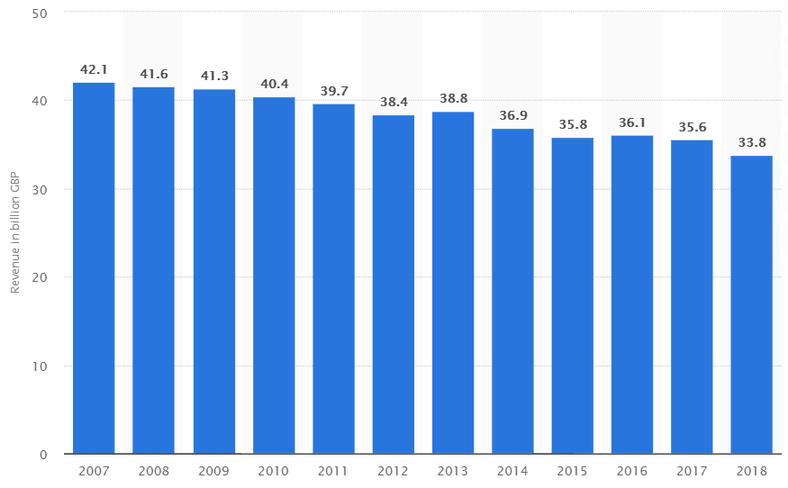
Figure 1: UK Telecom Industry Revenue from 2007 to 2018
(Source: Statista, 2020)
The company is planning for connecting the people and the entire community through the internet without relying upon the traditional approaches but with the assistance of the renowned Gigabit Networks. Besides, with the advancements of Internet of Things (IoT) the company personnel are encouraged with the aspiration of working together so that they can accumulate and be acquainted with incredible ideas, technologies along with innovations, which can assist to develop the society as a whole (Vodafone Limited, 2020a). It must be mentioned in this regard that Vodafone’s major goal is to upgrade the sustainable living of the community by bestowing the customers with exceptional connectivity alongside providing innovative services by at least 70% in the developing markets. Additionally, concerning the vision statement of the company, Vodafone Ltd reported that “Our vision sets out our ambition to deliver connectivity and innovative services to improve people’s livelihoods and quality of life. Central to achieving this vision is our longstanding commitment to manage our operations responsibly and ethically” (Vodafone Group Plc, 2014).

Customers
Vodafone has considerably succeeded in engaging near about 650 million customers throughout the world through connectivity including more than 20 million broadband customers where more than 19.5 million customers are only from the UK. The reason owing to this commitment is that the company believes that every individual has the right to be technologically advanced and no one should be left unprivileged in adapting the same. The company also believe that engaging skills and knowledge with Vodafone is essential so that they can efficiently obtain the most out of the digital world and be aware of the recent trends.

SWOT Analysis
Strenghts:
- Marketing: One of the major strengths of Vodafone can be measured by its exceptional presence over 26 countries with 50 more partner countries including the market base of the UK. This indicates that Vodafone is strongly focused on expanding its market in rural areas.
- Brand: Vodafone has innovative ideas in promoting its brand. High brand equity is a symbol of trust and reliability. Vodafone is a powerful and customer-centric brand that trusts customers across different regions of the earth. This is also the reason why the company has significant consumer base in various European to Asian markets.
- M-Pesa: The considerable success of M-Pesa (a secure money transaction app launched by Vodafone) is one of the crucial strengths to engage people with a harmless, secure and inexpensive way of transacting money that altogether benefits the company and the community as well (Vodafone Group, 2020).
- Large range of products/services: Vodafone offers a very large range of products and services. Apart from the individual customers, it has also brought products for enterprise customers. The company offers both mobile and fixed services to a large segment of customers.

Weaknesses:
- Declining mobile customers in Europe :Recently, the customer base of Vodafone is declining because of the increasing competitors in the global market. Specifically, Vodafone’s performance in the European market is unable to secure its top position, which can be considered its major weakness.
- Huge debt: The net debt of Vodafone Idea is more than 25 times its income, before interest , tax , depreciation and amortisation. The rivals' low service tariffs have also forced Vodafone to lower the cost of its plans. This has generated a significant dent in sales and income for the company.

Oportunities:
- New initiatives planned by the company such as building UK’s infrastructure, increasing investment to trigger growth, enhancing the mergers are its opportunities through which it can attain its previous position in the market and sustain it in future.
- Better network coverage: One big problem facing mobile users is call drop or bad / spotty network coverage and its one issue that has not been resolved by any of the telecom providers. And this becomes an excellent opportunity for the company to outdo its competitors and provide a better, fast and efficient network for its customers.

Threats:
- Competition: Increasing competition in the telecommunications sector represents a major threat to Vodafone. Owing to the growing penetration of rivals, the company lost market share, sales and customers in some of the significant European markets in 2018.
- Uncertainties caused due to Brexit: Enhancement of intense competition in the markets from the rivals as well as Brexit can be considered as its threats.

PESTEL Analysis
Political:
The UK is one of the leading international trade players where the country has a trade shortage but having adequacy in the service sectors as per WTO (World Trade Organization). even though the corporate Tax year starts on 1st April but the company may prepare their accounts any time according to IFRS standards, which can be considered as a boon for the company. Contextually, the government has implied VAT of 20%.
Economical:
UK has secured the sixth position economically, its economic growth has been decreasing since 2016. This is mainly because the business investment is declining since 2018 with 106 Bilateral Investment Treaties (BITs), which can influence the performance of the company to a large extent. Brexit has created some pressures which will continue to affect Vodafone’s profitability in UK.
Social:
The role and significance of socio-cultural factors also in the business context has continued to grow. Most big businesses have comprehended the centrality of business-related socio-cultural factors, and how they can affect sales and profitability in particular regions. Changing social trends and lifestyles for people are influencing shopping habits for customers.
Tehnological:
The UK market is technologically advanced and hence Vodafone can optimally utilize this opportunity. In recent years , the company has expanded its range of services based on the increasing demand of individual as well as corporate customers. But the growing role of customer experience has pressured Vodafone to concentrate on this aspect too. The company is therefore utilising digital technology to provide greater user convenience and to increase customer engagement. Its my Vodafone app and website can be used to access a variety of services that Vodafone offers.
Legal:
Law and legal factors have taken on a very important part of the business world as well. Governments and law enforcement authorities across the world have increased the level of company monitoring and supervision. In its business strategy, Vodafone has made it an important focus area so as to avoid any chance of violation and non-compliance.
Environmental:
Environment and sustainability have become important business success factors in the twenty-first century. Such as the biggest companies in the world, Vodafone is also focused on reducing its carbon footprint and effect on the environment. It recycles and reuses much of the electronic waste produced during its business operations.

Role of the Employees
In the UK market, Vodafone has over 1300 employees who are working hard to integrate their efforts and thereby properly shape the organization as most of the companies of the UK discover the changes in the public and private sectors. In this concern, Vodafone UK has conducted research regarding employees’ satisfaction and performance considering their job roles involving approximately 505 senior managers and 861employees. By witnessing ‘Vodafone’s Better Business’ initiative as a part of improvement, it can be indicated that all the employees of the company are under strong pressure to explore new ideas and to find several opportunities to accomplish the organizational operations more fruitfully. The senior managers are at a determinant position with a tactical remit or interest in the progress of the workplace thus they are observed to maintain employee satisfaction concerning the soft elements of employee valuation and maintain their work-life balance. To sustain the workplace flexibilities, every member within a team is allocated crucial tasks by their managers. Surprisingly, the approach succeeded when the employees obtained most relevant equipment, tools and techniques for their role, which further facilitates the technology-roll-out process. Besides, the employees were provided with just-in-time training for using their new equipment optimally. In this process, the employees can carry out their processes (emails and application) with the assistance of secure network at their own pace. However, due to the increasing unemployment rate in the UK, the employees are afraid of exploring themselves, which is consequently leading the nation to face immense talent blockage recently. This can be disadvantageous for the company in the long run (Vodafone Limited, 2012).

Training and Developments
All of the employees of Vodafone can be benefitted from adequate training and development sessions through which the employees can explore themselves in future careers and shape them according to the changing demand. Simultaneously, the company can get several opportunities for market experiments. Hence, it is imperative that training is provided to the employees at every level of the organization to motivate them considering the criteria of enjoyment, stimulation under fulfilment and pride, valued under tribalism. Nevertheless, employees are encouraged and supported to comply with the National Vocational Qualifications (NVQs) for their development along with other wide ranges of professional development programs. Besides, providing rewards and benefits inspire and motivate the talented people within the organization. Rewards are given based on the annual, monthly or quarterly performances and appraisals are provided twice a year. On the other hand, employees are focused on setting their performance objectives considering the day-to-day activities which are further aligned with the company’s business strategies (Vodafone Limited, 2020d).

The Selected Role and Its Importance
Vodafone is generally aligned with customer services and relied on satisfying their needs. Hence, analysing the role of the Customer Service Team Leader will be appropriate. According to Reggie (Customer Service Team Leader of Vodafone), “Working at Vodafone is all about helping people feel ready to benefit from new technology.” Being one of the most valuable brands within the UK telecom industry market, the mentioned position has immense responsibilities in maintaining network connectivity, digital technology and mobile innovation to deter at unimaginable change with the assistance of proper people management (Vodafone Careers, 2020).

Skills and Knowledge required to Perform the Role
The most vital skills that Customer Service Leader must pursue is the ability to manage the people as per their needs both internally and externally. The service leader should have the skill to motivate and encourage the subordinates to gain maximum return instead of manipulating them by maintaining proper communication. They must have adequate patience and risk-taking abilities along with the skill of flexibilities in the context of complying with new changes.

Training and Development sessions Required
It is because of the decreasing market subscription of Vodafone in the UK that the company must be acquainted with certain innovative strategies. The areas of improvement that should be considered are presented through the following diagram. Taking consumers’ feedback through customer satisfaction surveys is the most crucial part concerning the adaptability of new changes within the customer service areas. Based on the feedback, they should evaluate the training procedure emphasizing on CSR as well as training and development activities. Furthermore, initiating customer engagement practice sessions and involving the customers in the best way possible will be helpful for the customer service leader of Vodafone to develop the UK customer base and re-establish its position in the market.
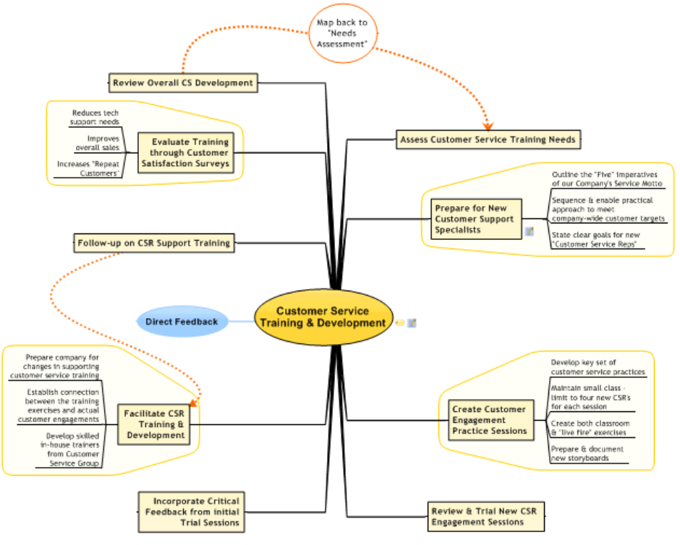
Figure 2: Training and Development Procedure of a Customer Service Leader
(Source: Biggerplate, 2020)

Conclusion
Based on the above analysis it can be concluded that, although Vodafone UK is one of the leading telecommunication service providers, its revenue is decreasing overtimes. Thus, the company should take certain initiatives where customers will be getting more involved to drive growth. For this, the company is planning for certain initiatives such as UK infrastructure setting, which will be helpful for it to sustain in the market but its internal, as well as external environment, must be explored efficiently thereby effectively facilitating people’s management.

References
Biggerplate, 2020. Customer Service Training and Development Mind Map. Biggerplate. [Online] Available at: https://www.biggerplate.com/mindmaps/o632733/customer-service-training-and-development-mind-map [Accessed May 4, 2020].
Parliament UK, 2017. Telecommunications Sector Report. House of Commons Committee on Exiting the European Union, pp. 1-22.
Statista, 2020. Total telecommunications industry revenue in the United Kingdom (UK) from 2007 to 2018. Statista. [Online] Available at: https://www.statista.com/statistics/270709/telecommunications-industry-revenue-in-the-united-kingdom-uk/ [Accessed May 4, 2020].
Vodafone Careers, 2020. The Spirit of Vodafone. Vodafone Careers UK. [Online] Available at: https://careers.vodafone.co.uk/home-page [Accessed May 4, 2020].
Vodafone Group, 2020. What is M-Pesa? Vodafone Group. [Online] Available at: https://www.vodafone.com/what-we-do/services/m-pesa [Accessed May 4, 2020].
Vodafone Limited, 2012. Exploring the Shift in Employee Expectations. The Perspective Series, pp. 3-19.
Vodafone Limited, 2020. Company History. Vodafone Through the Years. [Online] Available at: https://www.vodafone.co.uk/about-us/company-history/ [Accessed May 4, 2020]. Vodafone Group Plc, 2014. Our Vision and Approach. Sustainability Report, pp. 4-14.
Vodafone Limited, 2020a. Getting the UK set for our Digital Future. Vodafone Limited. [Online] Available at: https://www.vodafone.co.uk/mobile/sustainable-business/technology-for-society [Accessed May 4, 2020].
Vodafone Limited, 2020d. Opportunities to Develop. Vodafone Limited. [Online] Available at: https://www.vodafone.co.uk/our-responsibilities/our-employees/opportunities-to-develop/ [Accessed May 4, 2020].

