Name: Safia Ali Khalid Nassor
Student Number: 2506779
Module Code: LCHS4003
Module Title: Introduction to health and social care
Lecture Name: Aisha
Assignment Title: Component 1

Community mental health services
Task 1: Poster
Include a clear explanation of the chosen service service:
Community mental health service has an essential as well as an important position in presenting mental health care and, it gives care to people who are struggling and witnessing mental health issues for, adults and older adults with intense mental health needs as close to home as possible. (NHS England, 2024). The type of service users that community mental health services aims for is ‘children and youths, older individuals, people who struggle with substance misuse, people with severe mental health disorders e.g., (schizophrenia), people who have been discharged from mental health facilities’. (Tulane University, 2026). The professionals involved in community mental health service are ‘peer support workers, community psychiatric nurses, clinical psychologists, mental health occupational therapist, mental health community connectors.’ (NHS England, 2024). There is not just one place where a person or patient can go to community mental health service for help but, there is a broad of settings such as care homes, community centres, schools, community clinics as well as a patients own home. Having a community mental health service is important because, it is offered to all people different ages as well as groups and different areas supporting and providing different needs to them one by one by many professionals. (The King’s Fund, 2024)
Provide a brief history of the service:
In 1959, a new Act was introduced and passed by the Parliament which was the The Mental Health Act. People who had and have suffered from any mental health issues and mental disabilities were, handled and treated away from the public view and the patients community in Victorian asylums. (NICE, 2018). The issue of consent came to existence in 1983 as, The Mental Health act was revised. ‘Although people could still be detained under The Mental Health Act if they were at risk to harm themselves or others, most people being treated for mental health conditions at this time had voluntarily sought help.’ (NICE, 2018)

Describe the current functioning of the service:
The current function of community mental health services is, to help recover people and patients from any on going mental health problems, in the community from a team of professionals. (NHS Black County Healthcare, 2022).

Identify & explain 2 challenges faced by the service:
One challenged that is faced in the community mental health service is that there is a long wait time to receive help. This is a problem as a person can be contemplating to make a decision that could potentially put them in danger or harm. (Care Quality Commission, 2025). Another challenge that is faced in the community mental health service is that mental health problems are increasing which means that lots of people are struggling to get the support they need. This is a problem as the patients will eventually get used to living with a mental illness. (Rethink Mental Illness, 2025). This results in patients and people from looking for the help they need and deserve. (Rethink Mental Illness, 2025).

References:
- Care Quality Commission (2025) The state of health care and adult social care in England 2024/25. Available at: https://www.cqc.org.uk/publications/major-report/state-care/2024-2025/access/mh#:~:text=Access%20to%20mental%20health%20care,crisis%20and%20challenges%20with%20housing. (Accessed: 23 February 2026)
- NHS Black Country Healthcare (2022) Community Mental Health Services. Available at: https://www.blackcountryhealthcare.nhs.uk/our-services/community-mental-health-services#:~:text=Community%20Mental%20Health%20Teams%20(CMHTs)%20provide%20care,Assessment%20of%20mental%20health%20needs%20*%20Treatment . (Accessed: 23 February 2026)
- NHS England (2024) Community mental health service. Available at: https://www.england.nhs.uk/mental-health/adults/cmhs/#:~:text=Community%20mental%20health%20services%20play,Term%20Plan%20by%202023/24. (Accessed: 22 February 2026)
- NHS England (2024) Mental Health Practitioners. Available at: https://www.england.nhs.uk/mental-health/working-in-mental-health/mental-health-practitioners/#:~:text=Mental%20health%20practitioners%20can%20include:%20*%20Peer,illnesses%20to%20live%20well%20in%20their%20communities. (Accessed: 23 February 2026)
- NICE (2018) Mental health and the NHS. Available at: https://indepth.nice.org.uk/mental-health-and-the-nhs/index.html#:~:text=The%20Mental%20Health%20Act%20of,wards%2C%20or%20within%20the%20community. (Accessed: 23 February 2026)
- Rethink Mental Illness (2025) Are mental health problems increasing in the UK. Available at: https://www.rethink.org/news-and-stories/commonly-asked-mental-health-questions/are/are-mental-health-problems-increasing-in-the-uk/#:~:text=Barriers%20faced%20by%20people%20living,help%20they%20need%20and%20deserve. (Accessed: 23 February 2026)
- The King’s Fund (2024) community health services explained. Available at: https://www.kingsfund.org.uk/insight-and-analysis/long-reads/community-health-services-explained#:~:text=More%20integrated%20working,care%20teams%20and%20care%20staff. (Accessed: 23 February 2026)
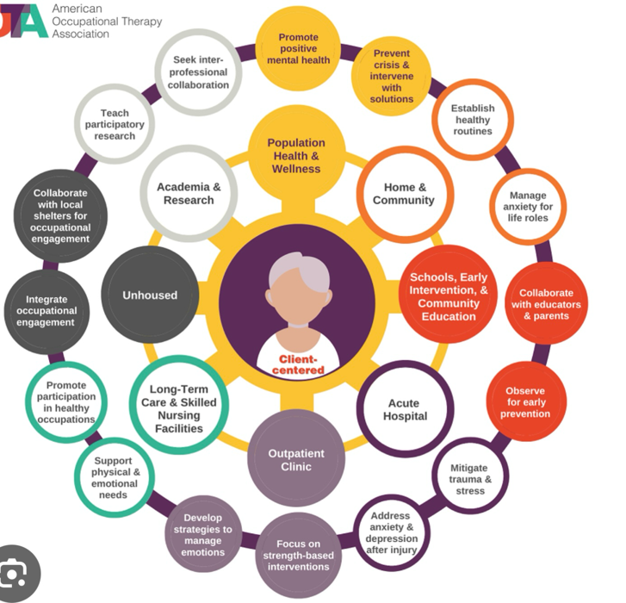
- Tulane University (2026) What Is Community Mental Health. Available at: https://publichealth.tulane.edu/blog/what-is-community-mental-health/. (Accessed: 23 February 2026)
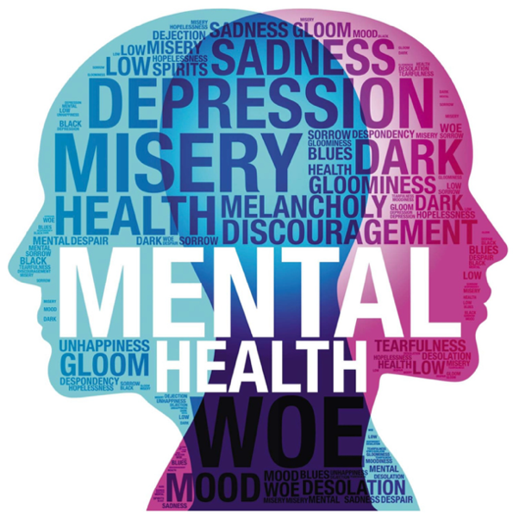


Task 2:
Ambulance services:
Origins:
The origin of ambulance service was introduced to the UK in 19th century, which the government put in place to give free care to all patients in need. (Nine, 2026). The Metropolitan Asylum Board established horse drawn ambulances before the World War 1. (BM Ambulance, 2024). The number 999 became introduced in the 1930s. (London Ambulance Service, 2025)
Historical context that shaped it’s development:
The ambulance service in the UK has historical context that has shaped it’s development, as it has developed by the use of carts to transport patients. In the 1890s, if a person was injured they would have to be transported by wheeled stretchers called ‘litters’ and, this was dependent on police, firefighters and taxi drivers to take them to the nearest doctors surgery or hospital. (London Ambulance Service, 2025). The ambulance then was pulled by horses instead of motor vehicles. ‘The first petrol driven ambulance appeared in 1904 and could carry a single stretcher at up to 15mph.’ (London Ambulance Service, 2025). It was just prior to the 20th century where there was a round the clock ambulance service in London that was then came into place. In 2003, that’s when the ambulance that is seen today is yellow and, the ambulance service initiated their ‘cycle response unit’ to supply life saving care.(London Ambulance Service, 2025)
How the service functions today:
The ambulance service in the UK functions as operating all the time (24/7), as 999 emergency contact number to get through to the ambulance service. The ambulance service main goal is to try provide urgent health care and, attention to wherever and whenever needed for patients for free, at the time they receive it. (London Ambulance Service, 2024). Another service that ambulance also deliver is that, they try to offer prearranged transport for the patient and, try to find a hospital beds ready for them to attend to. (London Ambulance Service, 2024). They also work alongside the fire service and police department. (London Ambulance Service, 2024). Ambulance services now work in a different way as they also can send skilled professionals to the patients home as well as, taking one to a more suitable setting outside of the hospital and, giving advice through phone calls. (NHS England, 2023). ‘Delivering a safe reduction in ambulance conveyance, which means that patients are only taken to hospital if that’s the right place for them’. ( NHS England, 2023).
It’s significance in enhancing the quality of life:
The significance is that now the ambulance service is able to give advice over the phone and, even paramedics go to a patients home to treat them as well as, taking a patient to a suitable location outside hospital. (NHS England, 2023). This shows that they are able to provide care effectively which can help them save more lives as they are able to treat patients fast since they’d know what care they need.

References:
- BM Ambulance (2024) The evolution of the London Ambulance Service. Available at: https://www.bm-ambulance-service.co.uk/999-family/london-ambulance-service-history/ . (Accessed: 19 February 2026)
- London Ambulance Service (2024) About us. Available at: https://www.londonambulance.nhs.uk/about-us/ . (Accessed: 18 February 2026)
- London Ambulance Service (2025) London Ambulance Service celebrates 60 years of saving lives. Available at: https://www.londonambulance.nhs.uk/2025/03/31/london-ambulance-service-celebrates-60-years-of-saving-lives/ . (Accessed: 19 February 2026)
- London Ambulance Service (2025) Our history – a timeline. Available at: https://www.londonambulance.nhs.uk/about-us/our-history/our-history-a-timeline/ . (Accessed: 18 February 2026)
- NHS England (2023) Ambulance services are at the heart of the urgent and emergency care system. Available at: https://www.england.nhs.uk/urgent-emergency-care/improving-ambulance-services/#:~:text=Ambulance%20services%20are%20changing%20to,his%20review%20into%20ambulance%20services. (Accessed:19 February 2026)
- Nine (2026) The History of Emergency services in the UK. Available at: https://ninegrp.com/pages/the-history-of-emergency-services-in-the-uk#:~:text=Due%20to%20the%20dire%20need,to%20all%20patients%20in%20need.&text=The%20999%2Demergency%20telephone%20number,a%20house%20fire%20in%201935. (Accessed:18 February 2026)

