Module: Entrepreneurship
Assignment 1

Student name: Ana Maria Cirstea
Student ID: 2011016

Contents

Introduction 3
PEST Analysis of UK Economy 4
Conclusion 8
References 9
Appendix A 11
Appendix B 12
Appendix C 13

Introduction

Entrepreneurship has a significant role in the UK economy, representing the backbone of the economy. 98% of private sector companies are small, contributing considerably to the UK economy. UK entrepreneurs and start-up creators provide various creative ideas and SMEs that drive the private sector forward.
Entrepreneurship creates prosperity and diversifies the economy, economic growth, and job creation. It introduces new goods, services and ideas to the market, encouraging creativity and developing goods or services that reduce people's dependence on outdated technologies to change society. Entrepreneurship solves social and fiscal problems by meeting the community's needs, and competition increases company efficiency and lowers customer costs. (IW Capital, 2019)

Traits are associated with natural abilities; therefore, entrepreneurs are born with these traits. To be a successful entrepreneur, you must have stress tolerance, self-confidence, persuasiveness, creativity, innovativeness, need for achievement, perseverance, autonomy and a proactive personality.

Skills are what you have acquired throughout your life. That is why we can say that entrepreneurs are not born, not made. To succeed in being a successful entrepreneur, you need skills such as HR management, promoter and networker, self-starter, finance, market research, marketing, tenacious and visionary, decision making and resource assembler.
PEST analysis helps businesses comprehend market growth or decline and their place, potential, and path. PEST factors - Political, Economic, Social, and Technological are used to evaluate a business's market.
PEST analysis helps to set priorities, allocate resources, plan time and growth, and create control mechanisms. In addition, this analysis helps spot strategy-related possibilities and potential risks and devise ways to benefit from or prevent them. (cipd.co.uk, 2022)

PEST Analysis of UK Economy

Political

The United Kingdom ranks seventh in the world in the Index of Economic Freedom 2022, making it one of the best-ranked countries in the mostly free' category. Although the Brexit process has harmed its position in most pillars, the United Kingdom is anticipated to gain greater economic freedom in the long run, particularly in the trade arena, as it seeks to forge free trade agreements (FTAs) with a variety of countries around the world now that it is free of the constraints imposed by the EU. A position of 8th worldwide in the Ease of Doing Business (Doing Business) 2020 study is also suggestive of the UK's better business environment, which aids private sector development. (data.imf.org, 2022)

People from other countries are finding it harder to get a job in the UK as a result of Brexit, which could mean I have fewer competitors from other countries.
As a result, the cost of raw materials for my business will increase significantly because the cost of suppliers will increase, and there will be a shortage of products, so I will have to find different suppliers, compare prices, maintain income and make sure that the business can continue to work. However, I also want to maintain the quality of service, so the choice between revenue and quality of service will be one of the difficult decisions for me, but it will depend on the overall goal of the company, which is to provide the best possible service. As a result, I will choose to prioritize customer happiness as a long-term commitment over future revenue growth.

In order to navigate the political environment in the UK, I need to use my decision-making skills, which will allow me to select answers to the problems I encounter in my business. After gathering the information I need, I will be able to make a decision taking certain aspects into account. For this, I need to determine all the skills that will help me weigh all the options I have.
In the institution above, I made the decision to offer quality to my clients because the objective of my company is to offer quality. The problem-solving skills helped me to concentrate and make a choice quickly and efficiently.

Economical

The economic engine of the UK economy refers to annual real GDP contracting by nearly 10.1% in 2021, the second-worst performer among major Western European economies, also affected by Brexit uncertainty; annual real GDP is expected to rebound strongly in 2022. It is growing by 5.6% and recording the region's highest expansion rate. That is partly due to the success of the immunization programme, which allows the economy to open up more fully than its Western European counterparts, whose vaccine implementation lags far behind that of the UK, as well as economic stimulus measures. However, the recent discovery and spread of the Indian form of COVID-19 among humans may hinder economic development in the short term if not adequately managed. In addition, the long-term influence of Brexit may harm the UK's economic standing in the EU, affecting transport. On the other hand, weakening the British pound could be a saving grace, making importers more competitive.
(ons.gov.uk, 2023)

For my business, rising interest rates can make a loan more expensive, meaning the monthly loan amount will be higher, increasing the fixed cost. Rising interest rates can also affect cash flow, allowing me to meet my current financial obligations while planning for the future. Interest rates can lead to late or missed debt payments, lowering credit scores - more debt to pay company costs. As a result, investment opportunities to expand the company could have been better. Because the interest rate on their savings account is going up, my clients will be more likely to save than spend money, but my target market is wealthy, so the interest rate may not affect them as much. As a result, even if my selling price increases, if the quality of my services and products remains good, they will continue to use my services.
All this leads to market research. As an entrepreneur, market research is a very important skill. Market research is the process of gathering, analyzing, and interpreting information about a market, a product or service to be offered for sale in that market, and the past, present, and potential customers of that product or service. I researched the characteristics, spending habits, location and needs of my business's target market and the industry as a whole and the specific competitors I would face.

Social

Net positive inflows of migrants will drive the UK population to grow by 5.8% between 2021 and 2040, with lower natural growth by 2030. The UK population will reach 72.3 million in 2040, making it the third largest in Western Europe. UK consumers should remain attractive until 2040 due to its large population and good incomes. Due to its large population and high cost of living, London had the most extensive customer market in the UK in 2020. London will remain the economic and financial centre of the country, making it an intelligent consumer market. By 2040, the area is expected to see the highest growth in consumer spending.
By 2040, the middle and lower middle classes will comprise half of the UK population. COVID-19 is expected to strike middle-class customers. It will affect their purchasing power and behaviour. Because of Brexit, rising housing costs and student debt, the social classes are gloomier than their peers worldwide. Housing is likely to remain the fastest-growing area of spending over 2021-2040 as housing costs rise, leading to lower wages and further away from home ownership. In 2019, the highest-paid full-time employees earned almost five times more per hour than the lowest. Increasing skills gaps and job opportunities in high-value-added fields such as high-tech, information and communication technology will help high-skilled workers. (Robards, 2022)

When more people stay at home, it means more people will use my service, and research has shown that nearly two-thirds of people said they want to make their house feel comfortable because they spend more time in it. That presents a huge opportunity for my business because it means more people will use my service when more people stay home. Consequently, there is a greater possibility that the total number of transactions will increase compared to before. On the other hand, if individuals spend more time at home, they may be more likely to clean up after themselves. They may not want to be there when the cleaners arrive because most people would be at work then. That may decrease the desire for my company.

To face this situation, as an entrepreneur, I will have to have self-confidence that I do things the right way and be innovative. I have to believe in myself because I know my capabilities, and I am innovative because I will need new ideas to manage different situations to which the company will be exposed.

Technological

According to Euromonitor International's 2020 Digital Consumer Index, the United Kingdom ranked sixth worldwide and second in Western Europe. That suggests that digital communication is rapidly improving. The market's notable standing can be ascribed to several factors, including the high adoption rate of smartphones, the population's technical knowledge, and the availability of communication services. Although house connectivity in the UK is better than mobile connectivity, the implementation of 5G has started to clear the way for new possibilities to be harnessed and unleashed, further bolstering the UK's mobile digital environment. Everyone is expected to have Internet connectivity by 2040, and the number of individuals committing to cell phone services is expected to reach 87 million. The above graph demonstrates the increasing significance of mobile technology in the workplace. (Euromonitor.com, 2022)

Technological advancements have not had much of an effect on my company because my company is not reliant on technology and is more likely to be serviced by HR. However, some services still need technology, such as battery-powered hooves. That is because fuel prices are very high, and customers expect this service to help them save money on their electricity bills. That helps build brand awareness because it shows customers that my company cares about them and can also increase the value of the service. In addition, to promote a business effectively, internet advertising is essential. People in this day and age are increasingly likely to purchase online because they are aware that the primary factors are ease of use and the ability to compare prices. Because of this, increasing the number of sales and improving customer engagement with a brand can be accomplished through online advertising platforms such as Facebook. However, if I do a poor job, many people may find out about it through evaluations posted on social media. That presents a potential risk. As a result, I may lose consumers or find it challenging to acquire new ones; however, I can attempt to prevent this by ensuring that my work is high quality.

To face this technological challenge, I must be tolerant to stress and have good HR management skills. In this way, I will be able to keep my clients happy.

Conclusion

In conclusion, the essay leads one to the decision that for an entrepreneur to operate a business successfully, they must possess some qualities and characteristics that allow for the seamless operation of the company. Many social, economic, technological, and political variables play a role in determining whether or not an individual has the potential to become a successful entrepreneur and create powerful enterprises. It is also possible to draw the following conclusion from the report presented earlier: the entrepreneur, by contributing novel ideas to the company, can contribute to the expansion and prosperity of the company. To become an exceptional business entrepreneur, having a clear comprehension of the characteristics necessary as an investor is helpful. While some skills can be acquired through excellent practice, others may be inherently present. Entrepreneurs are essential to the expansion of the economy because they are the ones responsible for the creation of new employment, the elevation of living standards, and the promotion of equitable regional development.

References

(Accessed: March 25, 2023).
bbc.co.uk (2022) Characteristics of an entrepreneur - the role of Business Enterprise and entrepreneurship - OCR - GCSE business revision - OCR - BBC Bitesize, BBC News. BBC. Available at: https://www.bbc.co.uk/bitesize/guides/zdqvf4j/revision/2 (Accessed: March 24, 2023).
cipd.co.uk (2022) Pestle Analysis: Factsheets, CIPD. Available at: https://www.cipd.co.uk/knowledge/strategy/organisational-development/pestle-analysis-factsheet#7986 (Accessed: March 25, 2023).
data.imf.org (2022) IMF data home page - IMF Data. Available at: https://data.imf.org/
Eisenmann, T. (2013) Entrepreneurship: A working definition, Harvard Business Review. Available at: https://hbr.org/2013/01/what-is-entrepreneurship (Accessed: March 20, 2023).
Euromonitor (2022) Digital consumer in the United Kingdom, Euromonitor. Available at: https://www.euromonitor.com/digital-consumer-in-the-united-kingdom/report (Accessed: March 25, 2023).
GOV.UK (2020) Apply for a traditional herbal registration (THR), GOV.UK. Available at: https://www.gov.uk/guidance/apply-for-a-traditional-herbal-registration-thr (Accessed: March 24, 2023).
IW Capital (2019) The importance of entrepreneurship to the UK economy, IW Capital. Available at: https://iwcapital.co.uk/the-importance-of-entrepreneurship-to-the-uk-economy/#:~:text=The%20small%20business%20arena%20makes%20a%20hugely%20significant,and%20SMEs%20that%20drive%20the%20private%20sector%20forward. (Accessed: March 24, 2023).
Mbda.gov (2018) 8 traits of successful entrepreneurs--do you have what it takes?, Minority Business Development Agency. Available at: https://archive.mbda.gov/news/blog/2010/07/8-traits-successful-entrepreneurs-do-you-have-what-it-takes.html (Accessed: March 23, 2023).
Nikki, R.K. (2023) Entrepreneurial skills - types, examples, & importance, Feedough. Available at: https://www.feedough.com/entrepreneurial-skills-types-examples-importance/ (Accessed: March 23, 2023).
Nikki, R.K. (2023) Entrepreneurial skills - types, examples, & importance, Feedough. Available at: https://www.feedough.com/entrepreneurial-skills-types-examples-importance/ (Accessed: March 23, 2023).
ons.gov.uk (2023) Gross domestic product (GDP), Gross Domestic Product (GDP) - Office for National Statistics. Available at: https://www.ons.gov.uk/economy/grossdomesticproductgdp (Accessed: March 26, 2023).
Pettinger, T., Afsa and Kuot, D.M. (2019) The importance and role of an entrepreneur, Economics Help. Available at: https://www.economicshelp.org/blog/143207/economics/the-importance-and-role-of-an-entrepreneur/ (Accessed: March 22, 2023)
Robards, J. (2022) National Population Projections: 2020-based interim, National population projections - Office for National Statistics. Office for National Statistics. Available at: https://www.ons.gov.uk/peoplepopulationandcommunity/populationandmigration/populationprojections/bulletins/nationalpopulationprojections/2020basedinterim (Accessed: March 27, 2023).
Royale, O. (2022) 8 skills of successful entrepreneurs (and how you can develop them), Oxford Royale Academy. Available at: https://www.oxford-royale.com/articles/8-skills-successful-entrepreneurs/ (Accessed: March 22, 2023).
Tyler, R. (2022) New British businesses hit record numbers, according to Global Entrepreneurship Monitor, The Times & The Sunday Times: breaking news & today's latest headlines. The Times. Available at: https://www.thetimes.co.uk/article/new-british-businesses-hit-record-numbers-according-to-global-entrepreneurship-monitor-gxk06t825 (Accessed: March 19, 2023).

Appendix A

Jenny graduated with a degree in MA mathematics and finance and worked at Odey Asset Management in London before founding Rubies in the Rubble. She started a jam, sauce, and ketchup company to reduce food waste. Jenny began a company to save food for people and society.
Entrepreneurship theories, like sociological theories, explain Jenny's background. Entrepreneurs' social culture drives them to start businesses to make money and meet people's needs. Jenny's father was a tiny farmer, and her mother was an artist and grower, so they preserved fruit and veggies yearly. Due to social norms, Jenny started a healthy food management company to protect resources and the ecosystem. (Radaelli and et.al., 2018). Jenny left her job and started a company at 25. Her boss backed her and told her to work hard and devote herself to the business. Jenny became an entrepreneur because her father was a farmer with a low salary, and she wanted to help her family.
Thus, social, economic, and societal factors helped Jenny become a great UK company.
She inspired me by passion, risk-taking, determination, courage, and art to run the company efficiently (O'Connor, 2018). Thus distinct to leave her job and start a company. Her boss backed her and advised her not to act half-heartedly, inspiring her to work hard and dedicatedly for the foundation business. Jenny became an entrepreneur because her father was a farmer. Having a small salary allowed her to help her family. Thus, Jenny becomes one of the UK innovators create and grow businesses.
Entrepreneurs like Jenny have these traits: passionate, determined, risk taking, communication, resource assembler, marketing, decision making and promote and networker.

Appendix B
SWOT ANALYSIS

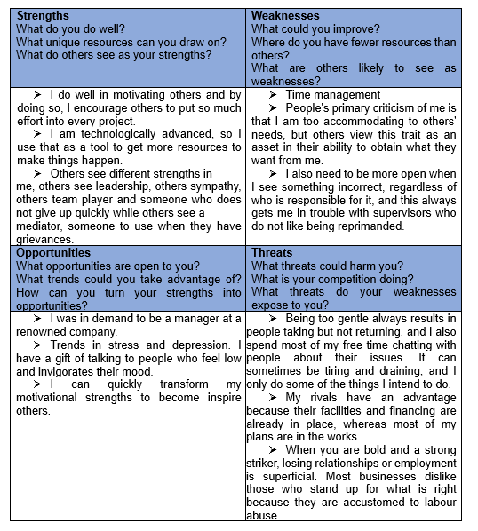

Appendix C

Individual Skills Audit

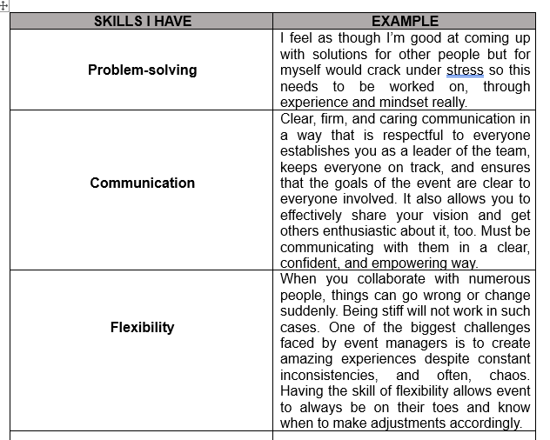
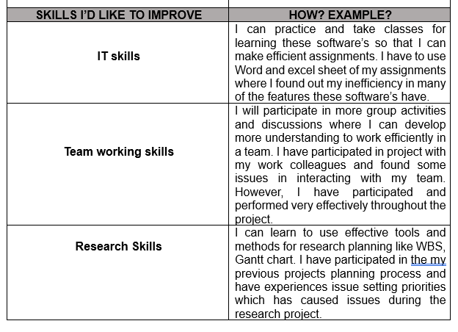

Personal development plan



