BUSINESS PLAN

ILAZAR24 LIMITED

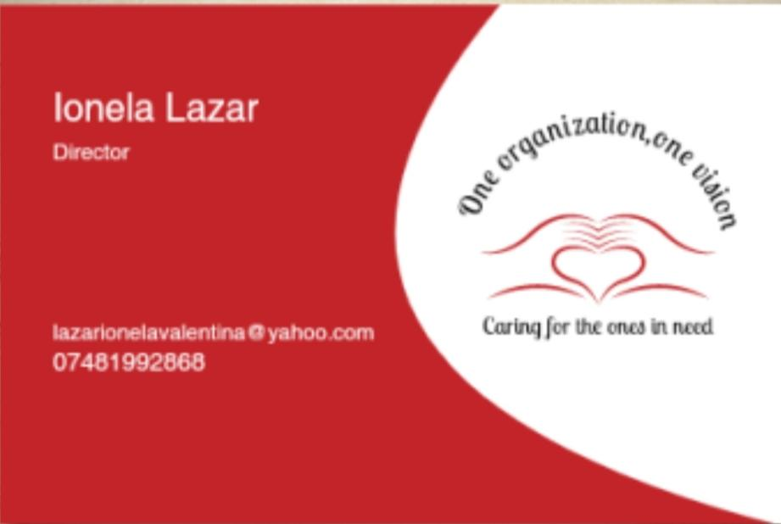

University of Wales Trinity Saint David

Contents page

Introduction………………………………………. Page3
Market activities………………………………… page3-7
Physical resources……………………………… page8-9
Human resources………………………………. Page9-11
Financial Resources……………………………. Page11-13
SWOT Analysis…………………………………. Page14
Appendices………………………………………. Page15-18
Referencing list…………………………………. Page18-22

Introduction

Behind any wish of making a lot of money or drive expansive cars, when you open a business you need to have in mind your passions, if the business you want to open is part of your passions you are in a good directions.
My job is my passion and I decided to make it more than that, to have my own Recruitment Agency where I can employ experienced healthcare workers and offer them good wages it is my dream.
For that I need a clear target market, a good market plan and to know my business market position.
The type of business is sole trader which means one owner responsible for the entire operation. Being a sole trader involves taking all the responsibilities for any business losses, all bills and business account (Harrison,2019).
Name of Business ILAZAR24 LIMITED recruitment agency for health care assistants.
The reason I am choosing a healthcare agency is simple, I know a lot of experienced care assistants that are looking for a job and they will love to work for me. Healthcare is a big filed and if you are good you can develop a career and have a successful business. I do not need many recommendation’s as I have been working in many homes and I know a lot of homes manages who will like to collaborate with me.
Business Owner Ionela Lazar.
Mission statement: ‘One organization, one vision’ ‘Caring for the ones in need’
Aim of Business: To provide a high quality of care, to employ well trained and reliable staff, to create a friendly and worm workplace.

Market Activities

Target market is the specific group of people you want to reach with your marketing messages (Shopify.com,2020). By aiming your marketing efforts at specific groups of consumers makes the promotion, pricing, and distribution of your products and/or services easier and more cost effective and provides a focus to all your marketing activities.
In this case the group of people my business will sell the services to are elderly people by direct contact or true Care homes or Nursing homes.
After a competitor’s analysis it shows that the 5 must use healthcare agencies in Cardiff and Bridgend area are:
1.Total care services
2.Randstad
3.Hoop Recruitment
4.Procare Nursing Agency
5.Everycare
Segmentation or divided is to segment the broad population of consumers into smaller and more specific groups, in order to design strategies that will appeal to those groups more effectively (Thompson,2020).
It can be demographic segmentation based on age, gender, income level, education, race, religion, marital status.
In this case an important factor is the age, which is usually elderly and income level, no everyone can afford to pay agency carers so as a new agency our prices needs to be lower than the competitor’s prices.
Market position refers to the consumer’s perception of a brand or product in relation to competing brands or products. Market positioning refers to the process of establishing the image or identity of a brand or product so that consumers perceive it in a certain way.
As a new recruitment agency, I like to think that we are reliable, experienced and we have a high standard of delivering care.
Market mix means the actions or tactics that a company uses to promote its brand or product in the market. Market mix is about putting the right product or a combination thereof in the right place, at the right time and at the right price (Economictimes.com,2020).
The 4Ps of marketing mix are product, promotion, place and price.
It was developed by E. Jerome McCarthy in the 1960s and introduced as a form of simplifying the marketing processes for businesses (Marketingmix.co.uk,2020).
Product-The product that my business is offering is care services in care homes and nursing homes.
Even if our competitors are well known in this field by high quality of staff, reliability and lower prices, ILAZAR24 LIMITED can make a difference.
Promotion-I will be promoting ILAZAR24 LIMITED on the social media like Facebook on ILAZAR24 LIMITED Facebook page, LinkedIn, Twitter, by direct contact with the managers of the care homes and nursing homes, by sending offers by email to the managers of care homes and nursing homes.
I can also promote my business by my employee when they are going to work, they can always have a chat with the clients about the values of my business.
Establish relationships with doctors and health professionals that will refer business to the Care and Nursing Home.
Develop an online presence by developing a website and placing the Company’s name and contact information with online directories. I have attached below few pictures from the website platform.

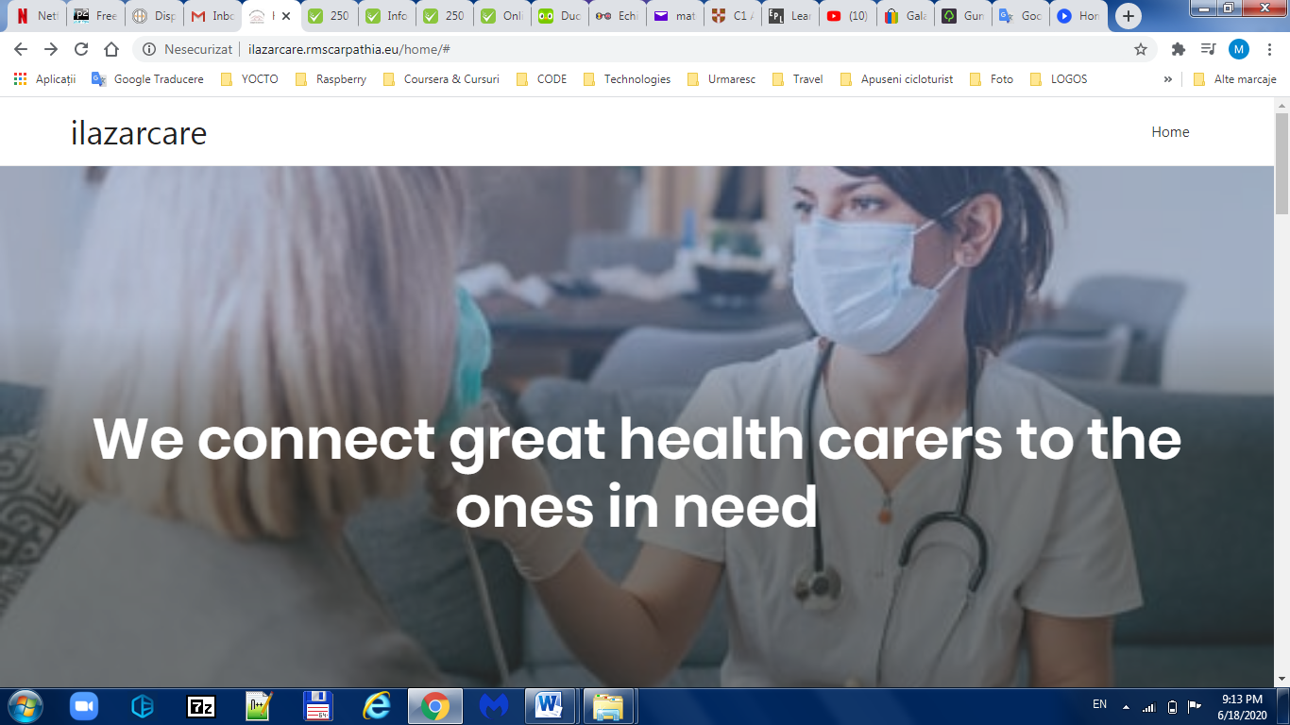

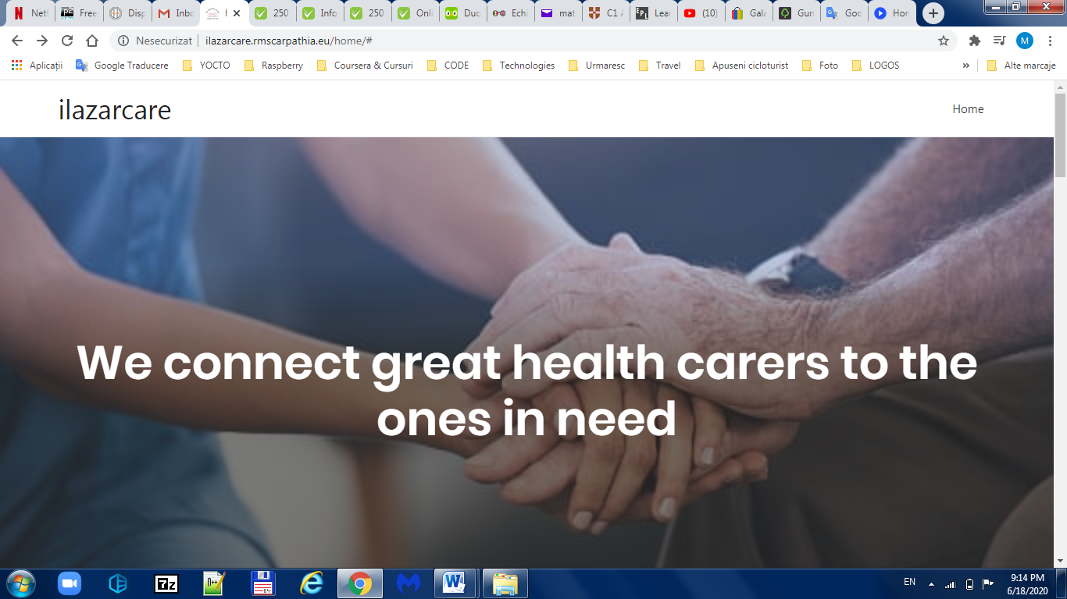
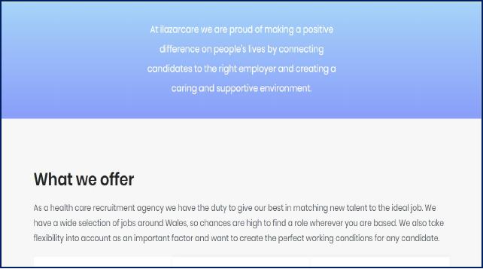

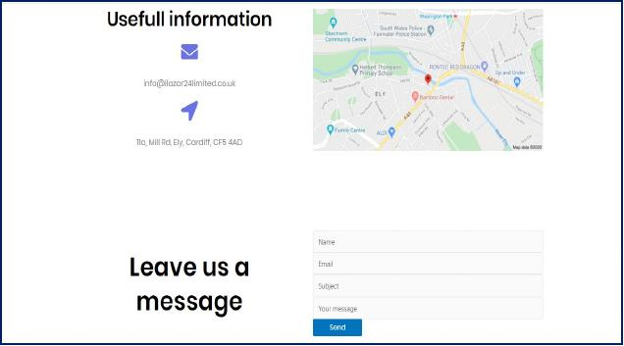

Place-The place that my business is going to activate is health care sector with the main office based in Cardiff, Wales.
Price-As the carer that are going to work for my agency are experienced the prices are going to vary depending on them qualifications. A level 2 qualified carer will be paid between £9 on a weekday/night and £14 on weekends day/night with double pay on bank holidays, a level 3 qualified carer or band3 is already a senior carer and medication trained therefore the price is a bit higher between £11 on a weekday/night and it goes up to £17 on a weekend day/night.

Physical Resources

The business is set up as a bricks business-the business has a commercial address.
The Office Address is 11 A Mill Road, Cardiff, CF5 4AD, it is a rent property located in a not very busy area with easy access to Cowbridge road, A38, A4232 and just 5 miles from M4 which is a real advantage.
Inside the office you can find 2 big rooms, 1 small room,1 dining room,1 living room, toilet, kitchen and 1 corridor. In front of the office there are 3 parking spaces reserved for ILAZAR24 LIMITED. For our safety the building is provided with 2 emergency exits and 3 extinguishers, the point meeting is in the car park. A complete evacuation plan and the fire panel can be found on the corridor.
The small room is going to be used as a manager office, one of the big rooms as a training room and the 2nd big room as an office for HR Manager.
The dining room is going to be the waiting room where the new candidates can have a sit before, they are going to be seen by the HR Manager.
As we are a 24/7 company, we also need a one call room where the person responsible for taking all the calls can stay.
The equipment’s necessary for this property are 5 computers/laptops-£ £499.95, 5PCS = £2499.75 (Johnlewis.com,2020), 1printer with fax and scanner-£406,80(Storehp.com,2020), 5 office desks-£419,95(Wayfair.com.uk,2020),5 office chairs-£552(Furnire-work.com.uk,2020), 1 table and 6 chair-£544,99(Amazon.co.uk,2020), a lockable drawer-£239,99(Funiwork.co.uk,2020), 1 coffee machine-£59,99(Argo.co.uk,2020),1 microwave oven-£39,99(Argos.co.uk,2020),1 fridge-£119,99(Argos.co.uk,2020), 1 water drop filters-£243,15(Watersystems4u.co.uk,2020), notebooks x 25-£47,75(Officemonster.co.uk,2020),pens x 36- £43,19(Officemonster.co.uk,2020), paper tops A4-£17,87(Officemonster.co.uk,2020), business card with the company logo-£11,98(Vistaprint.co.uk,2020),stapler x 10-£17,90(Officemonster,2020),Stamp-£8,30 x 6 -£49,80(Stamps4u.co.uk,2020),uniforms-£200,id badges-£3 each.
ILAZAR24 LIMITED fixed costs are the rent £650/month (Zoopla), water-£40/month (Welsh water), council tax-£150/month, electricity and gas-£50/month (ESB Energy), telephone and internet broadband £26/month (Virgin Media), business insurance £ 895/year (Admiral), advertising (website-£5/year)
The variable costs can be staff wages, depreciation of equipment but it is less likely to happen as everything will be brand-new.

Human Resources

The owner of ILAZAR24 LIMITED, Ionela Lazar has a 6 years’ experience in healthcare sector, and she is training to become a manager in healthcare.
As a new name in healthcare field ILAZAR24 LIMITED needs to get known, for the beginning should only employ experienced staff. For the same reason the Marketing Specialist is the owner as she knows the healthcare sector very well.
The Financial Specialist and the Director of Physical Resources is Marian Stan with a wage of £18000a year going to increase the next years according to profit, 26 days annual leave + statutory bank holidays.
The HR Manager is Elena Cioata with a wage of £25000 a year,26 days annual leave+ statutory bank holidays.
For making this business to run the main employees are the healthcare assistants, 20 HCA is more than enough for the start.
The first step for getting HCA is the recruitment process, by recruitment we understand the method finding and hiring people with the qualities and qualifications necessary for the vacancy.
Being a Limited, the business needs an accountant too. The accountant name is Ecaterina Sava, wage is £1000/year.

Healthcare assistant -job description

Type of job: Full-time or Part-time.
Job description: Helping people is your passion? Come and going us!
We value the diversity of our staff and we welcome any applications.
Responsibilities: As a carer you will be assisting the service users with personal care, getting up, with meals, bed changing, toileting while you make sure you maintain them independence and dignity.
Reports to: Senior Carer/Registered Nurse / Clinical Lead – Deputy Manager / Registered Manager
Requirements: A full set of mandatory trainings (Moving and Handling, Safeguarding, Health and Safety, POVA) and experience is required.
Salary: QCF level 2 qualified between £9-£14 and QCF level 3 between £11-£17.
Application instructions: You can apply via Indeed, LinkedIn or by using the email address: recruitment@ilazar24limited.co.uk.
For more information’s you can contact us at 07481992868.

To be considered for this role you will need:
- A valid DBS
- Proof of eligibility to work in the UK.
- 6 months experience in the last 2 years
Some of the benefits offered:
- Weekly pay available.
- Highly competitive pay rates.
- Easy, fast and hassle-free registration process.
- Long term block bookings available, as well as ad-hoc.
- Advanced bookings so you can plan and build shifts in around your schedule.
- You decide when you want to work, leaving the rest to us.
- Uniforms and id badge free.

Advertising- There will be several ways of advertising this job: By Indeed and LinkedIn, Facebook, Twitter, via email straight to the managers of the care/nursing homes.
A selection of CV’s will be made, and the selected candidates will by invited for an interview via email of phone calls but not before checking them right to work in the UK.
The interviews are carried out by 2 persons, the HR manager and the owner.
The chosen candidates will by advised to come to the office, an application form with a full background including bank details, education and two references will be completed.
The HR manager will help the new employee to apply for a DBS if he/she does not have an update service one.
If after receiving the DBS check and the 2 references back everything is ok, a contract will be signed and copy of the contract will be taken by the new employee.
The contract must contain job title and job offer, conditions, salary, number of weekly hours, location where the activity takes place, holiday entitlement, pension scheme.
A free uniform and id badge will also be provided.

Financial Resources

Easy to say ‘I want to open a new business’ but quite difficult to get money that are necessary for it. For this business the financial resources are the owner savings and business grant.
Business grants for SMEs payed by Government, grant is essentially an incentive package made available by various government bodies and organisations to individuals as well as businesses. Government grants (barring the finance grants) are usually non-repayable.
Depending upon the nature of the grant body and the grant objective, these grants can come in a variety of sizes and formats. As far as small businesses are concerned, such grants range from £1,000 to £500,000. Some of the bigger and more prized grants can go even higher (commercialfinance.co.uk,2020).
A reason I choose business grants as even is not easy to obtain them they are free money. They are there for a purpose, to help small businesses, this is the main reason why I want to open a business too, to help good workers that are not payed enough for the work they are doing.

(Grantfundingdexpert.org,2020).

Assets and liability
Assets is the economic value of anything which is owned by the company. Assets are those objects that can be converted into cash or generates income for the company shortly. It is helpful in paying out any debt or expense of the entity. Examples are cash, prepaid expenses, inventory, office equipment (Digit.Business,2020).

Liability the economic value of any debt or obligation owed by the company to any other individual or organization. The liabilities are the responsibilities arising out of past transactions, which must be paid by the company shortly, through the assets owned by the entity. Examples loans, bank overdraft, outstanding expenses, account payable (Surbhi,2020).

For this business I have chosen the market-based price which is going to help me to set the price for the service that my business is offering based upon existing market conditions. The price will be set by an agreement between ILAZAR24 LIMITED and the clients (Businessdictionary.com,2020).

SWOT Analysis for ILAZAR24 LIMITED

Strengths: The costs to open the agency is quite low, the demand of healthcare services is high as there are nearly 12 million (11,989,322) people aged 65 and above in the UK (Ageuk.org.uk,2019), healthcare agencies are not affected by the economy as to care for elderly is a priority.
Qualified(QCF level 2 and level 3 in healthcare) and experienced staff with up to date trainings such as Moving and Handling, Health and Safety, Food Hygiene, Fire training, Dementia, Catheter care ,End of life and palliative care training, Oral hygiene and Medication handling that can provide support in any environment.
Professional equipment and 24/7 support.
The head office of the agency is in a safe area with access to few main roads and M4, easy for the staff who wants to join the company and for the office staff.
Low prices can open a lot of gates as the managers of care and nursing homes are always trying to reduce the costs.
Weekly payed staff, hourly charges from the clients so they know how much they need to pay.
Weaknesses: The number of the competitors in this area, not enough carers available to attend the shifts, staff sicknesses, lack of contracts with care and nursing homes which means lack of shifts for the staff.
Insurance costs can be slightly high for healthcare businesses the for others.
Outdates staff DBS’s or trainings can be an impediment for providing care assistants when our clients are asking.
New name in healthcare industry can be a real disadvantage but it can be compensated by excellent services and caring staff.
Opportunities: Collaborate with different healthcare organisations, increasing funding’s for staff and company by providing care for a lot of clients, career development.
Threats: Changes in regulations, laws and policies because of Brexit, budget difficulties, the competitors.

Appendices

Questionnaire feedback
I have attached below few pictures from the research I have realised in order to realise the market analysis for my business plan.

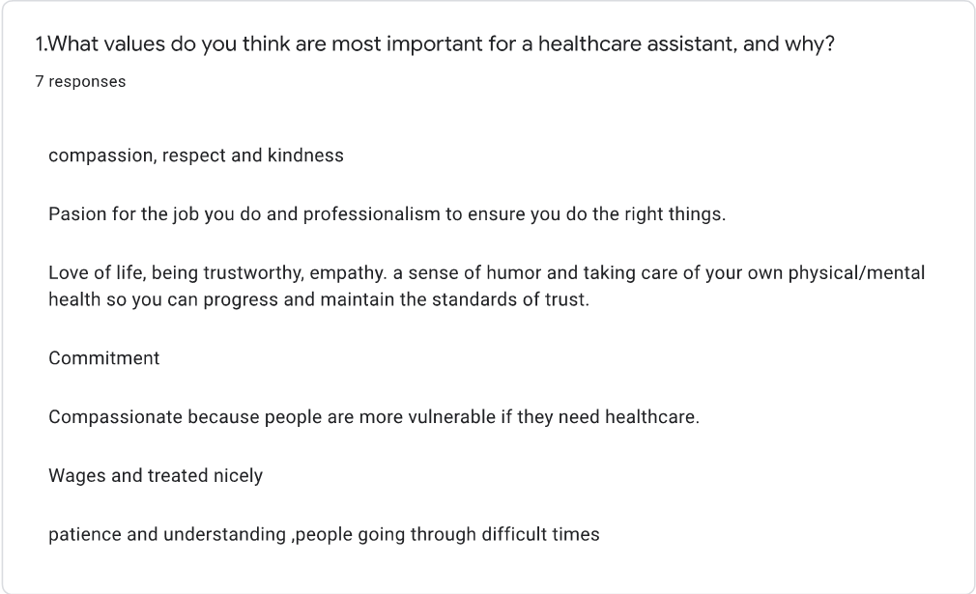

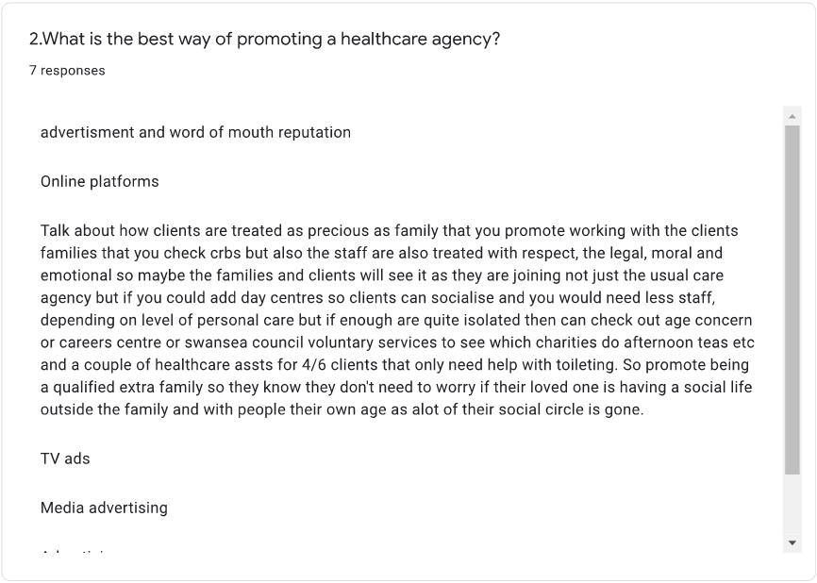

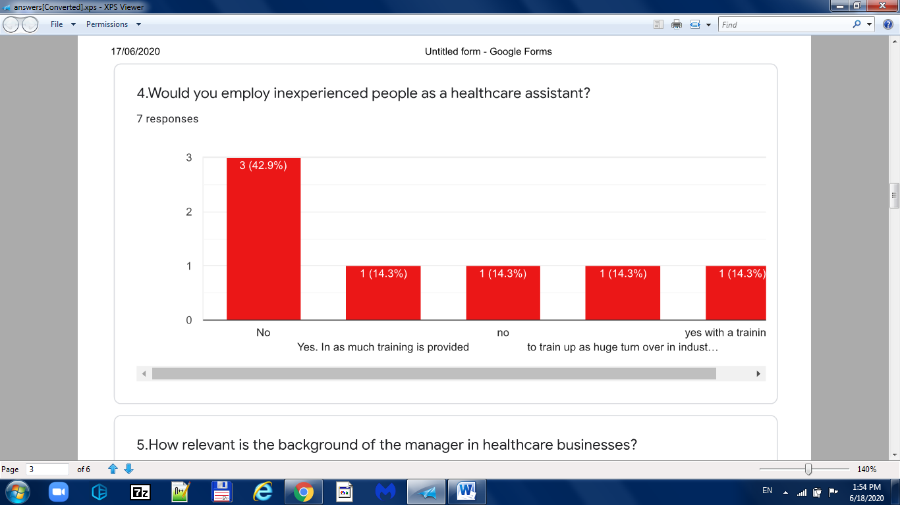

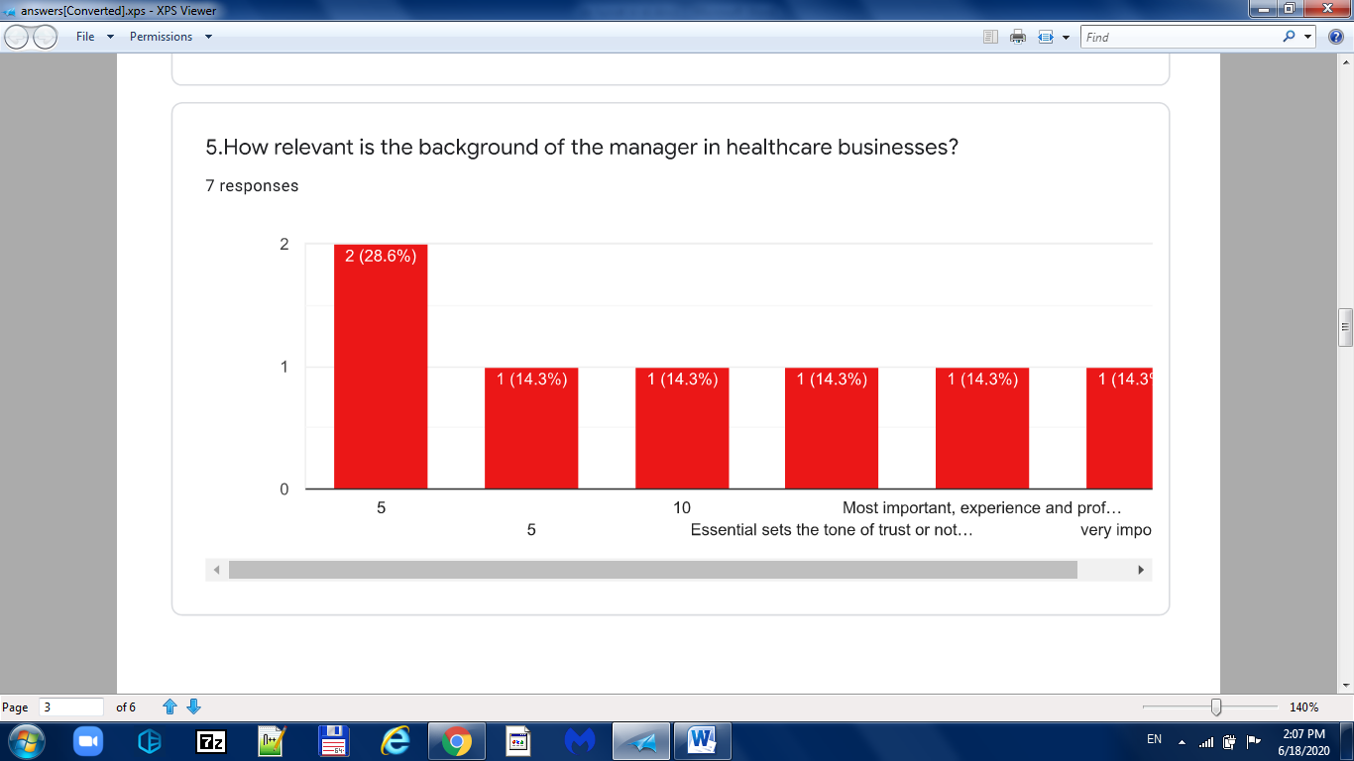

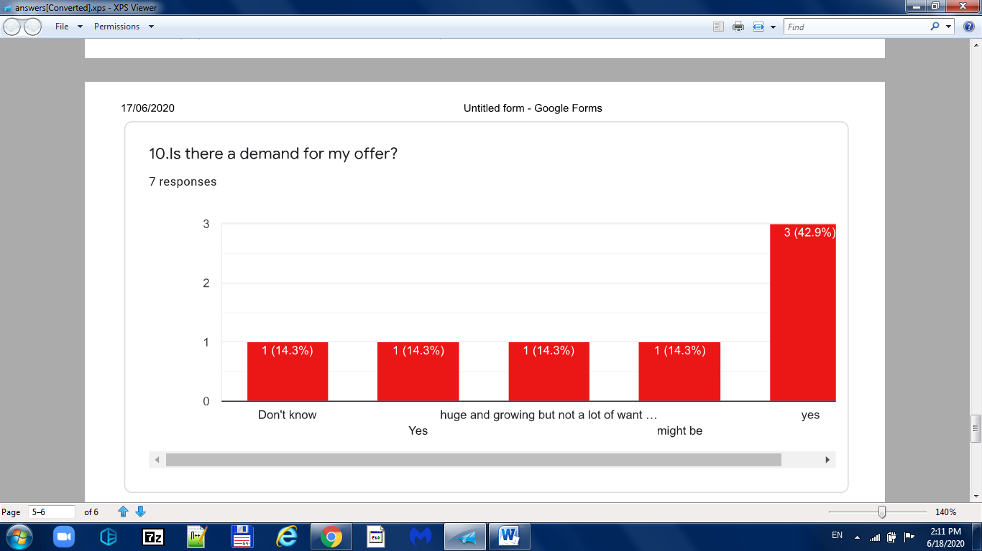

Referencing list

1.Ageuk.org.uk (2019) Later Life in the United Kingdom 2019. Available at: https://www.ageuk.org.uk/globalassets/age-uk/documents/reports-and-publications/later_life_uk_factsheet.pdf. (Accessed:02 June 2020).
2.Amazon.co.uk (2020) Furniture box UK Giovani Modern Black/White High Gloss Glass Dining Table Set and 6 Chairs Seats (Table + 6 White Lorenzo Chairs). Available at: https://www.amazon.co.uk/Furniturebox-UK-Giovani-Modern-Lorenzo/dp/B07J1VGCTM/ref=asc_df_B07J1VGCTM/?tag=googshopuk-21&linkCode=df0&hvadid=375419269849&hvpos=&hvnetw=g&hvrand=61838978177055799&hvpone=&hvptwo=&hvqmt=&hvdev=c&hvdvcmdl=&hvlocint=&hvlocphy=9045362&hvtargid=pla-823557943563&psc=1&tag=&ref=&adgrpid=83648335384&hvpone=&hvptwo=&hvadid=375419269849&hvpos=&hvnetw=g&hvrand=61838978177055799&hvqmt=&hvdev=c&hvdvcmdl=&hvlocint=&hvlocphy=9045362&hvtargid=pla-823557943563. (Accessed: 05 June 2020).
3.Argos.co.uk (2020) Cook works 700W Standard Microwave - White .Available at: https://www.argos.co.uk/product/9174030. (Accessed: 05 June 2020).
Argos.co.uk (2020) Bush M5085UCF Under Counter Fridge - White .Available at: https://www.argos.co.uk/product/8553401. (Accessed: 05 June 2020).
4.Argos.co.uk (2020) Russell Hobbs 24320 Luna Filter Coffee Machine. Available at: https://www.argos.co.uk/product/7590908?istCompanyId=a74d8886-5df9-4baa-b776-166b3bf9111c&istFeedId=c290d9a9-b5d6-423c-841d-2a559621874c&istItemId=ixixxaaxp&istBid=t&&cmpid=GS001&_$ja=tsid:59157%7cacid:598-923-9094%7ccid:9549408474%7cagid:97028012839%7ctid:aud-378671944447:pla-886058582043%7ccrid:422748696704%7cnw:g%7crnd:671077899647895771%7cdvc:c%7cadp:%7cmt:%7cloc:9045362&utm_source=Google&utm_medium=cpc&utm_campaign=9549408474&utm_term=7590908&utm_content=shopping&utm_custom1=97028012839&utm_custom2=598-923-9094&gclid=CjwKCAjw2uf2BRBpEiwA31VZjx-qj4Qf590aEYAtPeEpsKfR2t55PNlon1FbO9Ix9fxtqxgn68L60xoCLl0QAvD_BwE&gclsrc=aw.ds. (Accessed: 05 June 2020).
5.Businessdictionary.com (2020) Market-based pricing
Available at:http://www.businessdictionary.com/definition/market-based-pricing.html. (Accessed: 14 May 2020).
6.Digit. Business. (2020) What is an Asset? What is a Liability? Available at: https://digit.business/financial-literacy/what-is-an-asset-what-is-a-liability. (Accessed:14 May 2020).
7.Ebay.co.uk (2020) Yo Yo Retractable ID Badge Reels With Matching Open Faced ID Card Holder lot .Available at.https://www.ebay.co.uk/itm/Yo-Yo-Retractable-ID-Badge-Reels-With-Matching-Open-Faced-ID-Card-Holder-lot/232667459423?hash=item362c0faf5f:m:mk-GctRy1nM0kRlnm6V4NFw. (Accessed:06 June 2020).
8.Economictimes.com (2020) Definition of ‘Marketing Mix ‘. Available at: https://economictimes.indiatimes.com/definition/marketing-mix. (Accessed: 18 May 2020).
9.Furniture-work.co.uk (2020) Modello High Back Leather Faced Executive Chair. Available at: https://www.furniture-work.co.uk/modello-high-back-leather-faced-executive-chair.html?gclid=CjwKCAjw2uf2BRBpEiwA31VZj6ZUgE3HVf1dUTrufNFNVVWgAru7LxoFLCznuJ6YY3TlrVnT63R6QRoC7qQQAvD_BwE&gclsrc=aw.ds&sel=47458N. (Accessed: 05 June 2020).
10.Furniturework.co.uk (2020) Product Features. Available at: https://www.furniwork.co.uk/5-drawer-filing-cabinet.html. (Accessed: 05 June 2020).
11.Gov.uk (2020) Grants available for SMEs looking to export. Available at: https://www.gov.uk/government/news/grants-available-for-smes-looking-to-export. (Accessed: 22 May 2020).
12.Grantfundingdexpert.org (2020) Why Does the Government Give Grant Money? Available at: https://www.grantfundingexpert.org/why-does-the-government-give-grant-money/. (Accessed: 18 May 2020).
13.Harrison, P.M. (2019) What is a sole trader? Available at: https://startups.co.uk/what-is-a-sole-trader/. (Accessed: 14 May 2020).
14.Johnlewis.com (2020) HP 14 14-dk0011na Laptop, AMD Ryzen 5 Processor, 8GB, 256GB SSD, 14" Full HD, Natural Silver. Available at: https://www.johnlewis.com/hp-14-14-dk0011na-laptop-amd-ryzen-5-processor-8gb-256gb-ssd-14-inch-full-hd-natural-silver/p4209353?sku=238183015&s_ppc=2dx92700051421932678&tmad=c&tmcampid=2&gclid=CjwKCAjw2uf2BRBpEiwA31VZjwyQNpkJy1yEqhaDzTCThjf4njHstwi4ubg6GJw__F_WE9loIybrvxoCD50QAvD_BwE&gclsrc=aw.ds. (Accessed: 05 June 2020).
15.Marketingmix.co.uk (2020) 4Ps Of the Marketing Mix. Available at: https://marketing-mix.co.uk/. (Accessed: 18 May 2020).
16.Newberry, C. (2018) How to Define Your Target Market: A Guide to Audience Research. Available at: https://blog.hootsuite.com.target-market/. (Accessed:20 May 2020).
17.Officemonster.co.uk (2020) Manual Staplers. Available at: https://www.officemonster.co.uk/manual-staplers. (Accessed: 06 June 2020).
18.Officemonster.co.uk (2020) Pentel Assorted Oh! Gel Pens Display (Pack of 36) K497/3D. Available at: https://www.officemonster.co.uk/ballpoint-and-rollerball-pens/pentel-assorted-oh-gel-pens-display-pack-of-36-k497-3d--4. (Accessed: 05 June 2020).
19.Officemonster.co.uk (2020) Q-Connect Feint Ruled Case bound Notebook 192 Pages A4 K00060.Available at: https://www.officemonster.co.uk/manuscript-books/q-connect-manuscript-a4-book-ruled-feint-96-leaf-k00060--4. (Accessed: 05 June 2020).
20.Officemonster.co.uk (2020) White A4 Copier Paper (Pack of 2500) WX01087. Available at: https://www.officemonster.co.uk/plain-paper/white-a4-copier-paper-pack-of-2500-wx01087--4. (Accessed: 05 June 2020).
21.Shopify.com (2020) Target Market. Available at: https://www.shopify.com/encyclopedia/target-market. (Accessed:18 May 2020).
22.Stamp4u.co.uk (2020) Customised Self-inking Certified Stamp. Available at.https://www.stamps4u.co.uk/customised-self-inking-certified-stamp?channable=e33266.MTE2NjQtQ09QWQ&nfxsid=CjwKCAjw2uf2BRBpEiwA31VZjyYLTZQtutFVuHTr3ocBHpTRvUmxTFslFl3CkwwAK1C883HVcXVX7BoCOg0QAvD_BwE&nfxsid=5edab373d7eb21591391091&gclid=CjwKCAjw2uf2BRBpEiwA31VZjyYLTZQtutFVuHTr3ocBHpTRvUmxTFslFl3CkwwAK1C883HVcXVX7BoCOg0QAvD_BwE. (Accessed: 06 June 2020).
23.Store.hp.com (2020) HP Page Wide Pro 477dw Wireless Multifunction Colour Printer. Available at:https://store.hp.com/UKStore/Merch/Product.aspx?id=D3Q20B&opt=A80&sel=PRN&lang=en-GB&pup_e=1&pup_cid=55877&pup_id=D3Q20B%2523A80&gclid=CjwKCAjw2uf2BRBpEiwA31VZj7rmxTYiQaNnzU8XP2DmtwgoP-bXRa3J5MPwuXdGJCgqAhN1MHz2uRoCnXIQAvD_BwE&gclsrc=aw. (Accessed: 05 June 2020).
24.Surbhi, S. (2014) Difference Between Assets and Liabilities .Available at: https://keydifferences.com/difference-between-assets-and-liabilities.html. (Accessed: 14 May 2020).
25.Thompson, J. (2020) Customer Segmentation: Definition, Types & Examples. Available at: https://bizfluent.com/13724213/customer-segmentation-definition-types-and-examples. (Accessed:18 May 2020).
26.Virginstartup.org (2020) GOVERNMENT GRANTS: EVERYTHING YOU'LL NEED TO KNOW. Available at: https://www.virginstartup.org/how-to/government-grants-everything-youll-need-know. (Accessed:20 May 2020).
27.Vistaprintg.co.uk (2020) Your personality. Your pride. Your card. Available at:https://www.vistaprint.co.uk/lpt/bc1-cat-marquee-creation-1.aspx?mk=business+card+price&ad=e&crtv=304869736469&device=c&psloc=9045362&pstid=kwd-599215974&psite=mkwid%7c2Kgx7DVm&pscid=16461614&psagid=6600155946&psint=&psfid=&psnet=g&pspos=&psp1=%c2%a39.99&psp2=50%25&psaceid=&gclid=CjwKCAjw2uf2BRBpEiwA31VZjyRgLbEVjyZ5GajC0Oau5AQ81EqHlE51VvePRvZ_CiduyDdMAxlKMhoCmDMQAvD_BwE&couponAutoload=1&GP=06%2f05%2f2020+16%3a59%3a03&GPS=5696169180&GNF=0. (Accessed: 06 June 2020).
28.Watersystems4u.co.uk (2020) Water Dispenser, Drinking Fountain and Hot Water Boiler Supplier. Available at: https://www.watersystems4u.co.uk/3300-floor-standing-bottled- water-dispenser-cold-and-ambient.html. (Accessed: 05 June 2020).
29.Wayfair.co.uk (2020) Meggie desk. Available at: https://www.wayfair.co.uk/Zipcode-Design--Meggie-Desk-GJOU4747-L32-K~FINT3636.html?refid=GX433670403496-FINT3636_35662790&device=c&ptid=903536000308&targetid=pla-903536000308&network=g&ireid=65414889&PiID%5B%5D=35662790&device=c&gclid=CjwKCAjw2uf2BRBpEiwA31VZj-kCEHMFPrAVwHHvgbC-SfHm6esCkFs7JruoN9AaYoAzfRkiiGKhAxoCk7EQAvD_BwE. (Accessed: 05 June 2020).

