Data Handling & Business Intelligence
LCBB5000

Assessment2

Gabriela Borislavova Tosheva
Student ID2116099
University of Wales Trinity Saint David
Table of Contents
INTRODUCTION 5
TASK 5
Part I 5
Uses of MS excel tools for data visualisation and data analysis: 5
Demonstration of 2 Excel Functions along with the charts and graphs 9
PART 2 16
2.1 How many students like vanilla flavour of ice-cream? 16
2.2 How many students are Male and Female? 17
2.3 What are the Mean and Median of participants who likes chocolate and strawberry flavour ice-cream? 18
2.4: Using the dataset Ice-cream csv provided in conjunction with SPSS, give a specific example of clustering 19
2.5 Explain the most common data mining and text mining methods that can be used in business with real world examples. 21
2.6 Discuss the advantages and disadvantages of using SPSS and Excel. 23
SPSS 23
Advantages and Disadvantages of SPSS 23
Excel 24
Advantages and disadvantages of Excel. 25
CONCLUSION 26
REFERENCES 27

Task
Part I
Data visualisation is made up of two terms i.e. data and its visualization. Data just refers to raw and unprocessed set of large information which needs to be processed. Visualization means its expression in form of graphs and charts for better view and understanding (Askarpour, 2018). This uses common graphics like charts and plots plus animated visuals. It is used in many contexts not only in business context but also in education and other governmental uses where data is involved. Under this project data is provided for the superstore and on basis of such data various metrics and methods of excel are to be applied.

PART I
Uses of MS excel tools for data visualisation and data analysis:
Data analysis is a process of using data to conclude something out of it. Excel is a spreadsheet program and hence it is used to arrange the data in the row and column form which is called tabular representation of data. It also includes a number of data analysis tools, statistical tools and function for depth analysis. It is basically used for database management, accounting purpose, financial analysis, graphical representation, management purposes and other functions (Carter, Adam, Tsakis, and et.al., 2020). It offers focused analysis by filtration of data, sort in desired way, get only desired data on basis of given condition. Any field can be summarised on any given basis for getting targeted data. Excel contains about 400 functions such as summing of range, if analysis, exact, VLOOKUP, hlookup, avg, count function, min and max, trim tool, trigonometry function, mathematical function for mathematical operations, etc. It is used for storing data from the database. It is used to convert the raw data, facts and figures to convert into usable information. It also contains forecasting tools for future ascertainment. Every professional use advance excels for advancing their data management. Along with this the chart feature is very good feature under this. Charts are used for visualisation feature. Some charts show single data sets while some support multiple data sets for better data relationship management.
Use of excel for data processing: Excel pre-processing just refers to the converting of unstructured data to structured and understandable form. Some basic function may be used for the purpose:
IF function: It is a conditional function returns value like true and false. If the given expression agrees for the condition, it return true and if not, then returns false. For ex- if value is checked for condition greater than 3, but cell contains value 2 so it would return false.
IFERROR: It is also known to be trouble-shooter function when any error arises. It is used to handle errors when any common thing arises. For example, if user tries to divide the 0 value by any number then error arises (Giacobini, 2018, May).
Left and Right: This function is used to return the value from left and right of the given string value in the field. If left function is used it would return set of values from left and vice versa.
Many types of other function are also used in excel software for data processing. This make excel more powerful and useful tool for non-programmers.

Excel in data analysis:
Excel helps in processing data and converting it into final data. After making of final data it is again analysed for drawing some conclusion from it. Some features which help in analysis are as follows:
Pivot charts and tables: It is a reformatting and grouping tools for summarising the data set. This can be found under insert tab. It is used in case when data is much large to analyse.
Conditional formatting: It helps in formatting data according to the rule specified by the user. It is used to apply rule on multiple cells within the worksheet.
Remove duplicate: Using the conditional formatting user sort out the duplicate data and then using this option for such data could be deleted in single click on basis of applied rule.
Exact function: This help in comparing two values as exact match. It compares only two set of values (Hüsch, 2018).
Mathematical functions: Function like sum, average, count, count if, are some functions which are used to perform basic mathematical functions.
Data analysis tool: This is a tool pack solver which contains various basic and advance statistics function for data analysis. Descriptive analysis, regression analysis, standard deviation are some of the mostly used function under the same. It makes data analysis easy and fast.
Another basic function used for analysis are len, concatenation, trim, sort, countifs function make data analysis easy.
Great advantage of Excel is it is a full pack of inbuilt function making it a powerful tool. But it has a great limitation in relation to file size limits (Luo, Naidu, and Fang, 2022).

Demonstration of 2 Excel functions
Pivot Table:
Pivot table is a function of excel which is used to summarise and arrange the given large dataset in such a way so that various conclusion may be concluded from it. It helps in easy comparison and new trends on basis of various patterns. Excel not only help to summarise the data in given sheet, but it has also features like fetching data online from external sources. Such data analysis with help of charts and graphs help in better and efficient decision making.

Pivot table may efficiently group data in such a way so that figures related to total sales and profit for the particular era or period can be known easily. In addition to this the data can be filtered and sorted with the help of additional sort and filter option. It also facilitates data mining based on special formatting, random values, fields and variable of choice, Row column basis and fields given in dataset (Martin, B., Kanokwongnuwut, Taylor, and et.al., 2020). Here the data of superstore sales is analysed for multiple years from 2009 to 2012. Around 8400 row data is already given which is very large number. Out of this data for per year sales and profits is drawn out. Total order quantity is also filtered for the purpose of comparison. This shows that sales figure for the superstore is decreasing year by year. In between 2009 to 2010 the sales figure decreases by around 15% which also resulted in total sum of profits by difference of 68,178.69. In the same way it decreased again in by 130142 in 2011 and fallen to 3429944.981 but the level of profits increased. But the sale level increased in 2012 from 2011 level by 285727 but the level of profit decreased by 37866.4 margin. Order quantity also increased by 3067 units. Grand total in all the years for sales was 14915600.82 and total units sold during the period is 214780.

Pivot Table
Row Labels | Sum of Sales | Sum of Profit | Sum of Order Quantity
2009 | 4209896.846 | 434096.02 | 54508
2010 | 3560087.045 | 364917.33 | 54379
2011 | 3429944.981 | 380310.5 | 51413
2012 | 3715671.953 | 342444.13 | 54480
Grand Total | 14915600.82 | 1521767.98 | 214780

LOOKUP Function:
Lookup function refers to such function used to get the value according to the need and given condition. It helps in finding values by both vertically and horizontally along the data placed under rows and columns. VLOOKUP is used to find values by columns and HLookup which is another subsidiary function for the same helps in finding the values according to the rows of given table. This function requires a range for the given array. It searches for the exact match if the return value given to be 0 and if the closest values still lie in such array, it could be found by providing the logical value as 1 for the identical match. This function is used for getting data manually on different given conditions from the larger data sets. Searching data one by one is not possible hence it is a very best tool in excel functions (Traverso, 2021). For example, in the given context it is used for one lookup value in row ID. The VLOOKUP function can be accessed by simply typing the value in cells like the given way below:
=VLOOKUP (<Lookup value>, <table array>, <column index number>, <lookup value>)
Under this formula lookup value refers to the value for which the value is to be found in the reference column given in column index number. Table array is the group of all the fields i.e. row and column of data set. It includes title rows, data set cells till end. Third is column index number. This provides for such column number from which data is to be fetched corresponding to the lookup value fall in front of it. It also contains a value function for getting identical or an exact match. Finder may also search for the identical value in case the exact match value is not given (Vilela, Rodrigues, Solic, and et.al., 2019). From the given data let’s assume that user is required to find the profits for the 160th row id cell data. It can be performed in following way:
Step 1> In any blank cell type the Row ID for which data is to be fetched. It is in way as follows:
VLOOKUP
Enter Row ID | 160

Step 2> This would be the lookup value for the function. In second field the table array needs to be provided. In this case table starting from A2: K8401.
Step 3> In third place the serial number of profit column from the starting position of the table.
In this case profit column is lying at 9th place from starting position.
Step 4> At last lookup value field contains two value 0,1.
0 shows exact match while 1 is for nearest match (Xu, Zhang, Feng, and et.al., 2020).
So, formula framed for this is as follows:
=VLOOKUP (G3, Sheet1!A2:K8401, 9, (1))
decreased or increased value of sales and profit for each year
sales | profit
0 | 0
-649810 | -69178.7
-130142 | 15393.17
285727 | -37866.4

Representation of data: Charts and graphs are the best way to visually show the data for faster analysis purpose. Excel helps in better representation of database through use of line, column, pie and scatter charts. Some charts are used for showing relation between multiple data. Every type of charts is used according to their features. Pie charts are best when it comes to show the contribution to total amounts (Yamada, Watanabe, and Chibana, 2018).

Region | Total number of orders
Atlantic | 1080
North Carolina | 79
Northwest Territories | 59
Ontario | 2161
Prairie | 1706
Quebec | 781
West | 1991
Yukon | 542

PART II
2.1 How many students like vanilla flavour ice-cream?
 |  |  | Frequency | Percent | Valid Percent
Valid | vanilla |  | 95 | 47.5 | 47.5
Valid | Chocolate |  | 47 | 23.5 | 23.5
Valid | Strawberry |  | 58 | 29.0 | 29.0
Valid | Total |  | 200 | 100.0 | 100.0

From the above table it has been identified that there is total of 200 high school students. Out of total number of respondents, majority of the students i.e., 95, loves Vanilla flavor, 58 preferred Strawberry and rest favorite flavor is Chocolate.
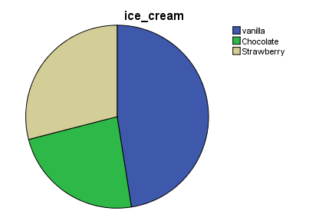

2.2 How many students are Male and Female?
Gender
 |  | Frequency | Percent | Valid Percent
Valid | male | 91 | 45.5 | 45.5
Valid | Female | 109 | 54.5 | 54.5
Valid | Total | 200 | 100.0 | 100.0

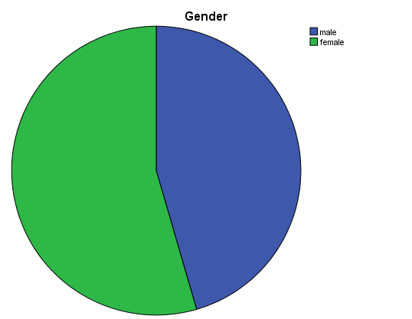
From the above illustrated table, it had been evaluated that there are 200 students and after adopting COUNT IF, the total number of male students is 91 and the total number of female students is 109 respectively.

2.3 What are the Mean and Median of participants who likes chocolate and strawberry flavour ice-cream?
52.5 | Mean
63 | Median of Chocolate
101.5 | Median of Strawberry
From the represented table, the mean of participants who likes chocolate and strawberry flavour ice-cream is 52.5 respectively. In addition to this, the median of students who like chocolate flavour ice cream is 63. Moreover, the median is 101.5 of the students who like strawberry flavour ice cream.
2.4 Using the dataset Ice-cream csv provided in conjunction with SPSS, give specific example of clustering (ex K-Means).
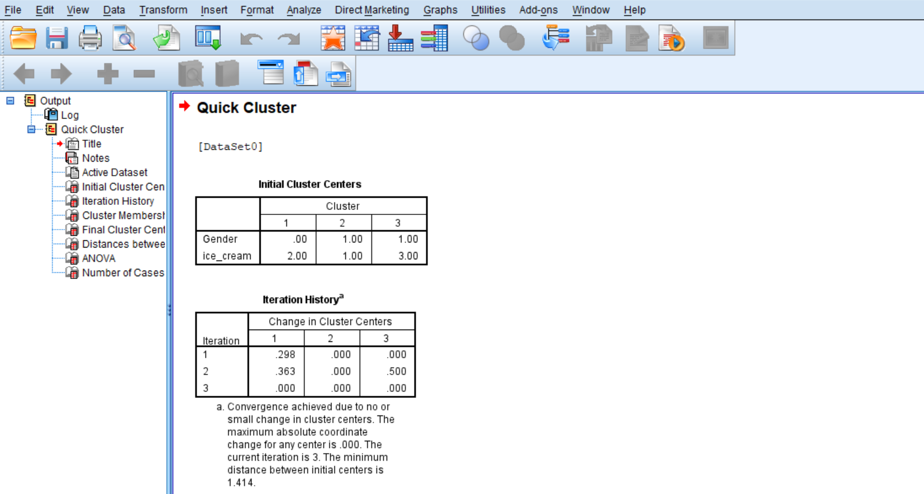

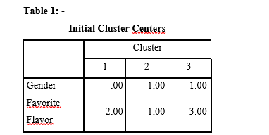
From the above illustrated Initial cluster table, it has been known that there are three cluster whose values are based on 2 variables which is Gender and Favorite Flavour where Vanilla is first cluster, Chocolate is second cluster and Strawberry is third cluster respectively.
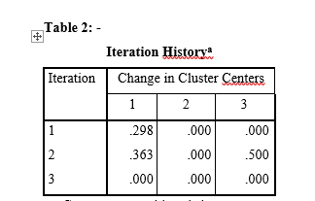
From the table figure of the iterations and the alteration in the cluster centers has been evaluated. In the first cluster a change of .298 has been seen, the second cluster change from .363 to .500 and in the third cluster there is no change.
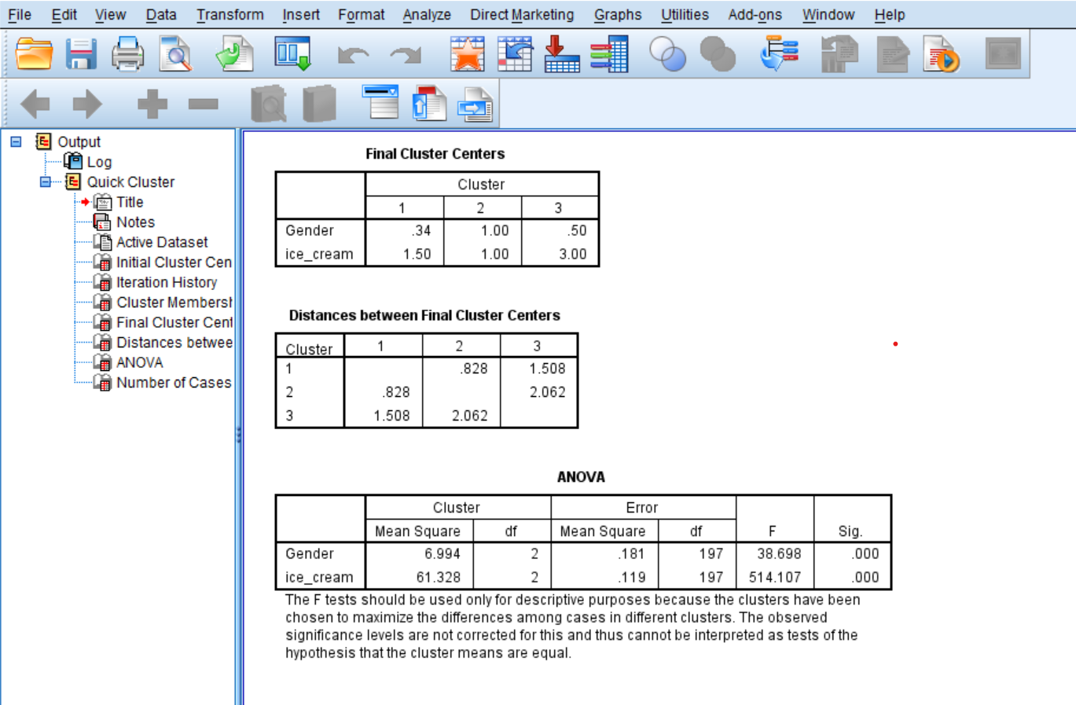

From the above table it has been evaluated that the final cluster in based on two components that is Gender and Favorite Flavor where first cluster is vanilla, second is chocolate and strawberry is third.

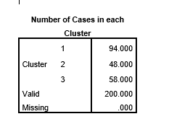

According to the above presented data vanilla flavour maximum influence on the forming of cluster and Chocolate the least.

2.5 Explain the most common data mining and text mining methods that can be used in business with real word examples.

SAS data mining- Statistical Analysis System tool assist in managing and analyzing the data by helping the user in managing, mining and changing different sets of data extracted from different sources. In addition to this, it also provides user with a special graphical user interface. These tools helps the user to make quick decisions. Furthermore, this tool is also utilized in cleaning, removing errors as well as eliminating unwanted and duplicate data from filling null values.
Oracle data mining – This tool is a one of the elements of Oracle Advanced analytics which aids developing and implementing the models (Thakkar, 2020). With the help of this various tasks can be conducted such as classification, detection, targeting, regression, detecting theft, profile segmentation and evaluating the first potency.
Aylien- This is one of the cloud-based tool which adopts machine learning, AI, language processor to assist the process of automation that is generated in human forms and documents. Aylien's text analyses and text mining tools are mostly used by researchers.
Thematic- This is also AI based tool which aid in transforming feedback into understandable and actionable data. Two products of this tool are - Thematic Intelligence and Thematic catalyst. The first assist in highlighting the feedback. It then takes to group of phrases in the category of positive or negative. The second product assist in making dashboards of the extracted information.

2.6 Discuss the advantages and disadvantages of using SPSS and Excel

SPSS
Statistical Package for the Social Sciences is one of the tools which is used by the individual in order to research, analysis the data and information as well as make financial decision. This is the tool introduced by IBM which allows in performing several models. Along with this, this one mining tool which assist in finding data or information (Moriarty, Held and Richardson, 2022). The advantages and disadvantages of the SPSS tool are as follow:
Advantages | Disadvantages
This tool is time saving software as user can perform the task within no time period. | With the help of this tool, user can interpret large sets of data.
AS this tool takes less times, so it results in utilising the resources in most effective and efficient manner. | SPSS fails to give accurate data when the information is incomplete or when there is fault in the data.
At the time of calculation, it gives accuracy. | At the time of complex problem, this tool gives only answer without any justification.
It concentrates on both conceptual as well as technical part in order to analyse the data. | To run the application, individual needs to lots of training session as well as it is quite expensive software.
Compatibility of SPSS is better as it assist in transferring of data from one programme to another. | The feature of Graphs are complex.

Excel
MS- Excel is a software introduced by Microsoft. The main use of this application is to perform data analysis (Li, Liu and Zhang, 2020). IN this software user can perform simple and complex calculation within no time period and the user adopt wide variety of formula to interpret the data.

Advantages and Disadvantages of Excel
Advantages | Disadvantages
Excel gives user wide range of choices. This helps in analysing data in an appropriate manner. | MS EXCEL is not completely reliable .
Through this platform, data can have presented in visualised form. | Sometimes it’s difficult to combine the data in the sheets.
Excel compromise of variety of formulas which helps user to do mathematical calculation easily. | Excel is not compactible while performing various task.
This software requires no hard training as user can use with minimum guidance. | It doesn’t help in quick decision-making process.
The user can access multiple numbers of spreadsheets at once. | The advance pricing rules are challenging to manage.
Conclusion
From the above report it can concluded that with the help of analytical tools information are derived in order make the analysis of people having different preferences. Moreover, various method of data mining and text mining are taken into the consideration which can be used in the business. Along with this, SPSS and Microsoft Excel help the user to analyse the large amount of data in an effective and appropriate manner.

REFERENCES
Books and Journals
Askarpour, V., 2018. Womanity as Represnted on-the-Cylinder Seals An Enactive Semiotics of Female Visualisation in Ancient Susiana (3500-1000 BC). Journal of Archaeological Studies. 10(1). pp.169-187.
Carter, E., Adam, P., Tsakis, D., and et.al., 2020. Enhancing pedestrian mobility in smart cities using big data. Journal of Management Analytics. 7(2). pp.173-188.
Giacobini, P., 2018, May. 3D visualisation of the HPG axis in mice and humans. In Endocrine Abstracts (Vol. 56). Bioscientifica.
Hüsch, M., 2018. Thomas Rahlf: Data Visualisation with R. Statistical Papers. 59(2). pp.847-848.
Katiyar, S., Walia, H. and Kumar, S., 2020, June. Personality Classification System using Data Mining. In 2020 8th International Conference on Reliability, Infocom Technologies and Optimization (Trends and Future Directions)(ICRITO) (pp. 1020-1023). IEEE.
Li, H., Liu, H. and Zhang, Z., 2020. Online persuasion of review emotional intensity: A text mining analysis of restaurant reviews. International Journal of Hospitality Management, 89, p.102558.
Luo, Y., Naidu, R. and Fang, C., 2022. Raman imaging towards in-situ visualisation of perchlorate adsorption. Water Research. p.119510.
Martin, B., Kanokwongnuwut, P., Taylor, D., and et.al., 2020. Successful STR amplification of post-blast IED samples by fluorescent visualisation and direct PCR. Forensic Science International: Genetics. 46. p.102256.
Moriarty, B., Held, B. and Richardson, T., 2022. Microsoft Excel Functions and Formulas: With Excel 2021/Microsoft 365. Stylus Publishing, LLC.
Piryonesi, S.M. and El-Diraby, T.E., 2020. Role of data analytics in infrastructure asset management: Overcoming data size and quality problems. Journal of Transportation Engineering, Part B: Pavements, 146(2), p.04020022.
Thakkar, J.J., 2020. Applications of structural equation modelling with AMOS 21, IBM SPSS. In Structural equation modelling (pp. 35-89). Springer, Singapore.
Traverso, A., 2021. Looking into the world from somewhere else: Mapping and the visualisation of racial violence in Australia. In Mapping Deathscapes (pp. 217-238). Routledge.
Vilela, P.H., Rodrigues, J.J., Solic, P., and et.al., 2019. Performance evaluation of a Fog-assisted IoT solution for e-Health applications. Future Generation Computer Systems. 97. pp.379-386.
Xu, S., Zhang, X., Feng, L. and et.al., 2020. Disruption risks in supply chain management: a literature review based on bibliometric analysis. International Journal of Production Research. 58(11). pp.3508-3526.
Yamada, M., Watanabe, S. and Chibana, T., 2018, April. Point-based, probabilistic analysis and visualisation of flood hazard and risk: a case study in Japan. In EGU General Assembly Conference Abstracts (p. 11360).

