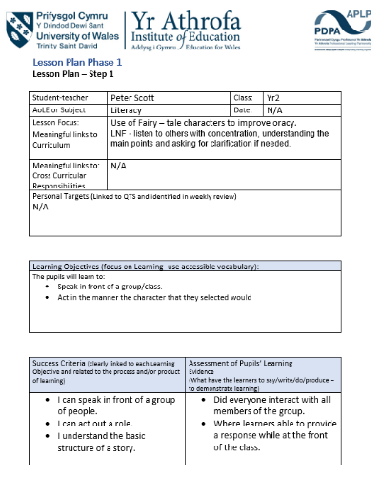
1
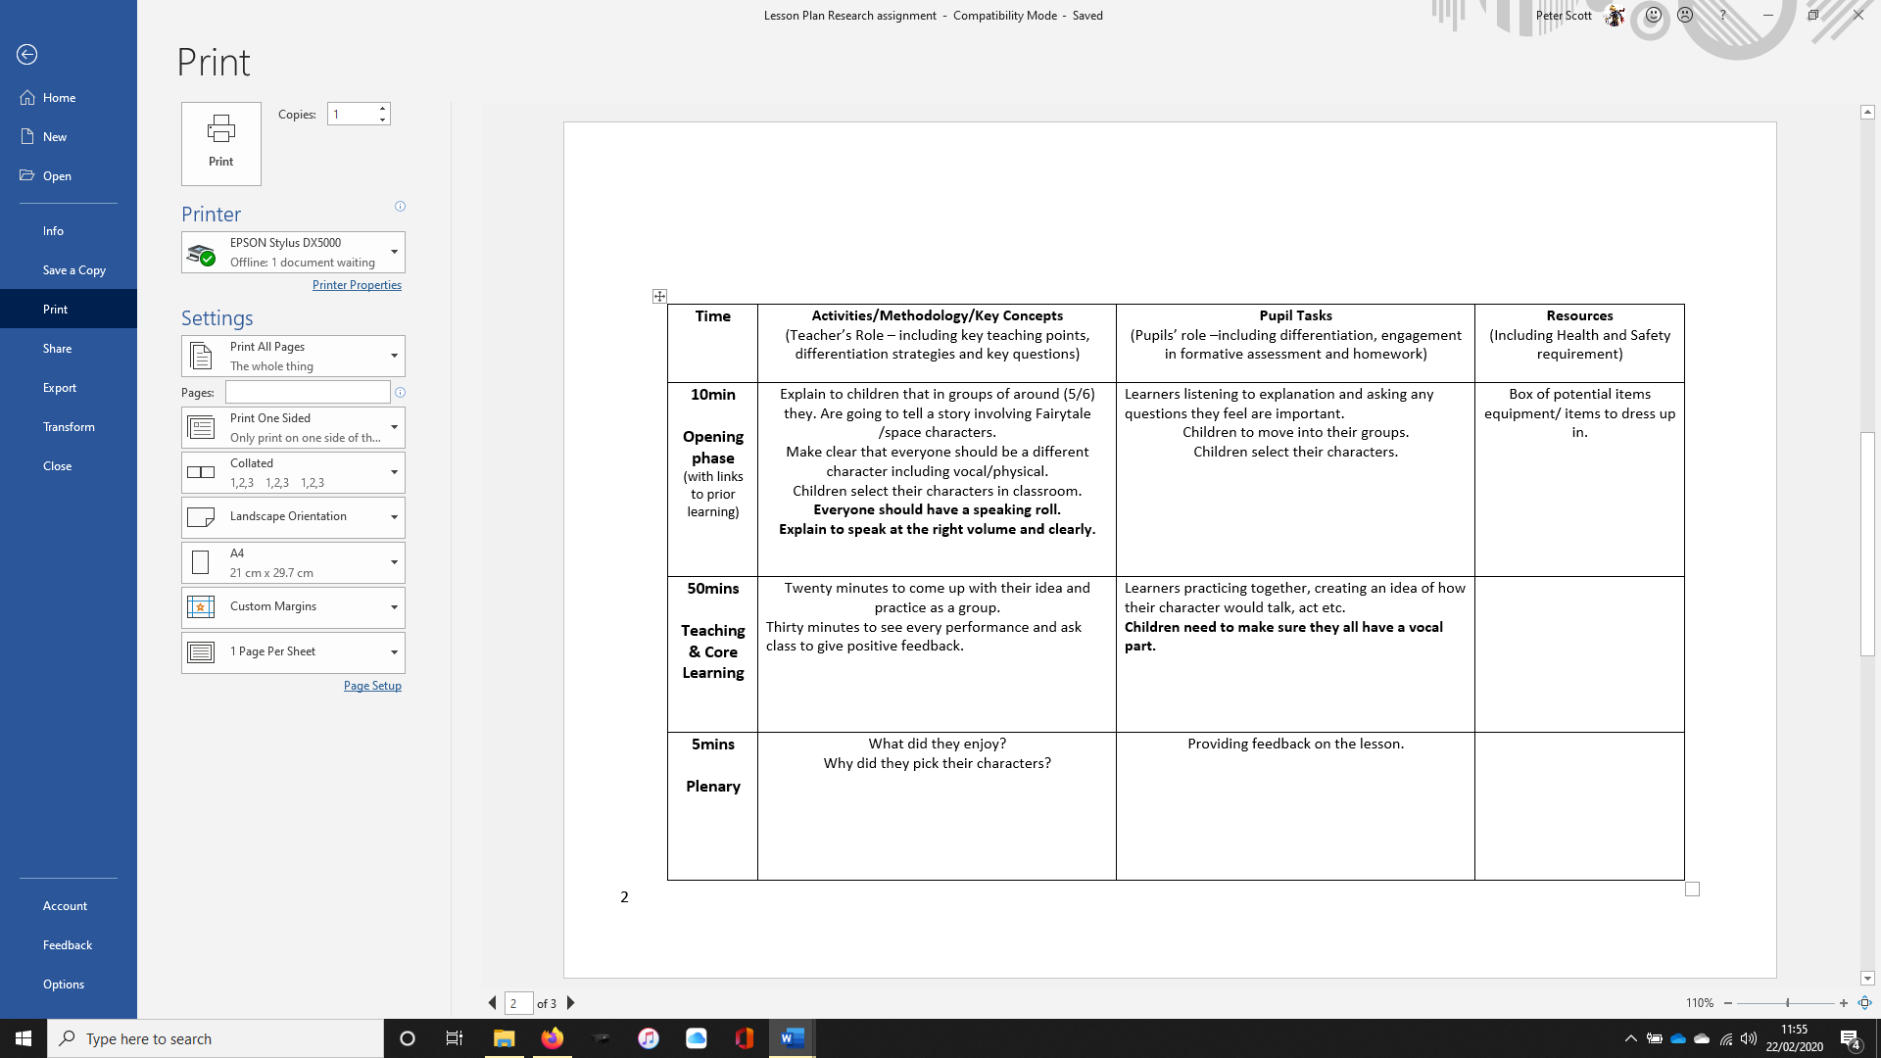
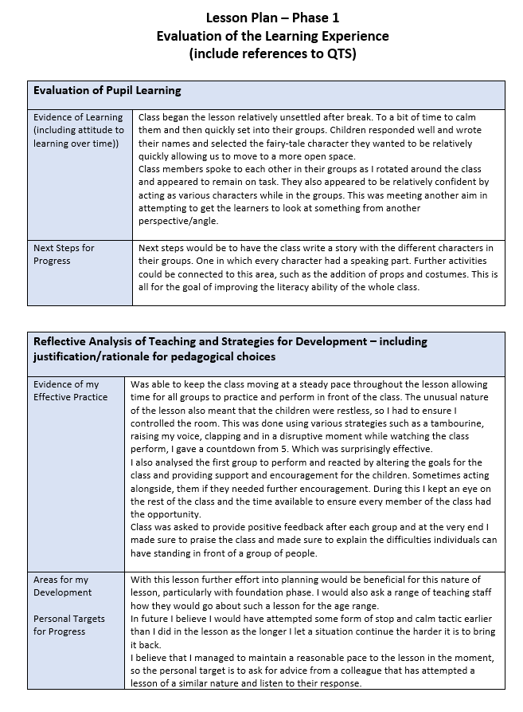
Learner Participation Observation schedule – 2

Name of Observer: Charlotte Winstone

Date of Session observed: 03.02.2020

Subject of session observed: Literacy (Oracy) – Drama

The Learners | X | Y | Z
Has the learner participated prior to the role-play? | Seemed less engaged prior to the lesson, slightly distracted. | Showed great interest in choosing a character and participating in activity. | Seemed enthusiastic when the introduction was taking place.
Is the learner interacting with the teacher? | Little interaction and engagement on receiving report/guidance from the teacher. | Able to independently work with group. | Able to interact and engage in support/guidance from the teacher.
Is the learner interacting with other class members? | Seems quiet within the group work breaking up to role play activity. | Communicating well within group work. Enthusiastic with role and somewhat taking control. | Seems to be interacting with other class members. Talking a lot within group discussion.
Does the learner require encouragement? | Required encouragement from the teacher to help with role and what to say. | No encouragement was needed. Able to work well with group and decide for themselves. | Needed prompting and guidance for the role of the chosen character.
Does the learner appear to be enjoying the role-play? | Seemed to enjoy joining in with the role play and able to confidently speak and help others in the group. | Showed great enthusiasm throughout. Less confident with speaking role, able to dance. | At times there seems some enjoyment very quiet but happy to interact with help from teacher.
Has the use of role-play distracted the learner from the original aim? | Yes, seems distracted from the lesson, wandering around the room at times. | No, this pupil was engaged throughout and concentrated on the creative side of the lesson. | Distracted by the unusual type of lesson. Unable to concentrate on what he was asked to do.
Level of Involvement | 1 / 2 / 3 / 4 / 5 | 1 / 2 / 3 / 4 / 5 | 1 / 2 / 3 / 4 / 5

The Teacher
Did the teacher pitch the language appropriately? | Children were engaged throughout the introduction. The language used was at the right level and appropriate for the lesson.
Speak clearly and concisely? | The tone of voice was clear and concise throughout. Introducing the activity, the level of communication was great and was needed to focus the children.
Keep the learners involved. | Throughout the lesson the teacher wandered around the room making sure all children had a role and a part to play.
Handle questions appropriately. | During the introduction where children were choosing their characters the teacher was able to answer all questions promptly and appropriately.
Secure the pupils attention. | Able to use different approaches to secure the pupils attention. It was nice to see this using setting the scene and able to let the children select their own characters.
Provide adequate support to all learners. | Able to offer children guidance and support throughout the lesson. Gave encouragement to some children who needed the support to join in and act.
Additional Comments:
Throughout the lesson the enthusiasm was brought through by the teacher which made an impact on giving the children the excitement to join in themselves. The layout of the lesson seemed to work well.
Learner Participation Observation schedule - 3

Name of Observer: Peter Scott

Date of Session observed: 03.02.2020

Subject of session observed: Literacy (Oracy) - Drama

The Learners | A | B | C
Has the learner participated prior to the role-play? | Was focused on teacher throughout but limited response. | Partial attention given that steadily grew as the lesson progressed. | Slightly distracted but appears excited for the activity.
Is the learner interacting with the teacher? | Minimal interaction, very quiet and limited response to direct questioning. | Softly spoken, however did respond to direct questioning. Grew in confidence throughout. | Regular interaction and responding well to any questions asked.
Is the learner interacting with other class members? | Interacted with female member of the group. Limited interaction with other members. | Had regular interaction with the different group members. | Good interaction with all members of the group.
Does the learner require encouragement? | Required encouragement to get involved. Did perform actions but limited talking. | Appeared excited to be involved. Didn’t require much encouragement. | No encouragement required, wanted to get involved.
Does the learner appear to be enjoying the role-play? | Appeared to be slightly apprehensive however did perform actions. | Appeared to grow into the activity as time progressed. Enjoyed watching the rest of the class. | Enjoyed the activity throughout their performance. Lost focus when others were up.
Has the use of role-play distracted the learner from the original aim? | Use of actions, acting out the character appeared to give more confidence than having to be vocal. | Was not distracted and appeared to both act and speak at the front of the class. | Role-playing another character appeared to improve focus.
Level of Involvement | 1 / 2 / 3 / 4 / 5 | 1 / 2 / 3 / 4 / 5 | 1 / 2 / 3 / 4 / 5

The Teacher
Did the teacher pitch the language appropriately? | Children understood the instructions and language was appropriate for the class.
Speak clearly and concisely? | Class was given clear instruction throughout and were reminded on occasion to keep their focus.
Keep the learners involved. | Learners focused attention was given during the introduction. Rotated around the groups keeping all the children involved throughout.
Handle questions appropriately. | Provided good support throughout and clear responses to any questions asked during the lesson.
Secure the pupils attention. | Was able to effectively and quickly gain the whole classes attention at all stages of the lesson with minimal effort.
Provide adequate support to all learners. | All groups provided excellent support throughout, both on the carpet and when performing.
Additional Comments:
Good focused work with pupils who appeared to require additional support and encouragement.
Interview Questions - 4

How are you feeling today?
X- Generally feeling happy, but I am a little ill.

Y- Really happy!

Z- Excited

Did something in the lesson occur to make you feel that way?
X- I felt sad because everyone was singing.

Y- I felt excited.

Z- I was a bit happy.

What did you learn in the lesson?
X- I learned about little Red Riding Hood.

Y- How to be a different character.

Z- I liked when (another student) acted as the big bad wolf.

What did you enjoy in the lesson?
X- Felt sad for the different fairy tale characters because I thought the wolf was going to eat them.

Y- I really enjoyed being a unicorn but wanted to be a chipmunk.

Z- I liked when (another student) acted as the big bad wolf.

What did you think of being different characters?
X- I enjoyed being the character but thought the story was sad.

Y- Excited because I could a different fairy tale character.

Z- Kind of and I liked it.

How does it feel to talk while being the character?
X- I was nervous up at the front.

Y- I was excited when I went up because I wanted my turn.

Z- I was a little happy doing it.

Would you like to be a character in future lessons?
X- I found it hard because I couldn’t do the voice.

Y- I liked to be another character and that it was something different.

Z- I found it hard at the front but I was less nervous being another character.
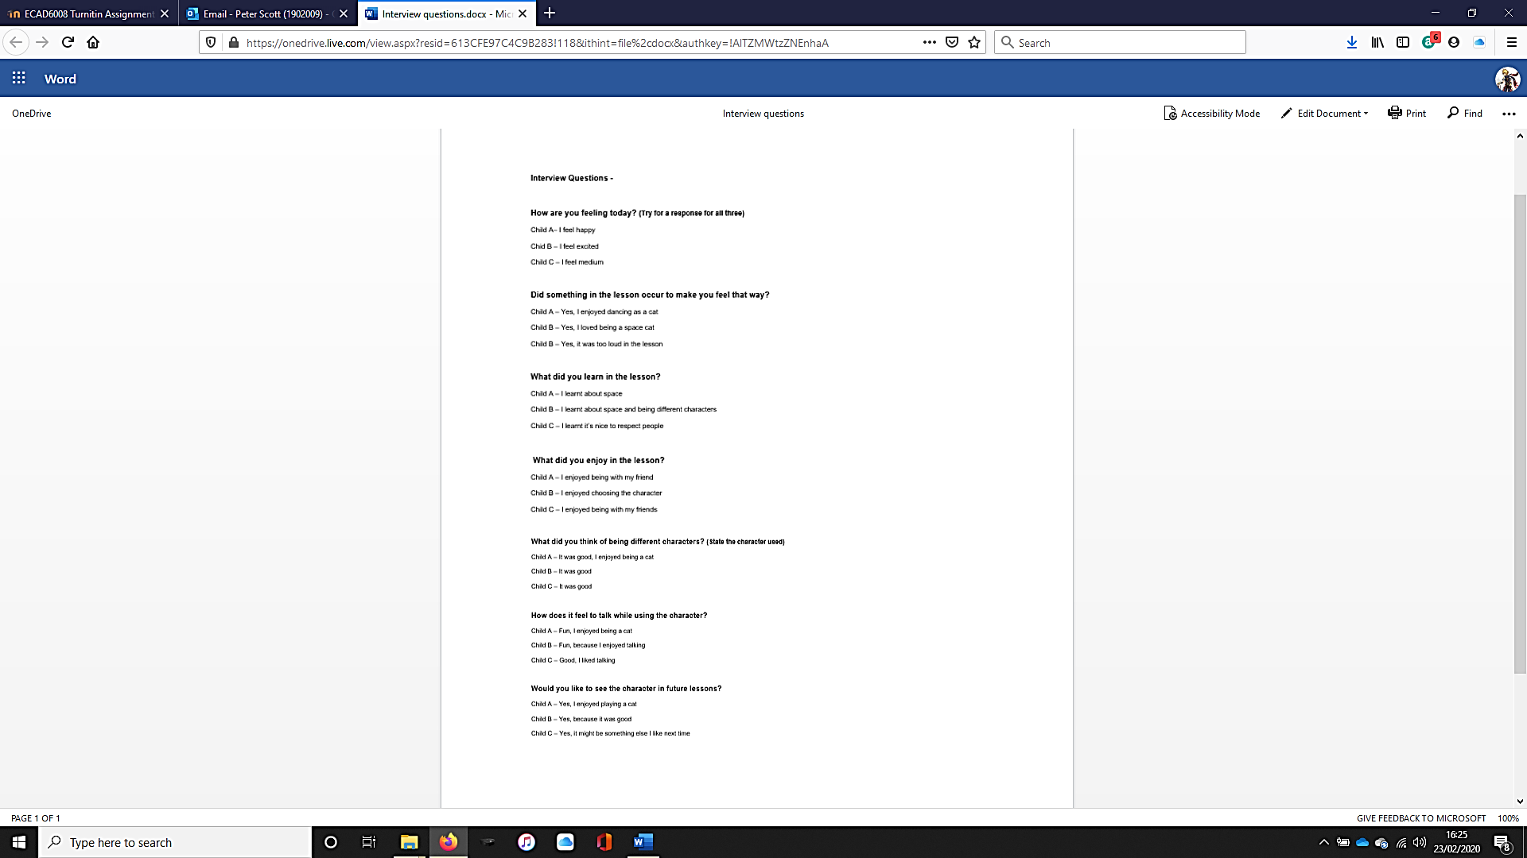
5

Reflection Pro-Forma Gibbs (1988) – 6

Describe what Happened. | Pupils were returning from break. Therefore, excitement was quite high and focus low. I, research partner and teacher/mentor were present with the class. Brief introduction to the activity in their classroom before moving the class to an available open space room. Research partner and teacher mentor did not interact with the children during the lesson. Gave basic introduction then set the children into groups of around 5-6. Children wrote their names and the character they wanted to be onto an A2 page. Children were then brought to the open space and set in their groups to create a narrative for their fairy-tale characters. Task appeared to complex for the children in the time given. Therefore, altered plan to instead have children act as their selected characters. Wanted children to act on the role they selected.
Describe your feelings and emotional response | Was nervous prior to the lesson due to a limited idea of how the learners would respond. Remained focused during the lesson and was fairly pleased with some of the children’s feedback. The children also appeared to genuinely enjoy the activity. During the lesson I was thinking of further methods to involve all the children in the activity. On reflection after the fact I am generally pleased with the children’s responses.
Consider what was good or bad about your response. | A positive was that all children responded in some manner while standing at the front of the class. They also all appeared to enjoy the activity.  I also believe I controlled the class effectively for how restless they were prior to going into an active lesson.  A potential issue is that the level of the task given to the children in the time available could have been more carefully chosen.
How do you make sense of your situation? | I believe things discussed above occurred because of the excitement myself and other members of the class were putting into the activity which appears to have had the effect of calming nerves and encouraging some of the children. It probably also effected the classes enjoyment of the lesson.  To further improve the situation a clearer understanding, of what was required of the learners would have benefited, or, at least a simplified task would have improved the situation. Further study of the literacy level and comprehensive abilities of the class would have helped cater for an improved situation.
What general conclusions can you draw from the event? | In conclusion one of the key factors appears to be the method of interaction with the child. The more animated I was the easier the children were able to fall into character and relax about standing in front of their classmates. On a basic reflection it does appear that having the children speak out as another character has both positive and negative aspects however it is clearly useful for having them think of another perspective.  To make this situation/experience more positive in the future allowing the children more time to plan with additional guided support should increase both the level of oracy being shown but also the confidence of the children. In future this could be done by having a pure planning lesson with support and then in a future lesson giving the children time to practice and perform in front of each other.  I also need to further develop my skills regarding my expressiveness and my ability to encourage and motivate the class.
Based on your reflections what would you do differently in the future. | To get the desired response of improved oracy ability using activities such as role play, the teachers’ response to what is occurring is almost as important as the learners. The more enthusiastic I was during the lesson the more willing the whole class was to get involved particularly children X, Y and Z.

