

Module Name: Managing Enterprise
Module Code: (BMSW4011_SWAN)
Assignment Name:(business plan)
Student Name: Salma Farache
Student Number:2408621
Lecturer: Scott James
Deadline: 03/07/2026

Table of Contents
- Business Plan for SweetBalance 3
Introduction 3
- Business concept and product offer 4
- Business ownership……………………………………………………………………4
- Mission, Aim and SMART Objectives………………………………………………..4
- Unique Selling Proposition (USP)…………………………………………………....4
- SMART Objectives…………………………………………………………………….5
- Location and Operations………………………………………………………………5
- Human Resources……………………………………………………………………..5
- Marketing and Branding………………………………………………………………6
- Market Research………………………………………………………………………6
- Financial Resources and Forecast………………………………………………….7
- SWOT Analysis………………………………………………………………………..8
- Conclusion……………………………………………………………………………..8
- Reference List…………………………………………………………………………9
- Individual Reflection…………………………………………………………………..11
- The appendices……………………………………………………………………..13

- Business Plan for SweetBalance

Word count :1006

Business Name:
SweetBalance
Business Type:
Sole Trader
Location:
Swansea and Online
Owner:
Salma

Introduction
SweetBalance is a dessert business based in Swansea with an online presence across the UK (British Nutrition Foundation, 2023). It was inspired by my volunteer experience with children and elderly people who have diabetes. They often expressed frustration at not being able to enjoy desserts due to dietary restrictions. This led me to create inclusive, nutritious desserts using natural sweeteners like dates and figs (Jones et al., 2019). SweetBalance aims to bring joy and healthier options to people who want cultural flavours without refined sugar. This strategic location allows access to both local communities and online shoppers across the UK. The idea was born from direct conversations with people who wanted to enjoy traditional sweets without compromising their health, especially diabetics and the elderly.

- Business Concept and Product Offer
The business will offer handmade, low-sugar chocolate and Lebanese sweets such as Maamoul and Baklava. All products will be crafted in small batches using natural ingredients (Barringer and Ireland, 2022). My target market includes health-conscious individuals, women, and people with diabetes. In the future, I will launch a sub-brand called Beirut Chocolate, inspired by Baklava and packaged as a luxury product (Baines, Fill and Page, 2019).

- Business Ownership
SweetBalance will operate as a sole trader business. This structure is simple to register, low-cost, and allows full control (Whittington et al., 2023). While it involves personal liability, it is suitable for a start-up with minimal risk and overhead (Marriott and Williams, 2018).
"Please refer to Appendix 1 for an image of the business cards."

- Mission, Aim and SMART Objectives
My mission is to offer inclusive desserts that celebrate culture and health. The first-year aim is to build a customer base in Swansea and online (Marriott and Williams, 2018).

- Unique Selling Proposition (USP)
SweetBalance’s USP is the combination of Lebanese flavours and health-focused ingredients. Desserts are handmade using natural sweeteners, offering an authentic yet inclusive experience (Kotler and Armstrong, 2021). The brand fills a gap in the UK market by offering desserts that are both indulgent and suitable for modern dietary needs. Its focus on natural sweeteners like dates and figs supports a healthy lifestyle, appealing to consumers who seek authenticity and balance in their diet.

- SMART Objectives
• Launch 10 products by October 2025
• Reach 100 regular customers by December 2025
• Achieve £500 monthly profit by April 2026
• Gain 1,000 social media followers by June 2026 (Statista, 2024)

- Location and Operations
I will begin from my home kitchen in Swansea to reduce costs and maintain quality. Sales will happen online via a dedicated website and promoted through social media (Food Standards Agency, 2023). In future, I plan to partner with local cafés and attend farmers' markets.

- Human Resources
- Initially, I will manage all areas of the business: baking, packaging, customer service, and marketing. As orders increase, I will hire part-time help locally to support production. In year two, I plan to recruit a marketing assistant to help with social media promotion and a delivery support assistant to manage local orders and logistics (Young and Young, 2018).To help visualise the structure, the organisation chart below shows the expected team setup by the second year of operation:
Salma Farache
(Owner/Manager)
|
----------------------------------------
| |
Kitchen Assistant Marketing Assistant
(Part-time, Year 1) (Part-time, Year 2)
|
Delivery Support
(Part-time, Year 2)

- Marketing and Branding
Marketing will focus on Instagram, Facebook, and TikTok, where I’ll share visuals, videos, and customer feedback (Tuten and Solomon, 2020). I’ll use Canva to design promotional content and build brand recognition (Chaffey and Ellis-Chadwick, 2019).
"Please refer to Appendix 2 for an image of the Instagram ad."

Packaging will use traditional patterns and eco-friendly materials. Discounts will be offered to new customers who follow and share the page. These platforms offer excellent engagement opportunities with visuals, stories, and reels that resonate with food lovers (Tuten and Solomon, 2020). Marketing efforts will also include email newsletters and customer loyalty rewards. This integrated digital strategy aims to build community, increase visibility, and drive online sales.
"Please refer to Appendix 3 for an image of the Flyer ad."

- Market Research
I conducted a questionnaire with 30+ responses. 41% preferred chocolate (figure 1), 90% were open to handmade products (figure 2), and 71% wanted low-sugar options. 58% supported natural sweeteners (figure 4), and most preferred online or café-based shopping (figure 5) (Statista, 2024). Secondary research supports these trends, showing rising demand for healthy, inclusive foods (British Nutrition Foundation, 2023; Food Standards Agency, 2023).
"Please refer to Appendix 4-8 for images of the questionnaire responses."

- Financial Resources and Forecast
The business will start with £1,000 personal savings and a £500 bank loan. I’ll spend £200 on ingredients and packaging, £220 on equipment, £13 on branding and website, £40 on marketing, and keep £240 for emergencies. A simple Excel forecast shows I can break even in 8 months if I sell 20 boxes/month (Alvarez and Alvarez, 2017). Profits will be reinvested into packaging, upgrades, and expanding Beirut Chocolate. This careful budgeting allows the business to manage early costs while staying agile in a competitive market. I also plan to use online accounting tools like QuickBooks to keep financial records organised (Alvarez and Alvarez, 2017).
"Please refer to Appendix 9 for an image of the Excel financial table."

- SWOT Analysis
Strengths: culturally rich, health-conscious recipes with handmade quality (Kotler and Armstrong, 2021).
Weakness: Limited production capacity as a sole trader, which may affect the ability to meet demand during peak periods.
Opportunities: Rising demand for diabetic-friendly and culturally diverse desserts (Food Standards Agency, 2023). This growing market opens the door for innovation in healthy treats.
Threats: Established dessert brands and customer reluctance to try new versions of traditional sweets (Jones et al., 2019).
Actions to overcome weakness:
1. Use pre-orders to manage volume and reduce waste.
2. Apply for start-up grants to invest in better equipment and workspace.
3. Partner with cafés for small-batch supply deals that increase visibility.
4. Develop a detailed scheduling system to balance production and delivery efficiently.
5. Seek mentorship from other small food business owners to learn scaling strategies and avoid common pitfalls.

Conclusion
SweetBalance is more than just a dessert business, it’s a heartfelt mission born from compassion and culture. This journey began from listening to people who felt excluded from life’s sweet moments due to dietary restrictions. By combining traditional recipes with health-conscious innovation, SweetBalance gives people the chance to enjoy what they love without guilt or worry. This is a brand built not only on ingredients and profit, but on kindness, inclusion, and purpose. With passion and continuous learning, I believe SweetBalance will touch lives and grow into something truly special.
Reference List:
Alvarez, C. and Alvarez, A. (2017) Business Plans That Work. 3rd edn. London: McGraw-Hill.
Baines, P., Fill, C. and Page, K. (2019) Essentials of Marketing. 7th edn. Oxford: Oxford University Press.
Barringer, B.R. and Ireland, R.D. (2022) Entrepreneurship: Successfully Launching New Ventures. 7th edn. Harlow: Pearson Education.
British Nutrition Foundation (2023) Consumer attitudes to healthy eating. Available at: https://www.nutrition.org.uk/ (Accessed: 14 June 2025).
Chaffey, D. and Ellis-Chadwick, F. (2019) Digital Marketing. 7th edn. Harlow: Pearson.
Fill, C. and Turnbull, S. (2019) Marketing Communications: Discovery, Creation and Conversations. 8th edn. Harlow: Pearson.
Food Standards Agency (2023) Eating Well: UK food and health survey. Available at: https://www.food.gov.uk/ (Accessed: 10 June 2025).
Jones, P., Rowley, J., Kupiec-Teahan, B. and Lenihan, H. (2019) ‘Digital marketing in micro-businesses: From push to pull marketing’, Journal of Small Business and Enterprise Development, 26(3), pp. 310–326.
Kotler, P. and Armstrong, G. (2021) Principles of Marketing. 18th edn. Harlow: Pearson Education.
Marriott, S. and Williams, M. (2018) The Financial Times Guide to Business Start Up 2018–2019. Harlow: Pearson Education.
Skybus Airlines (2017) Marketing and Branding for Startups. London: Skybus Publishing.
Statista (2024) Online food delivery & dessert consumption in the UK. Available at: https://www.statista.com/ (Accessed: 5 June 2025).
Tuten, T.L. and Solomon, M.R. (2020) Social Media Marketing. 4th edn. London: Sage.
Whittington, R., Regnér, P., Angwin, D., Johnson, G. and Scholes, K. (2023) Exploring Strategy: Text and Cases. 13th edn. Harlow: Pearson.
SweetBalance (2025) Financial Table for SweetBalance. Microsoft Excel Spreadsheet. Unpublished internal document.
SweetBalance (2025) Promotional Image for SweetBalance. Created using Canva. Unpublished internal document.
Young, M. and Young, H. (2018) Starting a Business: A Step-by-Step Guide. London: Kogan Page.

- Individual Reflection:
Word count :523
Working on my business plan for SweetBalance has been an eye-opening journey that helped me discover my potential as a future entrepreneur. This project allowed me to apply everything I have learned so far about planning, research, marketing, and budgeting. It gave me the chance to express a business idea that came from personal experience, and it showed me how much effort is needed to build something from the ground up.
One of the most important things I learned was how to develop a full business plan by thinking about real customer needs. I used both primary and secondary research to better understand the market. From my questionnaire results, I was able to shape my product ideas, improve my pricing strategy, and decide where to sell. I never realised before how powerful research can be in guiding a business decision. I also enjoyed learning how to turn a simple idea into a structured plan that includes financial forecasts, marketing strategies, and growth plans.
Another skill I developed is understanding how to present my brand in a way that connects with people. I designed my logo, thought carefully about the business name, and made decisions about colours and packaging to reflect my culture and values. It was exciting to see how branding can influence how people feel about a product. Before this project, I didn’t fully understand the emotional side of branding, but now I know how important it is.
Time management was also something I improved. I had to plan each section of the business plan carefully to stay on track. Some tasks, like the financial forecast and the SWOT analysis, were more challenging than I expected. I had to stay focused and ask for help when I needed it. By sticking to a schedule and working step by step, I managed to complete the project on time and to a standard I’m proud of.
One trait I realised I need to develop more is confidence when taking business risks. I often hesitate when trying something new, especially when there is a chance of failure. However, I’ve learned that risk is a normal part of starting a business. Not everything can be perfect from the beginning. What matters most is being willing to try, learn, and improve. I want to work on this by testing small ideas, getting feedback, and not being afraid to make changes.
If I were an angel investor, I would absolutely invest in SweetBalance. It’s not just a business idea; it’s something that came from my heart. The idea was inspired by people I supported through volunteering, and it has a clear purpose: to help others enjoy desserts that are healthier, handmade, and culturally meaningful. I believe there’s a real gap in the market for this, and I am committed to doing the work to make it succeed.
SweetBalance began as a response to a need, but it grew into a reflection of my passion, identity, and belief in inclusivity. This journey has not only taught me about business, it is helped me believe in myself. I now feel confident, motivated, and ready to turn this dream into something real.

- The appendices

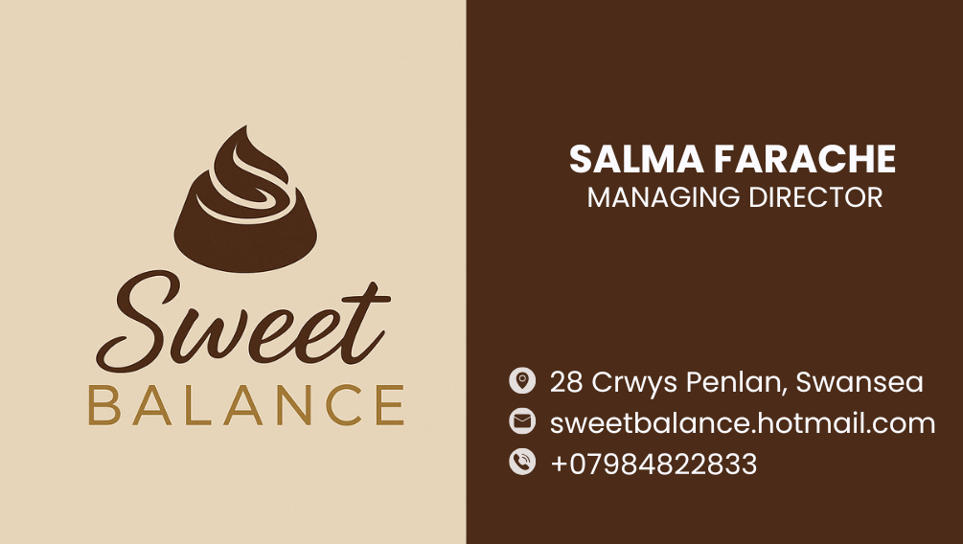
Appendix 1 (Canva,2025)

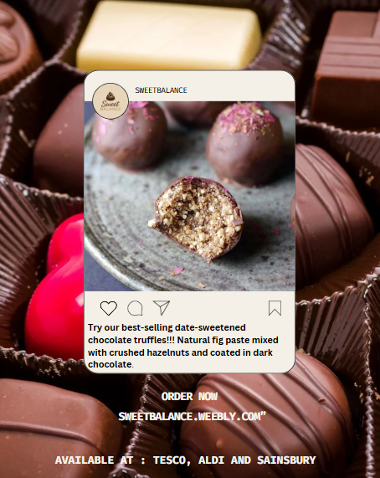
Appendix 2 (Canva,2025)
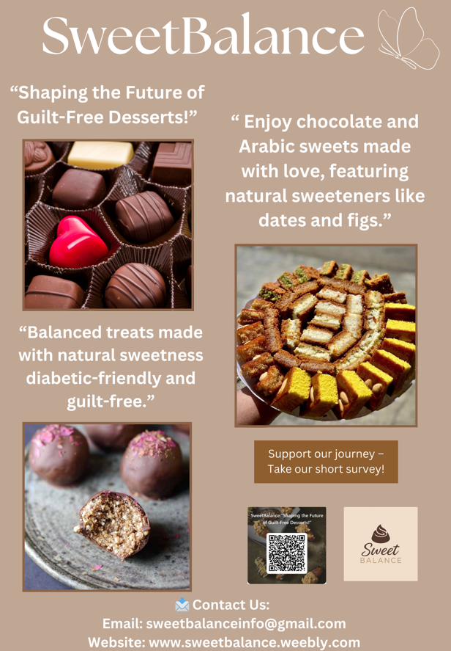
Appendix 3 (Canva,2025)

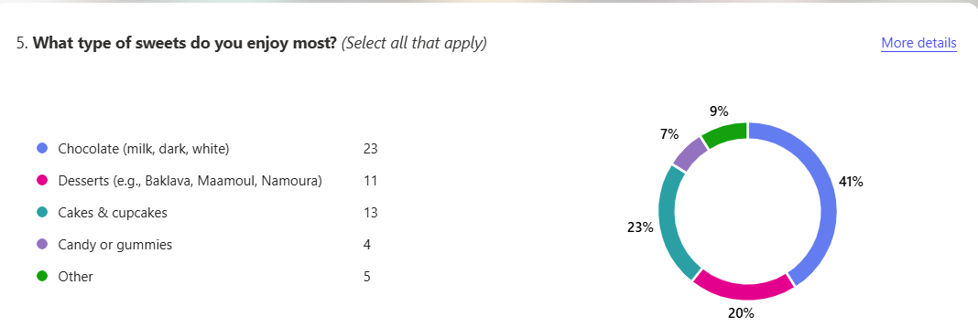
Appendix 4 (Microsoft forms,2025)
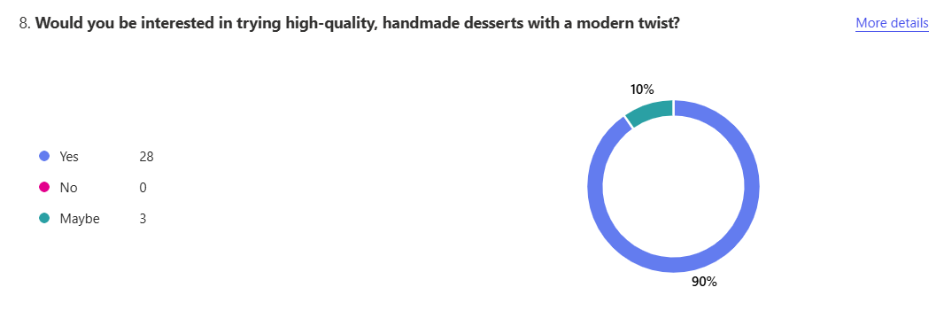
Appendix 5 (Microsoft forms,2025)

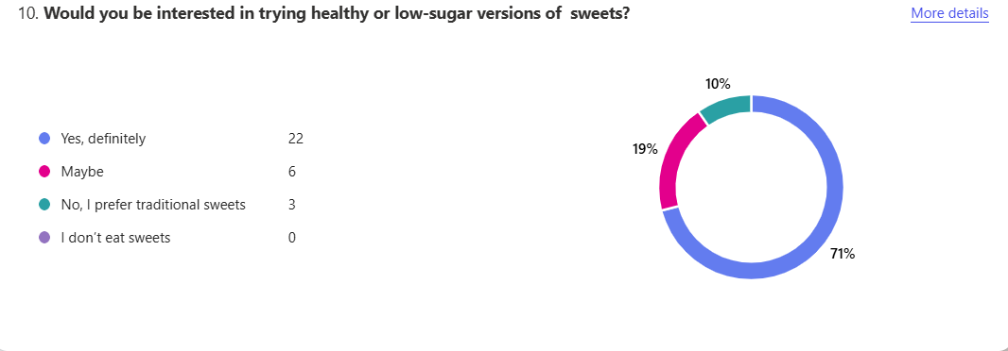
Appendix 6 (Microsoft forms,2025)

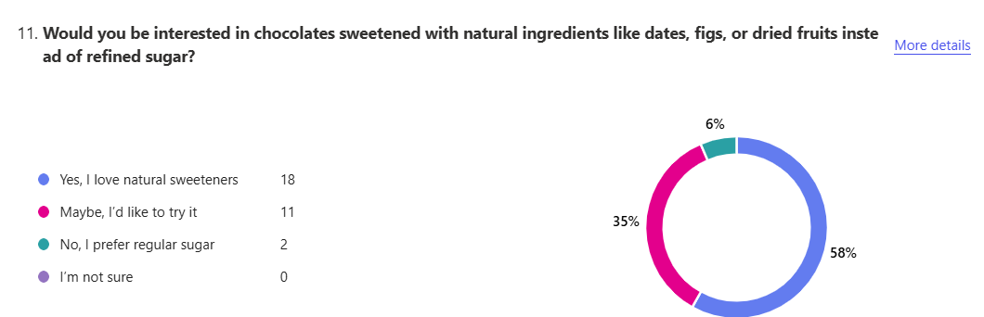
Appendix 7 (Microsoft forms,2025)
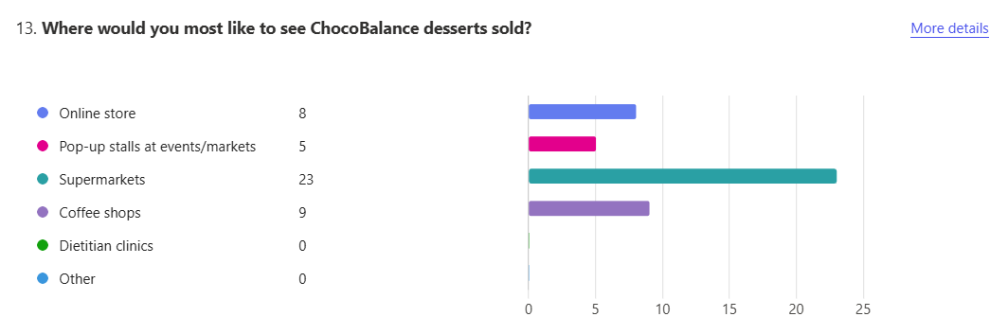
Appendix 8 (Microsoft forms,2025)
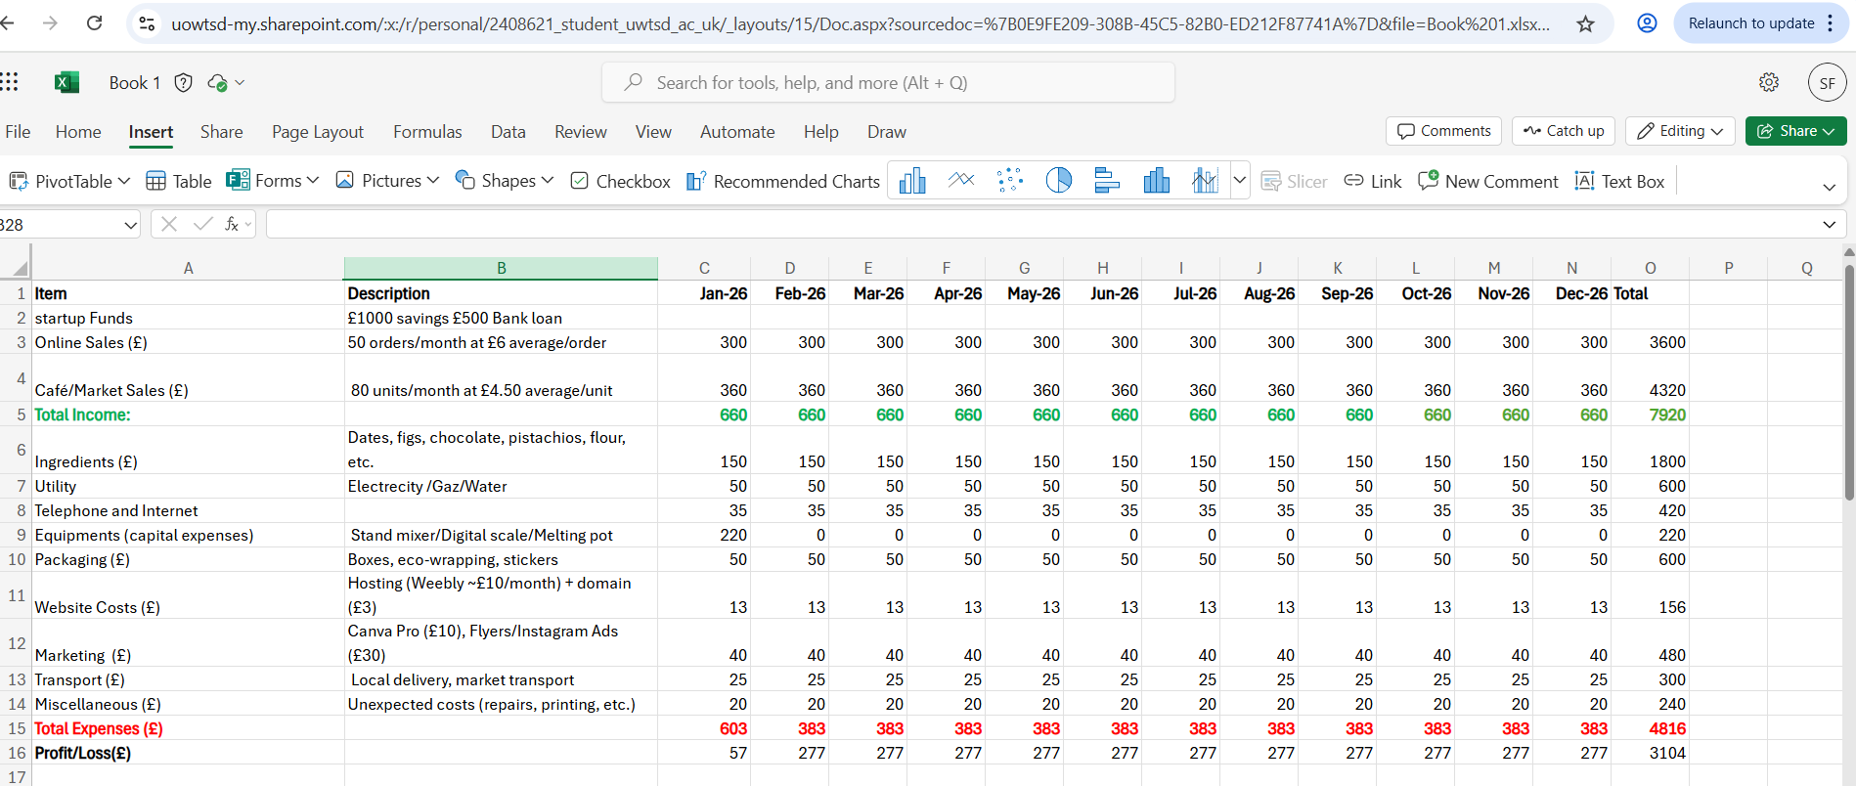
Appendix 9 (Microsoft Excel,2025)

