Assessment 1: Individual Blog

Student name : Stanislav Dragov
Student ID: 1919084

Tesco PLC and its new project
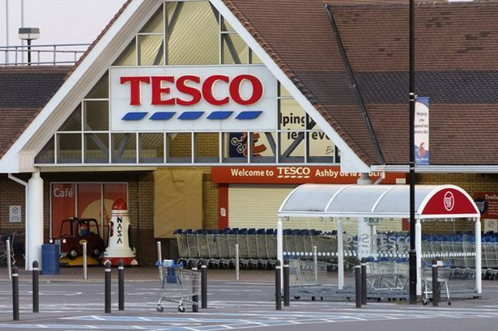
In 1919, Jack Cohen was established Tesco by selling different daily commodities or groceries from a small stall located in the East end of London and he started it by selling tea from a supplier, named T.E Stockwell and from where the first three letters of TES had been taken and CO had been taken as a symbol of cooperation (Case Study: TESCO PLC: Reporting Corporate Governance Matters in UK Published Accounts, 2017). From the beginning of Tesco, Jack bought a few stores but after 1950, the number of stores dramatically increased by the number 800 and over. Nowadays Tesco has been taken a new project named “Your smile is our satisfaction” and in this project, their main goal is to serve better quality of products to right people to ensure the ultimate success in the competitive market with huge profitability.
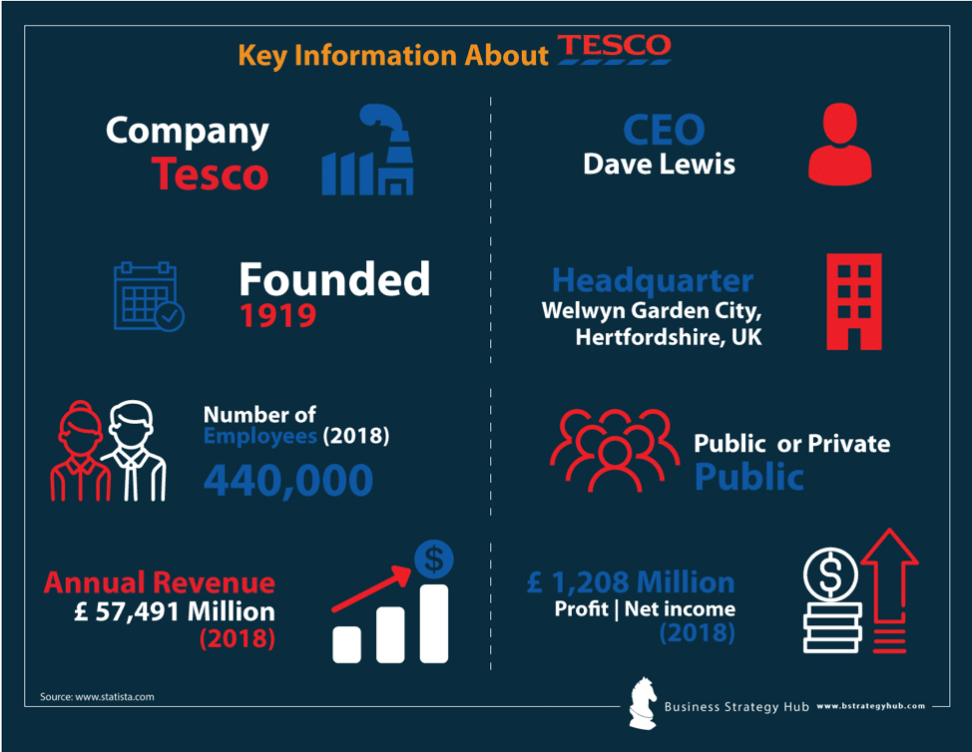
The main objective of a firm behind their success is ensuring product’s quality, price, best distribution channel and it is the key objective to generate the profits and achieve the goals of a firm by spreading awareness and securing the funds. Some internal and external factors which influence the firm and its operations and profitability are considered as the firm’s environment of that firm but the firm can take the internal factors under its control and it has no control over its external factors but Tesco is much more successful to control all its internal and external factors (Greif, 2018). The marketing policy of a firm maintains some specific steps to satisfy the customers, like- understanding the needs of a customer, developing strategy, making a decision, executing a plan based on decisions, and delivering the results (Holman and DeLozier, 2019). So, Tesco PLC focuses on customer satisfaction to reach their valuable clients and achieve great success by bringing a smile to their face.

Blog-01

Product: Highest satisfaction with the quality products
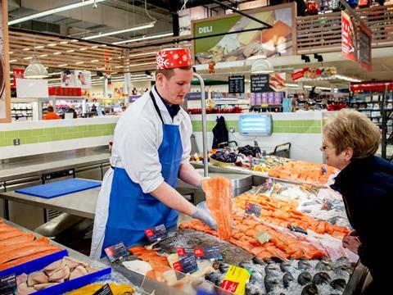
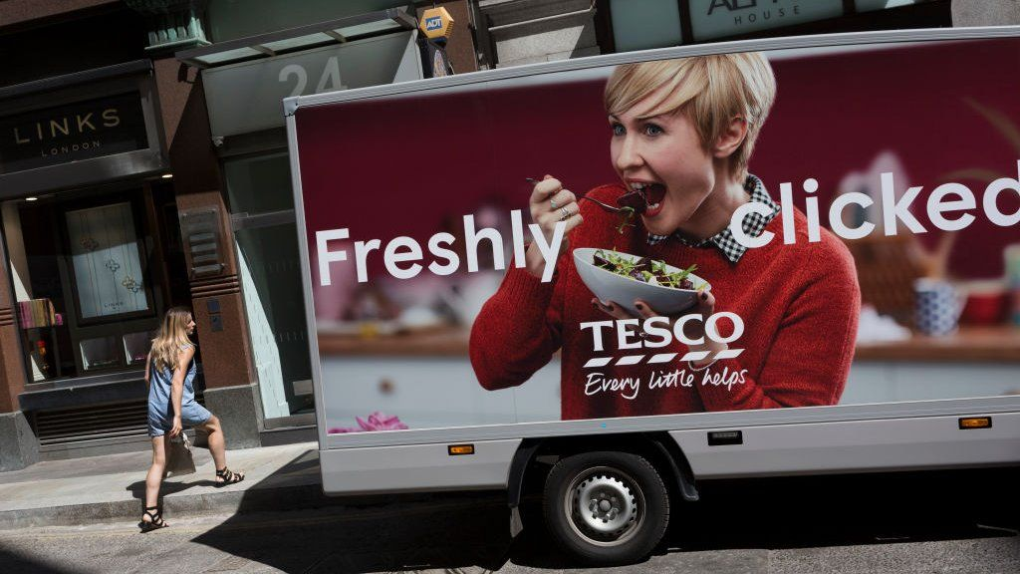
The best product is contemplated as one of the core elements of Tesco which allude to offering to individuals or groups of individuals as par their demands and can achieve a bigger satisfaction. (Sriram, Chintagunta, and Neelamegham, 2015). For example- if a company wants to take physical goods like- cars as their business products it should consider upper-class people as its target market. But if the company chooses the sybaritic products for the lower class people, this illogical act will take the business into huge losses because of not choosing the perfect product for the perfect audience. So, before corresponding the products, Tesco must identify the customer’s demand and wants to launch the desire products as per their satisfaction and we have been taken grocery products so that we can target every level of people in their daily and need basis. Three steps related to products are considered by Tesco - the development of the product, packaging, and branding.
To cope with the expanded changing trend Tesco is developing their products from time to time to compete with the competitors and to sustain in this competitive business world with great customer satisfaction. A well-wrapped product is much more attractive to customers not only for the smart looking but also for its ensuring good quality which is offered by Tesco and our main promo is “We will ensure the best product and our product’s quality never goes out of date”.

Blog 02

Price: The ultimate cost to satisfy customer’s demand
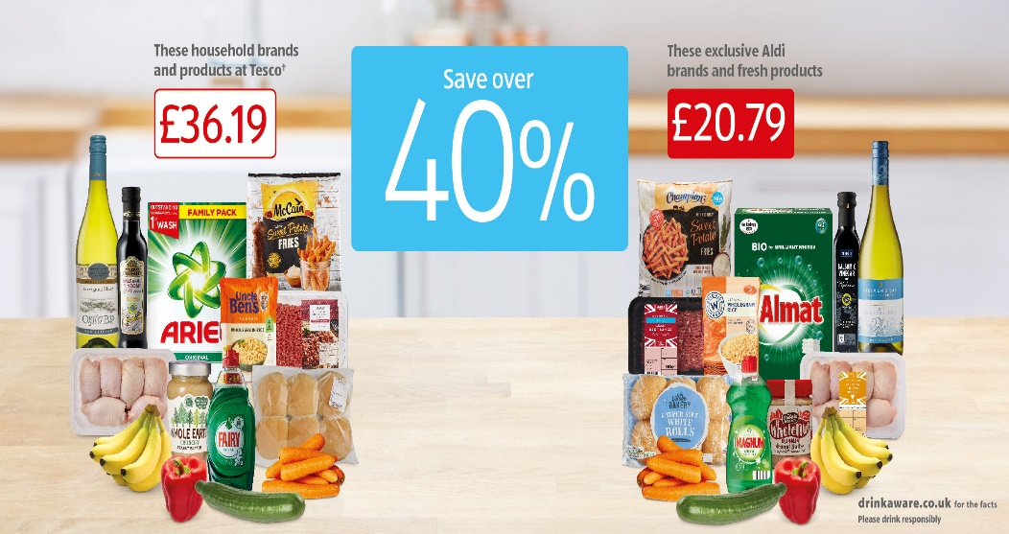
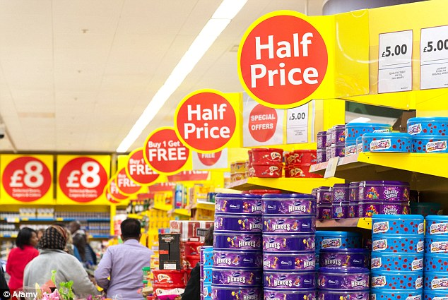
The second important objective of us is to give heed to the price level and most of the companies determine their price by appraising the quality of products and the performance level (Kolberg, 2016). Smart customers can judge the quality level of the products by their price range and the price level gleams how the market gives value to the product’s quality. For example- UK is the most developed countries around the world for manufacturing automobile and among top 10 automobile company, Mercedes Benz is considered as the best quality automobile company for their amazing quality and this brand not only ensure the best quality but also charges the highest price (Atkinson, Hamburg and Ittner, 2017). But Tesco PLC offers the best quality products for less pricing strategy to their clients to achieve customer satisfaction and to lead the market. And the CEO of Tesco told that “If you come to our door, we will satisfy your need with the best quality at a lower price” (Stone, 2015).

Blog 03

Place: Linking with the availability of products
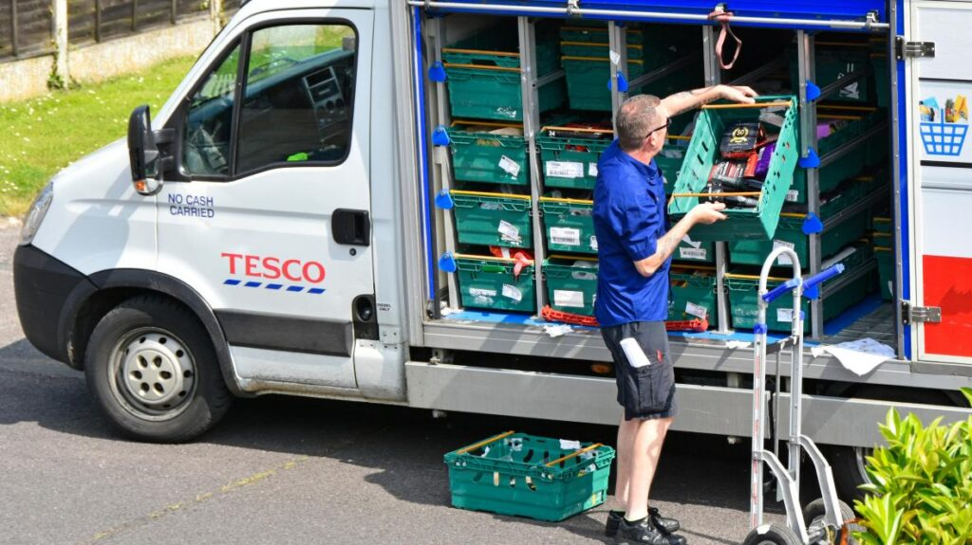
The place is another core element by which a product is made obtainable to the target market and this element is commonly used as the term distribution. A place can be referred to as a marketing channel because it moves the product manufacturer to customers (Baines, Fill, and Page, 2015). For example- the food products have been passed four stages to reach the ultimate customers and the stages are- processing stage, warehouses, wholesalers, and retail sellers or supermarkets (Bucklin, 2017). By exercising this channel a food manufacturer anticipates its goods accessible to the target audiences and make ensure that the product quality must be well until it reaches customers. But we manufacture our own products by our producers and send all the products to every branch of Tesco without any extra intermediaries so that we can ensure better product quality (Wilkinson, 2018).

Blog 04

Promotion: A strong method of communication
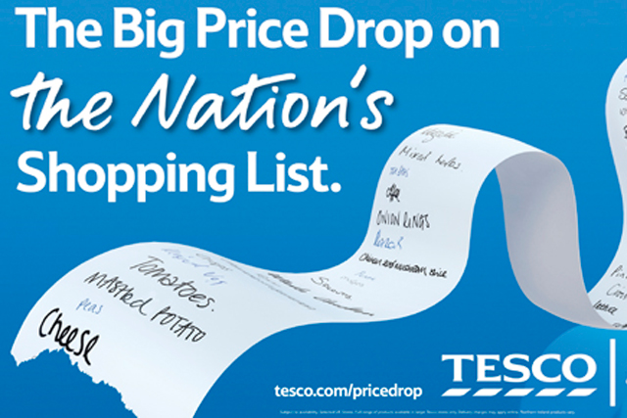
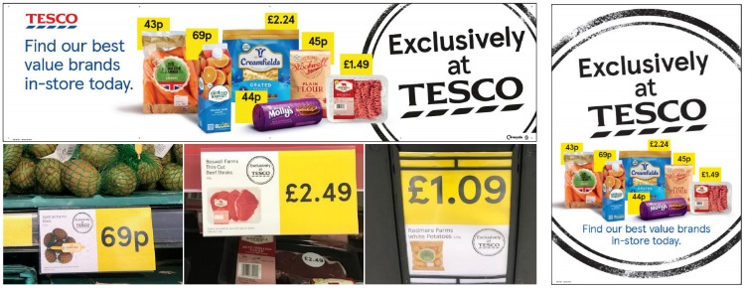
For reaching the information about products to customers Tesco communicates its valuable clients through some methods and we can refer to it as promotional activities (Clow and Baack, 2019). For increasing sales, Tesco promotes its products through advertisement, public relations, or sales promotion. The advertisement refers to non-personal communication for promoting products, services by a firm, or through their sponsors. We do advertise our brands' various ways, like- newspaper, television, radio, billboard, magazines, or through internet sections like social media, website, or personal email. Sales promotion is taken by Tesco for attracting the customers who are searching for the best quality at a lower price, and this type of promotional activity shows the uniqueness of our products to the people who are searching for the best quality (Barnes, 2020). Public relations mode is used for taking opinions from potential customers to achieve the company’s goal and increase the product’s saleability and we eagerly give value to our regular customers.

Blog 05

Plan implementation and periodic evaluation

A firm or company may be committed to different agencies or groups of agencies to promote their business and products to increase profitability and it must be payment based. But often there is a lack of coordination of work between promotion and marketing mix. For example- if a company wants to integrate its marketing elements, it should efficiently utilize its resources. A firm may be adopted different strategy to cope with changing trend but if a strategy is fitted today may not be fitted in near future and that’s the reason why Tesco evaluates their all program periodically for achieving its goal (Evaluate Marketing Strategies of TESCO, 2020).

Blog 06

Tesco PLC and its marketing Control

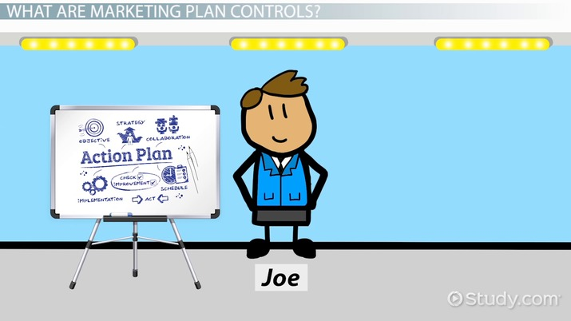
Marketing control indicates the process which monitors the whole planning relating to the business operations of the specific firm. Control includes some processes and it is also involved in setting standards and if the plan is going against the plan the marketing manager can take necessary correction steps. Four types of marketing control have been established by Tesco PLC such as - profitability control, strategic control, annual control, and efficiency control (Jaworski, 2017). Efficiency and profitability control accommodates the company to pay close heed to its profits, cost, sale, etc. because they are relative to the company’s growth. Efficiency control involves in company’s analysis at the micro-level including sales, promotional activities, marketing mix, firm’s marketing process, etc. So Tesco is focused on this efficiency and profitability control so that they can manage their marketing most productively and effectively. Annual control is taken by Tesco based on the monthly or quarterly monitoring system and this type of control focused on sales analysis, analysis of market share, sales to expense analysis. Strategic control is used to evaluate a company’s whole activities or programs in a long term perspective. To strengthen and maximize the company’s market opportunities, Tesco involves itself in this strategic control.

Conclusion
Our Product’s quality, price of the product, easy distribution, and availability of the products ensure our brand value and also enhance the revenues which encourage us to enhance our investment (Harvey, Lusch, and Cavarkapa, 2015). So, Tesco is taken all its valuable decisions based on the satisfaction level of the customers. Among all elements of the marketing mix, product’s price and quality are much more important because it reflects the company’s budget as well as customer satisfaction level. And besides this, Tesco ensures the product’s placement to reach the products to the hand of the customers as early as possible.

References
Atkinson, J., Hamburg, J., and Ittner, C., 2017. Linking Quality To Profits. Singapore:
Toppan. Baines, P., Fill, C., and Page, K., 2015. Essentials Of Marketing. Oxford: Oxford
University Press.
Bizfluent. 2020. Evaluate Marketing Strategies of Tesco. [online]
Available at:
<https://bizfluent.com/how-7608270-evaluate-marketing-strategies.html> [Accessed 17
November 2020].
Bucklin, L., 2017. A Theory of Distribution Channel Structure.
Clow, K., and Baack, D., 2019. Integrated Advertising, Promotion, And Marketing
Communications of Tesco
Greif, E., 2018. Book Review: Marketing Environment: Modern Marketing
Thought. Journal of Marketing, 29(1), pp.113-113.
Harvey, M., Lusch, R., and Cavarkapa, B., 2015. A Marketing Mix for the 21st
Century. Journal of Marketing Theory and Practice, 4(4), pp.1-15.
Holman, R., and DeLozier, M., 2019. The Marketing Communications Process. Journal of
Marketing Research, 13(3), p.319.
Jaworski, B., 2017. Toward a Theory of Marketing Control: Environmental Context, Control
Types, and Consequences. Journal of Marketing, 52(3), p.23.
Sriram, S., Chintagunta, P., and Neelamegham, R., 2015. Effects of Brand Preference, Product
Attributes, and Marketing Mix Variables in Technology Product Markets. Marketing Science,
25(5), pp.440-456.
Barnes, R., 2020. The great Tesco beauty gamble (the Tesco supermarket chains marketing
strategy for breaking into the UK beauty services market). Strategic Direction, 27(7).
Corporate Governance: An International Review, 2017. Case Study: TESCO PLC: Reporting
Corporate Governance Matters in UK Published Accounts. 3(2), pp.100-101.
Stone, M., 2015. Scoring Points: How Tesco is Winning Customer Loyalty. Journal of
Database Marketing & Customer Strategy Management, 11(2), pp.185-187.
Wilkinson, M., 2018. The Tesco Roundabout. Books Ireland, (236), p.373.

