Dissertation Proposal
Kelsee Gwyther
Student Number: 1702748
Course Title: BA Photography in The Arts
Word Count: 2643
Tutor: Paul Duerinckx

Throughout my life, I’ve taken the photograph for granted, that everything was exactly as I remember it. My family is keen on capturing the moment, with a camera on hand to record anything of importance, to keep the memory just as it had been. Only, the photographs in our archive don’t hold the same stories they once did, half we don’t even remember. Some hold the greatest moments of our lives: births, birthdays, weddings. Others: photographs of chairs and wallpaper.

But it’s the images of nothing we remember the most, I can reminisce about the floral bevelled wallpaper throughout my great grandmother’s house, how some corners had started peeling with the damp in the back bedroom. However, the trip to Disneyland Paris in July 2004 was one I hardly recall, though the two memories were around the same time.

First Keyword – Memory

Memories are split into two components: actual and virtual, fuelled by memory, imagination and perception. Part of what we remember is fact, the other part is narratives to fill in the blanks. We use photography as a means or remembering, keeping the memory alive. The photograph is often what we consider as gospel, whatever happened in that image is definite, with no way to change the image, we often alter the memory to fit what we’ve been shown or seen. Roland Barthes said, “The Photograph does not necessarily say what is no longer, but only and for certain what has been.”, [Barthes, 1980, 85]. The photograph is true, everything in the photograph is certain, but the story is not. The story is adaptable, something someone once told you about an event happening in your childhood is certain, especially when they have the images to back it up. But what if those stories weren’t true?

The person telling you about that moment in your childhood only has the photographic representation of that memory, again made up of actual and virtual details. How many of our childhood memories are true? We do not truthfully see for ourselves, every image has various stories involved, like Chinese whispers when we were at school, the actual memory has been blocked and altered so many times it quickly becomes a work of fiction. It is in the ideas handed down like moral warnings, our first memories are made up of parents telling us what happened, ‘your eyes will turn square if you watch the tv too long without blinking’, ‘if you eat your carrots, you’ll be able to see in the dark’ and many more. While we were young and impressionable, it has been drilled into us that ‘what you see, is what you get’.

Barthes said, “Not only is the Photograph never, in essence, a memory (…), but it actually blocks memory, quickly becomes a counter-memory.” [Barthes, 1980, 91]. Acting as a physical block for the actual memory, the photograph can override any factual memory left and fills in with imagination and perception. Even when there is a block, we become invested in the story of the photograph, especially if they’re our own. Memory is full of stories itself, every moment we’ve experienced is stored for safe keeping, more often than not with a photograph to reinforce the story. We can also get flashes of memories that are gone as quick as they appear just by the sight of a certain object or smell, I believe those are memories in their truth. The photograph isn’t able to provide a taste or smell so our memories can still be more actual than virtual in that form, but perception can provide a fleeting moment of sensation. As we rely on photographs as the best physical representation of our memories, objects we encounter in every moment are more likely to become memory objects.

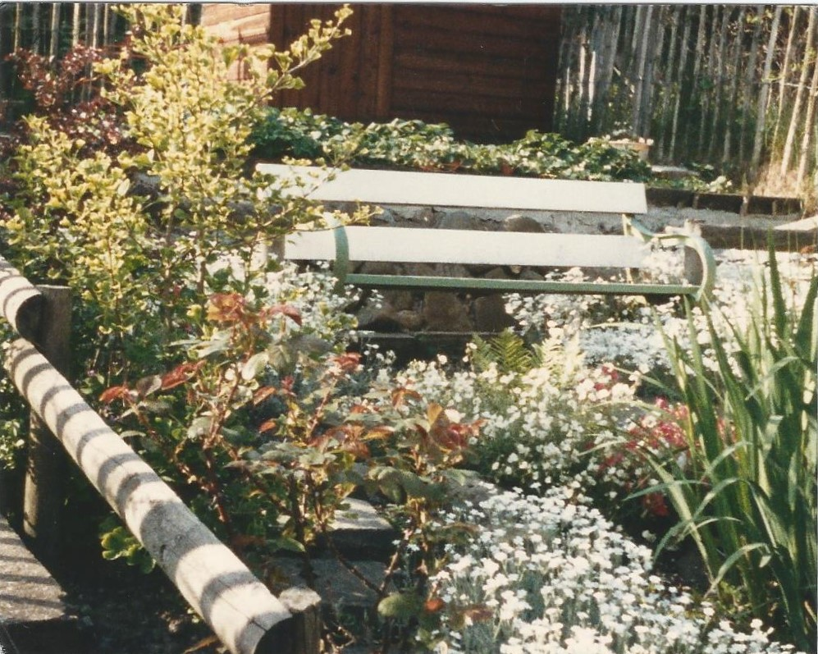
^{Figure 1.}
My first photograph is one of my own memory-objects, a photograph of a garden in bloom, plants and flowers surrounding a bench with steps in the background. I feel connected to the photograph physically, like I’m stood behind the camera when it was taken, I have this overwhelming feeling of belonging in this image, I can see myself walking around and sitting on the bench as a child. This is a false memory. This photograph was taken in my grandmother’s house in Heol-Isaf, years before I was born. And even though I remember it vividly, the memory is actually made of videos and stories shown to me as a young child, from my parents and relatives. Learning that this was a false memory was like I lost a piece of my identity; this photograph has been a part of my memories for the majority of my life.
In Memory Images, 1927, Siegfried Kracauer said, “Compared to photography, memory’s records are full of gaps.” [Memory (Documents of Contemporary Art), 45, 2012]. While the memory stores every event experienced, like when knitting a blanket, the memory is full of links, but when a stitch is dropped, imagination can alter that experience to create a new memory. I think that Kracauer makes a good point, our memory’s records are full of missing pieces, and even though we grab onto parts of every moment, unless we use the act of evocation and delve into the deepest parts of our memory, we will never recollect every moment, no matter how significant they are.

Second Keyword – Perception

Perception along with memory are two of the key elements of Memory in photography, perception is personal. Nobody perceives an image the same way, working alongside memory, perception can also create a sense of dejá-vu. While the actual in memory is truth, the virtual; perception, is often mistaken for dejá-vu. When we see a photograph, perception is always an aspect, however small, it can affect the core memory. Perception takes the only connection left and alters it to create the memory we want. In place of parts of the core memory, the photograph can add fragments through time to make stories through imagery. An aspect of perception in the photograph is dejá-vu, we often associate parts of an image with a memory of another that never existed, creating sensation through imagery. Although, the photograph can be used as the memory-object; while the image presents the memory in virtual form, the photograph itself can be the object we associate with the memory. It is the means of remembrance but when the image is no longer the memory and the photograph becomes the memory-object, it takes on various roles in our journey for the true memory. However, it is more probable that we recognize a true memory in the form of an object, smell or sensation because we attach it to an essence of the moment, so when we experience new moments, we identify similar details and create a sense of dejá-vu and familiarity.
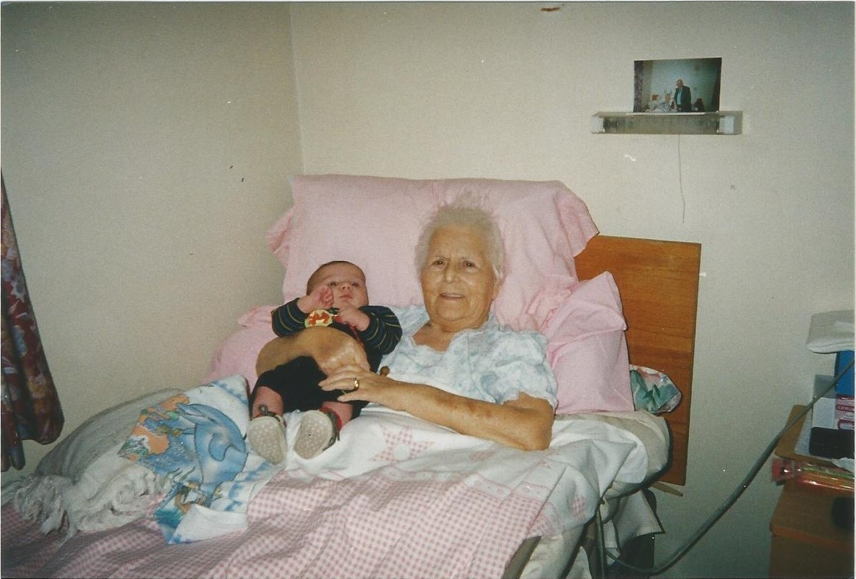
^{Figure 2.}
Throughout my life, I have sifted through tens of family photo albums, and have often felt like I’ve experienced pieces of the memories laid out before me. When in fact, I’m not in most of the photographs, one particular photograph that gives me this feeling is the photograph of my brother Iestyn and Nanna. This photograph captures a moment I thought I remembered extremely well, a photograph of my Nanna holding my first brother, in her house a few years before she passed away. I remember being sat on the bed next to her while the photograph was taken but I’m not physically in the image, I remember the smell of beef broth and fresh bread cooking while we huddled together around her bed. The photograph holds both happiness and grief for me as it was the only photograph I had before she got ill but upon further investigation, that moment wasn’t exactly as I remembered. After speaking to my mother and sister who were with me when the photograph was taken, they said that I had been sat in the parlour with my great grandfather listening to the radio. I had no recollection of the core memory; at some point I may have been in that exact room and sat on the same bed but it in fact wasn’t at the time of this photograph. My memories seem to have blended together and created a new memory, something that almost felt like dejá-vu.

“It may be said that we have no grasp of the future without an equal and corresponding outlook over the past, that the onrush of our activity makes a void behind it into which memories flow”, said Bergson [Bergson, 1896, 69], who seems to be highlighting his perception of how we perceive memories and future memories. I believe we can create new memories based on the fact we remember our past, however, we may create a fabricated blanket to fill in the holes of the memories we don’t remember. We start perceiving images differently when we’re told the narrative isn’t true, most memories are made up of perception, like a phone camera duplicating pixels to achieve the image we think we want, our memories conduct a recount of as much of the moment as possible while taking what we want to see into account.

Recognition is a form of perception, we often get a sense of dejá-vu when we recognize a smell, sensation or place we’ve visited before which brings forth a burst of past memories that we then associate with present time. Bergson says, “On one theory, the recognition of a present perception consists in inserting it mentally in its former surroundings” [ Bergson, 1896, 105]. I think he was not only referring to the dejá-vu we experience when perception alters previous memories to fit the current moment, but the blending of perception and memory that makes up half of our whole lifetime of memory records.

Third Keyword – Narrative

Throughout memory, there is story. The moment the memory is captured in a photograph, the context changes, perception guides the image to a new form of itself. The story of the moment is forever stored away, to intertwine with the actual, only when the moment is captured, perception strips back the immediate connection through a form of frosted glass. The story can be seen by the memory maker, but its common that we fill in the blanks, using imagination and perception, sometimes the blanks aren’t too far off the truth. Barthes said “Photography never lies: or rather, it can lie as to the meaning of the thing” [ Barthes, 1980, 87], I think that the Photograph can lie, but more often than not, the memory has already been altered without actually knowing. As I mentioned earlier in First Keyword – Memory, our memories are already altered and fed to us from a young age. When our memories are shown to us, the person(s) reminiscing usually merge memories together, unknowingly or not, we are presented with a false reality. Essentially, a story. We believe our memories are our own, when in fact, they are the representation of other’s memories merged into fragments to create our own.

Narratives can change the photograph whether intentionally or not, but for me, along with the story comes sensation, I often associate music with the memory. By recalling a memory, I often find myself singing along to a song that I remember that my conscious mind has connected to the memory, automatically pinning the two together. Sutton said, “We have no time, no need, to examine the ways in which we interpret photographs or time to appreciate the interval they create in experience, within which memory and perception create interpretation. Consider, for instance, when photographs are taken out of their context. Without text to accompany them, without pages to frame them, and most important, without other images to nourish them, they force us to confront the processes of interpretation.” [Sutton, 2009, 135]. Without context, each image is open for interpretation, thus giving us the power to create any narrative we see fit, for the photograph.

As a child, my life was shown to me through photographs and the stories that came with them, as an adult, I now realise that I’ve always been looking in on my childhood memories as an outsider. I was never included really, in the story telling part, I was just there to receive the information; “this is my godmother, I remember her well, she was such a lady”, “that was our first dog, you remember her don’t you?” and “look at the hair on him!”. I was always looking through the frosted glass, as I got to my late teens, I realised that I could make memories and recall them as my own. They were entirely mine, including the narratives that I wrote along side them, still, my memories weren’t only mine. I shared many fond memories with school friends, as many inside as outside of school, but I couldn’t only rely on my own memories to tell the truth. Like perception, the memory could be perceived in many different ways because of the narrative, when we reminisce about memories that are shared between multiple people, we consider the other perceptions and piece them together to get the best version of the event. Just like creating a visual fiction, each person or thing has a significant role in the memory, and if not, often are edited out, like they or it never appeared in the memory.
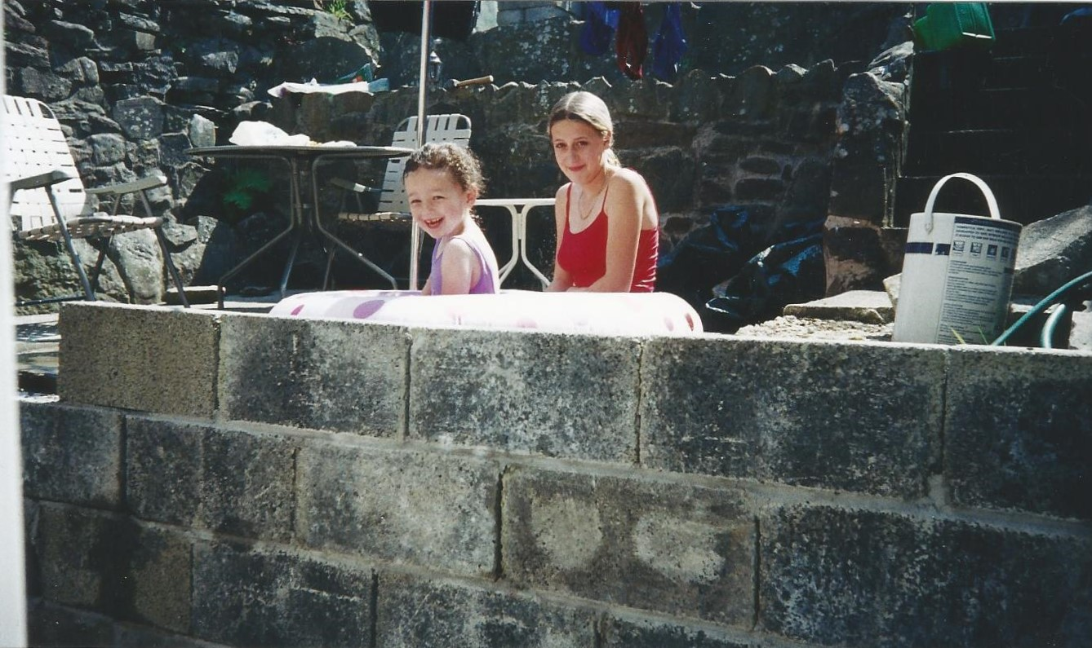
^{Figure 3.}
My final photograph is a physical representation of a core memory, though the narrative that surrounds it is less than exciting, I relate to the story not only because it includes me directly but for the first time in the essay, the photograph is entirely true. My sister and I are sat in a paddling pool, at the bottom of our garden, with the sun shining down on us. I was excited because it was the first time, we had used it, with my hair tied back so it wouldn’t get wet, we had fun in the purple spotty paddling pool. Not long after, my brother joined us, all while my parents sat in the deck chairs next to the steps. That was it, there were no other details about the moment that any of us remembers, so it was set in stone. But like every other memory, the narrative is limited, as the core memory, the narrative is pure, it is only when we relive other memories, that they start blending together, reminding us of similar times or parts of the story forgotten. Reminiscing about this moment years later, my parents said, “that was just before your birthday, it wasn’t long after that, you fell and cracked your head open”. Now when I see that photograph, I’m reminded of the great time I had with my siblings and the pain of falling over a shoe while playing rugby in the living room. Narratives are subjective to the memory, I find that even if the story is truth, it is up for interpretation. Narratives are equally important in memories, working alongside memory and perception to create a moment we can later recall, with a story to identify it by. Using my family archives has been important to this proposal, as I was inspired to connect with the sensation surrounding my memories. Through the story comes sensation, to me, sensation is what is created by connecting with core memories and memory objects, the purest form of memory is surrounded by sensation.

I wish to further explore how memory links to sensation through photographic memory-objects by delving deeper into my family archives, to unearth rich memories from before my birth and through my childhood. I plan to investigate my memories using analog techniques and archival imagery, which will hopefully lead me to the title of my dissertation. –

What is the best means of remembrance? Using photography, memory-objects and sensation, explore what can be considered as the most reliable representation of memory.

Bibliography
Barthes. R, (1980), Camera Lucida. London: Vintage 2000.

Bergson. H, (1896), Matter and Memory Dover Ed. London: Republication of the 1912 edition, translated by N. Margaret Paul and W. Scott Palmer, originally published by George Allen & Co., Ltd., and The Macmillan Co.

Farr. I, (2012), Memory (Documents of Contemporary Art). London: Whitechapel Gallery, The MIT Press

Sutton. D, (2009), Photography, Cinema, Memory: The Crystal Image of Time. USA: University of Minnesota Press

References
Barthes. R, Camera Lucida, 1980. Pages, 85,87,91. London: Vintage 2000

Bergson. H, (1896), Matter and Memory Dover Ed. Pages, 69, 105. London: Republication of the 1912 edition, translated by N. Margaret Paul and W. Scott Palmer, originally published by George Allen & Co., Ltd., and The Macmillan Co.

Farr. I, (2012), Memory (Documents of Contemporary Art). Page 45, Siegfried Kracauer (Memory Images, 1927). London: Whitechapel Gallery, The MIT Press
Sutton. D, (2009), Photography, Cinema, Memory: The Crystal Image of Time. Page 135. USA: University of Minnesota Press

Illustrations
- Figure 1 – ‘Garden in Bloom, Heol-Isaf, 1992’ Family Archive
- Figure 2 – ‘Iestyn and Nanna, 2002’ Family Archive
- Figure 3 – ‘Our Garden, girls paddling pool, 2003’ Family Archive

