Ben Shears
Ben.shears@renishaw.com
Ben Shears
ACMA5002 – Design Assignment

Table of Contents:
Introduction – 3
Concept Design Appraisal – 4
Consideration of expected customer and end user needs: 4
Public Perception and Aesthetics: 4
Pick and Place Requirements: 4
Development of a Design Specification: 5
Development of Quality Function Deployment: 6
Voice of Customer Section: 7
Technical Requirements Section: 7
Relationship Matrix Section: 7
Customer Requirement Priorities Section: 7
Technical Requirement Priorities Section: 8
Competitive Evaluation Section: 8
Interrelationships: 8
Design and Development Work Undertaken – 9
Techniques used to generate new designs or features: 9
Proposed Design Changes: 9
Gripper claws – 9
Cylinder – 10
Drive plate – 10
Old Concept v New Concept images: 11
Design for X techniques and considerations: 11
X=MANUFACTURING 11
X=ASSEMBLY 12
X=RELIABILITY 12
X=SERVICEABILITY/ MAINTAINABILITY 12
X=ENVIRONMENT 13
Risk management techniques used: 14
Environmental product life cycle factors considered: 14
Manufacturing Process Proposal – 15
Business needs and Cost Drivers: 15
Chosen Manufacturing Process and Justification: 15
Gripper Claw, Cylinder and Drive plate- 15
Worm-Screw and Shaft – 15
Motor – 16
Joint – 16
Manufacturing Process Design – 17
The sequence and layout of the proposed production process: 17
Conclusion – 18
Works Cited 19

Introduction –
I have been tasked with the job of redesigning and developing the below 3 jaw gripper for use on a Co-bot pick and place system:
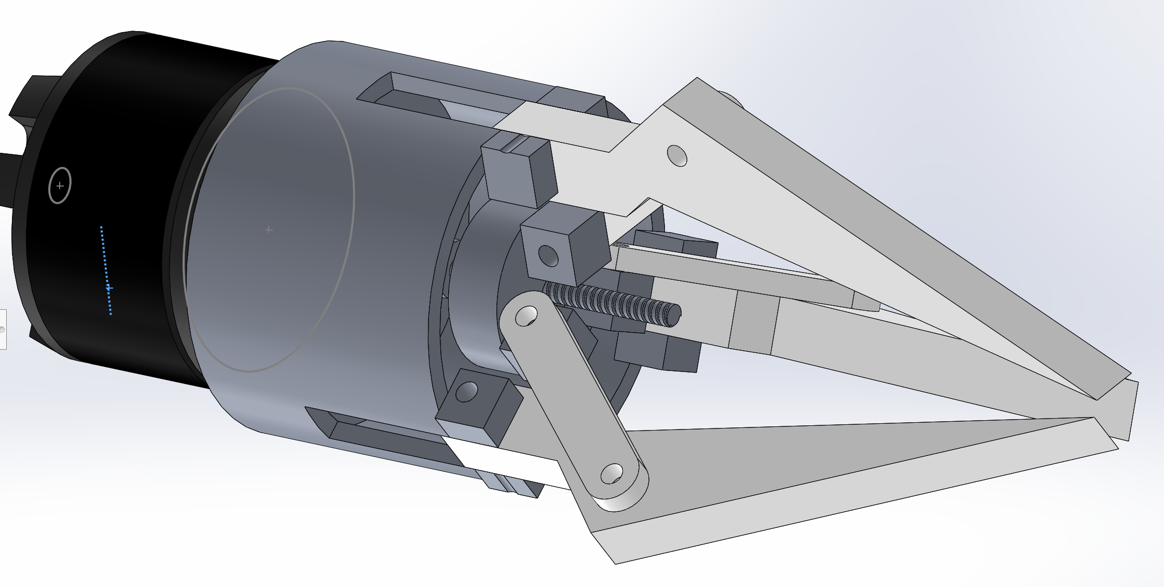
Figure 3a
(Morgan, 2021)
The co-bot gripper will need to be used for a range of pick and place operations and should be re-designed so that it is adaptable and as future proof as possible. When re-designing the co-bot gripper I will also be thinking about design for manufacture to optimise the manufacturability of the system. It has been stated in the project design specification that the co-bot gripper will be manufactured in volumes of around 1000/2000 units per week. This equates to around 50 units per day if the manufacturing facility were to run on 8hrs days, 5 days a week. These volumes aren’t huge, although the co-bot gripper consists of multiple components so each component will need to be made 50 times a day. I will try to design the gripper so that it is as robust and low maintenance as possible.

Concept Design Appraisal –

Consideration of expected customer and end user needs:
I will be basing the expected customer to require very similar needs to the engineering industry that I currently work in (Renishaw Plc). Therefore, the gripper claws will need a complete redesign to accommodate rectangular parts like the encoder readheads that Renishaw manufacture and produce. The customer will most probably need the tips of each gripper to be made from a soft material to avoid scratching of components during pick and place operations.

Public Perception and Aesthetics:
The gripper will need to appear very co-bot friendly for the public eye and for industries to invest and buy the product. Another important aspect to ensure companies want to invest and purchase the co-bot assembly will be for the gripper to also look aesthetically pleasing and as modern as possible.

Pick and Place Requirements:
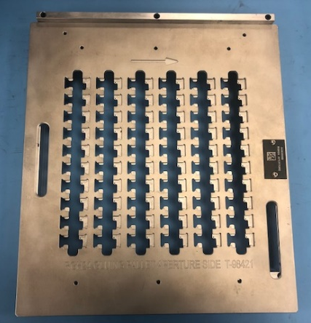
My initial thoughts as stated were to apply the co-bot pick and place system to where I currently work which is at Renishaw Plc, the system would be used to load the readhead cores (Figure 4b) we produce onto a aluminium tray with machined pockets (Figure 4a). This is needed prior to the tray being run through a gluebot process. The tray can hold up to 60 readhead cores at any one time and would save the company a small fortune on labour as loading the readhead cores into each pocket on the tray has proven to be a very timely exercise.

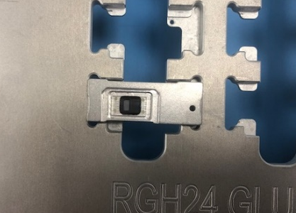

Figure 4b

Figure 4a

Development of a Design Specification:
In order to re-design the co-bot gripper I will need to development the existing specifications to define what is essential or desirable for the expected customer.
Functional Requirements
Ref | Target Requirement | E / D | Justification
1.1 | Needs to be able to accurately locate RGH24’s within toting. | E | This is so the robot knows where it will be picking from.
1.2 | Needs to be able to secure pickup RGH24 readhead cores from toting. | E | To be able to unload parts from toting within production.
1.3 | Must be able to place RGH24 readhead cores into pockets of Gluebot tray accurately so parts sit flat. | E | To be able to successfully load the Gluebot tray correctly with parts so that the operator can run the tray through Gluebot.

Rig Mechanisms
Ref | Target Requirement | E / D | Justification
2.1 | The worm-screw/drive plate mechanism needs to be able to open enough to pick up a RGH24 readhead core with ease. | E | This is so the RGH24 core can physically fit in the grippers jaws.
2.2 | The motor must drive the drive plate up the worm-screw enough to get a good firm grip on the RGH24 core. | E | This is so that the RGH24 core is securely held and isn’t going to fall out of the jaws on movement of the robot.

Environmental Protection
Ref | Target Requirement | E / D | Justification
3.1 | The co-bot must be designed as environmentally friendly as possible, to have the smallest carbon footprint on the planet as possible. | D | To help battle climate change and to be seen as a ‘clean’ eco-friendly product.

Transport Requirements
Ref | Target Requirement | E / D | Justification
4.1 | Fixed permanently upon installation. | D | The Co-bot will not need to be transportable when installed.

Legislative and Safety Requirements
Ref | Target Requirement | E / D | Justification
5.1 | The co-bot must be safe for operators to work next to. | E | The co-bot will be located on the production line operating near and along side operators so this needs to be met for their safety.
5.2 | Co-bot must fail safe. | E | In the event of a power-cut or unexpected collision the machine must fail safe and only return to home to reset itself when told to do so and slowly.
5.3 | The Co-bot system must be CE marked and Risk assessed. | E | To ensure it complies with the government’s rules.

Development of Quality Function Deployment:
Quality function deployment is a process used to design a new product or develop an existing product based around the ‘Voice of the customer’.
Below is a diagram called the ‘House of Quality’ which is a useful tool commonly used in quality function deployment:
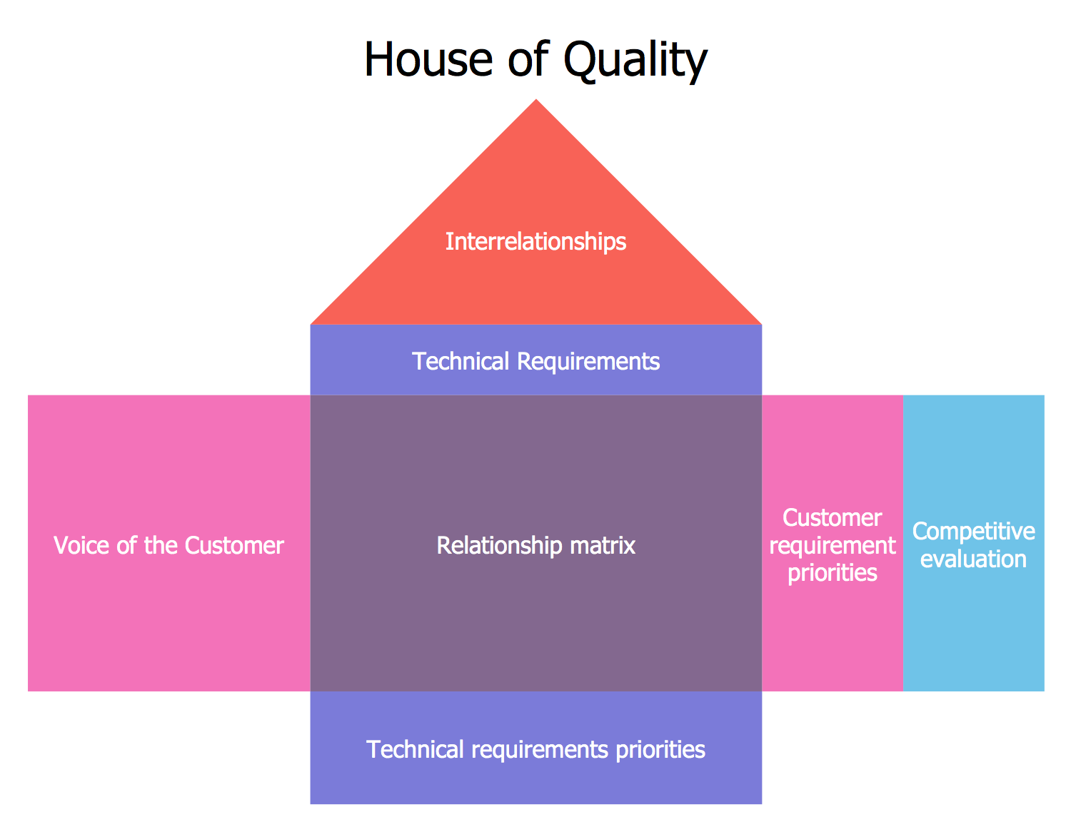
Figure 6a
(Concept Draw, 2018)
As you can see above in the house of quality diagram there are many different sections it consists of.

Voice of Customer Section:
This section is where the true voice of the end user/customer is heard. It is important in this section that you allow the customer request whatever they desire whether it be within your capabilities or not the customer should not be influenced in any way at this point. This is a very important stage within designing as it is critical to listen and understand exactly what the customer wants before starting to develop design ideas.
In the case of the gripper assembly there wasn’t a specific customer, although from the PDS, it is visible to see the customers’ needs and what is required on the gripper.

Technical Requirements Section:
This is often referred to as the ‘HOW’ room. It is called this as it is where the engineers must decide how they are going to measure and evaluate the customers desired attributes that have been requested. Every attribute needs to be quantifiable.
When applying this to the gripper assembly the solutions for the target requirements were discussed in the development/design stage, so if there were any problems, such as a certain customer target from the specification not being hit, then the option to redesign around the issue was there.

Relationship Matrix Section:
The relationship matrix room is the largest room in the house of quality, this is because this room is where the relationship between the customers voice is related to technical requirements. At this point the customer is made aware of how the engineers plan to countify how they will meet each specified attribute, if any attributes can’t be quantified or met then it will be discussed here to ensure the customer is still happy to proceed.
This is a difficult one to compare due to not being able to contact the customer, therefore I spoke to an Engineer within Renishaw to seek their opinion of the relationship matrix section in comparison to the specification and capabilities, they thought that each attribute was met well.

Customer Requirement Priorities Section:
This is where the customer communicates their highest priorities out of the attributes specified in the Voice of Customer Section. They will also put across how critical each attribute is and what effect it would have on them if the attribute wasn’t met.
Due to Renishaw being the customer I spoke with an Engineer who looks after the Gluebot machine and they ranked the order of prioritises for the attributes depending on their importance.

Technical Requirement Priorities Section:
This is where the engineer will prioritise the technical requirements based upon the customer requirement priorities section. As what the engineer could have been thinking is important and planning on prioritising could change after seeing what the customer cares about most. This room also gives the company a chance to compare technical specifications to competitors and quantify as best as possible how competitors do in this area such as how many service hours and downtime is required etc.
Based on the customer requirement priorities section and the feedback the Engineer gave me, I reordered and prioritised the technical requirements to suit to ensure I am focussing on what the customer desires the most firstly.

Competitive Evaluation Section:
This is where you compare yourselves to other similar providers/competitors and decide what sets you apart. This is an important room as it gives the company chance to see where their weaknesses are so that they can target these to improve to essentially be more competitive. Techniques such as planned satisfaction rating and improvement factors are used to help identify what the company is behind or lacking in.
I took a look at the market for co-bot systems and saw how expensive they were selling for so decided to set my focus on reducing the cost by having a lean manufacturing process with good cycle times. I found that the businesses weakness were marketing due to only now starting out in the market. I scored multiple companies on their cost, delivery lead times along with the quality of product to compare to the concept design and give me development ideas.

Interrelationships:
This room is the direct relationship between the How’s and the What’s from both the technical requirements section and the voice of the customer section. Therefore, each attribute must be re-justified between engineer and customer and rated as achievable or going to prove a problem due to complexity issues or another constraining attribute interfering. The discussion is then had whether the customer would like to keep this attribute and wait the extra time/pay the extra money or if it really isn’t going to massively effect the assembly.
All attributes asked for within the PDS were easily achievable so there wasn’t much to be discussed for this section in this particular case.
(leansixsigmatraining, 2010)

Design and Development Work Undertaken –

Techniques used to generate new designs or features:
The main technique used to generate new ideas for designs and features was holding brainstorming meeting with colleagues, everything said and thought about was written down as minutes and that really helped when coming to generating ideas. Another technique used was mind-mapping, reverse thinking, looking at PDS for defined attributes.

Proposed Design Changes:

Gripper claws –
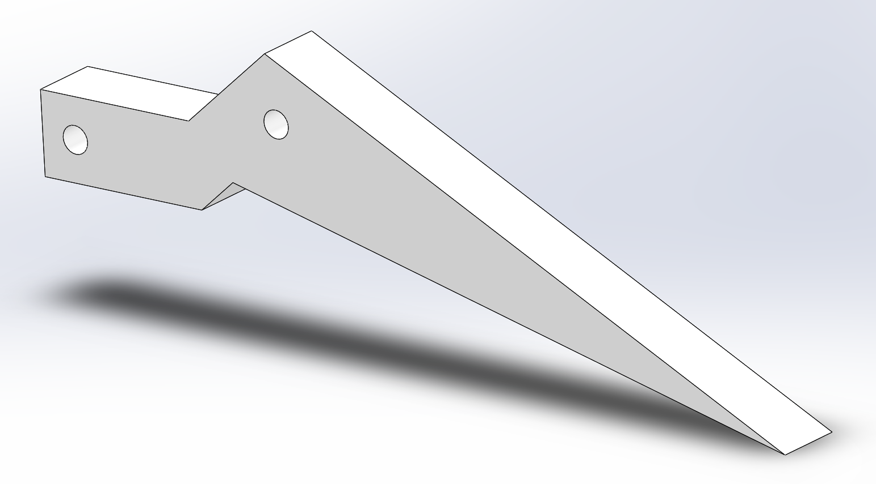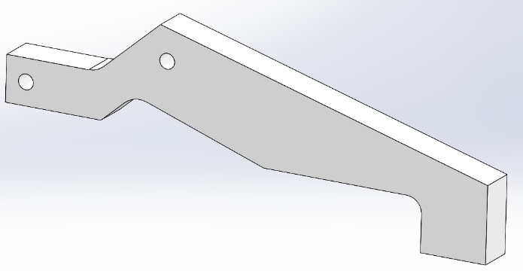
CONCEPT DESIGN DEVELOPED DESIGN
The current gripper system as shown above has three gripper claws. This is great for reliably picking and placing items that have circular/cylindrical faces on them but isn’t the best choice when picking square/rectangular components up. I propose that the design is changed to two gripper claws opposite each other instead of the three currently. I think this would be beneficial as then both sides of the readhead cores we produce can be grabbed and gripped securely by the co-bot with minimal risk of losing grip and dropping components. The issue with picking up rectangular parts (the readhead cores) is unlike circular components with three gripper claws they won’t self-centre and align themselves when being picked up, therefore the co-bot needs to be heavily reliant on its axis to ensure the arm carrying the gripper is in the correct place before picking. If not, this could result in components being picked up incorrectly and therefore placed incorrectly in the tray, or potentially being dropped by the gripper system which could ultimately result in scrap parts due to cosmetic damage causing a loss of profits. To help avoid this issue of incorrectly grabbing parts I would re-design the width of both claws to be larger than the readhead face it will be clamping on, this allows for more variation if something were to go wrong. I would also change the shape of the claws so instead of them having a point the clamping face would be rectangular. This not only increases the clamping area but reduces the chance of the point scratching the readhead and causing cosmetic damage. To eliminate the risk of cosmetic damage altogether the choice of having the grippers rubber coated for softness and grip could be optional for customers depending on what components the system will be handling, I believe this will also make the jaws look more friendly and aesthetically pleasing. The material to be used for the gripper claw will be stainless steel to ensure strength and durability over its life-span, this material has been selected as this component is the most wearable part due to it coming into contact with materials very frequently when picking and placing.

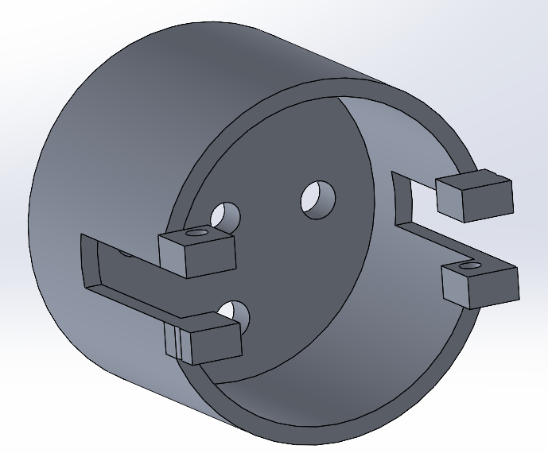
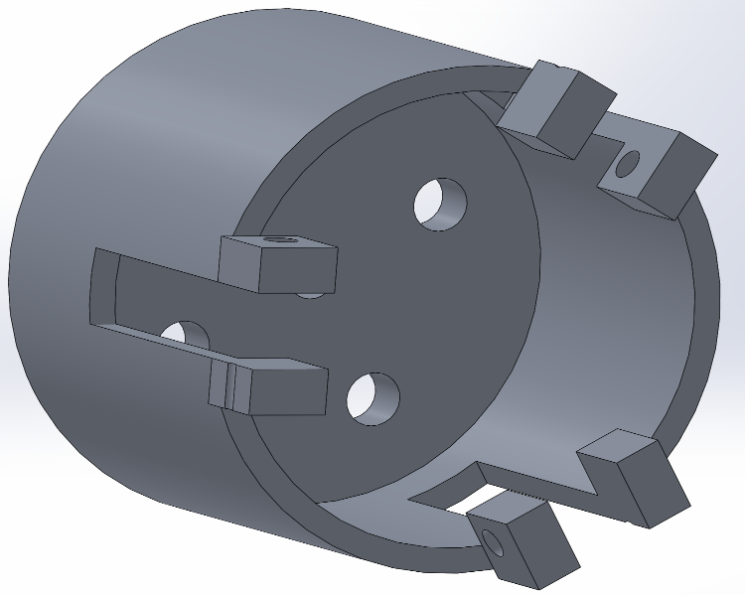
Cylinder –
CONCEPT DESIGN
DEVELOPED DESIGN

Due to changing the number of gripper claws, the cylinder which can be seen above will also need to be modified. It will be modified so that the jaws can be fixed opposite each other. One of the fixture slots can also be removed due to only two being required. The material to be used for this component will be an aluminium billet due to it being housing and not needing much strength, due to it being a larger customer visible face it will be made from a high finish grade of Aluminium.

Drive plate –
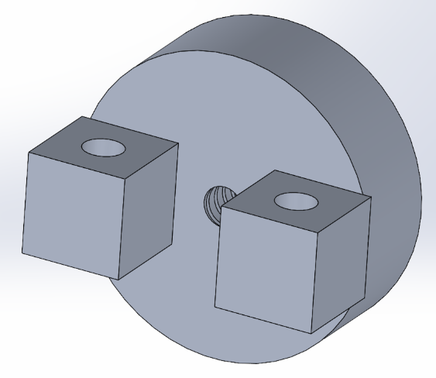
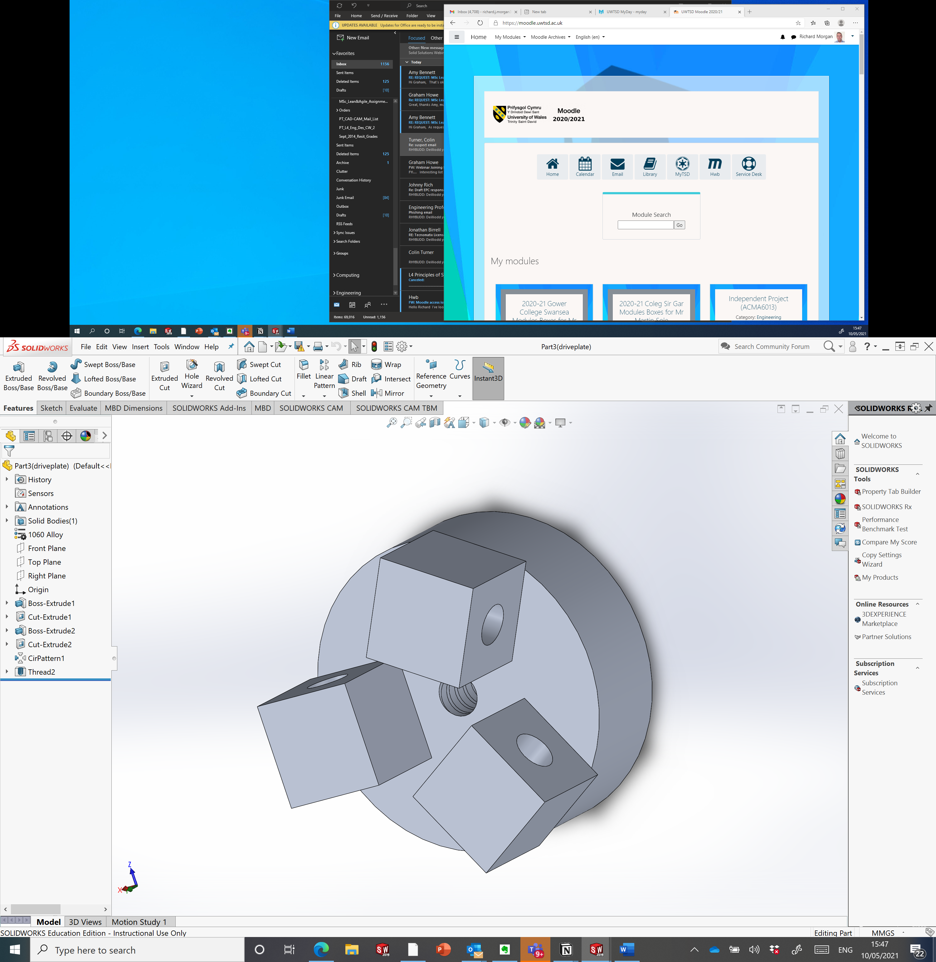
CONCEPT DESIGN DEVELOPED DESIGN
Again, due to changing the number of gripper claws the drive plate seen above will also need to be modified, removing one fixture point and placing the remaining two fixture points opposite each other so that the jaws can function in the correct positions when the motor powers the worm-screw. The material to be used to manufacture this will be Aluminium the same as the Cylinder above, this is due to Aluminium being cheaper than steel and more than strong enough to hold a good thread for the worm-screw function.

Old Concept v New Concept images:
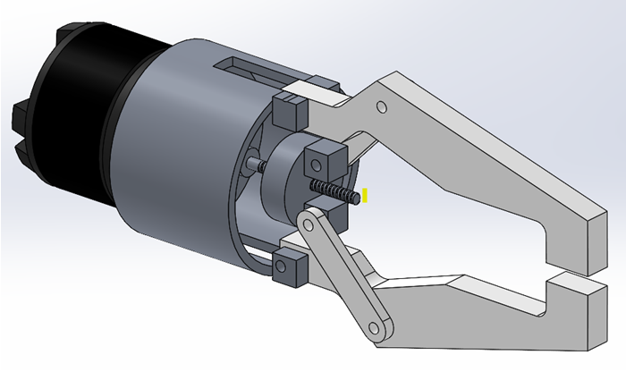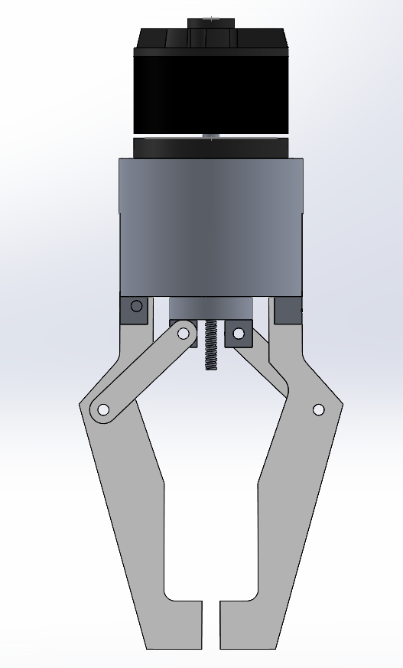
NEW CONCEPT OLD CONCEPT

Design for X techniques and considerations:

X=MANUFACTURING
Design for Manufacture (DFM) is a way of designing components so they are easier to manufacture with standard machine tools and as minimal amount of tooling as possible. This not only saves on cost due to tooling and the machine complexity capability needed but will often speed up the machining time meaning you receive your parts a lot sooner and have a much faster lead time for customers. Another massive part of DFM is trying to reduce the amount of components needed and always sticking to standard fixings/fasteners where possible.
- I developed the gripper claws so that they are rectangular not only so they can function better when picking up RGH cores but so they are more machinable, as curves always prove more difficult to machine.
- Due to deciding to go with two gripper claws that then had a knock on effect on the Drive plate and Cylinder components meaning they have less features, this speeds up machine cycle times massively and saves on tool wear as spoken about above.
- I have also managed to use standard fasteners to save on machining.

X=ASSEMBLY
Design for Assembly (DFA) is used to maximize the ease of building an assembly, reducing the number of components and tools required to build the finish assembly. Often self-aligning components are used along with components that can only be insert one way (Poka-Yoke), this is to reduce the possibility of an assembly being built incorrectly. The main aim with DFA is to reduce the amount of fixings so less components need torqueing/tightening along with removing as many non-essential parts as possible without effecting the product function.
- In my development designs I decided to make the bottom of the gripper jaw a flat surface so when mounting the jaws to the rest of the assembly you can rest the jaw in place on top of the cylinder face and the through holes will line up for you to put the bolt through. This speeds up the assembly process.
- All other design for assembly aspects I was thinking of were jig and fixturing based and not product based.

X=RELIABILITY
Design for Reliability (DFR) is used to determine the probability that a given assembly or component will fail to function correctly under normal operating circumstances. Often the choice of material plays a huge factor in a component’s reliability. To improve reliability all failure modes need to be assessed and design solutions found to overcome these failures. For example if an assemble has a risk of shorting to the outer case then perhaps the outer case material needs to be rethought and change to non-conductive, or the PCB inside the assembly needs to be cased better leaving a larger gap between the circuit board and outer case.
- I used material selection when designing for reliability. This is why I chose strong robust materials such as stainless steel and aluminium to ensure they would have a long life span and be durable in a production environment, a good motor was also selected to ensure the assembly was an reliable as can be.

X=SERVICEABILITY/ MAINTAINABILITY
Design for serviceability (DFS) / maintainability (DFM) is used to keep maintenance to a minimum to reduce the amount of downtime required. This not only allows production to continue producing for longer hours but also saves the plant maintenance team time and money. Injuries during carrying out standard maintenance activities are also accessed here and the risk level is reduced to a minimum where possibly. The required maintenance should be able to be carried out and performed with easy access to components and with minimal basic hand tools.
- The gripper claws are easily replaceable when they become worn.
- Due to the motor being located on the end of the assembly this can also easily be accessed for maintenance when and if required.

X=ENVIRONMENT
Design for the environment (DFE) is one that most designers leave until the end to consider. Although this approach should be considered from the start of the design process as it is an approach to reduce the environmental impact and carbon footprint from the product. Everything from the machining/manufacturing process to packing should be considered. Each material should be considered and given a purpose after the products life cycle is over, whether it have a second use or for it to be disposed and potential recycled to build another product. If the product uses electricity or any other form of energy then whether it is energy efficient or not needs to be looked into.
- I designed the product from robust materials to make it last, therefore it will be sustainable, and it also uses little electricity and produces no emissions. After the products life cycle the metal can be melted down and re-purposed.
- The product is to be packaged in recycled cardboard to help recycle other products waste and have a positive impact on the environment.

Risk management techniques used:
I used an FMEA to identify and improve any possible risks that the product may face.

Environmental product life cycle factors considered:
To increase the product life cycle the decision was made to rubber coat the gripper jaws to not only stop them from scratching the parts but to extend their life by making them more resistant to wear.

Manufacturing Process Proposal –

Business needs and Cost Drivers:
From a business point of view, in order to manufacture the 1000/2000 units per week and make profit on it, the manufacturing process and technique is critical. If the process is too complex, then the cost of machining increases. To maximise profits, cost drivers such as factory space, cycle times and machine maintenance must be minimised where possible.

Chosen Manufacturing Process and Justification:

Gripper Claw, Cylinder and Drive plate-
The chosen manufacturing process for machining the gripper claws, cylinder and drive plate designed for the co-bot system will be on a CNC machine (Mazak FJV). I chose this method, not also due to the parts suiting the machine but due to its speed and repeatability. Also, over time the machine will pay for itself. The machine will also massively reduce salary overheads of operators due to them not needing to be as skilled and being able to operate multiple machines.
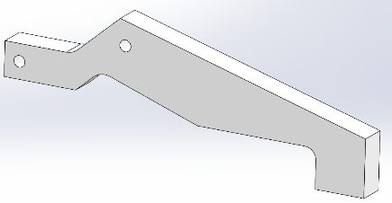
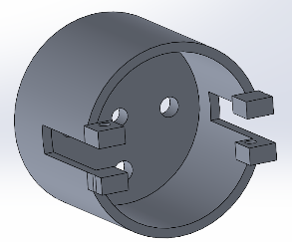
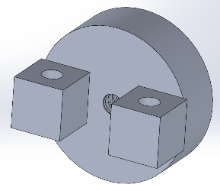
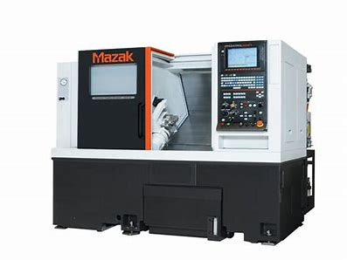
(John Hart, 2019)

Worm-Screw and Shaft –
The process design for machining the worm-screw will be a CNC Citizen lathe with a bar feeder attached. This will allow the machine to run automated when fully programmed. I chose this method of machining due to the parts being circular in shape and it being more cost effective to than using a Mazak milling/turning CNC. The Citizen can also load itself with bar so when it is setup the machine needs very minimal attention. Citizens can carry out complex features such as threads that are seen on the worm-screw to a high standard.
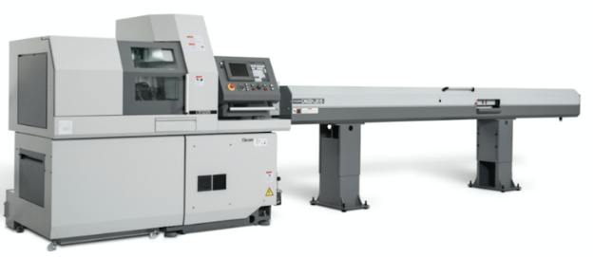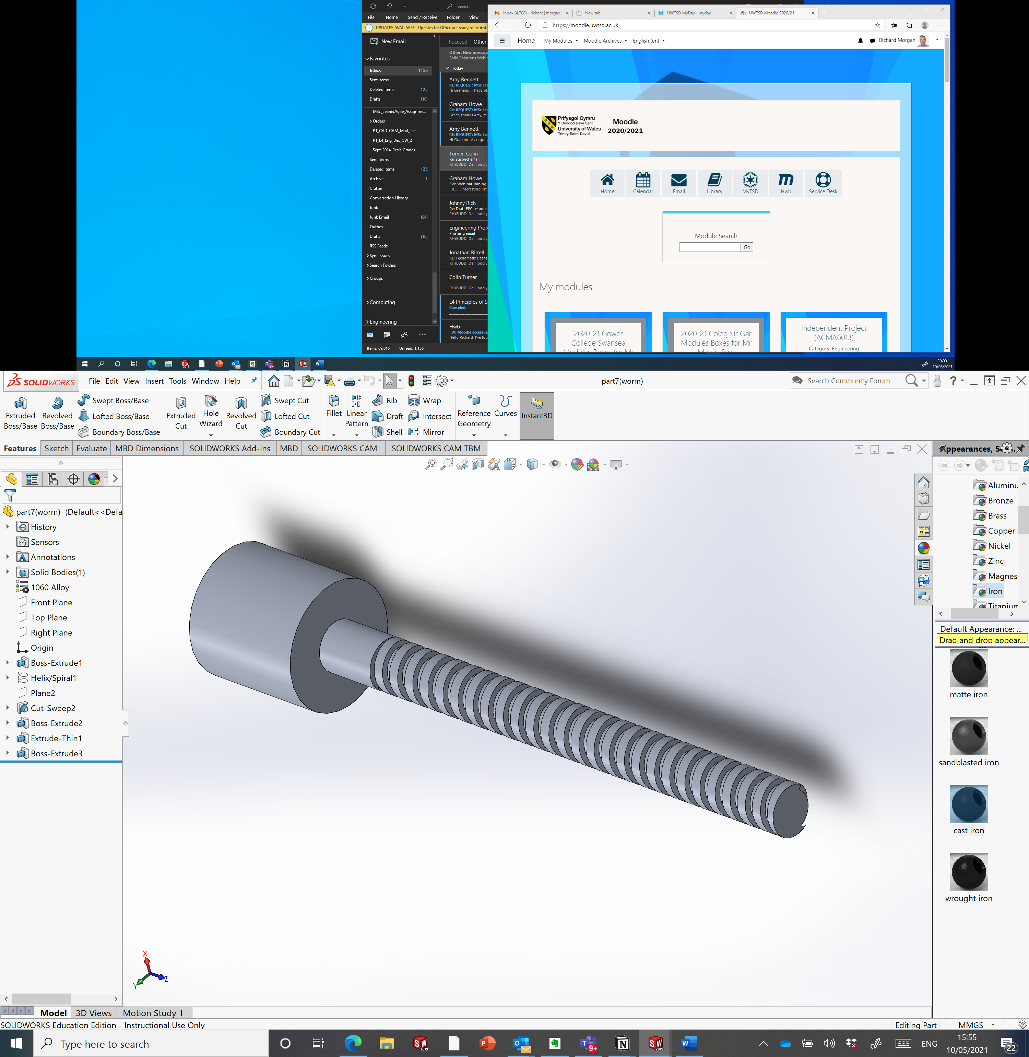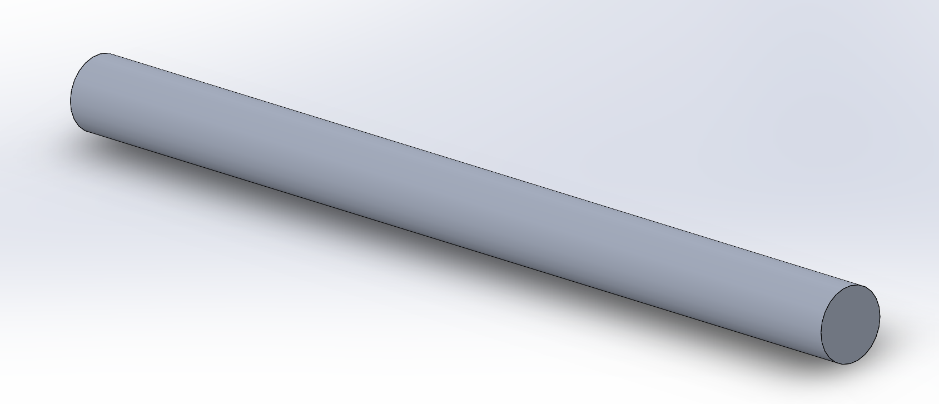
(Adept Machine Tools, 2019)

Motor –
The motor will be purchased from a supplier so will not require manufacturing, this is a cheaper option due to the number of components the motor requires both electrically and mechanically. Suitable motors can be bought from RS components.
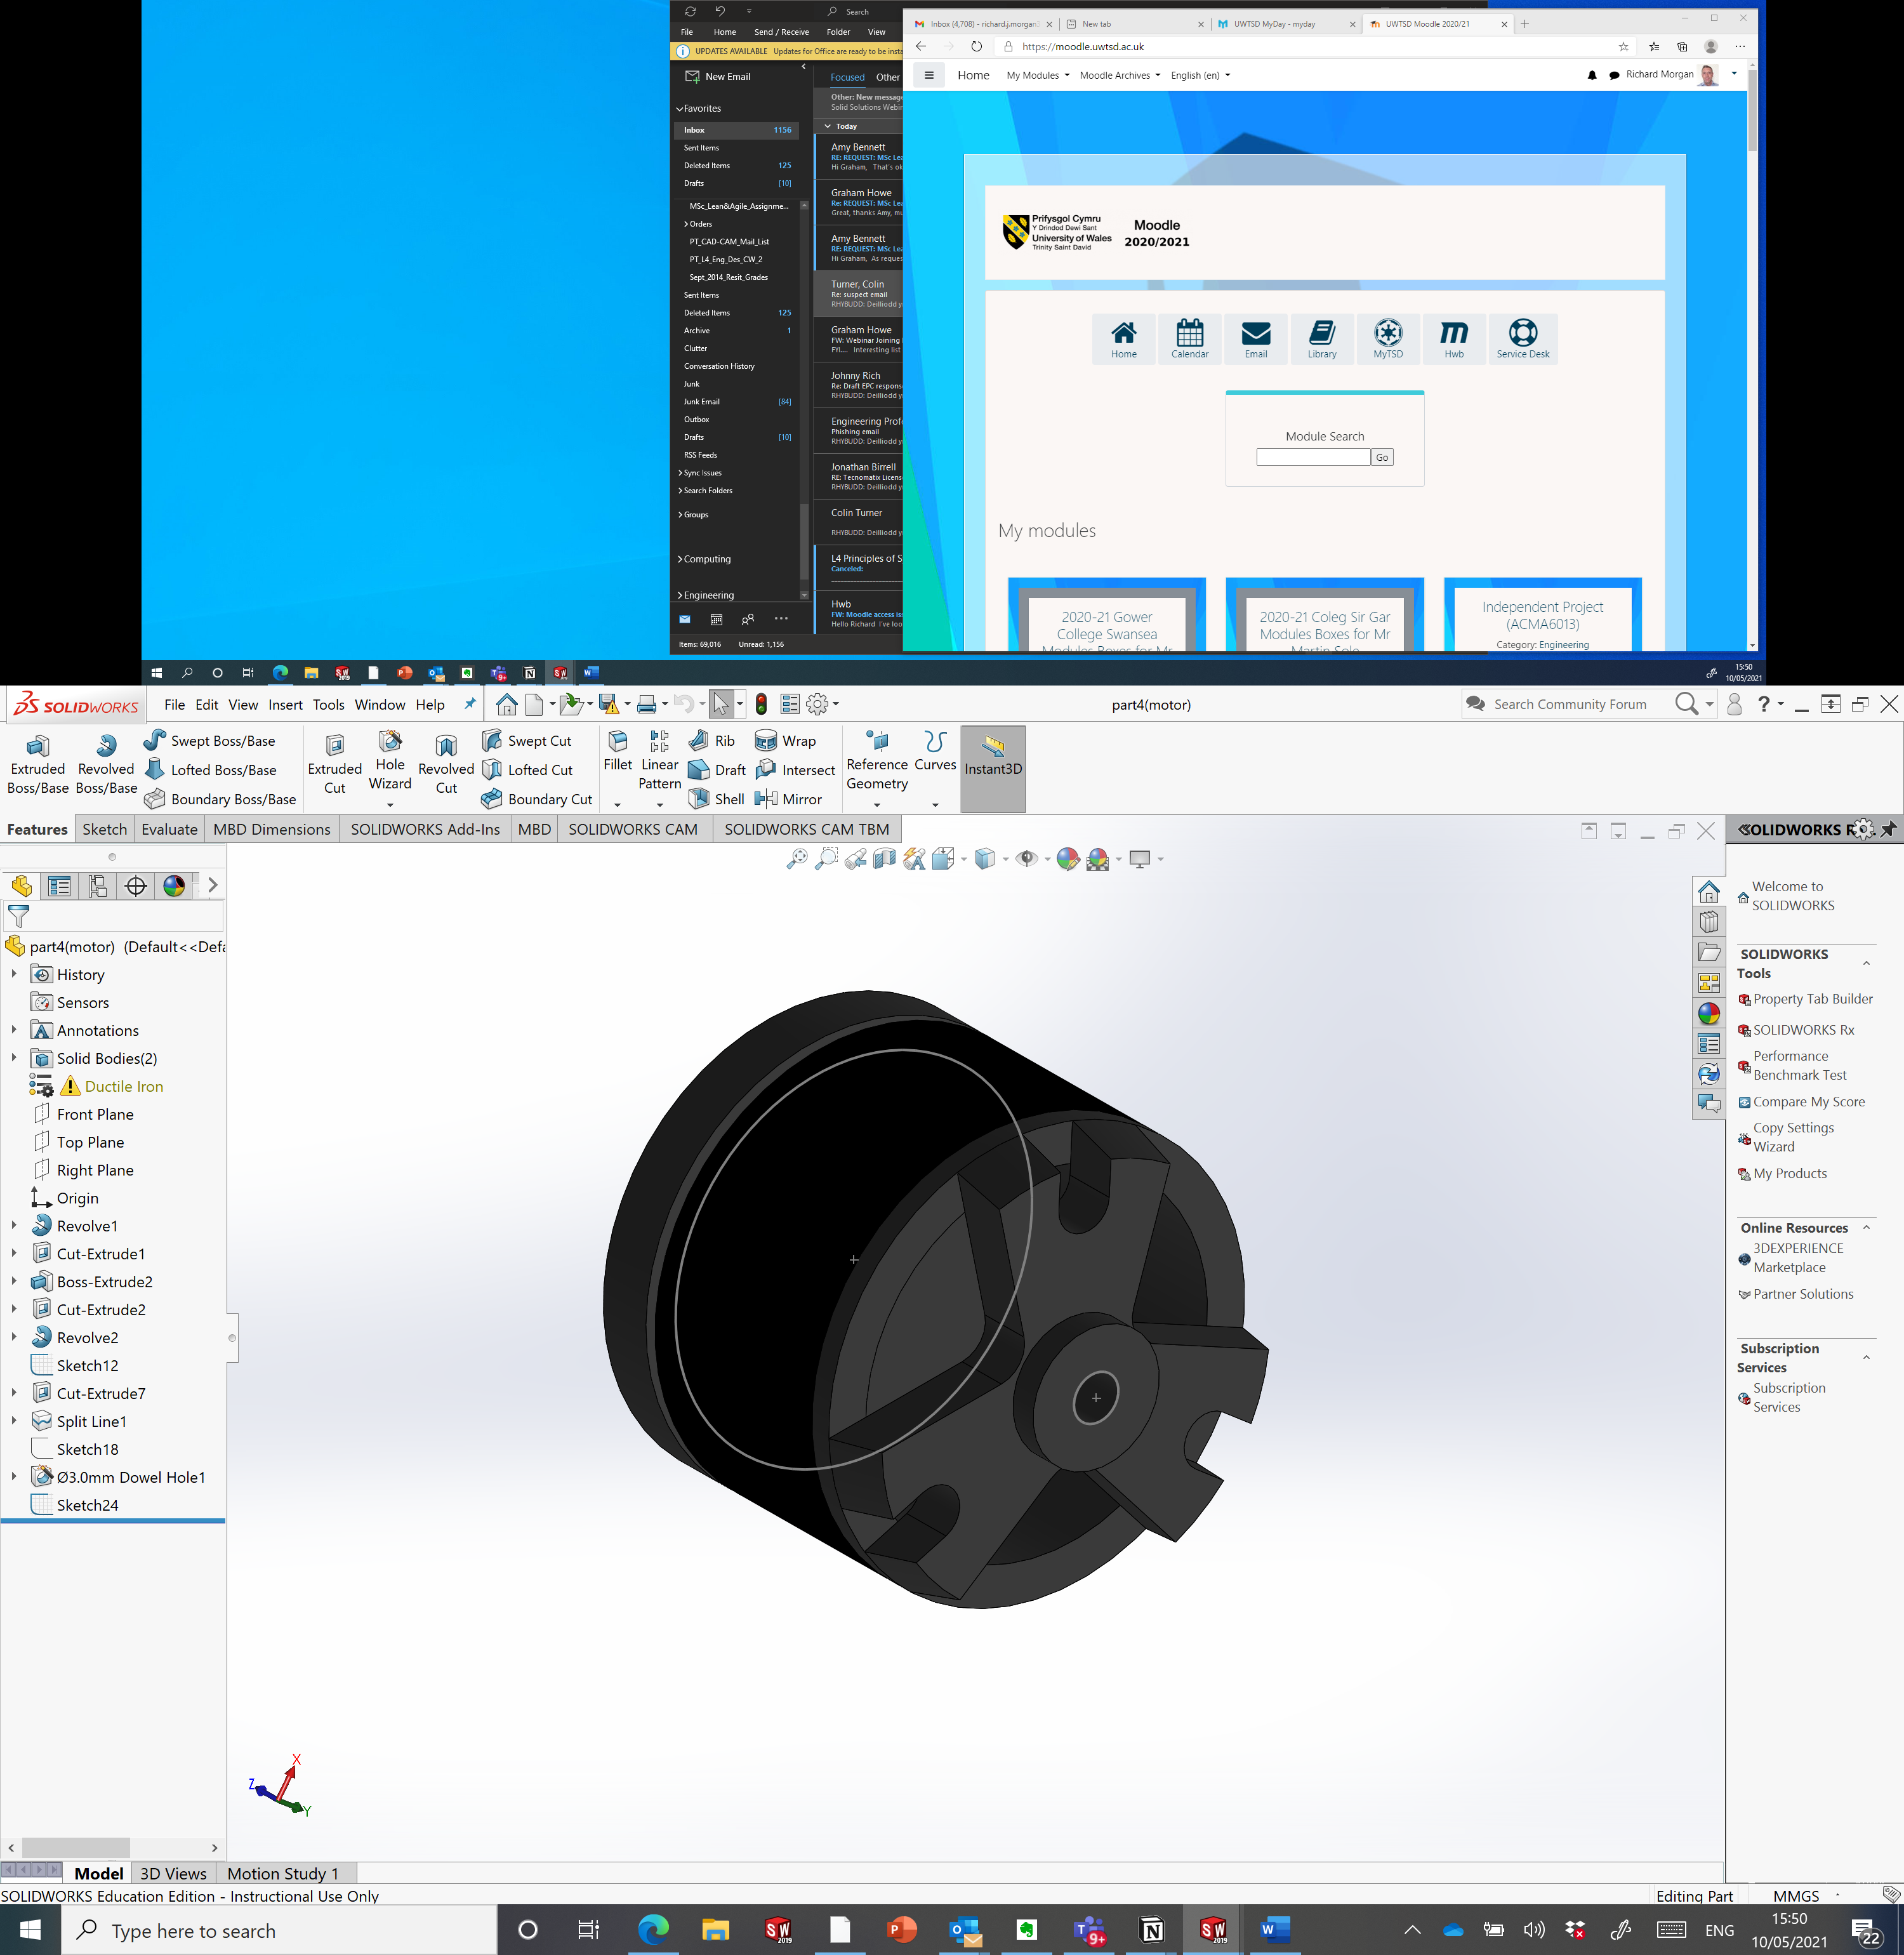

Joint –
The joint components will be laser cut due to their thickness. I chose this method as this will also allow for 100+ of them to be cut at once meaning these will most probably have the quickest lead time out of all the assembly components. There is nothing complex about their shape which makes them perfect for laser cutting. The laser cutter will also provide enough accuracy to keep the component within tolerance.
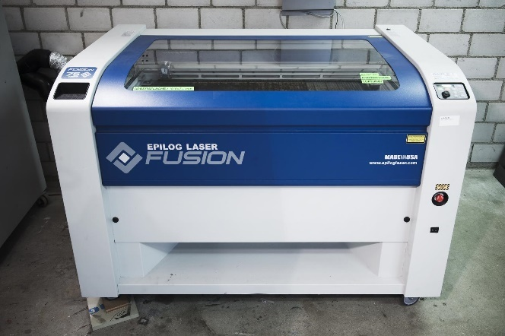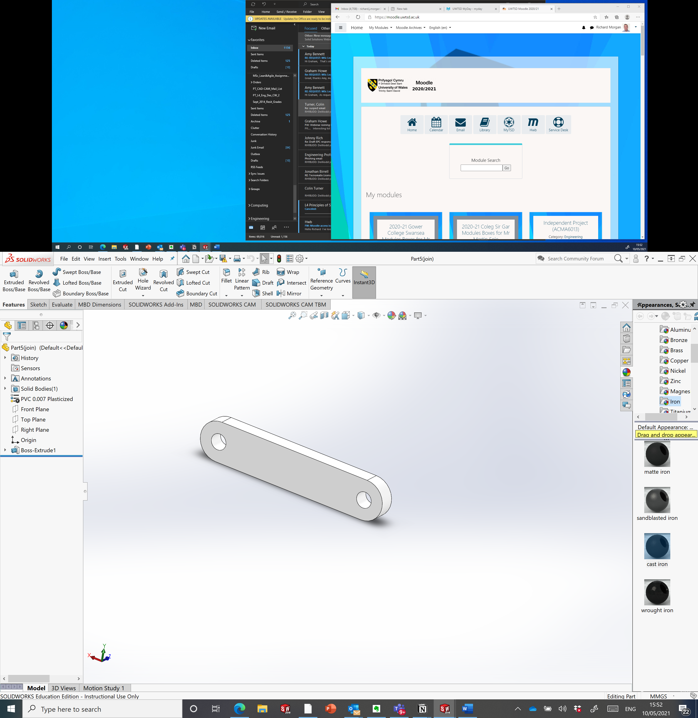
(Fusion Laser, 2019)

Manufacturing Process Design –

The sequence and layout of the proposed production process:
See the flow chart below where you can see each step of the manufacturing process from when the order is received to when it is dispatched to the customer.
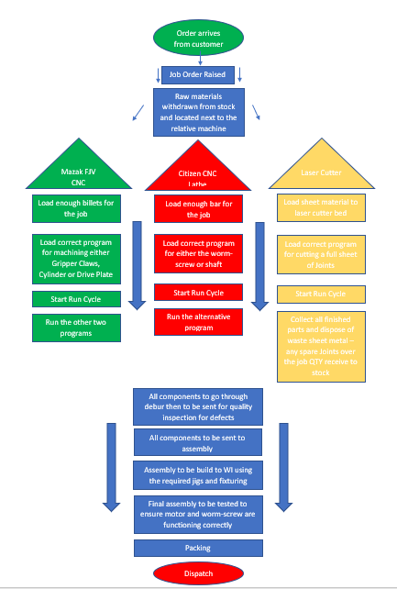

Conclusion –
To conclude I think that the concept design needs to be altered to allow for adaptation in the Co-bots grabber as stated above in this report. I think that two rectangular jaws will encompass a lot more components than a circular grabber system for most engineering firms, I also went down this route due to it being more relatable and useful to my company Renishaw plc as we are currently looking for a pick and place system to load our Gluebot trays. I believe that developed this product ethically think of the environmental impacts as well as choosing the most lean and suited manufacturing process. I carried out an FMEA on the developed product to find its weaknesses and threats, I then went on to minimize these potential risks. Overall, I believe that the product is eye catching aesthetically and will be very competitive in the market due to its cheaper manufacturing cost along with its simple mechanism and low serviceability.

Works Cited
Adept Machine Tools. (2019). https://adeptmachinetools.com. Retrieved from https://www.bing.com/images/search?view=detailV2&ccid=hvHiXD1P&id=C777F8E1225F1F3B90AE2CC84B82DF6530476933&thid=OIP.hvHiXD1PvXR5YWQtHy6KbAHaDN&mediaurl=https%3a%2f%2fadeptmachinetools.com%2fwp-content%2fuploads%2f2018%2f10%2fCAV-BAR-LOADERS.png&cdnurl=htt
Concept Draw. (2018). Concept Draw. Retrieved from https://www.bing.com/images/search?view=detailV2&ccid=68zdNATT&id=CCE8AAE8263E9C67494D2075963FD4FE39148B7B&thid=OIP.68zdNATTo6RC5KR2mV3GfAHaFw&mediaurl=https%3a%2f%2fth.bing.com%2fth%2fid%2fRebccdd3404d3a3a442e4a476995dc67c%3frik%3de4sUOf7UP5Z1IA%26riu%3d
Fusion Laser. (2019). Retrieved from Fusion laser cutters: https://www.bing.com/images/search?view=detailV2&ccid=rBWHARPY&id=117868EA1F1B8F152324B44ACE93A28849998B71&thid=OIP.rBWHARPYvWQZMVEFE2uccgHaE7&mediaurl=https%3a%2f%2fwww.dynamo.ch%2fsites%2fdefault%2ffiles%2fstyles%2flarge%2fpublic%2fdynamo-metall-lasercu
John Hart. (2019). www.johnhart.com.au. Retrieved from https://www.bing.com/images/search?view=detailV2&ccid=YAz76Z2Y&id=D3EF38A3E748834EA6F5965B421F378676B61995&thid=OIP.YAz76Z2Ya_DdBjGd8VabrgHaFj&mediaurl=https%3a%2f%2fwww.johnhart.com.au%2fimages%2fcnc-turning%2fMazak_quick-Turn-Smart-100S.png&cdnurl=https
leansixsigmatraining. (2010). Quality Function Deployment Tutorial. Retrieved from Youtube: https://www.bing.com/videos/search?q=Quality+Function+Deployment&&view=detail&mid=BCF4599EB6C7C345E976BCF4599EB6C7C345E976&&FORM=VRDGAR&ru=%2Fvideos%2Fsearch%3Fq%3DQuality%2BFunction%2BDeployment%26FORM%3DHDRSC3
Morgan, R. (2021). Moodle. Retrieved from ACMA5002 - Design Assignment.

