Name: Yanko Yankov
Reflective Portfolio
2023
Student Number: 2127550
Programme: Certificate in Higher Education Skills for the Workplace
Module Name: Professional Career Development
Lecturer: Masud Ibrahim

Swot Analysis and Personal Development Plan (PDP)
This portfolio represents me and what I’ve learned over this course. To present my personal qualities was elaborated a SWOT analysis. This analysis is commonly used by various entities when planning their strategies before a project to present all the internal and external factors that can impact the project (Namugenyi, et al., 2019). SWOT stands for Strengths, Weaknesses, Opportunities and Threats (Helms & Nixon, 2010).

SWOT analysis
Strengths | Weaknesses
- imaginative, open-minded, and curious  - value emotional expression and sensitivity  - very good at improvising and adapting to opportunities  - self-assured, even-tempered, and resistant to stress  - able to influence people around  - ability to fit in  - Excellent Communicator  - Good-natured | - Too confident at times  - Don’t tend to test my own limits  - Don’t ten to filter opinions  - Passion-driven rather than programmatic  - People-pleasing  - Unfocused  - Disorganised  - Overly accommodating  - Overly optimistic  - Restless
Opportunities | Threats
- Every problem is an opportunity | - Possible conflicts with teammates/ managers  - May have troubles of enacting programmatic plans.
Figure 1. SWOT analysis of Yanko Yankov
My self awareness allowed me to create the SWOT analysis above. Based on the points highlighted in it I can draw the
Objective | Time | Activities | Success Criteria | Resources
Short -Term
Improve organization skills and focus | 3 months | - creating a daily to-do list  - prioritising tasks  - setting aside specific times for work and relaxation | - completing tasks on time,  - feeling less overwhelmed,  - having a more structured routine | books, articles, or online courses on time management and organization
Develop better self-awareness | 6 months | - regular reflection,  - meditation, or  - seeking feedback from others | - being able to recognize personal strengths and weaknesses,  - understanding personal triggers for stress and anxiety,  - having a better understanding of how one's actions affect others | self-help books, mindfulness apps, or working with a coach or therapist
Improve decision-making skills | 3 months | - analysing past decisions,  - practising making decisions under pressure, and  - seeking input from others | - feeling more confident in decision-making,  - making more effective decisions, and  - having a better understanding of the consequences of different choices | books, courses, or workshops on decision-making
Develop stronger boundaries | 6 months | - setting clear boundaries with friends, family, and colleagues,  - practising saying no, and  - focusing on personal needs and goals | - feeling more empowered and less drained by social interactions,  - having more time and energy for personal pursuits, and  - feeling less resentful towards others | could include books, articles, or working with a therapist or coach
Long -Term
Improve leadership skills | 2 years | - seeking out leadership opportunities,  - taking courses or workshops on leadership, and  - seeking feedback from colleagues and mentors | - being able to inspire and motivate others,  - being able to delegate tasks effectively, and  - being able to resolve conflicts in a constructive manner | books, courses, or working with a coach or mentor
Cultivate greater emotional intelligence | 3 years | - practicing empathy and active listening,  - seeking feedback on emotional intelligence, and  - seeking out emotional intelligence training | - being able to understand and manage one's own emotions,  - being able to understand and empathize with others' emotions, and  - being able to build stronger relationships | books, courses, or working with a coach or therapist who specializes in emotional intelligence

The various Learning Styles

Kolb’s Experimental Learning Theory
Kolb’s Experiential Learning Theory teaches that learning is compiled by four separate constructs (Kayes, 2005):
Concrete experience (CE) which suggests the use of direct experience feelings and emotions in one’s interaction with the surrounding environment (Kayes, 2005);
“Reflective observation (RO) involves looking back on extant experience, recollecting details of the experience and gathering new information about the experience” (Kayes, 2005);
Abstract conceptualization (AO) draws conclusions out of previous experiences and elaborates a plan for future actions (Kayes, 2005)
Active experimentation (AE) puts the plan to the test by exercising it. Kolb’s theory is that these four constituents find themselves in two bipolar dimensions – one of them is related to collecting data, where CE counterweights AC and a dimension where data is being processed in which RO opposes AE (Kayes, 2005). One learns by using at least one of the four modules to deal with a learning problem. For example, a person can make their preferences for CE over AC or RO over AE when faced with a learning dilemma (Kayes, 2005).
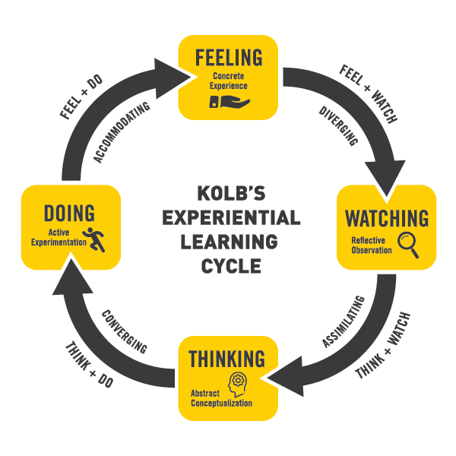
Figure 1 Kolb's learning style, Available at: https://www.uwindsor.ca/fahss/1005/what-experiential-education

Honey & Mumford
Along with several other learning styles the one described by Honey and Mumford is widely spread among business and academic structures (Penger & Takavcic, 2009). Being relatively similar to Kolb’s Experiential Learning Model (ELM), their style was developed several years based on the learning preferences of trainees. Finally, they came up with the Learning Style Questionnaire (Penger & Takavcic, 2009). Honey and Mumford have built their style by establishing four different types of learners:
The Activist group are like the group of active experimentation, defined by Kolb (Duff & Duff, 2002).
The Reflector corresponds with the reflective observation of Kolb’s style ( (Duff & Duff, 2002).
Theorist group reminds me of the abstract conceptualisation by Kolb (Duff & Duff, 2002).
Pragmatist duplicates concrete experience defined by Kolb (Duff & Duff, 2002).
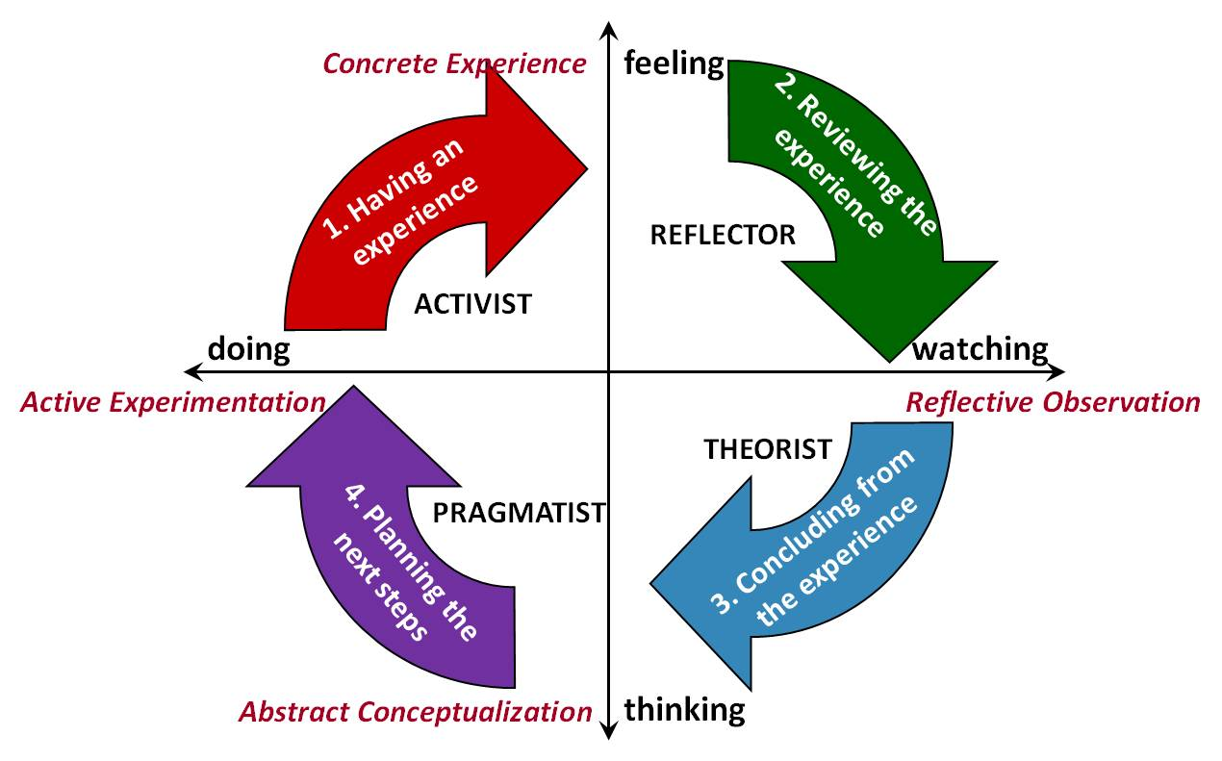
Figure 2. Honey & Mumford learning style, available at: https://realizeengineering.files.wordpress.com/2018/05/honeymumfordschematic.jpg

Neil Fleming’s learning Style
Neil Fleming has researched the VARK learning style (Joshi, et al., 2020). VARK stands for Visual (V), auditory(A), read-write (R/W), and kinaesthetic (K) (Joshi, et al., 2020). In contrast with the above, Fleming reviews the possibility for a learner to use more than one of the styles (Joshi, et al., 2020). They are considered the “multimodal learner group” (Joshi, et al., 2020). The VARK model has been widely utilised to analyse the learning styles of medical students among many other models on learning styles. According to the neurological system that a learner chooses to receive information through, the acronym VARK stands for four major sensory modes of learning: visual (V), aural (A), reading/writing (R/W), and kinesthetic (K). Visual learners learn through studying images, charts, graphs, videos, text, and graphics in multimedia elements, posters, concept maps, algorithms, mnemonics, and computer-based training modules. Podcasts, discussions, aloud reading, storytelling, audiobooks, and audio applications in multimedia elements all provide learning opportunities for auditory learners. Words and texts are preferred by readers and authors as a means of gathering information. Kinaesthetic learners are more inclined to engage in touch, feel, hold, and perform activities during their studies. They favour practical work, simulations, case studies, role-playing, dissection, field trips, and project-based learning. They also favour early clinical exposure. (Joshi, et al., 2020).
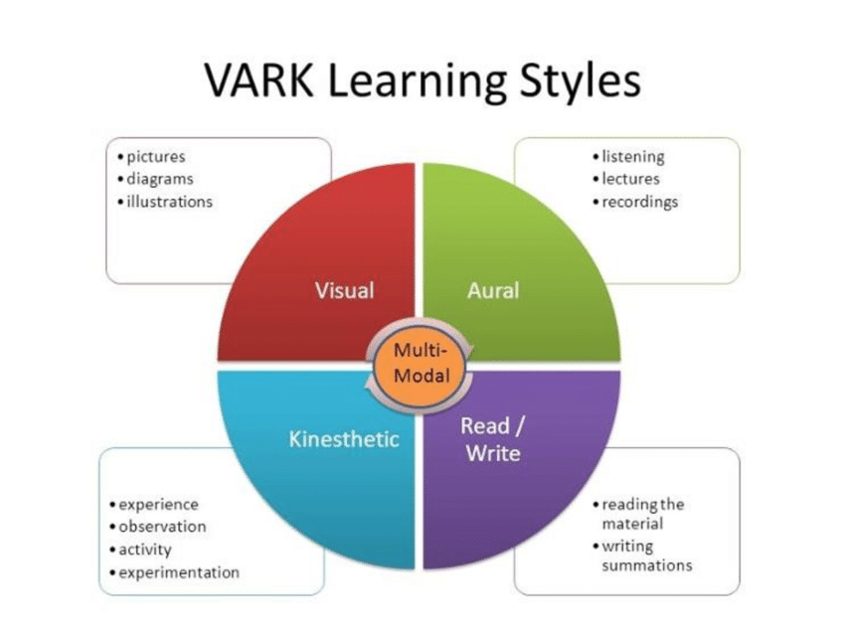
Figure 3. Neil Fleming’s learning Style, Available at: https://www.researchgate.net/figure/VARK-Learning-Styles_fig13_353018470

Summary of the module
This module has prepared me for recruitment process when applying for a new job, as well as for the events following successful selection. It aimed:
1. To introduce strategies for self-evaluation and career development planning.
2. To inspire effective employee confidence and competence in the trainees.
The structure of the module itself looks very similar to Kolb’s learning method where theory was put under consideration, past experiences were recalled (in the form of CVs) to serve as the building blocks for a plan that is going to affect the future. There was a practical part, when the trainees were able to touch and feel the selection and working process (Kayes, 2005).
Figure 1 visualises the Kolb’s learning style. Following the various position in the learning process, we can clearly match them with the events of the course.

Concrete experience
The cycle's initial phase, called Concrete Experience, involves learners having a new experience, such as taking part in a novel activity or coming across a novel circumstance. Self-awareness is the ability to become the focus of one's own attention (Morin, 2011). One actively identifies, processes, and saves information about the self in this condition (Morin, 2011).
Because it entails being present and totally immersed in the experience, paying attention to one's thoughts, feelings, and responses to the circumstance, self-awareness plays a vital part in this stage. Learners who are self-aware may recognise their strengths and shortcomings, prejudices, and preconceptions as well as how these things affect their performance and ability to learn.
Personal development plans are tools that assist people in identifying their objectives, areas of strength, and areas in need of development. Self-awareness is crucial for developing a personal development plan since it enables people to recognise their areas of strength and development.

Reflective observation
The second phase of the cycle is reflective observation, during which students consider their experiences from a variety of angles, including situation analysis, people-watching, and outcome evaluation (Kayes, 2005).
When studying employment law, students must consider the rules and laws that govern working relationships from a variety of angles. Reflective observation is essential to this approach because it aids students in understanding the legislation's purpose, the effects it will have on various stakeholders, and the circumstances in which it will be used. Learners can gain a greater grasp of the laws and rules governing employment interactions by reflecting on various scenarios and applying the law to actual situations (gov.uk, 1996).

Abstract conceptualisation
The third stage of the cycle, known as abstract conceptualization, is where students build abstract theories and concepts in response to their reflections and observations. This phase entails synthesis, generalisation, and application of concepts to fresh contexts.
Learners must evaluate their strengths, interests, and professional goals when considering their options after graduating from university. They must also create abstract concepts and theories based on their thoughts. Abstract conceptualization is essential to this process because it enables students to recognise connections, themes, and patterns in their past experiences and create a future plan.
Learners can gain a thorough grasp of their skills and shortcomings and how they relate to their professional aspirations by synthesising and generalising their ideas. With this approach, they can find other job choices.

Active Experimentation
The fourth stage of the cycle, Active Experimentation, is where students apply their newly acquired knowledge and abilities to actual circumstances and put their theories to the test.

Writing a resume and doing mock interviews are activities that actively experiment because they provide students the chance to employ their knowledge and abilities in real-world settings. Learners can practise and improve their communication, presentation, and job application techniques by taking part in simulated job interviews and CV writing.
In order to apply knowledge and abilities to real-world circumstances, active experimenting is essential in the learning process. This can improve learning outcomes and prepare students for future encounters.
Kolb's Experiential Learning Theory offers a valuable framework for understanding how individuals learn and develop through experience. The four stages of the cycle - Concrete Experience, Reflective Observation, Abstract Conceptualization, and Active Experimentation - offer a guide for learners to engage in a cyclical process that leads to deeper learning outcomes. The application of this theory to the development of personal and professional skills can lead to more effective learning and career success. (Duff & Duff, 2002)
Reflective observation plays a crucial role in personal and professional development by helping learners to analyze experiences from different perspectives. By engaging in reflective observation, learners can develop critical thinking skills and gain a deeper understanding of how their experiences shape their beliefs and values. In the context of studying employment legislation, reflective observation can help learners to understand the rationale behind the legislation, its impact on different stakeholders, and how it applies in various contexts (Dennison, 2010).
Abstract conceptualization is essential in identifying alternative career paths and developing a plan for the future. By synthesizing and generalizing their ideas, learners can develop a comprehensive understanding of their strengths and weaknesses and how they relate to their career goals. This process can help them identify alternative career paths and develop a plan to achieve their goals (Brockbank & McGill, 2007).
Active experimentation is crucial in enhancing learning outcomes and preparing learners for future experiences. By participating in mock job interviews and CV writing, learners can practice and refine their skills, which can help them succeed in their future careers.
In conclusion, Kolb's Experiential Learning Theory offers a powerful framework for personal and professional development. By engaging in a cyclical process of learning that includes concrete experience, reflective observation, abstract conceptualization, and active experimentation, individuals can develop a deeper understanding of their experiences, their strengths and weaknesses, and how to achieve their goals. Applying this theory to personal and professional development can lead to more effective learning outcomes and career success.

References
Brockbank, A. & McGill, I., (2007). Facilitating reflective learning in higher education. 2nd ed. Maidenhead: Open University Press.
Dennison, P., 2010. Reflective practice: The enduring influence of Kolb's Experimental Learning Theory. The Journal of Learning and Teaching at the University of Greenwich, 9(1), pp. 23-28.
Duff, A. & Duff, T., (2002). Psychometric properties of Honey & Mumford's Learning Styles Questionnaire (LSQ). Personality and Individual Differences, 33(1), pp. 147-163.
gov.uk, (1996). Employment Rights Act 1996. [Online]
Available at: Employment Rights Act 1996
[Accessed 28 March 2023].
Helms, M. & Nixon, J., (2010). Exploring SWOT analysis - where are we now?: A review of academic research from the last decade. Journal of Strategy and Management, 3(3), pp. 215-251.
Joshi, A., Upadhyay, H., Ganjiwale, J. & Patel, M., (2020). Preferred learning styles of medical students in an Indian medical school: Implications for learner-centered pedagogy in competency-based medical education. National Journal of Physiology, Pharmacy and Pharmacology, 10(10), pp. 845-850.
Kayes, C., (2005). Internal validity and reliable ability off kobes learning style inventory version 3 (1999). Journal of Business and Psychology, 20(2), pp. 249-257.
Morin, A., (2011). Self-Awareness Part 1: Definition, Measures, Effects, Functions, and Antecedents. Social and Personality Psychology Compass, 5(10), pp. 807-823.
Namugenyi, C., Nimmagadda, S. & Reiners, T., (2019). Design of a SWOT Analysis Model and its Evaluation in Diverse Digital Business Ecosystem Contexts. Procedia Computer Science, Volume 159, p. 1145–1154.
Penger, S. & Takavcic, M., (2009). Testing Dunn & Dunn's and Honey & Mumford's learning Style Theories: The Case o the Slovenian Higher Education System. Management : Journal of Contemporary Management Issues, 14(2), pp. 1-20.
Verdonschot, S., (2006). Methods to enhance reflective behaviour in innovation processes. Journal of European Industrial Training, 30(9), pp. 670-686.

