
Lewis Jones (1804902)
School: Engineering, Manufacturing and Logistics
Course: MSc (Hons) Engineering Project Management
Supervisor: Andrew Thorn
Designing a CFD simulation to determine damper pressure drop
Major Project (M7X01373)

Executive Summary

An investigation has been conducted into the feasibility of using a Computational Fluid Dynamics (CFD) simulation provided by the 3D modelling software SolidWorks to accurately determine the effect a damper has on duct pressure within a HVAC system. The investigations were validated by construction of a test rig to produce data on a physical model for a comparison where the goal was to achieve a similarity of ten percent to simulated values.
The project was divided into five phases in order to track key milestones, the first phase was to identify the problem and to determine the scope and desired outcomes, this was discussed above. The second phase included research into the topic area in both an academic and industry related standards. The standard BS EN 1751 showed the author the approved methodology of how to test the pressure drop in a damper and provided the dimensions and requirements needed to construct a rig to carry out physical testing. Furthermore, the author researched case studies and academic literature to examine previous works carried out to gain insight into reliability and accuracy of any simulated results achieved. This highlighted to the author the importance of several factors of CFD simulations including the fact that result accuracy is heavily dependent on these values inputted by the user.
Following this research, the construction phase of the project can begin, and the testing rig can be constructed. Once constructed the rig would then be calibrated as per the procedure that has been written and simulation testing can begin. Moving onto the simulation phase, the author determined it was necessary to test the initial boundary conditions and settings of the simulation as research indicated this was integral to achieving a set of accurate data. This initial simulation showed a difference of less than ten percent when comparing the physical tested static rig pressure versus the simulated static rig pressure. The author was satisfied with this and believes it indicated robust modelling of the rig and simulation settings meaning any later refinement work could be focused on the damper as the rig had been previously validated.
After this initial validation the damper was modelled into the simulation and the initial conditions for the validation study were mimicked. This however, provided results deemed unacceptable by the author with a maximum difference of 10.52 pascals (Pa), the author then began a mesh refinement study in an attempt to improve the accuracy. A feature provided by SolidWorks, known as a local region mesh, was used to envelop the damper and effectively dividing the existing elements around the area by two as specified by the author. The author wished to only refine as small of an area as possible as by increasing the cell count of the simulation the computational power and time is also increased proportionally. Therefore, the damper was selected as it is the subject of this study and 0.5 meters before and after to ensure enough space to demonstrate the full effect the damper will have on the air flow. By utilising this method, the author was able to refine the results to an acceptable level showing a difference of 3.85 Pa in the worst case and 0.05 Pa in the best case.

Acknowledgements

I would like to thank the following people, without whom I would not have been able to complete this research, and without whom I would not have made it through this journey to achieve my master’s degree.
Firstly, the team at the University of Wales Trinity Saint David, especially to my supervisor Andrew Thorn for providing valuable feedback throughout the project stages and experience helped to make this possible. Following this, I would also like to thank Rob Green also with the university for his expertise in CFD analysis provided a valuable insight and guided the decision-making when preforming the analysis.
Secondly, I would like to extend my gratitude to Flamgard Calidair Ltd who were instrumental in making this project possible by providing me with the time and resources to make all this possible. Specifically, I would like to thank Steve Edwards and Lee Bramald for giving me this opportunity to carry out this degree for the past three years, and I would also like to thank Tim Cook and John Greathead, whose knowledge of dampers and the regulation governing their manufacture aided me massively with the theoretical elements of the research.
Lastly but by no means least I would like to thank my girlfriend Chloe Stockton whose unending support and encouragement kept me going throughout the process, without her support I wouldn’t be here today. Also, a thank you to my parents Rob and Maria Jones who have seen me through various challenges throughout my lifetime.

Declaration Statement

This thesis is the result of the author’s original research. It has been composed by the author and has not been previously submitted for examination which has led to the award of a degree.

Signed: ___________________ (Lewis Jones) Date: 15/04/2021

Contents

Executive Summary 1
Acknowledgements 3
Declaration Statement 4
Contents 5
List of Tables & Figures 7
Introduction 8
Project Plan 10
Research Phase 11
Research Related Industry Standards 12
Designing the Test Rig 13
Literature Review 15
What is CFD? 15
How Does CFD Work? 16
Pre-processor 17
Solver 17
Post-processor 18
Why Use SolidWorks? 19
Setting Appropriate Boundary Conditions 21
Inlet Boundary 21
Outlet Boundary 22
Wall Boundary 22
Defining & Refining a Mesh 23
Structured Mesh 24
Unstructured Mesh 24
The Immersed Body Mesh 25
Testing Phase 26
Calibration Procedure 26
Damper Test Procedure 34
Flamgard Pressure Drop Testing Procedure 34
Purpose 34
Criteria 34
Test Specimen 34
Test Rig 34
Instrumentation and measuring equipment (per duct section) 34
Procedure 35
Stage One 35
Stage Two 35
Results 36
Simulation Design 36
Simulation Set-Up 37
Boundary Conditions 44
Goals 45
Calibration Test Results 47
Final Simulation Design 49
Testing Results 50
Validation Phase 52
Discussion 53
Limitations and Recommendations 54
Conclusions and Future Work 55
Conclusion 55
Future Work 57
References 58

List of Tables & Figures

Table 1 - Calibration Simulation Table 49
Table 2 - First Set of Simulated Results 52
Table 3 - Results After Refinement 53
Table 4 - Dampers That Have Been Physically Tested 55

Figure 1- Project Plan Summary 11
Figure 2- BS EN 1751 Test Rig Recommendation 13
Figure 3- 1m Test Rig 15
Figure 4 - 0.6m Test Rig 15
Figure 5 - 0.3m Test Rig 16
Figure 6 - Blanking Plates 28
Figure 7 - Temperature Sensor Input 29
Figure 8 - Pressure Connecting Points 29
Figure 9 - K factor Input 30
Figure 10 - Settings Screen 30
Figure 11 - Atmospheric Pressure Input 31
Figure 12 - Manometer 31
Figure 13 - Fan Speed Monitor 32
Figure 14 - Remote Fan Speed Control 32
Figure 15 - FCO510 Flow Reading 32
Figure 16 - 0.3m Flow Traverse Points 33
Figure 17 - 0.6m Flow Traverse Points 33
Figure 18 - 1m Flow Traverse Point 34
Figure 19 - Pitot Tube Orientation 34
Figure 20 - Calibration Sheet 35
Figure 21 - Damper Pressure Drop Form 38
Figure 22 - Simulation Wizard 39
Figure 23 - Initial Condition Settings 40
Figure 24 - Analysis Type 41
Figure 25 - Fluid Selection 43
Figure 26 - Wall Condition and Surface Roughness 44
Figure 27 - Flow Parameters 45
Figure 28 - Test Rig Model 45
Figure 29 - Inlet Velocity Condition 46
Figure 30 - Outlet Pressure Condition 47
Figure 31 - Inlet Pressure Goal 48
Figure 32 - Outlet Pressure Goal 49
Figure 33- Simplified Damper Test Rig 51
Figure 34 - 1m/s Flow Trajectory 52
Figure 35 - 15m/s Flow Trajectory 52
Figure 36 - Mesh Refinement Region 53

Introduction

Flamgard Calidair is a globally recognised authority in the design and manufacture of high quality and integrity specialist H\eating Ventilation and Air Conditioning (HVAC) dampers and associated equipment. Their products boast a global operation across multiple industries including Nuclear, Oil & Gas, Power Generation and Tunnel & Metro. In an effort to maintain this status, the company has created and opportunity for this author to focus upon Research and Development (R&D) and innovate testing procedures to advance the business and ensure the company remains competitive across all sectors. As different projects require different specific elements such as the addition of insulation, certain testing practices need to be carried out to ensure compliance to customer specifications and the highest quality is maintained. The most commonly requested test on any new Flamgard dampers is described as a “pressure drop” test. This test aims to determine the difference in air pressure within the ducting on both sides of the damper, thus understanding the effect the damper has on the airflow. This phenomenon is described as damper pressure drop across various industries hence the name of the test. As air is drawn through ductwork with a damper fitted within, that damper will create a resistance to the airflow (Marivani AND Hamed, 2017). If additional features are including to the damper such as insulation or strengthening beams for larger sizes, these may cause and increased pressure within the duct and waste energy while increasing the wear of the fan, as it must now spin faster to maintain the desired flow rate (Guo et al., 2017). Therefore, by carrying out this test Flamgard can determine the exact effect these additions and if any design changes have increased the pressure to undesirable levels.
Flamgard currently have the means to perform this testing however, there is a certain procedure that must be followed and certain parameters that must be meet. For example, an existing test rig has been manufactured according to relevant standards at one meter squared as this is the largest damper module size. This means currently Flamgard only has the capacity to pressure drop test at one size and every sample has to be physically manufactured at cost to the business with materials and labour, there is also the element of time required for manufacturing. Therefore, Flamgard must include a longer lead time when conducting R&D on customer projects and include cost for manufacture, not to mention if any changes are required due to a discovery while conducting R&D time and labour is again required for re-work and potentially remanufacturing of the damper. To combat this, the author proposed that this testing process is simulated through a Computational Flow Dynamics (CFD) software created by Dassault Systemes called SolidWorks. Thus, enabling Flamgard to carry out pressure drop testing in the early stage of damper design, thus reducing the R&D cost to Flamgard as the damper will not need to be manufactured and numeral simulations can be carried per day on dampers with various modifications. Furthermore, if Flamgard has a reduced R&D cost these savings could be passed on to the customer and make the company more competitive. Therefore, the aim of this project is to research and create a flow simulation using the CAD software SolidWorks to accurately predict the effect of pressure drop of a HVAC damper within a duct.
Before creation of the simulation can begin research must be conducted on various areas as there are key points the author must consider to ensure this simulation will be accepted within industry. For example, the author must examine the software that way carries out and produce simulated variables, by examining literature from academic sources such as Ramlan AND Darlis (2019) who examine the use of its CFD package in the automotive sector and describe the ease of use of the flow simulation package and its increased use within modern industry. However, despite what software is being used the size of the data sample is critical to validating results. Thus, the author felt that using just a one-meter squared damper would not provide an adequate data sample to be able to justify the simulations results therefore to achieve this aim, a selection of different size dampers will need to be tested to ensure the simulation can be validated when doing multiple studies across a range of various damper sizes. The new rig will then feature ductwork suitable for dampers at 300mm², 600mm², 1m² to ensure a large amount of data is available for the validation stage. To ensure these results and testing would be valid and able to be industry recognised standard documents would have to be reviewed to ensure compliance British Standards document number EN 1751. Once this is confirmed and the rig has been constructed, dampers going through the shop floor at the previous given sizes could be tested to create the data sample required to allow the author to compare any simulated values to achieve a ten percent accuracy.

Project Plan

The initial phase is to create a project plan using the Microsoft package Excel, to enable the author to keep track of all tasks associated with the project and ensure the project is completed within the agreed upon time.
Figure 1- Project Plan Summary
The project has been separated into five phases:
- Planning Phase – In this phase the author will identify methods and aim to improve upon a testing procedure to provide Flamgard Calidair with a simulation to provide rapid pressure drop testing results to potential customers at the project quotation phase.
- Research Phase – This phase will allow the author begin reviewing industry standards to ensure any testing procedures or simulations conform to standards. Furthermore, the author can also review academic literature for best practices regarding CFD simulation design.
- Construction Phase – Once standards have been reviewed this phase’s purpose is to create a suitable test rig to enable physical testing to carry out on dampers. It will also allow for calibration of any associated testing equipment to ensure accuracy of any results.
- Testing Phase – This phase has two parts, one is to begin testing dampers to achieve a wide range of data to be used in later stages, while the author carries out an initial simulation design using the same testing procedure.
- Validation Phase – Once both physical and simulated testing have been carried the two can be compared and adjusted until an accuracy of ten percent has been achieved. Once achieved it will be presented to the directors of Flamgard Calidair for approval and the project will be completed.
The project has been broken into phases to allow the author to hold review once each phase has been completed. This will enable the author to determine if the project is keeping to its intended schedule, operating within budget and has successfully produced all of the required deliverables to date (Naybour, 2018). A Gantt chart has also been created (APPENDIX A) to graphically represent project stages and progress.

Research Phase
This phase’s purpose is to allow the author to gather information across multiple sources to ensure the rigor of any simulation designed and all testing equipment and practices will be in accordance to relevant industry standards, Thus the simulation may be able to be accredited by a professional body later and Flamgard’s customers can be confident in the results that have been achieved. Furthermore, it allows the author the opportunity to examine other individuals who have created similar simulations and learn valuable lessons that will aid the author in designing simulation to optimise design time. All research used for this purpose will be from academic journals and will be peer reviewed to again ensure academic rigor of this work. Firstly, the author will look into relevant industry standards.

Research Related Industry Standards

Initial research directed the author to the British Standard (BS) document EN 1751 “Ventilation for Buildings – Air Terminal Devices – Aerodynamic Testing of Dampers and Valves”. This document specifies the methodology for testing and rating of dampers to be used in air distribution systems, more specifically within section six of the document it discusses the determination of flow rate and pressure testing requirements. Therefore, before any test rigs can be constructed this document must be reviewed to ensure any data obtained is valid. The recommendations found in this document will be summarised below:
- Before testing can begin the damper to be tested must be mounted in a system containing a fan, a means of controlling the air flow rate within the test rig, a flow rate measuring system and test ducting. Figure 2 illustrates the requirements for the test rig and has been taken from the standards document.

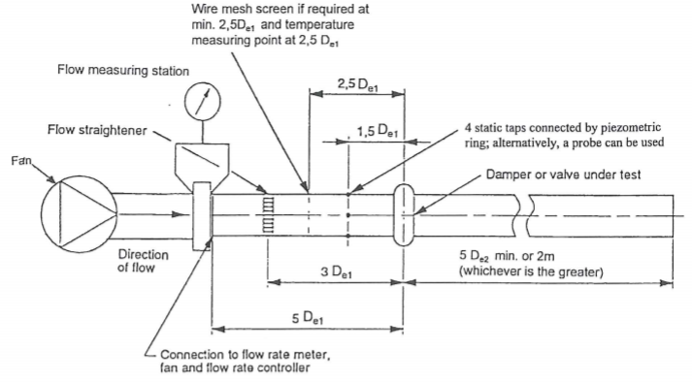
Figure 2- BS EN 1751 Test Rig Recommendation
- The ducting for the test rig must have the same cross-sectional dimensions as the damper being tested, so if a 1m² damper is being tested, the cross-sectional area of the duct must be 1m². The upstream test duct must be straight for a minimum length of five times the damper cross-section, indicated in figure 1 as “5 D_{e1}”. The downstream duct must also be straight for a minimum length of five times the damper cross-section or on smaller units two meters, the figure that is the greatest must be used. This is indicated in Figure 2 as “5 D_{e2}”.
- The reason for the long straight duct is to minimise the risk of a turbulent flow manifesting within the test rig, to further combat this, the standard document requires flow straighteners to be fitted before the damper in the test rig. This flow straighteners must be fitted 3 times the damper cross-section, indicated in figure 1 as “3 D_{e1}”. It also allows when necessary the addition wire mesh screens to be placed at two and half times Infront of the damper to ensure and achieve a suitably uniform velocity profile. It is denoted as “2.5 D_{e1}” within figure 2.
- Finally, the instrumentation required to measure pressure has been specified, the document states that the upstream duct static pressure can be measured using a single probe pitot static tube at the centre of the ductwork. This measuring point must be placed at one and half times the damper cross section, denoted as “1.5 D_{e1}” within figure 2.
Taking these key points into account the author can now begin the designing process of the multiple test rigs.

Designing the Test Rig

As stated above the test rig must be designed to BS EN 1751 to ensure conformance to industry standards. Furthermore, in order to ensure the maximum number data is available for the simulation three duct sizes will be constructed, one at 300mm², 600mm², 1m². The sketches below show the individual rig designs while factoring relevant standards. As all rigs will be joined to the same fan a plenum has been fitted to the front of the fan with to allow one fan to run all three ducts and to minimise space usage. However, there will never be multiple sizes running at the same time, a blanking plate will be fitted to those not in use so they do not cause any fluctuation in test results.
Below are drawings of the new test rig which accommodates three sizes (1m2, 600m2, 300m2) to ensure a good data range and the simulation can be used across multiple sizes:
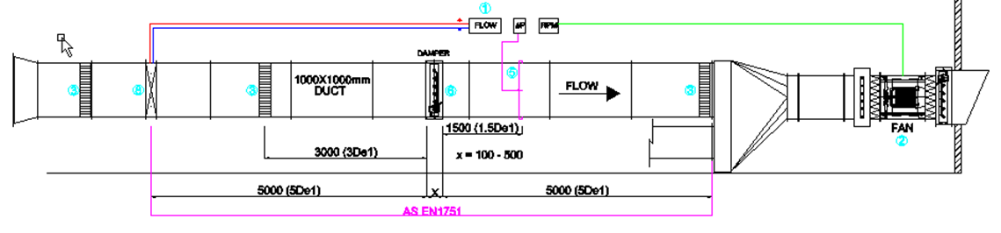
Figure 3- 1m Test Rig

The new design is manufactured in accordance with standards as shown the value (1.5 De1) where De1 is the damper size so 1.5De1 = 1.5 x 1000. Thus, the pressure monitoring equipment is 1500mm away from the damper.

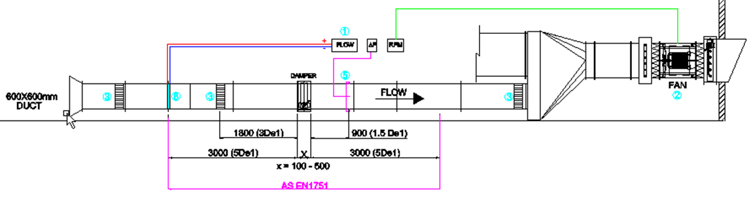
Figure 4 - 0.6m Test Rig

The additional sizes have also been designed in accordance with BS EN 1751. Again, using the 300mm square duct as an example, De1 in the 0.3m2 is equal to 300mm therefore, 1.5 De1 for the pressure monitoring equipment must be 1.5 x 300 = 450mm.
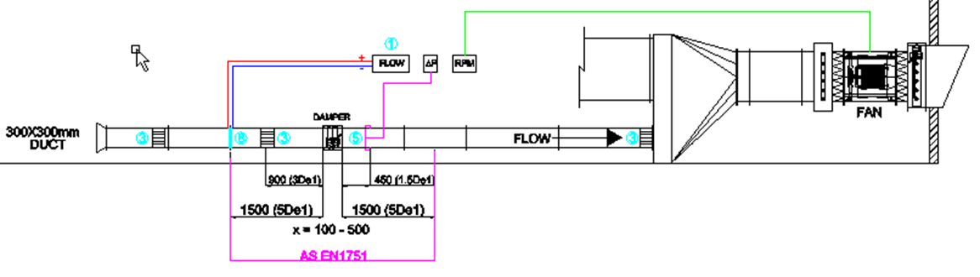
As the rig design has been confirmed and the materials can be placed on order the author will review academic literature and relevant case studies in preparation for creating the simulation.
Figure 5 - 0.3m Test Rig

Literature Review

What is CFD?

Computational Fluid Dynamics (CFD) is the analysis of systems concerning the flow of fluid, heat transfer and associated phenomena including chemical reactions by method of computer-based simulations (Versteeg AND Malalasekera, 2007). This methodology is a very powerful and extends to a wide range of industrial and non- industrial applications, some examples of these are:
- Aerodynamics of aircraft and vehicles
- Environmental engineering (distribution of pollutants)
- Biomedical engineering (Blood flow through arteries)
- External and internal environments of buildings (heating, ventilation and air conditioning)
There a several unique advantages to preforming this type of study, for example, the user is allowed to preform experiments under hazardous conditions that would normally be impossible to replicate safely, such as extreme levels of radiation (Morozova et al., 2020). Furthermore, it allows business to turn around designs and concepts at vastly reduced lead times due to no need of manufacture, which will in turn reduce cost’s (Morozova et al., 2020). However, the disadvantage to this system is the high costs associated with purchasing and subscribing to the required software (Perone et al., 2021). Versteeg AND Malalasekera (2007) in their text have estimated the minimum cost of the hardware required to be able to run software between five thousand and ten thousand pounds excluding any maintenance costs. Moreover, the perpetual licence fee for commercial software naturally can range between ten thousand pounds to anywhere up to fifty thousand pounds, this can depend upon the number of extra features desired by the company (Gebraad et al., 2016). The investment required to obtain this software therefore is not small, but the total expense is not normally as great as the cost required to use a high-quality experimental facility (Versteeg AND Malalasekera, 2007). Despite these high costs it is Versteeg AND Malalasekera (2007) belief that the variable cost of an experiment such as, hiring an appropriate facility including personnel hour costs, is related to the number of data points and the number of configurations to be tested. Whereas, CFD codes are able to produce extremely large volumes of data for results at virtuality no added expense, however, a specifically trained operator will be required to optimise and run this program or there is risk of data being invalid or models being created incorrectly (Haddadi et al., 2016).

How Does CFD Work?

CFD codes are structured around the numerical algorithms that can tackle fluid flow problems. In order to offer easy access to their solving power commercial CFD packages include sophisticated user interfaces to input parameters of a problem and to examine the results (Misev AND Hills, 2018). Hence, all codes contain three main elements:
- A Pre-processor
- A Solver
- A Post-processor

Pre-processor

Pre-processing consists of the input of the problem to be investigated by the CFD program, by the means of an operator-friendly interface and subsequent transformation of this input into a form suitable to be used by the solver (Hariharan AND Sivashanmugam, 2018). As per the literature written by Versteeg AND Malalasekera (2007) activities by the user required in the pre-processing stage include:
- The definition of the studies geometry of the region of interest, or as it commonly known the computational domain. In this case the test rig
- Generating a “grid” or it is more commonly known as the mesh of cells is the sub division of the domain into a smaller number of non-overlapping sub domains.
- Selection of the physical or chemical phenomena that will need to be modelled, in this case the damper to be tested.
- The definition of the fluid properties, for example in this case it will be air at atmospheric pressure.
- The specification of appropriate boundary conditions at which cells will coincide with or touch the domain boundary.
The solution to a flow problem (e.g. the pressure drop) is defined at nodes inside each cell, thus the accuracy of any CFD solution is governed by the number of cells within the studies mesh (Martins et al., 2014). So, the greater number of cells present within a study the better the accuracy of the solution, however the trade-off is to achieve this computational accuracy is the time required to complete the study (DesJardin et al., 2017). Therefore, the accuracy of a solution and it’s cost in terms of calculation and required computer hardware are dependent upon the fineness of the mesh, this can be optimised but this will be discussed in more detail later.

Solver
There are three distinct streams of numerical solution techniques:
- Finite difference
- Finite element
- Finite volume
However, for the purpose of this research the Finite Volume Method (FVM) which is a special finite difference formulation that is fundamental to the most well-established CFD codes, such as the software of the authors choice SolidWorks. In summary the numerical algorithm comprises of the following steps:
- Integration of the governing equations of fluid flow over all the (finite) control volumes of the computational domain.
- Discretisation, this is the conversion of the resulting integral equations into a system of algebraic equations.
- Solution of the algebraic equations by an iterative method.
The FVM is a method for representing and appraising partial differential equations in the form of algebraic equations (Chernyshenko et al., 2018). Similar to the finite element method values are calculated at discrete places on a meshed geometry. “Finite Volume” denotes the small volume surrounding each node point on a mesh, in FVM, volume integrals in a partial differential equation that contain a divergence term are converted to surface integrals, using the divergence theorem (Chernyshenko et al., 2018). These terms are assessed as fluxes at the surface of each finite volume, because the flux entering a given volume is identical to that leaving the adjacent volume, these methods are considered conservative (Li et al., 2017). This method boasts an advantage in memory usage and solution speed, particularly in larger problems, such as problems including problems with high Reynolds number turbulent flows and source term dominated flows (e.g. combustion) (Clain et al., 2011).

Post-processor
Due to the increased popularity of engineering workstations which have developed increasingly impressive graphic capabilities, allot of development work has been carried out within this field (Niemeyer et al., 2014). Therefore, leading CFD packages such as SolidWorks are now equipped with tools enabling the user to visualise various results such as;
- Particle tracking, the ability to view the flow of the fluid within the computational domain.
- View manipulation, the user is able is able to rotate and scale the model to examine various features close up.
- Surface plots, these can be either 2D or 3D to enable the user to examine points where for example there is high pressure or a disruption of flow.
SolidWorks now also includes the facilities to show animations to aid designers with dynamic results display, and in addition to graphics all codes produce reliable alphanumeric output (McLoughlin AND Farren, 2020). However again this is dependent on the ability of the simulation creator. As in other areas of Computer Aided Engineering (CAE) this process has revolutionised the communication of ideas to the non-specialist.
Now the theory behind CFD has been explored, the author will now look into the validity of using SolidWorks to carry out this research.

Why Use SolidWorks?
Before the analysis and any simulation design can begin, the author wishes to consult with academic journals to ensure the validity of the software analysis will be carried out. This is to give customers and users confidence that any data generated through this study will be accurate. The first study to be analysed was conducted by Joseph Wallace (2017) titled “Investigation of SOLIDWORKS Flow Simulation as a Valid Tool for Analysing Airfoil Performance Characteristics in Low Reynolds Number Flows”. Wallace (2017) begins by discussing a key advantage of the software, the ability to create rapid prototypes and testing units that may not be possible to replicate within the real world, such as hazardous environments within offshore rigs or nuclear power stations. In this case the author can create a wind tunnel or a ducted network across a building. Thus, allowing the organisation to preform test’s on various designs at higher rates due to a reduced timeframe and cost’s due to no need for physical manufacturing and material lead times (Wallace, 2017). This point is reaffirmed by Ramlan AND Darlis (2020) who discussed the use of CFD simulations specifically SolidWorks and ANSYS CFX within the automotive sector with the advantages of reducing lead times within Research and Development (R&D) projects in the aid of providing an organisation with a competitive advantage. Wallace (2017) further discusses the advantages to this software is the ability to create and control the environment of which the subject will be tested within. More specifically, regarding this dissertation topic, when designing a HVAC system. It allows the users to design an efficient ventilation setup with the purpose of; minimising energy use, thermal comfort of the occupants and predictive control of building HVAC systems using real-time weather inputs (Morozova et al., 2018). Therefore, the author can input conditions of the flow and necessary manipulations fluid type, velocity of the fluid and typical climate of the location where the damper will be placed, thus providing tailored results for clients based upon client location. However, this software does come with disadvantages using both CFD and this specific software, specifically the accuracy of any CFD solution is only good as the initial boundary conditions set to the numerical model (Ramlan AND Darlis, 2020). A boundary condition defines the inputs of the simulation model, these include conditions such as; velocity and volumetric flow rate determine how the fluid enters or exits the model. Other conditions such as; film coefficient and heat flux determine the interchange of energy between the model and its surroundings (Patel, 2013). Furthermore, boundary conditions link the model being simulated to its surrounding’s so if these conditions are not set correctly and are not properly defined any results may be inaccurate and unreliable (Ahmadi AND Sefidwash, 2018). Moreover, to maximise the accuracy of a simulation the subject of the study will require specific material properties and spatial conditions to truly understand the behaviour in a specific environment (Wynn AND Clarkson, 2018). Some users may be inexperienced with material properties leading to an inaccurate result; however, SolidWorks is equipped with a varied material library to input these values in for users to ensure validity of work (Wallace, 2017). There is also another limitation to this software, it may be able to carry out a number of various tasks, it is important to know that there are certain tasks that it will not directly model. This includes directly modelling chemically reacting flows like combustion despite being able to model heat generation in a solid or fluid which can be used to model the energy from a combustion process (Bock, 2015). It will however, model mixed gas flows such as a fuel gas in air, allowing modelling of fuel/air ratios under divergent conditions. This capability has clear application to modelling the flow of fugitive fuel gas that may have preceded a gas explosion. Flow Simulation will also not directly model radiant exchange between a gas (including ionized gases like a flame) and a solid to include decrease of radiant exchange by an absorbing medium such as water vapor (Bock, 2015). However, for the purpose of this study this feature is not relevant and therefore not be considered by the author.

Setting Appropriate Boundary Conditions
The previous section highlighted the importance of proper boundary conditions to determine the accuracy of the study and the validity of the results. Therefore, the author wished to dedicate a section of this review to better understand boundary conditions of a study and ensure accuracy of the authors simulations. The literature prepared by CFDyna (2017) discussing the different types of boundary conditions and their applications and limitations within CFD. In any simulation involving a fluid, in this case air at atmospheric pressure, there must be an entry and exit for the fluid and as the project is based around an internal simulation, this review will cover “Inlet”, “Outlet” and “Wall” boundaries as they are seen to be the most relevant by the author. When the author describes the simulation as internal, this is referring to the computational domain of the study in question which can then be discretised into a computational grid or a mesh to solve the discretised equations of fluid flow (Vernon, 2019). In an external flow, which is commonly used for aerodynamics a CFD simulation will examine the flow around a geometrical object, therefore the computational domain is a volume of suitable dimensions around the subject of the study (Mirsadeghi et al., 2013). Whereas an internal flow problem, the computational domain is defined by the confines of the subject in questions, so in this case the ductwork of the test rig. Thus, the space inside the subject is discretised into a mesh (Mirsadeghi et al., 2013). hence why the author is further investigation the three boundaries mentioned above, as the rig has an inlet for airflow, an outlet by the fan and the wall boundary is the ductwork.

Inlet Boundary
The inlet boundary condition is the distribution of all flow variables that need to be specified at inlet boundaries, mainly flow velocities. These type of boundary conditions are common and specified where inlet flow velocity id known (Lauren AND Nordstrom, 2018). The primary consideration of the “Inlet” boundary is to select between; static pressure, total pressure and mass flow rate, which will be based on the actual information available regarding the true operating conditions of the physical system and robustness of the solver (Lauren AND Nordstrom, 2018). The Inlet value based on this project will be governed by the flow rate (in meters per second) generated by the fan in the test rig, as the test being carried out will be taking the pressure drop caused by the open damper in a duct system in order for customers to accurately determine fan speeds to sufficient airflow in a HVAC system.

Outlet Boundary
In outlet boundary conditions the distribution of all flow variables needs to be specified, mainly flow velocity. This can be thought as a conjunction to the inlet boundary condition (Mohammadi AND Zamzamian, 2018). This type of boundary conditions is common and is specified where the outlet velocity is known. The flow attains a fully developed state where no change may occur in the flow direction when the outlet is selected far away far away from the geometrical disturbances (Hu et al., 2020). This is further reinforced by Tu AND Lui (2015) who state the outlet boundary condition whenever possible should be placed as far away as possible from the region that is being analysed. It should also be avoided in regions of strong geometrical changes or wake regions with recirculation. So, the flow of the fluid when entering the outlet must be fully developed or there will be instability to the numerical procedure of the simulation and potentially leading toward an inaccurate result (Teleken et al., 2012). Thus, the author will conduct a basic study to analyse how the flow will behave after the damper to ensure the flow attains a fully developed state where no change will occur in the flow direction, this will ensure validity of results obtained are not affected.

Wall Boundary
A Wall boundary condition is assigned to a face by primarily defining the behaviour of the flow rate at that face (Lan et al., 2012). In a CFD simulation, a wall can be internal surface or an external surface. The subject of this study is an internal simulation and within an internal simulation walls are required to store a fluid or contain the expansion of gasses. Specifically, to this project, the fluid is air and it will be flowing throughout a network of ducting. As the fluid is in a contained environment a “Wall” boundary condition must be implemented into the equation as dependant on the type of material and shape of the subject wall in question, therefore it can generate a source of turbulence within the flow domain. Hence, to ensure the maximum level of accuracy with the results produced the surface characteristics of the wall need to be considered and inputted within the simulation (Hanbin et al., 2015). The test rig in shown above has had various features installed such as flow straighteners and a tapered entry to aid the air flow within the test rig to reach a fully developed and continuous state. To confirm this is accurate the author will run a basic wind tunnel study and will be able to determine if the following boundary type can be applied. The author wishes to apply a “no-slip” condition to the study in this topic. According to research from Rap (2017) a no-slip boundary condition is usually assumed at a solid surface of which fluid cannot penetrate; thus, it is assumed the speed of the fluid layer that is in contact with the boundary is identical to the velocity of this boundary. Meaning there is no relative movement between the boundary and the fluid layer or there is “no-slip” (Semenov AND Rubio, 2015). Furthermore, the purpose of the study is to determine the effect fitting a Flamgard Calidiar damper within a ducted network and not of the effect of the ductwork itself, as this would have been calculated in the customer’s model. Secondly, as the pressure will inevitably drop the longer the ducted network is built, Flamgard’s simulation is only to one specific section. The author thus believes the boundary condition will isolate and determine solely the dampers performance as intended, furthermore when further reviewing the BS EN 1751 standard it states that the addition of surface and material of the ducting does not need to be included within the results.

Defining & Refining a Mesh
Further researching methods of improving accuracy of CFD simulations, the author discovered another critical consideration, to develop a high-quality mesh. Thus, the final section of this review is researching into optimal mesh generation techniques. Mesh generation is the practice of creating a mesh, a subdivision of a continuous geometric space into discrete geometric and topological cells (Peng AND Zhou, 2018). Typically, these cells form a simplicial complex and are used as a discrete local approximation of the larger computational domain (Peng AND Zhou, 2018). Meshes are created by computer algorithms coupled with human guidance through a Graphical User Interface (GUI) dependant on the complexity of the domain and the type of mesh desired (Mohamed et al., 2017). The author’s goal is to create a mesh that accurately captures the input domain geometry, with high quality (well-shaped) cells and without so many cells as to make any subsequent calculations intractable, while attempting to generate a fine (small number of elements) mesh in areas that are important for the subsequent calculations. As the numerical solution is calculated inside these individual cells by solving governing fluid flow equations inside (Ali, 2020). Mesh generation techniques can be divided into two categories:

Structured Mesh
A structured mesh is defined as a mesh where the inner nodes have the same number of elements around them (Song et al., 2017). Another interpretation as described by Mohamed et al. (2017) is that a structured mesh is that it follows a given topological pattern that is reproduced in all the directions of space. Typical element choices are quadrilateral in two dimensional quadrilaterals and in the case of three-dimensional shapes hexahedra, this types of meshes are usually highly space efficient since the neighbourhood relationships are defined by storage arrangement (Aissa et al., 2017). Furthermore, this method can save the user time and not use as computer memory, as it is possible to fill the same volume with fewer hexahedra or quadrilaterals thereby lowering the cell count. Thus, the CFD computational time and memory usage (Song et al., 2017). As mentioned above structured grids generally have a different topology than an unstructured grid therefore it is difficult to make a direct cell count comparison. However, Chawner (2020) hypothesised at its simplest, each hexahedron can be decomposed into 5 tetrahedra that share its edges, giving a 5:1 reduction in cell count for the same flow field resolution. The benefit to reducing a simulation cell count becomes apparent when generating a mesh with a wide variation in resolved length scales, this will require many more tetrahedra’s than hexahedra (Aissa et al., 2017). However, the disadvantage of this method particularly for highly complex shapes is an increased rate in grid non-orthogonality or skewness that can cause unphysical solutions due to the transformation of the governing equations (Tu et al., 2013).

Unstructured Mesh
Although, structured meshes were historically considered the ‘norm’ In CFD practice but unstructured meshes have become much more common of late. An unstructured mesh is identified by irregular connectivity which cannot easily be expressed as a two-dimensional or three-dimensional array in computer memory. Meaning the node valence requirement is relaxed and any number of elements can meet at a single node (Ghaffari, 2015). Typical choices for this meshing technique are triangles in two dimensional shapes and tetrahedra’s with three dimensional shapes. One of the reasons this method has become more common is the advantage of this method providing a more convenient mesh adaptivity leading to a better mesh refinement, which unlike a structured mesh it can be used on complex shapers such as outlining the complex geometry. For example, one of the studies using CFD and this meshing technique is the mapping of blood vessels in viscous flow simulations (Tu et al., 2013). Furthermore, this method requires a small user time and effort as there is no need to lay out block structures or relations, this also means that an unstructured method is more suitable to inexperienced users due to requiring less user input and is able to generate a suitable mesh under most circumstances (Ibanez et al., 2016). Further to what was said above, an un-structured grid when compared to structured grids requires a larger amount of computational memory for storing elements, nodes and a connectivity table to link them (Loseille, 2016). The structured mesh does not face this issue as the mesh is defined according to a specified pattern, thus CFD computation run time is reduced (Bonfiglioli et al., 2016).

The Immersed Body Mesh
This is authors preferred choice of mesh generation and although is an alternative strategy to the methods mentioned above it does share similarities with both techniques. in this method known as an immersed body mesh, the creation of the mesh starts independently from geometry itself and the cells can arbitrarily intersect the boundary between solid and fluid (Buchan, 2019). Unlike traditional meshes mentioned above which require the user to mesh the surfaces of the body and then grow that surface meshes outwards into a three-dimensional volume mesh (Tryggvason, 2016). This approach makes it possible to use a Cartesian-based mesh which comes under the structured mesh category, specifically such a mesh can be defined as a set of cuboids (rectangular cells), which are adjacent to each other and to the external boundary of the computational domain, orientated along the Cartesian coordinates (Tu et al., 2018). The Cartesian based approach allows the mesh to align itself with the flow direction leading to more accurate results and a better convergence in the CFD solver (Tur et al., 2014). SolidWorks utilise and have adapted this meshing technique into its Flow Simulation program by developing a technology known as SmartCells. Solidworks SmartCells are Cartesian based meshes which are usually an order of magnitude smaller in size when compared to traditional CFD meshes and are still able to provide the same level of resolution and accuracy (Finkelstien, 2020). The advantage of using this method is give the user a software that prioritises speed and not compromising accuracy and make an easy to use system that does not require the user to adapt to the complexities or limitations of the software (Finkelstien, 2020).
Using the research from this chapter the author can now proceed with preliminary designs of the simulation. The author can also proceed with reference to relevant standards, create a testing procedure to obtain physical test results for comparison with simulated data.

Testing Phase

Before any testing practice can begin the test, the rig duct must be calibrated to provide a bare duct pressure reading to perform the calculation to obtain the dampers effect on pressure.

Calibration Procedure

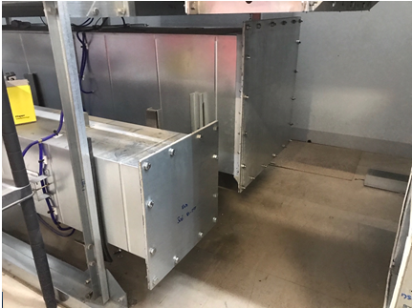
- First stage is to select the required duct size (300mm, 600mm or 1m) and ensure the duct sizes bot being used are blanked off using the blanking plates provided.
Figure 6 - Blanking Plates

- Set up the Furness Controls Micromanometer (FCO510) by connecting the micromanometer to the correct flow grid (placed at 5 De1 in the front of rig), ensuring the correct orientation of the positive (+ve) and negative (-ve). The RED silicone pipe is +ve and the blue silicone pipe is -ve. After this is plugged in the temperature sensor into the micromanometer also placed at the top of duct in the front.
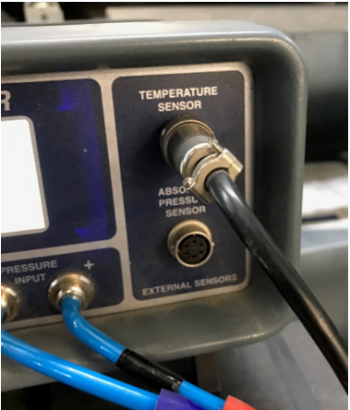
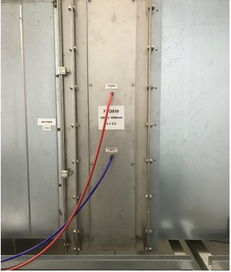
Figure 7 - Temperature Sensor Input
Figure 8 - Pressure Connecting Points
- Turn the micromanometer on and check the pitot settings and ensure the K-factor and duct area are set correctly, the k factors determined from previous calibration runs below:
- 300mm Duct – K = 0.83 – Area = 0.092
- 600mm Duct – K = 1.90 – Area = 0.360m2
- 1000mm Duct – K = 2.30 – Area = 1.0m2
Press ENTER to access the Options Menu
Use the arrow keys to select Pitot Tube Data and press ENTER
Once set, use ESC to return to the previous menu or back to the main screen.

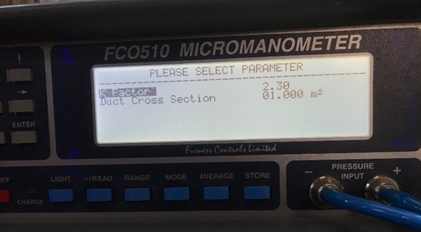
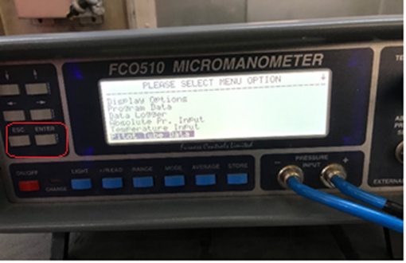
Figure 9 - K factor Input
Figure 10 - Settings Screen

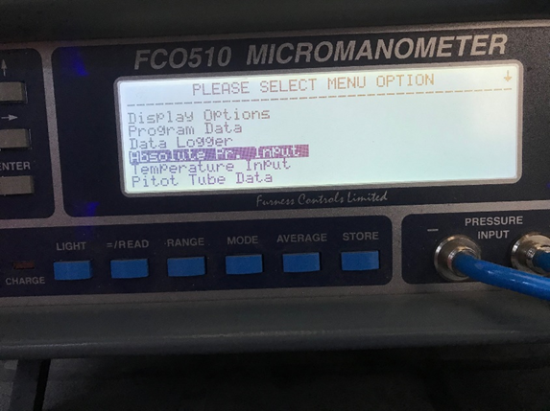
- Input the atmospheric pressure at the time of the test into the FCO510 in the Absolute Pr. Input section (shown in Figure 11). Once set, use ESC to return to the previous menu or back to the main screen.
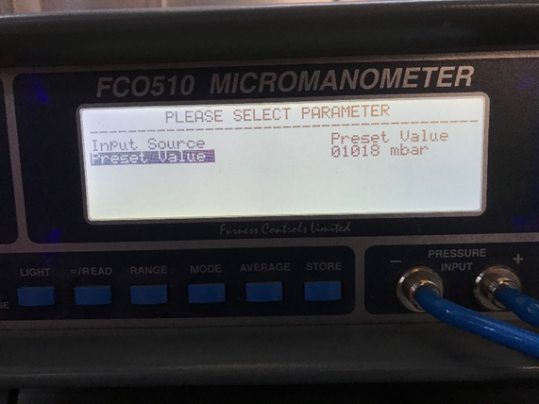
Figure 11 - Atmospheric Pressure Input
- Connect Digitron 2020P handheld digital manometer to the Wilson pitot tube
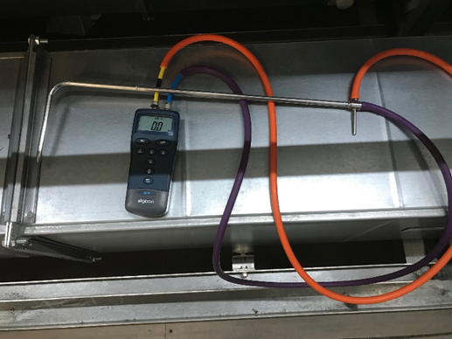
Figure 12 - Manometer
- Turn fan power on using the isolating switch of the fan panel, and on the control panel built within press LOC/REM to set fan into remote control (press LOC/REM until remote appears in the LCD Display). This will allow the user to use the remote to control the speed of the fan (press the green button to activate the fan and turn the knob to adjust speed). The remote is shown in Figure 14.
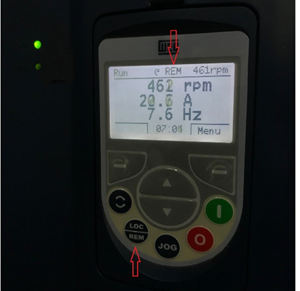
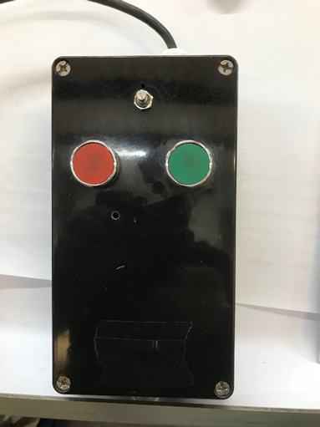
Figure 13 - Fan Speed Monitor
Figure 14 - Remote Fan Speed Control

- Set FCO510 to display Velocity by pressing MODE until Average Velocity m/s appears on the display and then press =/READ to show the current velocity of air traveling through the duct.

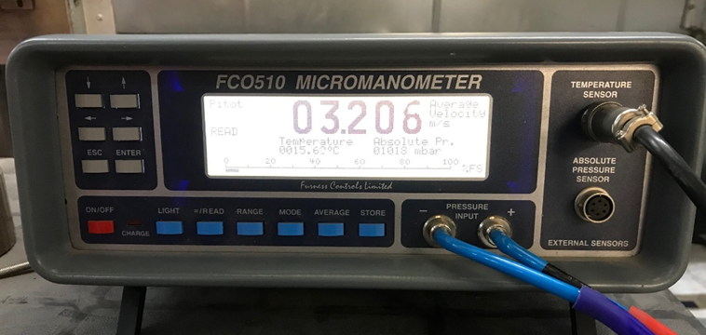
Figure 15 - FCO510 Flow Reading
- Monitor the velocity reading until the chosen flow rate becomes stable (e.g. 3.2 meters per second). Once stable, the user can commence Pitot traverse of the duct being tested. Set the distance markers on the pitot tube to an equal distance for the required set points determined by duct size. The points for all duct sizes will be shown below:

- 300mm Duct = 5 traverse points (from 1 side of duct – full duct width) 5 at 50mm.
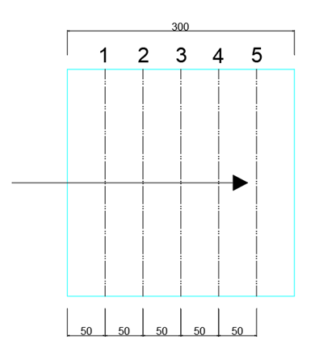
Figure 16 - 0.3m Flow Traverse Points

- 600mm Duct = 8 traverse points (from 2 sides of duct – 4 per side) 1 @ 50mm, then 3 at 70mm
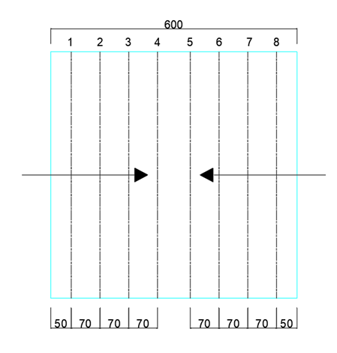

Figure 17 - 0.6m Flow Traverse Points
- 1000mm Duct = 8 traverse points (from 2 sides of duct – 4 per side) 1 @ 50mm, then 3 at 125mm

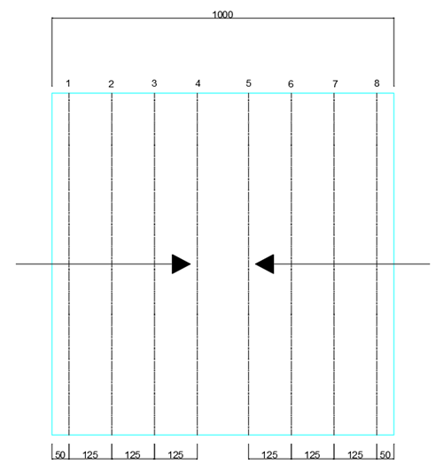
Figure 18 - 1m Flow Traverse Point
- Ensure Pitot tube faces into the airstream at 90° with the pointed tip facing into the flow. Maintain the correct orientation of the pitot tube during the traverses.
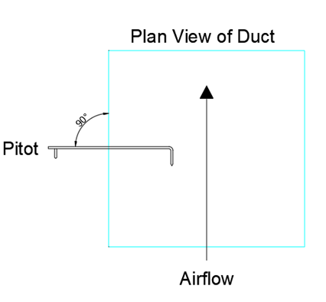
Figure 19 - Pitot Tube Orientation

- Record Pressure Pa readings from 2020 Manometer at each pitot point on the Calibration Record Sheet (shown in figure 20)
- Transpose data from the Calibration Record Sheet into the Calibration Calculation Excel Spreadsheet.
- Check the Pitot Velocity m/s and Grid Velocity m/s which should be within 0.1m/s.
- Check values of Pitot Velocity m/s and Grid Velocity m/s against the Velocity reading from the FCO510 which again should be within 0.1m/s. If the FCO510 reading is not sufficiently accurate then adjust the K factor within the settings to align the velocities with Pitot Velocity m/s and Grid Velocity m/s.
- Repeat stages 12 to 16 for at least 4 different fan settings/duct velocities to ensure accuracy across a range of air speeds.
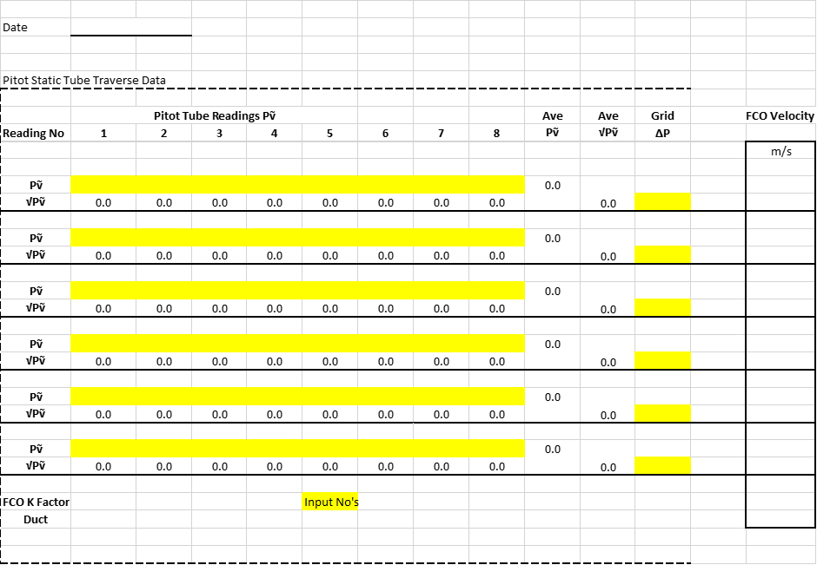
Figure 20 - Calibration Sheet

Damper Test Procedure
Once the rig has been successfully calibrated a damper can be mounted to the rig to begin testing. However, a test procedure must be written to ensure all tests are performed in the same way despite the user to ensure validity of all physical tested results and to give the author parameters to base the simulation design and ensure any testing matches procedures highlighted in BS EN1751. The testing procedure will be highlighted below:

Flamgard Pressure Drop Testing Procedure
(In accordance with EN 1751:2014)

Purpose
To determine the pressure drop of an in-duct mounted damper in accordance with: - EN1751 Ventilation for buildings — Air terminal devices — Aerodynamic testing of damper and valves.

Criteria
The damper will be tested at flow rates rising in increments of 1 m/s velocity, starting at 1 m/s to 15 m/s. Flow rates and pressures shall be recorded using the Pressure Drop Record form.

Test Specimen
The damper shall be 1000mm x 1000mm, 600mm x 600mm or 300mm x 300mm, with standard Flamgard Calidair flanges and drillings to suit the required test duct section. The damper type shall be recorded along with any non-standard features.

Test Rig
The test rig shall be constructed as to comply with the minimum requirements of EN1751 with regards to length, location and fitting of required components.
The test rig is comprised of three duct sections of 1000mm x 1000mm, 600mm x 600mm and 300mm x 300mm. Only one duct section can be used at a time. Duct sections not in use will be fitted with a sealed blanking plate to prevent any air flow.

Instrumentation and measuring equipment (per duct section)
The test rig will be fitted with a rectangular flow grid, which will be connected to a Furness Controls FCO510 microprocessor digital manometer, to give calibrated duct velocities. The FCO510 will automatically take account of duct air temperature and atmospheric pressure to ensure accurate velocity readings.
Four Dwyer A-301 pressure taps connected to form a piezometric ring shall be used to measure the in-duct pressure. The pressure will be measured using a calibrated Digitron 2020P digital manometer.

Procedure

Stage One
The correct test rig duct size shall be selected to match the test damper. The test rig duct inlet and outlet sections shall be bolted directly together without any damper inserted. The other two test duct sections shall be closed off using the correct blanking plate. Once completed:
- The fan will then be started and run at 1 m/sec as indicated by the FCO510 Flow Monitor.
- The system will be allowed to stabilize for 1 minute before the static pressure is read from the 2020P Manometer.
- The static pressure will be recorded next to the duct velocity within the Pressure Drop Record form.
- Next, the Fan speed will be increased to indicate 2m/s velocity and allowed to stabilize for 1 minute.
- The static pressure will be recorded next to the duct velocity within the record sheet Pressure Drop Record form.
- This procedure will continue, increasing in 1 m/sec increments until the maximum fan speed is reached.
- This data for ‘bare duct’ performance will be recorded for use in the pressure drop calculations under ‘Rig Static Pressure’.

Stage Two
- The test rig inlet and outlet sections shall be separated, and the test damper inserted and bolted in.
- Stage one will then be repeated with the damper fitted and the results recorded in the Pressure Drop Record form under ‘Rig & Damper Static Pressure’.

Results
To ascertain the pressure drop for the damper, bare duct pressure will be subtracted from damper and duct pressure drop, at each flow velocity using the formula:
(Rig & Damper Static Pressure – Rig Static Pressure)
This is done automatically by the digital copy of the Pressure Drop Record form and displayed under Damper ∆P. Using the same form, the Damper Pressure Drop data will then be graphically presented.

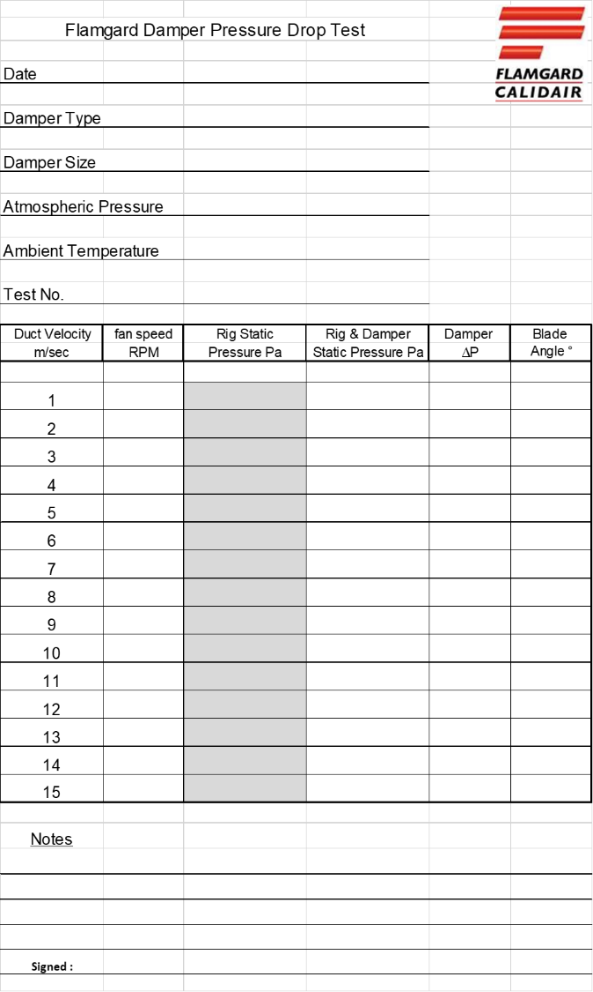
Figure 21 - Damper Pressure Drop Form

Simulation Design
This simulation will be designed around the one meter squared damper which has been selected as it has the most available results and is the most common size manufactured by Flamgard Calidair.
Before a simulation with a damper in place could begin, the author felt it was best to run a basic study to determine the behaviour of airflow within the duct to ensure the correct boundary conditions could be placed in the final simulation. Furthermore, it also provides the author with the opportunity to test the setup of the simulation. Meaning once the author has inputted variables like the surface roughness of the duct materials the simulated results of bare duct pressure with results documented from the ductwork calibration procedure.

Simulation Set-Up
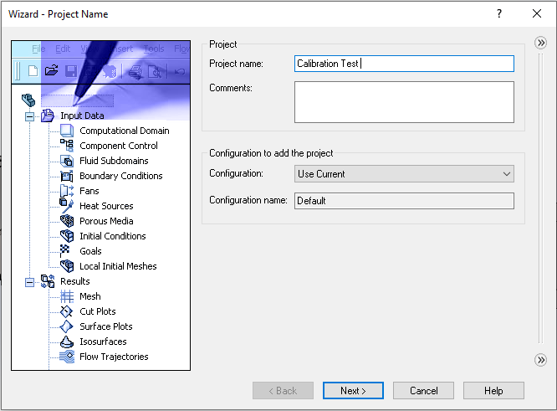
To set up the simulation the “Project Wizard” in SolidWorks flow simulation as using this allows the author a quick and reliable method to help the user make the best use of computing resources (Warren, 2020). Furthermore, it enables users to turn off features that they are not concerned with, for example radiation, to provide a faster solution (Warren, 2020).
Figure 22 - Simulation Wizard

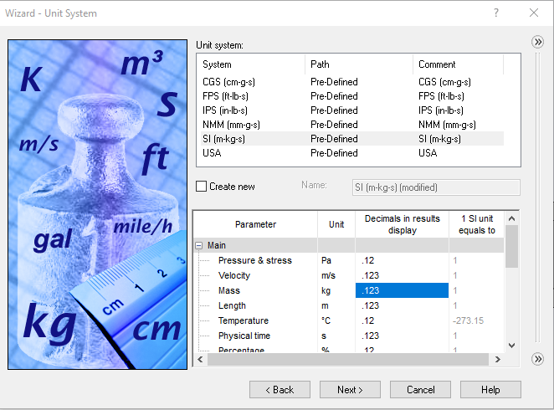
This initial screen (shown in Figure 22) is to name the project and select the configuration of the model the user wants to use
Figure 23 - Initial Condition Settings
The second screen (shown in Figure 23) gives the user the option to select the units they wish to use in the simulation, in this case the measuring equipment used by Flamgard operate using the following units:
- FC0510 Flow Monitor – measures velocity of air traveling through the rig in Meters per Second (m/s)
- 2020P Manometer – measures the pressure within the duct at Pascals (Pa)

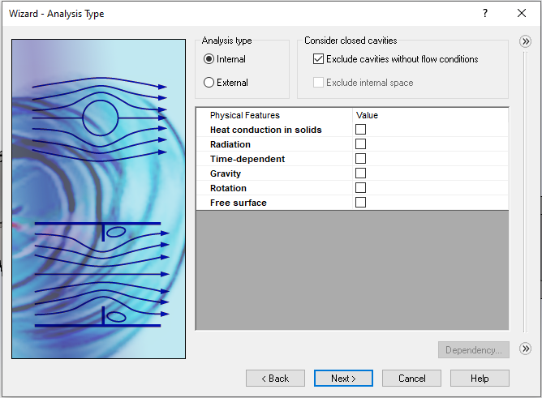
At this stage the author must decide what type of simulation to run and what features to consider when calculating. There are two different types of analysis, an external analysis is for users who wish to determine how flow moves around a solid body. Whereas, an internal analysis is set to determine how a fluid flows through a system (Abdulkarim et al., 2019). Therefore, an internal analysis will be selected for this project, as the author wish to see how air flow through a duct network and the effect the damper has on that air flow. Regarding the physical feature selection:
Figure 24 - Analysis Type
- Heat conduction in solids – this feature is used when a user wishes to conduct thermal analysis, for example running simulation on an electronics enclosure to determine what cooling fan is required to keep it at an optimal temperature (Warren, 2020). However, as this project is not looking into thermal characteristics of the test it is un-checked to save computational power.
- Radiation – this feature is specific to heat transfer in the form of radiation, such as solar radiation. It can be used for considering heat transfer on structures exposed directly to intense solar radiation (Sherak, 2019). As the test rig is within an enclosed R&D area this feature is not necessary for the project and thus is un-checked.
- Time-dependant – this feature also referred as “Transient” analysis which will allow the user to determine and animate how a fluid changes over time (Kurtin, 2016). This can be used in aerodynamic testing as the user can set different speeds at certain time intervals and the animation tool will animate the flow of fluid around the body. In this project the flow will be remaining at a constant speed, so this feature is not necessary and therefore is un-checked.
- Gravity – this feature allows the user to input a gravitational force on a study they are running and can be adjusted based on where the object will be placed. However, with the authors simulation. The effect of gravity is not going to be included within this simulation as the duct in question is not of a significant length or significant change in altitude. Therefore, the author has concluded the affect of gravity will be negligible (Sobachkin AND Dumnov, 2014).
- Rotation – this allows the user to create a rotating region, such as a fan, thus showing how the flow will behave around the fan blades at any given rotation speed. Although this rig does have a fan, the author is not interested on how the flow behaves around this fan as it is behind the damper thus having no direct effect on pressure drop.
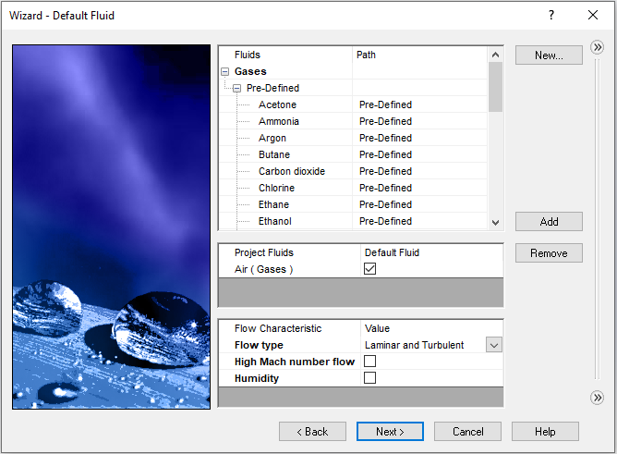
- Free Surface – this feature is for users who need to simulate fluid behaviour when a gas and a liquid (or two other immiscible liquids) are sharing the same region of space without an intervening solid (Wasserman, 2017). For example, within petrol tankers where the petrol tank has not been completely filled and there is a sloshing effect. This feature does not need to be considered in this study because there is only one fluid present within the rig and it is encased in a solid boundary.
Figure 25 - Fluid Selection
This next step asks the user to define a Liquid or gas to be used within the study. The author has selected air as the default fluid as this is present within study. It also asks if the user wants to specify a type of flow the object is likely to face, the author has selected laminar and turbulent because the aim of this initial simulation is to determine the behaviour of flow through the bare duct to maximise simulation accuracy.
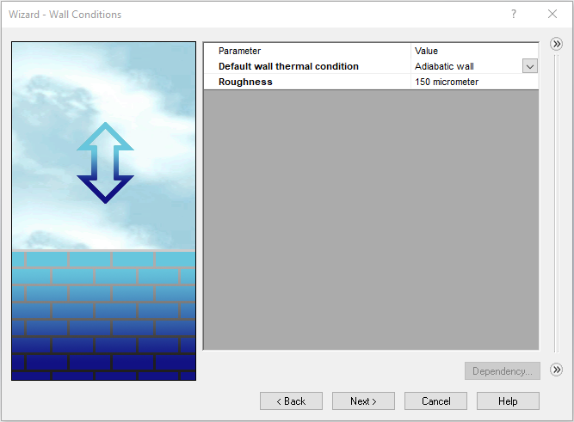
This section (shown in Figure 26) asks the user to define the wall surrounding the internal simulation both in terms of thermal properties and surface roughness. The author has defined the wall as “adiabatic” which in terms of thermodynamics is defined as a wall between two thermodynamic systems that does not allow heat or matter to pass across it (Su et al., 2017). Since this project does not involve any type of heat transfer analysis it will save computational power and increase simulation speed assuming there is none (Warren, 2020). The roughness figure is used in the calculation of the velocity profile within the boundary layer, thus if a value of zero is used the solver will assume the walls are perfectly smooth. The ductwork used in this rig is made from galvanised steel therefore the roughness value will be 0.15x10⁻³m or 150 micrometres (Engineering ToolBox, 2003).
Figure 26 - Wall Condition and Surface Roughness
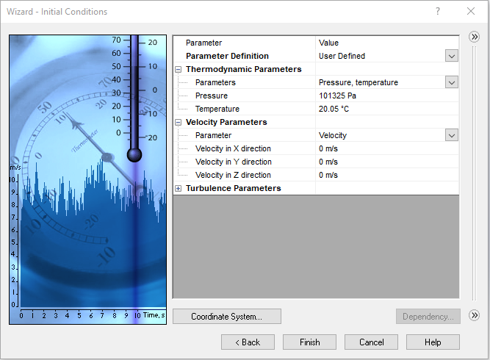
Figure 27 - Flow Parameters
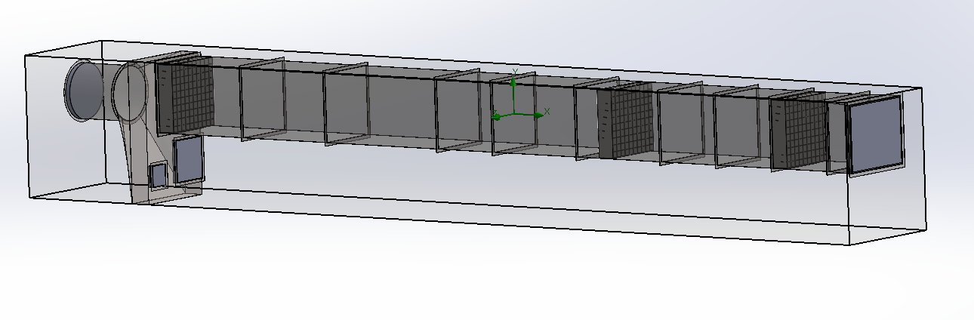
This final section (shown in Figure 27) asks the user to define the initial conditions of the simulation and define the default environment the object in question is to be placed in. The first part is to define the climate and ambient temperature of the environment, the test is carried out in standard atmospheric pressure (101,325Pa) and an ambient temperature of 20.05ºC. Furthermore, as the rig is placed inside a building with the doors closed the author is not going to place any velocity parameters as they are negligible.
Figure 28 - Test Rig Model
The aim of this first test is to run simulations on the rig without the damper present to test if the boundary conditions and the inputted values into the simulation wizard are correct. It will also determine how the air will flow through the duct at different speed to determine if the flow is laminar or turbulent. The author has also added lids to cover all points where the fluid can either enter or escape, lids are required within internal flow analysis as they are the point where boundary conditions such as; mass flow rate or static/total pressure (Fetke, 2018).

Boundary Conditions
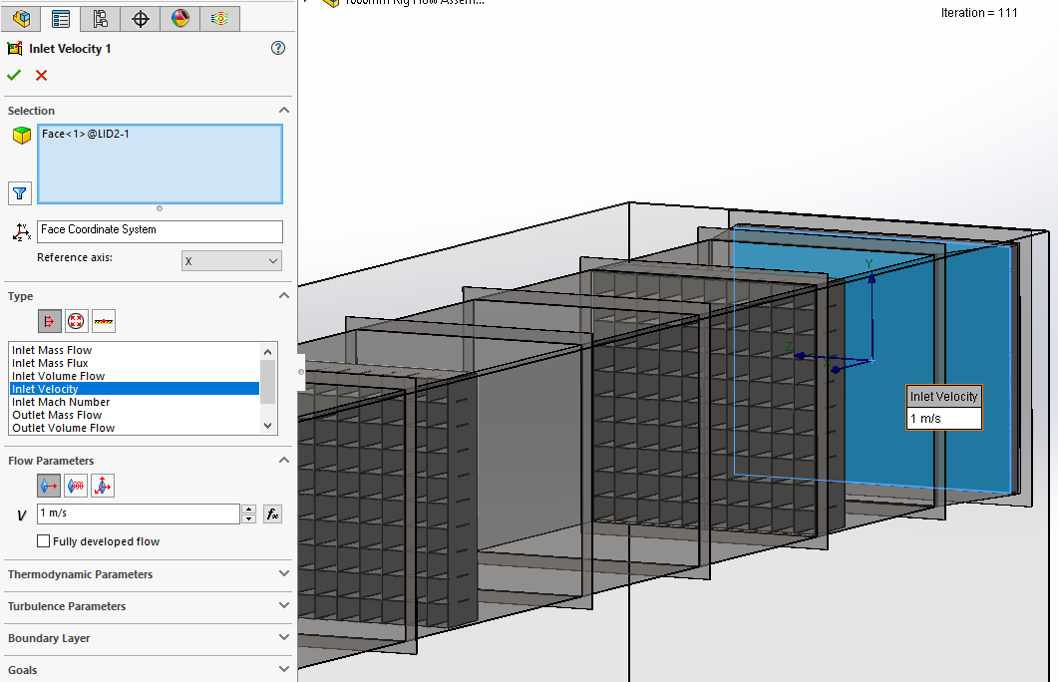
The first boundary condition set is an inlet velocity at the inlet taper of the test rig. Using the inlet lid an inlet velocity of 1m/s has been set, the author will run fifteen simulations increasing the velocity by 1m/s at a time.
Figure 29 - Inlet Velocity Condition
The second boundary condition is the outlet for the flow. As the flow is known by the user it is typical within CFD studies that the outlet boundary is based on the flow pressure at the outflow point (Simscale, 2021). Hence the author has placed a Static Pressure boundary condition at this point.
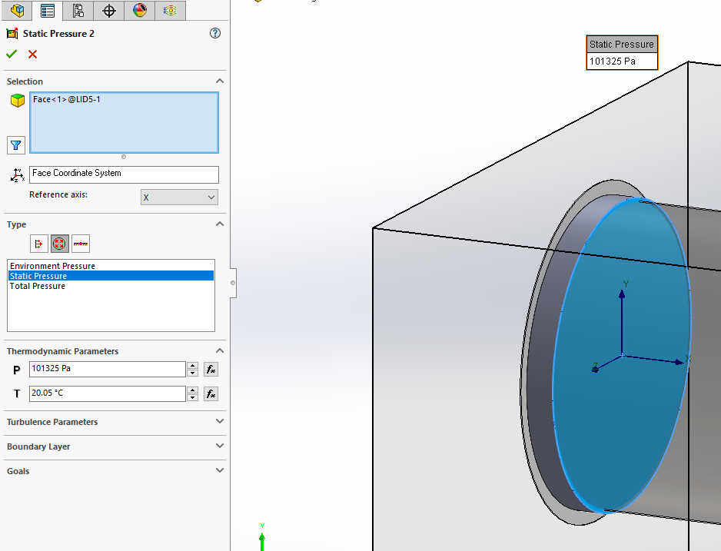
Figure 30 - Outlet Pressure Condition

Goals
To work out the pressure drop across the rig the author must first set two surface goals. The main purpose of setting goals is to define what are the key design objectives for the simulation (Gauvin AND Huard, 2016). Specifically, a surface goal is a parameter on selected surfaces within the model. This type of goal is very useful for obtaining pressure drop which will be explained below.
The first surface goal is placed on the inlet lid and it will be measuring the average total pressure value.

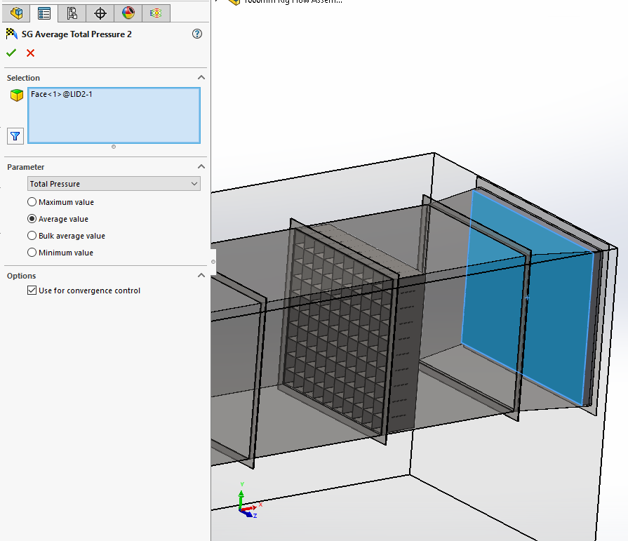
The second surface goal is placed at the point of which pressure would be measured on the physical testing rig to ensure the simulation is as close to reality as possible.
Figure 31 - Inlet Pressure Goal

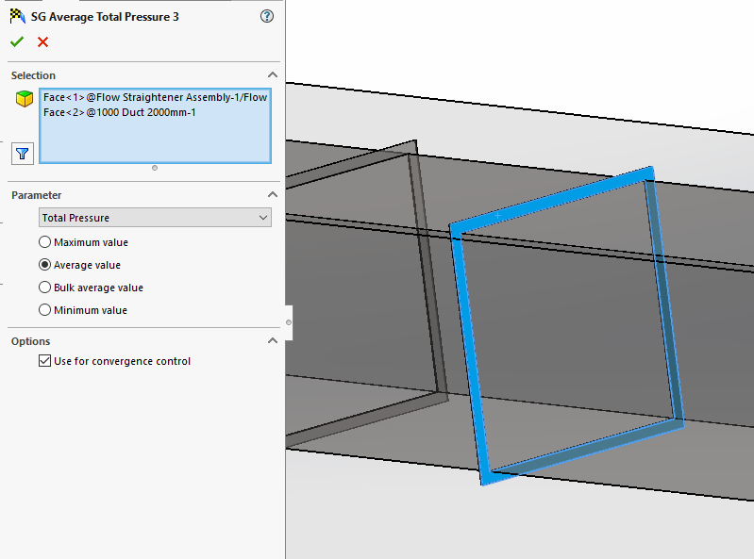
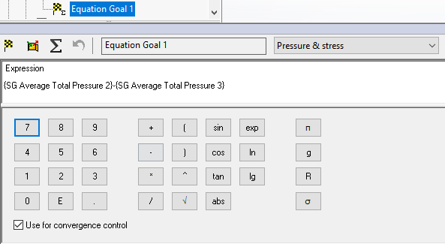
To calculate the pressure, drop an equation goal can now be set up, this goal can be defined using any of the SolidWorks goal types in a mathematical equation. The pressure drop will be calculated by subtracting the average surface pressure from the inlet boundary and the average total pressure from the pressure measuring point after the damper would be fitted.
Figure 32 - Outlet Pressure Goal

Calibration Test Results
The simulation was meshed and run at fifteen different inlet velocity speeds from 1m/s to 15m/s and the following results were achieved:
Duct Velocity (m/sec) | Simulated Pressure (Pa) | Rig Static Pressure (Pa) | Difference %
1 | 1.53 | 1.5 | 2%
2 | 6 | 6.2 | -3%
3 | 13.3 | 13.4 | -1%
4 | 23.5 | 24 | -2%
5 | 36.5 | 36.8 | -1%
6 | 52.5 | 52.3 | 0%
7 | 71.4 | 70 | 2%
8 | 93.25 | 91 | 2%
9 | 118 | 111 | 6%
10 | 143.2 | 138 | 4%
11 | 173.1 | 167 | 4%
12 | 206.5 | 196 | 5%
13 | 243 | 237 | 3%
14 | 282.6 | 275 | 3%
15 | 325.2 | 318 | 2%

Table 1 - Calibration Simulation Table
All results that were simulated had an accuracy of within ten percent which is what the author was aiming to achieve as indicated in the project aim. This test has told the author the simulation set up and the boundary conditions were suitable and testing can begin with a damper modelled within the simulation. Furthermore, it also gives the author a good idea of how accurate the simulation can be when compared to physical testing and can give confidence in the ductwork modelling.

Final Simulation Design
The same simulation set up will be used as the test for the bare rig as it has proven to be accurate, however there will be changes to the rig design and one of the boundary conditions. Figure 33 shows the design of the simulation rig, it has been adapted to only include the duct section as per the British Standards document. The reason the full rig was included in the initial simulation is to gauge how the flow behaves in the duct network and determining if flow is turbulent or laminar. The results from this study are shown in Figure 34 and Figure 35.

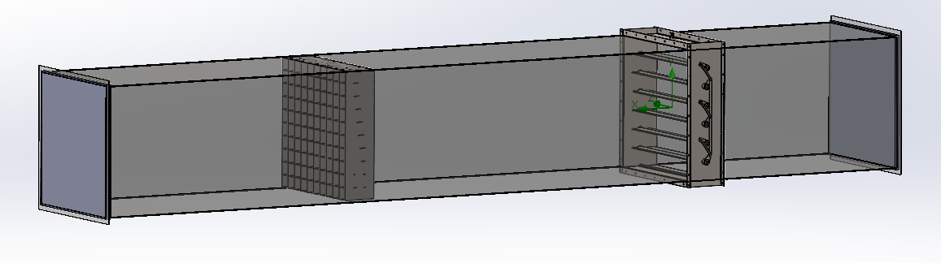
Figure 33- Simplified Damper Test Rig
The simulation design is based on Figure 2 so the inlet pressure is measured at 5De1 and the pressure is measured at 1.5De1. These two values are present within an equation goal as per the previous simulation.
The boundary condition change is via the inlet velocity where there is an option to specify if the flow has been fully developed. The author has used this feature as using the previous simulations it has been determined there is no turbulent flow at the testing speeds.
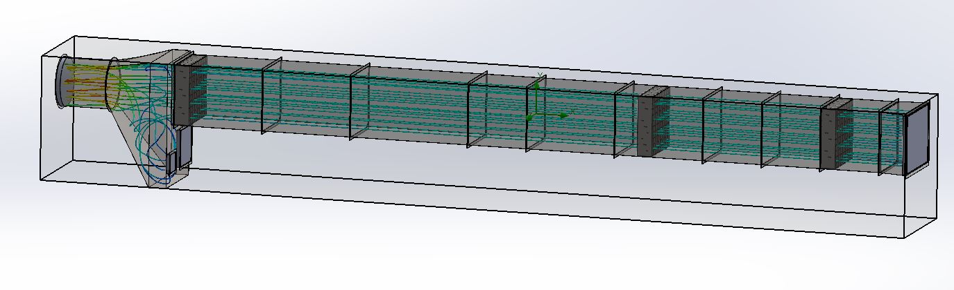
Figure 34 - 1m/s Flow Trajectory
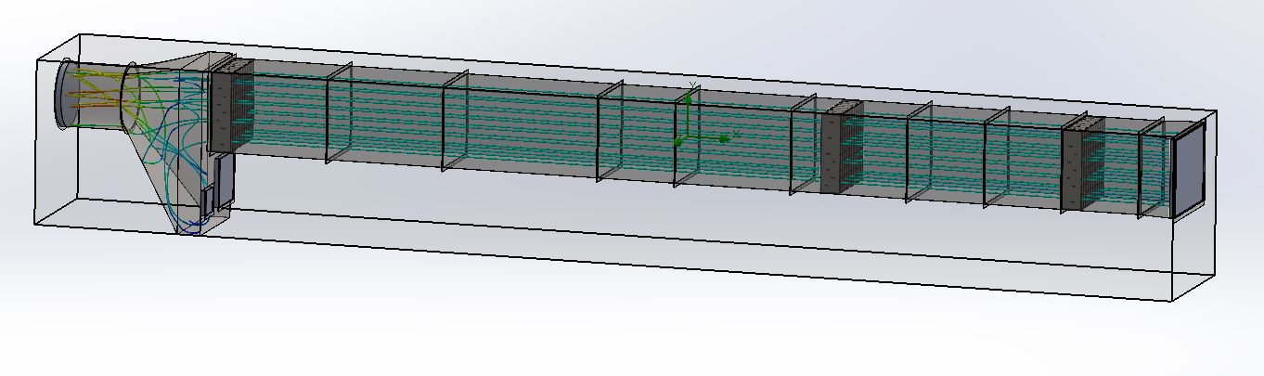
Figure 35 - 15m/s Flow Trajectory

Testing Results
The table below shows a what pressure drop the simulation has achieved compared to what was document during the physical testing stage. This table is specific to the CFD-01 damper however more damper types will be tested at a later date to confirm:
 | Physical Test Values |  |  | Simulated Values
Duct Velocity (m/sec) | Rig Static Pressure (Pa) | Rig & Damper Static Pressure (Pa) | Damper (∆P) | Damper (∆P) | Difference (Pa) | Blade Angle (°)
1 | 1 | 1.5 | 0.5 | 0.2 | -0.30 | Fully Open
2 | 5.2 | 6.2 | 1 | 0.82 | -0.18 | Fully Open
3 | 12 | 13.4 | 1.4 | 0.98 | -0.42 | Fully Open
4 | 21.6 | 24 | 2.4 | 1.92 | -0.48 | Fully Open
5 | 34 | 36.8 | 2.8 | 3.03 | 0.23 | Fully Open
6 | 49 | 52.3 | 3.3 | 4.45 | 1.15 | Fully Open
7 | 66 | 70 | 4 | 6.9 | 2.90 | Fully Open
8 | 86 | 91 | 5 | 8.95 | 3.95 | Fully Open
9 | 105 | 111 | 6 | 11.33 | 5.33 | Fully Open
10 | 130 | 138 | 8 | 14.05 | 6.05 | Fully Open
11 | 157 | 167 | 10 | 16.01 | 6.01 | Fully Open
12 | 184 | 196 | 12 | 19.62 | 7.62 | Fully Open
13 | 223 | 237 | 14 | 20.83 | 6.83 | Fully Open
14 | 258 | 275 | 17 | 24.14 | 7.14 | Fully Open
15 | 297 | 318 | 21 | 31.52 | 10.52 | Fully Open
Table 2 - First Set of Simulated Results
Table 2 shows the initial results achieved by using the same method as the calibration simulation. Once past five meters per second the results start to differ at a point that is not acceptable to the author, therefore further work needs to be done to refine the simulation results. To achieve this, the author has placed a local mesh to envelope the damper, which is the region of interest of the study. The local mesh ensures the speed of the simulation is not compromised as by applying the refinement to areas of interest, the total cell count in the computational domain can be reduced by a significant portion. Meanwhile, the same level of precision with results can be achieved (Wang et al., 2019). The region to be refined is shown in Figure 36.

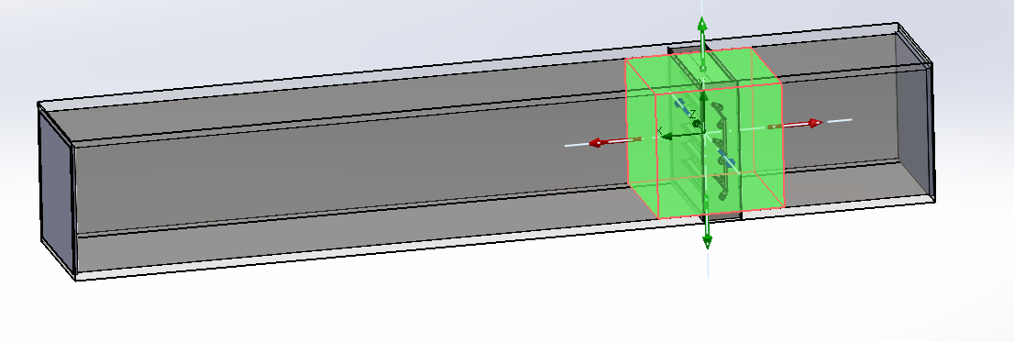
Figure 36 - Mesh Refinement Region
Using this method, the following results have been achieved:

 | Physical Test Values |  |  | Simulated Value
Duct Velocity (m/sec) | Rig Static Pressure (Pa) | Rig & Damper Static Pressure (Pa) | Damper (∆P) | Damper (∆P) | Difference (Pa) | Blade Angle (°)
1 | 1 | 1.5 | 0.5 | 0.13 | -0.37 | Fully Open
2 | 5.2 | 6.2 | 1 | 0.57 | -0.43 | Fully Open
3 | 12 | 13.4 | 1.4 | 1.19 | -0.21 | Fully Open
4 | 21.6 | 24 | 2.4 | 2.03 | -0.37 | Fully Open
5 | 34 | 36.8 | 2.8 | 3.07 | 0.27 | Fully Open
6 | 49 | 52.3 | 3.3 | 3.35 | 0.05 | Fully Open
7 | 66 | 70 | 4 | 4.35 | 0.35 | Fully Open
8 | 86 | 91 | 5 | 5.59 | 0.59 | Fully Open
9 | 105 | 111 | 6 | 7.02 | 1.02 | Fully Open
10 | 130 | 138 | 8 | 10.06 | 2.06 | Fully Open
11 | 157 | 167 | 10 | 12.23 | 2.23 | Fully Open
12 | 184 | 196 | 12 | 15.85 | 3.85 | Fully Open
13 | 223 | 237 | 14 | 17.53 | 3.53 | Fully Open
14 | 258 | 275 | 17 | 20.75 | 3.75 | Fully Open
15 | 297 | 318 | 21 | 23.96 | 2.96 | Fully Open
Table 3 - Results After Refinement
By preforming this refinement, the author has been able to replicate the results of the physical tested results with the maximum difference being 3.85 Pa at 12 m/s. With the author now satisfied with the simulated results difference the next phase of the project can begin, which is the validation of the simulation and the methodology carried out above.

Validation Phase

The purpose of this research was to identify if a physical testing service offered by Flamgard Calidair could be simulated, in order to provide a saving on manufacturing costs and time spent by the R&D team testing dampers. This phase specifically, includes a discussion of the simulated results achieved in the chapter above and to determine the strengths and limitations of results achieved.

Discussion
The simulation carried out by the author showed that it is possible to replicate the tested results with a simulation and achieve an accuracy of less than four pascals. However, before the test on a damper began the author simulated the full test rig to perform a calibration of the simulation and determine if the settings used would achieve accurate results. The calibration simulation showed positive results being all within a ten percent difference of physical tested values (as shown in table 2). The significance of this is the validation of initial boundary conditions of the simulation, as it was highlighted in the research section that the accuracy of an any CFD simulation is heavily dependent on these values inputted by the user (Ramlan AND Darlis, 2020). Secondly, as the value for pressure drop is calculated by subtracting the static pressure of the bare test rig by the static pressure of the rig with a damper fitted. If the tested and simulated value for bare test rig static pressure is similar it gives an early indication of successful modelling of the rig, and enables the author to narrow down any refining exercises to the damper region as the rig has been previously validated. With the addition of a damper added to the simulation the author mimicked the initial boundary settings used in the validation simulation as the results had proved reliable. However, the first set of results achieved (as shown in table 3) showed a maximum difference of 10.52 Pa, the author felt this difference was too great and believed the simulation could be refined to provide a greater accuracy. Referring to research conducted earlier in this report, the author believed the key to improving accuracy in the simulation was refining the mesh generated. It was stated that the key to generating accurate simulation results was through a high-quality mesh (Mohamed et al., 2017) however, as stated above the refinement only needed to be around the damper as the rig had proved to be accurate. Therefore, the author used a feature in SolidWorks and created a region mesh encompassing the damper and 0.5m in front and behind it to ensure the effect on flow was captured fully. This region mesh increases the mesh cell count around the damper by effectively dividing the existing elements around the area by a number specified by the author (Wang et al., 2019), thus improving the overall accuracy of the simulation (Martins et al., 2014). Furthermore, the author also highlighted this region specifically as encompassing the whole test rig would have massively increased the cell count and thus the solve time of the simulation, as the higher number of cells the greater the computer memory usage (Song et al., 2017). By utilising this methodology, the author refined the results to a maximum of 3.85 Pa difference, thus showing an improvement.
The author was satisfied with the second set of results achieved, as when looking at the scale of the unit Pascal the difference is incredibly small. For example, when examining atmospheric pressure denoted as 1 atm, it is measured at 101,325 Pa at sea level (ICAO, 1993). Therefore, the results above when looking at the worst case at 3.85 Pa there is a difference of 0.0038 percent of atmospheric pressure. Furthermore, examining Pascal’s as a unit, one pascal is equivalent to pressure exerted when applying one Newton of force at a right angle over an area of one squared meter (Britannica, 2021). When considering these factors, the author feels the results above have a good accuracy and the simulation design is reliable and can be used to test the other sizes.

Limitations and Recommendations
One of the limitations to this study is the lack of variety and testing carried out on other damper types manufactured by Flamgard. Although, the CFD-01 is the most commonly manufactured damper by Flamgard, and this simulation has been able to provide results within an accepted accuracy. To truly consider this a pressure drop simulation for all of Flamgard’s damper range one sample of each type would need to be simulated. Physical test results have been recorded for the following dampers at one meter squared and simulations will be carried out in future studies:
Damper Type | Description
BLD-01 | Blast Damper
CFD-01-ICB | Insulated Fire Damper
CCD-01 | Control Damper
CID-01 | Isolation Damper
CWL-01 | Weather Louvre
Table 4 - Dampers That Have Been Physically Tested
Secondly, this report mainly focused on the simulation design for the one meter squared so future work for this project includes adapting the simulation to include the 0.3 meter squared and the 0.6 meter squared. The authors plan is to use the exact same set up and simulation design for the other sizes to test if the simulation can be used across multiple sizes, that way the author and clients of Flamgard can have confidence in any results obtained. However, if results cannot be achieved for the other sizes the one meter square may have to be revisited and revised to ensure accuracy. One concept the author has considered is to use the parametric study option, this will allow the creation of a duct network that will adapt its size based on the damper it is being presented with. By using this method, the author can input a damper into a computational domain and using a series of mates the ductwork will grow or shrink to form match the surface it is mated too (Sanchez, 2016). This will save further time as the user will not need to model ductwork for each test specimen.

Conclusions and Future Work

Conclusion
This dissertation focused on the possibility of developing a CFD simulation to overcome challenges to a specific set of testing performed by Flamgard Calidair. It was identified by the author that Flamgard Calidair while preforming these tests would have to manufacture the damper in question thus allocating materials and labour to constructing the prototype impacting potential profits from a contract. Thus, resulting in a longer lead time when conducting R&D on projects and include cost for manufacture. not to mention additional labour if any changes are required due to a discovery while conducting said R&D. Therefore, the author proposed this simulation around the practice enabling pressure drop testing in the early stage of damper design, thus reducing the R&D cost to Flamgard.
The next stage was to create a project plan to allow the author to keep track of the progress being made. The author elected to split the project in five separate phases, first of which is the planning phase. This was to allow the author to identify the aim and determine the aim of the project as highlighted in the paragraph above.
The second phase was to begin research into the topic in depth by reviewing relevant industry standards to ensure the feasibility of the simulation and that the simulation could be potential be accredited by a professional independent body potentially in the future. The most prominent standard the author came across was British Standard (BS) document EN 1751 “Ventilation for Buildings – Air Terminal Devices – Aerodynamic Testing of Dampers and Valves” of which contained specific instructions of how to build a pressure drop test rig at any given size. As currently shown in figure 1. This data was used to design three separate test rigs to enable Flamgard to test smaller dampers for both customer and the author to test adaptability of the simulation. Furthermore, this phase was also to allow the author to review academic literature and case studies of previous CFD simulations to see if the methodology could be adapted to suit the dissertation aim. The author looked in various practices of refining a simulation to ensure the maximum accuracy of any results obtained including setting appropriate boundary conditions as it was indicated by Ramlan AND Darlis (2020) the accuracy of any CFD solution is only good as the initial boundary conditions set to the numerical model.
The third phase can commence once the rig design has been completed and construction can begin, after construction the test rigs will need to be calibrated to ensure their accuracy. A duct calibration procedure was created and included within this report, this included a list of required testing equipment and a step-by-step guide to ensure it can be done by any user.
The fourth phase is where testing can begin, however it is within two separate categories, including physical testing of dampers on the constructed. The testing procedure was including within this report to give an understand as to how any data for comparison was obtained and to show the similarities between the simulation design and physical testing. The author also decided to do a pressure drop test on a bare rig with no damper modelled within. This was to validate the simulation set up and give an early indication of the accuracy of CFD simulation when compared to physical testing, the author was able to achieve an accuracy of within ten percent and was satisfied so decided to use the same set-up in future studies. Once the damper was added to the model the author used the same set up as the bare rig set-up, but this proved results that were not acceptable to author as the maximum difference was 10.52 pascals.
Therefore, the author began a mesh refinement strategy focusing specifically on the area around the damper. Thus, a region mesh was used to encompass the damper and include 0.5 meters before and after the damper to ensure an accurate representation of flow was recorded. The region mesh increases the cell count by effectively dividing the existing elements around the area by a number specified by the author and thus increasing the accuracy of the simulation. Furthermore, by only specifying the region around the damper the increased cell count will minimise the increase of solve time of the simulation, as the higher number of cells the greater the computer memory usage. By utilising this methodology, the maximum variation had dropped from 10.52 into what the author considered acceptable 3.85 pascals. Once the results were deemed acceptable the simulation design was considered a success and ready to be validated and work can begin on integrating the other duct sizes and damper types.

Future Work
Using the SolidWorks simulation add-on’s gives potential for future adaption of existing physical testing procedures in use by Flamgard Calidair. However, any future work will require deeper analysis of the capabilities of the simulation software, but initial findings have found the following trails could be carried out:
- One test currently in use is what’s called a “blade deflection test”. This is where a specially designed rig is pressurised to a given specification and a Dial Test Gauge (DTI) is placed on the blades and measure the amount the blade deflects. By using the Finite Element Analysis (FEA) it can allow the user to apply a pressure to a surface and will both graphically and provide the user with a visual feedback to determine where and by exactly how much the blade will bend (Erickson, 2019).
- Another new potential application of SolidWorks is the investigation of the effect of a fire within a duct network. Specifically, SolidWorks CFD package has the ability to perform analysis of fluid flow and heat transfer. The author has gained experience in the use of SolidWorks CFD throughout the use of this project and in the future wishes to apply the experience to the solution of fire investigation. Holecek (2018) has written an article regarding the use of CFD in various applications such as the simulation of combustible materials close to a fireplace hearth to coincide with industry standards such as the NFPA 211 Standard for Chimneys, Fireplaces, Vents, and Solid Fuel-Burning Appliances. This piece could be reviewed in depth and the author could adapt the methodology to fit Flamgard Calidair’s purposes.

References

Abdulkarim, A.A., Ates, A.A., Altinisik, K.A. and Canli, E.C. (2019) Internal Flow Analysis of a Porous Burner Via Cfd. International Journal of Numerical Methods For Heat & Fluid Flow [online]. 29 (8), pp. 2666-2683. [Accessed 08 January 2021].
Ahmadi, S. and Sefidvash, F. (2018) Study of Pressure Drop in Fixed Bed Reactor Using a Computational Fluid Dynamics (Cfd) Code. Chemengineering; Basel [online]. 2 (2), pp. 1-27. [Accessed 20 November 2020].
Aissa, M., Verstraete, T. and Vuik, C. (2017) Toward a Gpu-aware Comparison of Explicit and Implicit Cfd Simulations on Structured Meshes. Computers & Mathematics with Applications [online]. 74 (1), pp. 201-217. [Accessed 04 December 2020].
Ali, A. (2020) CFD Workflow Guide: How to Set Up a Fluid Dynamics Analysis. Simscale [blog]. 10th November. Available from: https://www.simscale.com/blog/2016/09/cfd-workflow-quick-guide/
Bock, S.M. (2015) New open-source ANSYS-SolidWorks-FLAC3D geometry conversion programs. Journal of Sustainable Mining [online]. 14 (3), pp. 124-132. [Accessed 05 January 2021].
Britannica (2021) Pascal unit of energy measurement [online]. Available from: https://www.britannica.com/science/pascal-unit-of-energy-measurement
Buchan, A.G., Dargaville, S. and Pain, C.C. (2019) A Combined Immersed Body and Adaptive Mesh Method For Simulating Neutron Transport Within Complex Structures. Elsevier [online]. 134, pp. 88-100. [Accessed 04 December 2020].
Chawner, J. (2020) Quality and Control – Two Reasons Why Structured Grids Aren't Going Away. Pointwise [blog]. Available from: https://www.pointwise.com/theconnector/2013-March/Quality-Control-Two-Reasons-Structured-Grids-Arent-Going-Away.html. [Accessed 15 January 2021].
Chernyshenko, A.C., Olshanskii, M.O. and Vassilevski, Y.V. (2018) A Hybrid Finite Volume – Finite Element Method For Bulk–surface Coupled Problems. Journal of Computational Physics [online]. 352, pp. 516-533. [Accessed 16 December 2020].
Clain, S.C., Diot, S.D. and Loubere, R.L. (2011) A High-order Finite Volume Method For Systems of Conservation Laws—multi-dimensional Optimal Order Detection (Mood). Journal of Computational Physics [online]. 230 (10), pp. 4028-4050. [Accessed 27 March 2021].
Desjardin, P.D., Bojko, B.B., McGurn, M.M., (2017) Initialization of High‐order Accuracy Immersed Interface Cfd Solvers Using Complex Cad Geometry. International Journal For Numerical Methods in Engineering [online]. 109 (4), pp. 487-513. [Accessed 21 January 2021].
Engineering ToolBox, (2003). Roughness & Surface Coefficients. [online] Available at: https://www.engineeringtoolbox.com/surface-roughness-ventilation-ducts-d_209.html [Accessed 08 January 2021].
Erickson, A. (2019) Introduction to SOLIDWORKS Simulation Webinar: What is Finite Element Analysis?. Computer Aided Technology [blog]. 11th January. Available from: https://www.cati.com/blog/2019/01/introduction-solidworks-simulation-webinar-finite-element-analysis/
Fetke, M. (2018). SOLIDWORKS Flow Simulation: Lid creation for non-planar faces. Computer Aided Technology [blog]. 26th June. Available from: https://www.cati.com/blog/2018/06/solidworks-flow-simulation-lid-creation-non-planar-faces/
Finkelstien, A. (2020) “Under the hood” of SOLIDWORKS Flow Simulation Understanding SmartCell technology – Part 1. Computer Aided Technology [blog]. 3rd March. Available from: https://www.cati.com/blog/2020/03/under-the-hood-of-solidworks-flow-simulation/
Gauvin, P.G. and Huard, P.H. (2016) Hydrodynamic Film Thickness Measurements and Cfd Analysis Identify the Root Causes of Repetitive Thrust Bearing Failures on a 45 Mw Hydro Generating Unit at Hydro-québec. Earth and Environmental Science [online]. 49 (7), pp. 1-11. [Accessed 07 March 2021].
Gebraad, P.M.O., Teeuwisse, F.W., Van Wingerden, J.W., Fleming, P.A., Ruben, S.D., Marden, J.R. and Pao, L.Y. (2016) Wind Plant Power Optimization Through Yaw Control Using a Parametric Model for Wake Effects—a Cfd Simulation Study. Wind Energy [online]. 19, pp. 95-114. [Accessed 09 January 2021].
Ghaffari, M., Hsu, C. and Linninger, A. (2015) Automatic Reconstruction and Generation of Structured Hexahedral Mesh For Non-planar Bifurcations in Vascular Networks. Computer Aided Chemical Engineering [online]. 37, pp. 635-640. [Accessed 04 December 2020].
Guo, Z.G., Sun, Z.S., Zhang, N.Z., Ding, M.D. and Wen, J.W. (2017) Experimental Characterization of Pressure Drop in Slender Packed Bed (1 < D/d < 3). Chemical Engineering Science [online]. 173 (14), pp. 578-587. [Accessed 27 March 2021].
Haddadi, B., Jordan, C. and Harasek, M. (2017) Cost Efficient Cfd Simulations: Proper Selection of Domain Partitioning Strategies. Computer Physics Communications [online]. 219, pp. 121-135. [Accessed 09 January 2021].
Hanbin, Z., Xingying, L., Jinsen, G., Yajun, Z. and Zhiping, Z. (2015) The Difference Between Specularity Coefficient of 1 and No-slip Solid Phase Wall Boundary Conditions in Cfd Simulation of Gas–solid Fluidized Beds. Elsevier B.v [online]. 286, pp. 740-743. [Accessed 04 December 2020].
Hariharan, N.H. and Sivashanmugam, P.S. (2018) Cfd Simulation of Twin Thermoacoustic Prime Mover For Binary Gas Mixtures. High Temperature [online]. 56 (2), pp. 309-311. [Accessed 23 December 2020].
Holecek, J.H. (2018) APPLICATIONS OF SOLIDWORKS FLOW SIMULATION COMPUTATIONAL FLUID DYNAMICS SOFTWARE TO THE INVESTIGATION OF FIRES. The Warren Group [online]. pp. 1-15 [Accessed 19 October 2020].
Hu, F.H., Wang, Z.W., Tamai, T.T. and Koshizuka, S.K. (2020) Consistent inlet and outlet boundary conditions for particle methods. International Journal for Numerical Methods in Fluids [online]. 92 (1), pp, 1 -19 [Accessed 7 December 2020].
Ibanez, D.I., Seol, S.S. and Smith, C.S. (2016) PUMI: Parallel Unstructured Mesh Infrastructure. ACM Transactions on Mathematical Software [online]. 42 (3), pp. 1-28 [Accessed 9 October 2020].
International Civil Aviation Organization (1993) Manual of the ICAO Standard Atmosphere, Doc 7488-CD, Third Edition.
Kurtin, K. (2016) SOLIDWORKS: Flow Simulation’s New Transient Explorer. Computer Aided Technology [blog]. 2nd November. Available from: https://www.cati.com/blog/2016/11/solidworks-flow-simulations-new-transient-explorer/
Lan, X.L., Xu, C.X., Gao, J.G. and Al-Dahhan, M.A. (2012) Influence of solid-phase wall boundary condition on CFD simulation of spouted beds. Chemical Engineering Science [online]. 69 (1), pp. 419-430 [Accessed 7 December 2020].
Laurén, F. and Nordström, J. (2018) Practical Inlet Boundary Conditions For Internal Flow Calculations. Computers & Fluids [online]. 175, pp. 159-167. [Accessed 20 November 2020].
Li, J.L., Liu, F.L., Turner, I.T. (2017) A Novel Finite Volume Method For the Riesz Space Distributed-order Advection–diffusion Equation. Applied Mathematical Modelling [online]. 46, pp. 536-553. [Accessed 02 February 2021].
Malalasekera, H.K. and Versteeg, W. (2007) An Introduction to Computational Fluid Dynamics: The Finite Volume Method. 2nd ed. Prentice Hall: Pearson.
Marivani, M., Hamed, M.S. (2017) Evaluate pressure drop of slat screen in an oscillating fluid in a tuned liquid damper. Computers & Fluids [online]. 156, pp. 384-402. [Accessed 04 December 2020].
Martins, N.M., Carrico, N.C., Ramos, G.R., Helena, M.H. and Didia, I.D. (2014) Velocity-distribution in Pressurized Pipe Flow Using Cfd: Accuracy and Mesh Analysis. Computers & Fluids [online]. 105 (12), pp. 218-230. [Accessed 03 November 2020].
McLoughlin, K.M., Farren, M.F. (2020) An Action Research Enquiry into the potential of SolidWorks in the teaching of rotation in Junior Certificate Technical Graphics. International Journal of Transformative Research [online]. 7 (1), pp. 26-35. [Accessed 05 January 2021].
Mirsadeghi, M.M., Cóstola, D.C., Blocken, B.B. and Hensen, M.H. (2013) Review of External Convective Heat Transfer Coefficient Models in Building Energy Simulation Programs: Implementation and Uncertainty. Applied Thermal Engineering [online]. 56, pp. 134-151. [Accessed 12 September 2020].
Misev, C.M. and Hills, N.H. (2018) Steepest Descent Optimisation of Runge–kutta Coefficients For Second Order Implicit Finite Volume Cfd Codes. Journal of Computational Physics [online]. 354 (2), pp. 576-592. [Accessed 18 January 2021].
Mohamed, A.M., Verstraete, T.V. and Vuik, C.V. (2017) Toward a GPU-aware comparison of explicit and implicit CFD simulations on structured meshes. Computers & Mathematics with Applications [online]. 74 (1), pp. 201-217 [Accessed 9 October 2020].
Mohammadi, S.M. and Zamzamian, K.Z. (2018) Characteristic‐based inlet and outlet boundary conditions for incompressible flows. International Journal for Numerical Methods in Fluids [online]. 86 (12), pp. 737-749. [Accessed 23 December 2020].
Morozova, N., Capdevila, R., Trias, F.X. and Oliva, A. (2018) Towards Real-time Cfd Simulation of Indoor Environment. Iccfd10 [online]. 9 (13), pp. 1-15. [Accessed 20 November 2020].
Morozova, N., Trias, F.X., Capdevila, R., Perez-segarra, C.D. and Oliva, A. (2020) On the Feasibility of Affordable High-fidelity Cfd Simulations For Indoor Environment Design and Control. Building and Environment [online]. 184 [Accessed 09 January 2021].
Naybour, P. (2018) List and Describe Five Types of Review in The Project Lifecycle. Parallel [blog]. 19th January. Available From: https://www.parallelprojecttraining.com/list-and-describe-five-types-of-review-in-the-project-lifecycle/#:~:text=2)%20Stage%20reviews%20are%20similar,and%20identifies%20any%20corrective%20actions. [Accessed 10 December 2020].
Niemeyer, K.N., Niemeyer, K.N., Sung, C.S. and Sung, J.S. (2014) Recent Progress and Challenges in Exploiting Graphics Processors in Computational Fluid Dynamics. The Journal of Supercomputing [online]. 67 (2), pp. 528-564. [Accessed 05 January 2021].
Patel, M. (2013) Computational Fluid Dynamics (CFD) Simulation Benefits Practical Applications. Hitechcfd [blog]. 20th January. Available From: https://www.hitechcfd.com/cfd-knowledgebase/cfd-simulation-benefits-practical-applications.html [Accessed 20 November 2020].
Peng, B.P. and Zhou, C.Z. (2018) An approach of dynamic mesh adaptation for simulating 3‐dimensional unsteady moving‐immersed‐boundary flows. International Journal for Numerical Methods in Fluids [online]. 87 (4), pp. 180-201 [Accessed 9 October 2020].
Perone, C.P., Romaniello, R.R., Leone, A.L., Catalano, P.C. and Tamborrino, A.T. (2021) Cfd Analysis of a Tubular Heat Exchanger For the Conditioning of Olive Paste. Applied Sciences [online]. 11 (4), p. 1858. [Accessed 15 February 2021].
Ramlan, I.B.R. and Darlis, N.B.D. (2019) Comparison Between Solidworks and Ansys Flow Simulation on Aerodynamic Studies. Industry, Engineering and Innovation [online]. 1 (1), pp. 1-9. [Accessed 20 November 2020].
Ramlan, I.B.R. and Darlis, N.B.D. (2020) Comparison Between Solidworks and Ansys Flow Simulation on Aerodynamic Studies. Industry, Engineering and Innovation [online]. 1 (1), pp. 1-9. [Accessed 20 November 2020].
Rapp, B.E. (2017) Microfluidics: Modeling, Mechanics and Mathematics. 2nd ed.: Elsevier. [Accessed 20 November 2020].
Sanchez, S. (2016) Running a Parametric Study and Analysis in SOLIDWORKS to Create a Flow Simulation Project. Engineering.com [blog]. 26th September. Available from: https://www.engineering.com/tutorials/running-parametric-study-analysis-solidworks-create-flow-simulation-project/
Semenov, S. and Rubio, A. (2015) Droplet Wetting and Evaporation. 2nd ed.: Academic Press. [Accessed 20 November 2020].
Sherak, M. (2019) Radiation in SOLIDWORKS Flow Simulation. Computer Aided Technology [blog]. 2nd July. Available from: https://www.cati.com/blog/2019/07/radiation-in-solidworks-flow-simulation/
Simscale (2021) Pressure Inlet and Pressure Outlet. Simscale [online]. Available from: https://www.simscale.com/docs/simulation-setup/boundary-conditions/pressure-inlet-and-pressure-outlet/
Sobachkin, A. and Dumnov, G. (2014) Numerical Basis of CAD-Embedded CFD. Dassault Systems [online]. February. Available from: https://www.solidworks.com/sw/docs/Flow_Basis_of_CAD_Embedded_CFD_Whitepaper.pdf
Song, R.S., Liu, J.L. and Cui, M.C. (2017) A new method to reconstruct structured mesh model from micro-computed tomography images of porous media and its application. International Journal of Heat and Mass Transfer [online]. 109, pp. 705-715 [Accessed 9 October 2020].
Su, S.S., Chen, J.C., Ma, Y.M., Chen, J.C. and Sun, C.S. (2017) The Heat and Work of Quantum Thermodynamic Processes with Quantum Coherence. Cornell University Quantum Physics [online]., pp. 1-8. [Accessed 19 February 2021].
Teleken, J.G., Werle, L.O., Parisotto, I., Marangoni, C., Meneguelo, A., Bolzan, A. and Machado, R. (2012) Computational Fluid Dynamics Simulation of the Feed Distribution System of a Falling Film Distillation Device. Computer Aided Chemical Engineering [online]. 31, pp. 845-849. [Accessed 20 November 2020].
Tur, M.T., Albelda, J.A., Nadal, E.N. and Rodenas, J.R. (2014) Imposing Dirichlet boundary conditions in hierarchical Cartesian meshes by means of stabilized Lagrange multipliers. International Journal for Numerical Methods in Engineering [online]. 98 (6), pp. 399-417 [Accessed 19 October 2020].
Tyggvason, G. (2016) Fluid Mechanics. 6th ed.: Elsevier.
Vernon, D.V. (2019) Internal simulation in embodied cognitive systems: Comment on “Muscleless motor synergies and actions without movements: From motor neuroscience to cognitive robotics” by Vishwanathan Mohan et al. Physics of Life Reviews [online]. 30, pp. 122-125. [Accessed 27 March 2021].
Wang, H.W., Liu, J.L., Wen, G.W. (2019) An Adaptive Mesh‐adjustment Strategy For Continuum Topology Optimization to Achieve Manufacturable Structural Layout. International Journal For Numerical Methods in Engineering [online]. 117 (13), pp. 1304-1322. [Accessed 08 November 2020].
Warren, R. (2020) How Do I Create a SOLIDWORKS Flow Simulation Project?. Computer Aided Technology [blog]. 25th August. Available from: https://www.cati.com/blog/2020/08/how-do-i-create-a-solidworks-flow-simulation-project/
Warren, R. (2020) How Do I Create a SOLIDWORKS Flow Simulation Project?. Computer Aided Technology [blog]. 25th August. Available From: https://www.cati.com/blog/2020/08/how-do-i-create-a-solidworks-flow-simulation-project/. [Accessed 5 September 2020].
Wasserman, S. (2017) SOLIDWORKS Simulation 2018 Focuses on Free Surface Flows. Engineer’s rule [blog]. 25th October. Available from: https://www.engineersrule.com/solidworks-simulation-2018-focuses-free-surface-flows/
Wynn, D.C. and Clarkson, P.J. (2017) Process Models in Design and Development. Research in Engineering Design [online]. 29, pp. 161-202. [Accessed 04 December 2020].

Appendix A

