understanding and engaging in the customer experiences
Bitabrata Chowdhury (1713201)

Executive summery
The report will basically focus on supermarket Asda, it will try to Critically discuss customer experience based on the example of Asda and another supermarket.
The report will confine the discussion of how ethic and sustainability have enhanced the customers experience.
The researcher will also try to find out with what kind of strategy and tactics Asda is trying to make the customer relation management develop ,which will be done through applying CRM models and theories .

Table of Contents
Executive summery 1
1. 0.Terms of reference 2
2. 0. Procedure 2
3.0 Introduction 3
3.1. Main Findings 4
3.2 Sainsbury 6
3.3Tesco 6
3.4 Asda’s CRM discussion with other models and theories 7
4. 0. Conclusion 9
5.0. Appendices 10
10
6. 0. Acknowledgement 12
7.0. Reference 12

0.Terms of reference
Maria Heffernan have asked to compile the report by 27/03/2020 about the development of customer experience of Asda. How Asda is making the development in the customer relationship through ethical and sustainability procedure.
The main purpose of this report is to find out either Asda CRM, ethical, sustainability, quality objectives .It will also look how the mission statement of Asda is helping to understand its relationship with the customers .

By 27/03/20 Bitabrata Chowdhury will submit the report

0. Procedure

- Included source of information
- Website, online newspaper, books, online journal

3.0 Introduction

Ethics the word becomes more crystal clearer when it comes in practical use : for an example, when it is said it is the right things to do ” when someone is referred as the most ethical person in the world or just the opposite ” Generally, ethics is always directed as a habits of thought and empathetically behaviour take others’ in order to achieve more good
For an academic example the large discussion of ethics is quite complex, with various kinds of logical ideas as some of the ideas are , pragmatism, virtue ethics, care ethics, place ethics, and so on) offering strategy for establishing particular issues.
To understand the amalgamation sustainability and ethics which will be completely depending on how the well ethics is understood ,continuously focusing on and proper justification about what should be done right in order to stay good to other human being , quite honestly ethics includes the quality of our interaction as well as our reflection upon those behaviours.(Becker,2013)
The word ethics have a very old year history, but sustainability this word have entered the public lexicon very recently. In olden days people use of ethic is reserved for critically empowered management prospective for example to sustain history and sustainable farmers etc as part of a strong goal to maintain a solid balance between natural reserve availability and manmade harvest .
As a critical assessment of how to define Ethics it may be demonstrate as
ETHICS PERFORMANCE ASSESMENT PROCESS
ASSESMENTS TYPE  ASSESMENT SCOPE | MORE DEVELOPMENT | IMPLEMENTED ETHICS | OBSERVE ETHICS
INDIVIDUAL | analysis of personal dilemma | Individual ethical practice | Quantitively individual ethical assessment
GROUP | hypothetical or real solution of personal dilemma by joint discussion | Group ethical practice inventory | Unethical behaviour assessment of a larger group
ORGANISATION | To get a moral dilemma solution taking organisation as a whole | Inventory of wider organisation ethical process | Assessments of the ethical or unethical behaviour in an organisation as a whole

The above chart can easily describe how the ethical or unethical values can be described and monitored in the prospective of Individual, group or organisation as a whole.
The research can be focused on the Ethics management tools
This tools can be looked on different kind of angle from both of the origins , it can be looked on both the mainstream business and on the other hand particular business ethical culture .in the main stream ethical tools can be looked as the rewards for the correct human behaviour which can be termed as Human resource . If the other aspect is to be seen which can be indicated as the accounting the key performance of ethical strategy have to be looked upon. The basic of strong ethical management is the way how the managers or the organisation behave ,by doing this it b=not only enhance the overall staff ethical behaviour but also helps to lift up the ethical value of the whole organisation as a whole .The good ethical practices also have a great effect on the customers experience on the organisation (Laasch and Conaway, n.d.)
moreover, in the matter of sustainability it can be said that the term sustainability become b=very popular in terms of business development and studies indicate that rest is the acceptable development. None of the business organisation nor the government wants to hear that the activities what goes on in the particular organisation is unstable. Its rather easy for the business to bring experts to show the right path of sustainability, to make the action more logical in terms of ethic and sustainability concern. (Borowy, I., 2014.)
Research shows that ethics and sustainability both plays a big part to determine the customers satisfaction of a organisation, so research will now try to focus on the following organisation customers experience and how they differ or similar to each other in their approach

3.1. Main Findings
CUSTOMERS EXPERIENCE OF ASDA AND OTHER 2 SUPERMARKET
ASDA
Asda roots goes back to 1920’s with just two branches but then it seems to be just a dream to what it has achieved till today.
1958 – Asda retails store is under planning
1963- inspired with the America trip the Asquith brothers gives United Kingdom its first self-service supermarket
1965 – first large supermarket store build keeping in mind the large car park was due to change the way people shop their thinking was so good at that point of time.
1966 – Asda started selling general merchandise
1970 – Asda was growing it have like 30 stores
1980 - Asda brought changes in the stores, it had a new look, in this year the 100 stores were opened
1990 -Asda is on the right track, it brought the clothing brand also in 1990s
In the 2000 era it had shown growth in terms of financial also as stores is concern and they are going strong, try to keep up the changes with other supermarkets (Corporate - ASDA. 2020)
According to the current CEO Roger Burnley no change in original strategy of going forward and “winning on price, stressing in consistent on customer experience and pushing growth where customers looked upon ”. Burnley also said. “It requires shear determination and patience in the short term, growth in the medium term and for the long term it need sustainability…the need of the place is to prioritise and concentrate on what will make a difference between customer demand and what they don’t want Asda continues to accelerate its financial position, as well as continue to invest in technology to ensure it provides a consistent and trusted care free shopping. Daily check of the delivery for the fresh produce and quick scan shopping is the key in the priority list with the click and collect stores .Asda is also introducing new technology to make the shopping experience more smoother (Hammett, 2020)
in the words of chief executive Andy Bond, involving customers in every steps of the business, to lift the cover on how things are done and enable the customers to help make decisions that have an impact on what is sold and how things are sold .
Wal-Mart-owned Asda have recruited a panel of 18,000 shoppers as they are going to have a big influence on purchasing discussion. The company will reward the customer who comes up with the best idea that saves the business money. It is also to open a “transparent” store in Wales during 2010, where shoppers can see the in and out of the store which normally the customers can’t see. Hence the company now tries to be more ethically connected with their customers to make them loyal customers from regular.
According to Aisle Spy blogger, according to the blogger it will be sustainability and ethical sourcing. Ethical or organic produce might not be perceived as prime Asda strong points in comparison with supermarket like Waitrose or Marks & Spencer , but customers growing interest around sustainability and ethical sourcing can be noticed where people want to know about the product so they can make the final call before they reach to a conclusion .The Democratic Consumerism fast track movement tried to make a ties with the sensibilities as Asda has always tried to sink in the idea of sustainability with its entire price message. Asda have always tried to make the business huge sustainable saves costs, improves efficiency and allows its consumers to get more competitive prices. Getting on top of the sustainable price for customers, on delivering the consistency to the customer experience and investing constantly where the customers focus now days
Throughout the last part of 2019 online trade of food and George businesses of Asda have grown by far .It had put a big effort to remove 6500 tones of waste plastic its operation .Asda always consulted their own staff to discuss the increase in the pay rate ,by taking this measure it want to use the right people in the right place strategy . (Asda puts its focus firmly on the customer, 2020). The other supermarket the researcher would like to research in this context is Sainsbury, while Sainsbury’s, meanwhile, wants to keep its position in the middle segments among the hugely contested supermarkets (Hammett, 2020). They are approaching the situation in a very different market strategy to make the customers happy as far as customers experience is concern ,A big positive sign can be seen as having make significant changes in approaching ethically by making the stress easy for the customers particularly for the autism or def customers and also taking staff with disabilities and make them assure that the organisation do care for them .As a part of non-visible disabilities awareness week, the upper management of Sainsbury have worked with colleagues, to boost their confidence , who use deaf signing language to help people with hearing impairment or deafness. in the store to give them a pleasure experience while shopping In Liverpool, three of Sainsburys stores trialled an initiative aimed at making shopping easier for those with autism. The organisation did want all customers to have a great shopping experience and they are determined by this sustainable approach they will achieve their goal.
In the matter of establishing the customer relationship Porter’s Generic Strategies can be mentioned, porter derived a conceptual typology of three generic strategies -cost leadership, differentiation and focus strategies , he describe how using any of the strategy framework how organisation can be benefited (Eldering, 2009.)
Cost leadership application in Asda – the strategy helps Asda to grow its market share in the middle class and middleclass hold the major market position as far as the market ratio is concern ,Asda also use its cost strategy globally to get the most financial success ,it also provide discounts & coupons to get most out of the Cost leadership strategies .
Differentiation -Asda take it as a secondary strategy to get their product difference than which is available so that it can attract customers and hence create the relation with them. Asda also use the band logo to make the difference between another competitor.
Focus - Asda also use full extent of this strategy by focusing on the low cost and giving the best value.

3.2 Sainsbury

Sainsburys allows consumers to come up with various store related question about the recent modifications when they begin their shopping experience. The staff is there to help in any case assisting shoppers in the shopping service and priority checkouts specially if little children is around with the shopper. Regarding helping shopper with autism Staff are trained specially to help them so that they can have the same experience as a normal shopper get in Sainsbury .the staff sometimes spent time with the child who is suffering with autism to gain knowledge directly from them This help to give the customer the level of satisfaction while the much need help is there. Sainsbury also launched a number of pioneering initiatives to make their stores as welcoming as possible to those with disabilities. In 2015 Sainsbury launched west less ,this initiative to tackle high level of food waste across the Uk -stand out an remarkable step to help the society which in return boost customers interest towards the organisation , The organisation does attract customers by ethically doing the west management help to the society .its mission is to change the way customers buy ,cook & eat the food and throw away which in turns also educate the customers .it also try to give practical hints to the customers how to save money from their food bills .example how the mining town Swadlincote ,Derbyshire is leading by example . The organisation are helping customers by guidance to reduce their waste. One of the other way Sainsbury help their customers to leave a healthier life. Going with the health mission of the government Sainsbury have also remove the sugar contain from their chilled fruits drink, which according to the figures have taken out 80.3 tons of sugar per year from the customers baskets. (Making everyone feel valued, 2020)
Recently Sainsbury have started a till free store in London as a trail basis which will open a new dimension to the customers service ,the satisfaction of the customers is quite well ,so it can be seen that Sainsbury is already trying to keep a step ahead of the customers satisfaction from the other competitors . (Ainsworth, p., 2019)

3.3Tesco
Likewise, Sainsburys Tesco is not so far back to keep the customers satisfaction level quite high but a huge question mark in the issue of Tesco ethical issue when the research shows that from sales of live turtles in China to the treatment of suppliers, the company has been the target of many campaigns over its approach to business. Tesco indicate that they are doing all they can do in the sustainability issue how do the company's ethics really stack up is a big question., Tesco looks down with lots of ethical issue which really push them behind in the comparison that of Sainsbury This includes: climate change, palm oil, environmental reporting, habitats & resources, pollutions and toxics, human rights, worker's rights, irresponsible marketing, animal rights, animal testing, factory farming, use of controversial technologies, political activities, and anti-social finance. (How ethical is Tesco plc? | Ethical Consumer, 2020)
Customer satisfaction comes first as it continue to give the customer a real value for each money spend .the customers view point about Tesco have changing now as it continue to improve ,as the turnover in the guest count is increasing and the recommendation is growing day by day
It is relaunching some of it won branded product as the demand is growing and Tesco can feel the lost customer connection is coming back again .most recently Tesco have rolled out some of their exclusive at Tesco product which have picked up the demand quite a bit and These products contains exceptional value and customers are responding very positively. In Asia, Tesco have launched almost 600 new Own Brand products, with positive customer feedback and an increase in Own Brand sales participation in both Thailand and Malaysia. (Tescoplc.com, 2020

3.4 Asda’s CRM discussion with other models and theories
After the discussion of the comparative customers satisfaction review of Asda ,Sainsburys and Tesco the research will now concentrate on Asda’s organisation policies and practices in regard ethics and sustainability have helped the development of Asda’s Customers Relationship Management system .to critically discuss the point we have to understand what is the meaning of customers relation management .
According to studies customer relation management is the technique ,practice, technology and strategy through which an organisation try to keep track of customers data and more important the relation with the customers that will help the organisation to create a unique bond to drive the retention further and push the growth of sales (What is CRM (customer relationship management) ? - Definition from WhatIs.com, 2020) this system of customers relation management have evolved in-house in the organisation itself as this is when the particular organisation is trying to collect the data in the point of sale .Research shows that it is more successful than the past as in the past the data collected is not sufficient to make the bonding with the customers .Now through advance system modern store have been successfully able to create the relation by getting proper data of the customers (mills, Q., 2004)
In simple terms CRM system comprises of consumers data and information, documents all submerged in a database so the organisation can use it to build up the long-term relation with the customers
In modern days the most effective is the social customers management through social media management.
Like in the page of social media ,when the customers follow the page the customers network can be created and the data can be acquired about the shopping choice of that particular guest , fast information can be created through it , the organisation can follow the opinion about its product in real time and can also come across a real honest opinion .Customers opinion is spontaneous in that forum and it is almost honest to a larger extent .The other hand the business can respond to the negative response quite quickly .Ideas can be exchange so it helps to involve the customers with the organisation .
There is another term which is very crucial to understand the CRM model, which is termed as CDP OR customer data platform, this need to be understood carefully in order to understand organisation customers relationship management. CDP according to David Rabb which is actually a market created system that itself create a persistence, customers data base which is off the field, that other system can access when required. (Nicastro, 2020
To make the things clearer a comparison between CRM AND CDP is discussed below
CDP | CRM
All the data access can be managed by marketing cell | All the data which is sourced is controlled by the IT department
Individuals data collected anonymously | Only known data is being accumulated
Report can be achieved about customers behaviour | Report can be made only on sales forecasting
Data can be manipulated through this system both offline and online unlimited | Limited data access with basically third-party source
This is often termed as flexible data model | Only identified data source only
It collects both known and unknown information | Strict in the data scheme
Source (Know your CDPs from your CRMs and DMPs? 2019)
There are few CRM module which research found that can be compared which Asda’s undertook as a organisation policies and practice to develop their customers relationship management
Developed in 2004 by peppers and Rogers the IDIC CRM model is made up of four step which in terms helps to strengthen the customers relation more.
The relevant discussion about Asda’s approach came from Andy Murray ‘s explanation
Identifying each customer – Asda is approaching to this point in a very different way according to Andy they are trying to identify needs of the customers by increasing the product in terms of quality and quantity as well ,they are taking a simple approach towards saving the customers time by making it simple and seamless .
Making difference by each customers – Asda is trying to make a difference by creating an awareness in the organisation to get the customers trust ,by creating the consistency of the experience of individual customers ,support local community ethically so that the consumers notice the difference in the approach
Customers interaction- Asda have got a different approach of creating more awareness of customers reaction, it has now opened some of its stores inside for the customers so that they can have a look on the operational ways in a border way
Customize the needs of the customers – Asda is looking to create a agency partner ecosystem for the growth of how they serve to the customers, things can be customize according to the individual needs of their customers (Putting customers first in our communications, 2018)
This are some of the approach which Asda have taken to make the customers relationship management system stronger so that the bond between both of them become more transparent and durable.
With the following up a strategy like IDIC model Asda is likely to understand the insight need of the customers so that Asda can personalize more individual demand
Another model is worth mentioning here is Buttle’s crm value chain model
This model indicates that all the customers are not the same so to give the extra attention to the most valuable customers It usually divided into five steps
First the customers portfolio is analysed which helps Asda to identify the most valuable customer.
Intimacy of the customers – when the customer is being detected personalized data could give insight about how to attract the customer or make the customers happy personally
Networking the customers – making the customer is the top priority where it can be done by keeping the customer by social networking
Valuing proposition development – this stage after the need is understand of the customers, different types of discount, offers can be placed to make the customers happy according to the individual need
Relationship management – Now when the relation is being established then it depends to maintain the relationship.
This are some highlighted discussion about securing a good customer relationship management which will help to understand how Asda is approaching to make a good customer relationship management system. (Bean, 2019)
While ending the discussion about Asda customer relationship management it is worth mentioning the Mc Kinsey’s framework and how Asda is trying to follow it , according to Rick De Vlieger it is the model for making the analysis internally and according to McKinsey organisation can be segmented into 7 different component (Vlieger,2013)
THE SEVEN FACTORS
HARD S | SOFT S
STRATEGY | STYLE
STRUCTURE | STAFF
SYSTEMS | SKILL
 | SHARED VALUE

The seven components if compared with Asda’s for example it is concentrating in price and customers experience after the merger with Sainsbury have not worked out -this could be seen as a good strategy move which is in the 7 factor ,on the other soft s as far as the staff is concern Asda have lot to offer like it offer some competitive package and really nice incentive when any staff work hard ,so acclamation of good work is there likewise .

4. 0. Conclusion
To draw a conclusion, it could be highlighted that the main purpose of the report is to find out how is the customers experience developed by Asda Ethically and sustainability .It is found through out the report that ethical managerial tolls could be used to manage customers satisfaction .Ethically how Asda is infusing customers satisfaction is the main purpose of the report .
Research highlights that Asda and its parental company wall mart have lots of Ethical issue. The company have been downgraded in the rating system in a number of options like climate change, environmental issue, pollutions, human rights, rights of the workers, supplier, marketing controversy in technologies and political activity. keeping this issue behind Asda have been trying to hold on to their mission statement where they want to keep customers in the first place. Being a sustainable business, they have gone to 20% more energy saving than earlier years they have also gone around 53% recyclable content in the carry bags which is great success. They have taken other approach towards both ethical and sustainable issue to give customers experience a new dimension (Your.asda.com. 2020.) Their CRM system is also in place as found in the research which is quite connected towards to their values and the business strategy is also focused in that. Asda moto is find out as, customers come first ,happy to help all the time ,always available to help ,its quality can be trust ,it claim as the countries best for the new customers , best for the workers for the job and obtain the best supermarket as it promise to grow in the coming years .

5.0. Appendices

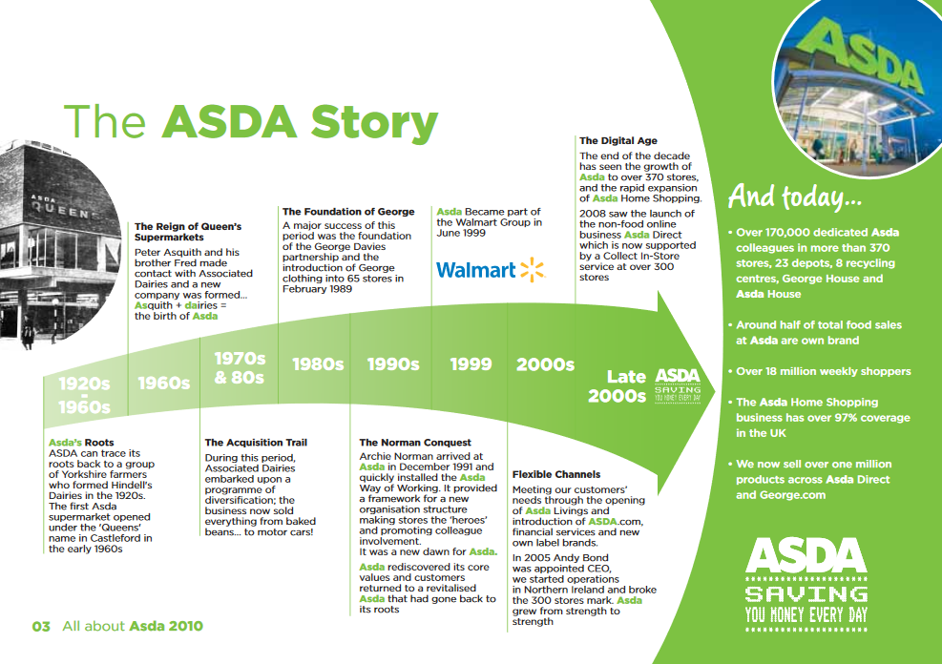

TIMELINE OF ASDA
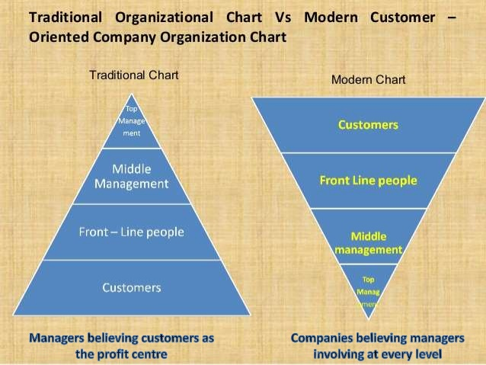

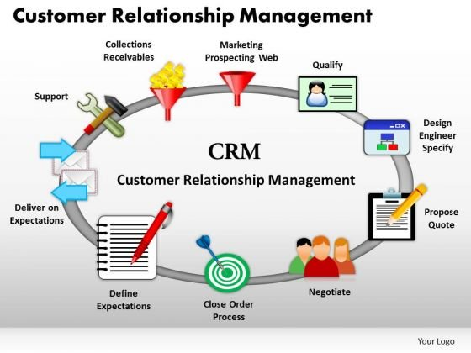

CUSTOMERS RELATION GRAPH AND CHART
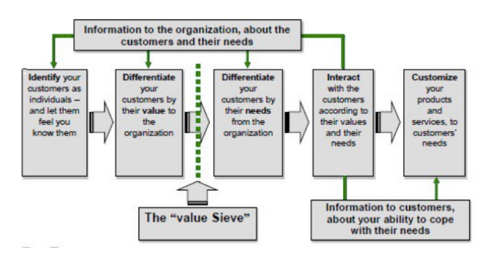

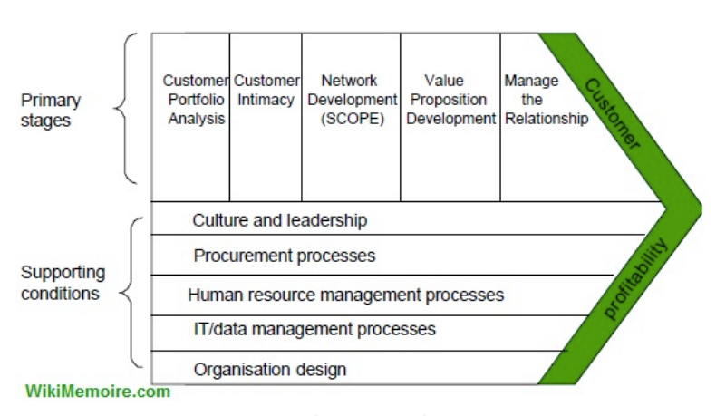

6. 0. Acknowledgement
To compile this Report the researcher sincerely thanks the guidance of Maria Heffernan, as she has guided in the most difficult time to make this report.

7.0. Reference
Ainsworth, p., 2019. (online) Available at: <https://cxm.co.uk/tag/sainsburys/> (Accessed 24 March 2020)
About.sainsburys.co.uk. 2020. Making Everyone Feel Valued. (online) Available at: <https://www.about.sainsburys.co.uk/making-a-difference/our-values/our-stories/2017/making-everyone-feel-valued> (Accessed 20 March 2020).
Becker, C., 2013. Sustainability Ethics and Sustainability Research. New York: Springer, p.8.
Bean, J., 2019. (online) Available at: <https://www.business2community.com/sales-management/what-is-a-crm-model-02235682> (Accessed 23 March 2020).
Butler, A., 2018. ASDA Generic And Intensive Growth Strategies. (online) Essay48. Available at: <https://www.essay48.com/13769-ASDA-Porters-Generic-Strategies> (Accessed 25 March 2020).
Borowy, I., 2014. Defining Sustainable Development For Our Common Future. London (u.a.): Routledge, p.2
Corporate - ASDA. 2020. Our History. (online) Available at: <https://corporate.asda.com/our-story/our-history> (Accessed 23 March 2020).
Corporate - ASDA. 2018. Putting Customers First In Our Communications. (online)Available at: <https://corporate.asda.com/article/putting-customers-first-in-our-communications> (Accessed 26 March 2020)
Eldring, J., 2009. Porter's (1980) Generic Strategies, Performance And Risk: An Empirical Investigation With German Data. Diplomica Verlag, p.6.
Ethicalcorp.com. 2020. Asda And Sustainability – Better Things In Store? | Ethical Corporation. (online) Available at: <http://www.ethicalcorp.com/business-strategy/asda-and-sustainability-better-things-store> (Accessed 19 March 2020).
Ethical Consumer. 2020. How Ethical Is Tesco Plc? | Ethical Consumer. (online) Available at: <https://www.ethicalconsumer.org/company-profile/tesco-plc> (Accessed 20 March 2020).
Hammett, E., 2020. Asda Refocuses on Price and Experience Following Failed Sainsbury's Merger. (online) Marketing Week. Available at: <https://www.marketingweek.com/asda-price-customer-experience/> (Accessed 19 March 2020).
Iseethics.files.wordpress.com. 2020. (online) Available at: <https://iseethics.files.wordpress.com/2013/09/ethics_and_sustainability_primer.pdf> (Accessed 19 March 2020)
Internet Retailing. 2020. Asda Puts Its Focus Firmly on The Customer. [online] Available at: <https://internetretailing.net/customer/customer/asda-puts-its-focus-firmly-on-the-customer-19638> (Accessed 20 March 2020).
Know Your Cdps From Your Crms And Dmps?.2019 (online)Available at: <https://www.marketingmag.com.au/hubs-c/opinion-harper-cdp/> (Accessed 24 March 2020).
Laasch, O. and Conaway, R., n.d. Principles Of Responsible Management. United Kingdom: PRME, p.3.
Mills, Q., 2004. Collaborative Customer Relationship Management: Taking CRM To The Next Level. 1st ed. Boston: springer, p.4.
Nicastro, D., 2020. (online) Available at: <https://www.business2community.com/sales-management/what-is-a-crm-model-02235682> (Accessed 24 March 2020)
Search Customer Experience. 2020. What Is CRM (Customer Relationship Management) ? - Definition from Whatis.Com. (online) Available at: <https://searchcustomerexperience.techtarget.com/definition/CRM-customer-relationship-management> (Accessed 24 March 2020).
Tescoplc.com. 2020. (online) Available at: <https://www.tescoplc.com/media/476422/tesco_ara2019_full_report_web.pdf> [Accessed 20 March 2020].
Vlieger, R., 2013. 7S Model Example & Explanation ▷ Mckinsey 7S Model Worked Out ◁ | Call The one. (online) Call the ONE | Direct contact with professionals via video calling and webinars. Available at: <https://www.calltheone.com/en/consultants/7s-model> (Accessed 25 March 2020).
Your.asda.com. 2020. (online) Available at: <https://your.asda.com/system/dragonfly/production/2012/01/04/12_59_19_568_All_about_Asda.pdf> (Accessed 26 March 2020)

