

The Studio Engineer
M4X01561

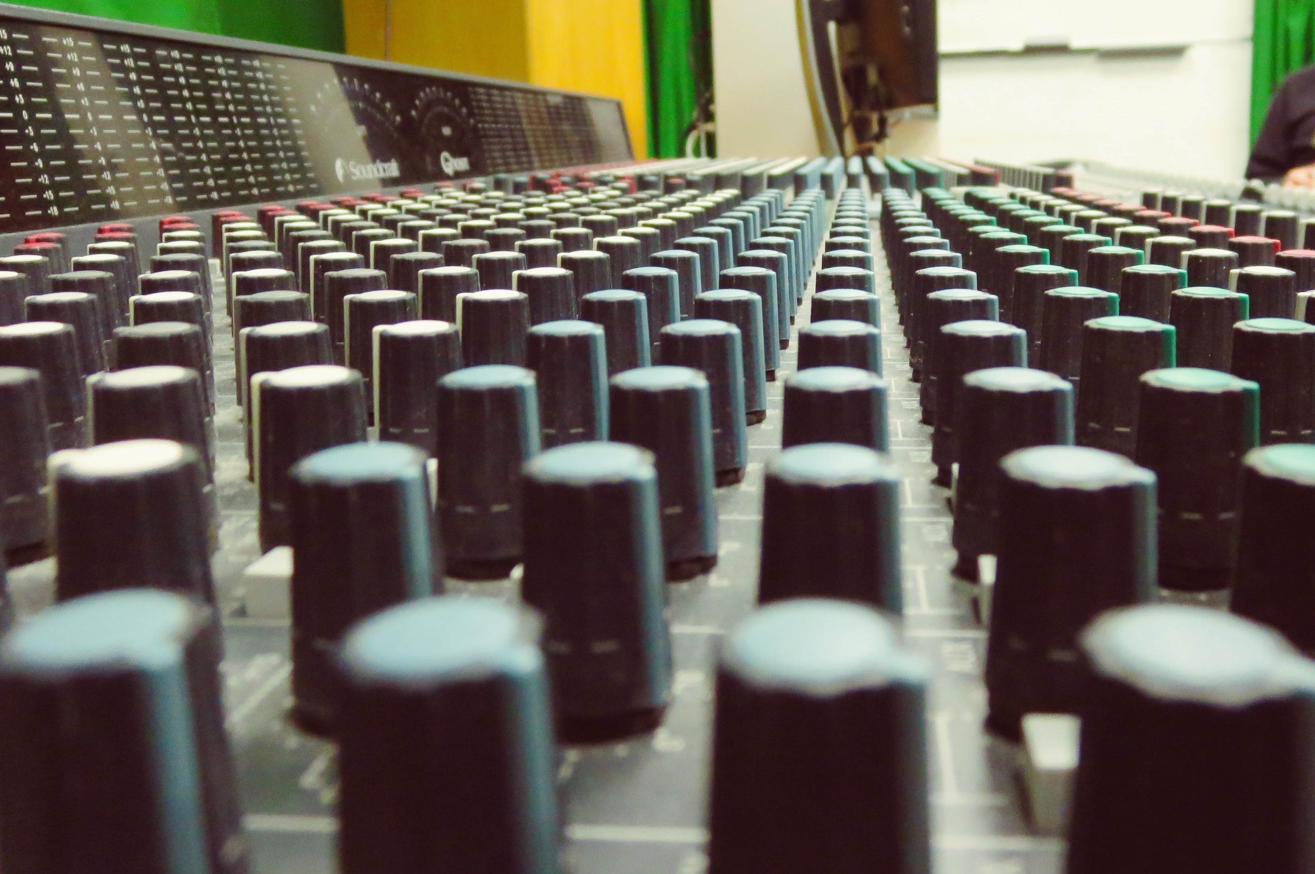

LEVEL 4 2016-17

Module Title: The Studio Engineer
Module Code: Level 4
20 Credit Module

Tuesday 1:30pm – 2:30pm (Group A & B) AB302
Monday 9am – 12pm (Group A) Studio 1
Thursday 2pm – 5pm (Group B) Studio 1

Module Coordinator: Paul Hazel
Email: paul.hazel@uwtsd.ac.uk

SYLLABUS
This module provides an introduction to the studio environment, through weekly practical sessions and lectures conducted in both the computer lab and the recording studios. These sessions provide students with an introduction to studio engineering and an understanding of audio, MIDI, hardware and software, including DAWs, monitors, microphones, FX units and more. Sessions conducted in the recording studio are a mix of theoretical instruction and workshop style sessions that allow the students a hands-on experience under the direction of the lecturer, whilst the lecture will cover more theoretical aspects associated with studio engineering.
The following material will be covered to provide the theoretical underpinning to the practical elements of the module:

- Health and safety aspects of studio engineering.
- Introduction to the DAW through audio and MIDI.
- Audio mixer, theory and practice.
- Microphone techniques.
- Routing and processing audio signals: microphones, DI, patch-bay, desk inserts, auxiliary sends, etc.
- Effects and signal processing and use of outboard equipment, e.g. compressor, gate, FX units, etc.
- Setting up a headphone mix for performers.
- Recording acoustic instruments, e.g. drums, guitar, piano vocals, etc.
- Performing a basic stereo mix-down session and producing a stereo master.
AIMS
- To introduce students to the theory and practice associated with studio engineering.
- To familiarise students with the basic equipment, software and technology associated with recording studios, including basic instruction in the use of mixers, monitors, microphones, FX units and other hardware.

LEARNING OUTCOMES
Upon the successful completion of this module, the student should be able to demonstrate the ability to:
- Safely and competently operate studio equipment and conduct a multi-track recording session.
- Conduct a mixdown session, producing a stereo master recording.
- Work together in a team of engineers and performers.

TIMETABLE
The course is taught over a twelve week period, starting in week one of semester one. The first session in the week will be a one-hour lecture focusing on the theory of studio engineering. The second session in the week will be a three-hour practical session conducted in the studios, primarily Studio 1. Students in these sessions will build their sound engineering skills through practical demonstrations and recording sessions with live musicians. There will be a feedback and tutorial week in week six.

BIBLIOGRAPHY

Essential
Huber, D. and Runstein, R. (2013) Modern Recording Techniques. Burlington: Focal Press.
Owsinski, B. (2009) The Recording Engineer's Handbook. Boston, MA: Course Technology PTR.
White, P. and Mead, D. (2011) Studio Recording Basics (Basic Mixing Techniques, Effects & Processors, Multitracking & Mixers). London: SMT.

Recommended
Bartlett, B. and Bartlett, J. (2012) Practical Recording Techniques. Boston: Focal Press.
Huber, D. (2007) The MIDI Manual. Boston: Focal Press.
Rayburn, R. and Eargle, J. (2011) Eargle's the Microphone Book. Oxford: Focal.

Background
Massey, H. (2000) Behind the glass. San Francisco: Backbeat Books.
Massey, H. (2009) Behind the Glass Vol II. San Francisco: Backbeat Books.
Swenson Gordon, K. (2012) The Recording Secrets Behind 50 Great Albums. Milwaukee, Mich: Backbeat Books.

Journals
Future Music
Sound on Sound
Mix Magazine
Computer Music

Websites
www.recordingmag.com/resources.html
www.audacity.sourceforge.net
www.recording-history.org
www.planetoftunes.com
www.projectstudiohandbook.com
www.createdigitalmusic.com

COURSE OUTLINE

Week | Week Beginning Date | Studio Composition 3
1 – 5 | 3 October | Sound, signals, microphones, analogue and digital signals (digital audio, MIDI).
6 | 7 November | Feedback Tutorials.
7 - 11 | 14 November | Time-domain effects, compression, gates.
ASSESSMENT
Coursework: 100%
Multi-track Project:
Each student is required to create a recording, around two minutes in length, including a drum kit and at least three other instruments or vocals.
This assignment requires students to work both in groups and individually.
Students are to write a report (around 1000 words) clearly describing the recording, mixing and production methods used (using both text and images). The report should also include a short (250 words, say) evaluation of the project.

Submit:
- A stereo master recording as a 44.1kHz/16-bit stereo file (or as an audio CD).
- All session files used in the production of the final mix (on DVD-R, memory stick, or HD).
- A report (via Turnitin).

Assignment due: 13.01.17

FEEDBACK
Written Feedback: 13.02.17
Feedback is an essential part of all education and training programmes. It helps learners to maximise their potential at different stages of training, raise their awareness of strengths and areas for improvement, and identify actions to be taken to improve performance.

Feedback can be seen as informal (for example in day-to-day encounters between teachers and students or trainees, between peers or between colleagues) or formal (for example as part of written or clinical assessment). However, there is no sharp dividing line between assessment and teaching in the area of giving feedback on learning. Feedback is part of the overall dialogue or interaction between teacher and learner, not a one-way communication.

During your studies you will therefore receive feedback in many ways, including the following:
- Dialogue between teachers and students in formal classes
- Direct questions and responses from teachers inside and outside formal classes
- Email correspondence between teachers and students
- Interactions between students and teachers using Moodle
- Informal comments and responses to work undertaken in classes
- Comments and annotations added to written submissions, such as essays and reflective journals
- Formal written feedback in response to assignments recorded on the summative assessment module feedback forms

