

MARKETING PLAN FOR TRAVELODGE

Student Name

Rebeca A. Baccela

Student ID number
2230716

Marketing Essentials BMIH4005

Module Lecturer: Christopher Wilkin
Introduction:
This marketing plan is prepared for Travelodge, a renowned hospitality company, with the aim of enhancing its market position and driving business growth. The plan incorporates various frameworks such as SWOT analysis, Porter's five forces, and market segmentation to gain insights into the company's competitive landscape and customer preferences (Nikbin, 2022; Siripipattanakul, 2022; Praesri, 2022). By leveraging collaborations, competitor analysis, and climate PESTLE analysis, Travelodge can make strategic decisions and capitalize on opportunities (Villagrasa et al., 2017; Abiodun & Kolade, 2020; Pathak et al., 2021). The plan also sets objectives, defines a value proposition, outlines the marketing mix, and includes an action plan and control mechanisms. Recommendations for digital marketing, international expansion, and market trend monitoring are provided to ensure Travelodge's continued success.
SWOT analysis is an effective tool to understand the overall company position or strategy in the competitive business market. It has played an effective business mechanism in the global business market (Nikbin, 2022). Compressive analyses in fig. 1 appendix.
Travelodge has a dynamic brand identity for making their customer more satisfied in the competitive marketplace. It has made a tremendous influence on creating a diversified impact in business management systems. It has also cost-effective pricing to make professional development in the competitive market (Siripipattanakul, 2022).
On the other side, it has a few service offerings to make sure customer satisfaction. Additionally, the company has focused on the only market in the UK rather than another market segment in another country. It has also less product diversification (Wichmann, 2022).
Travelodge has business expansion opportunities for making a sustainable influence on the business market. Besides, it has implemented a sustainable value proposition system in the global competitive market.
Last, but not the least, the market competition is high at this moment. It must face an economic slowdown that leads to less effective business in the global marketplace. It has experienced a customer-changing mindset for making business diversification (Siripipattanakul, 2022). Compressive analyses in fig. 1 appendix.
Marketing segmentation and targeting: Compressive analysis fig 2 appendix.
Travelodge has implemented a market segmentation and targeting strategy to make sure a sustainable value proposition system in the competitive market. The company has focused on a customer demographic segmentation strategy. They can design their pricing strategy based on customer income, age, education status, and sexual orientation. Besides, it can focus on customer lifestyle, values, and so forth for making their business more professional (Praesri, 2022). On the other hand, they can focus on customers' previous buying history for making a sustainable impact on their business development.
Competitors: Analysing the competitive landscape is crucial for businesses to develop effective strategies. Two commonly used tools in competitor analysis are the perceptual positioning map and Bowman's strategy clock. The perceptual positioning map helps visualize the positioning of products or brands in the minds of consumers based on key attributes or dimensions. It allows businesses to identify their competitors' positions and opportunities for differentiation (Villagrasa et al., 2017).

Similarly, Bowman's strategy clock provides a framework for understanding different competitive strategies. It presents eight strategic options that businesses can adopt based on price and perceived value. These strategies range from low-price offerings to high-value differentiation and help businesses assess their competitive position in the market (Villagrasa et al., 2017).

Collaborators: Collaboration and partnerships play a vital role in the success of organizations. By demonstrating an awareness of B2B relationships, partnerships, and franchises, businesses can leverage synergies, expand their reach, and tap into new markets. B2B relationships involve working closely with other businesses to exchange goods, services, or expertise, creating mutually beneficial opportunities (Abiodun & Kolade, 2020).

Partnerships allow organizations to combine their strengths, resources, and capabilities to achieve common goals. Collaborating with the right partners can lead to increased innovation, shared knowledge, and improved market presence. Franchises provide an opportunity for businesses to expand their operations through established brand networks and benefit from the franchisees' local market knowledge (Abiodun & Kolade, 2020).

By fostering strong collaborations and partnerships, organizations can enhance their competitive advantage, gain access to new markets, and leverage shared resources for mutual growth and success.
Porter’s five forces: Compressive analysis fig 3 appendix.
Porter's five forces help them to make or understand the competitive atmosphere in the global business market. It has made a tremendous impact on creating or making effective business mechanisms in the global business market (Nikbin, 2022).
Travelodge must consider the threat of new entrants in the global arena. By analysing market trends, they have made their business strategy. Besides, they have focused on the bargaining power of suppliers for making effective business decisions. Similarly, they can focus on the bargaining power of buyers in the competitive market (Mishbakhudin, 2022). In the meantime, it must focus on the threat of substitute products and services for making effective business dynamism in the competitive market. Last, but not least, it can focus on competitive rivalry to make sure positive business dynamism.
Climate PESTLE analyses:
A PESTLE analysis of Travelodge from a climate perspective reveals several factors that can impact its operations and growth. Firstly, climate change regulations and policies, such as carbon emissions reduction targets, may require Travelodge to implement sustainable practices and invest in energy-efficient technologies (Pathak et al., 2021). Secondly, extreme weather events and changing weather patterns can affect travel patterns and demand for hotel accommodations (Buhalis & Costa, 2006). Thirdly, rising consumer awareness and preferences for eco-friendly options may influence Travelodge's brand positioning and marketing strategies (Meadows et al., 1992). Finally, the need to adapt to climate-related risks, such as sea-level rise in seaside locations, can impact the company's investment decisions and property management strategies. Considering these climate-related factors in its strategic planning can help Travelodge mitigate risks, capitalize on opportunities, and align with sustainability goals.
Objectives:
The objective of Travelodge's marketing plan is to increase website traffic and social media followers (Travelodge, n.d.). The SMART target for this objective is to achieve a 20% increase in website traffic and a 15% increase in social media followers within six months. The success of the plan will be measured through key performance indicators (KPIs), such as website analytics to track traffic and engagement metrics on social media platforms. The KPIs will be monitored monthly to assess the effectiveness of the marketing strategies (Huang & Sarigöllü, 2014). The target completion date for achieving the specified increases in website traffic and social media followers is six months from the start of the marketing plan.
Value proposition:
Travelodge has provided useful value propositions to its valued employees and clients. They can provide luxurious or affordable mechanisms to ensure potential diversity in the global business market. It provides competitive prices to the clients so that they can afford it easily (Marpaung, 2022). It has made a tremendous influence on creating positive value propositions in the competitive business market. It also provides a convenient atmosphere for making a diversified influence on the competitive market and creating long-term business deals with clients. They also provide a comfort zone for their clients and make crucial value to obtain a competitive edge in the global business market. They can communicate their value proposition for making or creating sustainable influence in the global competitive market and create a positive image in terms of their brand identity. They can use social media marketing to boost their brand value in front of a couple of clients. The company can link its value proposition to its valued customer by making or providing sustainable influence in giving them leisure travel including family travels, vacations, and so forth for creating or making effective business decisions. This has affected a lot in their targeted customer for creating effective business mechanisms in the global marketplace. It has made their life easier to create a sustainable business environment.
Marketing mix:
The marketing mix has been instrumental in formulating a robust marketing plan within the competitive business landscape, providing sustainable influence in the global marketplace (Kucuk, 2023). Travelodge, as a player in this dynamic market, offers comfortable and cost-effective accommodations, aiming to meet the needs of its valued clients (Kucuk, 2023). By providing superior services and incorporating various amenities such as air conditioning, Wi-Fi, and televisions, Travelodge aims to enhance customer satisfaction (Kucuk, 2023).

Price, an essential element of the marketing mix, presents numerous considerations when setting prices for products and services (Khalayleh, 2022). Travelodge strategically establishes reasonable prices for its offerings after analyzing its demographic customer segments, ensuring competitive pricing within the industry (Khalayleh, 2022).

Selecting a convenient location is another vital aspect of the marketing mix, contributing significant value to a company's portfolio (Istikomah, 2022). Travelodge has recognized the importance of this factor and strategically positioned its 500+ hotels in the heart of cities with excellent transportation links, maximizing its presence and impact in the globally competitive marketplace (Istikomah, 2022).

Promotion plays a crucial role in creating an efficient marketing plan and sustaining decision-making processes within the global business environment (Ho, 2022). Travelodge utilizes multiple channels, including social media marketing, to ensure a sustainable value proposition in the competitive marketplace (Ho, 2022). By leveraging social media platforms and engaging customers through various sites, Travelodge enhances its marketing activities and adds competitive value propositions to its global presence (Dewi, 2022). Additionally, strategies such as email marketing and search engine marketing further contribute to Travelodge's effective business atmosphere and overall marketing success (Dewi, 2022).

By effectively integrating the elements of the marketing mix, Travelodge positions itself to thrive within the competitive hospitality industry, delivering value to its customers and maintaining a sustainable influence in the global market.
Action plan by implementing Gantt Chart fig 4 in the appendix.
Unique selling points:
Travelodge has established unique selling points and affordable prices, making it an ideal choice for budget-conscious travellers. With attractive locations and superior service, it creates effective business dynamism and a competitive edge. The unlimited-hour front desk service ensures customer satisfaction, contributing to sustainable influence and proper market standards (Amiarno, 2022).
Control:
Travelodge measures success through metrics such as new customer acquisition, positive brand attitudes, and increased profits, using KPIs like customer growth, satisfaction surveys, online reviews, revenue growth, average room rates, and occupancy rates, ensuring effective evaluation and data-driven decision-making to enhance customer experience and drive financial performance.
Conclusion:
In conclusion, Travelodge's marketing plan incorporates thorough analysis and strategic changes to enhance its market position. By leveraging insights from SWOT analysis, customer segmentation, competitor analysis, and PESTLE analysis, Travelodge aims to improve customer satisfaction, increase brand loyalty, and drive profitability. Recommendations include embracing digital marketing trends, expanding internationally, and staying initiative-taking in monitoring market trends and customer preferences. Through these measures, Travelodge can stay ahead of the competition, adapt to evolving consumer needs, and maintain a strong presence in the Hospitality industry.

References:
- Abiodun, E.A. and Kolade, O.G., 2020. Marketing strategies impact on organizational performance. In Buhalis, D. and Costa, C. eds., 2006. Tourism management dynamics: trends, management and tools. Routledge.

- Altay, B.C., Okumuş, A. and Adıgüzel Mercangöz, B., 2022. An intelligent approach for analyzing the impacts of the COVID-19 pandemic on marketing mix elements (7Ps) of the on-demand grocery delivery service. Complex & Intelligent Systems, 8(1), pp.129-140.

- Amiarno, Y., 2022. Bauran Pemasaran, Word of Mouth dan Brand Image Terhadap Minat Berkunjung Kembali di Radioterapi: Marketing Mix, Word of Mouth and Brand Image on Returning Interest in Radiotherapy. Journal of Public Health Education, 1(3), pp.117-129.

- Baidun, A., Prananta, R., Harahap, M.A.K. and Yusuf, M., 2022. Effect Of Customer Satisfaction, Marketing Mix, And Price In Astana Anyar Market Bandung. Al-Kharaj: Journal of Islamic Economics and Business, 4(2).

- Buhalis, D. and Costa, C. eds., 2006. Tourism management dynamics: trends, management and tools. Routledge.

- Chowdhury, T.A. and Naheed, S., 2022. Multidimensional political marketing mix model for developing countries: An empirical investigation. Journal of Political Marketing, 21(1), pp.56-84.

- Dewi, F.M. and Sulivyo, L., 2022. Influence of Consumer Behavior and Marketing Mix on Product Purchasing Decisions. Aptisi Transactions on Management (ATM), 6(2), pp.151-157.

- Ho, C.I., Liu, Y. and Chen, M.C., 2022. Factors influencing watching and purchase intentions on live streaming platforms: From a 7Ps marketing mix perspective. Information, 13(5), p.239.

- Huang, R. and Sarigöllü, E., 2014. Assessment of brand equity measures. International Journal of Market Research, 56(6), pp.783-806.

- Istikomah, I., Saputra, G.W. and Yusuf, M., 2022. Marketing Mix Strategy and Financial Capabilities in Improving Sharia Stock Investment. Journal of Applied Management and Business Administration, 1(1), pp.21-27.

- Kaur, B. and Singh, J., 2023. Significance of Brand Perception in Stimulating Consumer Engagement. In Promoting Consumer Engagement Through Emotional Branding and Sensory Marketing (pp. 211-219). IGI Global.

- Khalayleh, M. and Al-Hawary, S., 2022. The impact of digital content of marketing mix on marketing performance: An experimental study at five-star hotels in Jordan. International Journal of Data and Network Science, 6(4), pp.1023-1032.

- Kucuk, S.U., 2023. Marketing and Marketing Mix. In Visualizing Marketing: From Abstract to Intuitive (pp. 7-13). Cham: Springer International Publishing.

- Marpaung, N.N., 2022. The Influence of The Marketing Mix on Buying Decision (Study on Rb Collection Pasar Baru Bekasi). International Journal of Education, Information Technology, and Others, 5(2), pp.166-176.

- Meadows, D.H., Meadows, D.L. and Randers, J., 1992. Beyond the limits: global collapse or a sustainable future. Earthscan Publications Ltd.

- Mishbakhudin, M. and Aisyah, M., 2022. The E-Marketing Mix Strategy of Tokopedia Salam during the Covid-19 Pandemic. International Research Journal of Business Studies, 14(3), pp.215-227.

- Nikbin, D., Iranmanesh, M., Ghobakhloo, M. and Foroughi, B., 2022. Marketing mix strategies during and after COVID-19 pandemic and recession: a systematic review. Asia-Pacific Journal of Business Administration, 14(4), pp.405-420.

- Pathak, R., 2021. National Education Policy 2020: Can it improve Faculty Motivation and Academic Outcomes in India. International Research Journal of Modernization in Engineering Technology and Science, 3(4), pp.573-579.

- Praesri, S., Meekun, K., Lee, T.J. and Hyun, S.S., 2022. Marketing mix factors and a business development model for street food tourism. Journal of Hospitality and Tourism Management, 52, pp.123-127.

- Siripipattanakul, S., Siripipatthanakul, S., Limna, P. and Auttawechasakoon, P., 2022. Marketing Mix (4Cs) Affecting Decision to be an Online Degree Student: A Qualitative Case Study of an Online Master’s Degree in Thailand. International Journal on Integrated Education, 5(4), pp.31-41.

- Travelodge. (n.d.). About Our Company. [Accessed] (May 19, 2023)
- https://www.travelodge.co.uk/about/

- Villagrasa, J., Sánchez, F. and Donaldson, C., 2021. DECIPHERING THE STRATEGIC CLOCK HANDS: FROM THEORY TO REALITY. In INTED2021 Proceedings (pp. 9571-9584). IATED.

- Vivek, R., Brahmi, M., Nanthagopan, Y. and Aldieri, L., 2023. A Systematic Review Using a Factor in Pestle Framework: COVID-19 Pandemic and Expansion of Economic Environments. Frugal Innovation and Social Transitions in the Digital Era, pp.26-40.

- Wichmann, J.R., Uppal, A., Sharma, A. and Dekimpe, M.G., 2022. A global perspective on the marketing mix across time and space. International Journal of Research in Marketing, 39(2), pp.502-521.

- SimilarWeb. (n.d.). Website Performance Analysis: travelodge.co.uk. Available at: https://pro.similarweb.com/#/digitalsuite/websiteanalysis/overview/website-performance/*/999/3m?webSource=Total&key=travelodge.co.uk [Accessed] (May 19, 2023)

Appendix:
Fig 1.
SWOT analysis of Travelodge:
Strengths:
Strong presence and brand recognition in the UK, Ireland, and Spain (Travelodge, n.d.).
Extensive hotel network with over 590 hotels and 40,000 guest bedrooms (Travelodge, n.d.).
A diverse range of accommodation options, including Travelodge PLUS hotels and Travelodge SuperRooms® (Travelodge, n.d.).
Customer-centric approach with rooms designed based on customer feedback (Travelodge, n.d.).
Affordable pricing options cater to different budgets (Travelodge, n.d.).
Weaknesses:
Reliance on budget-conscious customers, potentially limiting revenue from higher-end markets.
Limited international presence compared to global hotel chains.
Opportunities:
Expansion into new locations to capture untapped markets (Travelodge, n.d.).
Growing demand for eco-friendly and sustainable practices in the hospitality industry (Meadows et al., 1992).
Increasing trend of experiential travel, offering unique experiences and local immersion to guests (Buhalis & Costa, 2006).
Threats:
Intense competition from both independent hotels and global hotel chains.
Economic fluctuations and uncertainties affect the travel and tourism industry.
Changing customer preferences and expectations in terms of technology and amenities (Buhalis & Costa, 2006).
Fig 2.
Market and targeting segmentation:
Demographic Segmentation: Gender Distribution: 55.33% male and 44.67% female (SimilarWeb data).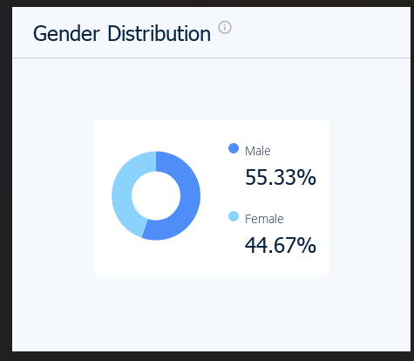
Age Distribution: 23.90% aged 25-34, 19.23% aged 35-44, and 18.15% aged 45-54 (SimilarWeb data).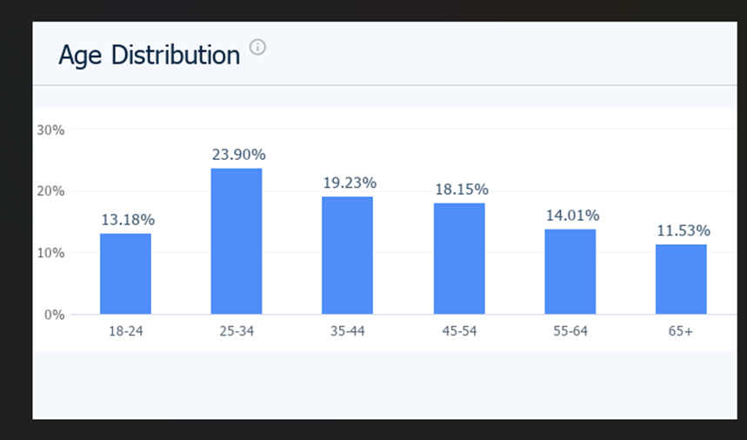
Targeting:
Business Travelers:
Travelodge caters to business stays for both large companies and small startups (Travelodge, n.d.).
Offers amenities like spacious work desks and convenient locations.
Leisure Travelers:
Families:
Travelodge provides comfortable rooms designed for families (Travelodge, n.d.).
Accommodations include separate pull-out beds for children or extra guests.
SuperRooms®:
Travelodge offers premium economy options with enhanced amenities (Travelodge, n.d.).
Features include in-room Lavazza coffee machines, adjustable showers, and more.
Budget-Conscious Travelers:
Travelodge targets budget-conscious travellers seeking affordable accommodation (Travelodge, n.d.).
Emphasizes value for money without compromising on quality and comfort.
Fig. 3.
Porter's Five Forces Analysis for Travelodge:
The Threat of New Entrants:
The moderate barrier to entry is due to initial investment and market competition.
"As the first value hotel brand in Britain, Travelodge has grown considerably and now boasts over 590 hotels with 40,000 guest bedrooms in the UK, Ireland, and Spain" (Travelodge, n.d.).
Bargaining Power of Suppliers:
Low supplier bargaining power due to multiple suppliers and the ability to switch.
"Our hotels are situated in prominent city centres, towns, seaside locations, and important roadside stops" (Travelodge, n.d.).
Bargaining Power of Buyers:
Moderate buyer bargaining power due to wide hotel options.
"Travelodge provides excellent accommodation options for all types of travellers" (Travelodge, n.d.).
The threat of Substitutes:
High threat of substitutes from alternative accommodations.
"We are the perfect choice for any traveller" (Travelodge, n.d.).
Competitive Rivalry:
A highly competitive industry with numerous players.
"Travelodge, the largest independent hotel brand in the UK" (Travelodge, n.d.).

Fig.4.

Gantt Chart:
To implement a marketing plan, it is required to ensure a sustainable decision-making system in the competitive business ambience. It has played a considerable influence in delivering positive aspects of business effectiveness in the globalization era (Chowdhury, 2022). Implementing the Gantt chart has played a plethora of roles to make a sure dynamic impact in the competitive business market for value-driven decision-making systems.
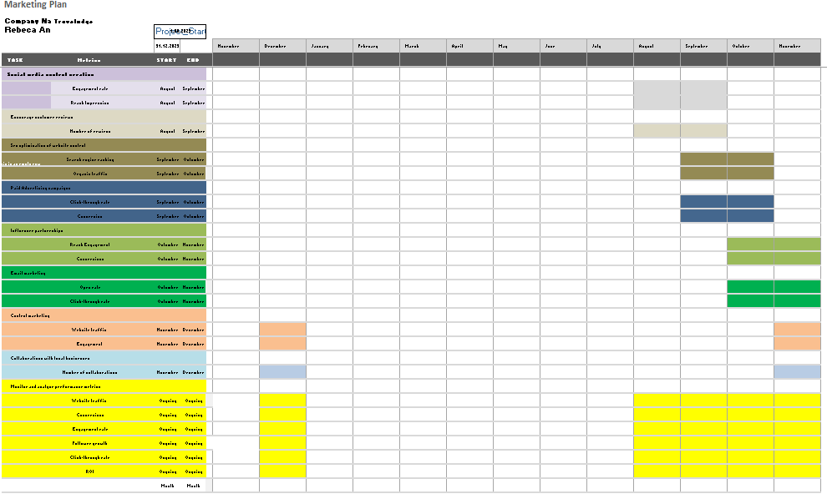
The Gantt chart has helped the organization to make sustainable business decisions in the global competitive market and it has a diversified influence on effective business mechanisms and business development impact. It has created a value-driven decision-making system and ensured solid influence on proper marketing plans in the global business market (Baidun, 2022). It has added a value proposition system to accelerate business decision-making complications in the global marketplace.
The success of the plan will be measured through key performance indicators (KPIs), such as website analytics to track traffic and engagement metrics on social media platforms. The KPIs will be monitored monthly to assess the effectiveness of the marketing strategies (Huang & Sarigöllü, 2014). The target completion date for achieving the specified increases in website traffic and social media followers is six months from the start of the marketing plan.

Marketing Plan Presentation: Travelodge
Slide 1:
Script: Marketing Plan Presentation: Travelodge



Slide 2:
Script: Company name and logo Travelodge.
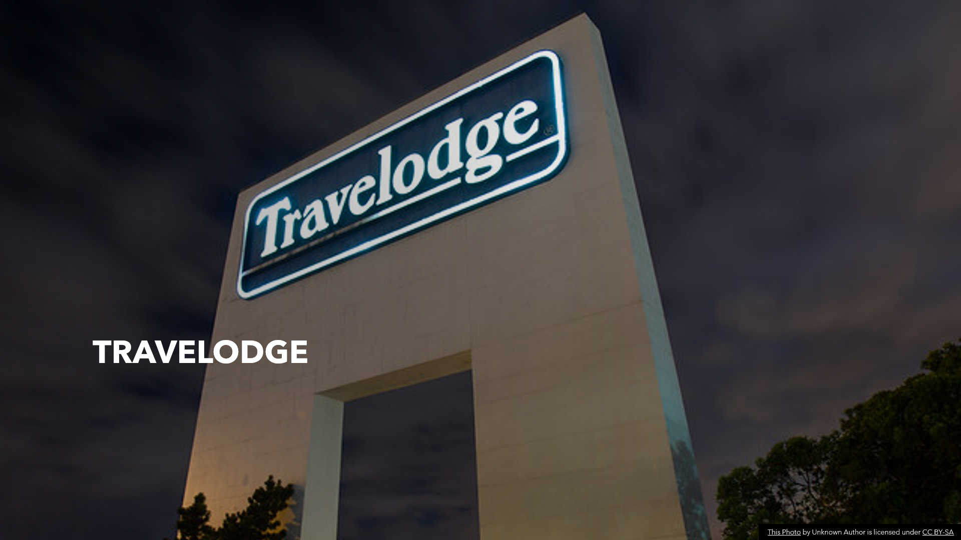

Slide 3:
Script:
Welcome to the marketing plan presentation for Travelodge. The marketing plan aims to increase Travelodge's market share and brand awareness. The strategies outlined include targeted advertising, personalized promotions, and improved customer experiences. By implementing these strategies effectively, Travelodge aims to position itself as the preferred choice for budget-conscious travellers. Let's delve deeper into the plan.
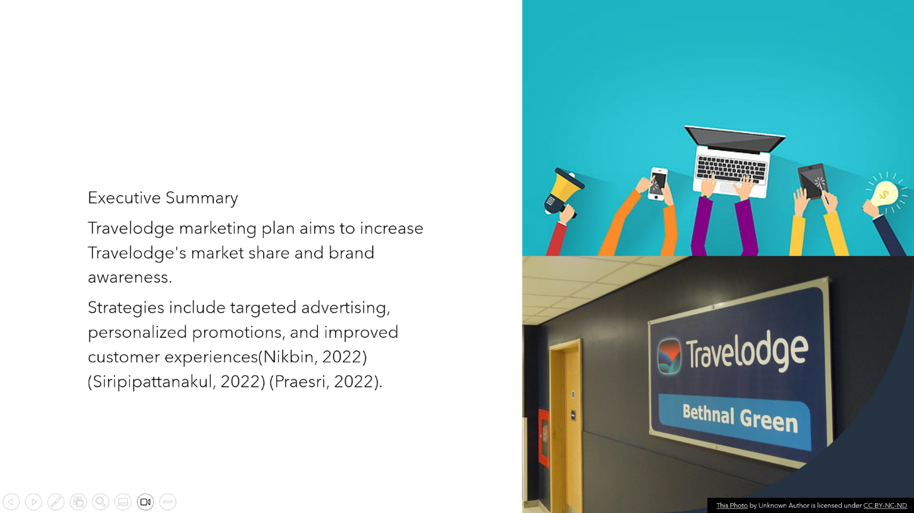

Slide 4
Script:
The market analysis reveals that the hospitality industry is experiencing steady growth, driven by increasing travel trends. The target market for Travelodge comprises budget-conscious travellers seeking affordable and convenient accommodations. With competitive rates and strategic locations, Travelodge aims to capture this market segment effectively. By understanding the needs and preferences of the target audience, Travelodge can tailor its marketing efforts to meet their expectations and provide the best value for their money.
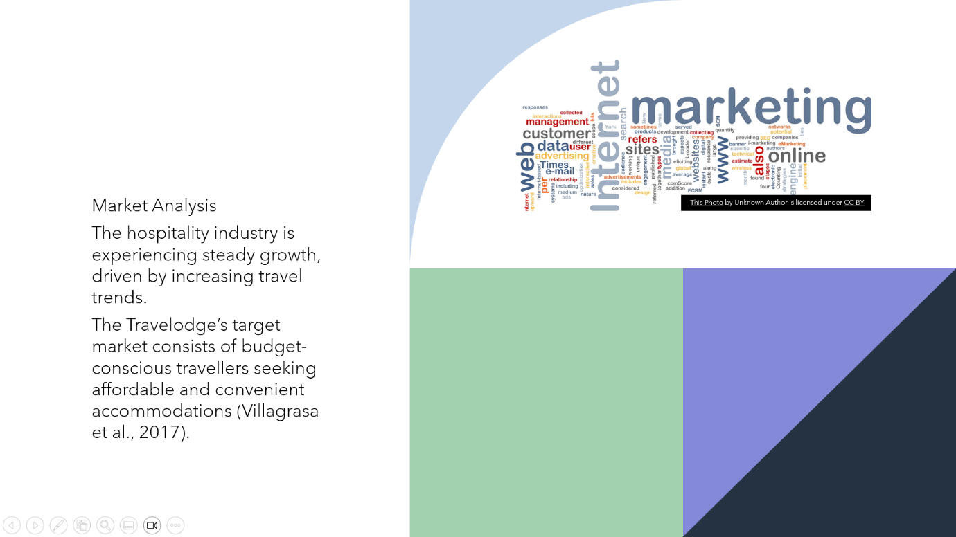

Slide 5:
Script:
The SWOT analysis for Travelodge reveals important insights. Travelodge's strengths lie in its extensive network of hotels and cost-effective operations. However, there is a need to differentiate the brand and improve the online booking experience to address weaknesses. Opportunities include expanding into emerging markets and leveraging digital marketing channels. It is important to be aware of threats posed by competition from other budget hotel chains and economic factors impacting travel. By capitalizing on strengths and seizing opportunities, Travelodge can overcome challenges and achieve success.
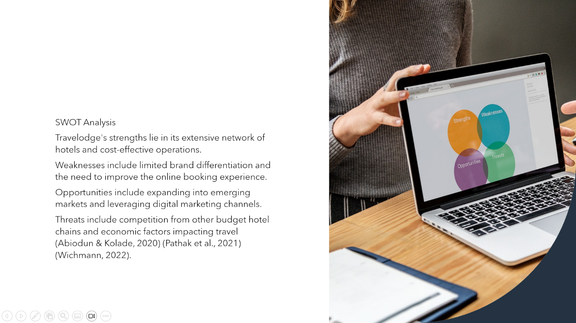

Slide 6:
Script:
The target market and segmentation strategy play a crucial role in the marketing plan. The target market comprises budget-conscious travellers of all ages, including families, business travellers, and others, based on location and travel purposes. By effectively segmenting the audience, Travelodge can tailor its marketing messages and offerings to cater to their specific needs and preferences. This approach allows Travelodge to connect with the target market on a deeper level and establish itself as their preferred choice for affordable and convenient accommodations.
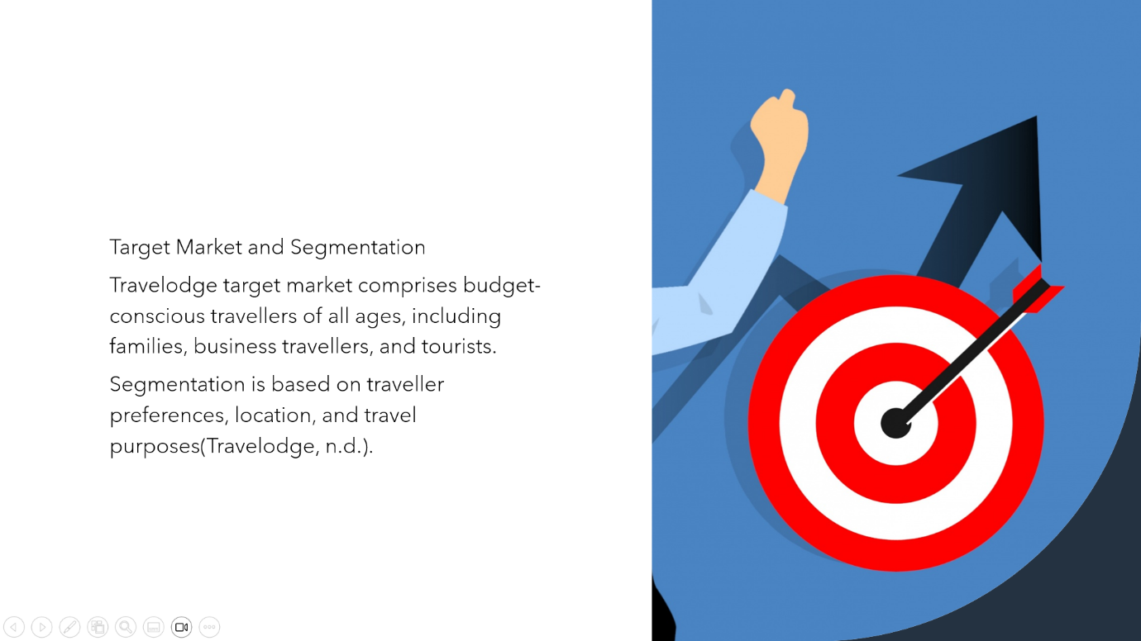

Slide 7:
Script:
The marketing strategy revolves around reaching the target market effectively. Travelodge will leverage various digital advertising platforms, social media campaigns, and establish partnerships with travel agencies. The unique selling propositions for Travelodge include affordable rates, convenient locations, and a loyalty program for frequent guests. By highlighting these key advantages, Travelodge aims to differentiate itself from competitors and create a strong brand presence. The marketing strategy aims to capture the attention of the target audience, build brand loyalty, and drive bookings and occupancy rates.
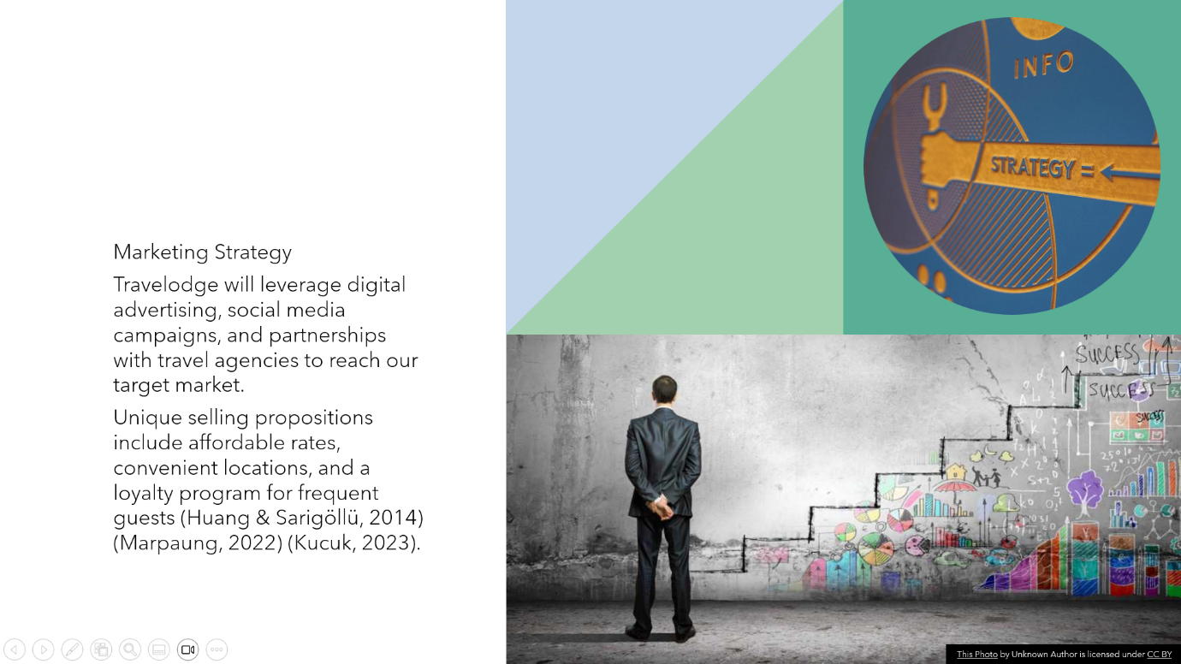

Slide 8:
Script:
Travelodge offers comfortable rooms with essential amenities, convenient locations near transportation hubs, and 24/7 customer service. Guests can enjoy affordable rates, hassle-free reservations, and a consistent quality experience during their stay. Travelodge understands that the target market seeks value for their money and strives to exceed their expectations in every aspect of their stay. By delivering exceptional service and maintaining consistent quality, Travelodge aims to build trust and loyalty among its guests.

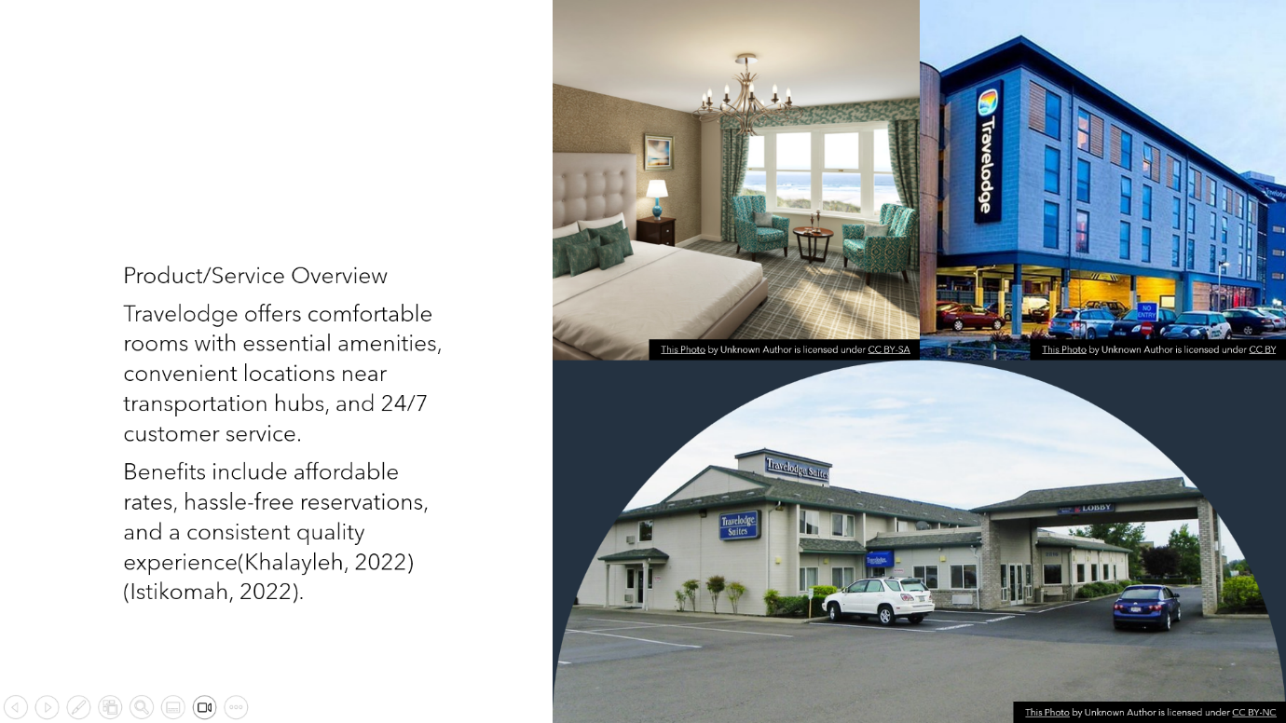

Slide 9:
Script:
The promotion and communication strategy is crucial for reaching the target audience effectively. Travelodge will utilize targeted online advertising, social media platforms, and email marketing to reach and engage with its audience. The key messages will highlight Travelodge's affordability, convenient locations, and exceptional value for money. By effectively communicating these messages through various channels, Travelodge aims to create awareness, generate interest, and drive bookings.

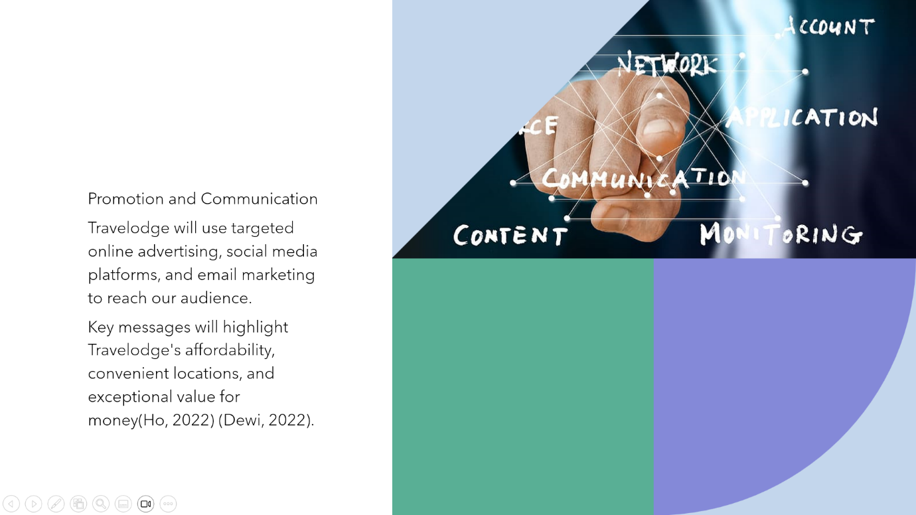

Slide 10:
Script:
The distribution strategy focuses on providing multiple channels for customers to book their stays. Travelodge will encourage direct bookings through its website, while also partnering with online travel agencies and strategic partners. By collaborating with popular travel websites and platforms, Travelodge aims to enhance its visibility and accessibility to the target audience. This multi-channel approach ensures that customers have various options to choose from when making their reservations, making it more convenient for them to book with Travelodge.
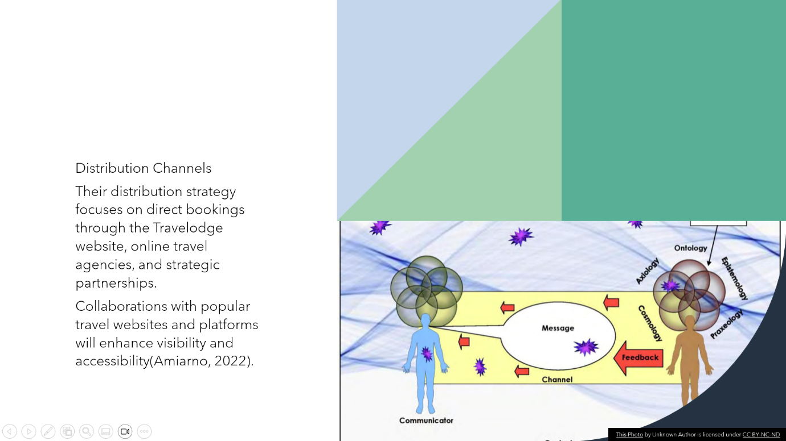

Slide 11:
Script:
The marketing budget for Travelodge includes allocations for advertising campaigns, digital marketing initiatives, and customer experience enhancements. By investing in targeted marketing efforts, Travelodge aims to increase brand awareness and capture a larger share of the target market. The expected return on investment (ROI) comes in the form of increased bookings, higher occupancy rates, and improved customer loyalty. By effectively utilizing the allocated budget and tracking key performance metrics, Travelodge can measure the success of its marketing initiatives and ensure a positive ROI.
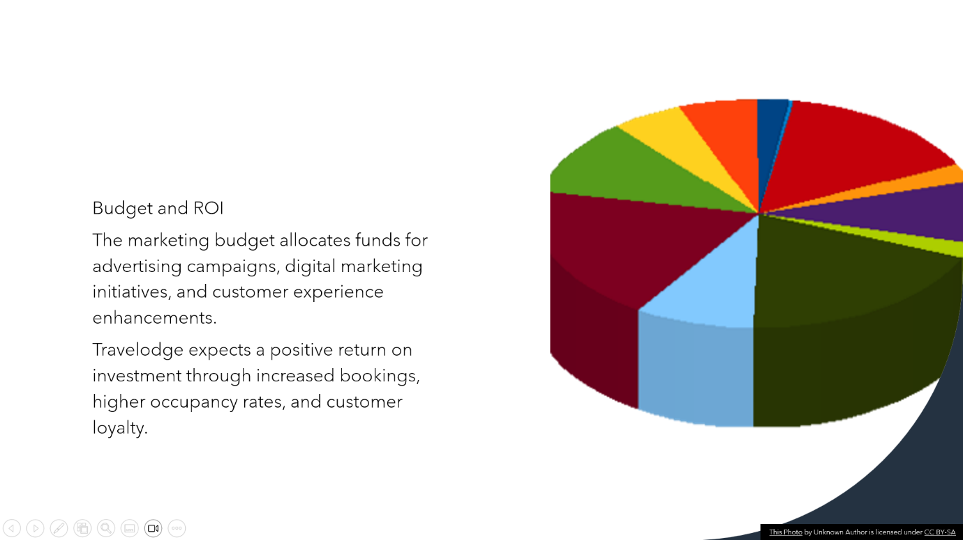

Slide12:
Script:
In conclusion, Travelodge's marketing plan is designed to position the company as the preferred choice for budget-conscious travellers. By leveraging its strengths, targeting the right audience, and implementing effective strategies, Travelodge anticipates significant growth and increased market share. With its focus on affordability, convenient locations, and exceptional customer experiences, Travelodge aims to build strong brand loyalty and establish itself as a leading player in the budget hotel segment. The marketing plan provides a roadmap for success, and Travelodge is excited about the opportunities it presents2:

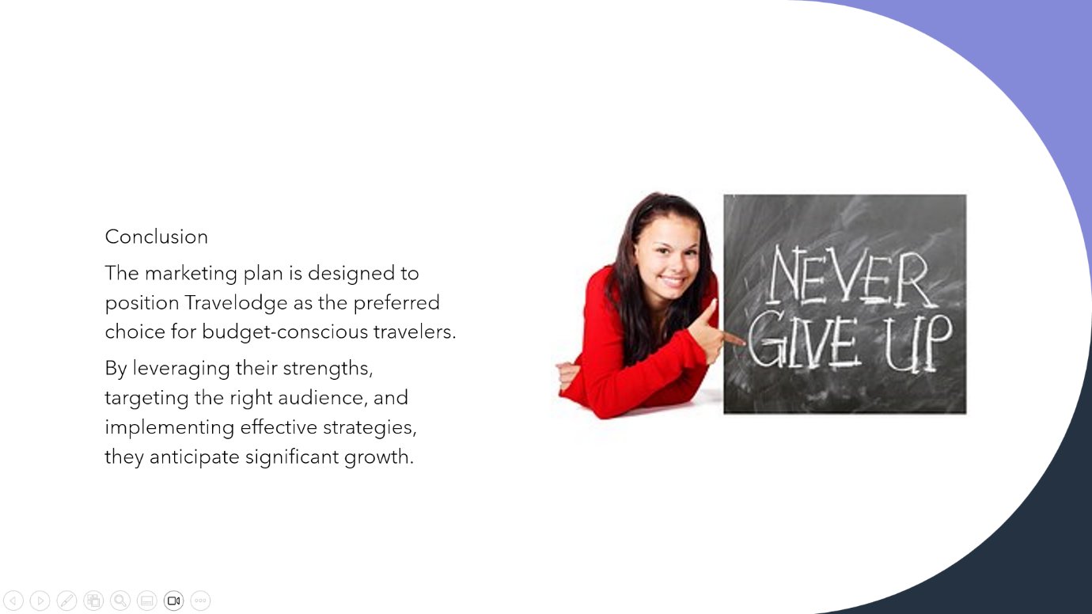

Slide 13:
Script:
Travelodge encourage questions or discussions regarding the details and potential opportunities presented in the marketing plan. Feel free to share your thoughts, ask for clarifications, or explore any areas of interest.

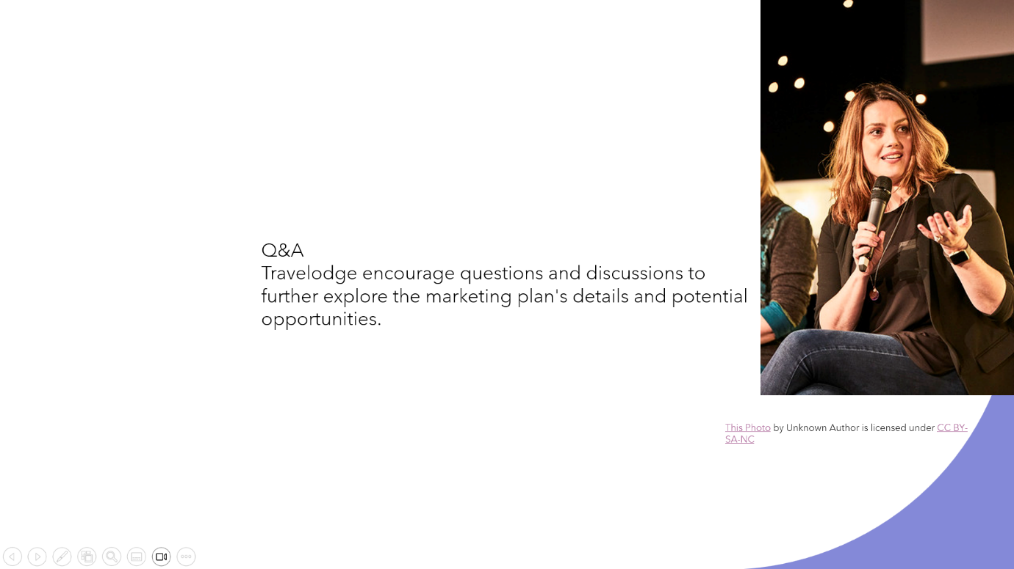

Slide 14:
Script:
Thank you!

Slide 15:
References list:


