Skills for the Workplace
Module Assignment Submission
Student Name: | Roselyn Tenkorang, Peter Owusu-Dome and Bandekila Jacques Nkenda
Student Number: | 1604295, 1604263, 1604635
Module No: | EMPL4013
Module Title: | Pathway Project 1: Sustainability and Global Citizenship

Statement of Confirmation of Authenticity
By the act of making this submission, the student declares that this is the work of the student named above. The work has not, in whole or in part, been knowingly presented elsewhere for assessment, or where assessment has been built on a previous assessment, this has been identified. Where materials have been used from other sources it has been properly acknowledged. If this statement is untrue, the student acknowledges that an assessment offence has been committed.
Attention is drawn to the plagiarism and unfair practice policies of both the University and of ILM.

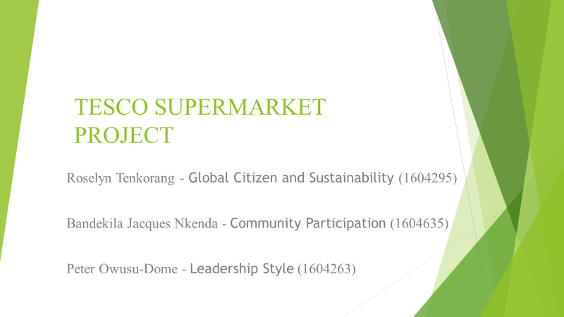

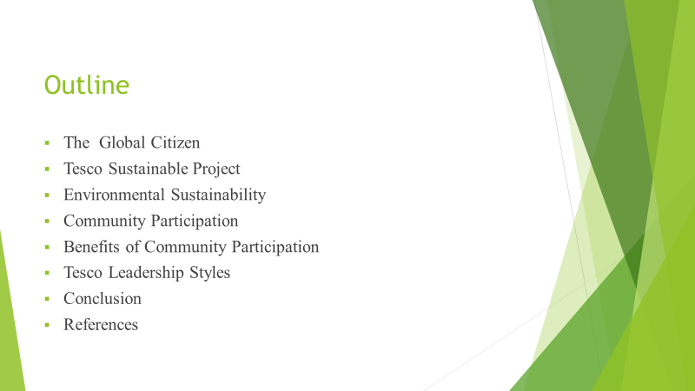
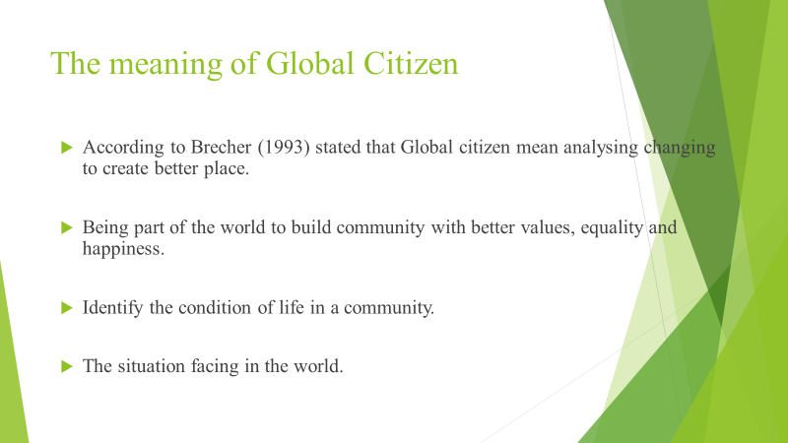

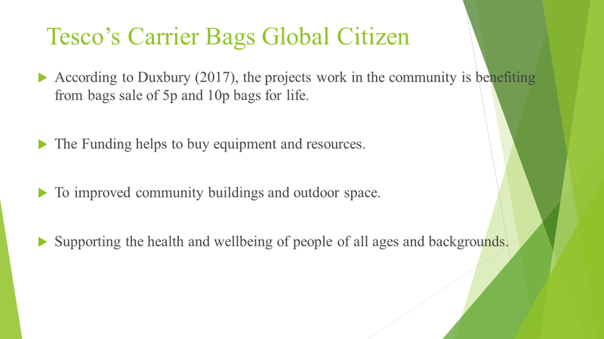
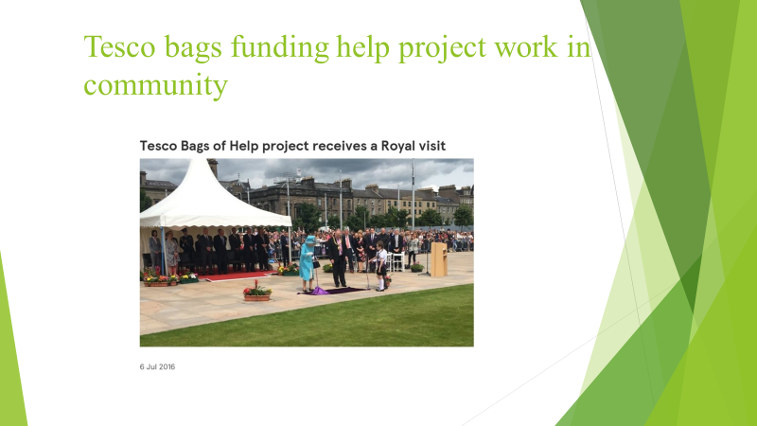

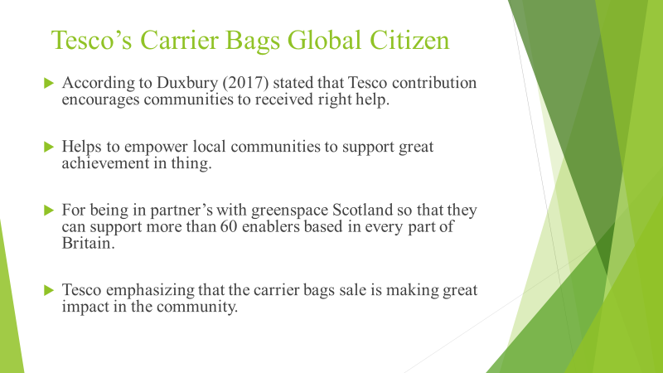

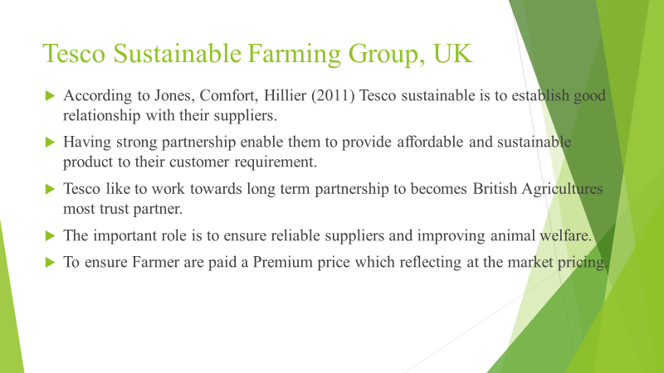

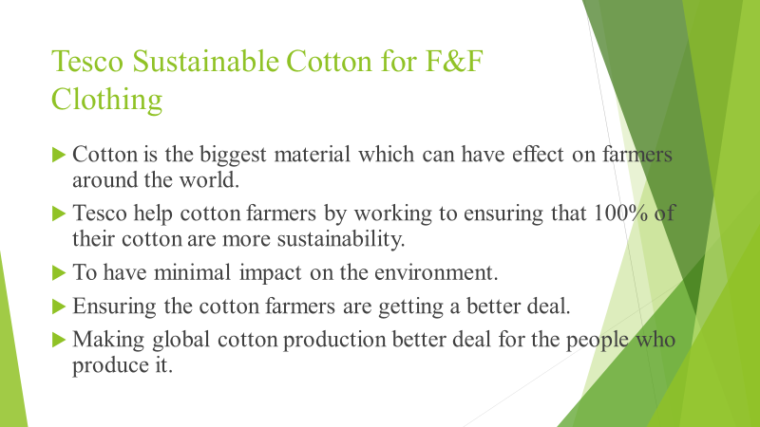

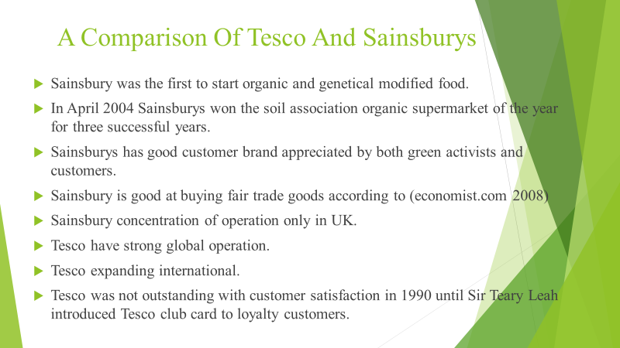

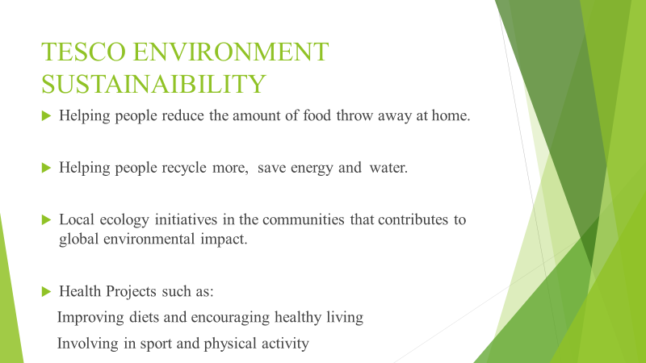

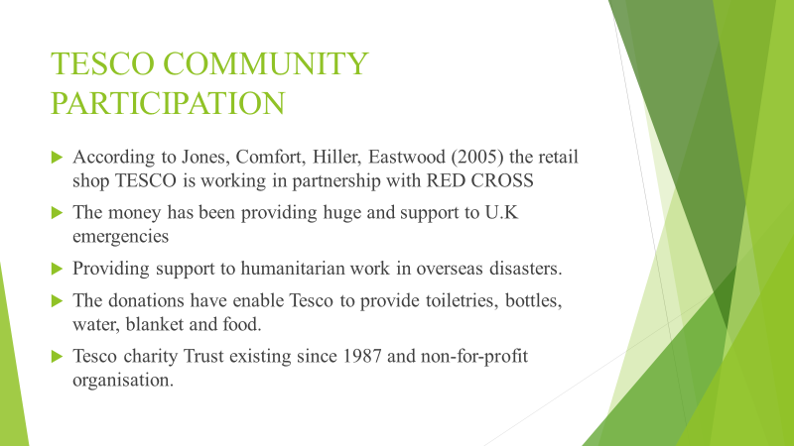

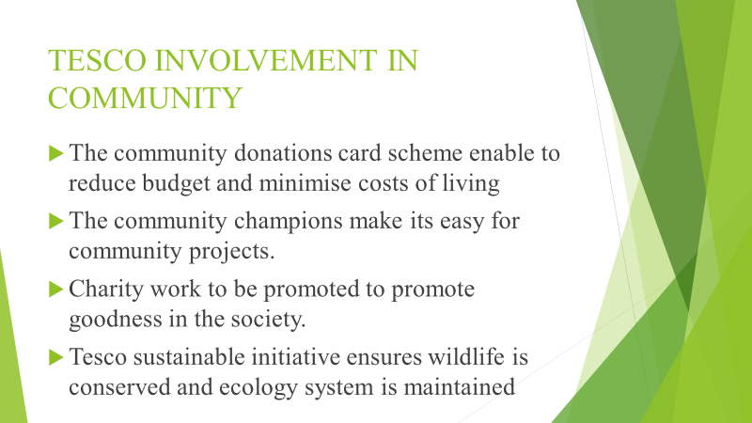

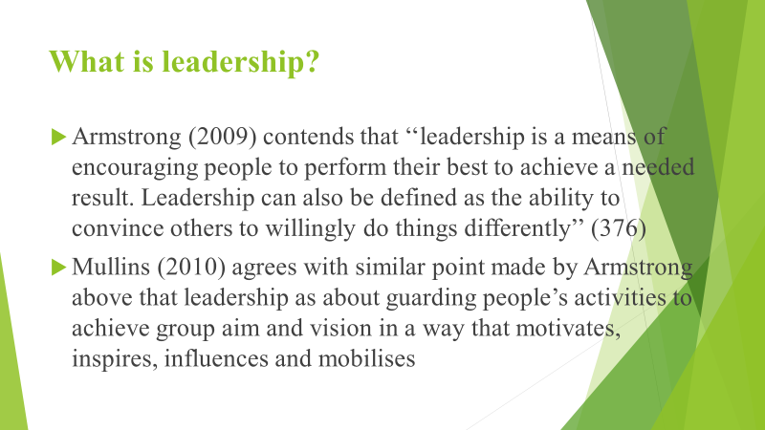

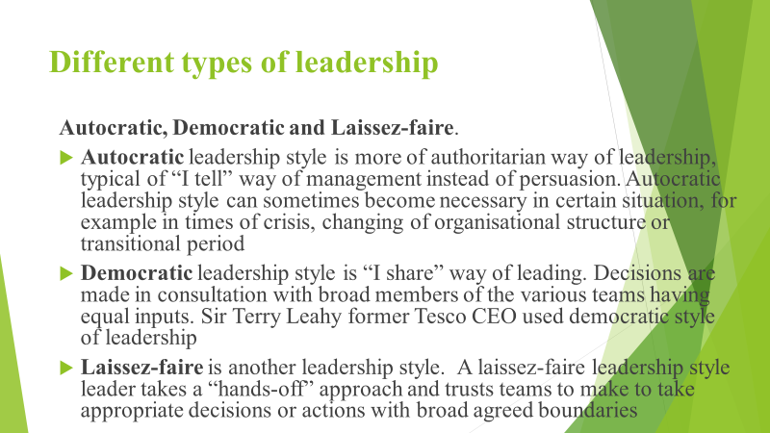

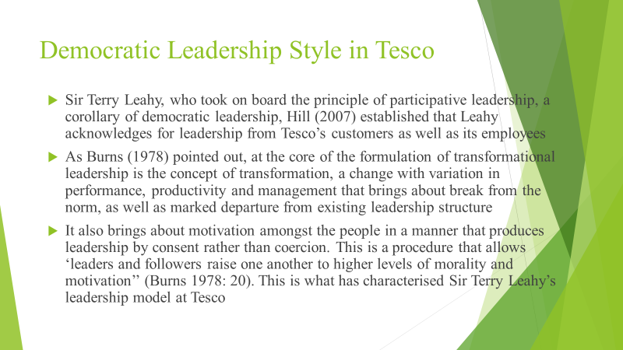

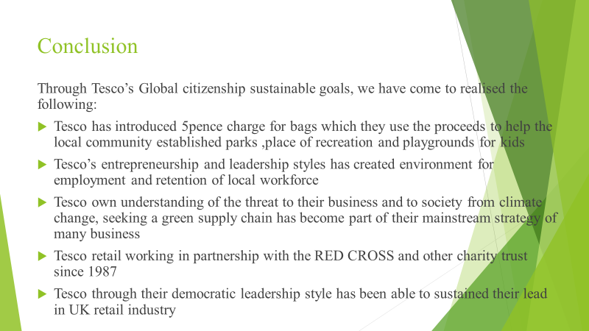

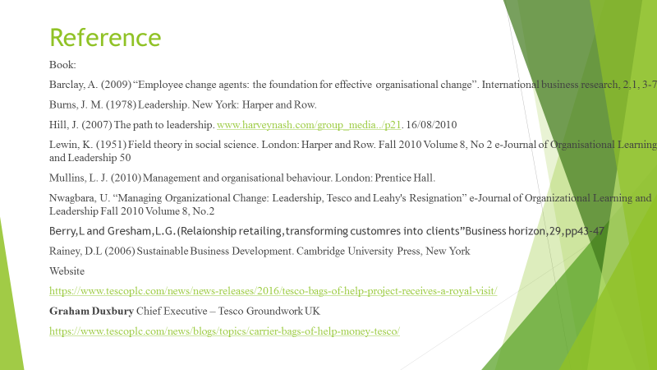

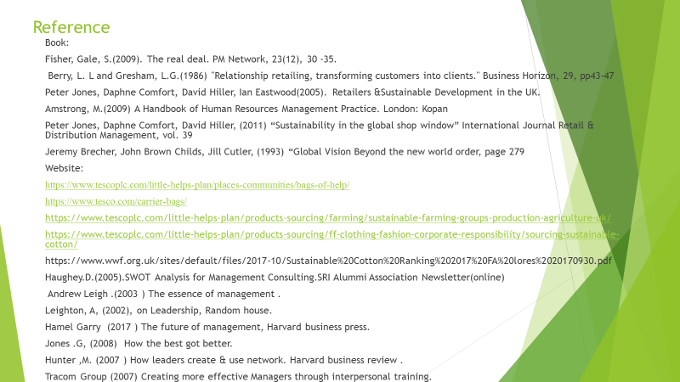

Learning Log
Firstly, this learning log would be reflecting when we started planning our project work as a team. We came together as a team of four people to re-sit our presentation of our project work. We were given the task by our lecturer of choosing organisations of three different sectors to present a project business plan.
According to Paul, Cadle and Thomas (2012) article it states that people agree to collaborate as team for different types of reason. By working as a group of people they would be sharing work experiences, to review diversity of knowledge and culturalism and having a lot of different options to resolve issues when working together as a group.
Prior to working as a group, we made sure to set aside time suitable to the schedules of everyone in the group. In order to successfully complete the project work everyone made sure to attend group meeting this allowed us to effectively delegate and carry out tasks. The group meetings enabled us to review our set task so that we were able to determine whether we were effectively meeting our targets in order to complete our task on time.
To allow for the team to adequately achieve the same goals, each of the members of the group were given the opportunity of selecting a task that suited their interests in order to complete their chosen task.
At the first presentation Peter Owusu-Dome was chosen to take the group leadership, during the resit presentation whilst Roselyn Tenkorang was selected as the team leader for the submission of the assignment. Peter was assigned to work on Tesco’s Supermarket Leadership Style. Roselyn Tenkorang worked on Tesco’s Supermarket Global Citizen and Sustainability. Bandekila Jacques Nkenda worked on Tesco’s Supermarket Community Participation. Terry Moses was delegated to work on Tesco’s Supermarket Entrepreneurship and Leadership. Visagan Maduraiweeran was assigned to work on Tesco’s Supermarket Environmental Sustainability.
Each member was obliged to work on what they have been assigned in order to ensure the tasks were completed within the scheduled time. However, due to difficulties encountered by some members of the team, we were not able to meet as frequently as previously arranged. The two members of the group who are no longer in our group are Visagan and Terry who were not able to attend meetings because of personal commitments.
According to Hardingham and Royal (1994) in order for a team to achieve its goals, it needs to each individual group member to work together in order achieve it main purpose. A united team must work together without involving themselves in other teams. The consistency having a stable team can be identified by knowing each member’s emotional strength and weakness.
Reflecting on the Project Work assignment the team can emphasize that the stability of the team can be compromised by members availability and punctuality. With some members not being ready with their task makes it difficult for the team to work effectively.
In all the group manage to complete the project work and able to present the work on time.

Reference
Hardingham, A. and Royal, J., 1994. Pulling Together Teamwork in Practice. Great Britain: The Cromwell Press, Wiltshire.
Paul, D. Cadle, J. and Thomas, P., 2012. The Human Touch Personal Skill for Professional Success. Swindon: British Computer Society Learning and Development Ltd.

