Ble mae’r Gymraeg? Where’s the Welsh? An investigation into the language of social interactions of secondary school students in a Welsh-medium secondary school.

Anwen Mair Worsfold
ECGE7002Q
14th April 2022
Yr Athrofa: Education and Humanities

DECLARATION FORM


Name of the Programme of Study: Bilingualism and Multilingualism (MA)

Name of Student (Capital Letters): ANWEN MAIR WORSFOLD

DECLARATION

I certify that the whole of this work is the result of my individual effort, and that all sources have been acknowledged.

Signed ..................................................... (Student)

Date .......14.04.2022....................................

DECLARATION

I am satisfied that this work is the result of the Student’s effort.

Signed .............. ................................................ (Lecturer)

Date .......... 14.04.2022..................................

CONTENTS

DECLARATION FORM …………………………………………………………….……………………….…….2

CONTENTS ………………………………………………………………………………………………....…….….3

ACKNOWLEDGEMENTS ……………………………………………………………………….……..…….….6

ABSTRACT …………………………………………………………………………………………..……….……….7

ACRONYMS ……………………………………………………………………………………..………..…………8

CHAPTER 1 Introduction…………………………………………………………….……………………….…9

CHAPTER 2 Literature Review…………………………………………………….……………………….…3

2.1 Types of Welsh-medium School…………………………...…………………………...….13

2.2 Creating Confident Welsh Speakers…………………………….……….………...…….16

2.3 The Language of Education…………………………………………………..………...…….17

2.4 The importance of schools ………………………………………………….....…………….19

2.5 Models of bilingual provision ………………………………………………...…..….…….20

2.6 Linguistic Ability …………………………..………………………………………...…..……….21

2.7 The role of teachers …………………………………………………………….....…..……….23

2.8 Which language? …………………………………………………………….....……….……….24

2.9 Relevance to pupils’ lives …………………………………………………...…..…..……….25

2.10 Conclusion …………………………………………………………..………....………...……….27

CHAPTER 3 Methodology ………………………………………………….…………………..…..……….28

3.1 The research questions …………………..……………….………………...…..…..……….28

3.2 Defining the approach …………………….……………...……………...……..…..……….28

3.3 Data Collection Activities …………………………………………….…...………...……….29

3.4 Data Analysis Methods …………………………..……….……………...……..…..……….39

CHAPTER 4 Results ………………………………………………….…………….……………..…..……….41

4.1 Parental Questionnaire (n=91) …………………………………………...…..…..……….41

4.2 Teacher Questionnaire (n=31) ……………………………………….…..….....…..…….50

4.3 Pupil Questionnaire (n=67) ………………………………………………….....…..……….59

4.4 Pupil Interview ………………………………..……….………..………….....…….…....…….78

4.5 Headteacher Interview ………………………………..……….………...…….......……….83

CHAPTER 5 Results and Recommendations ………………………………..……….…….……….86

5.1 How much Welsh do pupils speak at school? …………………..……..…..……….86

5.2 Teachers’ influence on pupils’ Welsh use …………………………….....…..……….87

5.3 With whom else do pupils speak Welsh? …………………………………....……….90

5.4 The Initial Language of Interaction……………………………...…………..…..……….92

5.5 Confidence ……………………………..…..……..................................................….93

5.6 Ability ……………………………..…..……..........................................................….95

5.7 Motivation ……………………..…..……..........................................................….97

5.8 Parents ……………………………..…..……........................................................….99

5.9 Extra-curricular opportunities ……………………………..…..……..................….100

5.10 The Wider Community ……………………………..…..……...........................….102

5.11 The effect of the COVID-19 pandemic ……………………………..…...........….103

5.12 Pupils’ own motivations for speaking Welsh…………………………...…....….103

5.13 Conclusion……………………………..…..……...............................................….104

REFERENCES………………………………………………………………..….…………………..…..……….106

APPENDICES …………………………………………………………………..…..……………………………110

Appendix 1: Information about the Central South Consortium Area…..............….110

Appendix 2: Parent Questionnaire ……………………………..….......……....................….111

Appendix 3: Teacher Questionnaire ……………………………..….......……..................….118

Appendix 4: Pupil Questionnaires ……………………………..….......…….....................….124

Appendix 5: Pupil Interview Questions ……………………………..….........................….133

Appendix 6: Headteacher Interview questions ……………………………..…..............….134

Appendix 7: Parent Questionnaire Additional Comments ….............................….135

Appendix 8: Teacher Questionnaire Additional Comments …...........................….137

Appendix 9: Pupil Questionnaire Additional Comments ….............................…...138

ACKNOWLEDGEMENTS
First and foremost, sincere thanks go to my course tutor, Dr Hywel Glyn Lewis. His guidance throughout the course has been indispensable. Thanks also go to Fay Sellick, my learning support tutor. Her well-timed assistance and support have been essential to my completing this thesis.
A special acknowledgement goes to my husband, Dominic for his unending support, and to my wonderful children Caitlin and Evan who have had to endure a living room full of books and a mother glued to a laptop. Thanks also to my father, Robin who has provided well-timed encouragement and means.
Final thanks go to my mother, Janet, for choosing Welsh-medium education for me and for being my primary source of support and encouragement throughout my life.

This thesis is dedicated to the memory of my great aunt, Major Sarah Lily Williams. Her love of language and of Welsh in particular was infectious.

ABSTRACT
Despite an acknowledged increase in the number of pupils from non-Welsh-speaking homes attending bilingual and Welsh-medium schools in Wales, the adoption of the language for social use amongst such pupils in anglicised regions of the country has been a matter of concern. This has led some to maintain that, for many pupils, Welsh is only the language of the classroom and has no role for them in wider social domains.

The motivations for these young people to speak Welsh with one another is, of course, a complex matter, with many influences both at the micro-, meso- and macro- level. The purpose of this research was to discover what factors may be impeding young people in Wales from adopting Welsh for social purposes with a view to developing strategies that could combat this phenomenon. A case study is presented of a Welsh-medium secondary school in an anglicised area in Central South Wales whereby the three largest stakeholders in Welsh-medium education took part in research to discover if this is a problem that can be addressed. Parents and teachers participated in a questionnaire to determine their influence on the children, and the Headteacher was interviewed as the lead policymaker for the school. More importantly, the pupils themselves participated both in a questionnaire and in an interview whereby they could express their thoughts and feelings and what they felt was affecting their language choice. This study, therefore, gave the pupils a voice in proceedings which allowed them to give their own insight into how they viewed the Welsh language, and its relevance to their lives.

ACRONYMS
BERA British Education Research Association
BICS Basic Interpersonal Communicative Skills
CALP Cognitive Academic Language Proficiency
LEA Local Education Authority
GDPR General Data Protection Regulation
GIDS Graded Intergenerational Disruption Scale

UWTSD University of Wales Trinity Saint David

Chapter 1

Introduction

‘Cymreictod’ features heavily in Welsh-medium schools’ goals and is also a priority for the Welsh Government which hopes to achieve one million Welsh speakers by 2050 (Welsh Government, 2018). The word is difficult to translate directly into English. In its broadest meaning, it is the concept of ‘Welshness’, including the use of the Welsh language and inextricably combines national identity, language use and competency, history, heritage, and culture. The concern about Welsh language use in schools was recently highlighted by Morris (2010) in her study of ‘Young People and Their Use of the Welsh Language.’ In her research, Morris (2010) analysed the social network study conducted for the Welsh Language Board between 2003 and 2005. In that study, data from the social interactions of 24 young people of secondary school age (13-17) in 12 study areas of Wales was collected using observations and questionnaires. Morris (2010) concluded that virtually no Welsh was used within peer-to-peer interactions in the most southern areas in the study once students reached secondary school age. Not one of those 12 study areas, however, involved central South Wales, which according to the 2011 Census (StatsWales, 2012) has the lowest percentage of Welsh speakers. To rectify this omission from the previous study, it was decided to focus this research on one of the so-called designated Welsh-medium secondary schools in central South Wales in an anglicized area. Morris Jones (1995), Thomas (2010) and Lewis (2011) discuss the definition of Welsh-medium education as it can mean different practices according to the region and ethos of the school. Morris Jones’ (1995) research highlighted that the difference in the amount of Welsh used in schools was not clear-cut, but since the Welsh Government’s 2007 publication ‘Defining schools according to Welsh Medium provision’, in the case of the school in question, it was a Welsh-medium school, defined as Category 1:
Welsh is the language of the day-to-day business of the school. Welsh is
used as the language of communication with the pupils and for the
school’s administration. The school communicates with parents in both languages. (Welsh Government, 2007:10)
Lewis (2011) notes that, in anglicised areas, the main purpose of these schools is to revitalise the Welsh language, providing access to the language to pupils who have immigrated to the country or who are from traditionally English language families (as well as from a minority of traditionally Welsh-speaking families).
An interesting linguistic point, however, is that, in defining the role of a Welsh-medium school, the intended language used between the pupils themselves is not actually noted. This may be for ease of interpretation of the data but neglects a fundamental purpose of Welsh-medium education, which is to create speakers who are “able to use the language with confidence in all aspects of their lives by the time they leave school.” (Welsh Government, 2018:40, italics added). This, incidentally, also raises the question as to whether peer-to-peer use of the language is a good indicator of confidence in Welsh. Baker & Wright (2017) discuss the importance of Welsh-medium education to the revitalisation of the language; however, they caution that without the language’s use outside the domain of the classroom, it can become the language of education only and not of social interaction. Upon leaving school, students risk losing their only opportunity to use the minority language and, therefore, by the time they themselves become parents, the language transmission cycle is broken.
In her study of the reasons parents choose to send their children to Welsh-medium schools in the Rhymney Valley, Hodges (2012) highlights that:
This is a phenomenon that has been noted in other European minority
language contexts, such as Catalan and Basque, [...] with the consequent ramifications when young parents do not then transmit their minority
language knowledge to their children. (Hodges, 2012:369)
This concern was also voiced by Pierce (1993) in his survey of students in the fifth form (Year 11) of a Welsh-medium comprehensive in the same area as the present study, Central South Wales, undertaken in 1983. This again highlights the fact that parents, despite having attended Welsh-medium education themselves, did not use it in social activity, but again committed their own children to Welsh-medium education. Schools therefore do not seem to succeed in breaking the cycle of language use, which is confined to the classroom and fails to penetrate external domains.
It is, however, widely considered crucial to the growth or revitalisation of a language that the cycle of language transference is completed with parents passing the language on to their children. The same issue was highlighted by Dorian (1981) in her study of the decline of the Gaelic language. Various language revitalisation frameworks refer to the practice of language passing through the generations as being essential, none more so than Fishman’s (1991) Graded Intergenerational Disruption Scale (GIDS). This 8-point scale is frequently viewed as a linear scale giving insight into a language’s level of vitality and, in the case of Welsh, it meets the criteria for Stage 1 as the language is used in education, mass media and the government at a national level. However, despite the availability of the Welsh language in education, it is clear that Stage 6 in the GIDS scale, (the use of informal oracy in the minority language between the generations) still has relevance to the situation in central South Wales. The scale cannot, therefore, be considered as linear, and although great leaps are currently being made in the revitalisation of the Welsh language, there are still many areas in which weaknesses can be addressed.
‘Cymraeg 2050: A million Welsh speakers’ (Welsh Government, 2018) highlights the fact that the number of households where both parents speak Welsh has diminished, thus it is schools that are increasingly becoming responsible for generating Welsh speaking children. Therefore, instead of focusing on parents, this dissertation shall investigate the language of social interactions amongst secondary-aged students.
A study of students’ motivations for using one language over another could, therefore, be a key to halting and reversing this language shift, which could have much wider relevance nationally (as well as, possibly, to similar diglossic contexts internationally). Bassey (1984) upholds that the relatability of a research project, especially within the domain of education, holds more value than the ability to generalise. Therefore, although any data and conclusions that could be drawn from this research would be specific to the case study under consideration, they may provide an insight into the perceptions of pupils which could be relatable to schools in other areas of Wales also.

Chapter 2

Literature Review
Striking a balance between the use of a minority and majority language has long been an issue in many bilingual countries across the world, not least in countries where the majority language is English (which is often afforded substantial status and prestige). In diglossic contexts generally, where languages are in contact, which language to use, when, where, and with whom can be an incredibly complex issue on a personal, societal and even national level, with many sociolinguistic factors affecting the language choice of a person. In bilingual education establishments, therefore, where children usually come from varying linguistic home backgrounds, despite the official language(s) adopted as a medium of curricular instruction, pupils’ choice of language for social communication can be equally complicated.

2.1 Types of Welsh-medium School
There are many different types of schools in Wales that deliver varying amounts of Welsh-medium content, but, in central South Wales, they are so-called designated Welsh-medium schools, or immersion schools as observed by Thomas (2010). The language of these schools is officially Welsh and, apart from lessons in English as a subject, all lessons are delivered in Welsh. Consequently, all pupils are usually fluent bilinguals. This places these schools in Category 1, “Welsh-Medium Schools” according to the previous Welsh Assembly Government’s (2007) definition, which were originally established for children to have a Welsh-medium education even in anglicised areas.
In 1944, the Education Act gave parents the right to have their children educated in their own language. For Thomas (2010), parents have been essential to Welsh-medium education growth as it was their lobbying that established the first private Welsh-medium school in Wales in 1939 in Aberystwyth (Aitchison& Carter, 2004), which became crucial subsequently in the growth of Welsh-medium schools in the public sector. Therefore, due again to considerable parental pressure, the first of these publicly funded primary schools, Ysgol Dewi Sant, was established in Llanelli in 1947. Lewis (2011) describes how these designated Welsh-medium school developed in three stages.
Stage 1: the development of designated Welsh-medium schools in anglicised areas to provide education in the home language for children from Welsh-speaking households. Secondary school examples were Ysgol Glan Clwyd in North Wales (established in 1956, and the first LEA designated Welsh-medium secondary school), and Ysgol Gyfun Gymraeg Rhydfelen in South Wales (established in 1962). These schools were again a direct result of pressure groups formed by parents to establish and expand Welsh-medium schools in Wales (Jones, 2006).
Stage 2: the perceived social mobility that was being afforded to Welsh-speaking children in Stage 1 schools led to designated Welsh-medium schools in anglicised areas providing for children both from Welsh-speaking households and English-speaking households. An example is Ysgol Gyfun Gymraeg Llanhari in South Wales established in 1974. Thomas’ (2010) research shows that, in South-East Wales, pupils attending these schools come predominantly from English language families, although a minority come from Welsh-speaking families. The result is that Welsh-medium schools in South-East Wales have a dual purpose. Morris Jones (1995) defines their role as that of maintenance of the language for those from Welsh language backgrounds (Maintenance-Heritage) and restoring the language to those from English language backgrounds (Immersion). Lewis (2000) argues that the good reputation of these schools was seen as a substitute for previous grammar schools when the comprehensive system was rolled out across Britain, resulting in parents from non-Welsh speaking households requesting to send their children to Welsh-medium schools during Stage 2 of their development. In their research on the motivation of non-Welsh speaking parents to send their children to these schools, Campbell & Packer (1992) found that bilingual education was viewed as enabling social mobility, which, they maintain, will ensure the continuation of Welsh-medium schools.
Hodges’ (2012) investigation of the reasons parents sent their children to a Welsh-medium school in South-East Wales supports this finding, but also found that parents opted for these schools for numerous and complex other reasons. Thomas (2010) ranks parents’ responses from a questionnaire distributed in 2004 to 178 parents from 45 Welsh-medium primary schools and 9 secondary schools across South-East Wales, the most important reason being bilingualism followed by the Welsh language and academic standards. These reasons corroborate with those found by Hodges (2012) and Campbell & Packer (1992).
Stage 3: the third stage in the growth of Welsh-medium schools was the subsequent development of schools for children from both Welsh-speaking and non-Welsh speaking backgrounds in areas that were traditionally Welsh-speaking (the heartland area known as ‘Y Fro Gymraeg’) due to increasing sociolinguistic problem of in-migration of non-Welsh speakers from other areas of the United Kingdom. Examples include Ysgol Penweddig in Aberystwyth, Ysgol Bro Myrddin in Carmarthen. C.H. Williams (1995) had suggested that to have a Welsh heartland, similar to the Gaeltacht areas in Ireland, ought to have reversed language shift, thus allowing people to use the Welsh language in every day social situations. Morris Jones’ (1995) research supported a ‘heartland’ concept as an example of how Welsh could be normalised in society, and also found that those in non-designated Welsh schools actually tended to use more Welsh socially in these areas. The demographic has changed a lot since 1964 when Owain Owain published his map outlining the geographical area of Y Fro (Owain, 1964), and the in-migration to the area of non-natives (particularly during the 1980s) has resulted in an increase of non-Welsh speaking families to the area. The need for these designated schools was, therefore, a reaction to the immigration of non-Welsh speaking families to the area which affected the provision of effective Welsh-medium education in the heartland (Dafis, 1985).

2.2 Creating Confident Welsh Speakers
The intention of these designated Welsh-medium schools is to teach a curriculum entirely in Welsh. Hodges (2012) notes, however, that despite producing a “seemingly impressive statistical increase in young Welsh speakers, [Welsh-medium education is] is not matched by an increase in language use among young people,” (Hodges, 2012:369, italics added). There appears to be a discrepancy between providing a Welsh-medium education and increasing “the number of confident Welsh speakers” (Welsh Government, 2017:38, italics added).

2.3 The Language of Education
Pierce (1993) found that those who were the product of Welsh-medium education would leave school, grow up and start families, but not speak Welsh within the home. In turn, they would send their children to Welsh-medium schools, despite the lack of inter-generational transference. Morris’ (2010) findings corroborate the lack of transference, with 59% of fathers and 62% of mothers classifying themselves as fluent or good Welsh speakers, and yet only 35% of young people surveyed said they spoke Welsh exclusively at home. Thomas (2010) attests that, in central South Wales, most of the pupils in Welsh-medium schools are from non-Welsh speaking homes, and C. H. Williams (1995) noted that:
Mid-Glamorgan [a former county in central South Wales] had the
highest proportion of Welsh-born residents but one of the lowest
rates of language transmission. (C.H. Williams 1995:51)

When considering reversing language shift, Fishman’s (1991) ‘Graded Intergenerational Disruption Scale,’ (GIDS) highlights intergenerational transference (Stage 6) as being the most crucial factor in its success. In the absence of Welsh-speaking parents, the responsibility for transferring the language falls on the school. There is a risk that, without intergenerational language transmission, a minority language becomes solely the language of education, whereby schools create linguistic islands within the wider society.
Ferguson (1959) outlines that in using a language only for ‘high’ (H) purposes such as education, it may not be appropriate to use this language in social situations.
An outsider who learns to speak fluent, accurate L and then uses
it in a formal speech is an object of ridicule. A member of the speech community who uses H in a purely conversational situation or in an
informal activity like shopping is equally an object of ridicule. (Ferguson, 1959:329)

In the heartland, where Welsh is widely used socially, diglossia (a term described by Ferguson (1959) above to mean a ‘high’ and ‘low’ version of the same language) should not be an issue, as the informal, ‘low’ language would be dialectal Welsh used socially, with a more formal, ’high’ form of Welsh being used at school. However, there is evidence that pupils from Stage 3 schools within the Welsh heartland speak a high percentage of English socially. Morris’ (2010) analysis of the Welsh Language Board’s (2006) survey of Young People’s Social Networks and Language Use demonstrated that although secondary-aged respondents in Bala and Pwllheli showed the highest rates of Welsh language use, nevertheless:
by contrast, there was a sharp difference
between the children’s use with the teacher in the classroom and
with friends outside the formal education setting, especially in
Llandysul/ Cardigan, Fishguard, Ammanford and Ystradgynlais.
(Morris, 2010:88)

The results of the questionnaire adopted were presented in percentage form, with four categories of interlocutors being teachers, friends in the classroom, friends during school breaks, and friends outside school. There was a marked decrease in all 12 of the surveyed localities when comparing the percentage of Welsh spoken with teachers and with friends in the classroom, and a larger gap still between teachers and friends during school breaks. This difference implies that it is not a lack of ability to speak Welsh, but that Welsh appears to have become the language of education. There are two main factors affecting ‘Y Fro Gymraeg’. Firstly, the macro influence of British society has caused a language shift. The second factor is a direct consequence of the first. Many children attending these Stage 3 schools are, by now, from non-Welsh-speaking backgrounds, and they are simply speaking their mother tongue in social situations. This supports C.H. Williams’ (1995) statement that Welsh has gone from being a functional language to a language of school.
Although the focus of this paper will be on a Stage 2 school according to Lewis’ (2011) categorisation of the development of designated Welsh-medium schools, it will be a valuable exercise to discover what schools need to do to get their pupils to adopt the language outside of the classroom if this has not even been achieved in those schools within ‘Y Fro Gymraeg’.

2.4 The importance of schools
Khleif (1980:100) identified Welsh-medium schools as “agencies of regeneration,” highlighting their role in the revitalisation of the Welsh language. Indeed, there has been a rapid growth in Welsh-medium education in Wales during the last sixty years at both primary and secondary levels, and the growth is continuing (Thomas, 2010).
These schools have provided a major contribution to the transmission of the language from one generation to the next. Indeed, Baker (1990:1) has described this provision as the “main engineer of attempted language reversal”. Recently, attention has been drawn to this in ‘Cymraeg 2050: Million Welsh Speakers,’ (Welsh Government, 2017) which recognises that any increase in Welsh speakers will be more dependent on schools than on the home as there are now fewer households where both parents speak Welsh. This was apparent in the ten targets set to increase Welsh speakers where half were focused on education (Welsh Government, 2018). Despite their historical influence on opening Welsh-medium schools as mentioned earlier, parents are criticised by J. E. C. Williams (1995) for not transferring the language through the generations. Regarding the language of the household, Pierce’s (1993) research found that many mixed families (where one parent was bilingual and the other monolingual) opted for the majority language (English) rather than Welsh; the language thus not passed on through the family. Baker (2004) maintains that:
For a minority language to survive, it has to produce new
speakers, mostly via the family and the education system […].
When there is a shortfall in the family reproduction of a
minority language, the responsibility for maintaining numbers
and densities of speakers falls on bilingual education. (Baker, 2004:2)

Schools have, consequently, become the main source of Welsh speakers.

2.5 Models of bilingual provision
In discussing the regeneration and inter-generational transference of the Welsh language, one cannot, therefore, downplay the important role of schools. Baker (2004:1) also refers to schools as “a major plank in language revitalisation and language reversal.” However, for schools to be able to produce “confident Welsh speakers” (Welsh Government, 2017:38) they need to be able to provide effective bilingual education, and the Welsh Government (2018) recognises that designated Welsh-medium education is the best model for producing fully bilingual individuals. Baker & Wright (2017) draw attention to so-called ‘strong’, effective models of bilingual provision within a typology of eleven models, despite highlighting that many more models are also adopted as hybrids. Two of these include Heritage-maintenance and Immersion which promote bilingualism and biliteracy.
Heritage-maintenance
In Heritage-maintenance bilingual education, pupils from minority language backgrounds attend schools where the minority language is preserved and promoted. This can be as little as one day a week, such as with Hebrew Saturday school, or full-time. In Heritage-maintenance education, the minority language is the day-to-day official language of the school.
Immersion
Immersion schools take students who do not speak the language and immerse them in the minority language whereby it is, in varying degrees, the day-to-day language of the school. This is different from the practice of majority language immersion criticised by Johnstone (2007) as submerging rather than immersing pupils. Immersion schools offer the opportunity for pupils to learn a previously unspoken language whilst maintaining their majority language outside of school. Baker & Wright (2017) maintain that the most efficient immersion model is early years full-time immersion where, by age 11, most pupils have a native-like grasp of the language.
Presently, designated Welsh-medium schools offer a combination of these two models: heritage-maintenance (for pupils from Welsh-speaking households) and immersion (during the early years for those from non-Welsh-speaking households).

2.6 Linguistic Ability
When pupils transfer from primary to secondary school at the age of 11, they are expected to be fluent in Welsh (Griffiths, 1997). However, Cummins’ (1999) theory of the development of language maintains that some children may not have yet developed Cognitive Academic Language Proficiency (CALP), which can take six years on average. This theory categorises language development into BICS (Basic Interpersonal Communicative Skills), which is the language adopted socially for creating relationships and interacting daily with others for example, and the aforementioned CALP, which is the language of academic work, for example, and can be likened to the ‘higher’ language discussed by Ferguson (1959). Griffiths (1997) does not specify what ‘fluency’ entails for transferring pupils to the secondary sector, but Thomas & Mayr (2010:107) found that at the age of nine, pupils are “still in the process of acquiring the Welsh mutation system and gender system.” It would be a fair assumption that, only two years later, this acquisition might still not be complete upon moving to secondary school.
Whereas an investigation of linguistic accuracy would encompass aspects of linguistic interference, involving code-mixing, code-switching and language fossilization (i.e., the lexical, syntactical and prosodical aspects of language as discussed by Lewis (2011)), it is emphasised that the research conducted and discussed in this thesis does not focus on the standard of language but use; as Mackey (1962) would term, the function of the language rather than the degree of accuracy. Matthias (1992) has already examined the degree and maintains that the language of pupils from non-Welsh backgrounds contain many incorrect developmental features of interlanguage. Davies (2013), however, questions the linguistic rules which are adopted when assessing language. For example, American English would be considered incorrect if assessed against the standards of British English. The idea of one standard language by which to assess pupils is contentious and, as Matthias (1992) found, students from English backgrounds attending Welsh-medium schools often end up speaking a language that does not follow standard Welsh rules, but which is still understandable. Indeed, Caerwyn Williams (1995) attests that:
No single person can be said to have mastered his or her own
language to perfection. There are differences of pronunciation,
of syntax and vocabulary. (Caerwyn Williams, 1995:29)

In Welsh-medium schools in South Wales in particular where teaching staff come from all over Wales, it is inevitable that pupils absorb the language of their teachers, being often their primary source of language, and that a mixed dialectal form of speaking would emerge.

2.7 The role of teachers
Morris Jones (1995) discusses how the curriculum itself restricts the domains of language that students are taught. The term ‘domain’ within language learning was first used by Fishman (1972) and referred to the specialist language within various topics, contexts or compartments of a person’s life. An example of this would be vocabulary related to football. A person may learn the terminology of the game in one language, but be unable to discuss it in another. As the majority of pupils in central South Wales learn Welsh through Welsh-medium education only, their domains of speech would understandably be restricted to what they have been taught.
Morris Jones (1995) further argues that the school setting doesn’t equip students with the necessary interpersonal language, so they are unable to discuss their matters of interest. Aiestaran & Baker’s (2004) research supports this, as they found that:
The natural dynamics of the classroom tend to favour the learning
of the receptive skills, listening, reading and to some degree, writing. Students have relatively fewer opportunities to speak or interact in
‘natural’ one-to-one or small group communication. (Aiestaran & Baker, 2004:26)

Morris Jones (1995) elaborates further on this point, observing that students rarely have the opportunity to initiate conversations when they do happen, as it is the teachers that often initiate exchanges within the classroom.
In addition to the type of language exchange to which pupils are exposed, Aiestaran & Baker (2004) found that, in the Basque country for example, a lack of competence in Basque hindered peers and teachers’ use of the language, which in turn hindered communication. Aside from accuracy, Matthias (1992) highlighted that confidence was also a contributing factor to pupils’ Welsh usage.

2.8 Which language?
As previously discussed, Morris (2010) documented wider use of English rather than Welsh when young people spoke with their peers. De Houwer (2020) attempts to address the issue of bilingual children who, nevertheless, choose to speak a single language, and concluded that, where children speak one language at home and another in the community or at school, the societal language’s influence would prevail. This was despite the status or prestige afforded to the societal language. In the case of Wales, the situation is different. In the Welsh heartland, Welsh is the societal language and the language of Welsh-medium education. For some, it is also the language of the home, and yet Morris’s (2010) report demonstrated a drop in Welsh language usage with peers no matter where within the heartland the young people resided.
Davies (2013) maintains that:
There is for all of us a tension between the self in all its particularities
and conforming to the mores [majority]of the group to which we belong.
Or wish to belong. (Davies, 2013:vii)

This statement appears to imply an inner turmoil when using a language, with a need for conformity at the fore. Baetens-Beardsmore (1986) identified the feeling of inner conflict or dual-identity as ‘anomie’ among Canadian French-English bilinguals. He argues that, in being stigmatized by the majority community, the feelings of wanting to reject the minority community may rise to the fore, and that it is not necessarily linked to proficiency, intelligence, or motivation, but it is, however, more prevalent in older learners rather than young children.

2.9 Relevance to pupils’ lives
To make up for the linguistic limitations within the school, Morris Jones (1995) maintains that
There remains a gap for providing more ordinary experiences through
the medium of Welsh, particularly in areas where Welsh is not strong.
(Morris Jones, 1995:104)

Extracurricular activities in Welsh, therefore, could provide the much-needed domains and informal language that schools do not transfer, and thus Welsh would gain greater relevance in young people’s everyday lives. Baker & Wright (2017:54) support the notion that:
for a language to survive inside the individual, a person needs to
become bonded in language minority social networks while at school,
and particularly after leaving school. (Baker & Wright, 2017:54)

Morris Jones (1995) attests that, in combination with the work at school, they contribute enormously to students’ use of Welsh among peers. Redknapp (2015) recognises the need to normalise the language at the community level to normalise bilingualism within the society and further make Welsh relevant to young people. In 1985, Baker identified a further influence on young people’s lives, namely that of mass media. He maintained that there was a large imbalance between English and Welsh language and culture on television and, ten years later, C. H. Williams (1995) observed that English, not Welsh, was the language of pop culture and mass media. This further compounds the issue that teen culture is predominantly in English. Edwards (1994) argued that, even if mass media (and pop culture) are available in the minority language, they must be of high quality, or the language risks being undermined. C. H. Williams (1995) agrees with this sentiment. He criticises Welsh popular culture as being too focused on the past, and on rural areas, which are not relevant to those he terms our “disaffected youth.” Davies (2016) acknowledges the profound effect Welsh language mass media can have on children's perceptions of identity, and recognises that, although great strides have been made to increase provision, there remains an enormous imbalance between English and Welsh content.
However, in addition to having relevance to pupils’ current lives, Baker (1990) emphasises the need for them to see Welsh as relevant to various aspects of their future lives as well:
To live, a language needs an economic basis. For children to leave
bilingual secondary education and find the Welsh language has no
market value will only, in time, create language disaffection and
decay. (Baker, 1990:93)

2.10 Conclusion
Welsh-medium education has been recognised as essential to the reversal of language shift and to the regeneration of the Welsh language. For those pupils in anglicized areas such as central South Wales, school may be the primary or sole source of language acquisition. In Morris’ (2010) study involving pupils in the Welsh heartland (Y Fro Gymraeg) where Welsh is widely used in society, it was found that, although young people used Welsh with teachers and other adults, they often used English with their Welsh-speaking peers. For these students, Welsh, therefore, risks becoming the academic language of school, but not of social interaction. Data on anglicized areas of Wales was not available, so it was deemed pertinent to ascertain the situation at a school in central South Wales.

Chapter 3

Methodology

3.1 The research questions
- How did pupils perceive the Welsh language and its relevance to their lives?
- What influenced pupils’ decisions to use one language over another?

3.2 Defining the approach
Throughout the literature review, three groups of people were identified as being the largest influences, namely, the teaching staff, the parents who decided to send their children to Welsh-medium education, and, of course, the pupils themselves. A combination of quantitative and qualitative methods was chosen which would produce data which could be easily statistically compared, could delve deeper into feelings and attitudes which could not be analysed in a quantitative way, and would ensure reliability and validity of the results.
Of the three research ‘traditions’ (ethnographic, survey and scientific), only the ethnographic and survey approaches would provide useful information about social language choice. The ethnographic tradition encompasses observation, which could have provided information about with whom precisely the pupils speak Welsh and when in a conversation the language may switch; however, within the time and logistical limits of the investigation due to restrictions related to a COVID-19 pandemic which affected life globally, including the school, during the period of the research, data collection by observation was not considered possible due to social distancing rules, for example. It was, therefore, decided that questionnaires to students, parents and staff members, and follow-up interviews with students were the best methods of collecting data in the circumstances. The Headteacher of the school concerned was also interviewed to discover what the school has already done to encourage the informal use of Welsh outside of the classroom and to discuss any perceived barriers to this. It was hoped that this research would identify factors which restrict students’ use of Welsh in social interactions, with the hope of finding a solution by using their own voices. Drawing on research questions by Morris (2010) and Thomas (2010), these were centred around parents’, students’ and teachers’ perception of ability in both languages, their home language, where, when and with whom they spoke which language, the importance of Welsh for their own identity and, in the case of pupils, their future choices.

3.3 Data Collection Activities
  - The Case Study
All participants in the study were chosen from the same Welsh-medium secondary school within the Central South Wales Consortium group. This ensured that all responses were about the same geographical area and school and, therefore, the same extra-curricular and community opportunities were available all students. As Morris (2010) found in investigating data from the social interactions of 24 young people of secondary school age (13-17) in 12 study areas of Wales, different areas had different responses according to whether the community was more anglicised, and so this ensured more reliable results for the location in question. Ideally, the study could have been conducted across more schools to compare the data and look at the wider societal issues, but that was beyond the scope of this study due to the practical limitations.
  - Ethical Considerations
Before commencing the research project and throughout the data collection phase, all possible ethical considerations were made and guidelines followed from the British Education Research Association (BERA, 2018), the Research Ethics & Integrity Code of Practice and the Research Data Management Policy of the University of Wales Trinity Saint David (UWTSD). These considerations were to maximise the benefit of the research activity and to minimise any harm that collecting the data could cause. It was also necessary to adhere to any policies which the school and the Local Education Authority (LEA) themselves adopted. The main ethical considerations were as follows.
Informed Consent
All questionnaires began with a covering letter explaining why the data was being collected, how the data would be used and stored, and asking for the participants’ own consent to be a part of the study. Participants were assured that their participation was voluntary and that they could withdraw their consent at any time. Any questionnaire without consent from a participant was removed from the raw data. The parental questionnaire also gave the option for a parent to give consent for his/ her child(ren) to participate in the study; however, pupils themselves also had to consent to participation individually. Participants were assured that all raw data were confidential and that those relating to both the teachers and pupils were anonymous. No identifying data would be seen by anyone other than the researcher, the tutor and, finally, an external examiner.
At the beginning of interviews, the points above were re-iterated verbally and in writing, and participants had to sign a form to give their consent.
Storage of Data
All data from the questionnaires were automatically stored using UWTSD’s Office 365 which kept the data on university servers alone and were password protected. A digital Dictaphone was used to record the interviews, and, after recording, the file was uploaded to the university’s cloud. Any data on the Dictaphone were then deleted in accordance with General Data Protection Regulation (GDPR) rules and the Data Management Policy of the UWTSD.
Anonymity, Confidentiality and Personal Data
Parental questionnaires were confidential and asked for an identifying code to identify which pupils had parental consent to participate. This was due to the questionnaires being sent out electronically since, in accordance with the COVID-19 school rules, it was not possible to send or receive physical letters. Once a list of pupil participants had been collated, these data were deleted from the questionnaire results. Pupil and teaching staff questionnaires were anonymous. Any identifying features in the open-ended questions or interviews for any participant were removed from the raw data so that participants could not be identified. Care was also taken to ensure that the report did not identify the school as, in doing so, the Headteacher’s identity and that of staff members would also be disclosed.
Protection of Vulnerable Participants
Before any research activity was carried out, a research proposal was submitted to the Ethics Board at the university detailing the above. Following its approval, a letter asking for permission to collect data, detailing the aims of the research and the methods to be adopted, was sent to the Head of Education at the LEA and to the Headteacher of the school. Once their approval was granted, the data collection could commence.
Participants under 18 must be considered as a potentially vulnerable group. As per the requirements of the LEA and of the school, the researcher had a full and current Disclosure and Barring Service check. For added security, no individual pupil was ever alone in a room with the investigator. All interviews were conducted at school with another member of staff present, and all the establishment’s safeguarding protocols were adhered to. To overcome the influence of a staff member on a pupil’s responses during interviewing, (the ‘Hawthorne’ Effect), the additional staff member was positioned at the other side of the room and was seen to be occupied with another activity.
It was also essential to ensure that students knew that they could leave at any time and not feel any pressure to answer at all. Pupil interviews were conducted in groups of three rather than individually so that they were less formal and there was less pressure on individual students.
Questions did not involve sensitive, upsetting, or embarrassing topics, but it was made clear that confidentiality could not be assured if something potentially or actually illegal was disclosed, or if it were felt that a child was at risk. Participants were informed in the consent form that, should any facts involving illegality come to light, the information would be passed on to the proper authority. However, this issue did not arise in this study.
COVID-19 Considerations
During the time of the investigation, there was a worldwide pandemic of COVID-19, which had an adverse effect on schools in Wales and throughout the United Kingdom, including the school involved in the study. As intimated previously in the inability to use observation as a research method, there were strict rules limiting the number of people that were allowed in a classroom and their physical proximity to others.
Questionnaires were, therefore, conducted remotely using Microsoft Forms as, at the time, paper letters were not allowed to be sent to and from school. Parents and teaching staff completed their questionnaires in their own time using their own devices. Pupils were given access laptops to complete their questionnaire with only one year group allowed in a classroom at a time in order to keep mixing between students to a minimum in accordance with the school’s rules.
Interviews with students were socially distanced, using a trio of students from the same year group and conducted at school.
The interview with the Headteacher was allowed to proceed face-to-face, but socially distanced.
Originally, a sample from each year group was to be taken, from Years 7 to 13. However, permission was only granted for Years 7 to 10, as examination classes had to complete tasks to replace their summer examinations and then were released to study at home to reduce the number of people on the school site.
  - Parental Questionnaires
The sample
Questionnaires (along with a covering letter) were e-mailed to each family unit of pupils from Years 7 to 10 (404 families in total). This was a voluntary response sample of 100% of the total population of family units in Years 7 to 10. In being a voluntary response sample, this was potentially not a representative sample of all parents and was likely to have been answered by those parents most supportive of their children’s bilingualism. As Youngman (1987) states: “being self-selected (…), respondents may not be representative of the characteristics the sample was intended to cover.” In total, 91 of the 404 questionnaires were returned, a total return of 22.5%. To achieve as large a response as possible, following the initial e-mail, a follow-up e-mail was sent one week later, as recommended by Cohen et al. (2018), to improve the initial return. However, a further follow-up was not deemed appropriate. It was also decided that, although incentives can improve response rates (Cohen et al., 2018), it was not practical or appropriate when contacting respondents via e-mail coming from the school. As mentioned, the total parent population for the survey, therefore, was 91.
Design and Distribution
Questionnaires were distributed to parents via a link to MS FORMS (through the UWTSD server to ensure security).
It was important in designing the questionnaire that there would not be too many questions so that respondents were more likely to complete it. It was distributed bilingually in Welsh and English to accommodate those of varying linguistic backgrounds.
The use of Microsoft Forms was intentional, as it has an immersive reader option and various accessibility options so as not to exclude any disabled parents from access.
With reference to Appendix 3, the questionnaire encompassed a range of issues, including parents’ motivation for sending their child to Welsh-medium education, perceived Welsh linguistic ability, parents’ prior experiences with Welsh-medium education, how they used Welsh in their own lives, and their expectations of their children with regards to the amount of Welsh they should and actually spoke at school. In addition, they were asked to consent to their child(ren) taking part in the study.
For the purposes of triangulation, teachers and pupils were also asked about the amount of Welsh they felt was spoken by pupils at school. Additionally, the pupil questionnaire asked about whether the pupils spoke Welsh at home, and this response was compared to the parental response.
  - Teacher Questionnaires
The sample
The sample size was determined on a basis of 50 teaching staff, and a confidence level of 95%: the recommended sample size being 45. It was the intention to sample 7 members of staff from each of the 6 Areas of Learning and the Additional Learning Needs department, but some Areas of Learning had far more staff than others. 45 members of staff were, therefore, chosen at random and e-mailed with the questionnaire and a covering letter. A follow-up e-mail was sent one week later.
In total, 31 of the 50 questionnaires were returned: a total return of 62%. This fell short of the ideal sample of 45 as determined by Qualtrics.com (2021); however, this was a high number of respondents, and they provided an insight into the perceptions of teachers.
The total teaching staff population for the survey, therefore, was 31.
Design and Distribution
The design of the questionnaire was very similar to that of parents, with a manageable number of questions and a variety of activities to maintain interest, whilst also gathering the necessary data.
All questions were in Welsh only as every participant was a fluent Welsh speaker.
The questions were intentionally kept similar to those in the parental questionnaire, but also to the pupil questionnaire so that responses between the groups could be compared in order that triangulation could increase the validity of results.
Again, reference to Appendix 4 shows that the questionnaire encompassed a range of issues, including perceived language ability, language use, and whether they felt pupils spoke enough Welsh at school. Aside from the triangulation of results, the purpose of these questions was to ascertain whether the teachers themselves used Welsh in situations outside of their work, and also whether there was a perceived lack of confidence amongst teachers which, in turn, may have affected the confidence of pupils.
  - Pupil Questionnaires
The sample
The sample was determined by those students with parental permission. Those meeting that criterion were requested to attend a classroom furnished with computers. As previously discussed, only students in Years 7 to 10 had permission from the school to participate. Parents gave their permission during their own questionnaire by answering that they consented to their child participating, and also by following a code using a pupil’s initials and tutor group. This would ensure that, if these data were to be subject to a cyber-attack, the respondents would be unidentifiable to anyone without access to the personal data (which was stored securely on the LEA’s server alone). This coded information was deleted from the results of the parental questionnaire once the sample of pupils had been taken, in adherence to GDPR guidelines.
Conducting the questionnaires at school ensured a high return rate. However, 96 students had received permission to participate. Of this, 4 students were not able to be identified using the code given by the parent, two withdrew their consent, and a further 23 students were absent due to illness or self-isolation, which itself provided insight into the effects of the COVID-19 pandemic.
In total 67 students responded to the questionnaire as follows:
Year Group | Total Number in the Year Group | Total Respondents | Representation of the Year Group (%)
7 | 112 | 24 | 21.4%
8 | 125 | 18 | 14.4%
9 | 106 | 14 | 13.2%
10 | 107 | 11 | 9.7%

These pupils came from a range of classes within the year group.
The total pupil population for the survey, therefore, was 67.
Design and Distribution
Questionnaires were distributed to pupils via a link to MS FORMS (through the UWTSD server to ensure security).
The design of the questionnaire was very similar to that of the parents and teachers; however, there were more questions to the pupil questionnaire due to the research question being focused on the pupils’ own perceptions.
All questions were written in Welsh and English, as, although every participant was a fluent Welsh speaker, it was felt among the teaching staff that, following the Lockdown periods, students had lost confidence or fluency in Welsh, especially those from English-speaking home backgrounds. In having the questions written bilingually, it allowed access to more students.
Reference to Appendix 5 will indicate that the questionnaire encompassed a range of issues, including language ability, language use, pupils’ linguistic confidence, the topics they discussed, whether speaking Welsh was important to them, their Welsh media consumption, and their future aspirations in Welsh-medium education.
  - Pupil Interviews
Pupil interviews were originally to be conducted based on a representative sample of each year group who answered the questionnaire. Due to the aforementioned COVID-19 restrictions however, interviews with students involved only 3 from Year 10 (the oldest in the sample) who had permission to participate. These three students were chosen as they each came from a different family background. One from a traditionally Welsh speaking family, one from a linguistically mixed family in which one parent was Welsh-speaking and one English, and one from an English-speaking family who had migrated to Wales from England.
The interview was semi-structured, with pre-prepared questions (see Appendix 6) with the intention of further investigating certain themes raised in the questionnaire, for example, the extra-curricular opportunities available to students. Where it was felt appropriate, further questions were asked to draw out more of a response.
  - Headteacher Interview
A semi-structured interview was also conducted with the Headteacher. The pre-prepared questions encompassed the linguistic aspirations for the school, the linguistic expectations of the school and what methods the school has previously trialled (or had intentions to trial) in order to improve the use of Welsh amongst students on a social level.

3.4 Data Analysis Methods
Wherever possible in the questionnaire, options were given for responses so that answers could be easily coded, and to avoid logging errors. This included questions such as
How important is it for you that your child(ren) attend a Welsh-medium school?
1 - Not at all important
10- Very important.
Wherever possible, numerical values were avoided so that responses were clear, for example:
Do you use Welsh at work?
Never, Rarely, Sometimes, Often, Always.
A spreadsheet was created with all the results from each questionnaire. From this, a different tab was created for each question so that the data could be analysed. Pivot tables were created for questions which had two easily comparable categories e.g., Comparing “Did you attend Welsh-medium school?” and “Do you speak Welsh?” in the parent questionnaire.
For most closed questionnaire responses, a “COUNTIF” function was used to count how many responses were given with the same answer. The total number of responses was verified using a SUM function which ensured that all responses had been included in the count. A graph was then produced.
Questions regarding domains where Welsh was used and people with whom pupils interacted in Welsh were drawn from the social network study conducted for the Welsh Language Board between 2003 and 2005 and analysed by Morris (2010).
For open questions such as “Apart from when you're talking about work, what else do you discuss with your school friends? This could be in English or in Welsh“, responses were categorised into common themes, and then counted and compared to other categories (such as the pupil year group) where appropriate.
In the parent questionnaire, a ranking activity was used in which parents were required to rank ten pre-specified reasons for sending their children to Welsh-medium education. These ten reasons were taken from Thomas’ (2010) research in which parents were allowed to freely answer the question in their own words. To analyse this data, where a reason was placed in the “most important” category, it was awarded 10 points, the second most important reason was awarded 9 points, and so on, until the least important reason was awarded 1 point. The total points for each reason were then added together to create an overall score, and the reasons placed in an overall rank order for all respondents.
The interviews were transcribed, and key themes were drawn out. Responses were then summarised.

Chapter 4

Results

4.1 Parental Questionnaire (n=91)
Every family unit from Years 7 to 10 was sent a questionnaire via e-mail, a total of 404 individual families. The questionnaire was created using Microsoft Forms. Questions were intended to ascertain parental support, expectations of their children, their own ability in the Welsh language, and how children may see their parents using the language in their everyday lives.
Question 1 was to ask consent from the parent themselves to participate.
Question 2 was to ask for a parent’s consent for a child to participate.

Question 3: How important is it for you that your child(ren) attend a Welsh-medium school?
1 - Not at all important, 10- Very important
Figure 1
67.0% of parents indicated that it was very important (10) that their children attend a Welsh-medium school. Overall, 93.4% of parents gave this question a response of 8 or above.
Question 4: What were the main reasons you chose Welsh-medium education for your child(ren)? Please rank the statements below, with the most important reason at the top and least important reason at the bottom.
 | 10 | 9 | 8 | 7 | 6 | 5 | 4 | 3 | 2 | 1
 | Most Important |  |  |  |  |  |  |  |  | Least Important | SCORE | RANK
The Welsh Language | 61 | 13 | 7 | 3 | 4 | 1 | 1 | 1 | 0 | 0 | 840 | 1
Economic (better job prospects) | 7 | 23 | 18 | 15 | 15 | 4 | 8 | 1 | 0 | 0 | 671 | 2
Bilingualism | 8 | 26 | 11 | 10 | 12 | 16 | 6 | 1 | 1 | 0 | 653 | 3
Better quality of education than English-medium | 9 | 16 | 16 | 12 | 9 | 13 | 5 | 6 | 4 | 1 | 612 | 4
School ethos and good name of the school | 2 | 6 | 16 | 17 | 21 | 8 | 13 | 5 | 3 | 0 | 560 | 5
Identity | 2 | 4 | 11 | 12 | 11 | 20 | 19 | 10 | 2 | 0 | 504 | 6
Easier to learn other languages | 0 | 0 | 4 | 11 | 7 | 13 | 9 | 32 | 12 | 3 | 375 | 7
Relatives speak Welsh | 2 | 2 | 5 | 8 | 5 | 6 | 15 | 18 | 25 | 5 | 363 | 8
Discipline | 0 | 1 | 3 | 3 | 7 | 10 | 11 | 15 | 12 | 29 | 288 | 9
Grandparents speak Welsh but I don't | 0 | 0 | 0 | 0 | 0 | 0 | 4 | 2 | 32 | 53 | 139 | 10
Figure 2
The table above shows how respondents ranked their reasons for sending their children to a Welsh-medium school. To successfully analyse the results, the number of respondents was multiplied by the rank to achieve an overall score for each reason. The Welsh language stood out as the top reason for parents to send their children to a designated Welsh school. Better job prospects, bilingualism, and the feeling that Welsh-medium education is of better quality than English-medium were the next most important reasons, with similar scores. The least important factor for parents was discipline.
Question 5: Do you speak Welsh?
- Yes, very fluently
- Yes, fluently
- Yes, quite fluently
- Yes, but not fluently
- I speak some Welsh
- I don’t speak Welsh at all
Figure 3

There appeared to be a broad selection of Welsh language experiences for the parents. However, when counting those who identified as very fluent, fluent or quite fluent in Welsh (the left-hand side of the chart), this totalled 48.4%. Only 16.5% did not speak any Welsh at all, whilst the remaining 35.2% had some knowledge of Welsh.
Question 6 - Did you attend a Welsh-medium school?
- No
- No, but I’ve learnt Welsh as an adult
- Yes- up to Primary School
- Yes- to Primary and Secondary School
Figure 4
Nearly half (47.3%) of all parents surveyed had attended Welsh-medium education from primary to secondary school.
Following questions 5 and 6, it was decided to compare these questions to ascertain whether those who attended Welsh-medium education had retained their fluency into adulthood.

Did you attend a Welsh-Medium School?
 | Yes- to Primary and Secondary School | Yes- up to Primary School
I don't speak Welsh at all
I speak some Welsh | 1
Yes, but not fluently | 2 | 2
Yes, fluently | 9 | 1
Yes, quite fluently | 11
Yes, very fluently | 20 | 1
Grand Total | 43 | 4

Figure 5
Comparing Question 5 and 6 - Do you speak Welsh? and Did you attend a Welsh-medium school? revealed that the majority of those who attended Welsh-medium education from primary to secondary school stated that they are quite fluent, fluent or very fluent. Only 3 individuals (3.3%) indicated that, after having attended Welsh-medium primary and secondary school, they were not fluent Welsh speakers, although they continued to send their child/ children to Welsh-medium school.
Question 7 - Do you use Welsh in your everyday life?
Respondents were required to consider various possible domains and the frequency of use ranging from Always to Never.

Figure 6
17.6% of all parents used Welsh always at work. This number fell significantly at home or with relatives, showing 6.6% and 7.7% respectively. Only 1.1% (accounting for one parent) spoke Welsh always with friends and during social activities.
Combining the Always and Often categories, 30.8% of people used Welsh regularly at work, 27.7% at home, 15.4% with relatives, 13.3% with friends, and 9.9% during social activities. These figures represent all surveyed parents, whether they consider themselves Welsh speakers or not. In the chart below, only those who consider themselves quite fluent, fluent or very fluent are considered.

Figure 7

When looking solely at those who state they spoke Welsh quite fluently, fluently or very fluently, the figures are quite different. 2.3% represents one parent.
Combining Always and Often to ascertain those who regularly speak Welsh in these situations revealed that 59.1% of these parents regularly speak Welsh at work, 54.5% regularly speak Welsh at home, although only 29.5% regularly speak Welsh with relatives, 27.3% with friends, and 20.5% regularly speak Welsh during social activities.
22.7% never use the language with friends, nor during social activities, whilst a quarter of respondents never use it with relatives.
Question 8: What language(s) do you speak at home regularly? Select all that apply.
- Welsh
- English
- Other (Please Specify)

Figure 8

Despite 48.4% of parents being fluent, quite fluent or very fluent in Welsh, 63.7% of parents indicated that they speak only English at home.
Comparing Questions 5 and 8: Do you speak Welsh? and What language(s) do you speak at home regularly? revealed that 16 (36.4%) of the parents who spoke Welsh quite fluently, fluently or very fluently spoke only English at home. 26 (59%) parents from this category spoke English and Welsh at home. Two parents (4.5%) stated they speak Welsh only at home. These both came from the “very fluent” speakers’ category. All of those who didn’t speak Welsh at all, spoke English only.
 | English/ Saesneg; | English/ Saesneg and Welsh/ Cymraeg; | Welsh/ Cymraeg; | Grand Total
I don't speak Welsh at all | 15 |  |  | 15
I speak some Welsh | 20 | 2 |  | 22
Yes, but not fluently | 7 | 3 |  | 10
Yes, quite fluently | 5 | 8 |  | 13
Yes, fluently | 6 | 4 |  | 10
Yes, very fluently | 5 | 14 | 2 | 21
Grand Total | 58 | 31 | 2 | 91
Figure 9

Questions 9 and 10:
What percentage of your child's school day do you think he/she SHOULD be speaking Welsh?
What percentage of your child's school day do you think he/she is ACTUALLY speaking Welsh?
- 100%
- 90% - 99%
- 70%- 89%
- 50% -69%
- 30% - 49%
- 10%- 29%

Figure 10

There was a clear disparity between the percentage of Welsh parents felt their children ought to speak and the amount they believed they speak in reality. Nearly three quarters (73.7%) of parents would have liked their children to speak Welsh 90% of the time or more. Only 26% of parents believed this to be a reality. All parents believed their children should be speaking Welsh 50% or more of the time, with 87.9% believing this is to be the reality.
Additional Comments
At the end of the questionnaire, parents were invited to express any additional comments in a free form way. Relevant comments were listed in appendix 6.8.
The comments overall expressed parents’ support for the Welsh language. Various themes were noted such as disappointment at the lack of Welsh their children were using, the lack of opportunities available to the children to use Welsh in a social domain, the importance of Welsh for social progression and career opportunities, the benefits of speaking Welsh. One final comment mentioned the effect of the pandemic on students and parents.

4.2 Teacher Questionnaire (n=31)
A sample of 45 teachers chosen at random were sent a questionnaire via e-mail. The questionnaire was created using Microsoft Forms. Questions were intended to ascertain expectations of their pupils, their own ability in the Welsh language, their use of Welsh in the classroom, and whether teachers were using the language in their everyday lives.
Question 1 was to ask consent from the teachers themselves to participate.
Question 2: To which faculty do you belong?
- Science and Technology
- Health and Wellbeing
- Languages, Literacy and Communication
- Maths and Numeracy
- The Expressive Arts
- The Humanities
- Additional Learning Needs (ALN)

Figure 11
The largest response was from the Science and Technology department, being one of the largest faculties in the school. However, overall, there was representation from a wide variety of subjects.
Question 3: Which language / languages do you speak regularly at home? Choose all relevant answers.
- Welsh
- English
- Other (Please Specify)
Figure 12
The majority of teaching staff spoke English and Welsh at home (48%.4%). 16.1% of staff spoke only Welsh at home, and approximately a third (32.3%) only English.
3.2% (representing 1 person) spoke three languages at home; namely Welsh, English and Spanish.

Question 4: Do you use Welsh in your everyday life?

Respondents were required to consider various possible domains and frequency of use ranging from Always to Never.

Figure 13

All respondents indicated using Welsh at work either Always or Often, with 93.5% having indicated Always. Of course, the nature of working in a designated Welsh-medium school is that Welsh is used in all aspects of school life, apart from English and Spanish lessons where the target language is used. 12.9% indicated that they use Welsh always at home. This is a lower figure than in the previous question, Question 3, where 16.1% indicated that they spoke only Welsh at home. This accounts for one individual having answered differently to the previous question. When using Welsh with relatives, there appears to have been a broad spectrum of responses. With friends, all respondents used some Welsh, with 54.9% of respondents having indicated Always or Often. 25.8% of respondents indicated that they rarely or never spoke Welsh during social activities, 38.7% used it sometimes, and 35.5% used it often. No respondents indicated that they always speak Welsh during social activities.
Question 5: How confident are you using Welsh in the following situations?
Respondents were required to consider various possible domains and levels of confidence ranging from Very Confident to Not at all confident. A Not Relevant option was also added as not all domains may contain other Welsh speakers.

Figure 14

Responses indicated that over 70% of staff were very confident using Welsh in all situations. For some, the question was irrelevant, e.g. if no one else at home speaks Welsh. One person (3.2%) indicated that he/she was not too confident using Welsh during social activities. 3 people (9.7%) indicated that they were not too confident using Welsh at work.
Questions 6 & 7: What percentage of the pupils' school day do you think they SHOULD be speaking Welsh?
What percentage of the pupils' school day do you think they ACTUALLY speak Welsh?
100%
90% -99%
70% -89%
50% -69%
30% -49%
10% -29%
Almost none

Figure 15

The majority of teachers (71%) indicated that they feel that pupils should speak Welsh 90% - 100% of the time. All teachers indicated that they felt that pupils should speak Welsh 50% or more of the time.
Conversely, 61.3% indicated that they feel that pupils actually spoke Welsh 30%-49% of the time. No teacher felt that students spoke Welsh more than 70% of the time.
Overall, therefore, teachers felt that students did not speak as much Welsh as they should.
Comparing parents’ with teachers’ responses to the same questions:
What percentage of the pupils' school day do you think they SHOULD be speaking Welsh?
What percentage of the pupils' school day do you think they ACTUALLY speak Welsh?
73.7% of parents and 71% of teachers felt pupils should be speaking Welsh 90-100% of the time. All parents and teachers indicated they should be speaking Welsh at least 50% of the time.
Only 26.4% of parents and 0% of teachers felt pupils actually spoke Welsh 90-100% of the time. 61.6% of parents and 9.7% of teachers felt pupils spoke Welsh for 50% or more, but less than 90%.
Question 8: In a usual lesson, how much Welsh do you use with PUPILS?
100%
90% - 99%
70%- 89%
50% -69%
30% - 49%
10%- 29%
Almost none

Figure 16

6.5% of teachers (2 individuals) indicated that they spoke almost no Welsh with students, with a further 3.2% (1 individual) indicating that he/she spoke Welsh 10% -29% of the time. These responses came from the Languages, Literacy and Communication faculty which included English and Spanish teachers teaching in the target language. 3 teachers felt they used Welsh 70%-89%, and the remaining teachers (80.6%) used Welsh 90-100% of the time.
In an average lesson, how much Welsh do you use with pupils? | 100% | 90% -99% | 70% -89% | 50% -69% | 30% -49% | 10% -29% | Almost none
ALN (Additional Learning Needs) | 1
Science and Technology | 4 | 4
Health and Wellbeing | 3 | 2 | 1
Languages, Literacy and  Communication |  | 1 | 1 |  |  | 1 | 2
Maths and Numeracy | 4 |  | 1
The Expressive Arts | 2
The Humanities | 2 | 2
Grand Total | 16 | 9 | 3 | 0 | 0 | 1 | 2
Figure 17
Question 9: In your opinion, what encourages or impedes pupils from speaking Welsh?
Respondents were required to freely write as many or as few reasons as they chose in a text box. These responses were grouped into main themes and coded to be analysed.
The main themes mentioned by most respondents were jointly Lack of Confidence, and Friends/ Peer Pressure. Habit was a close second place. Lack of Vocabulary seemed relevant to several respondents (7), and the influence of the Home Language and the Family were relevant to 6 and 5 respondents respectively.

Main Themes | Number of mentions
Lack of Confidence | 11
Friends/ Peer Pressure | 11
Habit | 10
Lack of Vocabulary | 7
Home Language | 6
Family | 5
Initial Imprint | 4
Lack of Ability | 4
Welsh is Not Cool | 4
Language of School | 4
Society/ Community | 2
Social Media | 3
Laziness | 3
Teachers Encourage | 3
Extra Curricular Activities | 2
COVID-19 Language Loss | 2
English is Easier | 1
Negative Attitude to Welsh | 1
Copying Behaviour | 1
Not Their Language | 1
Lack of Welsh Culture in the Area | 1
Lack of Practice | 1
Lack of Results | 1
Figure 18
Questions: 10 & 11
If you had to put a grade on your level of English, what would you put? (1 = very weak, 10 = excellent)
If you had to put a grade on your level of Welsh, what would you put? (1 = very weak, 10 = excellent)

Figure 19
These questions asked respondents to rate their own level of English and Welsh on a Likert scale of 10 to 1, where 10 represented excellent language skills, and 1 represented very weak language skills.
100% of teaching staff felt their English was good or excellent (between 7 and 10). 87.1 % of staff reported that their level of Welsh was good or excellent (between 7 and 10). 12.9% indicated that their Welsh language level was satisfactory (6 or 5).
Comparing individual respondents’ ability in Welsh to their ability in English.

Figure 20

Each respondent’s score for their Welsh language skill was subtracted from their English language skill, to ascertain if there was a disparity between both languages for each individual. 8 individuals indicated that their English and Welsh language skills were equal. If an individual’s score was in the negative, this indicated that they felt their Welsh was stronger, and Conversely, if the score was in the positive, this indicated that they felt their English was stronger than their Welsh.
The lowest negative number was -3, which indicated that 1 individual felt that his/ her language skills in Welsh were significantly stronger than his/ her English language skills. 1 individual felt his/ her Welsh was two points higher than his/ her English, and 3 respondents felt their Welsh was one point (therefore slightly) better than their English.
The highest positive number was 5. One respondent indicated their English was 5 points higher than their Welsh. One respondent indicated a disparity of 4 points between their English and Welsh skills, and a further two individuals felt that their English was 3 points higher than their Welsh. In total, 18 teachers (out of 31) felt their English was better than their Welsh skills, amounting to 58%.
12. Additional Comments
Respondents were given space to freely add any additional comments relating to the questionnaire they had just taken. See appendix 6.9.
Comments covered a wide variety of topics. One sought clarity on how to punish pupils for speaking English. Three comments mentioned confidence, accuracy, and skill in Welsh. One comment emphasised the lack of extra-curricular activities, and a further comment raised the effect of a COVID-19 pandemic on language.

4.3 Pupil Questionnaire (n=67)
Only pupils with permission from their parents were invited to answer a questionnaire which aimed to gauge their language use with various people and in various domains, along with their confidence speaking Welsh and perceived linguistic ability. Pupils were from Years 7 to 10 as Years 11, 12 and 13 were unavailable due to the effects of the COVID-19 pandemic at the time.
Question 1: was to gain consent from the participant to participate in the activity.
Question 2: Which Year are you in?
Pupils were asked to choose their Year group from the four options.

Figure 21
Year Group | Total Number in the Year Group | Total Respondents | Representation of the Year Group (%)
7 | 112 | 24 | 21.4%
8 | 125 | 18 | 14.4%
9 | 106 | 14 | 13.2%
10 | 107 | 11 | 9.7%
Figure 22
The largest group of pupils came from Year 7. This was over twice the number of respondents from Year 10. As indicated above, the COVID-19 pandemic greatly affected numbers of participants, as did the restriction of only being able to administer a questionnaire to those with parental permission. With small sample sizes, a word of caution should be given to the reader. Percentages were used throughout the data analysis to facilitate comparison between the various groups. It should however be noted that as the Year 10 participants were half that of the Year 7 participants that 4.2% represents 1 Year 7 pupils, whereas 9.1% represents 1 pupil. Where percentages may be misleading, it has been noted how many pupils this represented.
Question 3: Where do you speak Welsh?
Pupils were required to consider various possible domains and frequency of use ranging from Always to Never. It was decided to analyse the results according to year groups to ascertain whether the age of the pupils affected their language use in the various domains.
Use of Welsh at Home

Figure 23
No Year 7 or Year 9 pupils always spoke Welsh at home. 45.8 % of Year 7 however, almost never or never spoke Welsh at home, whereas 66.7% of Year 8 pupils, 78.6% of Year 9 pupils and 63.7% of Year 10 pupils almost never or never spoke Welsh at home.

Use of Welsh in School

Figure 24
100% of Year 10 pupils indicated that they spoke Welsh often or sometimes, although none indicated “always”. Most respondents from all year groups indicated that they spoke Welsh often in school.
Use of Welsh After School
Figure 25
29.2% of Year 7 pupils spoke Welsh always or often after school, but the majority (54.1 %) almost never or never did so. The majority of pupils other year groups (8, 9 and 10) also almost never or never used Welsh after school.
Use of Welsh on the weekend

Figure 26
Over 80% of all year groups never or almost never spoke Welsh on the weekend.

Use of Welsh in the Community

Figure 27
Combining the almost never or never responses again showed that the vast majority from every year group did not use Welsh in the community.
Question 4: With whom do you speak Welsh?

It was again decided to view the breakdown of results per year group.
Use of Welsh with Teachers

Figure 28
All pupils in Years 8, 9 and 10, and all but one pupil in Year 7 spoke Welsh always or often to teachers. One pupil in Year 7 spoke Welsh sometimes to teachers. Once again attention is drawn to the potentially misleading nature of the percentages, and so with small numbers of pupils the number as well as the percentage has been noted.

Use of Welsh with other adults in the school

Figure 29
Over 80% of all pupils always or often spoke Welsh to other adults in the school. 9.1% of pupils in Year 10 (1 pupil) and 1 pupil in Year 7 (4.2%) almost never spoke Welsh to other adults in the school. No respondents indicated ‘Never’ in this category.
Use of Welsh with Other Learners in Class

Figure 30
No respondents from Year 7, 8 or 10, and only one pupil (7.1%) in Year 9 indicated that they always spoke Welsh to other learners in class. Half (50%) of Year 7 spoke Welsh often to other learners in class. In comparing Years 7, 8, 9 and 10 who spoke Welsh often, a pattern emerged whereby less Welsh is used as pupils progressed through the year groups. Just 1 pupil (9.1%) in Year 10 spoke Welsh often to other learners in class, but this was not the case for over a quarter (27.3%) of Year 10 who indicated that they almost never spoke Welsh with their peers in class.
Use of Welsh with Other Learners Outside the Class

Figure 31
No respondents from Year 7, 8 or 10 always spoke Welsh to other learners outside the classroom, and only 7.1% (one pupil) of Year 9 indicated that he/she always did so. Again, a pattern of less Welsh as year groups progressed was revealed. The vast majority (81.9%) of Year 10 almost never or never spoke Welsh to their peers outside the class.
Question 5: Apart from when you're talking about work, what else do you discuss?

This question was intended to see which domains were discussed by pupils with their peers. If there was indeed a lack of social interaction in Welsh between pupils it would be pertinent to find out what they discussed. Pupils were given a text box to freely type their response. Topics were then coded and grouped for analysis.
Rank | Topic | Number of mentions
1 | Plans | 17
2 | The Weekend | 16
3 | Games | 14
4 | Sports | 10
5 | Life Outside School | 9
6= | Problems | 5
6= | Recent Events | 5
6= | Social Media | 5
6= | Life | 5
6= | Films | 5
6= | Everything | 5
12= | Food | 4
12= | Friends | 4
12= | Jokes | 4
12= | News | 4
12= | The Day | 4
12= | Gossip | 4
18= | TV | 3
18= | Personal Things | 3
18= | Hobbies | 3
18= | Family | 3
Figure 32

Where there was more than one mention of a topic.
Year 7 | Number of mentions | Year 8 | Number of mentions | Year 9 | Number of mentions | Year 10 | Number of mentions
Games | 8 | Games | 5 | Life | 3 | Plans | 5
The Weekend | 8 | Life Outside School | 4 | Everything | 2 | The Weekend | 3
Plans | 7 | Films | 3 | Life Outside School | 2 | Social Media | 3
Life Outside School | 3 | Gossip | 3 | Plans | 2 | Sports | 2
Personal Things | 3 | Plans | 3 | Sports | 2 | Recent Events | 2
Sports | 3 | Sports | 3 | The Day | 2 | Problems | 2
Problems | 2 | The Weekend | 3 | The Weekend | 2 | News | 2
Recent Events | 2 | Drama | 2 |  |  | Films | 2
Everything | 2 | Food | 2
Family | 2 | Jokes | 2
Friends | 2 | TV | 2
Hobbies | 2
Problems | 2
Recent Events | 2
Figure 33
There was a difference in what each year group discussed, but some themes remained popular in each year group. The Weekend and Plans were prominent in every year group. Games featured in Years 7 and 8 only. At least some students in every year group discussed Sports.
Question 6: Thinking about the media (television, the internet etc.), Which of the following do you do in WELSH?
Pupils were asked to rate the frequency they consumed different media in Welsh in order to ascertain the reach of this domain in their daily lives.

Figure 34
The vast majority of pupils very rarely, if ever, used Welsh in the media.
Question 7: How confident are you speaking ENGLISH with the following people:
Adults you know
Adults you DON’T know
Teachers
Close Friends
People the same age you DON’T know
In a bilingual group

Pupils were asked to rate their confidence with various groups of people when speaking English.

Figure 35
Pupils in Years 7 to 10 were the most confident (very or quite confident) in speaking English with adults they knew (74.6%) and with close friends (82.1%). 31.3% of pupils were confident speaking English with adults they didn’t know, whereas 38.8% were confident speaking English to teachers. 44% were confident speaking English in a bilingual group, but only 33% were confident speaking to people the same age they didn’t know in English.
Question 8: How confident are you speaking WELSH with the following people:
Adults you know
Adults you DON’T know
Teachers
Close Friends
People the same age you DON’T know
In a bilingual group
Pupils were asked to respond to the same question, but this time considering their confidence using Welsh.

Figure 36
Pupils were the most confident (very or quite confident) in speaking Welsh with teachers (83.6%) and with close friends (62.6%). 58.2% of pupils were confident speaking Welsh with adults they knew, whereas only 28% were confident speaking Welsh to adults they didn’t know. 37.3% were confident speaking Welsh in a bilingual group, and only 25.3% were confident in doing so to people of the same age that they didn’t know.
Question 9 and 10: How good is your level of English? How good is your level of Welsh?
10= Excellent
1= Very Poor
Pupils were asked to rate their own ability in English and in Welsh so that any disparity between the two perceptions could be analysed. A Likert scale was given for each of the above questions, ranging from 10 to 1, where 10 indicated ‘Excellent’ and 1 indicated ‘Very Poor’. The results for both questions are presented on the graph below.

Figure 37
Overall, English seemed to be stronger than Welsh. It was decided to compare every individual’s perceived ability in both languages as with the Teacher Questionnaire.

Figure 38
On an individual basis, 10 pupils (6.7%) noted that they felt their skills were equal for both languages. 7 pupils (10.4%) felt their Welsh was slightly better (-1 or -2 points), and 4 pupils (6.0%) felt their Welsh was significantly better (-3 points or -4 points) than their English. However, 36 pupils (53.7%) felt their English was slightly better (1 or 2 points) than their Welsh, and 10 pupils (6.7%) felt that their English was significantly better (3 points or more) than their Welsh.
Question 11: How important is it for YOU to be able to speak Welsh?
A Likert scale was provided to respond to this question, where 10 signified Very Important, and 1 signified Not Important at All.

Figure 39
52.2% of pupils indicated that the ability to speak Welsh was very important to them (9 or 10). 13.5% indicated that it was not very important (5, 4, 3, 2 or 1) and, of these, only one person (1.5%) responded that it was not at all important. A breakdown by Year group was then analysed.

Figure 40
When looking at the responses by year group, those who indicated that Welsh was very important (9 or 10) were mostly from Year 10 (72.7%), with 42.9 % of Year 9s, 38.9% of Year 8s and 58.3% of Year 7s.
Only one person from Year 7 indicated that the ability to speak Welsh was not at all important (1 or 2).
Question 12: Is it important for people to speak Welsh? Why?/ Why not?
Pupils were given a text box in which they could freely type their response. All but 3 responses indicated that it was important to speak Welsh. The reasons for this are written in black text in the table below. Text in red indicates the respondent felt it was NOT important for people to speak Welsh, and the reason is provided.

Is it important for people to speak Welsh? Why?/ Why not?
Reason | Number of Responses
To Keep It Alive | 25
There are Better Job Prospects | 18
It’s the Language of our Country | 9
To Know More Than One Language | 8
To Keep Our Identity | 6
For Those Who Fought For The Language | 3
It's Important | 2
Not Really | 2
It’s Fun | 1
It's Beautiful | 1
You can Learn Something New | 1
To Get More People to Learn | 1
It’s a school language Only | 1
Figure 41
Pupils responded overwhelmingly (25 out of 67 respondents) that it is important to speak Welsh to keep the language alive. 18 out of 67 respondents noted it was important due to improved job prospects.
Question 13: In your opinion, what encourages students to speak Welsh, or restricts them from speaking Welsh?
Pupils were given a text box in which to freely respond to this question and could give as many responses as they desired. The results were coded and counted to produce the following tables.

Restricts | Number of mentions
Other people who can't speak Welsh | 8
Other people speaking english (although they CAN speak Welsh) | 3
Teachers reminding us to speak Welsh | 3
Lack of confidence | 2
Welsh is not ‘cool’ | 2
Not enough of the community speaks Welsh | 1
Adults in school who don't speak Welsh (e.g. dinner ladies) | 1
Speaking English is easier | 1
Forcing people to speak Welsh | 1
English social media | 1

Encourages | Number of Mentions
Other person in a conversation speaking Welsh | 8
Teachers reminding us to speak Welsh | 6
Extra curricular activities in Welsh | 4
Pride | 3
Rewards | 3
Going to Welsh school | 3
Welsh tutors | 1
Learn our history | 1
More opportunities for Welsh speakers | 1
More Welsh primary and secondary schools | 1
Our culture | 1
Parents speaking Welsh | 1
Unclear
Rules | 1

Figure 42
The reason mentioned the most for restricting the use of Welsh was that other people didn’t speak Welsh. It is natural that one would use English in this situation. The next highest reason for restricting Welsh language use was ‘Other People Speaking English (Although they CAN Speak Welsh)’ with 3 participants having noted this reason. Conversely, the most mentioned factor for encouraging the use of Welsh was having the other person in a conversation speak Welsh, (8 responses). Teachers reminding pupils to speak Welsh was seen as encouraging for 6 pupils, although 3 pupils considered it a hindrance to using the language.
One respondent failed to preface his/her response to indicate whether they felt ‘Rules’ encouraged or restricted the use of Welsh. This was noted in the table above.
Questions 14, 15 and 16:
14: To what extent do you intend studying through the medium of Welsh in the Sixth Form? (That is, stay in this school after Year 11)
15: To what extent do you intend studying through the medium of Welsh at university? (Either wholly or partially).
16: To what extent would you like to work in Welsh in your career or vocation? (Either wholly or partially)
- No, definitely not
- Maybe
- Yes, definitely

Figure 43
Most pupils were undecided about their post-16 higher education and employment. However, 6% had already decided to not use Welsh after Year 11, 17.9% had decided not to use Welsh at all at university, and 16.4% did not intend to use Welsh in their future employment.
Additional Comments:.
As with parents and teachers, pupils were given a text box to freely write any additional comments they wished to make, relevant comments can be seen in appendix 6.10.
Overall, the comments reflect a positive attitude towards speaking Welsh from the pupils. Some displayed a clear pride in the language.

4.4 Pupil Interview
Three pupils from Year 10 were interviewed in a semi-structured interview together. The purpose of this was to delve deeper into certain aspects raised in an initial analysis of the questionnaires, and to explore emotions and opinions further.
Main Points
Each respondent was identified by a number from 1 to 3. Each individual’s answer is represented below preceded by their identifying number.
Question 1: Do you think you speak more or less Welsh compared to when you were in primary school?
All 3 respondents answered less. Reasons for this included:
1. There was less emphasis on accuracy. It felt like we were all learning, and that was the focus.
3. Now it’s about exams and tests. In my primary you were punished for speaking English.
2. In my primary you weren’t punished for not speaking Welsh. Everyone was understood to have come from an English language background.
Question 2: Should there be punishments for not speaking Welsh?
3. We don’t get punished here. Teachers allow English. It’s not good for us. We need more punishments.
2. We shouldn’t be punished.
1. It has become a way of being rude to the teacher. Lots of people don’t have the vocabulary in Welsh.
2. English is the language they first spoke to their friends, and it’s stuck.
Question 3: Do you feel a part of the Welsh community?
2. Yes. I do lots of activities in the medium of Welsh e.g., Eisteddfods and going to a Welsh speaking chapel. The only members of my family who don’t speak Welsh are those who have married in.
1. I’m from an English family. When I’m with English speakers they oppose the language. When I’m in the Welsh community I’m considered English. I can’t win.
3. I don’t feel a part of either community. Lots say it’s a dying language which is damaging. What’s the point in speaking a dying language?
3. Welsh speakers are on the rise because of the increase in Welsh schools.
2. But parents who went to Welsh schools just don’t use it. It’s not a good message for their children.
1. We need to know what’s going on in Welsh in the community. Better communication.
Question 4: What would you put on a form as your national identity?
1. Welsh, but English when I’m in England
2. Welsh, I’m very proud to be Welsh.
3. Welsh.
Question 5: Why do you think pupils don’t speak Welsh?
3. They don’t have a reason to use it after school.
2. Parents have forced their children to go to a Welsh school so that they have the best opportunities.
3. People don’t want to speak it as they’ve been forced to.
2. It’s seen as a formal language. English is most people’s first language. It’s easier to speak to people in English. You can give your opinion more easily in a language you’re more comfortable with.
1. We lack the ability to express ourselves, to discuss emotions in Welsh.
2. I’ve only ever seen people express emotion in English. We learn things through watching and listening to things. I don’t watch Welsh TV often.
1. We’ve learnt how to write it formally. Statement, Quotation, Analysis. We always have to say why we feel what we do.
2. People don’t talk like that.
1. We don’t see people using the language in the wider society. When I went to North Wales, I could see people using Welsh all around me. I ordered an ice-cream in Welsh.
Question 6: Are you corrected if you say something incorrectly in English?
All 3. No.
2. You’re constantly corrected in Welsh. We do need to be corrected, but this affects confidence.
1. I prefer subjects like science where the facts are more important. I don’t feel guilty if my language isn’t perfect. I prefer teachers who are open and look up words in front of you.
Question 7: Are you a part, or have you ever taken part in Welsh-medium extra-curricular activities?
2. Yes, they are so important to help you learn to speak Welsh in an informal way. It’s very hard to find activities in Welsh. Most are through the school.
1. The Urdd do a lot.
3. There’s not a lot of activities for us [Welsh speakers]. There’s no Welsh language Youth Club. It’s essential for young children to learn to speak informally from a young age or they’ll be afraid to speak Welsh. I speak quite formal Welsh as it’s school language.
2. A friend came to the house and didn’t know how to speak to my dad informally. They didn’t know when to use ‘ti a chi’ [the polite or informal forms of “you”]. They were embarrassed.
1. I don’t feel I know the informal language rules. Lots of extracurricular activities are sports. If you’re not sporty, there’s not much available.
2. If you do music, it’s competitive. You do Eisteddfods and they only choose the people with the most perfect Welsh from ‘posh’ Welsh families.
1. You’re judged as not Welsh enough, especially if you can’t roll your “r”.
Question 8: I read in an article that there are not enough opportunities for pupils to START conversations, and that usually the teachers do most of the talking. Do you agree or disagree with this?
2. Agree completely
3. It happens, but it’s not a problem
1. I want to ask a lot of questions but there’s not enough time to ask questions in class.
3. More people would interact in class if we were allowed to ask more questions.
1. Welsh and English [the subjects] are usually a lot of writing. Not much time to discuss.
Question 9: Do you think your peers have enough linguistic ability to speak Welsh socially?
2. Yes. People have the ability but not necessarily the confidence. The language I speak to a person depends on the language I originally spoke to them first. I do think we don’t know how to start informal conversations.
1. We don’t want to speak in case we get it wrong. We’re embarrassed. We don’t know slang words.
Question 10: Do you think your teachers influence your language?
1. With some teachers you feel you have to be perfect.
3. Some pupils speak English to teachers just to get on their nerves.
2. You mirror the people around you and how they speak. I’ve a different accent for different people.
Question 11: What do you talk to your friends about?
1. Everything and nothing!
2+3. Politics
3. We use Wenglish [code mixing and code switching] lots.
Question 12: Do you feel that the COVID-19 pandemic has affected your Welsh?
3. 100%. Only one person at home could speak Welsh so we used English. We had so much work, I spent most of my time in my room.
2. Yes, we didn’t have much time to speak to people. I have a Welsh speaking family, but I hardly saw them.
1. No, but I was in a different situation. In the first Lockdown, I helped my little brother with his schoolwork. In the second Lockdown, I came into school so that was a big help. The same thing happens over the summer though. We go away and forget.

4.5 Headteacher Interview
The Headteacher was interviewed to gain his/her perspective on the subject, but also as the leader of the school with overall responsibility for establishing the ethos of the school, including any linguistic policy.
Main points
Question 1: In your opinion, do your pupils speak enough Welsh?
No. They don’t hear and see it [being used] enough in their own society and that it is a way of life.
Pupils are switching to accommodate others where they have friends who don’t speak Welsh.
Parents want the best for their children and so send them to a Welsh school to have an advantage, but they don’t have the opportunities to use it.
You can live your life entirely through the medium of Welsh.
There’s too much emphasis on the Million Welsh Speakers via education rather than how Welsh is being used outside of school and in employment.
We need to change the mindset that we can use Welsh all the time, but the influence of English is so large on society.
Question 2: In which faculties or areas would you like to see an improvement in the use of Welsh?
I want to see more use of Welsh outside of the classroom. The Lockdown has affected that as there haven’t been people to remind children to speak Welsh. Once the habit has been made it’s hard to break. I want people to be proud of speaking Welsh outside the classroom.
There are fewer opportunities to use Welsh in this region than others. In Cardiff, Tafwyl has been an opportunity for pupils to see people in their own city speaking Welsh, not just teachers.
Question 3: As a school, what strategies have you tried to increase use of Welsh, whether effective or ineffective?
When the school first opened there was a language mentorship program, providing opportunities for the students.
Trips to Llangrannog and Glanllyn make the world of difference. No lessons, just immersion in the language doing activities and seeing people just living in Welsh.
We’ve moved away from punishing pupils for speaking English. I don’t know if it’s successful, but I don’t want to create an “English Not.”
With the new curriculum I hope that we can teach pupils more about Welsh in their local area. The history, the place names. Welsh was once the language of this area.
It’s important that it’s not the Welsh department’s sole responsibility. All staff, even non-Welsh speakers, have a role to play. The non-Welsh-speaking staff taking an interest in the language is beneficial.
Question 4: If money and time were no object, what would you like to see to improve Welsh language use in the school?
I would employ more staff to reduce lesson time to be able to run clubs and to be around pupils to promote Welsh use.
I’d run more language trips, especially to take pupils to Welsh areas. From personal experience this has been very successful in changing attitudes. Pupils get to see people living their lives in Welsh.
Maybe link up with a school in the Welsh heartland.

Chapter 5

Results and Recommendations
The study described in this thesis was located in a Welsh-medium secondary school in an anglicised area, outside of the Welsh heartland. If a lack of Welsh language use amongst peers was an issue in the Welsh heartland (as discussed in Morris 2010), what would be the overall situation in this area?
Data was collected from 91 parents of pupils in Years 7 to 10, 67 pupils in Years 7 to 10, and 31 teachers via a questionnaire. The Headteacher was also interviewed, as were 3 Year 10 students from the 67 who completed the questionnaire. Questions were varied and encompassed individuals’ confidence and perceived competence in speaking Welsh, along with questions about where and with whom respondents spoke Welsh (see Appendices 3 to 7 for individual questionnaires).

5.1 How much Welsh do pupils speak at school?
All parents and teachers felt that the pupils should be speaking Welsh 50% or more of the time, with 73.7% of parents and 71% of teachers noting that they felt this figure should be 90% or more. In reality, only 26.4% of parents felt their children spoke Welsh 90% or more of the time. The majority (61.6%) felt their children spoke Welsh 50% or more of the time (but less than 90%). Teachers (who saw the pupils in school daily) painted a very different picture. 9.7% stated that pupils spoke Welsh 70% or more, whilst 61.3% felt they spoke 30% or more (but less than 50%). The remaining teachers (9.7%) felt that pupils used Welsh for 10% or more (but less than 30%). Over 4 in 5 of pupils felt that they used Welsh often at school (82.1%), the remaining pupils stating that they used Welsh sometimes (11.9%) or almost never (6%). There was a clear disparity between teachers and pupils’ perceptions of how much Welsh was being used in school. Either pupils were not being realistic with their use of Welsh, or they were not aware of how much Welsh they ought to be using, or the teachers focussed more on those who were not speaking Welsh, rather than on those who did.

5.2 Teachers’ influence on pupils’ Welsh use
If pupils are to understand how much Welsh is expected in a lesson, then teachers ought to be setting the standard. All teachers (apart from 3 in the Languages, Literacy and Communication faculty where, presumably, English and Spanish were taught in the target language) used Welsh 70% or more in the classroom. More than half (51.6%) stated that they used Welsh 100% of the time with pupils. There is an argument that all lessons apart from those taught in the target language (English and Modern Foreign Languages) ought to be entirely in Welsh, but as Baker (2010) discusses in his article ‘Increasing Bilingualism in Bilingual Education’, there is a strong argument for translating and switching with bilingual students to increase their understanding of the topic and also to develop both languages.
Recommendation 1: Teachers should plan their use of English in class purposefully so that it is seen as a vehicle to furthering understanding and increasing Welsh usage. Currently English is used ad-hoc in the classroom as the teacher deems necessary, but with formal planning and dedicated resources, this would promote biliteracy as well as bilingualism.

Another consideration emanating from the data analysed in Chapter 4 is whether teachers were confident enough in their ability to speak Welsh. Over 80% of teachers stated that they were very confident or confident speaking Welsh in all the domains mentioned in the questionnaire: At home, at work, with relatives, with friends and during social activities. For some, this was not an option i.e., where relatives didn’t speak Welsh. Consequently, these respondents indicated “not applicable”. One respondent indicated “not applicable” for every domain, even at work, although teachers work through the medium of Welsh every day and had answered in a previous question that they used Welsh at work always. However, 9.7% stated that they were not confident speaking Welsh at work. Considering what was said earlier about the misleading nature of using percentages with low numbers, one must point out that this accounted for three members of staff. Two were from the Languages, Literacy and Communication faculty who stated that they used 10% -29% or almost no Welsh with pupils. The third member of staff was from the Health and Wellbeing faculty. This result was particularly interesting as these same people stated that they were very confident or confident speaking Welsh in all other domains. These same respondents graded their English ability as 10, 9 or 8, but their Welsh language ability as 5.
All teachers graded their English at 7 out of 10 or above, with 64.5% of teachers rating their English at 9 or 10. There was a marked disparity, therefore, between this and the teachers’ perceived ability in Welsh. Only 38.7% of teachers rated their Welsh at 9 or 10 out of 10. When comparing individual responses, 5 teachers stated their Welsh was better than their English, 8 stated their languages were equal, but 18 members of staff stated that their English was better than their Welsh (4 members of staff significantly so). In the comments, one teacher expressed that he/she felt that, after their many years in Welsh-medium education as a consumer, he/ she would struggle to write an essay using specialist language. One of the teachers recommended refresher Welsh language lessons for pupils and staff. If teachers were not confident in their own linguistic ability in Welsh, that could also possibly influence pupils’ confidence as well as correctness in their use of the language.
Recommendation 2: Providing teachers with the opportunity to improve their confidence in their Welsh language skills and eradicate fossilized errors. The Coleg Cymraeg Cenedlaethol could extend their Tystysgrif Sgiliau Iaith (Welsh Language Skills Certificate) course and qualification to teachers, and schools should give teachers directed time to complete it.

Teachers had responded overwhelmingly (80% or more) that they were confident in using Welsh at home, at work, with relatives, with friends and during social activities, although, when comparing this to the question on frequency of use within various domains, an interesting picture emerged. 32.3% did not use any Welsh at home, and only 16.1% of staff spoke only Welsh at home. The remainder of the teaching staff questioned were from bilingual households. Of course, this is not necessarily something that can be controlled by a staff member. Without questioning individuals for their reasons why one language was used predominantly instead of the other, it was impossible to gauge whether this was because other household members didn’t speak Welsh, or whether not using Welsh at home was a conscious choice.
Teachers were also asked to rate the frequency they used Welsh in the aforementioned domains (at home, at work, with relatives, with friends and during social activities). In analysing the results from the ‘always’ or ‘often’ categories for the various domains, only ‘at work’ showed a 100% result. For the other domains there was a very mixed picture. Not one member of staff stated that they always spoke Welsh during social activities, and only 35.5% noted that they did so often. With 93.5% of teaching staff stating that they were very confident or confident using Welsh in this domain, it can be surmised that the opportunities to use Welsh outside of work are limited. When comparing these results with those of the parents, a similar pattern emerged. The Headteacher stated that Welsh needed to be seen as a way of life, and teachers would be well placed to demonstrate this. However, one comment from a teacher seemed to sum up the situation well.
We need to change the society more than schools to support the language as an everyday language. Pupils don’t hear the language in their areas, and so it becomes the language of school only.

This statement emphasises how adults’ use of the language can influence pupils.
Recommendation 3: The school needs to offer more extra-curricular activities for the teachers e.g., staff choir or a staff football team. The local Welsh Language Initiative (Menter Iaith) should also link up with the teachers and parents to offer activities and events for working adults and families of older children.

5.3 With whom else do pupils speak Welsh?
Pupils were asked to rate how often they spoke Welsh with various interlocuters: teachers, other adults in the school, pupils within the classroom, and pupils outside of the classroom.
Other adults in the school:
Pupils spoke Welsh less often with other adults in the school compared to teachers (86.6% compared to 98.6%), although this was understandable as not all non-teaching staff spoke Welsh.
Peers
There was an enormous difference between the amount of Welsh spoken with adults compared to peers. Only 32.8% of pupils indicated that they spoke Welsh always or often to other learners in class, whereas 26.9% almost never or never did so. Year 9 appeared to use the least amount of Welsh with peers in class, followed by Year 10, Year 8, with most Welsh being used in Year 7. However, even among Year 7 pupils, only 50% stated that they used Welsh often with peers.
When analysing the use of Welsh by pupils with peers outside the class, results were even more shocking; only 13.4% often or always spoke Welsh with other learners outside of the classroom. The majority of pupils (59.7%) indicated using Welsh almost never or never with this group. Year 10 appeared to use the least amount of Welsh with peers outside the classroom (81.9% stating almost never or never); however, no group showed particularly encouraging results with regards to using Welsh socially. In fact, results showed a year-on-year reduction of Welsh language usage, suggesting an assimilative process of conforming to the linguistic culture of the school as pupils progress through the year groups. Conversely, questionnaire results indicated an increase in the importance of the Welsh language as pupils progressed through the school. Pride in the language however does not seem to translate into use with peers. If pupils were linguistically able to speak Welsh to teachers, why, therefore, was there such a lack of use with peers? The teacher’s questionnaire revealed that teachers felt that lack of confidence, peer pressure and habit were the three biggest factors in impeding pupils speaking Welsh. In questioning the pupils themselves however, it is maintained that a deeper understanding of their linguistic profiles was gained.

5.4 The Initial Language of Interaction
Comments from the pupil questionnaire and the interview revealed an interesting insight into young peoples’ language choice with individuals. One of the pupil questionnaire comments stated that, when one person started to speak English, the others would join in. As the Headteacher identified, this is a difficult habit to break. When asked what restricted them from speaking Welsh, 8 pupils claimed that other people didn’t speak Welsh, which could imply a lack of confidence in other students’ ability, especially as all students attending Welsh-medium school speak Welsh. Three people specified that other people who could speak Welsh, but didn’t, were an influence on their own use of Welsh.
The pupil interviews gave further insight into this. They indicated that it was neither lack of ability nor confidence which determined which language they would use with whom, but rather the language they had used in the first instance with that person which would continue to influence their language choice.
Recommendation 4: Prior to entering the secondary school in this investigation, Year 6 pupils from all the feeder primary schools should be taken to the Urdd centre in Llangrannog (a residential centre in the Welsh heartland) to meet for the first time, and only allowed to mix with the other schools under teacher supervision and adopting the use of Welsh. On meeting their new friends again in Year 7, they would, therefore, more automatically communicate with each other in Welsh, as this had been the initial language of interaction. This practice has already proven successful in other schools (Lewis 2000) to improve the adoption of Welsh as the regular language of communication amongst children in anglicised areas.

5.5 Confidence
Pupils were asked via questionnaire how they rated their confidence speaking English and Welsh with various people: Adults you know, Adults you DON’T know, Teachers, Close Friends, People the same age you DON’T know, and in a bilingual group. This was based on Morris’ (2010) aforementioned study so that a comparison could be drawn. Results from her research showed that 77% of young people (from the Welsh heartland) were confident or very confident speaking Welsh with teachers. This is surprisingly a lower level of confidence than in this author’s study in an anglicised area in which 83.6% of pupils felt confident or very confident in speaking Welsh with teachers. This was also higher than the level of confidence pupils had when speaking English with teachers (59.7%).
From the data gathered in this thesis, aside from teachers, confidence levels with other adults were significantly lower. 58.2% of pupils felt confident or very confident speaking Welsh to adults they knew, whereas this figure dropped to 28.3% with adults they didn’t know. Comparing this with the response given about speaking English with these groups shows an interesting pattern. Whereas pupils were more confident speaking Welsh than English with teachers, the opposite was found to happen with adults they knew and didn’t know. 89.5% felt confident or very confident speaking English to adults they knew, and 47.7% to adults they didn’t know.
When analysing the same question for peers, pupils were understandably more confident speaking Welsh with peers they considered close friends (62.6% responded being confident or very confident) than other peers they did not know, although, overall, a similar picture to that of adults emerged. Pupils were more confident speaking English than Welsh with their peers. Moreover, a different portrait to those speakers in the Welsh heartland was obtained. Those pupils in the heartland were significantly more confident speaking in Welsh with adults they knew. Indeed Morris (2010) found that it was the “with adults you know” category that was the highest rated in terms of confidence, followed by close friends, and then teachers. For pupils in the present study in the anglicised area, teachers came first place, followed by close friends, and then adults they knew. This appears to emphasise the warning from C.H.Williams (1995) that Welsh would become a language solely of school.
In searching for a reason why pupils lacked confidence in Welsh compared to English, some suggestions were made in the interviews and the general comments, one interviewed student stating: “you’re constantly corrected in Welsh. We do need to be corrected, but this effects confidence.” This sentiment was mirrored in a comment from the teachers’ questionnaire in which the respondent stated:
The emphasis of accuracy in Welsh sometimes means that people are less confident using it. For example, even though I’m Welsh first language and am confident in my oral and written use, I’m more likely to be corrected for my Welsh use than I would be for English, and this leads to uncertainty.

This, however, was the response of only two individuals, but it would appear that with significant differences in confidence in interaction with various groups, that this would benefit from further research.
Dodson (1995) cautions that without timely correction interlanguage (e.g., anglicized syntax and incorrect language forms) can become fossilized, and it is then very difficult to un-learn. He notes that the interlanguage phenomenon is particularly prevalent in students from English language backgrounds as they use forms based on their first language. Without correction these errors persist into adulthood, and in the case of teachers and parents the errors are then passed on to the next generation.
Recommendation 5: Teachers need to be made aware of how to sensitively correct pupils’ language and avoid correcting other adults’. See also Recommendation 2.

5.6 Ability
Although no assessment of linguistic accuracy was made, pupils were asked to rate their own perceived ability both in Welsh and in English from 1 to 10 (10 being excellent and 1 being poor). Overall, pupils responded that their English was better than their Welsh, but not significantly so. There was a difference of 1 or 2 points between the two scores for most pupils (53.7%). A further 14.9% felt that there was no difference between their two languages, and very few pupils noted that their Welsh was significantly better than their English (5.9%) or that their English was significantly better than their Welsh (14.9%). When asked if lack of linguistic ability was holding back pupils from interacting with peers in Welsh, the pupils interviewed agreed that their peers had the ability but lacked confidence in using the language. One pupil felt that there was a worry that he/she would embarrass him/herself by not speaking correctly or using appropriately informal language.
Parents who attended Welsh-medium education were also asked how they rate their fluency and, of those who had attended both Welsh-medium primary and secondary schools, 93.0% rated themselves as quite fluent, fluent or very fluent. Only 7% reported that they were not fluent. These results indicate that Welsh-medium education is indeed successful in creating fluent Welsh speakers, although the perceived disparity between ability in English compared to Welsh needs to be addressed.
The pupil interview provided some insight into this, which supports arguments made by Aiestaran & Baker (2004) and Morris Jones (1995) that pupils are often taught receptive skills but have little opportunity to interact productively, not least with each other in class. Pupils reported an over-emphasis on writing skills, but also that they felt they were taught to use formal rather than informal Welsh, and that they rarely had the opportunity to initiate conversations. This was to limit confidence due to not understanding how to use informal language with peers or discuss more everyday topics such as emotions.
Recommendation 6: Pupils should have designated time in which to promote oracy in an informal way. They should have the opportunity to appreciate and learn the local accent and dialect if they are not having that input at home.
Recommendation 7: Teachers who are not from the local area should use South Walian dialect in order pass it on to the pupils and reduce the chance that pupils speak neither one correct dialect of Welsh nor another.

It was felt important to discover what topics pupils discuss or domains to which they refer when interacting with peers. If this were mostly done in English (as results have indeed shown), then this would be pertinent information to any language planning strategy to promote oracy.
Pupils in the interview responded that they talk about “anything and everything,” and that code-mixing and code- switching was common practice. Fortunately, the results from the pupil questionnaire provided a deeper insight into topics discussed. The most frequently indicated topics of conversation were plans and the weekend, followed by games, sports and life outside of school. When broken down into year groups, the rankings of these topics changed considerably. Both Years 7 and 8 pupils mainly talked about games, whilst those in Year 9 reported talking mostly about daily life, and those in Year 10 about plans.
Recommendation 8: In order to teach pupils how to interact with each other, the school should use the pupils’ own interests to provide vocabulary (especially dialectal local to the area where possible) and use these interests as a springboard to promote oracy.

Films and other sources of media also featured as responses to this question, and Question 6 of the pupil questionnaire provided insight into their consumption of Welsh media. The majority of pupils rarely, if ever, used Welsh language media. It would, therefore, be natural that, if pupils consumed media in English, that they would almost inevitably discuss it in English.
Recommendation 9: More awareness needs to be drawn to the Welsh-language media available to students. Welsh media could be linked with homework so that students consume Welsh media outside of school.

5.7 Motivation
The comments in the pupil questionnaire show that pupils have a clear pride in their language. When asked how important it was for individual pupils themselves to speak Welsh, 52.2% indicated a score of 9 or 10 out of 10 (where 10 was the most important). Indeed 86.5% indicated a score of 6 or more. When asked why it was important for people to speak Welsh, however, the most mentioned reason by 25 respondents was to keep the language alive. This was raised in the pupil questionnaire in which pupils felt that, with an over-emphasis on having to keep the language alive and of the death of the language being imminent, this did not have the desired effect of spurring the pupils into action. Instead, it emphasised the feeling of futility and pointlessness in using Welsh.
Recommendation 10: The emphasis and perception need to move away from the idea that Welsh is a dying language in need of saving, or a language which will simply allow better job prospects. Pupils need greater information on the statistical increase of Welsh among young people, and knowledge about the growth of Welsh-medium schools, as well as the promotional strategies of the Welsh Government.

The second most popular answer with 18 mentions was better job prospects and, similarly, when listing their motivation for choosing Welsh-medium education, the Welsh language and better job prospects were at the top of the list for parents. This result was surprising as in Thomas’ (2010) questionnaire to parents in the same area, bilingualism and the Welsh language were at the top, with job prospects far lower on the list of importance. This indicates that Welsh is considered a talent, rather than a living language to be used in everyday life. A seemingly two-dimensional view of the language being merely a vehicle for social mobility and future employment limits the perception of the value of Welsh to the lives of young people.
Although better job prospects were seemingly a motivator for pupils, it was then surprising to see that the majority were undecided whether they wished to continue using Welsh as their medium of instruction for Post-16 education options and beyond. One suggestion is that pupils were unaware of the need of various careers for Welsh speakers.
Recommendation 11: Post-16 Welsh-medium opportunities should be promoted and advertised to pupils younger than Key Stage 4. The school’s Careers service needs to emphasise and promote the need for Welsh speakers.

5.8 Parents
Parental support is frequently cited as critical to the language of their children, and, so as major stakeholders, they were also asked about their own language, the language(s) used at home, and their motivation for sending their children to Welsh-medium education in the first place.
An overwhelming majority of parents (67.0%) responded that it was very important (10 out of 10) that their children attended a Welsh-medium school. No parent responded with a score lower than 5, and 93.4% responded with a score of 8 or more out of 10, which showed that it was important to all parents, to varying degrees. When asked why they chose to send their children to a Welsh-medium school, 67% of parents cited the Welsh language as their primary reason. No other result had such a strong response, which suggests that parents were indeed supportive of Welsh-medium education and saw value in their children speaking Welsh. However, one pupil interviewee expressed that Welsh speaking parents who do not use their Welsh at home with their children were not setting a good example and were emphasising the perceived pointlessness of the language. Of the parents surveyed, 48.4% (44 out of 91) stated that they were quite fluent, fluent or very fluent speakers of Welsh. However, 36.4% (16 out of 44) spoke only English at home. This meant that over a third of Welsh speaking parents did not use the language with their children.
59% stated that they spoke English and Welsh at home, but the amount of each language used was not stated. When considering Question 7: Do you use Welsh in your everyday life?, 54.5% of Welsh speaking parents indicated using Welsh always or often at home. This implies that, although some parents indicated having a bilingual home, they were not necessarily using the language regularly with their children. When comparing these answers with data from the pupils’ questionnaire, only 14.9% of pupils stated that they used Welsh always or often at home. This indicates either that parents over-estimated their use of Welsh, pupils under-estimated, or that parents are using Welsh, but their children are responding in English. Regardless of the situation, there is an issue to be addressed which appears to have persisted since the 1980s when Pierce (1993) conducted his research and found that inter-generational use of the language was lacking amongst Welsh-speaking parents in anglicised areas, despite sending their children to Welsh-medium schools.
Recommendation 12: Further research is required into how Welsh-speaking parents in anglicised areas use their Welsh with their children, and assistance and support should be given past pre-school age to maintain the practice with older children.

5.9 Extra-curricular opportunities
It was after school and on the weekend when pupils spoke the least amount of Welsh. 50.7% indicated never speaking Welsh in after-school clubs or activities, whilst a staggering 79.1% admitted never speaking Welsh on the weekend. Once again, the pupil interviews provided insight into the situation regarding activities outside school. The importance of extra-curricular activities in Welsh was emphasised by one of the pupils, stating that this was how pupils learned to speak Welsh in an informal capacity. However, all three interviewees agreed that there were not enough opportunities to speak Welsh in an extra-curricular capacity. One comment from the teacher questionnaire supported this statement. In addition to this, the interviewed pupils stated that most extra-curricular opportunities were provided by the school or the Urdd. However, there was criticism that most of the activities were competitive, and, if you were not ‘sporty’ or musical, that there was nothing on offer. The COVID-19 pandemic would have affected provision; nevertheless, the pupils interviewed were in Year 10, and would, therefore, have had experience of what was available before the pandemic restrictions.
The Headteacher also strongly supported the need for extra-curricular activities in Welsh and emphasised the effect of seeing Welsh spoken which in an event such as Tafwyl (a Welsh language festival held in Cardiff) can have on young people. The school has tried to run clubs on a Friday afternoon to promote the use of Welsh in situations outside of lessons and have previously run trips to the Welsh heartland. The Headteacher felt that these were effective and hoped to be able to run trips again once COVID-19 restrictions had ended.
Recommendation 13: More extra-curricular activities and trips should be organised for the school’s pupils, and a centralised method of sharing this information with parents and pupils should be adopted. The school should also work with the local Menter Iaith to achieve this.
Recommendation 14: The school should pair with a specific school in the Welsh heartland so that pupils can correspond with peers in a Welsh speaking area and see how Welsh is used in the community.

5.10 The Wider Community
49.3% of pupils stated that they never use Welsh in the community. This may be a linguistic choice, but, as with the extra-curricular activities, it was more likely that there were simply very few opportunities to use the language in the local area. In addition, Welsh speaking parents and teachers also noted a low use of Welsh in their own social activities, further indicating a lack of Welsh language provision at a community level. The pupil interviews further revealed that only a pupil from a traditionally Welsh speaking family felt a part of any wider Welsh community. A pupil from a mixed language household felt a part of neither the English nor the Welsh speaking community, and a pupil whose family had migrated to Wales from England felt rejected by both communities, although all felt that their national identity was Welsh. This implies that an anomie is at play, but unlike Baetens-Beardsmore’s (1986) definition, it is not the pupil that rejects one of their cultures, but this appeared to be a feeling of rejection by one or both language communities which could also be affecting Welsh language use socially. One comment in the pupil questionnaire requested that pupils should learn specifically about Welsh history, such as Owain Glyndwr, rather than English history. The interview with the Headteacher also supported the need for a sense of community among young people whereby they felt a part of both English and Welsh speaking communities. To this end, the Headteacher had done away with punishing pupils for using English at school, as this was counterproductive to the pupils’ sense of belonging.
Recommendation 15: With the new National Curriculum driving an emphasis on the relevance of school subjects within the context of the local area, the school should be putting opportunities in place for pupils to learn about Welsh history, including within the context of the local area.

5.11 The effect of the COVID-19 pandemic
There was considerable concern that, due to the COVID-19 pandemic, pupils had lost some of their language skills. One parent was concerned that his/her child had not had the linguistic support required over the lockdown periods, and the Headteacher felt that pupils’ language had definitely been affected. The interviewed pupils also felt that their language skills had diminished. These were indeed exceptional and unprecedented events, but, as one pupil interviewee pointed out, for Welsh-medium school children from an English-speaking background, they had periods of 6 to 7 weeks every summer holidays during which no Welsh was spoken which also caused a feeling of language loss.
Recommendation 16: The Urdd and local Menter Iaith could provide Welsh -language summer camps and activities for secondary school aged pupils, both online and face-to-face. These should be promoted through the school for effective communication.

5.12 Pupils’ own motivations for speaking Welsh
The pupils themselves provided many suggestions in the questionnaire as to what motivated them to speak Welsh. The largest number of mentions was given to other people initiating the conversation in Welsh. Some felt that teachers reminding pupils to speak Welsh was effective, although others regarded this as a hindrance. Some pupils cited that having rewards would encourage them to speak Welsh, but, whilst this might work in the short-term, it would not send the message that it was possible to live your life in Welsh, as the Headteacher would like. However, if in the first instance pupils were rewarded and that led to an increased culture of speaking Welsh with peers, then it could prove useful.
Recommendation 17: The school should have focussed weeks on starting and continuing conversations in Welsh. This happens on Su’mae/ Shwmae day where, nationally, people are encouraged to begin conversations in Welsh, although a longer, more focussed period of time would be beneficial.
Recommendation 18: The school should establish a meaningful reward system for those heard using Welsh with peers. Rewards would, however, have to be something that pupils would want to earn.

5.13 Conclusion:
The research questions set at the beginning of the data-collection phase were indeed answered.

- How did pupils perceive the Welsh language and its relevance to their lives?
- What influenced pupils’ decisions to use one language over another?
Overall pupils have showed pride in their language and offered reasons as to why it was important for them to speak Welsh. However, this had not translated into social use with peers. The possible reasons for this were many and varied and proved to be a complex sociolinguistic issue in which many agencies had a part to play in addressing it. At home, Welsh speaking parents who did not use their language with their children and family detracted from the message that it was purposeful. In the media, the constant rhetoric that Welsh is a dying language also detracted from giving the language a sense of utility among pupils.
School is, inevitably, the most influential agency in promoting the use of the Welsh language among pupils. Many suggestions at different levels of government have been continually made to this end from time to time, including the Welsh Government’s latest Welsh Language Strategy (2017). However, too much focus can also be placed on schools. It is, therefore, essential that pupils are made to realise by means of a wide range of strategies and involving various agencies how Welsh actually is and can be used in the wider society in order to grow a truly bilingual Wales with the intended million of Welsh speakers, and to understand what their contribution as individuals can be to the future of that Welsh-speaking population.

REFERENCES
Aiestaran, J. & Baker, C (2004) ‘Bilingual Education in the Basque Country: A Model of its Influence,’ In C. Baker (ed.) Cylchgrawn Addysg Cymru, Vol. 13, No. 1, pp. 1-7.
Aitchison, J. and Carter, H. (2004), Spreading the Word: The Welsh Language 2001. Ceredigion: Y Lolfa.

Baetens-Beardsmore, H. (1986) Bi-Lingualism: Basic Principles 2nd Edn. Clevedon: Multilingual Matters.
Baker, C. (1990) ‘The Growth of Bilingual Education in the Secondary Schools of Wales,’ In G.Evans (ed.) Perspectives on a Century of Secondary Education in Wales. Aberystwyth: Y Ganolfan Astudiaethau Addysg.
Baker, C. (2004) ‘Editorial’ In C. Baker (ed.) Cylchgrawn Addysg Cymru, Vol. 13, No. 1, pp. 1-7.
Baker, C. (2010) ‘Increasing Bilingualism in Bilingual Education,’ In D. Morris (ed.) Welsh in the Twenty-First Century. Cardiff: University of Wales Press.

Baker, C. & Wright, W. (2017) Foundations of Bilingual Education and Bilingualism. Clevedon: Multilingual Matters.

Bassey, M. (1984) ‘Pedagogic Research: On the relative merits of search for generalization and study of single events’, in Bel, J., Bush, T., Fox, A., Goodey, J. & Goulding, S. (eds.), Conducting Small-scale investigations in Educational Management, Thousand Oaks, CA: SAGE Publications.

BERA (2018) Ethical Guidelines for Educational Research, fourth edition. Available at: https://www.bera.ac.uk/publication/ethical-guidelines-for-educational-research-2018 (Accessed: 20 June 2020).

Caerwyn Williams, J. E. (1995), ‘Jac L. Williams and Bilingualism’ In B.M. Jones & P. Ghuman (eds) Bilingualism, Education and Identity. Cardiff: University of Wales Press.
Campbell, C. & Packer, A. (1992) Cymhellion Rhieni Di-Gymraeg Dros Ddewis Addysg Gymraeg i’w Plant. The Welsh Journal of Education, Volume 3, No.1.

Cohen, L., Manion, L., and Morrison, K. (2018) Research Methods in Education 8th Edn. London: Routledge.

Cummins, J. (1999) BICS and CALP: Clarifying the Distinction. Toronto: University of Toronto.
Dafis, C. (1985) Effeithiau mewnfudiad ar iaith mewn cymdeithas ac mewn ysgol. In G. Edwards & J. Jones (eds.) Ysgrifau ar Addysg, Rhif 3. Aberystwyth: Canolfan Addysg Ddwyieithog ac Addysg Iaith.
Davies, A. (2013) Native Speakers and Native Users: Loss and Gain. Cambridge: Cambridge University Press.
Davies, H. (2016) The role of Welsh language media in the construction and perceptions of identity during middle childhood. Aberystwyth: Aberystwyth University.
De Houwer, A. (2020) Why do so many children who hear two languages speak just a single language? Zeitschrift für Interkulturellen Fremdsprachenunterricht, Vol. 25, No. 1, pp 7-26.
Dodson, C.J. (1995) ‘The Effects of Second Language Education on First / Second Language Development,’ In B.M. Jones & P. Ghuman (eds.) Bilingualism, Education and Identity. Cardiff: University of Wales Press.
Dorian, N. C. (1981) Language death: The life cycle of a Scottish Gaelic dialect, Philadelphia: University of Pennsylvania Press.

Edwards, J. (1994) Multilingualism. London: Routledge.

Ferguson, C. (1959) Diglossia. Word, Vol. 15, No.2, pp. 325-340.

Fishman, J.A. (1972) The Sociology of Language. Rowley: Newbury House.

Fishman, J. A. (1991) Reversing language shift, Clevedon: Multilingual Matters Ltd.

Griffiths, M. (1997) ‘The different types of schools,’ In M. Griffiths (ed.) The Welsh Language in Education. Pontypool: WJEC.

Hodges, R.S. (2012) Welsh-medium education and parental incentives – the case of the Rhymni Valley, Caerffili, International Journal of Bilingual Education and Bilingualism, Vol 15, No. 3, 355-373.

Johnstone, R. (2007) ‘Characteristics of Immersion Programmes,’ in O. García and C. Baker (Eds.) Bilingual Education: An Introductory Reader, Clevedon: Multilingual Matters Ltd.

Jones, C. (2006), Is the prevalence of Welsh in schools stopping the language decline?, Ianua. Revista Philologica Romanica, Vol. 6, 93-109.

Khleif, B.B. (1980), ‘Language, ethnicity, and education in Wales,’ Contributions to the Sociology of Language, 28. The Hague: Mouton.
Lewis, H.G. (2000) Astudiaeth o dwf addysg ddwyieithog yng Nghymru hyd at 1988 gyda sylw arbennig i dair ysgol uwchradd ddwyieithog benodedig, Aberystwyth:Unpublished PhD thesis.

Lewis, H.G. (2011) The irony of methodological and administrative difficulties in the delivery of effective Welsh-medium education in traditional Welsh-speaking areas. Cambria.

Mackey, W. F. (1962) ‘The Description of Bilingualism,’ Canadian Journal of Linguistics 7, pp.51-85.

Matthias, J. (1992) ‘Dwyieithrwydd a’r Ysgolion Cymraeg,’ The Welsh Journal of Education, Volume 3, No.1, 14-21.

Morris, D. (2010) ‘Young People and their Use of the Welsh Language,’ In D. Morris (ed.) Welsh in the Twenty-First Century. Cardiff: University of Wales Press.

Morris Jones, B. (1995) ‘Schools and Speech Communities in a Bilingual Setting’ In B.M. Jones & P. Ghuman (eds.) Bilingualism, Education and Identity. Cardiff: University of Wales Press.
Owain, O. (1964) ‘Y Fro Gymraeg’, Tafod Y Ddraig, No. 4., p.2.
Pierce, G. (1993) Arolwg o Ddisgyblion Pumed Dosbarth Ysgol Gyfun Rhydfelen 1983. Gwaith ymchwil ar gyfer rhaglen deledu Y Byd ar Bedwar: Prifysgol Morgannwg.

Qualtrics (2020) Sample Size Calculator & Complete Guide. Available at: https://www.qualtrics.com/blog/calculating-sample-size/ (Accessed: 03 June 2020).

Redknapp, C. (2015) Welsh Language Use in the Community: A research study undertaken as part of the Evaluation of the Welsh Ministers' Welsh Language Strategy: A living language: a language for living, Bangor: Bangor University.

StatsWales (2012) Welsh speakers by local authority, gender and detailed age groups, 2011 census. Available at: https://statswales.gov.wales/Catalogue/Welsh-Language/Census-Welsh-Language/welshspeakers-by-localauthority-gender-detailedagegroups-2011census (Accessed: 13 April 2021).

Strubell, M. (2001) ‘Catalan A Decade Later’, In J. A. Fishman (ed.) Can Threatened Languages be Saved? Reversing Language Shift, Revisited: A 21st Century Perspective. Clevedon: Multilingual Matters.

Thomas, E.M. and Mayr, R. (2010) ‘Children's Acquisition of Welsh in a Bilingual Setting: A Psycholinguistic Perspective,’ In D. Morris (ed.) Welsh in the Twenty-First Century. Cardiff: University of Wales Press.

Thomas, H.S. (2010) Brwydr I Baradwys? Y Dylanwadau ar Dwf Ysgolion Cymraeg De-Ddwyrain Cymru. Cardiff: University of Wales Press.

Welsh Assembly Government, (2007) Defining Schools According to Welsh Medium Provision. Available at: https://gov.wales/sites/default/files/publications/2018-02/defining-schools-according-to-welsh-medium-provision.pdf (Accessed: 30 December 2021).

Welsh Government (2017) Cymraeg 2050: A million Welsh speakers – Work programme 2017-21. Available at: https://gov.wales/sites/default/files/publications/2018-12/cymraeg-2050-our-plan-for-2017-to-2021_0.pdf (Accessed: 03 March 2022).

Welsh Government (2018) Cymraeg 2050 A million Welsh speakers. Available at: https://gov.wales/sites/default/files/publications/2018-12/cymraeg-2050-welsh-language-strategy.pdf (Accessed: 8 January 2022).

Welsh Language Board (2006) Young People’s Social Networks and Language Use: Final Report, Cardiff: Welsh Language Board.

Williams, C.H. (1995) ‘Questions Concerning the Development of Bilingual Wales,’ In B.M. Jones & P. Ghuman (eds.) Bilingualism, Education and Identity. Cardiff: University of Wales Press.

APPENDICES

Appendix 1 – Information about the Central South Consortium Area

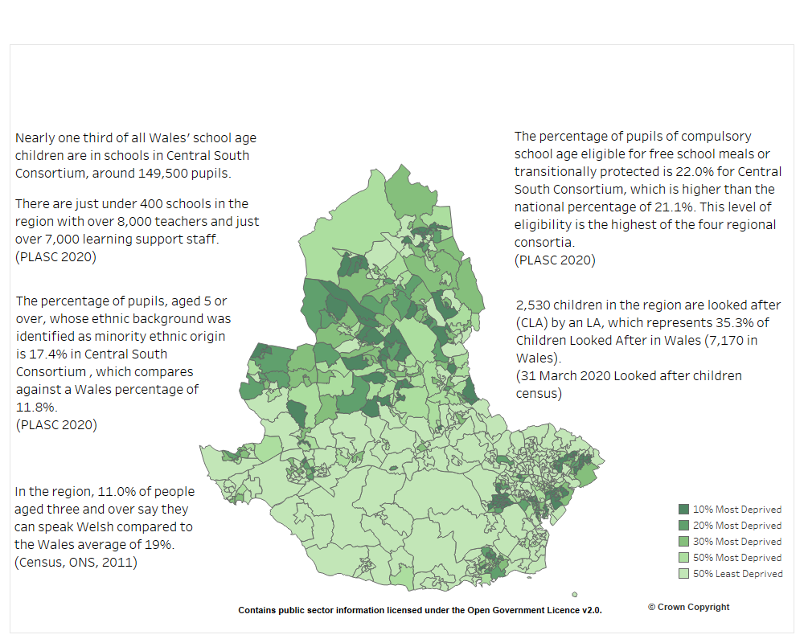

https://www.cscjes.org.uk/about-us

Appendix 2 – Parent Questionnaire

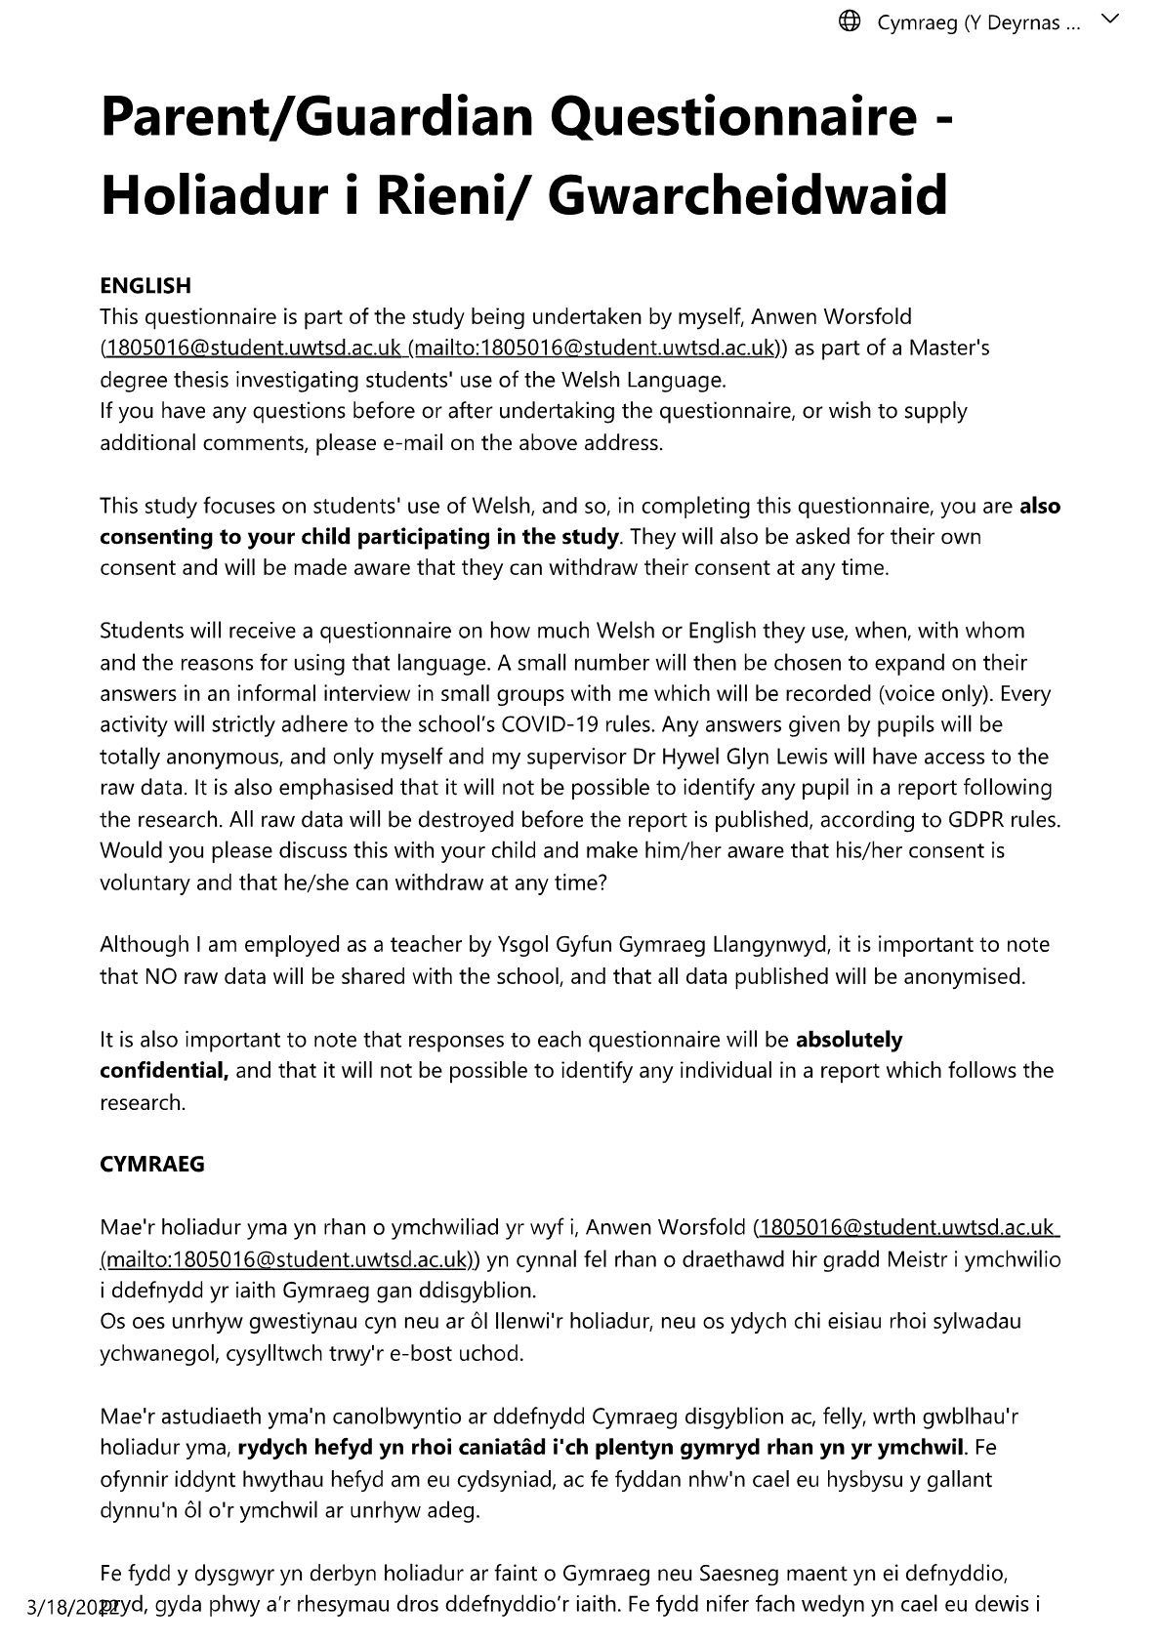

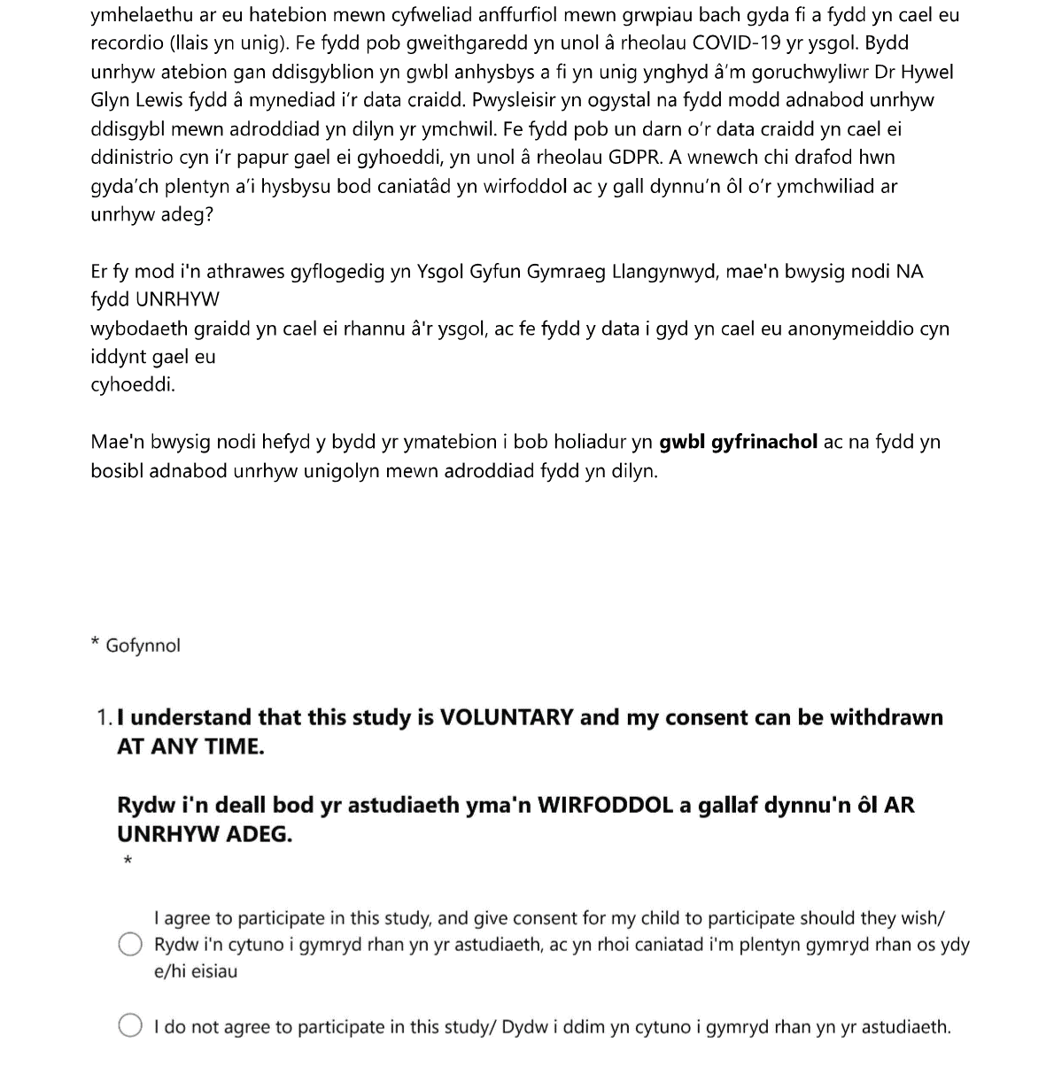

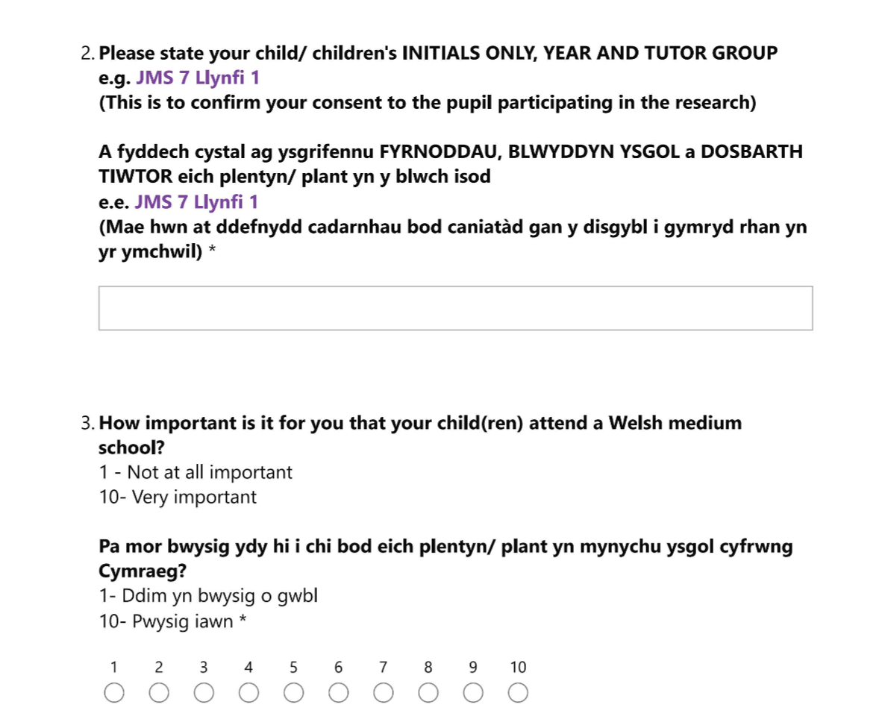

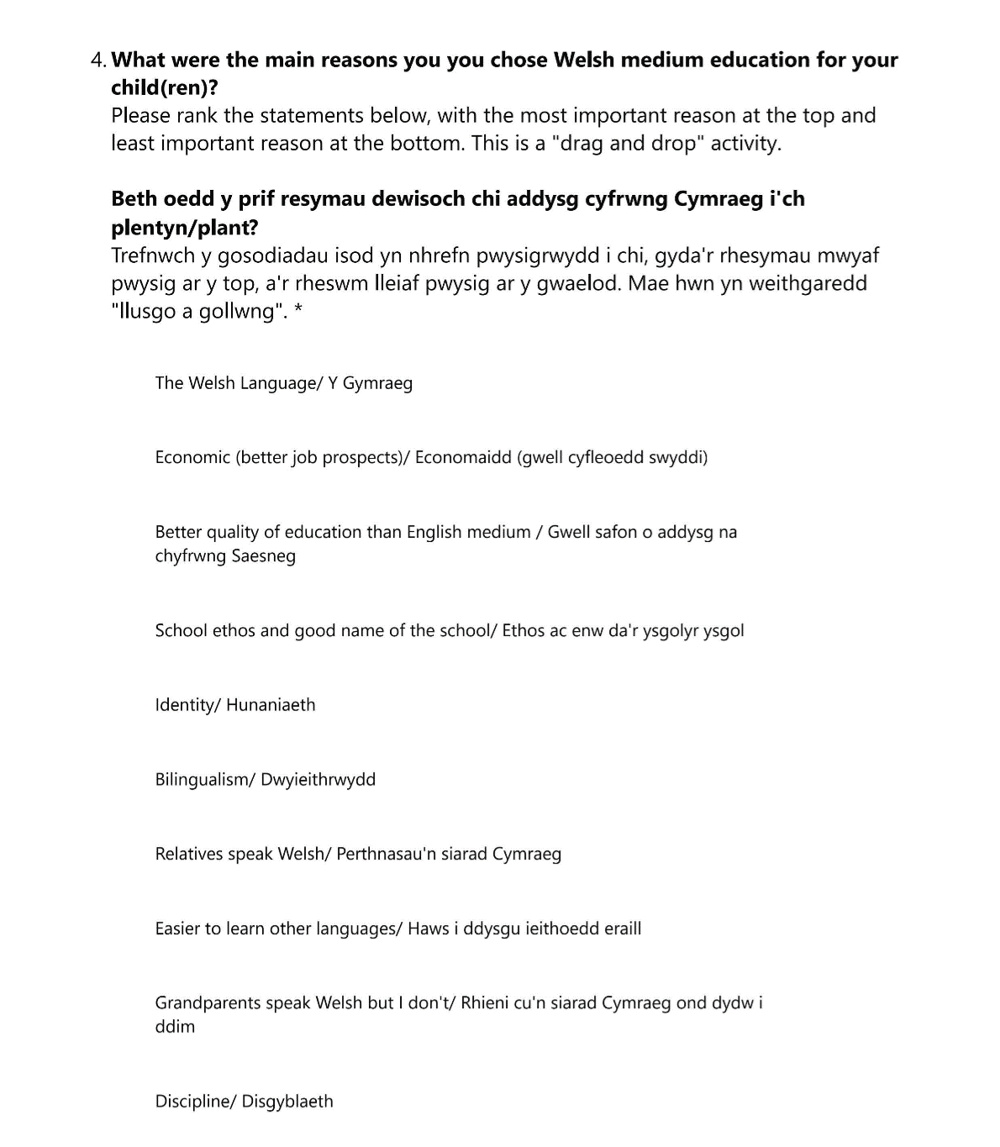

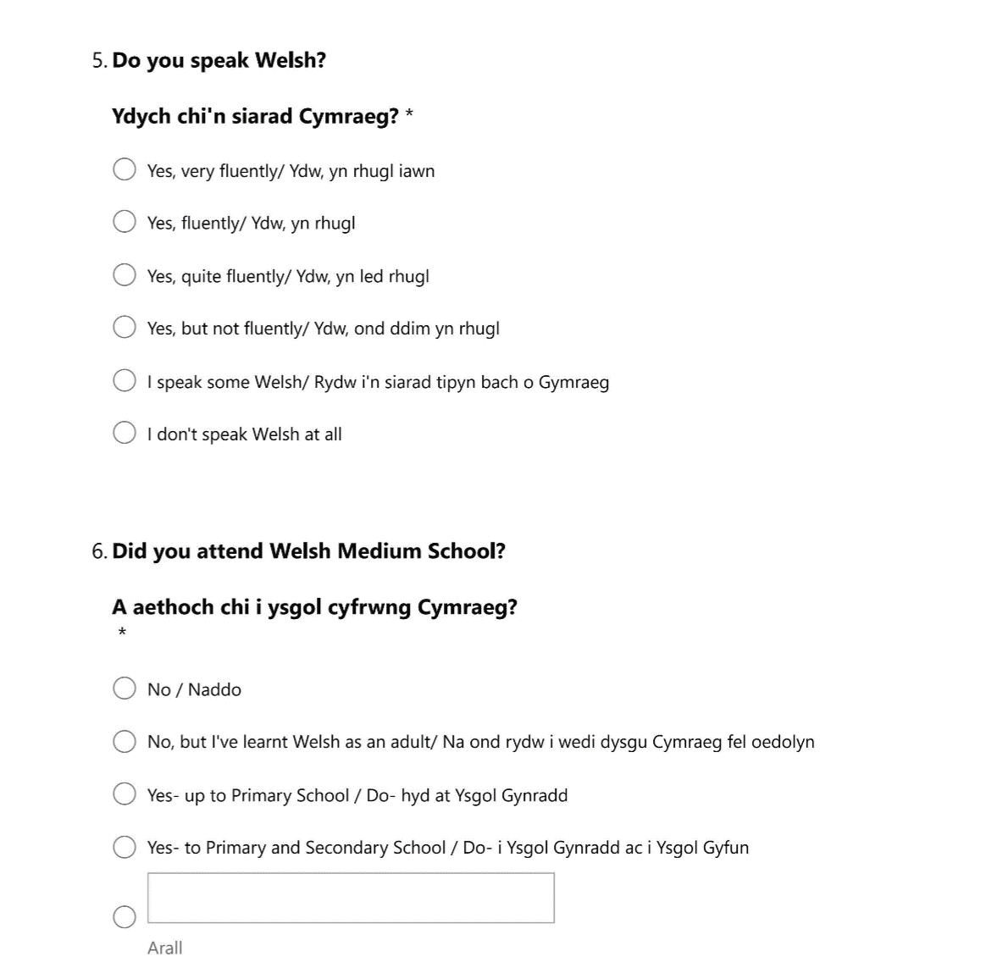

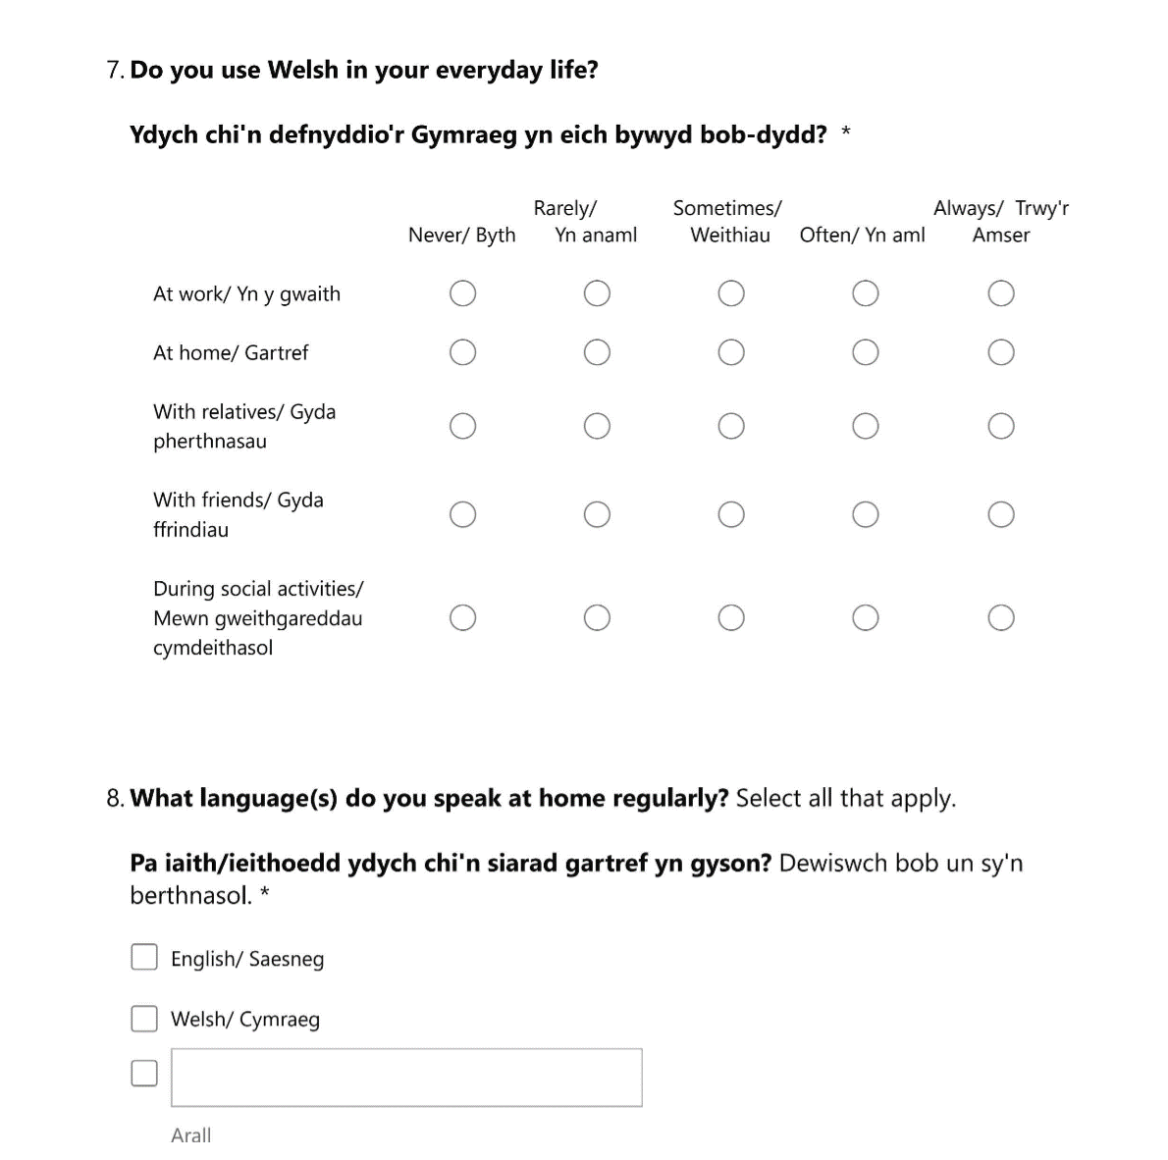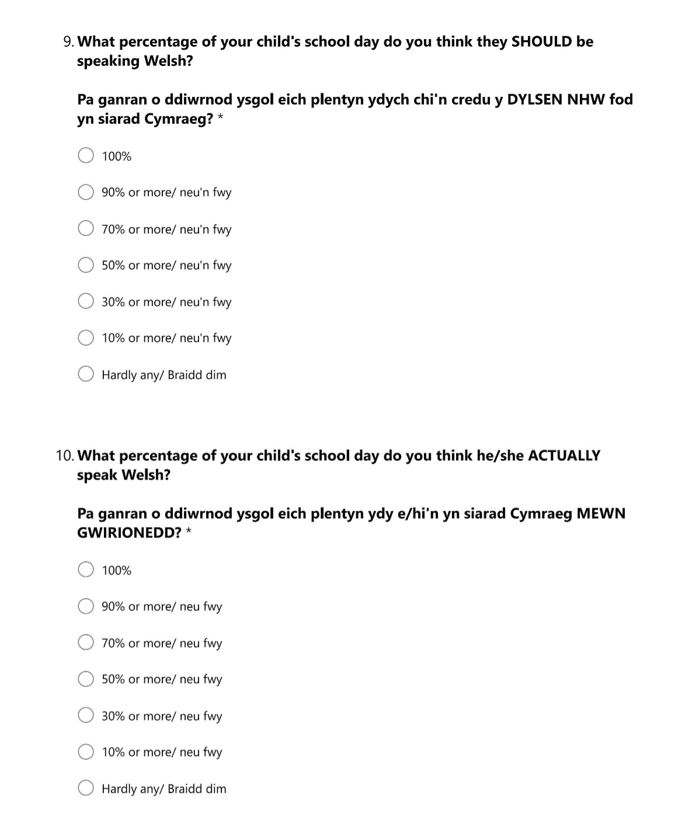



Appendix 3 – Teacher Questionnaire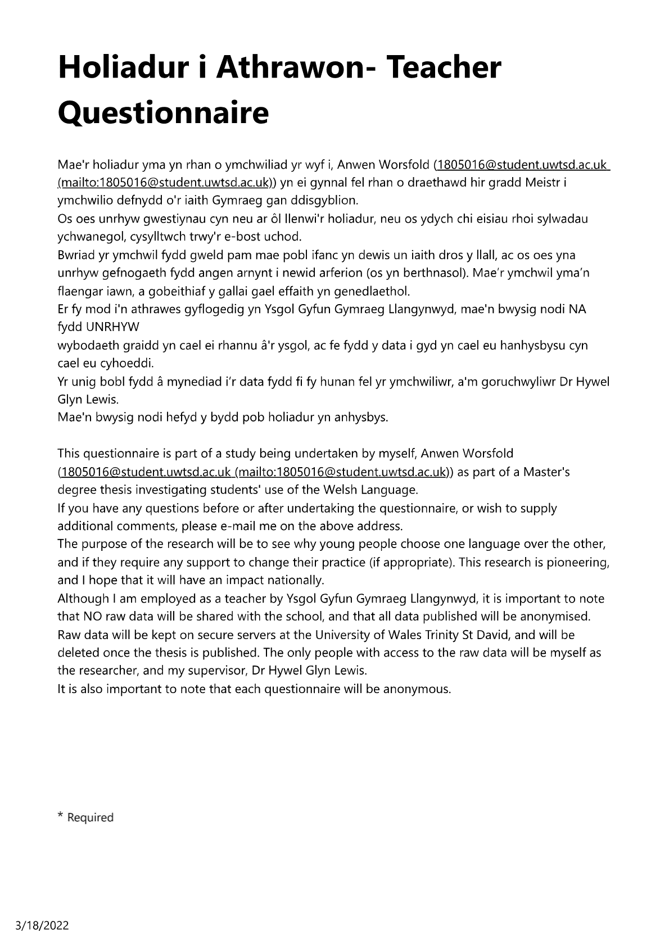

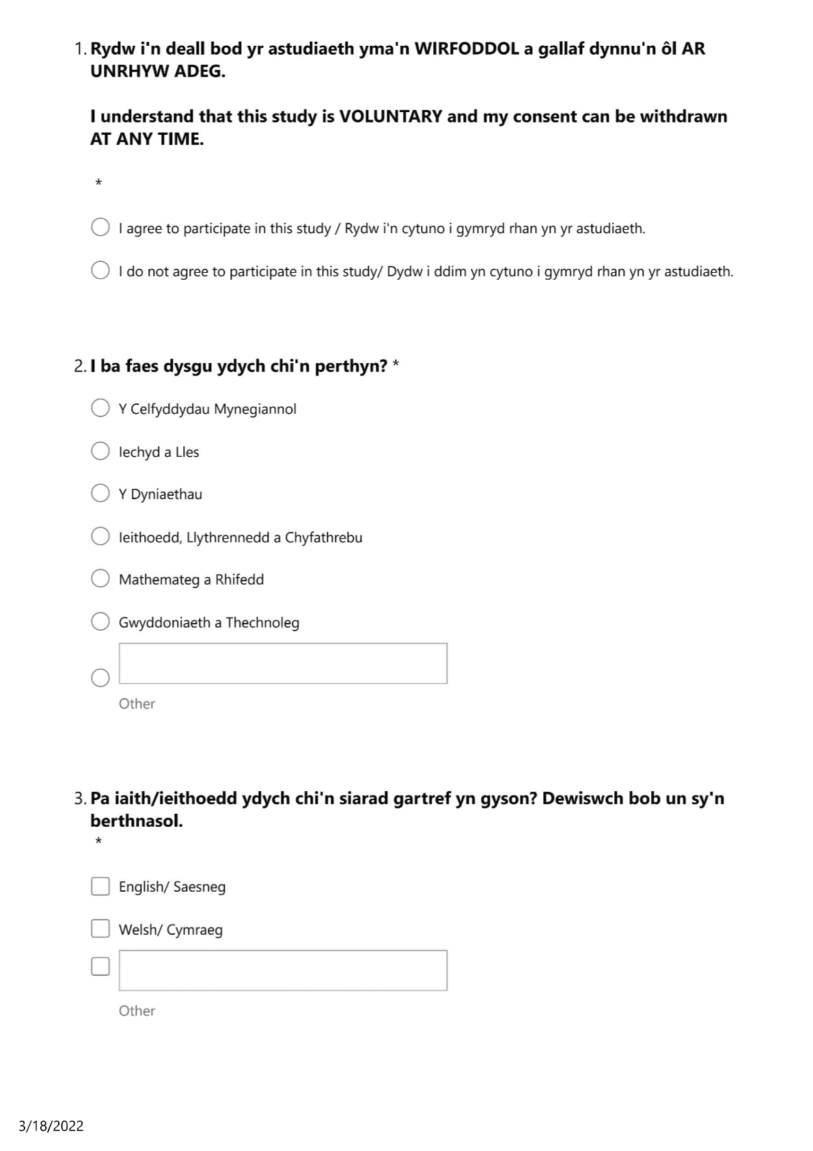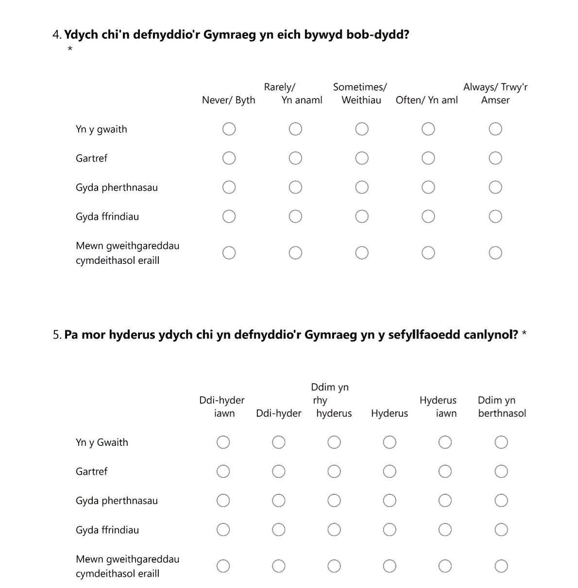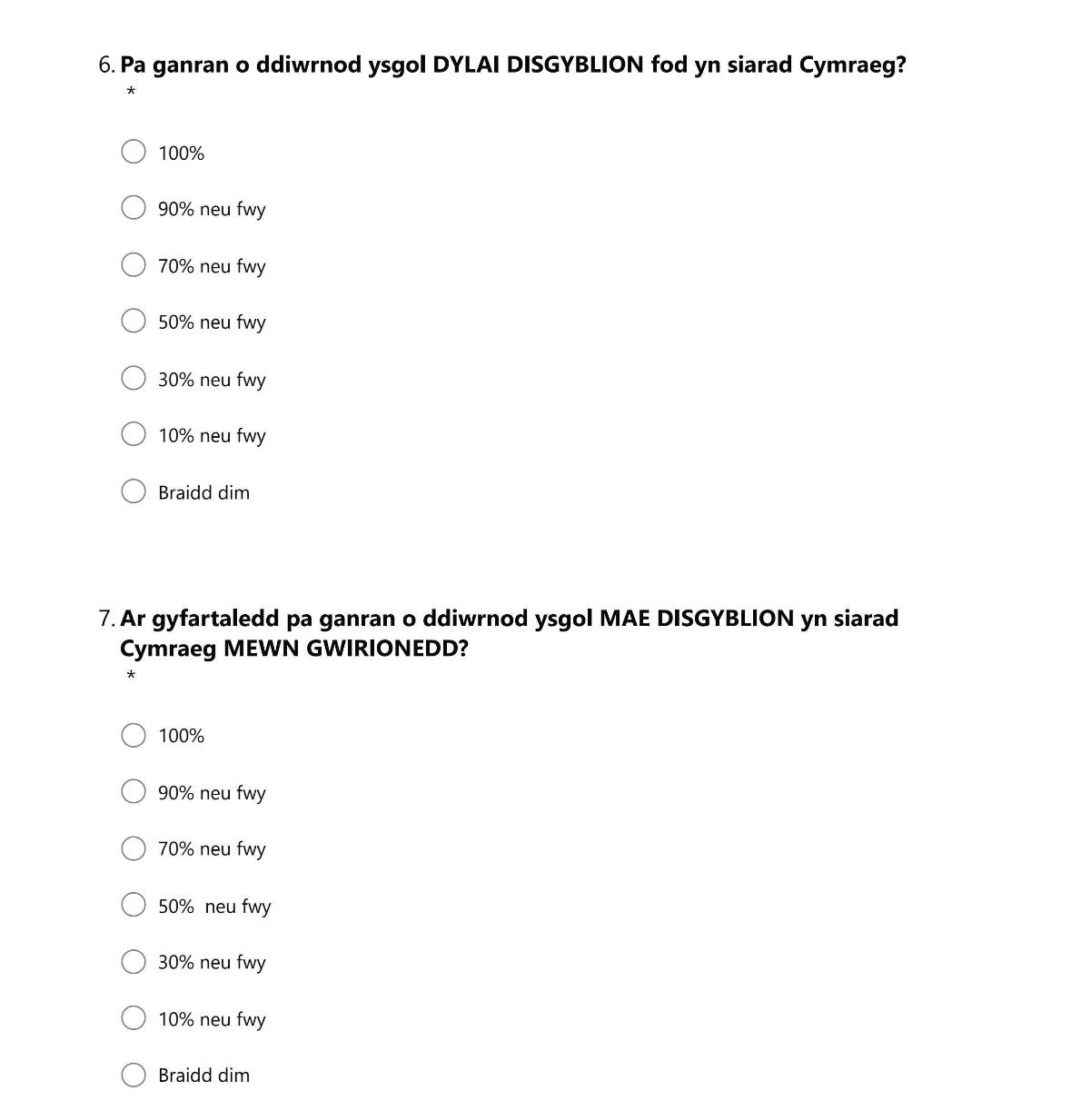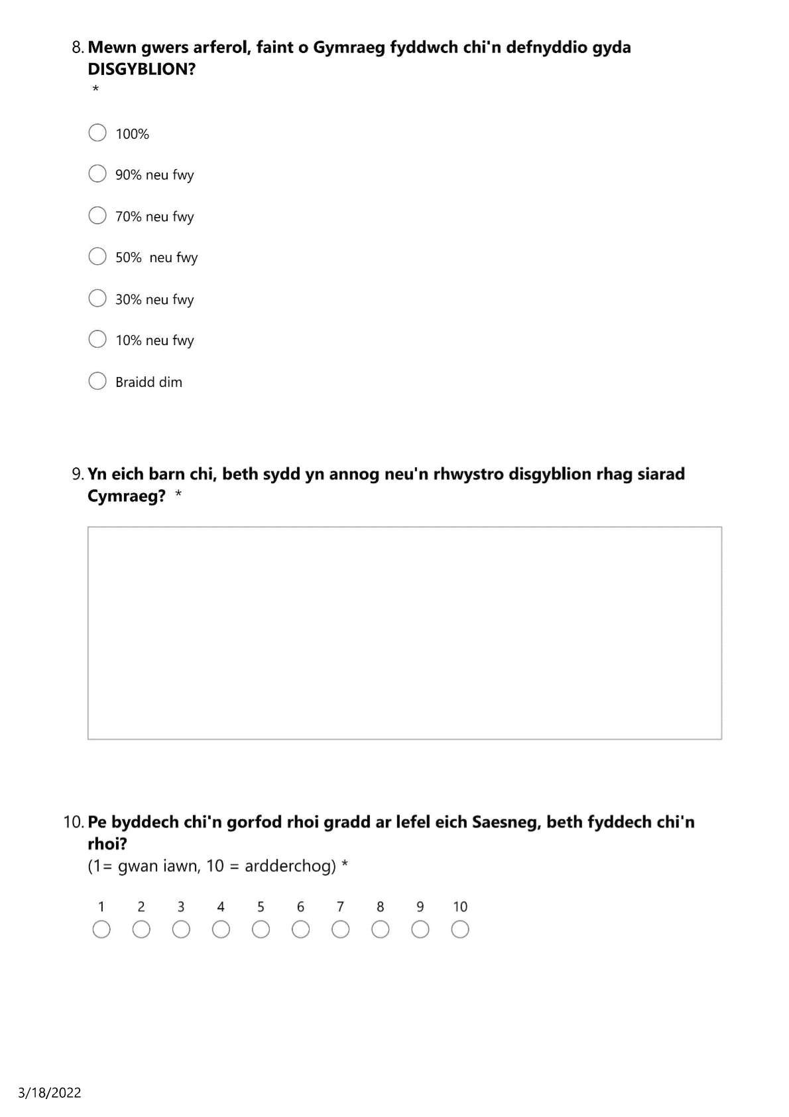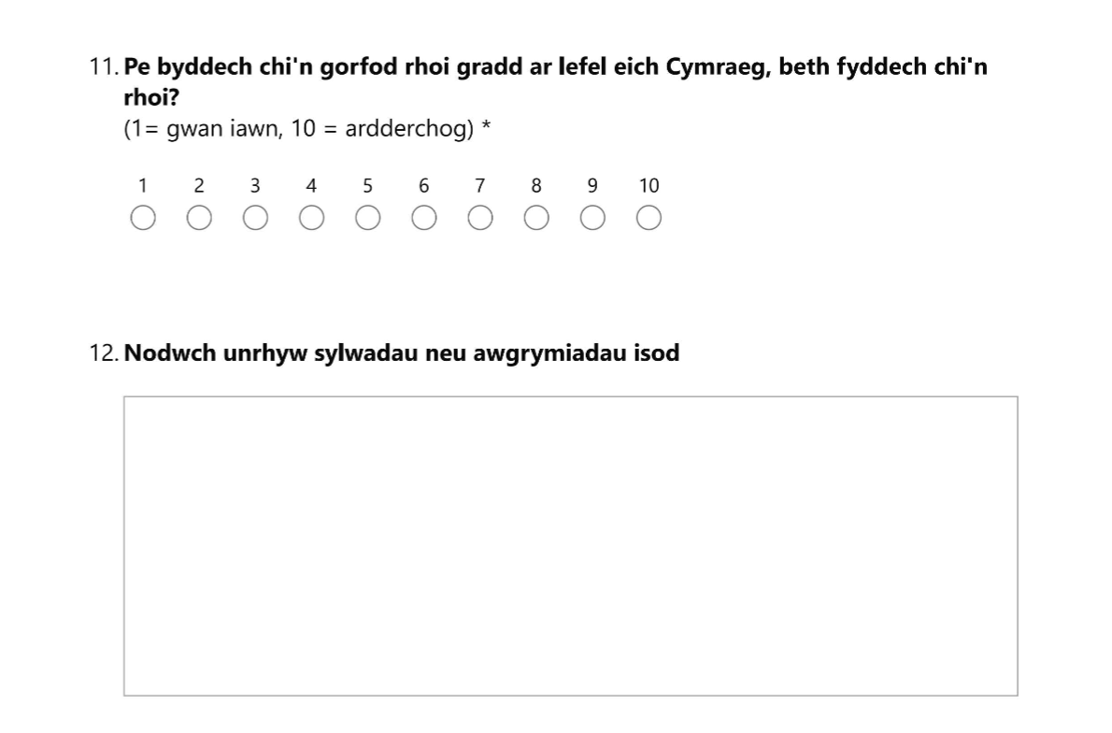

Appendix 4 – Pupil Questionnaires

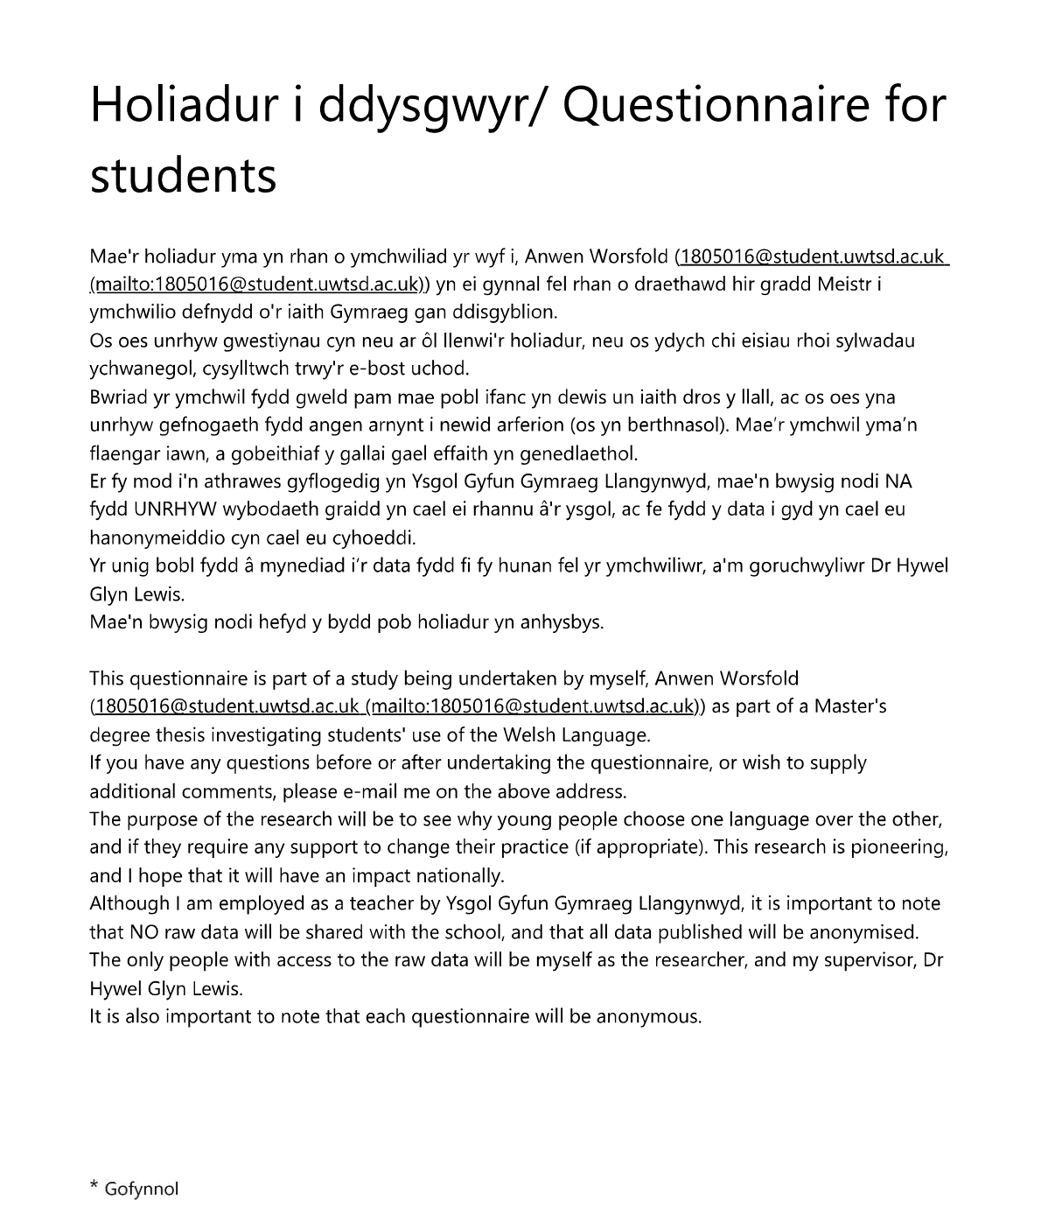

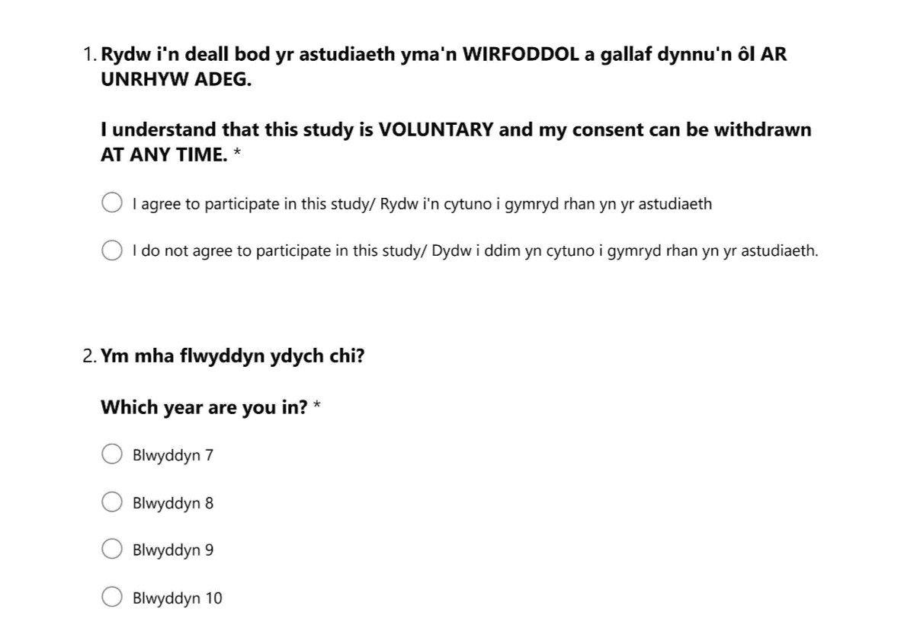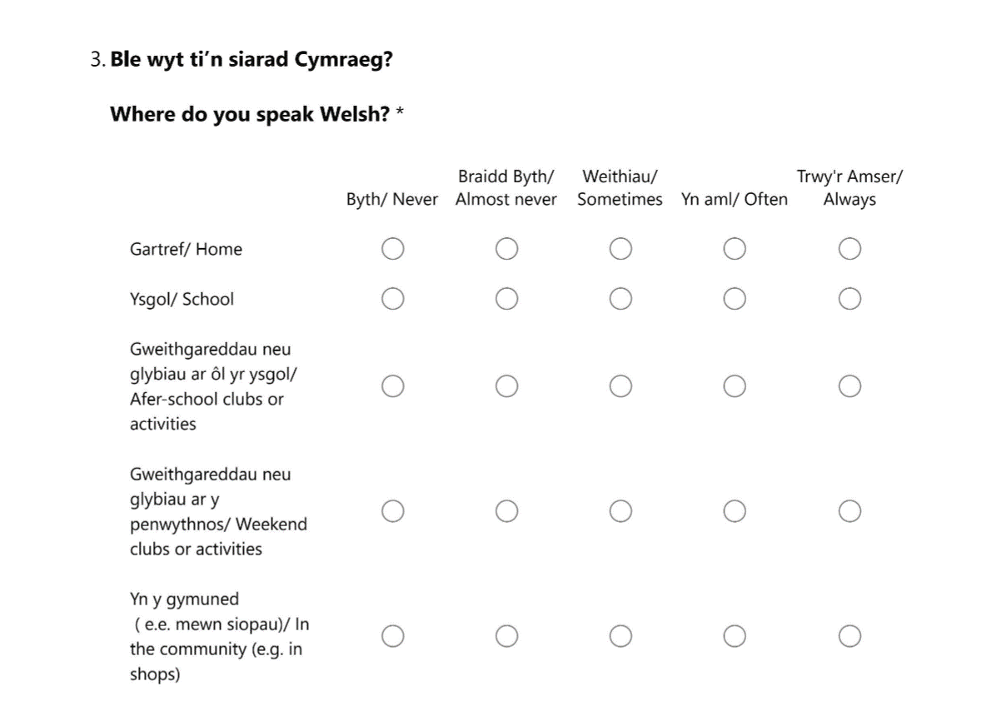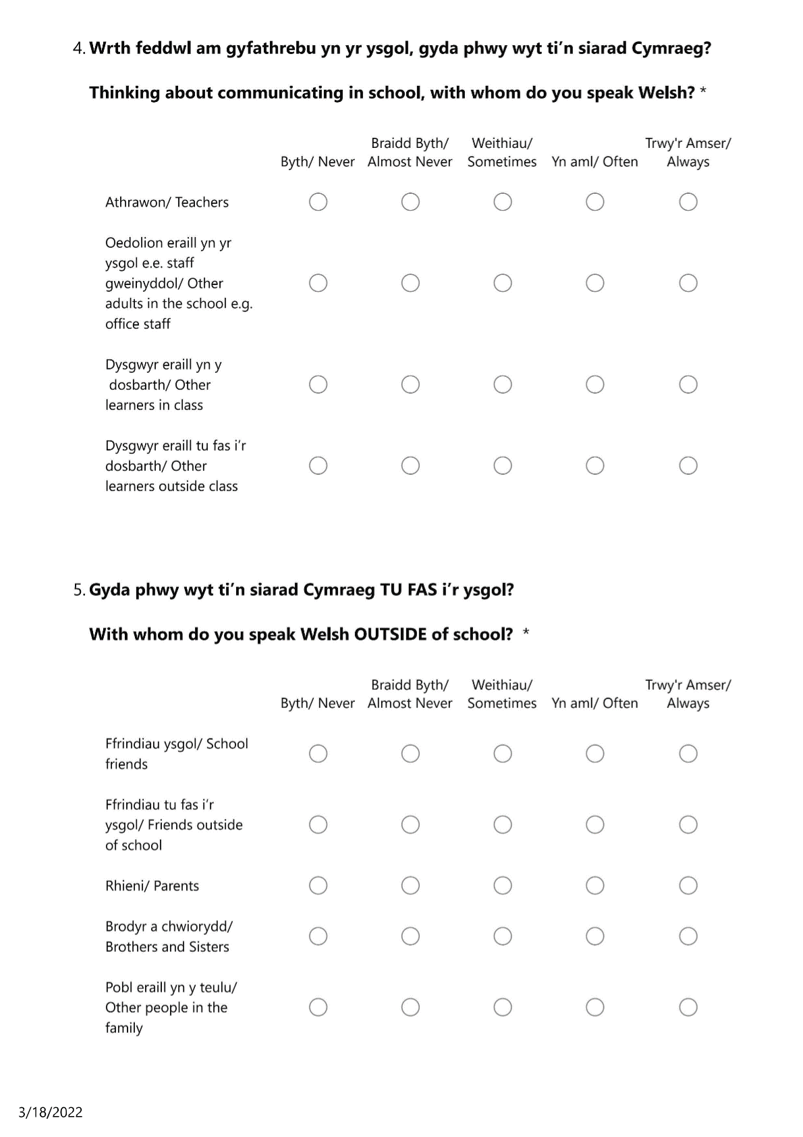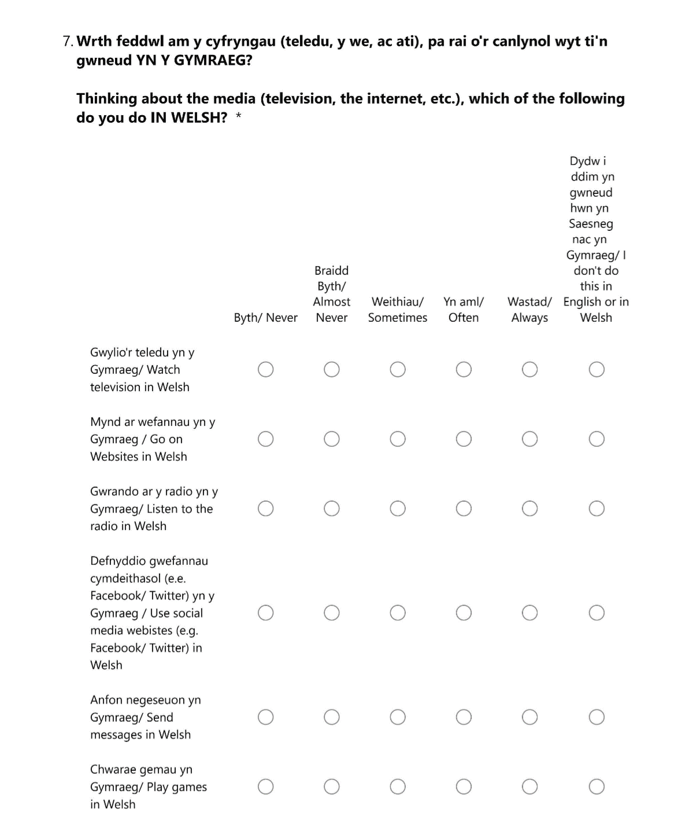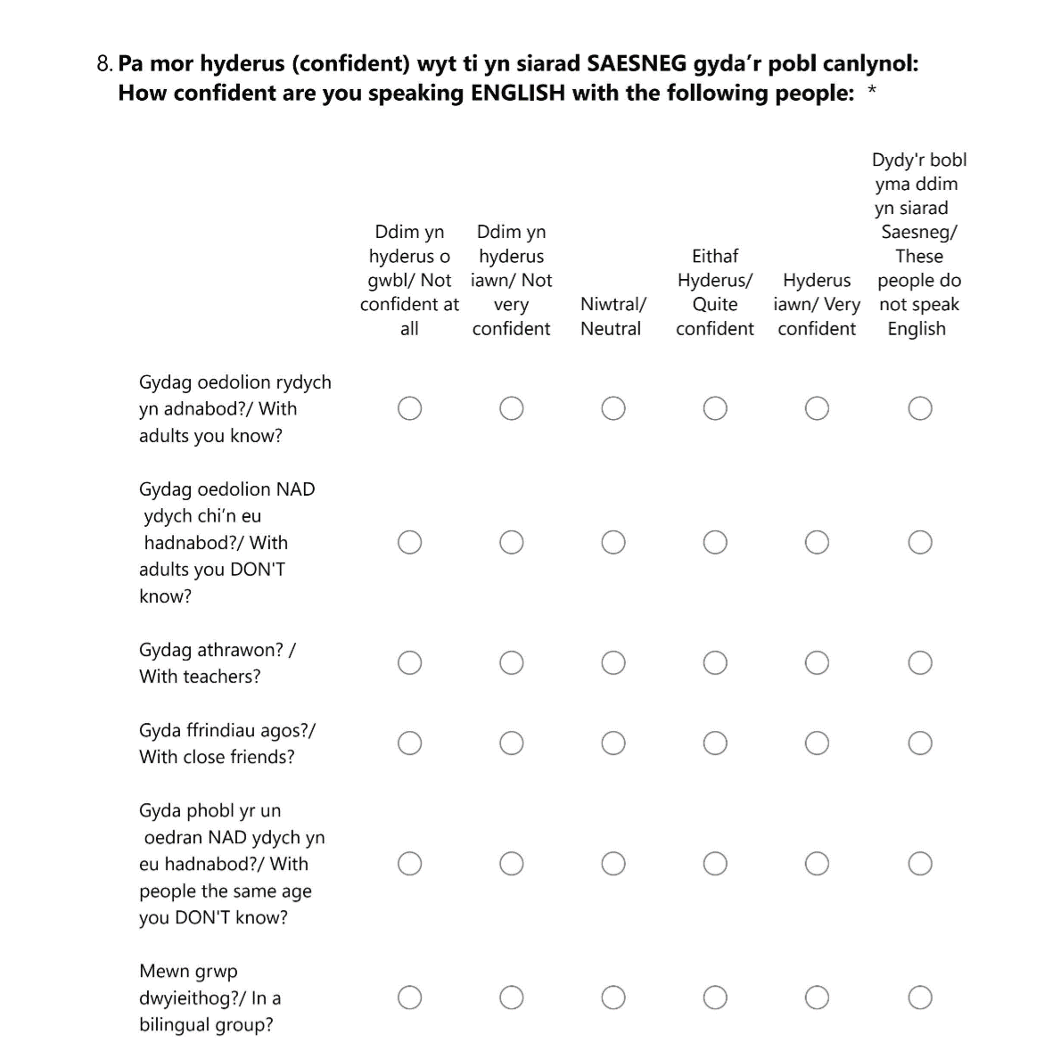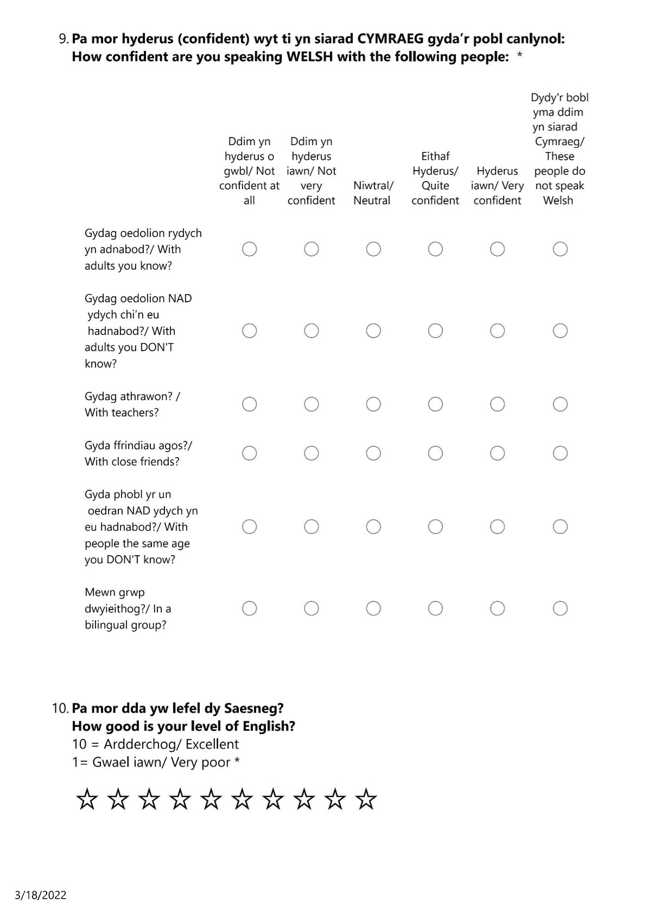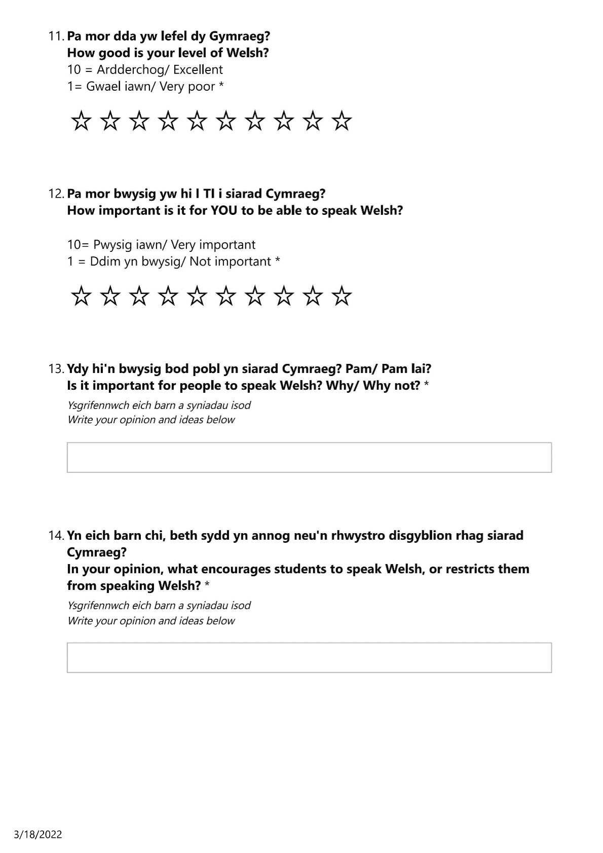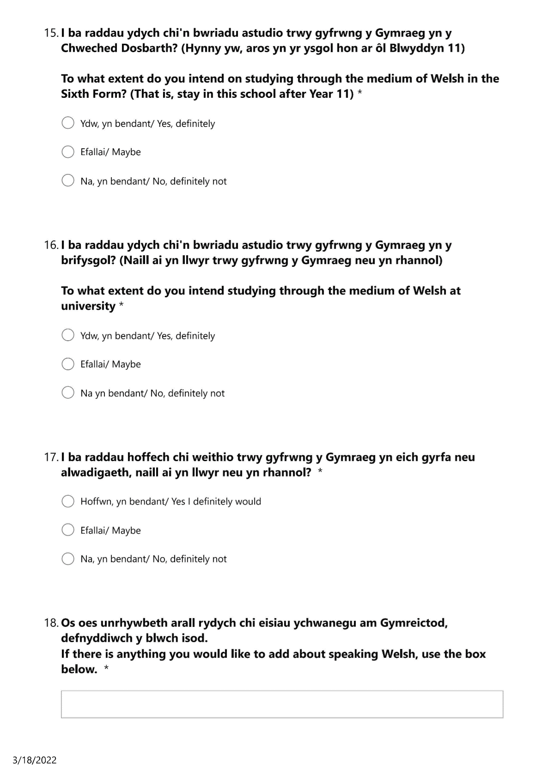

Appendix 5 – Pupil Interview Questions
Question 1 Do you think you speak more or less Welsh compared to when you were in primary school?
Question 2 Do you feel a part of the Welsh community?
Question 3 What would you put on a form as your national identity?
Question 4 Why do you think pupils don’t speak Welsh?
Question 5 Are you a part, or have you ever taken part in Welsh medium extra-curricular activities?
Question 6 I read in an article that there are not enough opportunities for pupils to START conversations, and that usually the teachers do most of the talking. Do you agree or disagree with this?
Question 7 Do you think your peers have enough linguistic ability to speak Welsh socially?
Question 8 Do you think your teachers influence your language?
Question 9 What do you talk to your friends about?
Question 10 Do you feel that the COVID-19 pandemic has affected your Welsh?

Appendix 6 – Headteacher Interview questions
Question 1 In your opinion, do your pupils speak enough Welsh?
Question 2 In which faculties or areas would you like to see an improvement in the use of Welsh?
Question 3 As a school, what strategies have you tried to increase use of Welsh, whether effective or ineffective?
Question 4- If money and time were no object, what would you like to see to improve Welsh language use in the school?

Appendix 7 – Parent Questionnaire Additional Comments
We need to ensure opportunities for the children to use their Welsh socially.
They only speak Welsh in lessons.... It’s a constant battle.
Although I expect my child to be taught and to communicate in Welsh, I see no reason why the children are not allowed to speak in English during "free " time, which enables them to progress in both languages.
Socially, I don’t think the children speak Welsh as often as they could/ should but hope this will improve as they realise how important it is to their identity, heritage, and culture.
It’s a huge regret that I wasn’t sent to a Welsh school, and so, I was adamant that my child was given the opportunity to attend and open her options for a career.
I am very pleased I made the decision to choose Welsh medium education for my children; I feel this will only enhance their career prospects as adults.
The situation today, it would seem, is exactly like secondary school in the 80s. I’m ashamed to say I very rarely spoke Welsh, and only then if teachers were nearby! Only the children from Welsh speaking homes would speak Welsh all the time. At home now, if I speak Welsh with the children, often they will switch back to English. My wife is English and only speaks English, so the language of the home is English. Speaking Welsh at home is unnatural for the children even though I’m fluent in Welsh and the reason is that my wife doesn’t speak Welsh.
Unfortunately, I don’t think that my daughter speaks Welsh outside of lessons e.g. on the yard with friends etc. And this is very disappointing to me considering she attends a Welsh school. I don’t know what the school does day-to-day to tackle this and I’d like to know. I don’t feel that enough is done to emphasise “Cymreictod” in the school.
Unfortunately, from experience, the children don’t realise the importance and how lucky they are to be able to speak Welsh. But again, from experience, the majority will appreciate this once they become adults.
Although my son has attended Welsh medium school, outside of school he never speaks Welsh, including when he meets up with friends from school on a social basis. I find it so disappointing he doesn't favour Welsh.
I find my children have a wider range of vocabulary and pronounce their words properly due to speaking Welsh.
I think it would have been useful to add a question whether I would make the same decision about sending my daughter to Welsh medium education following the pandemic. I have found supporting her with her work when I am not fluent in Welsh very hard, and it was the first time ever that I regretted putting her through Welsh medium education, and I wonder if others have felt the same?

Appendix 8 – Teacher Questionnaire Additional Comments
Disciplining the children is very hard. There is so much English to be heard, it’s impossible to punish everyone. It’s unfair to punish some only, and so it appears to the pupils that there is no punishment or consequence if they speak English.
We need more extra lessons for staff and pupils to re-learn the things they’ve forgotten e.g., grammar, mutation, spelling, etc.
We need to change the society more than schools to support the language as an everyday language. Pupils don’t hear the language in their areas, and so it becomes the language of school only. There aren’t enough extra-curricular activities that allow them to regularly use Welsh.
COVID has had a negative effect on the standard and use of Welsh by pupils.
The emphasis on accuracy in Welsh sometimes means that people are less confident using it. For example, even though I’m Welsh first language and am confident in my oral and written use, I’m more likely to be corrected for my Welsh use than I would be for English, and this leads to uncertainty.
The first language of most pupils is English.
I would find it difficult to write academic essays in Welsh, although I’ve done this constantly for the 6 years of university and teaching practice.
This comment was with reference to the teacher’s ability in Welsh and emphasised that he/she found it hard to write essays in Welsh, and so, the pupils themselves must also have found the use of academic language difficult.

Appendix 9 – Pupil Questionnaire Additional Comments
Good for jobs.
It can get annoying after a while.
More awareness about the language.
Not many people speak Welsh. I think this is because it's become a chore and they don't want to do it because they had to in school.
More people need the opportunity to learn and speak Welsh, so the language won't die.
I think that the Welsh language is slipping down a bit because of the influence people have on each other; if one person speaks in a language the other will join and do the same thing. If more people cared and spoke the language they are tend to [sic], then the population of the language would go back up.
It's a very important language so we should try to speak more of it, maybe try teaching someone it.
Why do people not learn about Owain Glyndwr in History, but do learn about English history?
Most of my family don't speak Welsh because they didn't learn as children. This is why Welsh schools are important.
I like the Welsh language for the reasons I have said, but I speak more English because more people in the world speak English and it's easier to speak to someone in a more popular language.
Speaking Welsh is important because it's like a talent.
I am proud to use Welsh, but not when I'm outside with friends or family, because most of my family members are from places in England.
We as a community should try get more Welsh medium schools.
I feel proud that I can speak the language and I want to carry on speaking fluently. I enjoy speaking Welsh with Mum, Gran and Grandad.
Speaking Welsh can be nice/ fun, but sometimes it can be a vexation as teachers and people in my family say, "speak Welsh! ".

