Jessica De Schoolmeester (2503086)
2503086@student.uwtsd.ac.uk
HTML & CSS Web Development
L4 - Introduction to Web and Database Concepts
19th November 2025

Table of contents
Introduction 2
Requirements 3
Implementation 4
Validation 5
Evaluation 6
6a) Website Usability 6
Accessibility 6
References 9
Appendices 10

Introduction

This report provides a brief understanding of important web development techniques that should be implemented such as usability, search engine optimisation and accessibility, while also providing an overview of how these principles are applied on my own website as well as within the two other comparable websites. This report also outlines screenshots of my website and a brief understanding of the errors that occurred when running it through a validator as well as outlining future improvements.

Requirements
The website has been created for an up-and-coming music festival featuring the first ever holographic music performances, with the main purpose of engaging and intriguing its target audience. The website has been designed to generate interest, provide essential information about the event, and promote the festivals concept effectively. The website has been developed to target audiences of people who regularly attend festivals as well as targeting individuals that are interested in innovation and holographic technology.

Implementation
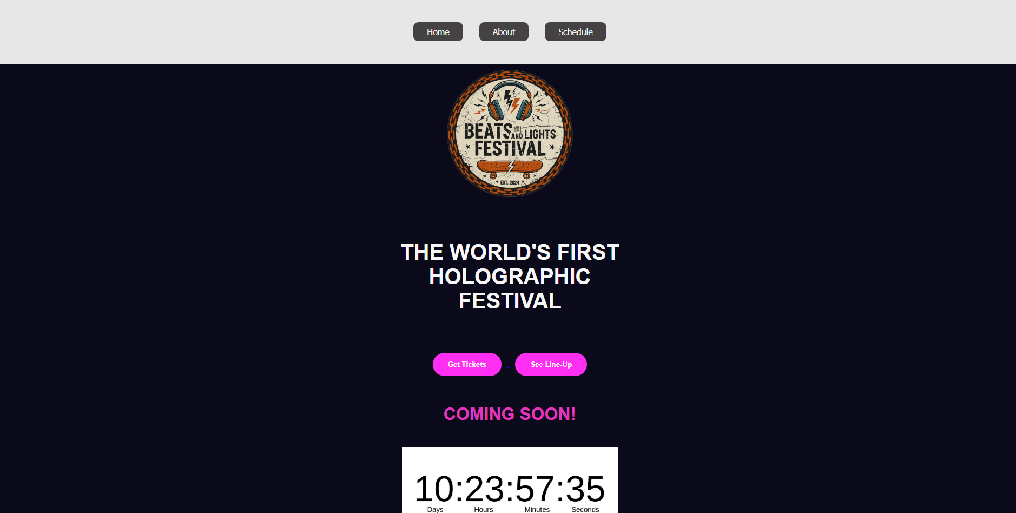

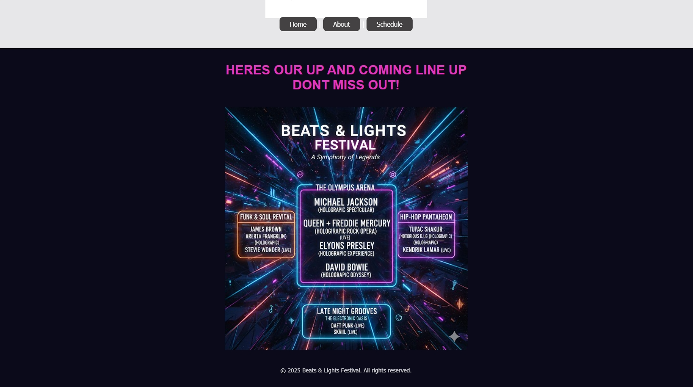
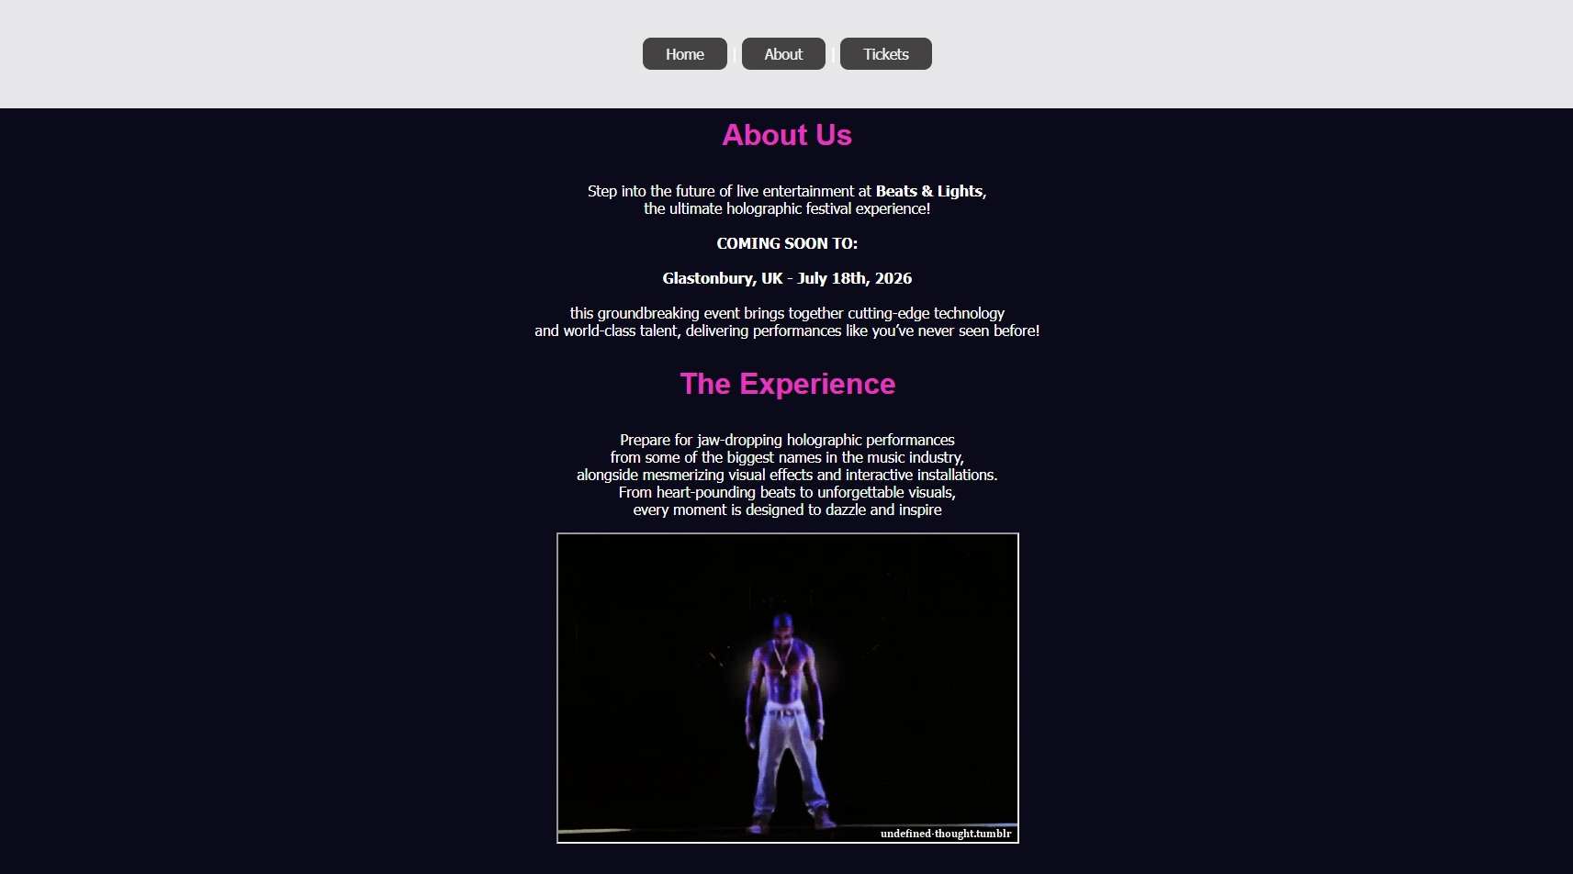
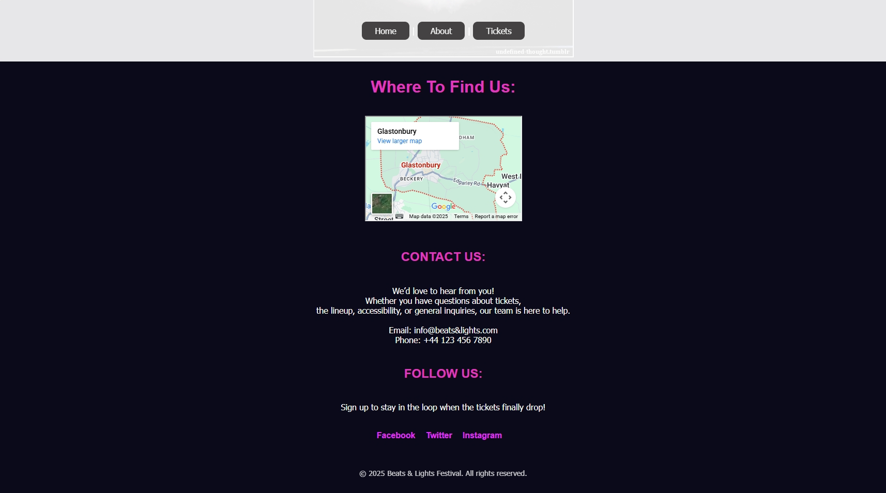
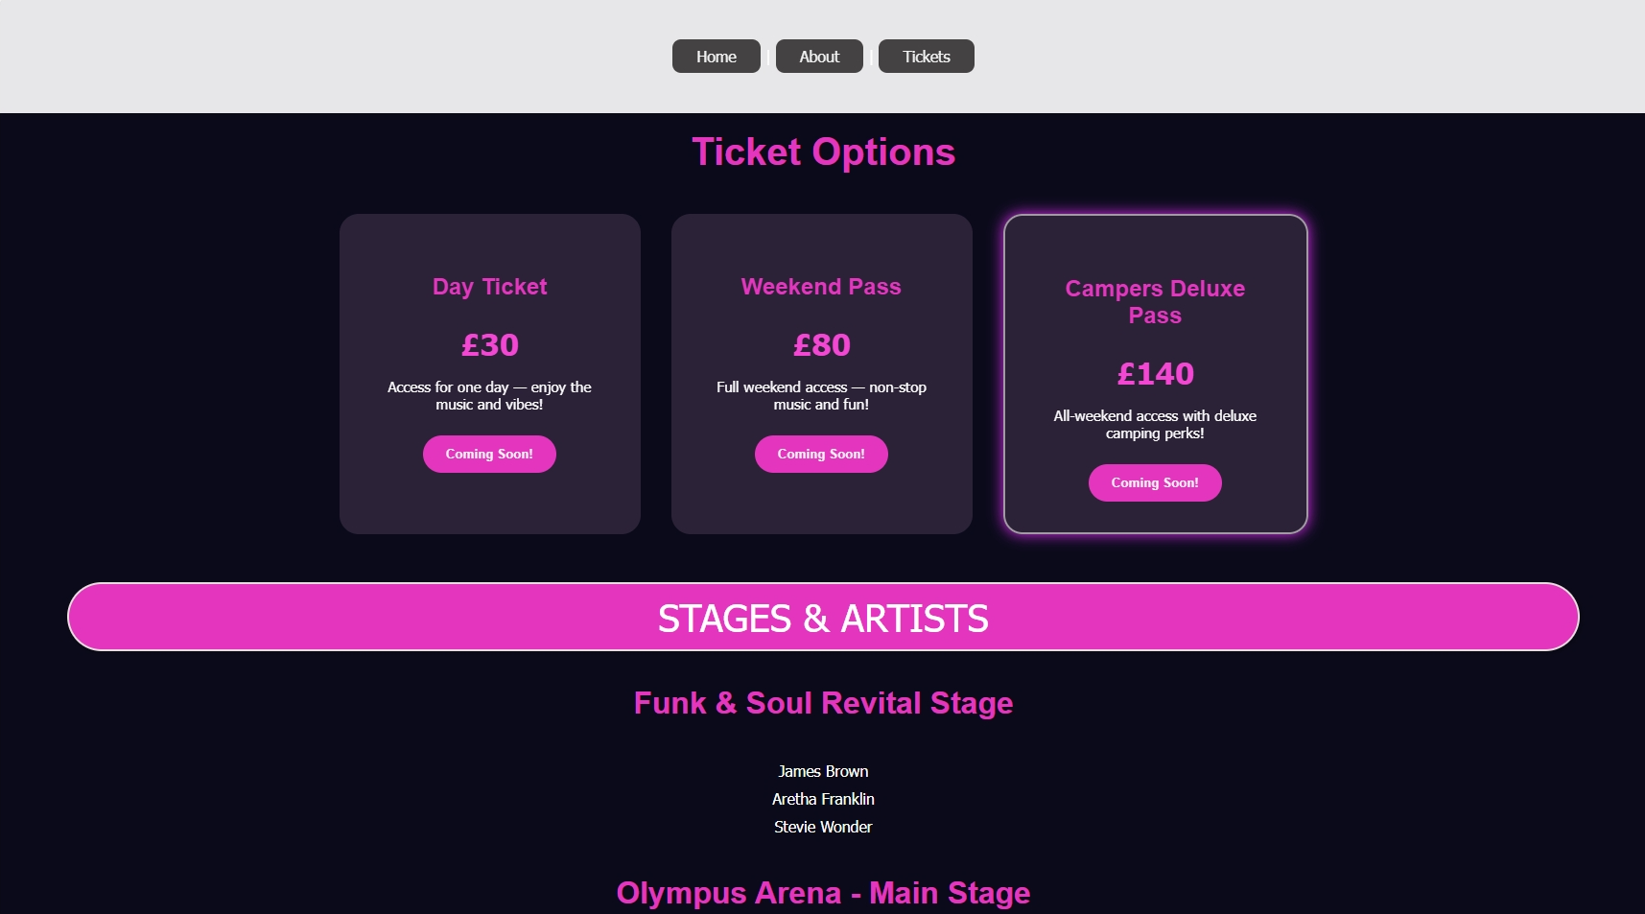
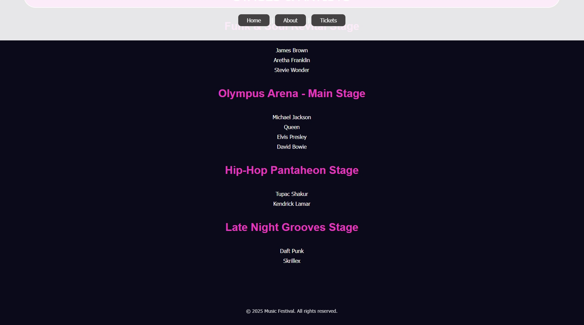

Validation

When validating the website, an error was flagged indicating that a <ul> element had been incorrectly wrapped around an <a> tag. To resolve this issue, I conducted further research into proper HTML structure and used ChatGPT to analyze the problem. This helped me identify the correct approach and determine the necessary adjustments to ensure valid markup. Initially, I tried placing <li> elements in front of each <a> tag, but this caused the navigation items to stack vertically, which was not the intended result. Instead, I removed the <ul> altogether, which achieved the desired layout.

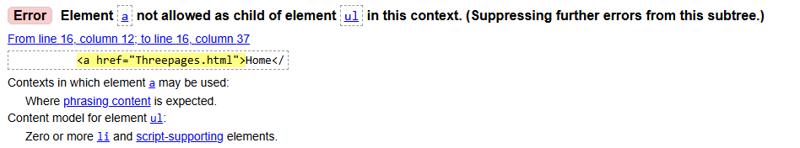

The error presented involved a <button> nested inside an <a> element. I attempted to resolve the issue and have a general understanding of why it caused an error. However, my adjustments did not achieve the desired behavior: clicking the “See Line Up” button should scroll the page down to the relevant section. I am still unsure how to implement this functionality correctly without nesting interactive elements, which remains an area for further improvement

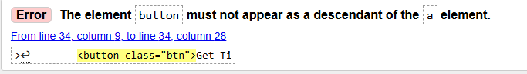

Evaluation

6a) Website Usability

Usability is a fundamental aspect of effective web development, as it directly influences how easily and efficiently users can interact with a website. High usability supports clear navigation, strong performance, and a responsive design that adapts smoothly across different devices. These elements ensure a satisfactory user experience by helping users access information quickly and allow users to be guided toward an intended action such as making a purchase [1]
This is supported by the study “Website usability, consumer satisfaction and the intention to use a website: The moderating effect of perceived risk” This research explores how the ease of using a website shapes consumers’ feelings about the site and their willingness to return, while also considering how risk perceptions influence these effects. The findings indicate that a user-friendly website boosts customer satisfaction, and this satisfaction is what ultimately leads users to revisit or reuse the site. Usability itself does not directly motivate future use but works through the positive experience it creates. The study also shows that when users perceive higher risk in online environments, the impact of usability on satisfaction becomes even stronger. In essence, creating straightforward, intuitive websites is crucial for improving user experience and fostering continued use, particularly for individuals who are more cautious about online transactions. [2]

6a) Accessibility

Accessibility is another attribute to web development that needs to be considered when designing a website as it allows people with a wide range of abilities to engage online with ease and get access to information for their daily activities. To accommodate these communities, it is essential that web developers apply the “Web content Accessibility guidelines 2.1” (WCAG 2.1). This guides web developers to incorporate techniques to ensure content is readily accessible to all people regardless of disabilities [3]

WCAG 2.1 is built on four core principles which are perceivable, operable, understandable, and robust. Together, these principles ensure that websites can be accessed and used by people with a wide range of abilities. They also emphasise making content available to all users and ensuring that websites can be navigated and controlled as well as presenting information clearly and developing websites to work reliably across different devices. The principles outlined in WCAG 2.1 are important because they create consistent guidelines for inclusive design and reduce barriers for users with disabilities and improve overall usability and quality for everyone.
Perceivable
If a user is unable to see, hear, or process certain formats, there should be alternative ways for them to access the same information, such as providing text descriptions for images, captions for audio, and a clear presentation of content. This ensures that all information on the website is accessible and perceivable to every user.
Operable
This helps ensure that users can navigate and interact with a website using different methods, such as keyboard controls. It reduces barriers that might otherwise prevent people with physical disabilities from moving through the site or completing tasks.
Understandable
Disabilities like dyslexia can make reading and understanding written text challenging. By presenting content more clearly and making interactions more predictable, users are better able to interpret information and complete tasks without confusion.
Robust
Ensuring a website is robust means developing it so that it works reliably with both today’s users and the technologies that may come later, including tools such as screen readers. The aim of this guideline is to make sure content is presented using consistent, recognized methods so that assistive technologies can properly interpret and interact with it [4]

6a) SEO – Search Engine Optimisation

Search Engine Optimization (SEO) is the practice of improving a website’s information, design, and layout to enhance its visibility and achieve higher rankings in search engine results. It plays a crucial role in web development by ensuring that websites reach the right visitors. Effective SEO allows users to find a site naturally through techniques such as keyword optimisation in titles, headings, and page content, which increases overall traffic. It also improves user experience, as search engines tend to prioritise websites that load quickly, work well on different devices, and offer clear, easy navigation. Search engines use a process called crawling, where automated bots scan webpages to understand their content. After crawling, the pages are analysed and stored in the search engine database. This process of storing your website’s content in a database increases the likelihood that your website will appear in relevant search results and be discovered by users [5]

6b) Evaluation of my completed website

Usability
From a usability perspective, the website presents a clean and intuitive layout, with all call-to-action elements fully functional. The site’s purpose is immediately clear, beginning with the browser tab labelled “Music Festival,” followed by the Beats & Lights Festival logo on the homepage. Additional elements, such as the About page detailing festival information dates and a map to guide you where it’s going to be held, further reinforce the website’s purpose and help users quickly understand its content and objectives.
When opened in a browser, the website adapts to the screen size which further reinforces the usability of the website.
Accessibility
An evaluation of the website was conducted using the WAVE accessibility tool, which identified several issues that need to be addressed to achieve compliance with WCAG 2.1. A recurring issue across all three pages was low colour contrast, which can make text difficult to read for users with visual impairments or complex reading needs. This directly affects the Perceivable and Understandable principles outlined in WCAG 2.1, as insufficient contrast reduces readability and limits users’ ability to access and interpret the content effectively - errors shown below.
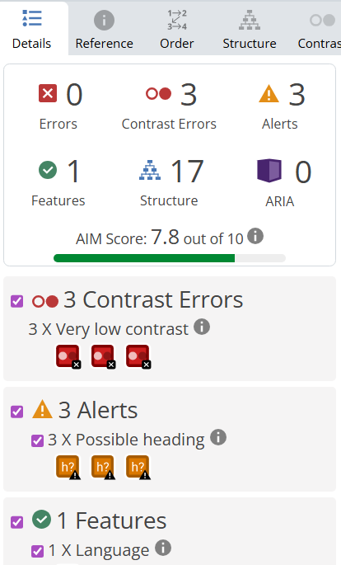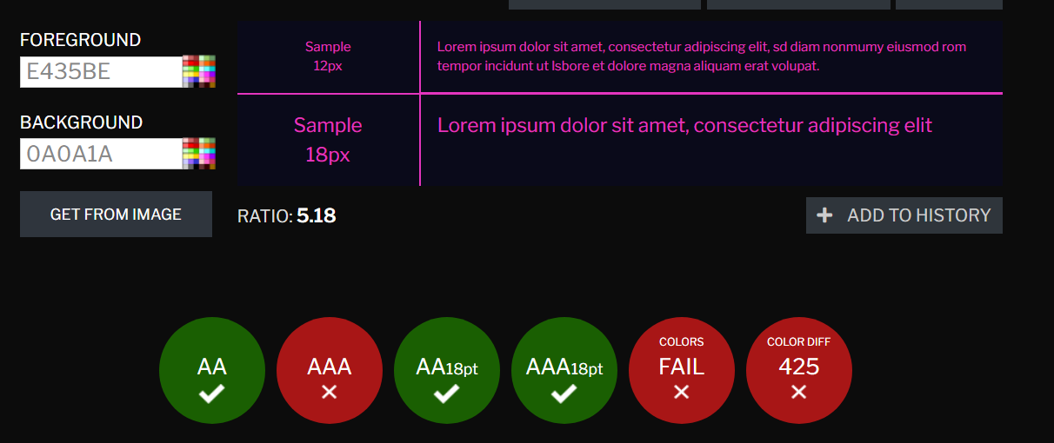

SEO – Search Engine Optimisation
Several on-page techniques were applied to improve the visibility and search engine performance of the website. First, descriptive and keyword titles were included, for example the homepage featured a prominent logo outlining the festival’s name helping users with the purpose of the site. In addition, the browser tab title displays Music Festival further reinforcing the websites’ theme and making its purpose clear from when the page loads.
The html structure follows standard formatting, with <h1> and <h2> headings used to organize content clearly and support search engine understanding of the page hierarchy. Comments were also inputted into the code and throughout to outline key features. However, during accessibility testing with the wave tool, an issue was identified where the heading structure on page 2 skipped from an <h2> to a <h4>. This inconsistency may affect both accessibility and SEO as it can disrupt the logical reading order for screen readers and reduce clarity of content.

Improvement Recommendations
When considering usability, accessibility, and search engine optimisation, several improvements could be made. Although the website provides a clean layout, functional call-to-action buttons, and a clear purpose, the HTML code could include more descriptive comments. For example, changing a button label from “See Line-Up” to “View Festival Line-Up” would better communicate its function. Additionally, the website lacks strong contrast and visual distinctiveness. The countdown timer, although functional, disconnected stylistically from the surrounding elements.

6c) Website Comparison

For this comparison I have chosen to evaluate TUI and EasyJet, as both are major travel booking websites that serve similar functions.

Usability
TUI
TUI’s website features a clean and well-organised layout, with a prominent search tool for holidays and clearly labelled navigation links. This design allows users to browse efficiently and quickly locate travel options. The consistent use of readable fonts, ample spacing, and an uncluttered interface contributes to a seamless and user-friendly experience. However, the large promotional banner on the homepage can be distracting due to its strong contrast, which may draw attention away from the main holiday search feature.

EasyJet
EasyJet’s website employs consistent fonts, clear headings, and a well-structured navigation system, making it easy for users to search for flights and manage bookings. While EasyJet also features promotional banners on the homepage, the high contrast colours help with the main purpose of the site - the holiday search remains prominent. Its simple design can make for a more efficient user experience.

Accessibility
TUI
TUI’s website demonstrates several strengths in accessibility, such as a clear structure with well-organised headings and navigation. However, when using the WAVE tool to evaluate the site further, it revealed significant issues, indicating that some elements may be difficult for users with visual impairments or other disabilities to access. With 31 contrast errors, text can be harder to read. While the website shows good intent in implementing some accessibility features, there remains considerable room for improvement.
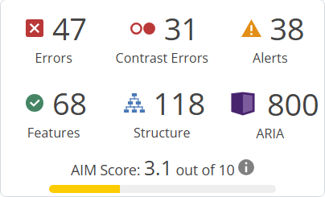

EasyJet

The EasyJet website demonstrates several positive accessibility traits, including a clear and simple layout that emphasises its primary purpose. However, an evaluation using the WAVE tool identified significant opportunities for improvement, revealing multiple accessibility issues that could hinder users with disabilities like the findings for TUI. That said, EasyJet offers 325 accessible features, compared to TUI’s 68 which would give EasyJet a slight advantage by providing a broader range of tools and options to accommodate users with varying accessibility needs.

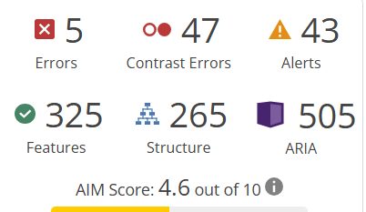
SEO – Search Engine Optimisation
TUI
TUI’s meta tags, titles, alt attributes, and headings are inconsistent and not fully optimized. Some meta tags are vague or too short, lacking clear keywords, which can reduce search visibility. Many images, especially banners and icons, are missing descriptive alt text, and where alt text exists, it is often vague or repetitive, limiting its usefulness for accessibility and SEO. The heading structure is irregular, with multiple <h1> tags on some pages and incorrect use of <h2> tags which can negatively affect both usability and search performance
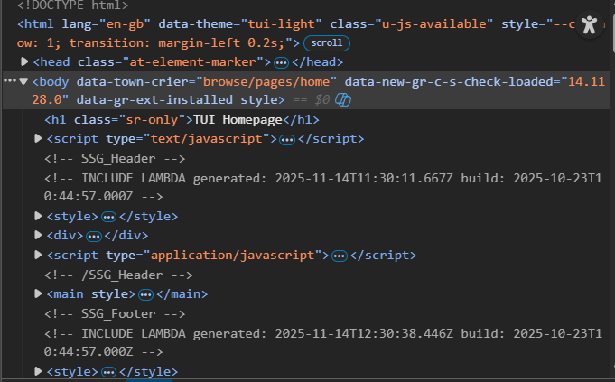
EasyJet
EasyJet’s meta tags, titles, attributes, and headings are generally well-structured and optimised. Meta tags and titles are clear, descriptive, and incorporate relevant keywords, supporting search visibility. Most images include meaningful alt text, which enhances accessibility and SEO, while decorative images are appropriately labeled or left empty. The heading structure is logical and consistent, with a clear hierarchy from <h1> to <h3> tags, and headings are descriptive and informative, improving both usability and search performance.
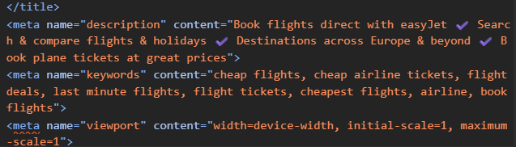
Mobile Friendliness
TUI
TUI’s website adjusts to different screen sizes on a smartphone. While the layout scales appropriately and the navigation collapses into a mobile-friendly menu, the promotional banner remains the largest element on the screen and can crowd other elements, making them appear smaller when navigating the website on a mobile device. The load times are sufficient but subpar. Some navigation elements are small to touch and may appear even smaller on older devices. TUI’s website remains functional, but usability issues and load times can affect the user experience and show room for improvement.

EasyJet

EasyJet appears to prioritise mobile friendliness with its simple and clean layout. The website has no issue with re-scaling, keeping the main feature, searching for flights, occupying the main area of the screen and pushing down promotional banners, preventing overcrowding. However, when navigating to other sections, such as package holidays or hire cars, a new page opens, which could cause issues for users with slower internet connections. In general, the website provides a smooth and user-friendly mobile experience, though page transitions could be improved.

Conclusion
EasyJet’s website outperforms TUI across usability, accessibility, SEO, and mobile friendliness. Its clean and simple layout, clear navigation, and responsive design make it easy for users to search for flights and manage bookings efficiently. EasyJet also offers a significantly higher number of accessibility features and demonstrates stronger SEO implementation through well-structured meta tags, meaningful alt text, and a logical heading hierarchy, enhancing both usability and search visibility. While TUI’s website is functional, with a clean layout and organized navigation, issues such as large promotional banners, inconsistent SEO elements, fewer accessibility features, and some mobile usability challenges limit the overall user experience. Consequently, EasyJet provides a more user-friendly, accessible, and effective online experience, giving it a clear advantage over TUI.

References

[1]
“View of The Importance of Website Usability in Digital Marketing: A Review”, Available: https://journalspress.uk/index.php/LJRCST/article/view/194/1344. [Accessed: Nov. 15, 2025]
[2]
D. B. ´ua,n 1, Luis V. Casalo´b,2, Miguel Guinalı, “Website usability, consumer satisfaction and the intention to use a website: The moderating effect of perceived risk,” 2012, Available: https://pdf.sciencedirectassets.com/271706/1-s2.0-S0969698911X00073/1-s2.0-S0969698911001160/main.pdf?X-Amz-Security [Accessed: Nov. 15, 2025]
[3]
“Accessibility in Web Development Courses: A Case Study - ProQuest”, Available: https://www.proquest.com/docview/2380481563/BC7DB89584924634PQ/2?accountid=130472&sourcetype=Scholarly%20Journals. [Accessed: Nov. 16, 2025]
[4]
“Web Content Accessibility Guidelines (WCAG) 2.1”, Available: https://www.w3.org/TR/WCAG21/#compatible. [Accessed: Nov. 16, 2025]
[5]
C. Mmeje, “What Is SEO? Search Engine Optimization Best Practices,” Apr. 14, 2025. Available: https://moz.com/learn/seo/what-is-seo. [Accessed: Nov. 10, 2025]

Appendices

Home Page
<!DOCTYPE html>
<html lang="en">

<head>
<meta charset="UTF-8">
<meta name="viewport" content="width=device-width, initial-scale=1.0">
<title>Music Festival</title>
<link rel="stylesheet" href="styles.css">
</head>

<body>
<header>
<!--Navigation, Home, About, Schedule-->
<nav>

<a href="Threepages.html">Home</a>
<a href="about.html">About</a>
<a href="gallery.html">Schedule</a>

</nav>
</header>

<!--Top Logo-->
<img class="Logo-for-home" src="Images/betterlogo.png" alt="Beats & Lights Festival Logo" width="300">

<h2 class="homeh2">
THE WORLD'S FIRST <br>
HOLOGRAPHIC<br>
FESTIVAL
</h2>

<!--Get Tickets Button-->
<a href="gallery.html">
<button class="btn">Get Tickets</button>
</a>
<!--See Line Up Button-->
<a href="#lineup">
<button class="btn">See Line-Up</button>
</a>

<h3>COMING SOON!</h3>

<!--Countdown to festival date-->
<div class="Countdown">
<img src="Images/Countdown.GIF" alt="Countdown to start date" width="400">
</div>

<h2>
HERES OUR UP AND COMING LINE UP <br>
DONT MISS OUT!
</h2>
<!--Image of upcoming line up-->
<section id="lineup">
<img src="Images/lineup.jpg" alt="Line up for festival" width="600">
</section>

<footer>
<p>&copy; 2025 Beats & Lights Festival. All rights reserved.</p>
</footer>

</body>

</html>

About Page
<!DOCTYPE html>
<html lang="en">

<head>
<meta charset="UTF-8">
<meta name="viewport" content="width=device-width, initial-scale=1.0">
<title>Music Festival</title>
<link rel="stylesheet" href="styles.css">
</head>

<body>
<header>
<nav>
<ul>
<a href="Threepages.html">Home</a> |
<a href="about.html">About</a> |
<a href="gallery.html">Tickets</a>
</ul>
</nav>
</header>

<!--About Us Description-->

<div class="about">
<h1>About Us</h1>
<p>
Step into the future of live entertainment at <b>Beats & Lights</b>,
<br>the ultimate holographic festival experience! <br>
<br><b>COMING SOON TO:<br><br>
Glastonbury, UK - July 18th, 2026</b><br><br>
this groundbreaking event brings together cutting-edge technology<br>
and world-class talent,
delivering performances like you’ve never seen before!
</p>

<!--What To Expect-->
<h1> The Experience</h1>
<p>Prepare for jaw-dropping holographic performances <br>from some of the biggest names in the music industry, <br>alongside mesmerizing visual effects and interactive installations.<br> From heart-pounding beats to unforgettable visuals,
<br> every moment is designed to dazzle and inspire</p>

<!--Holigraphic Image Of Artist-->
<iframe width="500" height="335"
src="Images/Artist.gif"
title="Holigram of an artist gif">
</iframe>
</div>

<!--Where to find the festival with map-->
<h2>Where To Find Us:</h2>

<div class="map-where">
<iframe
src="https://www.google.com/maps/embed?pb=!1m18!1m12!1m3!1d20023.714680473204!2d-2.7238904037345897!3d51.14600879091527!2m3!1f0!2f0!3f0!3m2!1i1024!2i768!4f13.1!3m3!1m2!1s0x4872162ed610f935%3A0xe0aaa17b465769db!2sGlastonbury!5e0!3m2!1sen!2suk!4v1759766485519!5m2!1sen!2suk"
width="300" height="200" referrerpolicy="no-referrer-when-downgrade">
</iframe>
</div>

<!--How to contact us-->

<h4>CONTACT US:</h4>
<p>We’d love to hear from you!<br> Whether you have questions about tickets,<br> the lineup, accessibility, or general inquiries, our team is here to help.<br><br>

Email: info@beats&lights.com <br>
Phone: +44 123 456 7890<br>
</p>

<!--Social Media Platforms-->
<h4>FOLLOW US:</h4>
<p>Sign up to stay in the loop when the tickets finally drop!<br><br>

<div class="social-links">
<a href="www.facebook.com">Facebook</a>
<a href="www.twitter.com">Twitter</a>
<a href="www.instragram.com">Instagram</a>
</div>
</p>

<footer>
<p>&copy; 2025 Beats & Lights Festival. All rights reserved.</p>
</footer>

</body>

</html>

Page 3
<!DOCTYPE html>

<html lang="en">

<html lang="en">
<head>
<meta charset="UTF-8" />
<meta name="viewport" content="width=device-width, initial-scale=1.0" />
<title>Music Festival - Tickets</title>
<link rel="stylesheet" href="styles.css" />
</head>

<body>
<header>

<!--Home, About & Tickets Navigation-->
<nav>
<ul>
<a href="Threepages.html">Home</a> |
<a href="about.html">About</a> |
<a href="gallery.html">Tickets</a>

</ul>
</nav>
</header>

<!--tickets section-->

<main>
<section class="tickets-section">
<h1> Ticket Options</h1>
<div class="tickets-container">
<div class="ticket-card">
<h2>Day Ticket</h2>
<p class="price">£30</p>
<p>Access for one day — enjoy the music and vibes!</p>
<button>Coming Soon!</button>
</div>

<div class="ticket-card">
<h2>Weekend Pass</h2>
<p class="price">£80</p>
<p>Full weekend access — non-stop music and fun!</p>
<button>Coming Soon!</button>
</div>

<!--ticket for premium card-->

<div class="ticket-card premium">
<h2>Campers Deluxe Pass</h2>
<p class="price">£140</p>
<p>All-weekend access with deluxe camping perks!</p>
<button>Coming Soon!</button>
</div>
</div>
</section>

<div class="schedule">

<div class="whats-on-box">
STAGES & ARTISTS
</div>

<!--Stages & Artists-->

<!--Funk & Soul Revital Stage-->
<div class="day funk-soul">
<h2>Funk & Soul Revital Stage</h2>
<ul>
<li>James Brown</li>
<li>Aretha Franklin</li>
<li>Stevie Wonder</li>
</ul>
</div>

<!-- Olympus Arena (Main Stage) -->
<div class="day olympus">
<h2>Olympus Arena - Main Stage</h2>
<ul>
<li>Michael Jackson</li>
<li>Queen</li>
<li>Elvis Presley</li>
<li>David Bowie</li>
</ul>
</div>

<!-- Hip-Hop Pantaheon Stage -->
<div class="day side-stage">
<h2>Hip-Hop Pantaheon Stage</h2>
<ul>
<li> Tupac Shakur</li>
<li> Kendrick Lamar</li>
</ul>
</div>

<!-- Late Night Grooves -->
<div class="day late-night">
<h2>Late Night Grooves Stage</h2>
<ul>
<li> Daft Punk</li>
<li>Skrillex</li>
</ul>
</div>

</div>

</div>
</main>

<footer>
<p>© 2025 Music Festival. All rights reserved.</p>
</footer>
</body>
</html>

CSS
body {
font-family: 'Inter', Tahoma, Geneva, Verdana, sans-serif;
color: #222;
background: #0A0A1A;
color: white;
margin: 0;
padding: 0;
text-align: center;
}

/* Header & Navigation */
header {
position: fixed;
top: 0;
left: 0;
width: 100%;
height: 120px;
background-color: rgba(255, 255, 255, 0.9);
display: flex;
justify-content: center;
align-items: center;
z-index: 1000;
box-shadow: 0 2px 5px rgba(0, 0, 0, 0.1);
}

nav {
display: flex;
justify-content: center;
align-items: center;
gap: 30px;
}

nav a {
background-color: #444242;
color: whitesmoke;
padding: 8px 25px;
border-radius: 9px;
text-decoration: none;
transition: background-color 0.3s ease, transform 0.2s ease;
}

nav a:hover {
background-color: #a105fb;
transform: translateY(-6px);
}

/* Logo */
.Logo-for-home {
padding-top: 100px;
margin: 0 auto;
}

/* Headings */

.homeh2 {
font-family: 'Inter', sans-serif;
font-weight: 700;
font-size: 2.5rem;
text-align: center;
color: #f8f7f8;
padding-bottom: 30px;
}

h1{
font-family: 'Inter', sans-serif;
font-weight: 700;
font-size: 2rem;
text-align: center;
color: #e435be;
padding: 10px;
border-radius: 6px;
}

h2 {
font-family: 'Inter', sans-serif;
font-weight: 700;
font-size: 2rem;
text-align: center;
color: #e435be;
padding: 10px;
border-radius: 6px;
}

h3 {

font-family: 'Inter', sans-serif;
font-weight: 700;
font-size: 2rem;
text-align: center;
color: #e435be;
padding: 10px;
border-radius: 6px;
}

h4{
font-family: 'Inter', sans-serif;
font-weight: 700;
font-size: 1.5rem;
text-align: center;
color: #e435be;
padding: 10px;
border-radius: 6px

}

/* Sections */

.Countdown {
padding-bottom: 70px;
}

.about {
padding-top: 100px;
}

.map-where {
padding-bottom: 10px;
}

/* Tickets Section */

.tickets-section {
text-align: center;
margin-top: 3rem;
}

.tickets-section h1 {
font-size: 2.5rem;
padding-top: 20px;
margin-bottom: 2rem;
}

.tickets-container {
display: flex;
gap: 2rem;
flex-wrap: wrap;
justify-content: center;
padding: 0 1rem;
}

.ticket-card {
background: rgba(228, 167, 225, 0.15);
backdrop-filter: blur(10px);
border-radius: 20px;
padding: 2rem;
width: 250px;
transition: transform 0.3s ease, box-shadow 0.3s ease;
text-align: center;
}

.ticket-card:hover {
transform: translateY(-10px);
box-shadow: 0 10px 25px rgba(0, 0, 0, 0.3);
}

.ticket-card h2 {
font-size: 1.5rem;
margin-bottom: 0.5rem;
}

.ticket-card .price {
font-size: 2rem;
font-weight: 700;
margin: 1rem 0;
color: #f347d3;
}

.ticket-card p {
font-size: 0.95rem;
margin-bottom: 1.5rem;
}

.ticket-card button {
background: #e435be;
color: #f5f3f3;
border: none;
padding: 0.75rem 1.5rem;
border-radius: 30px;
cursor: pointer;
font-weight: bold;
transition: background 0.3s, transform 0.2s;
}

.ticket-card button:hover {
background: #fff;
transform: scale(1.05);
}

/* Premium Card Highlight */
.ticket-card.premium {
border: 2px solid #a29ba3;
box-shadow: 0 0 15px #e42dfc;
}

/* Buttons */
.btn {
padding: 14px 28px;
background: #FF2EF3;
border: none;
border-radius: 30px;
color: white;
font-weight: bold;
cursor: pointer;
margin: 10px;
transition: 0.3s;
}

.btn:hover {
background: #6E00FF;
}

day {
background-color: #faf9f9;
padding: 10px 15px;
margin-bottom: 15px;
border-radius: 5px;
box-shadow: 1px 1px 5px rgba(0,0,0,0.1);
}

ul {
list-style-type: none;
padding-left: 0;
}

li {
padding: 5px 0;
}

.time {
font-weight: bold;
color: #c211b3;
}

.whats-on-box {
background-color: #e435be;
border: 2px solid #e6dede;
margin: 50px auto 0 auto;
padding: 10px 50px;
font-size: 2.5rem;
text-align: center;
border-radius: 50px;
box-shadow: 2px 2px 5px rgba(0,0,0,0.2);
}

.social-links a {
color: #e42dfc;
text-decoration: none; /* remove underline */
font-weight: bold;
margin-right: 15px;
font-family: Arial, sans-serif;
transition: color 0.3s ease;
}

.social-links a:hover {
color: #ff1493; /* darker pink on hover */
}

/* Main Content Area */
main {
padding: 70px;
margin-top: 0px;
}

.container {
max-width: 900px;
margin: auto;
background-color: #f21b1b;
padding: 20px;
border-radius: 8px;
}

/* Footer */
footer {
position: relative;
margin-top: auto;
padding: 1.5rem;
text-align: center;
font-size: 0.9rem;
opacity: 0.8;
}

