Impact of Virtual Learning Environment (VLE)

CONTENTS
- 1) Abstract
- 2) Introduction
- 3) Secondary data
- 4) Primary data
- 5) Discussion and conclusion

- Abstract
The education sector is undergoing significant challenges in the process of transforming learning models to face the new requirements of our hyper-connected society. in many sectors, typically to deliver instructional materials and facilitate communication.
Teaching students how to adequately interact as active and committed citizens in our Nomadic global society is the most challenging task facing educators nowadays.
Moreover, the university must consider a student’s knowledge of digital technologies to be able to design new educational models that respond to their current needs.
The aim of our research is to assess that knowledge and the use of digital technologies among college students and the relationship this has with their prior academic experience: whether the use of a VLE has a positive impact on student learning; whether the use of a VLE in teaching and learning helps develop independent learning; and whether the use of a VLE increases students’ motivation to learn.
Data collection includes:
- Secondary data from the study '' Virtual Learning Environment '' prepared by Emma Woodwork, powered by Opinion Panel Community
- validated ad-hoc questionnaire divided into 10 questions applied to 10 students of both sexes between 16 and 28 years of age (primary data).
The results show that, irrespective of gender and age, those students who have used Information and communication technologies in their secondary education have a better knowledge of how to use them to their advantage throughout their university learning process, but they also have several difficulties.

- Introduction
What is a Virtual Learning Environment?
A virtual learning environment is an online system that allows education materials to be transmitted through the internet to transfer knowledge from organization to student. Virtual learning environment examples include the following:
- Distance Learning Degree Programs
- Professional Certification Courses
- Instructional Videos
- Video or Audio Lectures
- Books, Articles, and Other Writings
- Podcasts
- Webinars
- High School or University Classes
But as with any type of training system, there are virtual learning environment advantages and disadvantages.

What is the Virtual Learning Environment?
A virtual learning environment is an online-based platform that offers students and professors digital solutions that enhance the learning experience. Unlike a virtual classroom, which is meant to replicate and replace the physical classroom environment for distance learners, a virtual learning environment (or VLE) harnesses technology to supplement an in-class experience, with, for example, digital communication, interaction and quizzes or polls run through the VLE.
A virtual learning environment refers to a system that offers educators digitally based solutions aimed at creating interactive, active learning environments. VLEs can help professors create, store, and disseminate content, plan courses and lessons and foster communication between student and professor (in the form of e-mails and discussions), even in real-time. Virtual learning environments are often part of a higher education institution’s wider learning management system (LMS).

3) Secondary data - '' Virtual Learning Environment ''
by Opinion Panel Community
I am going to show a study of Opinion Panel administered online a 5-minute survey to 600 learners that learners living in England and undertaking a course at one or more of the following training providers:
•Further Education college
•In the workplace
•Training centre
•Learn direct centre
•Community centre or library
the result of that survey gave the following data:

- VLEs were used in just over three quarters of courses (76%) across the five kinds of core training providers. They were most used in Learn direct courses (88%) and FE college courses (79%), and least commonly in courses provided at workplaces (55%).
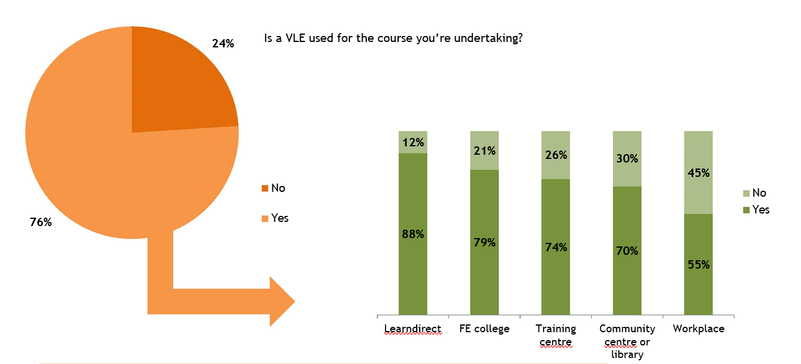

Q1.
- Is a VLE (virtual learning environment) used for the course that you’re currently undertaking/recently undertook at the following training providers?
All learners who are currently undertaking/recently undertook a course with the following providers:
Further education college (515), Workplace (82), Training centre (19), Learn direct (17),
Community centre or library (10)

Frequency of VLE usage

Most learners (73%) used the VLE twice a fortnight or more in term time. Meanwhile, about one out of ten (11%) learners used the VLE less than once a month in term time or never used it at all. There were no significant gender differences in VLE usage frequency.
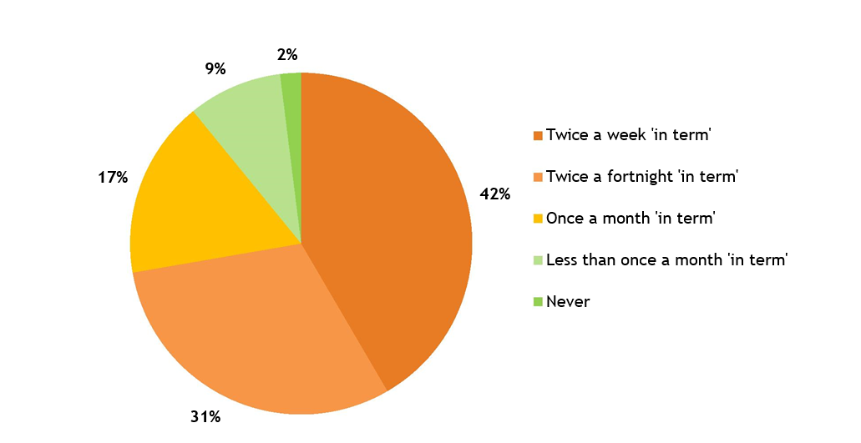

Q2
How often do/did you use a VLE to help you in the course you’re currently undertaking/recently
undertook?
Base:
All learner s who attended a course which uses a VLE (458)

SOURCE OF VLE ACCESS

Most learners said they accessed the VLE at their place of learning (86%) and from home (85%). A small proportion of learners said they accessed it only on the day at college or another training provider (5%). Interestingly, a significantly smaller proportion of 21-year-olds (76%), than those aged 18 (90%) or 17 and younger (92%), accessed the VLE from their place of learning.
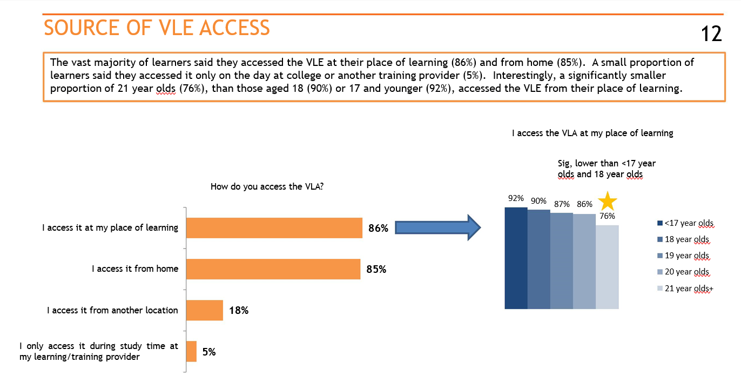

Q3
How do/did you access the VLE (virtual learning environment) for the course you’re currently
undertaking/recently undertook?
Base:
All learner s who attends a course which uses a VLE and use it (451)

MEANS OF REGULAR VLE ACCESS
A large majority (82%) of learners used their own laptop/PC to access the VLE and two-thirds (64%) used a laptop/PC provided at the place of their training. Roughly one in five (18%) learners used their mobile phone for regular VLE access.
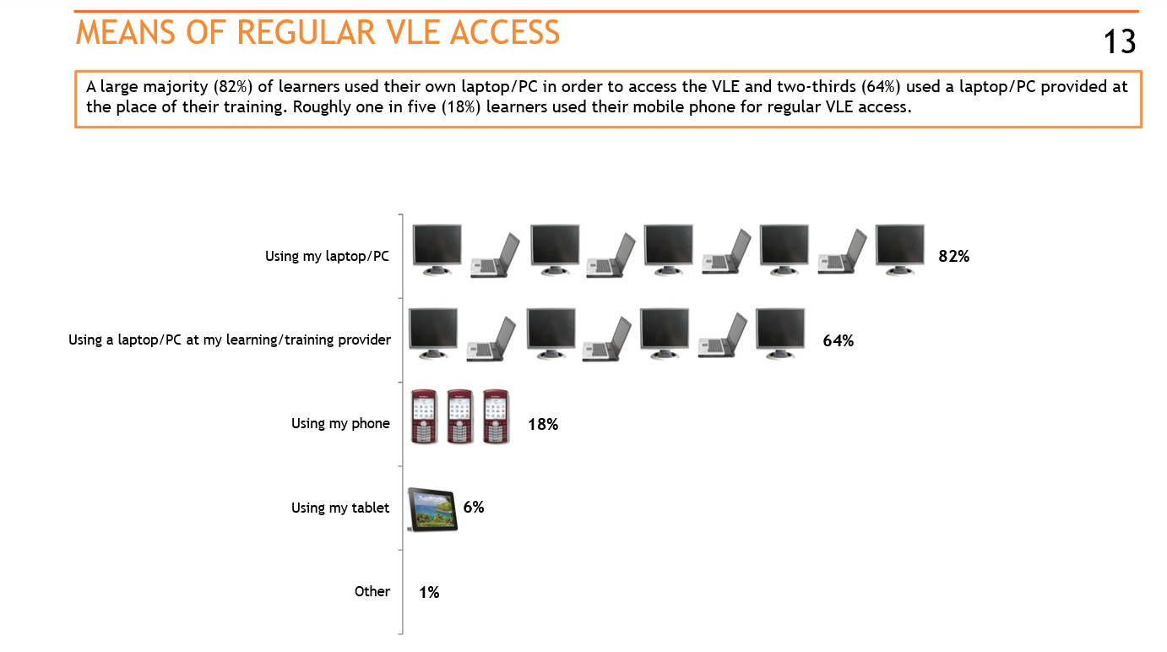

Q4
In what way do/did you most regularly access the VLE (virtual learning environment) for the course
you’re currently undertaking/recently undertook?
Base:
All learner s who attends a course which uses the VLA and use it (451)

MEANS OF REGULAR VLE ACCESS IF IT WAS AVAILABLE
Most (89%) of learners would want to use their own laptop/PC to access the VLE if it was available, and half of them (51%) would want to use their phone (51%) or a laptop/PC at the training provider.
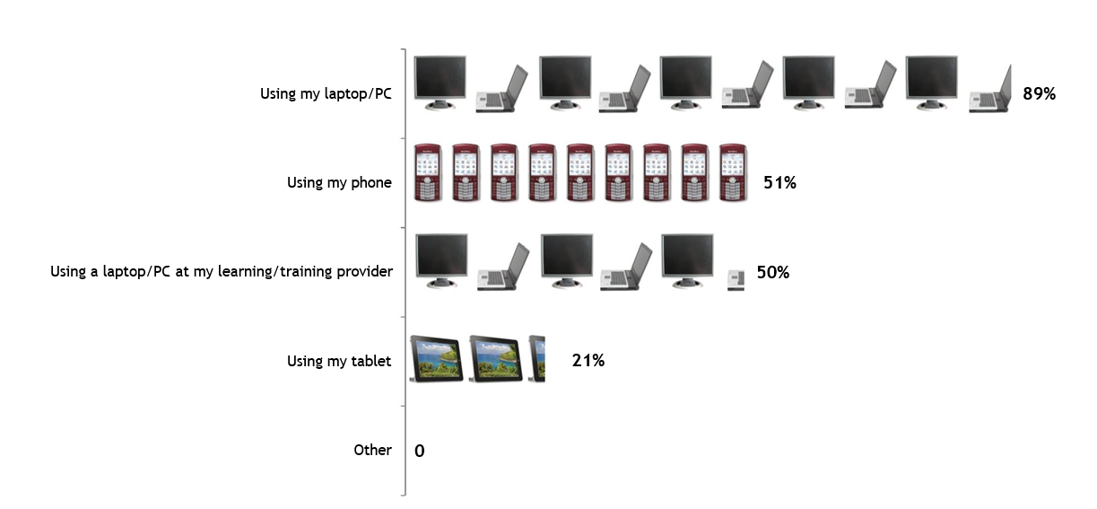
Q5
You said that your course does not/did not use a VLE (virtual learning environment). If your course did use a VLE, how would you prefer to access it?
Base:
All learner s who attends a course which does not use the VLA (142)

4) Primary Data
Methodology
1-minute online survey (monkey Survey), divided in 10 questions, administered at 10 students, both male and female between 16 and 28 years old.
Results were delivered as data tables.

Questionnaire
1) how was the switch from traditional to virtual lesson?
- easy - Neither easy nor difficult - difficult
2) do you think VLE is more time saving?
- Yes - No
3) do you think VLE is more flexible in terms of time?
- Yes - No
4) do you think that financially the VLE is more/less expensive for students?
- More - it's the same - Less
5) do you feel more/less concentrated during VLE lessons?
- More - it's the same - Less
6) since you started your university program with VLE, have you ever felt discomforted with technology?
- Yes - No
7) do you think it is easier to ask your professor for clarification in person or online?
- In person - it's the same - Online
8) do you think teamwork between students is more effective online or in person?
- online - it’s the same - in person
9) how often have you or your professor had technical problems during your VLE lessons?
- Always - Sometimes - Rarely
10) Do you think the teacher-student communication has improved from the intruding of the VLE?
- Yes - it’s the same - No

Results
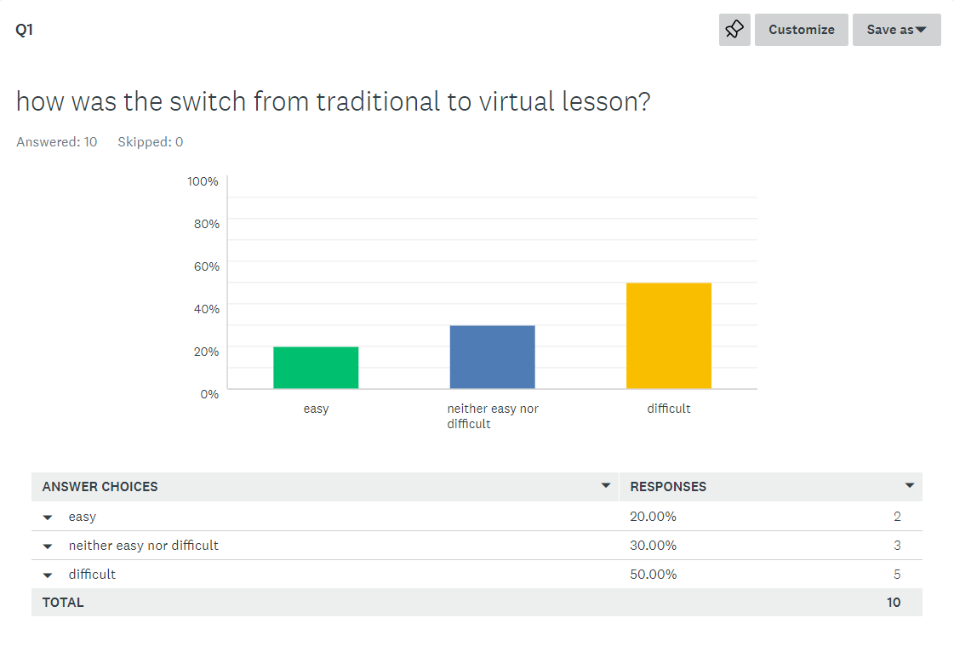
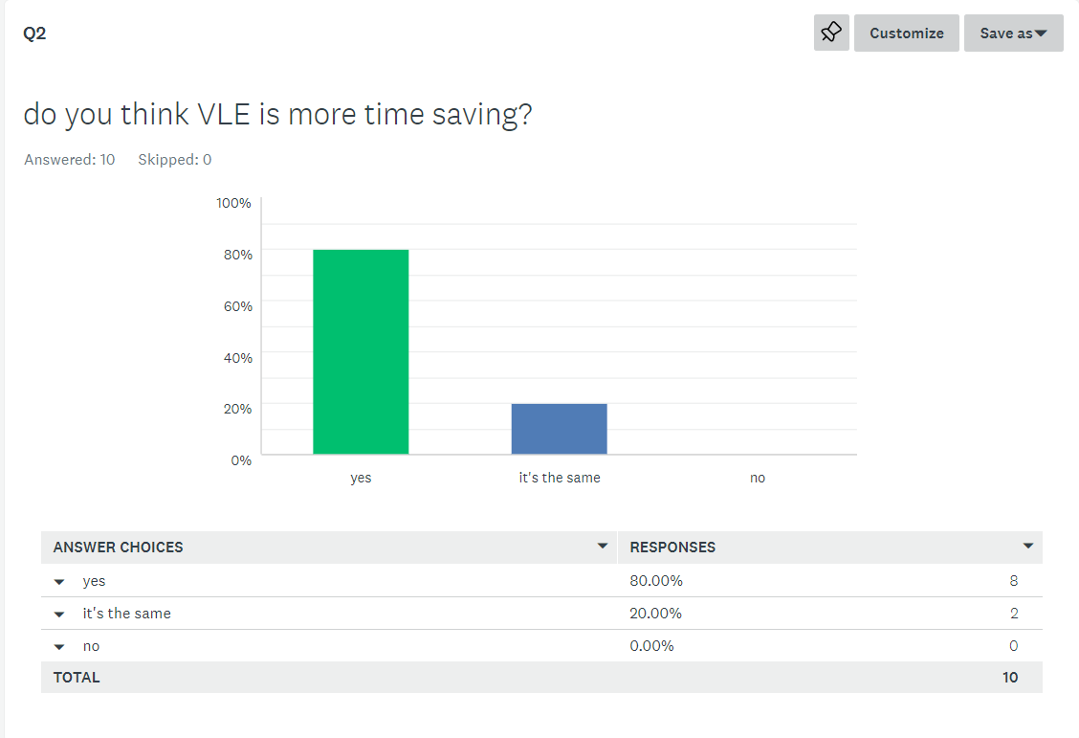
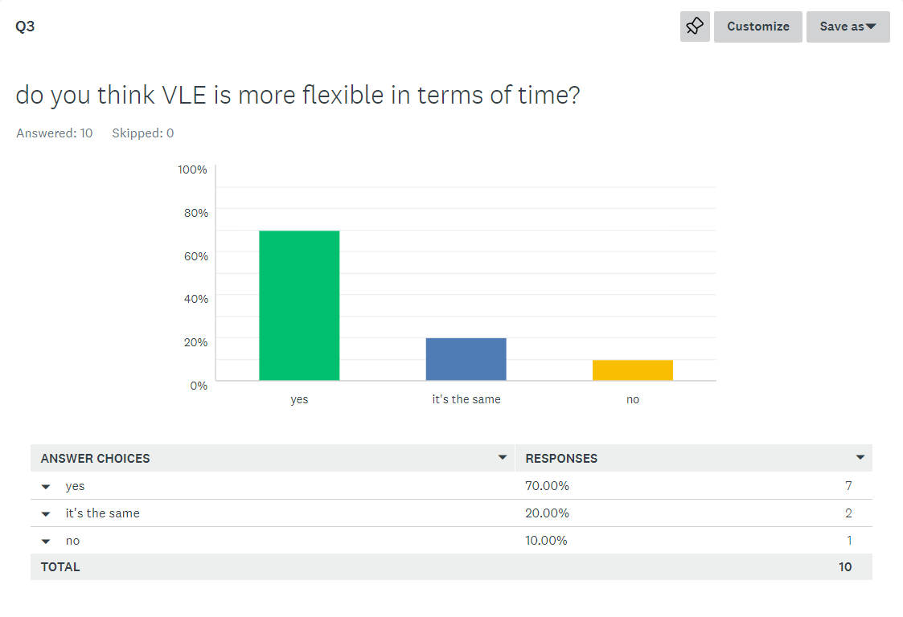
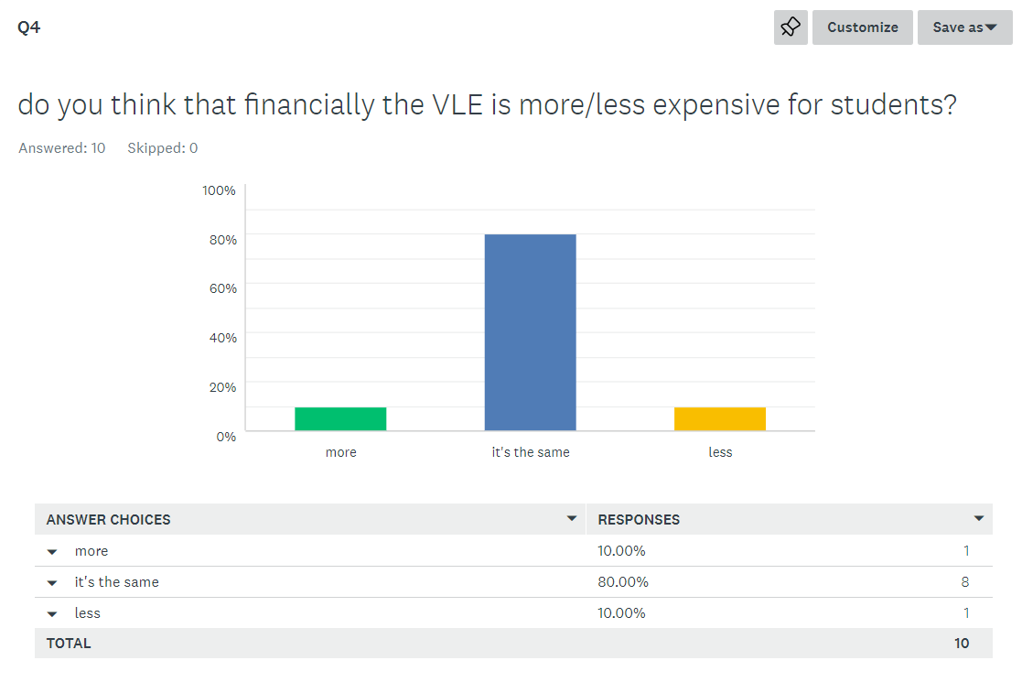
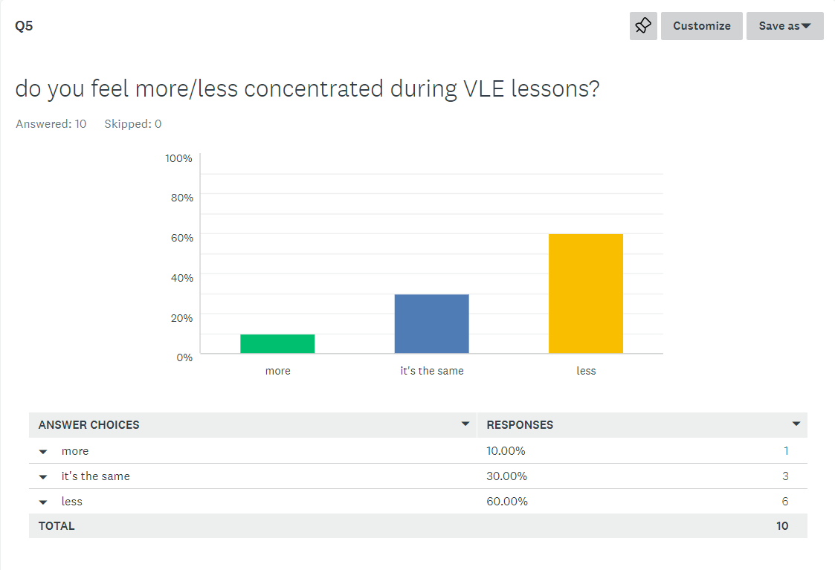
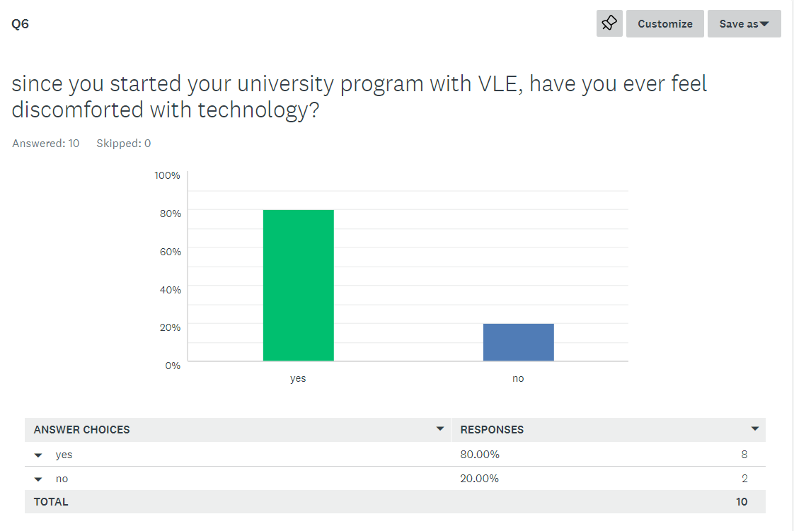

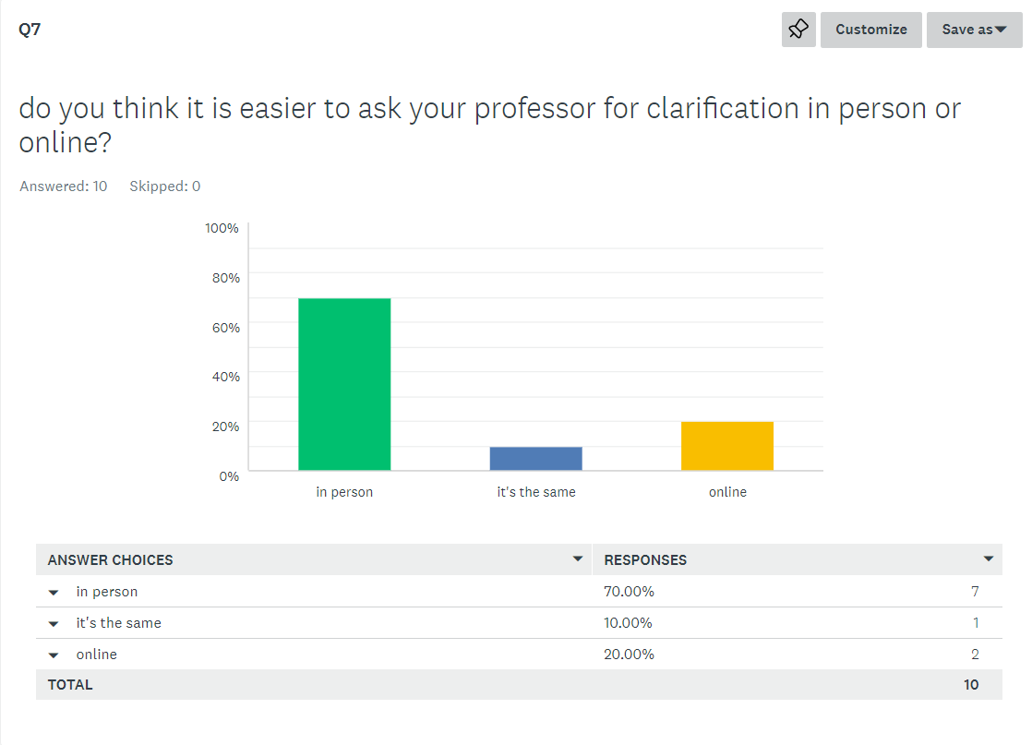
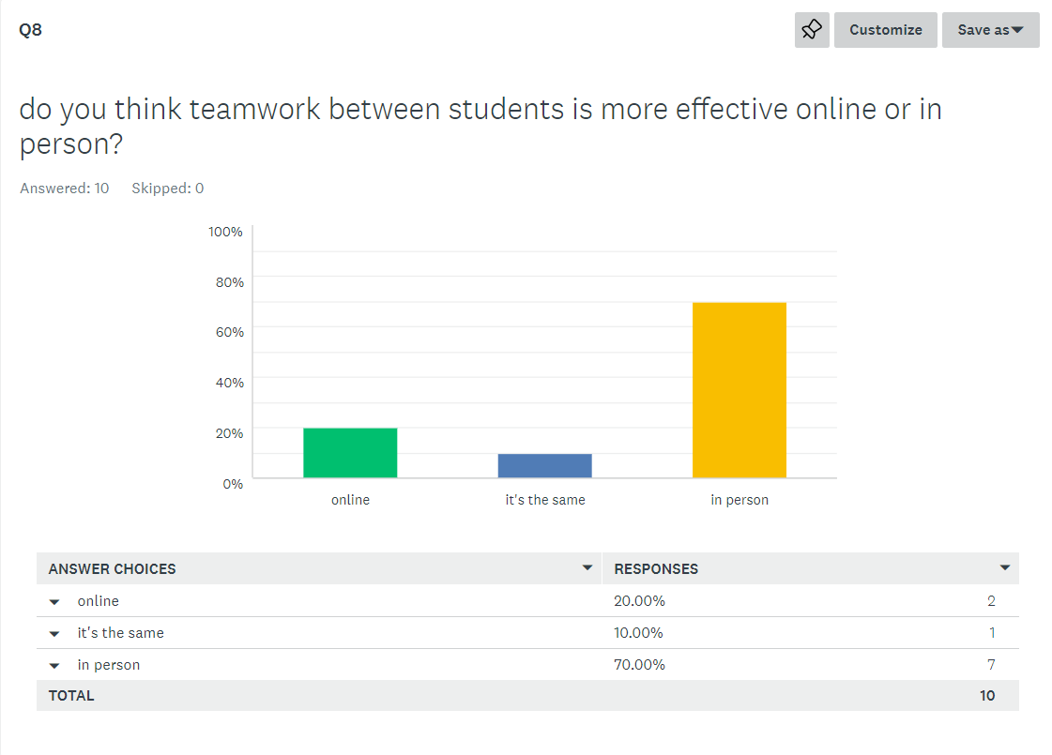

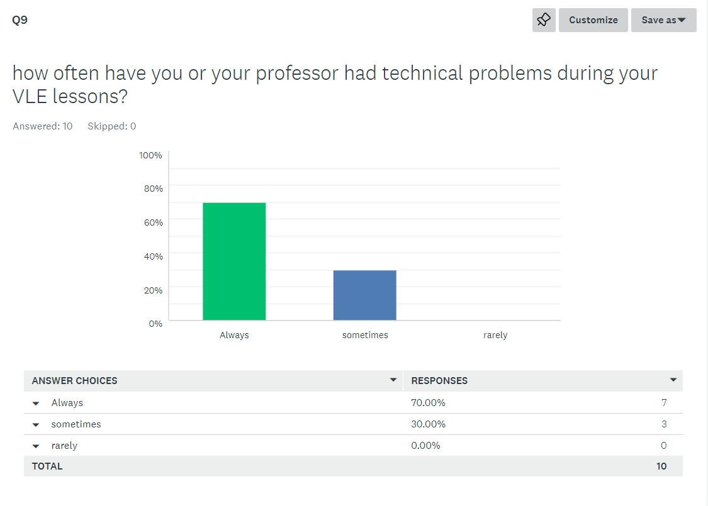
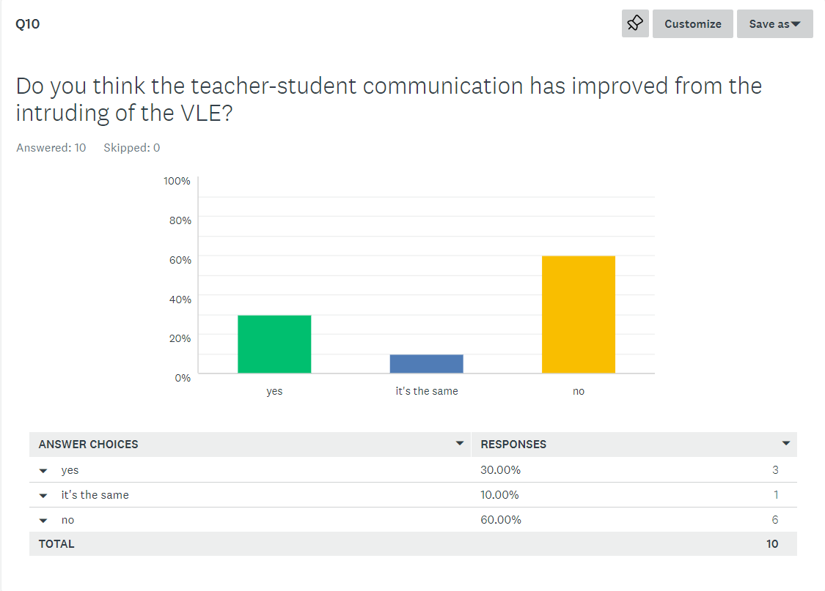

5) Discussion and conclusion
Pros and Cons of VLE
Pros | Cons
• Improved accessibility  • Immediate feedback on learning  • Greater flexibility and comfort  • Easy Tracking and Assessment: | • worse quality of communication  • discomfort with technology  • Technical Problems  • teamwork less effective

the results of both surveys found the success of the VLE in terms of time-spending, flexibility, and comfort. learners, especially learners-workers could follow a course of study and at the same time fit work and family commitments more easily thanks to the VLE.
on the other hand, from an economic point of view it does not present many differences. students no longer must spend money on transport but will have to invest more resources in IT equipment such as computers, modems, wi-fi.
Despite the many pros in the VLE, there are also many cons, which can prove to be major obstacles for students, especially those with different needs.
From the second survey (primary data) we can see that many students find a concentration cable during online lessons. this is probably due to the considerable deterioration in communication. the quality of the communication is in fact far inferior to the traditional lesson because there is a lack of factors that make the presence of the teacher feel such as the physical presence, body language and the variation of the tone of the voice, which capture the attention between one frae and the other.
Moreover, the VLE itself requires a certain familiarity with the communication software and the online university system that manages the modules, assignments, and communications with the institution, and some people could be difficult, especially if the system interface is not and intricate and not intuitive enough. this often causes a discomfort effect towards technology and consequently towards the study in general.
moreover, the VLE almost eliminates the connection factor between students, and this, in addition to influencing the relationship between students at an interpersonal level, also drastically affects teamwork.
we consider that in the circle of friends of an average person, it is made up mostly of people he met during his studies, if this factor should be missing it could create more lonely people in the future.
the VLE is a new technology that has the potential to improve the education of millions of people, more than it has already done in the last 2 years. but precisely because it is a new technology, it still must develop and improve. moreover, it would be right that a student could have the possibility to choose whether to use the VLE or not during his study path, since some people have different needs.

References
SurveyMonkey Survey Summary
29422368.pdf (core.ac.uk)
Youth Sight report (publishing.service.gov.uk)

