BMSW4012

Professional Career Development
Brigita Makulova

Introduction
Career advancement is a basic part of human development and management in any field of specialty. By attending the Professional Career Development lectures, I realized many approaches and theories that provide a solid foundation in the field of career development and career progress. The following concepts have been highlighted in these lectures; Personal Development Planning, Theory of Growth Mindset, SWOT Analysis, and Holland’s theory of vocational choices. Both frameworks have offered different instruments and approaches to analyzing and enhancing my career growth. Consequently, this reflective essay is developed concerning Gibbs’ Reflective Cycle to assess and discuss my learning process throughout these lectures. I have benefited in terms of changing my perspective on how to plan for a career and most importantly how to realize career aspirations (Adeani, et al., 2020).

Description of Learning Experience
The Professional Career Development lectures being one of the informative aspects of the program offered a clear working understanding of the purpose and significance of proper conceptual tools, as well as theories of planning a professional career. The first sessions were devoted to Personal Development Planning, starting with the definition of the concept and the focus on the elements of individual reflective analysis and a step-by-step plan of goals. PDP, various activities were demonstrated to determine the existing competencies, assets, deficits, and activities of the participants. The lectures then moved to a discussion of growth mindset which effectively began the introduction of what it means to have a fixed mindset and a growth mindset and how this impact one’s professional career. The SWOT analysis was introduced as a hands-on tool for assessment and was then proceeded by a study of Holland’s Theory of Vocational Choices which offered an understanding of how personality could be matched to careers (Sigala, 2023).

Feelings and Thoughts
These lectures were interesting for me as a student: a little curious and a little anxious, at the same time. To think that I would have to critically examine my general competence and vocation plans felt like a tough task. Looking at the sessions I went through, I changed my mind and shifted from an anxious state to an enthusiastic one because of the importance of a highly structured approach to career planning. Personal Development Planning appealed to me, as it gave me a structure that I could follow and start putting some plans into action. Very profitable was the definition of growth mindset which expanded my perception of individual traits and the process of professional evolution.

Evaluation of the Experience
The big plus of the lectures was the blend of the academic content of the subject matter with real-world solutions that have been employed by practitioners. Another relevant practice was Personal Development Planning, in which practical means of concerning professional aims were discussed. This advice provided an applied structure to goal setting and coming up with timelines and other milestones within career progression. The main emphasis was placed on the changes in the students’ attitude toward the learning process addressing the formation of a growth mindset which shifted the perspective on challenges and failures.

Analysis of Personal Development Planning
through the PDP process above, I was able to make an evaluation of my present professional status. From this analysis, few areas emerged as needing emphasis hence calling for attention in the areas of leadership and communication. Some of the detailed SMART targets I set for myself include enhancing skills in presentation and project management for instance. Career goals included career mobility to achieve higher ranks in the organization and other certified professional goals. Creating an action plan made me realize that for any action plan to be successful, goals should be SMART (Specific, Measurable, Achievable, Relevant, Time-bound) (Grant, 2020).

Implementation of Growth Mindset Principles
The idea of the growth mindset has appeared to be rather helpful in adapting to professional difficulties. To achieve positive results, I also have consciously tried to take a proactive approach toward such threats by treating challenges as development experiences. They have included scenarios like offering to take on challenging tasks and also opting to receive feedback that can build one up. I have established a system of writing a diary to improve and document progress and knowledge gained in the process – both about various difficulties encountered or about new trends in the development of the profession. Positive self-talk has now turned into a crucial strategy when addressing tests and other difficulties (Kapasi and Pei, 2022).

SWOT Analysis Insights
Combined with the strengths and threats, opportunities and weaknesses that one gets to discover during a SWOT analysis undeniably do possess the potential of enlightening one in aspects regarding their professional image. My strengths include: being a proud mother, which has improved my multitasking and patience skills, and my cooking skills show my focus, creativity, and attention to detail. There are some weaknesses as well which include: I’m not very confident especially when tough words are used. This analysis shows me various opportunities which include the demand for a person with good organizational skills along with patience and empathy. There are many online courses for language learning offering help in improvement. The threats I found are difficulty in balancing family responsibility with work (Owens, 2020).

(Author, 2024)

Application of Holland’s Theory
Holland’s Theory of Vocational Choices helped provide a significant understanding of the congruence of personality characteristics and satisfaction with work. Based on the described framework, I associated myself with the Social and Conventional ones. I think this understanding has helped me pay more attention when looking for the type of jobs that have those characteristics so that properly fit the jobs to my traits. The theory has helped judge possible job fields and work settings for applicability as a strategy (Hartmann, et al., 2021).
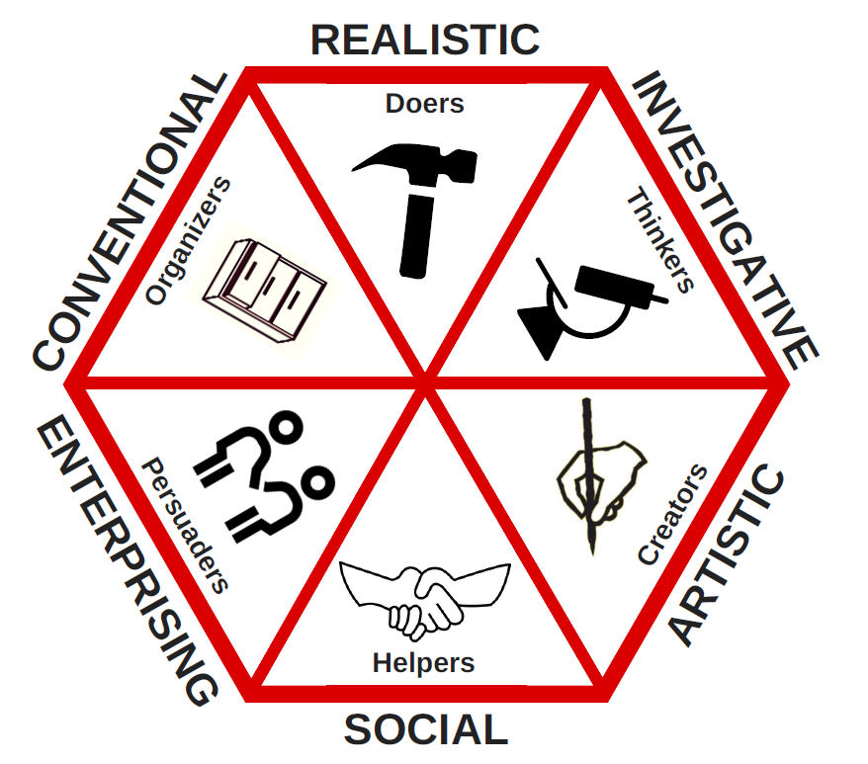
Figure 1 Holland's Theory of Vocational Choices
(Louisville.edu, 2024)

Impact on Professional Development Strategies
The application of these various frameworks has in one way or another impacted my viewpoints on professional growth. I have provided a monthly format for self-assessment of skills and a quarterly format for assessing progress toward goals. Many of the growth mindset principles have become a guide to my learning strategies as they help me perceive difficulties as benefits as opposed to inconveniences. I purposefully look for mentors or other professional contacts as I know how important these people are in one’s career (Kilag and Sasan, 2023).

Challenges and Areas for Improvement
By analyzing what I have done in implementing these concepts, I see that there are a few things that were not done well. Although I have managed to start different development activities, I could be more proactive in searching for mentorship chances and setting a good systematic networking plan. This means that the timelines that we set should be more detailed to facilitate more accurate measures of accountability as well as the level of realization. Also, I require enhanced lab-on-a-chip fabrication strategies as well as coming up with better ways of juggling professional development between activities and currently assigned obligations (Anjum, 2020).

Action Plan for Future Development
I have designed a vast action plan based on the knowledge from these lectures. This includes enhancing a clear-taken format of PDP with institutionalized regularity for the review of PDP progress and change of PDP objectives. I will ensure that I engage in growth mindset behaviors through intentional engagement in difficult tasks and generosity of reflective practices. It also has strategies for the weaknesses as highlighted in the SWOT analysis that I’ve undertaken for this purpose such as participating in public speaking clubs and going to network events (Yeager and Dweck, 2020).

Integration of Professional Development Tools
The integration of PDP, the establishment of the growth mindset approaches, SWOT analysis, and Holland’s theory offer the teachers a logical tool kit for constant personal development. The following is my current SWOT analysis: The current SWOT analysis is among the most important facts that have been identified during this process This means that I intend to review the SWOT analysis frequently to monitor progress or explore further areas that could be developed further. The growth mindset approach will persist in informing my perceptions about challenges and failure. These tools will be used to ensure that further congruence between personal attributes and vocational decisions is maintained as the result of frequent self-reflection (Robertson, et al., 2020).

Conclusion
The professional Career Development lectures have been very helpful to my thinking about career direction and self-development. I have come to appreciate that my professional growth can be made to look more organized and purposeful through the use of different frameworks as well as different theories. Personal Development helps in achieving a growth mindset with the SWOT and Holland’s Theory to become fully equipped in providing career development. These tools have helped me overcome some of my various weaknesses and in the achievement of optimal results in the selection of my career paths about certain predetermined characteristics. I will continue to engage with this type of systematic practice regarding professional learning and apply every strategy periodically to review to improve its effectiveness. In conclusion, these lectures have provided insights and methodology that can be very useful in my professional life when dealing with these issues they 5/setup. This experience has helped me realize the fact that learning should be a lifelong process as much as one is pursuing a professional career.

References
Adeani, I.S., Febriani, R.B. and Syafryadin, S., (2020). ‘Using GIBBS’reflective cycle in making reflections of literary analysis’, Indonesian EFL Journal, 6(2), pp.139-148. https://journal.uniku.ac.id/index.php/IEFLJ/article/download/3382/2034
Anjum, S., (2020). ‘Impact of internship programs on the professional and personal development of business students: a case study from Pakistan’, Future Business Journal, 6(1), p.2. https://link.springer.com/content/pdf/10.1186/s43093-019-0007-3.pdf
Grant, A.M., (2020). ‘An integrated model of goal‐focused coaching: an evidence‐based framework for teaching and practice’, Coaching researched: A coaching psychology reader, pp.115-139. https://www.academia.edu/download/39847618/An_integrated_model_of_goal-focused_coaching__Grant_ICPR_2012.pdf
Hartmann, F.G., Heine, J.H. and Ertl, B., (2021). ‘Concepts and coefficients based on John L. Holland’s theory of vocational choice—Examining the R package Holland’, Psych, 3(4), pp.728-750. https://www.mdpi.com/2624-8611/3/4/47/pdf
Kapasi, A. and Pei, J., (2022). ‘Mindset theory and school psychology’, Canadian Journal of School Psychology, 37(1), pp.57-74. https://journals.sagepub.com/doi/pdf/10.1177/08295735211053961
Kilag, O.K.T. and Sasan, J.M., (2023). ‘Unpacking the role of instructional leadership in teacher professional development’, Advanced Qualitative Research, 1(1), pp.63-73. https://journals.researchsynergypress.com/index.php/aqr/article/download/1380/1110
Owens, I., (2020). ‘Supplementing the SWOT Matrix for Personal Growth and Leadership’. Library Diversity and Residency Studies, 1(1), pp.33-36. https://repository.lsu.edu/cgi/viewcontent.cgi?article=1006&context=ldrs
Robertson, P.J., Hooley, T. & McCash P, (eds.) (2020). ‘The Oxford Handbook of career development’, New York: Oxford University Press. https://books.google.co.in/books?id=7BQuEAAAQBAJ&printsec=frontcover#v=onepage&q&f=false
Sigala Maxwell, F., (2023). ‘The Extent to which Admission of Students into Cameroon Opportunity Industrialization Centre (OIC) Relates to Holland’s Theory of Vocational Choice’, Web of Semantic: Universal Journal on Innovative Education, 2(4), pp.330-338. http://eprints.umsida.ac.id/11512/1/The%20Extent%20to%20which%20Admission%20of%20Students%20into%20Cameroon%20Opportunity%20Industrialization%20Centre%20%28OIC%29%20Relates%20to%20Holland%E2%80%99s%20Theory%20of%20Vocational%20Choice.pdf
Yeager, D.S. and Dweck, C.S., (2020). ‘What can be learned from growth mindset controversies?’, American Psychologist, 75(9), p.1269. https://psycnet.apa.org/manuscript/2020-99903-019.pdf

