

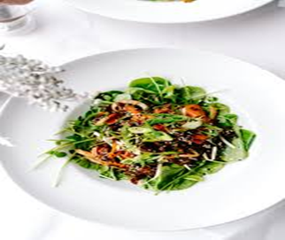

MD MUHIBUR RAHMAN ID:2127738
Food Menu of Hotel Trinity
Hotel Trinity: On the waterfront of Swansea, Wales, sits the independently run Hotel Trinity, which has four stars. The hotel serves the common person and offers meals to residents of Wales City. Dinner entrees and champagne flights are offered by the hotel. The r ]
staurant serves a limited menu that is affordable at Wales and the UK levels. All the best for the holiday season! Make your vegan potluck a global celebration this season. We've prepared a complete conventional British Christmas meal, complete with all the staples.
Statement: Customers must be informed that hazards may well be contained in some of our products, and we have made this disclaimer from a vegan perspective. The government defines dairy, seafood, poultry, hazelnuts, and tree nuts as allergens. Please make sure that you are not hypersensitive towards this item before placing a purchase that contains this component.
Statement of Hygiene: Vegans are accommodated at Hotel Trinity's restaurant. Guests who request exclusively veggie dishes are also considered as well. Guests must make their needs known and just be specific about the quality of food they want.
Calories per serving: The hotel takes great care to maintain a clean kitchen to ensure that guests do not become ill from eating there. It promises that both the eatery itself and its staff of cooking and wait staff adhere to strict hygiene standards. There is plenty of drinkable freshwaters, which has been purified until getting constantly eaten. This practice adheres to the standards set forth by the UK and Wales about hospitality sanitation. The kitchen staff at the Hotel Trinity is conscious of serving meals that are low in fat and calories. To limit their quantity of calories, customers are encouraged to place orders for specific, measured amounts of cuisine. Calorie consumption can be kept in check thanks to the inclusion of juices and veggies in virtually every cuisine.

Starting Menu
- Mustard mayonnaise is stir-fried with caramelized onions and offered alongside a dish of baked mackerel that has been flavoured with a variety of seasonings-15$
- The restaurant's special vinegar sauces; ingredients including seafood mackerel, champagne, and sparkling wine cost an extra -10$
- Sugar bread reads and broccoli risotto the greenish onions and ginger roasted brassica vegetable crops topping ing 8$
- Spice it up with salt and pepper and some extra creamy mozzarella. Since protein and carbohydrates are both allergens, this dish is served with Mashed spuds to strike a balance- 11$
- Pastries filled with beets and balsamic; cornstarch shaped like french chips for easy grasping; blended bread flavoured with mustard, creams, and minced onions- 12$
- It comes with a vinaigrette salt-mixed, chocolate-pouring sauce as well as a short list of ingredients that you can't have if you have sensitivities to things like cheese, eggs, and starches. 9 $
Appetizers and openers
- Pork pieces seasoned with cloves and rosemary, meat marinated in onion, chilli powder, sugar, herbs, and orange essence Food allergies include cloves, alcohol, and animal albumin; with potatoes cooked in honey- 28$
- Quinoa and Malvasia Cheese Casserole
- Heavy creamy mozzarella, mustard, and sugar, atop a bed of small dough pastries that have been cooked in the microwave. There are several allergies in this dish, including the proteins and sugars that accompany the Malvasia-16$
- Promote its products with a tangy salty balsamic and white wine coating
- Rods made of cornstarch that has been underground after being flavoured with eggs, buttermilk, and a variety of seasonings. Dairy, eggs, and starches are among the hazards present in the chocolatey and balsamic salt side dishes- 11$
- Allergy warning: contains both fungus and liquor; served with sautéed garlic, Viognier, and Cabernet Chardonnay champagne- 22$
- An allergy to both the scraping and the Pinot wine. Burgers made with mascarpone and butternut squash, drizzled with Cabernet champagne and a tangy mustard topping and served on wheat bread rolls- 20$
- Complete herring sautéed in salts, chilli, lemon zest, peanut oil, lemon fingers, onions, and rosemary; complete salmon cooked in the ovens using White wine. The tuna is served on a dish, coated with aluminium to preserve its freshness and comes with a bottle of bubbly- 30$

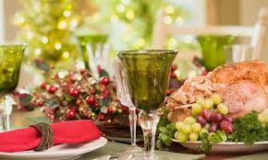
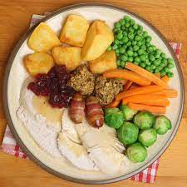
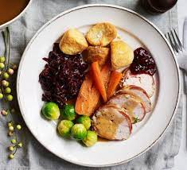
Desserts & Wine
- Brownies with chocolates and a glass of red Unpleasant odours encompass dairy, chocolatey, and red alcohol; chocolates are the chardonnay creams packed with chocolatey nuggets camembert and frozen yoghurt of their choice as a flavouring- 5$
- Glucose with simmered apple pastry; four whole pears cooked in shortbread pastry infused with champagne and presented with Black tea; aromatic strawberries, chocolates, apples, stems, and champagne are all allergies- 7$
- Croissants soaked in blueberry essence and topped with whole blackberries; red wine, strawberries, and cream are also all known to cause allergic reactions- 8$
- Barbecued Black Pepper Cucumber and Beverages from the Factory Allergies alert: lactose and almonds are present in the Cranberries Blueberry Waffles with Carmen Miranda Melted Mocha- 12$
- For a caramelized dish, a raw custard is layered over of a raw or barely scorched casing, and then the whole thing is baked. Traditional dishes contain zucchini, cucumber, and root crops; ingredients like eggs and nuts are avoided by those with food allergies- 10$
Fizzy Wine
- Prosecco, which would be a beverage with added carbonation, can be made from either white or black grapes. To a smaller degree and with less widespread availability than white imperial stouts, fuchsia and even red champagnes are indeed produced- 8$
- Black grapes with a moderate body with around 10 and 30 per cent volume liquor and also stronger polyphenols than strobe wines but fewer than those with full-on fruit flavours- 12$
- White Cranberry vodka- Moscato grapes are commonly used as a synonym for sweet drinks. They could taste extremely sugary and have even less liquor than a standard drink. This champagne is perfect for pudding following meals since this helps people relax without overpowering their sweet tooth- 16$
- Champagne- The mild flavour and fizz of bubbly make it an ideal base for a wide range of refreshing spring drinks. It’s delicious and flowery aromas make it a great summertime beverage or appetizer- 9$

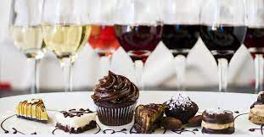


References
Anoff, I., 2012. Food Service Equipment Contractors. Cornell Hotel and Restaurant Administration Quarterly, 7(1), pp.49-52.
Anugrah, A., 2021. Development of Food and Beverage Service Module at Vocational High Schools Culinary Service Expertise Program. JURNAL PENDIDIKAN TEKNOLOGI KEJURUAN, 4(1), pp.19-24.
Kimes, S., Chase, R., Choi, S., Lee, P. and Ngonzi, E., 2012. Restaurant Revenue Management. Cornell Hotel and Restaurant Administration Quarterly, 39(3), pp.32-39.
Liu, C., Cai, X. and Zhu, H., 2015. Eating Out Ethically: An Analysis of the Influence of Ethical Food Consumption in a Vegetarian Restaurant in Guangzhou, China. Geographical Review, 105(4), pp.551-565.
Mercer, D., 2010. “Cleaning-in-place: Dairy, food and beverage operations”, third edition. Trends in Food Science &amp; Technology, 21(7), pp.368-369.
Reiffenstein, T., 2017. Ramen restaurant clusters in Japan: Geographical variety, locational lore, and evolutionary characteristics. The Canadian Geographer / Le Géographe canadien, 61(3), pp.440-456.
Sormaz, Ü. and KAYA, Ş., 2019. Regional Kitchen Applications In Food And Beverage Operations: Sample of Gaziantep. Gastroia: Journal of Gastronomy And Travel Research, 3(2), pp.304-323.
Thompson, G., 2015. Restaurant Profitability Management. Cornell Hospitality Quarterly, 51(3), pp.308-322.

