

Assignment Title: Developing Relationships and Workplace Achievement
Programme: BA Leadership and Management Skills for the Workplace

Student Name: Zafar Ahmed Sadik
Student No: 1605839
Lecturer Name: Ze Zook

Table of Contents
Introduction 3
Examining the expectations and requirements of people 4
Expectations and requirements of employers 4
Expectations and requirements of employees 4
Administering people in accordance with guidelines and career pathways 5
Administering people in accordance with guidelines 5
Career pathways 5
Managing career development of people 8
Managing performance and succession planning. 10
Managing performance 10
Succession planning 11
Support structures within the organisation 13
Techniques for supervision and formal appraisal 14
Techniques for supervision 14
Formal appraisal techniques 15
Methods of ensuring fair and objective assessment/appraisal. 17
Methods to monitor evaluate and record individual feedback. 18
Reporting performance appraisal including the importance of confidentiality. 19
Learning styles and the range of training/development opportunities available. 20
Mechanisms to provide appropriate feedback to individuals. 21
Career development strategies including the wider context of sustainability. 23
Conclusion 24
References 25

Introduction
Understanding the integration among all the involved employees on based on their relationship is absolutely an important context to expect the successful achievement. In business platform dynamics issues force the relationship unstable and the continuity of these relationships depends on some core mechanism which one business cannot avoid. This assignment will represent about the expectation requirements, administration ways, managing career development, supportive structure, supervision, assessment, monitor, measurement, performance evaluation, learning styles, training development, feedback, career development as to perfectly understand the relationships and workplace achievement.

Examining the expectations and requirements of people

Expectations and requirements of employers
Basically, in business context employers are always in touch of seeking the skilled, productive, experienced, effective, appropriate and absolute employee that will meet their requirements to achieve the success by perfectly performing their assigned tasks. The employers are also interested to capture the experienced one as the business platform is a place of uncertainty, risky and unstable which requires the master mind to meet these by the support of most appropriate strategic ways. Business profitable figure is the ultimate objectives, so the employers set up policies, rules-regulations, standards as to monitor, measure and control the overall performance of employees to meet the ultimate success. Thus, the employees are required to obey and making of the perfect sense where the employer gets supportive hands for meeting their specific goals and objectives (Alexander, 2017).

Expectations and requirements of employees
Fundamentally employees are the key mechanism to get the work done which meet their achievement within the workplace context. So a lot of expectations from the employer’s perspectives meet their specific requirements to employees but to fulfil those requirements and expectations employee needs some basic issues such as supports from employers, friendly environment, satisfactory means of wages and salaries, ethical treating behaviours, flexible workplace context etc. to perfectly doing their activities. The requirements from the employees are also the effective, safe and friendly environment where they can show their skills, practices the best and also the best effort to gain the ultimate success (Chaskalson, 2011).

Administering people in accordance with guidelines and career pathways

Administering people in accordance with guidelines
The most appropriate administration in references to controlling is the absolute mechanism which creates pathways through the perfect guidelines. As career is a highly expected necessary phase of everyone life, then standards qualifications, requirements and key skills are necessary to capture a bright future. The perfect guidelines and career pathways are the absolute things to capture the effective achievement within the workplace context (Carter, Cook and Dorsey, 2011).
The basic administrations for guidelines can be the standards instructions, principles, key disciplines issues, formative ways, controlling mechanisms etc. The most appropriate guidelines will depend on the platform where the individual want to be and where the individual is remaining at present. The guidelines require the identification of strengths and weakness of the specific individual as to document a perfect ways and configuration where the most appropriate guidelines can be formed (Chen, 2016).
There are some certain things that needs to be under special consideration while documenting the guidelines for specific individual such as…
Guideline should be specific and future perspectives oriented
Administrations should meet affordability of the individual
The guidelines will be effective when they meet to individual interest
The guidelines need to clear, simple, understandable and objectives oriented
Guidelines should meet the necessities, affordability and capability of individual
Finally, the guideline should be real time oriented where the necessary modification can be applied (Alexander, 2017).

Career pathways
Career pathways formulating from the most appropriate time specifically at student level should be devised as the pathways can be created in single line not the line more than one. This means that if an individual want to be for example a pilot then all the mechanisms he needs to do for achieving the ultimate success. To gain the success, absolute effort should be give and so the perfect integration between the guidelines and career pathways is absolute. Career pathways can be formed in many ways but the most absolute basement should be interest, capability and enough opportunities (Burke, 2015).
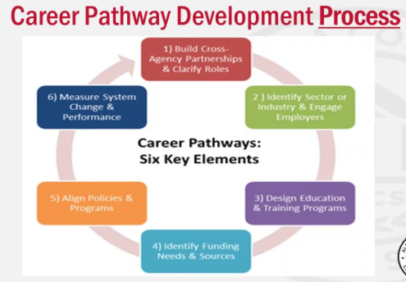
Figure: Career pathways development process (Charoux, 2016).
Building cross-agency partnerships and clarity roles
One of the most important issue in building the career pathways is building cross agency partnerships and clarity roles which means the clarifying stages in relates to making the absolute relationships with the related agents through the standards roles and regulations. The agent’s partnerships need to seek from the diverse source as to make the choice from the alternative and also the perfect integration between these relationships should be present where the roles are absolute and clear (Casale and Zhu, 2013).
Identify sector and engage employers
The identification of sectors where the interested sectors are available and also the perfect engagement with the employers need to be available as the career pathways can be developed by focusing on the specific sectors where they can bank on (Casale and Zhu, 2013).

Design education and training program
All the mechanisms will be available if the most appropriate education can be available for learning the best things and also the perfect training need to be available for implementing the learning within the workplace.

Identify funding, needs and sources
The identification of funding for implementing the sector-wised development and making the continuity of career where the needs and sources will be available for presenting the appropriate mechanisms which will be required for perfect completion of career pathways (Carter, Cook and Dorsey, 2011).
Align policies and programs
Specific policies and programs should be developed in order to perfectly handle the platform as well as for capturing the most absolute achievement by using the available resources appropriately. The policies and programs will be helpful for arranging with the perfect platform which will devise the specific pathways that need to be followed perfectly.
Measure systems change and platform
Measuring the systems change as well as the platform is essential as only the effectiveness will be captured when the assembly of all the related issues are available. Changing is absolute and necessary for capturing the better phase than the current situation and also the necessity includes the absolute systems integration with the latest dynamic phase (Charoux, 2016).

Managing career development of people
Managing career development is essential and absolute as only the appropriate guidelines and effective pathways are not helpful to perfectly capture the best effectiveness in the workplace context. The resolving issue is to manage the development stages through the appropriate rules and regulations basis and the below figure mentions the key issues for managing the career development such as…
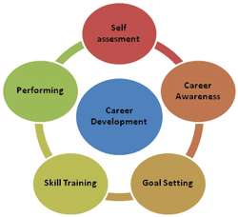
Figure: Managing career development (Duck, 2007).
Self-assessment
Self-assessment is the first and foremost steps to develop the career as if the appropriate evaluation can be possible then the strength and weakness can be identified which specifies the absolute guidelines requirements.
Career awareness
Career awareness can be possible if the appropriate interest can be given within the specific sectors and all the related information is available for this. This can be done through different mechanisms such as campaign, seminar, learning styles, training etc. (Chaskalson, 2011).

Goal setting
Goal setting needs to be presented as of the objective is clear and perfectly define then the entire activities can be perfectly done on the basis of the specific goal. Setting the goal is not so easy as this required absolute and specific strategic observation about the future which will be helpful to achieve the goal (Duck, 2007).
Skill training
Skill training need to be available as only the skills are not so much helpful where the absolute training is necessary to perfectly maintaining the absolute growth of skills. To develop the skills appropriate training can be helpful to making the perfect implementation of these skills.
Performing
Performing in the basis of course of action is necessary to achieve the specific career level and all the things need to do the action on the basis of specific goal. The performance also requires the standards ways of guidelines and appropriate controlling mechanisms for perfectly managing the career development overall activities (Chen, 2016).

Managing performance and succession planning.

Managing performance
Managing performance is essential as to capture the best achievement from the respective performance but managing performance is not so easy where all the involved issues of the performance needs to be planned, monitored, measured and controlled in order to manage the performance. The below figure is respectively associate with managing the performance such as…
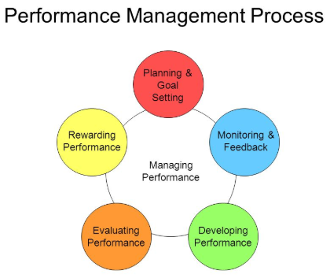
Figure: Managing performance (Ryan, 2012).
Planning and goal setting
Planning is the very first step where the entire to-be activities are documented for moving approaches steps by steps procedurally and the goal need to be pre-defined by the support of planning phase. The goal setting phase requires the most appropriate planning where all the activities will follow the pre-defined planning to capture the devised goal.

Monitoring and feedback
Monitoring activities are done in order to collect the data where the measurement of performance is given as feedback as to manage the performance. The monitoring activities can be done through self-assessment and also the feedback from the expert of documented performance (Duck, 2007).
Developing performance
Developing performance can be done by assembling all the growth mechanisms which will improve the performance level. The development phase is an important issue as without that the performance cannot meet the current challenge and challenging situation.
Evaluating performance
Performance evaluation is higher level observation than the performance monitoring where all the performance-based data are collected and compared with a standard form where the performance evaluated as because to measure the performance condition.
Rewarding performance
Rewarding the performance is an important issue where through the perfect appraisal gives the inspiration to hold on and to develop the performance where the rewarding is appropriate as an incentive (Chen, 2016).

Succession planning
Succession planning basically denotes to the replacement from old to new as to capture more experienced and capable which meet the developed and challenging situation, the below figure shows the process of succession planning such as…
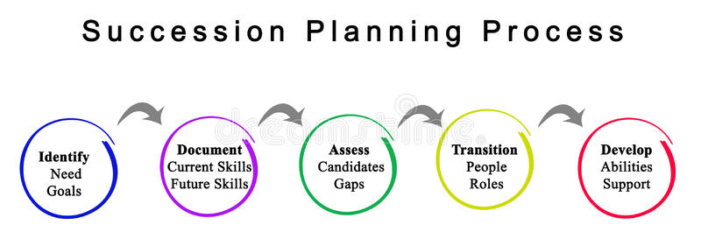
Figure: Succession planning process (Moran, 2013).
Particulars | Descriptions
Identify | Identify is essential where the need goals are figure out in respect to objectives and the identification creates the pathways of consequences activities to move forward (Elsdon, 2003).
Document | In response to goals, the current document in regards to current skills and future skills are need to identify where the skills will be available to meet this goals.
Assess | Assess will be helpful to evaluate own performance in order to identify the performance level and the perfect comparison among the existing candidates to finding out the best one (Duck, 2007).
Transition | Transition helps to figure out he people roles in developing the performance level in respect to capture the goal.
Develop | By supporting the abilities and by assembling the required qualifications, the development phase will be helpful for the improvement of performance (Moran, 2013).

Support structures within the organisation
Organisational structure basically denotes to the allocation of tasks, coordination and supervision of the involved activities within the organisational context. To support the organisational structure is not easy which require the support from all the involved issues equally as balancing is the key term for supporting the structure. Supporting the structure works as the administrating the structure activities where the involved issues will be performed in the monitored ways. Basically, the task allocation, task coordination and task supervision is the core issues where the other activities are worked as supporting or accessories (Fournier, 2017).
There are various ways about how the organisational structure can provide support such as…
The perfect identification of all the involved issues within the organisation perfectly
After identification, the perfect balance for assigning the tasks should be done respectively
The assigned tasks should be effectively performed from the individual scope and should provide the support and then combining the entire works to meet the specific goals.
Supervising all the assigned tasks should be performed in order to control the tasks activities to balance with standards.
Finally, all the essential supportive issues from all the involved responsive should be available as real time basis where the most appropriate configuration can meet the expected goals (Gordon and Steele, 2017).

Techniques for supervision and formal appraisal

Techniques for supervision
Techniques for supervision are essential to manage all the activities of supervision where each and every activity respectively performed within the special observation to find out the fault and error to resolve. The below issues are common to work as techniques for supervision such as….
Case consultation
Case consultation basically forms a case under special authorisation to represent the similarity which makes the perfect sense about the respective figure and gives appropriate suggestion in relates to give associates configuration for making the performance appropriate (Jackson, 2016).
Co-counselling
Co-counselling means such like observation where the appropriate suggestions respectively forms as guidelines in representing the performance to meet the expected level. Co-counselling is associate to provide appropriate guidelines on the basis of respective concerns to improve the performance (Harris-Bowlsbey, 2004).
Live observation
Live observation denotes the phase of monitoring the entire activities where each and every activity is taken under special consideration. All the respective tasks are observed in real time basis when the task is performing and so it is effective to reduce the fault and error which can be solved immediately.
Role play
Role play basically works as a representation where the supervisor acts like someone and supervise the works and gives appropriate suggestion on behalf of this role model. This technique is effective as the individual can be taught in way where the individual is interested to and feels like flexible.

Coaching
Coaching specially denotes a group of observation where a group of individuals performed their assigned tasks and the supervisor observe all the activities at the same time and also the appropriate guideline are delivered to all at the same time (Jackson, 2016).

Formal appraisal techniques
Formal appraisal techniques are really essential to traditionally apprise the most appropriate individual on the basis of his overall performance and there are some techniques are shown in below figure such as …
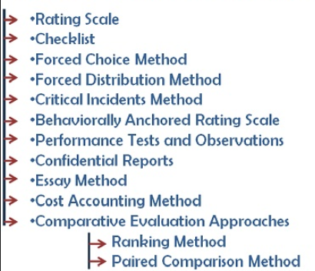
Figure: Formal appraisal techniques (Ryan, 2012).

Formal appraisal techniques | Meanings
Checklists | Checklists in simple sense works as tick (checkmark) on the respective forms of performance documents e.g. tick (checkmark) on very excellent, good, bad, very bad (Ryan, 2012).
Forced choice methods | By forced choice method a candidate is selected for performance appraisal by the choice of authority and so often appraisal doesn’t follow the performance rather choice of authority.
Forced distribution method | By forced distribution method, performance is appraised in a row and here more candidates are selected for one performance.
Critical incidents methods | This technique is sudden where the performance is appraised without any pre-panning (Sabatino, 2004).
Performance tests and observations | Performance test requires additional tests on performance for getting the appraisal under special observations.
Confidential reports | Confidential reports works as suggested reports from the authority which suggested by the responsive authority (Jackson, 2016).
Essay methods | In this method, the candidate performance descriptions are written down with numbers to represent their performance level.
Cost accounting method | This method works as how much costing incur from the individual candidate which represent their performance from descending order.
Comparative evaluation approaches | This technique used two approaches such as ranking method and paired comparison method for performance appraisal (Kets de Vries, 2010).

Methods of ensuring fair and objective assessment/appraisal.
To ensure a fair and objective assessment, absolute methods are necessary to perfectly capture the appropriate results from the respective performance such as…
Assessment centre
Assessment centre is appropriate where the centre point works for assessing all the performance within the respective business context and as all the performance are assign within this centre point then the alternative information can also be evaluated to capture the most perfect one (Sabatino, 2004).
Appraisal by objectives
Basically, it focuses on the results where the performance meet the objectives of the concerned context and so the respective performance will be provided from all the involved employees to meet the specific objectives and then how the performance is given measured for appraisal (Virtue, 2016).
Human assets accounting
Human assets accounting respectively figure out all the human within the respective context as assets and the associates’ measurement about their performance about how much they are capable to perform the certain tasks.
Behaviourally anchored rating scale
By this method, performance is appraised through behaviourally approaches to authority rather than the performance itself. This method is mostly appropriate when the performance meets the normal or regular level but the attitudes meets the expected level of satisfactory behaviour (Vogel, Koonce and Robinson, 2017).

Methods to monitor evaluate and record individual feedback.
Individual feedback is essential for giving the response from the assigned workplace context and also the perfect monitoring, evaluating and recording the individual feedback by the below methods…
Peer review
Peer review in simple sense means that reviewing the performance again and again as to find out the fault, error and complexities within the performance context. Peer review is mostly appropriate for self-assessment where the individual is the core one to evaluate own performance (Wallace, 2004).
Self-evaluation
Self-evaluation is respectively effective for assessing the individual performance by comparing with the standards and this method is effective for every individual which is assigned to complete this respective task.
Quantitative evaluation
Quantitative evaluation is necessary when the self-evaluation requires the additional touch of evaluation from the third parties and the quantitative method evaluates through unstructured, numerical and statistical ways.
360-degree feedback
360-degree feedback basically denotes to the overall evaluation from the respective context such as supervisor, peers, even customers. This feedback is so much effective but sometimes individual feels like complexity because of inflexibility (Kets de Vries, 2010).

Reporting performance appraisal including the importance of confidentiality.
The importance of confidentiality is really essential as this requires the privacy as for security and also the effectiveness within the systems. The reporting in regards to confidentiality meets the perfect interaction where the confidentiality denotes to the individual skills, quality and privacy based concerned issues (Gordon and Steele, 2017). To appraisal the performance, some confidential issues are really needed to keep in private as all the information needs not present with the performance appraisal reports. The below issues are required to be considered while to represent the reporting through performance appraisal…
The reports should be involved the accuracy and literacy of the respective performance
The reports should be effective in regards to the respective performance
The appraisal should also be considered for further development of performance
The performance reviewing should maintain the confidentiality of individual
The performance appraisal reports should meet the objectives and policies of the respective context
Finally, the appraisal techniques should follow both the positive and negative approaches as to figure out the effective means of output (Chen, 2016).

Learning styles and the range of training/development opportunities available.
There are various types of learning styles within the organisation context but in respect to their assigned performance and also the learning styles will follow the effective means of outcomes in response to the respective context (Harris-Bowlsbey, 2004). There are two ways of learning styles such as…
Visual learning styles
Visual learning styles are helpful to capture the essential knowledge and learning from the respective context and the learning is more effective as lessons are learned from the visual sites more perfectly than the just only reading. Actually, the learner learned from the practice which uphold experience from the related context.
Learning by auditory tools
From the closest observation the respective employees within the specific context of business platform is essentially learned from auditing the specific tasks. The learner represents themselves as supervisor which also helpful for self-assessment within the specific platform of business context (Harris-Bowlsbey, 2004).
Learning from others
Experience not only gathers from individual practice but also from the practice of others performance and also the respective platform will be the sources of leaning where everyone is associated to capture the specific goals from their respective area.
Learning from context
Individual can also learn from the context he associated to perform his assigned tasks respectively and also the learning from the others context is combined in this issue. This learning is helpful to perfectly know about the business platform where he meant to be performed (Carter, Cook and Dorsey, 2011).

Mechanisms to provide appropriate feedback to individuals.
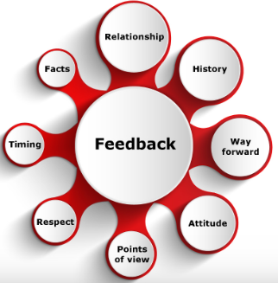
Figure: Mechanisms to provide degree feedback (Kets de Vries, 2010).
Relationship
Relationship is one of the most important feedback provided mechanisms where the relationships denotes to the attitude of feedback to the individual. For example, if a relationship with a manager and a subordinate is good enough then it can be said that the performance of subordinate is well and if the relationship of subordinate is not good then the performance of the individual is not well enough (Fournier, 2017).
History
History carries the performance data which can be delivered to individual by sharing about the past and here the individual can meet the feedback when the history says about the history in response to his specific performance.
Way forward
Way forward is moving approaches which is related with sharing the performance level in respect to the context of business platform. Way forwards can represent the feedback through the moving approaches (Kets de Vries, 2010).

Attitude
Attitude denotes the feedback where the respective performance in response to the individual is represented through the way of manner. Attitude represents the feedback context by showing manner to individual in response to the specific performance.
Points of view
Points of view represent the specific issues of performance level in response to the wider business context and the points of varies from one person to another, so the appropriate feedback cannot be captured from the individual perspectives (Vogel, Koonce and Robinson, 2017).
Respect
Respect from one to another and here respect to individual denotes how much he is able to perform within his respective context. The respect from the authority meets the standards ways of manner where the individual feels like special because of respect from performed activities.
Timing
Timing means the specific period which is taken or provided to represent the specific performance of individual within the specific period of timing. For giving the appropriate feedback, a real timing is essential as the feedback in delay time will not be effective.
Facts
Facts represent the feedback consent by a specific issue upholding where the facts generate some key issues from the performance of the respective individual. Facts represents all the key issues from the specific performance by categorising and segmenting (Casale and Zhu, 2013).

Career development strategies including the wider context of sustainability.
Career development strategies can be devised from the experienced based practice in regards to sustainability and successful people always undertake some key strategies for developing the career of oneself such as…
Clear expectations
Every individual need has an absolute expectations about the desired career level where the interest, adoptability and capability combined all the mechanisms that is necessary. One individual can develop oneself by having a clear expectation what is want to be gained.
Working hard with confident
After setting up the clear expectations then the task is to work hard to meet the expected career level where without working hard the desired career level cannot be gained. But the support from the inner that means the confident to work hard for attaining the goal (Gordon and Steele, 2017).
Being a leader
Leading oneself is really necessary where the leading from the others may not be effective as because the actual leading need the perfect justification of individual. If the individual is enough to lead himself then the expected career can be gained.
Think alternative
Besides, the core objectives, it’s necessary to capture some alternative as to reduce the risks and also capturing the best issues to achieve. But it will not be effective to think about the alternative at all time by neglecting the core issues as the core objective always should be in main focus.
Live and act everyday
The final phase is to live and act everyday where the continuity should be present by avoiding any delay and gapping as acting in real time basis. Actually, the acting should be on specific basis where the individual can develop the own career effectively and efficiently (Moran, 2013).

Conclusion
Business context understanding is vital issues as understanding the integration among all the involved employees on based on their relationship is absolutely an important context to expect the successful achievement. Also, the perfect knowledge of business platform is essential as in business platform dynamics issues force the relationship unstable and the continuity of these relationships depends on some core mechanism which one business cannot avoid. Thus, developing relationships in relates to business context in order to achieve the best from workplace environment by combining all the mechanisms involved within the respective business context effectively and efficiently.

References
Alexander, L. (2017). 675 ways to develop yourself and your people. Amherst, Mass.: HRD Press.
Burke, A. (2015). Career planning. Hollywood, FL: Frederick Fell Publishers.
Carter, G., Cook, K. and Dorsey, D. (2011). Career Paths. Somerset: Wiley.
Casale, G. and Zhu, C. (2013). Labour administration reforms in China. Geneva: International Labour Office.
Charoux, J. (2016). Developing relationships at work. Randburg: Knowledge Resources.
Chaskalson, M. (2011). The mindful workplace. Chichester: Wiley-Blackwell.
Chen, C. (2016). Career Endeavour: Pursuing a Cross-Cultural Life Transition.
Duck, S. (2007). Human relationships. Los Angeles: Sage Publications.
Elsdon, R. (2003). Affiliation in the workplace. Westport, Conn.: Praeger.
Fournier, C. (2017). The manager's path.
Gordon, V. and Steele, G. (2017). The undecided college student.
Harris-Bowlsbey, J. (2004). Take hold of your future. Adel, IA: National Career Assessment Services.
Jackson, S. (2016). Diversity in the workplace. New York: Guilford Press.
Kets de Vries, M. (2010). Reflections on leadership and career development. Chichester: Jossey-Bass.
Moran, M. (2013). Building your IT career. Indianapolis, Ind.: Pearson Certification.
Ryan, M. (2012). Reflections on learning, life and work. Rotterdam: Sense Publishers.
Sabatino, C. (2004). The play of your life. [Emmaus, Pa.]: Rodale.
Virtue, D. (2016). The courage to be creative.
Vogel, B., Koonce, R. and Robinson, P. (2017). Developing leaders for positive organising.
Wallace, P. (2004). The Internet in the workplace. Cambridge: Cambridge University Press.

