BMSP4005

Fieldwork Report

Distinctiveness of Llanelli

Student: Jonathan Preston
Student No.1807552
Lecturer Dr. Anthony Burns

Introduction
What images are created in our mind when we think about Llanelli? Its proud Rugby Union history is well known. Providing fourteen players to the British Lions test team and seven other players to the Lions Squad. A total of eighteen Llanelli players have captained the Welsh National Team (Llanelli RFC, n.d.). The Parc y Scarlets is one of Llanelli’s most recognisable destinations for Rugby supporters nationwide. But that aside the town of Llanelli suffered a decline after the demise of the coal industry which evokes thoughts of poverty and social discourse. Llanelli sits in the county of Carmarthenshire and the preserved county of Dyfed in West Wales. The town boasts a historical past which once saw it evolve into a beacon of industrialisation.
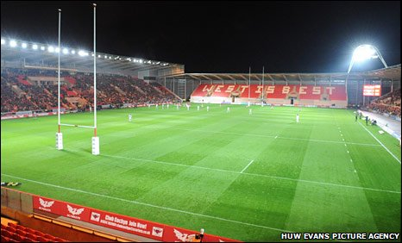

The Geology of Llanelli
Due to the geology of the area the land arguably exploited for coal mining. The geographical position of what is now Llanelli was located closer to the equator during the Carboniferous period. This presented the conditions which created coal during a process of decaying plants, heat, pressure and rising and falling sea levels over the next 300 million years. Prior to the industrial revolution the coal would have been mined in very small quantities and generally for domestic use. It was the arrival of Chauncey Townsend that marked the beginning of large-scale mining in Llanelli and the industrial revolution.
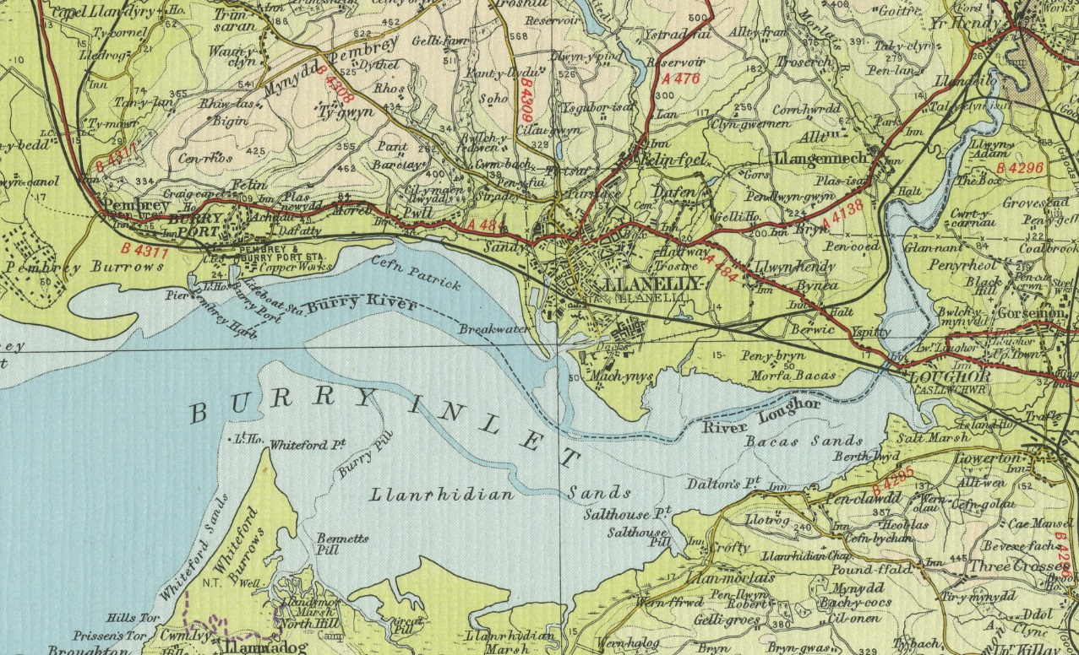

Chauncey Townsend
Chauncey Townsend was a Member of Parliament at Westminster and businessman who began his career in the linen industry as a draper. He was also known for work as a merchant, particularly in the areas around Swansea in South Wales where he developed coal mining, smelting and refining lead and copper. Townsend mined in areas around LaSalle, Landore and at Lanelli. The coal was used to fuel his smelting plants and for export. At the time of his death on 28th March 1770 most of his wealth had been used to finance his mining business (Hughes, 2000). Townsend founded, among many other enterprises, the Middle Bank works. He was later joined in by others including John Freeman, George Pengree, Alexander Raby, Joseph Rotton. Arrivals from Cornwall included some of the families whose names were to be deeply inscribed into the industrial history and townscape of the area (Wales on Line, 2013).
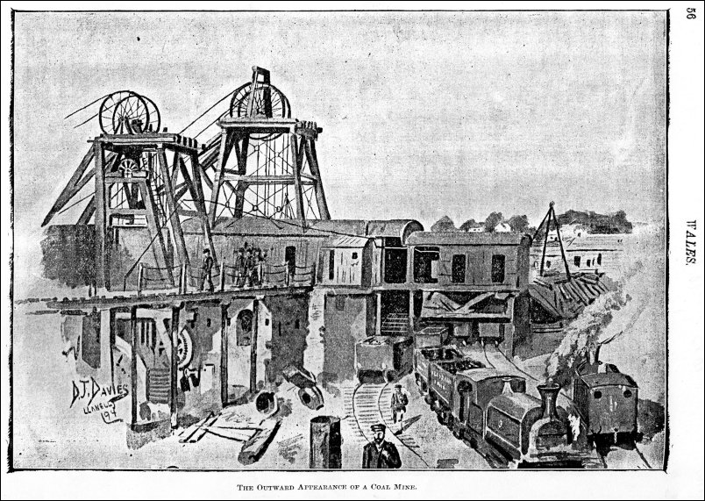

The Economic Downturn
Prior to the arrival of the industrial incomers the area was largely arable land. The land was farmed by local families to sustain the small population at the time. The increase in demand for coal drove the change from 1700 -1750 (Hannam, 2019). By 1913 232,000 were employed in the 620 Welsh coalmines (Burns, 2018) However, by 1985 the British Government at the time led by Margaret Thatcher began a series of pit closures across the country which marked the beginning of the end of the coal industry in Wales. For Llanelli this downturn would be long lasting and bring with it all the negative social and economic effects of mass unemployment.
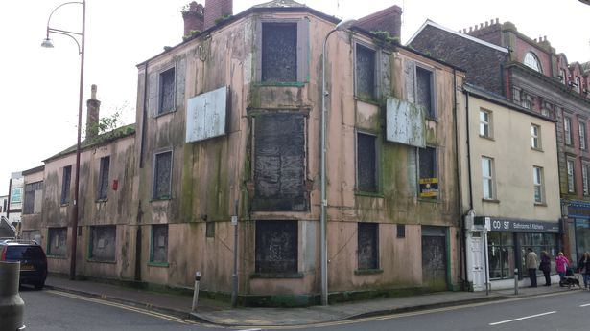

The Steel Industry in Llanelli
Tata steel are known to work with local authorities and waste management bodies throughout the United Kingdom. Active engagement with outside agencies ensures that recycling rates for steel packaging are met. Used packaging, recovered from kerbside collections, incinerators and can banks be then reprocessed into new steel products at Tata Steel Port at Talbot Works. This all contributes to the sustainability of the industry in Wales and the UK.
The Packaging Recycling department is based at the Trostre Works in Llanelli which works to achieve the recycling targets set by EU and UK law. Evidence is recorded by issuing Packaging Waste Recovery Notes (PRNs). These are sold to companies as proof that they have met their obligations to fund the recycling and recovery of packaging waste as required by the UK Packaging Waste Regulations (TATA Steel, 2019).
By importing limestone, coal and iron ore from suppliers from other countries the steelworks produce coils of steel. The whole process begins at the Port Talbot works where a product known as Pig Iron which is Iron Ore smelted by the heat generated by coal furnaces. Limestone is then added to remove impurities. 300 tonne steel pieces known as ‘torpedos’ are transported by a specially constructed rail system to the Boss plant where they are turned into steel coils before being shipped to Trostre where they are made into tinplate to produce packaging for companies such as
DSC for food and cleaning products, Crown France, Crown Braudstone, Ardagh Sutton Food and Heinze (Jones, 2019) .
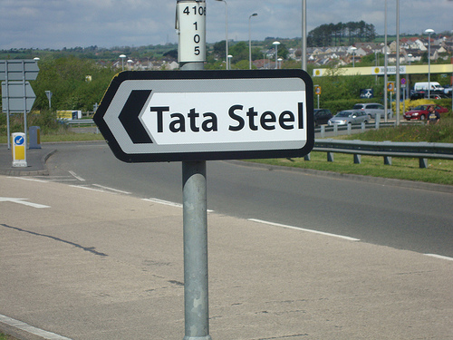

The Wetlands Centre
Founded by Sir Peter Scott the Wetlands centre offers a positive insight into how regeneration can add to the appeal of areas which have suffered the negative affects of unemployment. Despite the area being largely man made the Wetlands centre is a place of natural beauty which attracts visitors to the area, provides an educational experience for schools/ universities and has created several quality jobs in the area.
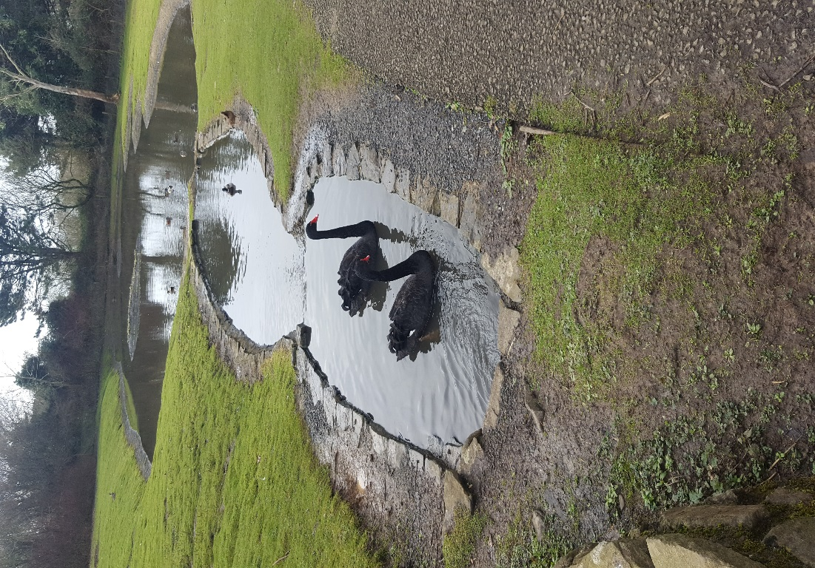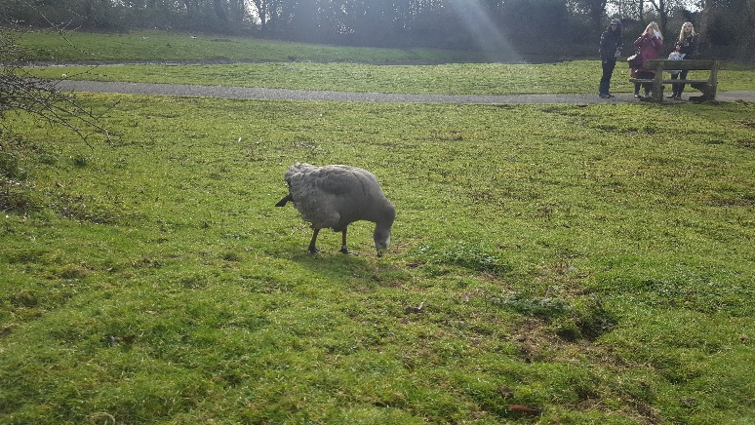
Originally born of the Slimbridge Centre for science and conservation the Wetlands centre opened in 1991 after seven years of development. It is spread across 250 acres of land at Trotter. Another 200 acres was later developed at the turn of the century. The Wetlands centre is now the home to an extensive variety of birds including Caribbean Flamingos’, Shelducks, kingfishers and the almost pre-historic looking Australian Wood Duck. In terms of footfall the Wetland centre had 24,000 visitors in the year 2014 which has risen year on year to approximately 70,000 in 2018 (Rees, 2019).
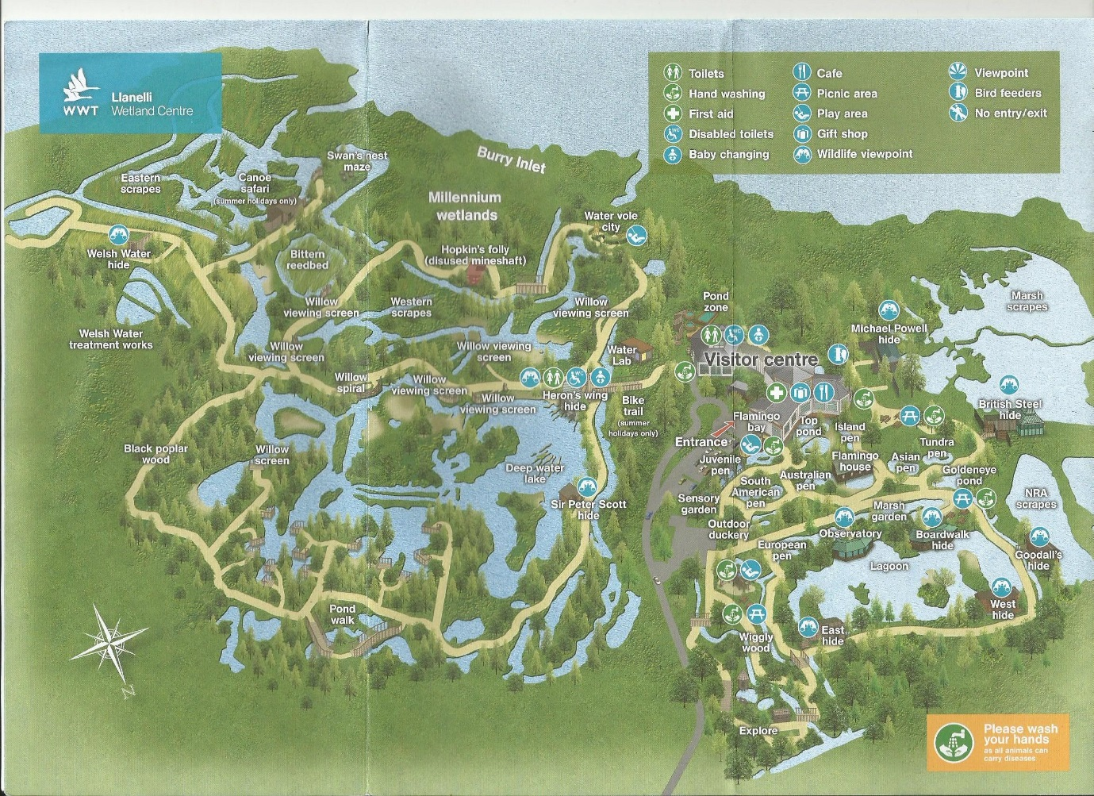

Conclusion
It is evident that with the political will and the vision of those who want for a better outcome, regeneration projects do work to some extent. The Wetlands centre is an example of how redundant land can be developed into a place of study and enjoyment. To be at one with the natural world creates a strong sense of wellbeing and can provide communities with some optimism about the future of the area. The steel industry and the plant at Trostre have neutered a positive environment conscious with the local authority and have proved to be adopting sustainable ways of working which bode well for the future if the steel industry is to survive in West Wales. But there is a lot more that could and should be done. In these uncertain times of Wales’ place in Europe investors will be hesitant to invest and European funding is set to cease, towns like Llanelli still stand proud of their heritage despite there being no real sight of a regeneration plan for the long term.

Bibliography
Burns, A. (2018, February 12). Dr. Llanelli Caol Formation. Wales / UK.
Hannam, J. (2019, Jan 29). The Roots of Modern Llanelli. Wales / Carmarthenshire.
Hughes, S. (2000). Landscapes of the Early Industrial Period in Swansea.
Jones, N. (2019, February 19). Port Talbot Steel Works. Wales / UK.
Llanelli RFC. (n.d.). Retrieved from http://www.llanellirfc.co.uk/125-2
Rees, S. (2019, February 26). Llanelli Wetlands Centre. Wales / Uk.
TATA Steel. (2019). Retrieved from https://www.tatasteeleurope.com
Wales on Line. (2013, March 21). The Copper Kings: Industrialists as Heroes and Villains. Retrieved from Wales on Line: https://www.walesonline.co.uk

