Part C Implementation Submission

Neil O’Mahoney
0351709
Cyber Security BSc Undergraduate Part Time
Table of Contents
Table of Contents 2
Identification of Problems completing the exercise 3
Additional coding problems: 3
Thought process: 3
Additional coding problems: 4
Context 4
Logic Diagrams: 6
While Statement – Do you still wish to play? 7
If statement - Randomisation 7
Nested If statement - Checking If Cards Match, Incrementing Counters & Attempts. 8
If statement – All pairs matched 9
Testing & Screenshots 10
Biblography 19
Annex A: Code 20
Annex B: installation Instructions 27

Identification of Problems completing the exercise
- Ask the user if they wish to play the game in the first instance.
- Need to have an array element that contain pairs.
- Need to display these pairs on a screen.
- Randomise these pairs.
- Receive input from the user of coordinates.
- Compare these coordinates.
- If the cards are a pair, then ‘match’ them.
- If they have been used before then they will be discounted.
- When the full number of pairs have been reached then the game has ended.

Additional coding problems:
- Check if the user has reached the pairs in the shortest amount of time
- Validation checks
- Save the name and number of the user to an outside source
- Complete a highest rank table

Thought process:
- Ask the user if they wish to play the game in the first instance.
Use a while loop and request user input to the program, use of a variable that matches ‘y’ or ‘Y’ otherwise it assumes the user doesn’t wish to carry on.
- Need to have an array element that contain pairs.
This will be single elements; the elements will need to contain an even number there will also need to be enough pairs inside.
- Need to display these pairs on a screen.
Use the ‘printf’ statement, if the display is longer than 4 then use a new line.
- Randomise these pairs.
Use the rand command or the fisher-yates method or something similar. This will mean that the user will not know the location of the cards so it will be hidden by an ‘X’
- Receive input from the user of coordinates.
Allow the user to input the ‘x’ and ‘y’ axis into the screen. This will then produce a location in the element table. This will inturn display the contents of that card(s).
- Compare these coordinates.
This will give a value which must be checked. If the value is ‘0’ then this means it has been chosen previously. The values cannot exceed 6 and go no lower than 1 to be valid.
- If the cards are a pair, then match them.
This will be an if statement; if user input 1 = x and user input 2 = x then output ‘it’s a match’. There will need to be an increment in a counter table which will later be used to determine if the max amount of matches have been reached, which the game can end.
- If they have been used before then they will be discounted.
If the user input = 0 on either the first or second input then this means that the card has previously been used. An increment will need to be passed to a counter to show attempts has been increased. Possibly used later for a score table.
- When the full number of pairs have been reached then the game has ended.
if matches counter = X then end the game. If attempts < X then the game must continue.

Additional coding problems:
- Check if the user has reached the pairs in the shortest amount of time.
This means that there will need to be a check done against the current counter and the one contained within a file. If the one within the file is less than that of the one that’s just been achieved, then after the user has inputted their details it will need to be saved into a separate file.
- Save the name and number of the user to an outside source.
- This can be achieved by using an if statement to check an attempt counter so that if it is less than the current ‘highscore’ then the file gets opened and the details are recorded. The current details of the user in the ‘highscore’ file gets moved to a hall of fame.
- Complete a highest rank table
This could be achieved by sorting the highest to lowest within the hall of fame based on the attempts field.
- Validation checks
To ensure that the user is inputting the expected format of data a ‘while statement’ with an upper and lower limit could be used. Preferably with || (or) within a given range.

Context
From the ‘Fisher-Yates’ shuffle (an algorithm that shuffles a sequence) it is believed that this or something similar will need to be used to randomise the elements with an array. The array will need to be predefine (so there are enough pairs of cards/ numbers within).
Displayed below is a pseudo code version of Fisher-Yates method: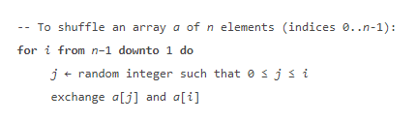
[1]
A logical statement about how to swap the code around is demonstrated in the below:
1. Create a list of consecutive integral numbers from 1 to n. Penn Wu RHESL - Volume 6, Issue 22 (2013), pp. 29-38 31
2. Randomly select a number from 1 to the total number of the list, say k.
3. Counting from the low end, remove the kth number from the list, and then place it elsewhere.
4. Repeat the last two steps until all the numbers have been removed from the original list.
5. The sequence
[2]

Loosely based this would be a method of moving the elements in the array around. Tekpool improves on this method by introducing an upper and lower limit:
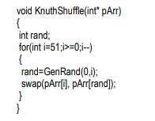
[3]
Based on the above information it would be best to use the improved Tekpool method of the Fisher-Yates shuffle algorithm within the program. This will assist with the randomness of the event and the probability that it will be less likely to repeat the same patterns.

Logic Diagrams:

Writing the blank grid table as a nested ‘if’ statement:

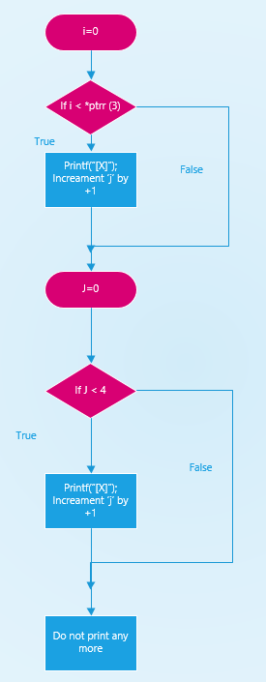

While Statement – Do you still wish to play?

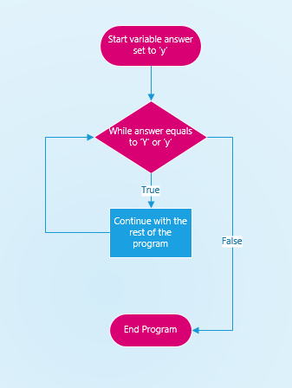

If statement - Randomisation
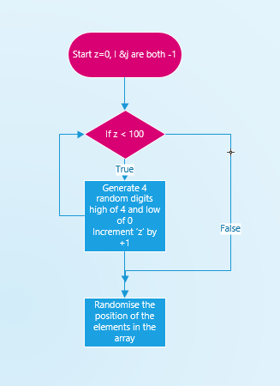

Nested If statement - Checking If Cards Match, Incrementing Counters & Attempts.

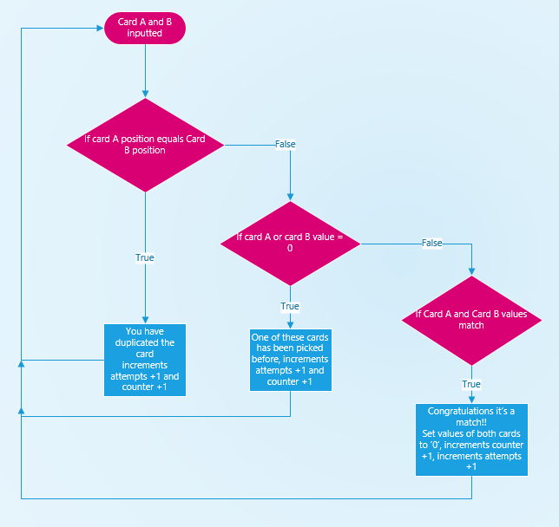

If statement – All pairs matched
Must = 6 for the game to end, relies on ‘Card Match Statement’ above to increment the counter to 6.
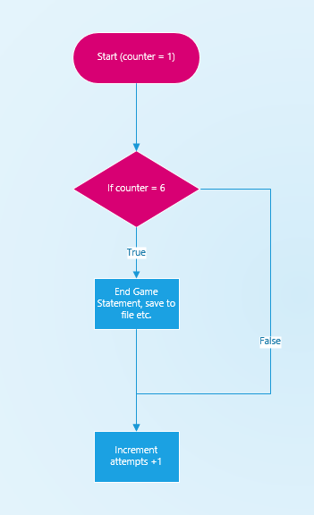

Testing & Screenshots
Number of Test | 1
Program Name | Question C Program  Do you wish to play this game?
Type of Test | Normal Operation
Data Inputted | y
Expected output | Proceed to next question
Actual Output | Proceeded to next question
Pass/ Fail | Pass
Date of Test | 01/05/2019
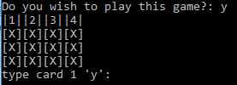
Number of Test | 2
Program Name | Question C Program  Do you wish to play this game?
Type of Test | Boundary Operation
Data Inputted | Y
Expected output | Proceed to next question
Actual Output | Proceeded to next question
Pass/ Fail | Pass
Date of Test | 01/05/2019
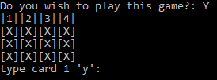

Number of Test | 3
Program Name | Question C Program  Do you wish to play this game?
Type of Test | Abnormal Operation
Data Inputted | 7
Expected output | Exit the program
Actual Output | Exit the program
Pass/ Fail | Pass
Date of Test | 01/05/2019
Number of Test | 4
Program Name | Question C Program  Type card 1 ‘y’:
Type of Test | Normal Operation
Data Inputted | 2
Expected output | Proceed to next question
Actual Output | Proceed to next question
Pass/ Fail | Pass
Date of Test | 01/05/2019
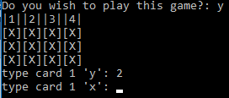
Number of Test | 5
Program Name | Question C Program  Type card 1 ‘y’:
Type of Test | Normal Operation
Data Inputted | 7
Expected output | Repeat question
Actual Output | Repeat question
Pass/ Fail | Pass
Date of Test | 01/05/2019
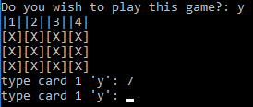
Number of Test | 6
Program Name | Question C Program  Type card 1 ‘y’:
Type of Test | Abnormal Operation
Data Inputted | -1
Expected output | Repeat question
Actual Output | Repeat question
Pass/ Fail | Pass
Date of Test | 01/05/2019
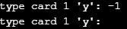
Number of Test | 7
Program Name | Question C Program  Type card 1 ‘y’:
Type of Test | Abnormal Operation
Data Inputted | g
Expected output | Repeat question
Actual Output | Code scrambled
Pass/ Fail | Fail
Date of Test | 01/05/2019
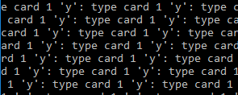
Number of Test | 8
Program Name | Question C Program  Type card 1 ‘x’:
Type of Test | Normal Operation
Data Inputted | 1
Expected output | Gives the value of the card
Actual Output | Gives the value of the card
Pass/ Fail | Pass
Date of Test | 01/05/2019
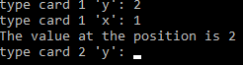

Number of Test | 9
Program Name | Question C Program  Type card 1 ‘x’:
Type of Test | Boundary Operation
Data Inputted | 7
Expected output | Repeats the question
Actual Output | Repeats the question
Pass/ Fail | Pass
Date of Test | 01/05/2019
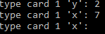

Number of Test | 10
Program Name | Question C Program  Type card 1 ‘x’:
Type of Test | Boundary Operation
Data Inputted | -1
Expected output | Repeats the question
Actual Output | Repeats the question
Pass/ Fail | Pass
Date of Test | 01/05/2019
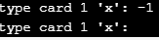

Number of Test | 11
Program Name | Question C Program  Type card 1 ‘x’:
Type of Test | Abnormal Operation
Data Inputted | g
Expected output | Repeats the question
Actual Output | Code scrambled
Pass/ Fail | Fail
Date of Test | 01/05/2019
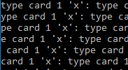
Number of Test | 12
Program Name | Question C Program  Cards do not match
Type of Test | Normal Operation
Data Inputted | Cards do not match
Expected output | Increments attempts counter, repeats question
Actual Output | Increments attempts counter, repeats question
Pass/ Fail | Pass
Date of Test | 01/05/2019
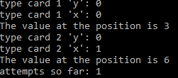
Number of Test | 13
Program Name | Question C Program  Cards match
Type of Test | Normal Operation
Data Inputted | Cards match
Expected output | Increments attempts counter, moves onto next question
Actual Output | Increments attempts counter, moves onto next question
Pass/ Fail | Pass
Date of Test | 01/05/2019
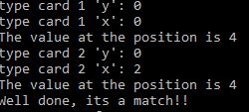
Number of Test | 14
Program Name | Question C Program  Cards match but one has been picked before
Type of Test | Normal Operation
Data Inputted | Cards match
Expected output | Increments attempts counter, repeats question, tells user they are duplicating.
Actual Output | Increments attempts counter, repeats question, tells user they are duplicating.
Pass/ Fail | Pass
Date of Test | 01/05/2019
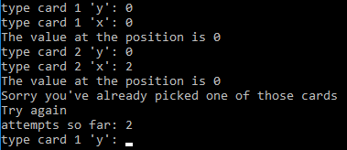
Number of Test | 15
Program Name | Question C Program  Cards match end of game
Type of Test | Normal Operation
Data Inputted | None (end of game or matches = 6)
Expected output | Increments attempts counter, file checks high score displays name, requests your name.
Actual Output | Increments attempts counter, file checks high score displays name, requests your name.
Pass/ Fail | Pass
Date of Test | 01/05/2019
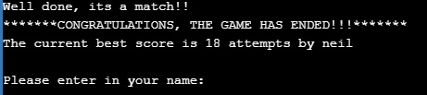
Number of Test | 16
Program Name | Question C Program  Cards are all matched
Type of Test | Normal Operation
Data Inputted | ‘dave’
Expected output | Replaces current high score best. Moves old high score to hall of fame.
Actual Output | Replaces current high score best. Moves old high score to hall of fame.
Pass/ Fail | Pass
Date of Test | 01/05/2019
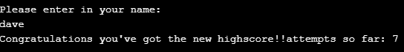
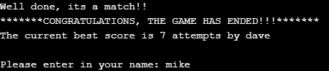

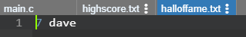
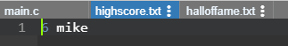

Number of Test | 17
Program Name | Question C Program  End of game, enter in name
Type of Test | Abnormal Operation
Data Inputted | GAVIN
Expected output | Continues to next screen and records ‘GAVIN’ as an entry.
Actual Output | Continues to next screen and records ‘GAVIN’ as an entry.
Pass/ Fail | Pass
Date of Test | 01/05/2019

Number of Test | 18
Program Name | Question C Program  End of game, enter in name
Type of Test | Abnormal Operation
Data Inputted | 3
Expected output | Repeat the question
Actual Output | Continues to next screen and records ‘3’ as an entry
Pass/ Fail | Fail
Date of Test | 01/05/2019

Bibliography

[1] | M. Roberts, “The Fisher-Yates Algorithm,” None, Unknown Unknown 2016. [Online]. Available: http://extremelearning.com.au/fisher-yates-algorithm/. [Accessed 01 May 2019].
[2] | P. Wu, “TEACHING ALGORITHMS AS LANGUAGE UNSPECIFIC TOPICS OF CS,” REVIEW OF HIGHER EDUCATION AND SELF-LEARNING , vol. 6, no. 22, p. 31, 2013.
[3] | Tekpool, “Shuffling - Shuffle a deck of cards,” 2006.

Annex A: Code

//Code written by Neilo O'Mahoney 2019

#include <stdio.h>
#include <stdlib.h>
#include <time.h>
void thewholething();
int wishtoplaygame();
int main()
{
thewholething(); //calls the whole program as a function
return 0;
}

void thewholething() //calls the function
{
char answer;
answer = wishtoplaygame(); // no arguments passed but returns a value
int i, j, z;
int answer1, answer2, attempts = 0, match = 0, low = 1, high = 5, highscore;//highscore is read from external file
char scorename[10];
char highscorename[10];
int r, *ptrr; //points to 'r'
r = 4; //displaying use of pointers
ptrr = &r; //pointer becomes 'r'
int j1, j2, i1, i2, random;
srand(time(NULL));//seed random time charged ONCE ONLY
int jLow = 0; //bottom of x range
int jHigh = 2; //top of x range
int iLow = 0; //bottom of y range
int iHigh = 3; //top of y range
int myarray[3][4] = { 1,1,2,2,3,3,4,4,5,5,6,6 }; //elements in the array
int tempvar;
int ia = -1; //must be a lower value than 0
int ja = -1;
int ib = -1;
int jb = -1;

while (answer == 'y' || answer == 'Y') //validation check
{
printf("|1||2||3||4|\n");// x- axis grid display
// Print initial array
for (i = 0; i < 3; i++)
{
for (j = 0; j < *ptrr; j++) //displaying use of a pointer - no actual need for this
{
printf("[X]"); //'x' to be printed in place of the card
if (j == 3) //if j equals to 3 then drop down a line.
{
printf("\n");
}
}
}
// Run randomisation 15 times
for (z = 0; z < 100; z++)// Run randomisation 100 times
{
j1 = rand() % (jHigh - jLow + 1) + jLow; //generate random

j2 = rand() % (jHigh - jLow + 1) + jLow; //generate random

i1 = rand() % (iHigh - iLow + 1) + iLow; //generate random

i2 = rand() % (iHigh - iLow + 1) + iLow; //generate random

tempvar = myarray[j1][i1]; //myarray becomes tempvar shuffles the cards
myarray[j1][i1] = myarray[j2][i2];
myarray[j2][i2] = tempvar;
}
/*//Test purpose print final array
for (i = 0; i < 3; i++)
{
for (j = 0; j < *ptrr; j++)
{
printf("%d ", myarray[i][j]);
if (j == 3)
{
printf("\n");
}
}
}*/

while (match < 6) //6 is the max number of matches they should have on this game
{
ia = -1;
ib = -1;
ja = -1;
jb = -1;
while (ia < 0 || ia > 5) //lower and upper limit, grid does not go over 4
{
printf("type card 1 'y': "); //printed on the screen
scanf("%d", &ia); // reads the first digit (starting at 0, then the second digit
}
while (ja < 0 || ja > 5) //lower and upper limit, grid does not go over 4
{
printf("type card 1 'x': "); //printed on the screen
scanf("%d", &ja); // reads the first digit (starting at 0, then the second digit
}

printf("The value at the position is %d\n", myarray[ia][ja]); //displays the output of the cell that has been requested

while (ib < 0 || ib > 5) //lower and upper limit, grid does not go over 4
{
printf("type card 2 'y': "); //printed on the screen
scanf("%d", &ib); // reads the first digit (starting at 0, then the second digit
}
while (jb < 0 || jb > 5) //lower and upper limit, grid does not go over 4
{
printf("type card 2 'x': "); //printed on the screen
scanf("%d", &jb); // reads the first digit (starting at 0, then the second digit
}

printf("The value at the position is %d\n", myarray[ib][jb]); //displays the output of the cell that has been requested

if (ia == ib && ja == jb)//This statement checks if the user has duplicated the position of the cards
{
printf("Thats a duplicated card, you cannot do that,\n");
printf("Try again\n");
}

else if (myarray[ia][ja] == 0 || myarray[ib][jb] == 0) //this statement stops the user from picking cards that have already been chosen.
{
printf("Sorry you've already picked one of those cards\n");
printf("Try again\n");
}
else
{
if (myarray[ia][ja] == myarray[ib][jb]) //if both cards a and b are the same then *nested statement*
{
printf("Well done, its a match!!\n");
myarray[ia][ja] = 0; //this resets the card (used later to check if its been chosen previously)
myarray[ib][jb] = 0; //this resets the card (used later to check if its been chosen previously)
match = match + 1; //increaments the match integer (this is used later on when matches reaches a certain number the game is over)
if (match == 6) //this is the key number of matches to end the game *nested statement*
{
attempts = attempts + 1;
printf("*******CONGRATULATIONS, THE GAME HAS ENDED!!!*******\n");
FILE *fp;
fp = fopen("highscore.txt", "r"); //opens and reads the contents of the file
fscanf(fp, "%d", &highscore); //scans the score element
fscanf(fp, "%s", &highscorename); //scans in the highscorename element
fclose(fp); // closes the file
printf("The current best score is %d attempts by %s \n\n", highscore, highscorename); //display on screen the elements from the file
printf("Please enter in your name: ");
scanf("%s", scorename);

if (attempts < highscore)
{
printf("Congratulations you've got the new highscore!!");
FILE *fp;
fp = fopen("highscore.txt", "r"); //this opens the file and moves the current highscorers name into the hall of fame.
fscanf(fp, "%d", &highscore); //reads the score in file
fscanf(fp, "%s", &highscorename); //reads the name in file
fclose(fp); //closes the file
fopen("halloffame.txt", "w"); //opens hall of fame file
fprintf(fp, "%d %s", highscore, highscorename); //prints into the file the old highscore name into the hall of fame.
fclose(fp); //closes hall of fame.
//write to file
fopen("highscore.txt", "w");
fprintf(fp, "%d %s", attempts, scorename); //this is where the user beat the current highscore and their details now replace the old one.
fclose(fp); //close the highscore file down.
}
else

{
printf("Well Done, youve completed it, but not a high score!!");
//write to file
fopen("halloffame.txt", "w"); //open hall of fame
fprintf(fp, "%d %s", attempts, scorename); // record the current players details to the hall of fame.
fclose(fp); //close the hall of fame.
}

}
}
}
attempts = attempts + 1; //increments the attempts variable which keeps a running score of the user
printf("attempts so far: %d \n", attempts);
// }
//}
}
printf("\nwould you like to play again? y/n: ");
scanf(" %c", &answer);
}
printf("Maybe another time");
}

int wishtoplaygame() //function no arguments passed bu returns a value //returns integer entered by the user.

{
char answer = 'y';
printf("Do you wish to play this game?: ");
scanf(" %c", &answer);
return answer;
}

Annex B: installation Instructions

Copy the code into a new source file
Right click ‘Source files’ in the solution browser
Add > new Item > Visual C++ > utility > textfile.txt > right click > rename > call it ‘highscore.txt’
Repeat to create a new file called ‘halloffame.txt’
See figure below for closer inspection


