ACBA 5018
Cerith Edwards
UWTSD – 2219938 DR Deborah Hughes
1/3/2025


Business Management
Table of Contents
ORG Chart 2
What is an ORG Chart 2
Advantages and Disadvantages 2
Various ORG Charts 3
Hierarchical 3
Matrix 3
Flat 4
Personal Background 5
Previous roles 5
Current Role 6
Current ORG Chart 6
Culture 7
My Proposed ORG Chart 7
Conclusion 8
References 9

ORG Chart

What is an ORG Chart

An Org chart is short for an organisational chart. This is a visual representation of a company’s internal structure. It illustrates the hierarchy of positions, roles and responsibilities within an organisation. A typical ORG chart will display the relationship within a business, ranging from departments, teams and individuals in a hierarchy format. Usually with the most senior positions at the top and the entry level positions at the bottom. The purpose of an ORG chart is to provide a visual for employees with a clear understanding of the companies structure and reporting lines, helping facilitate communication, decision making and collaboration within the business or organisation. It helps employees understand where they fit in and who they report to. ORG charts can also help identify gaps or overlaps in roles. (Chen, 2024)

There are several types of ORG charts, however the most common ones as discussed in our recent lecture with Dr D. Hughes are the Hierarchical (also known as the traditional org chart), Matrix and flat. There are several advantages and disadvantages to ORG charts, each ORG chart being specific to the type of business. However below I have highlighted my opinion to the advantage and disadvantage to ORG charts overall.

Advantages and Disadvantages

Advantages:

- An organisational chart makes it easier for staff members to understand who they report to and who they are accountable to by clearly displaying the reporting relationships within a company.
- It establishes a clear hierarchy and structure within an organization, an org chart can assist staff members in understanding their roles and who to consult for advice.
- By clearly defining who has the power to make decisions, organisational charts can help decision-making.
- Employees can benefit from using organization charts to understand possible career paths within the company and to identify possible areas for growth and development.

Disadvantages:
- Organisational charts may be inflexible and unresponsive to organisational changes, which could make it challenging to adjust to new challenges or opportunities.
- Misunderstandings regarding how work is completed may arise because organisational charts don't always appropriately show the networks and connections that exist within a company.
- Collaboration among workers and open communication may be discouraged by the hierarchy and authority that organisational charts can represent.
- Depending on the volume of staff maintaining an Org chart can be very time consuming. Staff can often change roles and departments and ORG chart can often requirement regular updates and maintenance work.
(Nishadha, 2024)

Various ORG Charts

Hierarchical

The most common type of Org chart is the pyramid shaped chart. This is called the hierarchical chart. A hierarchical organisational chart places higher-ranking employees above lower-ranking ones based on their position or degree of authority within the company. A company's chain of command and levels of authority are frequently depicted using this kind of chart. (Lucidchart, 2024)

Below is an image supplied by Jacob Morgan on the Forbes website, which briefly shows the flow of an hierarchical org chart, as you can see this shows a chain of command with the most senior ranking at the top feeding down to entry level. A good example of where this chart would be used would be in the military. (Jacob, 2015)

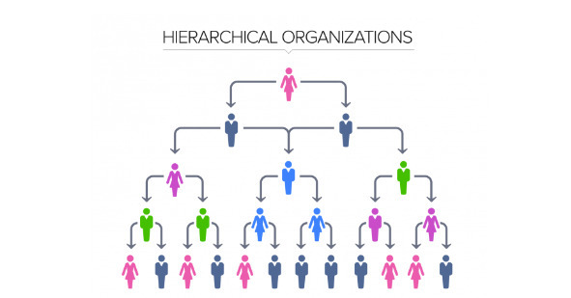
Figure 1 - Hierarchical ORG, (Jacob, 2015)

Matrix

An organisational structure known as a matrix chart is one in which staff members are accountable to multiple managers or supervisors. Any business structure where each project is overseen by two or more "bosses" is known as a matrix organization. For instance, staff members report to project managers in addition to department heads. The matrix structure definition includes the idea that managerial positions are flexible and can change according to the demands of a project. (Esther, 2024)

Employees in a matrix organisation are categorised by both product/service and function. More co-operation and communication between various projects and departments are made possible by this structure. However, as they negotiate reporting relationships, it can also cause employees to become confused and have conflicting priorities.

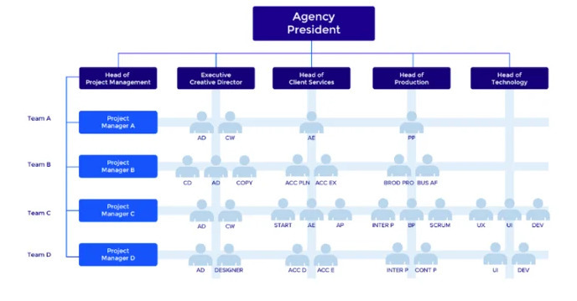

Figure 2 - Matrix Chart

Flat

An organisation with fewer tiers of management between the top executives and the frontline staff is known as a flat org chart. Also known as a horizontal organisational structure this has levels ranging from entry-level employees to the highest company leadership. Workers may answer to one or two tiers of management whom oversee all team members or alternatively they may even report directly to the company/business owner. (motion, 2024). With fewer levels of hierarchy, this kind of organisational chart usually gives workers greater freedom and direct access to decision-makers. A more agile and responsive organization, improved communication, quicker decision-making are all possible outcomes of this structure.

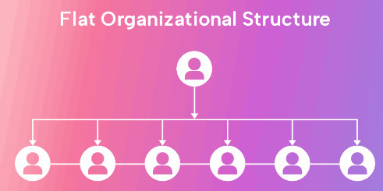
Figure 3 - Flat org chart, (motion, 2024)

Personal Background

Previous roles
With 20 years experience of working in different job roles. I have experienced many different Org charts. Prior to my role as a Trainee QS I spent 19 years in the Civil Service. Within these 20 years I experienced a few different roles within the operational areas. A few of my roles are listed below

- Admin assistant
- Admin operative
- Executive officer (team leader)
- Head of training and facility management for a department
- Project to delivery Change and improvement for the Agency

Within one of the branches of the Civil Service I was employed there were around 6000 staff. (GOV.UK, 2024). There were so many org charts there that I found it unbeneficial as you only really knew people within your own team/department. However, the departmental org charts were helpful, with each department being treated as an individual business area. Briefly from what I remember ORG charts were split into several levels. I only ever worked in a hierarchical structure. Although this is my preferred type of org chart. I believe this does not work for a larger number of employees, however splitting this up to individual departments does provide you with the information you require.

The 6000 employees would all be split into charts like the ones presented below. You would have a senior leadership team org chart followed by an individual departmental chart.
It was similar to my creation below:

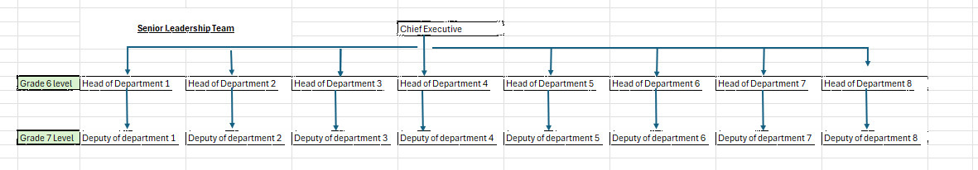
Figure 4 - SLT GOV
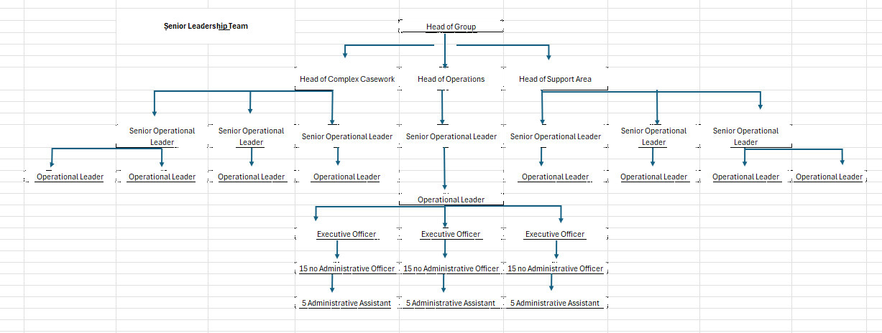
Figure 5 - Departmental ORG chart
As you can see form the above the Org charts, they are suitable and beneficial for individual departments, but not if you needed to contact another department. Another issue with this Org chart was that no one was “named” from Operational Leadership down to Admin assistant, again making it difficult to identify who was required for each role or task you need.

Current Role
I’ve been a trainee QS for 30 months now at premier forecourts. I have again found myself in a hierarchical ORG chart. I will use this management structure as an example for my review. Although my current employer only has 33 office staff compared to the 6000 in the government department. I believe this Org chart works a lot smoother due to the layout. The company currently uses a hierarchical management structure with multiple layers of management.

Current ORG Chart
At the top is the board of directors, 2 of whom are office based daily. This is made up of an chairman (company owner), Non-executive director (also the company accountant), the managing director (MD) (shared owner) and a operations director. The MD and Ops director are the two office based staff members. We then have the executive team, who are made up of departmental leaders. This is made up of a operations manager whom is responsible for the contract managers. HR manager is responsible for a pay roll assistant. A health and safety compliance manager with an assistant H&S member. A head of finance who has 2 assistants. A procurement manager who has 4 staff members to include a on site stores manager. Then we have my department who has a head of commercial, responsible for 2 trainee QS, a freelance consultant and a vacant post.

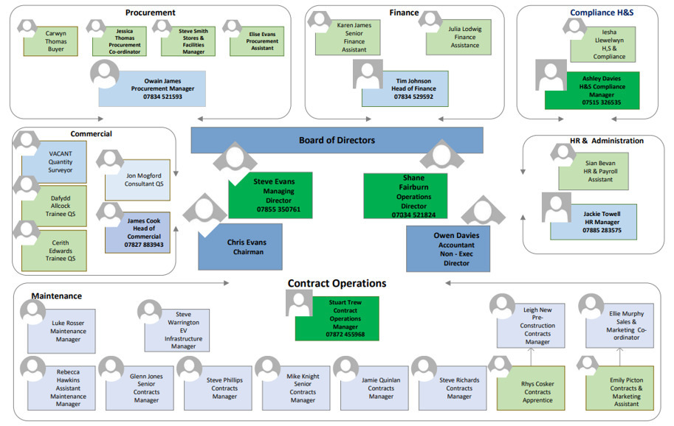
Figure 6 - Premier org chart (personal communications, 2024)

While this traditional management structure works well for Premier and continues to do so. I believe there are some drawbacks to this approach. Firstly I don’t like the layout, with the circular movement, I would prefer it is set up similar to my previous employee as I believe it has better structure for the line of command. Another issue I find with this structure and in particular the hierarchical structure is that it can lead to a lack of autonomy and empowerment among employees. With decision-making authority concentrated at the top, front-line employees may feel disempowered and disengaged from their work. Looking at this structure it can also lead to communication issues and delays in decision making, this is due to information often having to filter through a few layers of management before meeting the appropriate decision maker. This can slow down the decision-making process and hinder projects. Although a flat or matrix org chart could be more beneficial for promoting direct communication, producing quicker decision making and promoting employee empowerment.

Another element I like about our current ORG chart is that it has a colour scheme, this helps people who are unaware of people’s status within the company identify the roles. Again I think we could improve this with colours with a better variation in contrast.

- Green – Senior leadership team
- Light blue – head of departments
- Grey – Contracts team
- Light Green- administrative staff

Culture
However, in my opinion I believe Premier has something that out weighs any ORG chart. I believe the culture and leadership styles instilled by Premier throughout the years its been trading is more important than any ORG chart layout. The culture in Premier defines the values and beliefs and the behaviours of the staff. The culture within has shaped how we interact with each other, make decisions and contribute to the overall success of the company. The strong and positive culture has lead to improved employee engagement, increased productivity, which overall improves the day to day operations of the company.
However, I do realise an ORG chart outlines the formal hierarchy of the company and the structure is important to understand and know staffs’ roles and responsibilities contribute. It does not however dictate how we work together or the overall atmosphere within the company. Without the strong culture and relevant behaviours employees can feel disconnected, unmotivated and uninspired, all of which can hinder the company’s future and current operations. In essence, culture is the foundation upon which an organization is built, influencing how employees think, act, and relate to each other. A well-defined and positive culture can create a sense of unity, purpose, and belonging among employees, ultimately driving success and sustainability for the organisation. I believe all ORG charts layouts/structures would benefit my current company as I believe we have the behaviours and culture to adapt to each one.

My Proposed ORG Chart
Although my opinion culture is extremely important, I would however change the layout of the ORG chart for the organisation. My Proposed change is as below:

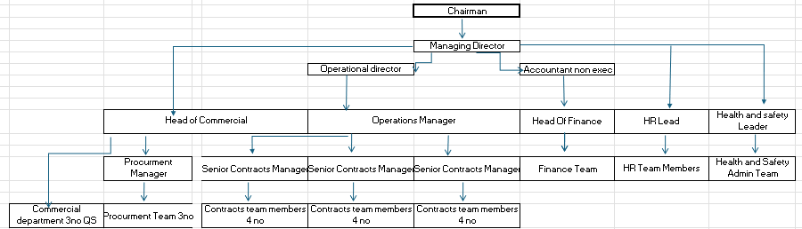
Figure 7 - (personal communications, 2024)
The main Change I have made is the layout. I like to see a chart that is hierarchical and shows this with the most senior management team at the top of the chart, indicating reporting lines. As you can see in this chart every team will report to the managing director. The managing director is a shared owner and I believe he needs to know how his teams are performing and will have direct contact/reporting with each department lead. The other change I would introduce is I would get the Head of commercial to manage the procurement team and the commercial team to oversee all costs/spending associated with each job. This would bring the departments closer and take accountability for all spending costs in the company. Knowing the commercial lead on a personal level, he has a commercial and procurement background and will be able to further improve, lead and improve the department while reporting directly to the managing Director. The commercial lead will play a critical role in driving business growth, optimising operations, and maximising profitability for the company. By overseeing the commercial and buying team, they ensure that the company remains competitive, efficient, and successful in the market. These would be the small changes I introduce. I wouldn’t change much more, mainly due to the low numbers in each department, hence why I have left the rest reporting as we currently do; as shown above.

Conclusion
In conclusion, while the current hierarchical management structure may have served Premier well in the past, I believe there are opportunities for improvement by changing the layout and reporting structure. This would help the organisation to be more agile, responsive, and competitive in today's fast-paced business environment. It will also utilise leaders strength to lead the correct departments to their peak performance.

References
Chen, J., 2024. Organizational Chart Types, Meaning, and How It Works. [Online]
Available at: https://www.investopedia.com/terms/o/organizational-chart.asp
[Accessed Wednesday 13th November 2024].
Company 1, 2023. Asphalt standard detail. s.l.:Premier forecourts.
Esther, C., 2024. Matrix Organizational Structure in Project Management– A Complete Guide With Examples. [Online]
Available at: https://www.workamajig.com/blog/matrix-organizational-structure
[Accessed Wednesday 13th November 2024].
GOV.UK, 2024. Working for DVLA. [Online]
Available at: https://www.gov.uk/government/organisations/driver-and-vehicle-licensing-agency/about/recruitment
[Accessed 19 November 2024].
Jacob, M., 2015. The 5 Types Of Organizational Structures:. [Online]
Available at: https://www.forbes.com/sites/jacobmorgan/2015/07/06/the-5-types-of-organizational-structures-part-1-the-hierarchy/
[Accessed Wednesday 13th November 2024].
Lucidchart, 2024. 10 types of organizational structures (+ org charts for implementation). [Online]
Available at: https://www.lucidchart.com/blog/types-of-organizational-structures#:~:text=Hierarchical%20org%20structure&text=It%27s%20the%20most%20common%20type,each%20employee%20has%20a%20supervisor.
[Accessed Wednesday 13th November 2024].
motion, 2024. What Is a Flat Organizational Structure? (Pros, Cons, Tips, and FAQs). [Online]
Available at: https://www.usemotion.com/blog/flat-organizational-structure
[Accessed Wednesday 13th November 2024].
Motor Fuel Limited 2023, 2023. The Largest Independent Forecourt Operator In The UK. [Online]
Available at: https://www.motorfuelgroup.com/
Nishadha, 2024. Advantages and Disadvantages of Organizational Charts Structures. [Online]
Available at: https://creately.com/blog/hr-planning/advantages-disadvantages-organizational-charts/
[Accessed 2nd December 2024].
personal communications, A., 2024. Premier ORG Chart. Swansea: Ashley.davies@premierfcltd.com.
Premier Forecourts and Construction, 2023. Forecourt. [Online]
Available at: https://www.premierforecourtsandconstruction.com/forecourt/

